
ANA NICA
2130971



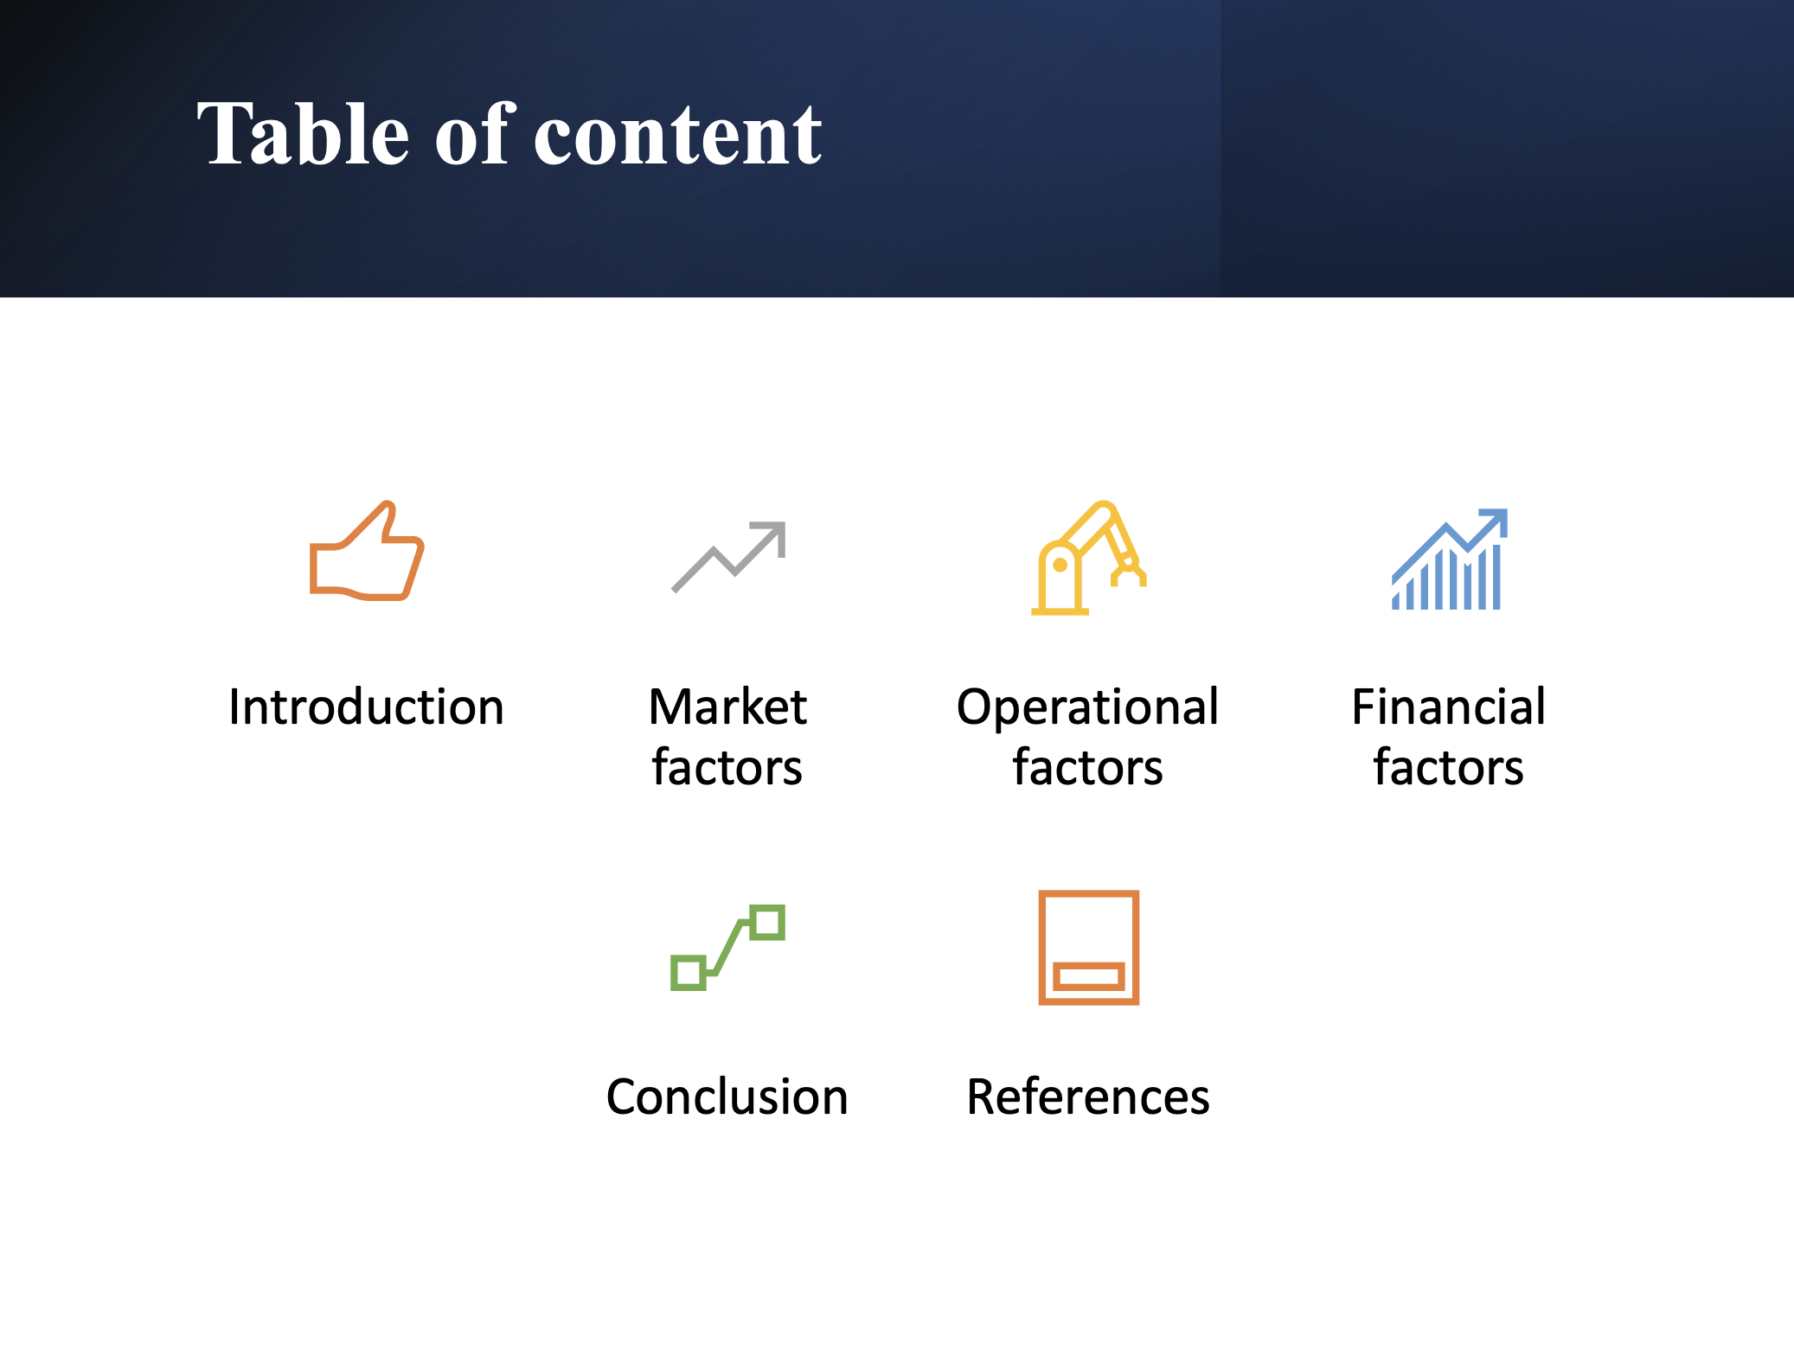

Introduction
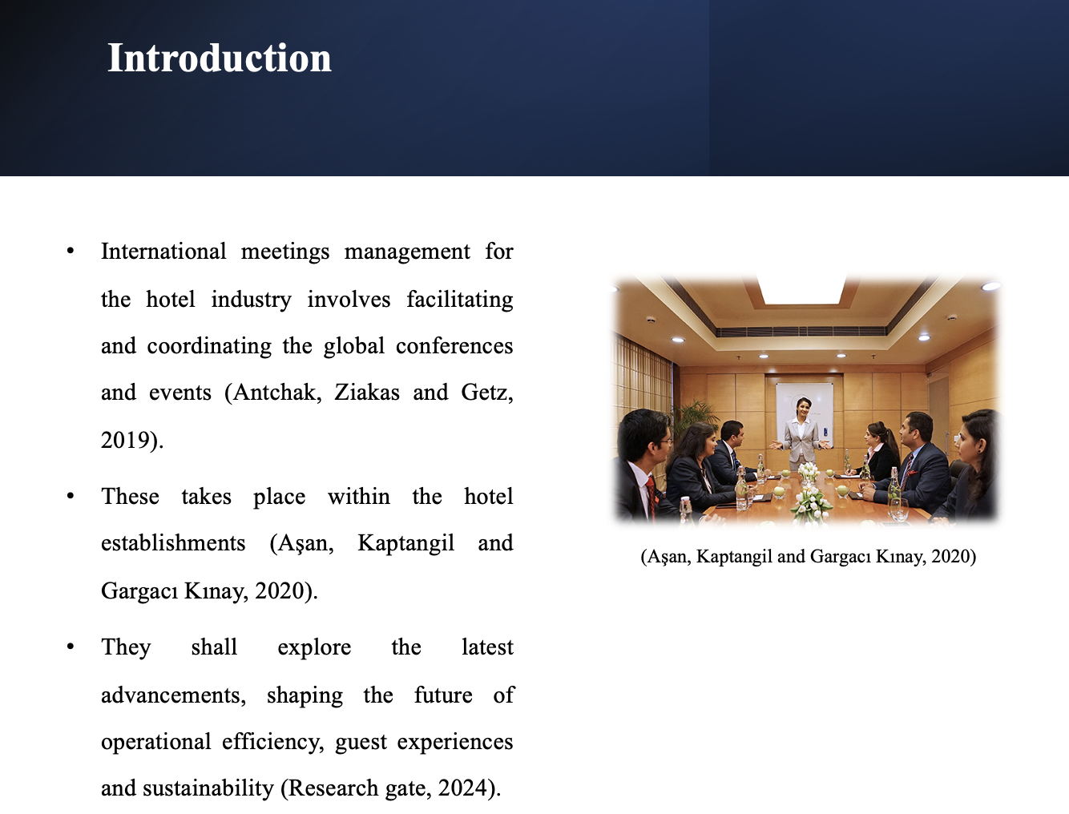
- The feasibility and strategic research for the chosen event will be discussed.
- The market, operational and financial factors will be discussed at the event as well.
- The event taking place will be including the theme of technology and innovation within the hospitality sector.
- The event name will be 'TechHospitality Summit' that will bring together industrial leaders, hospitality professionals and technological innovators.

Market factors
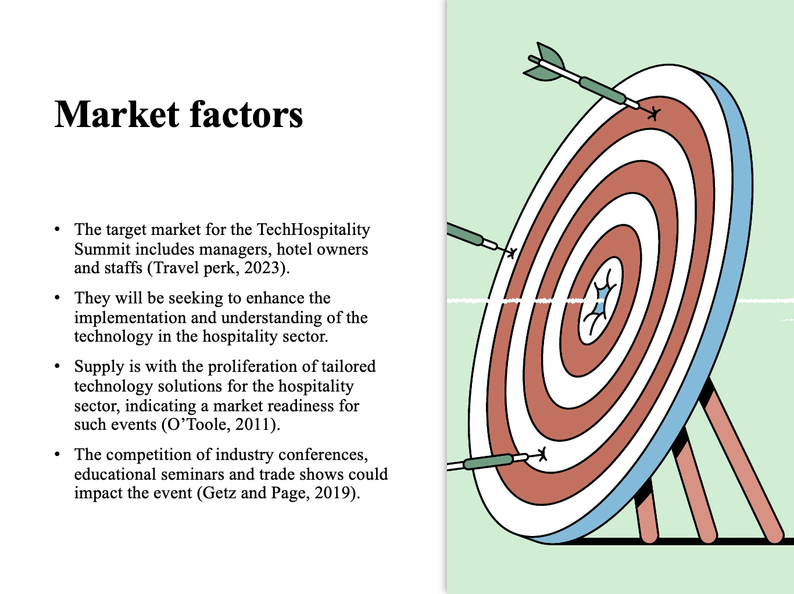
- Additionally, virtual summits, digital content platforms and online webinars will also offer similar insights and networking opportunities.
- These will be diverting the potential participants, resources and attention away from the TechHospitality Summit event.
- Additionally, technology companies will specialise in hospitality solutions.
- It will also be beneficial for investors and industry consultants, interested in the intersection of technology and hospitality as the key audiences.
- Demand for this type of event increasingly relies on technology for efficiency, competitive advantage and guest satisfaction.

Cont..
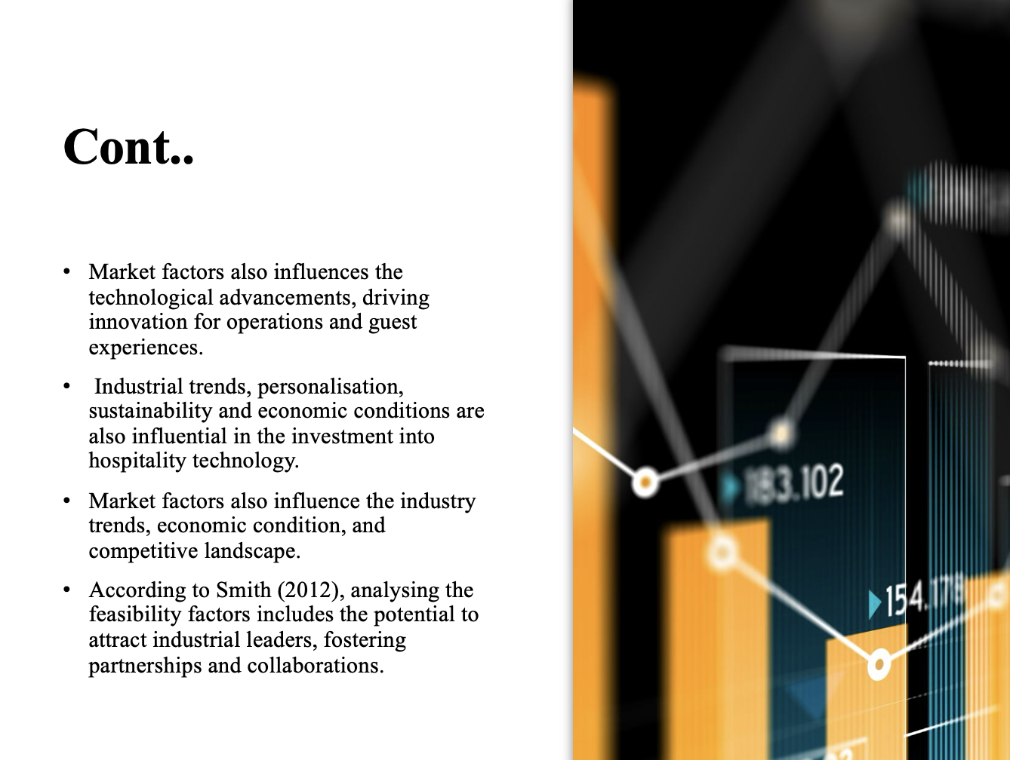
- Additionally, the networking opportunities facilitate meaningful connections, driving growth of the business and opportunities for the participants.
- Moreover, through careful execution, planning and implementation, this summit event could generate revenue streams from ticket sales, fee and sponsorships.
- These could be ensuring financial viability for the future as well. It offers a platform to showcase innovative technology solutions and answer the skills and knowledge of the attendees. The event will focus on the emerging trends, ensuring competitiveness and relevance. The regulatory changes also impact security and data privacy within the sector.

Cont..
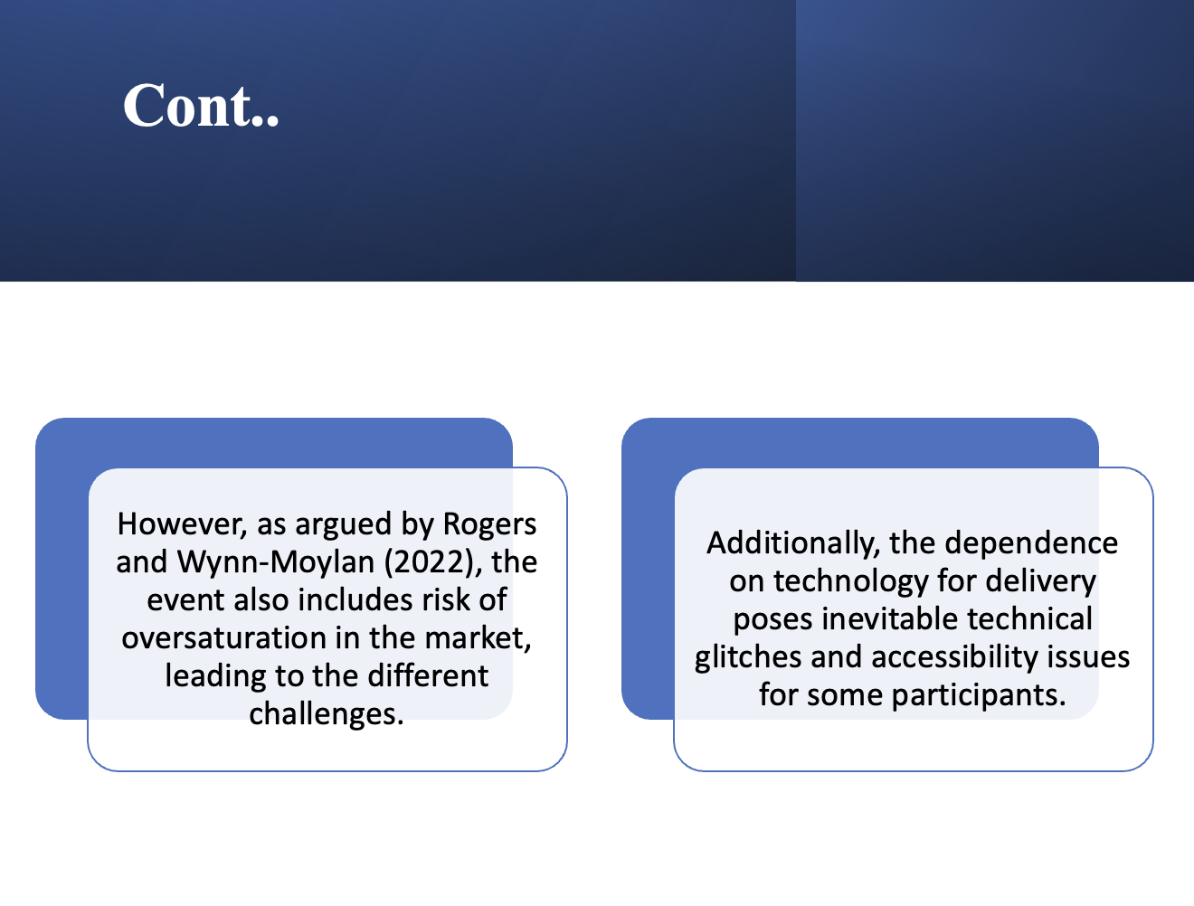

Ultimately, speakers that will be hosting meetings might fail to meet the expectations of the attendees, leading to dissatisfaction among them.

They could also harm the reputation of the event and damage the goodwill. There will also be the risk of economic downturns that impact and affect the revenue streams. Moreover, the regulatory changes, data privacy and restrictions could require costly adaptations.

Operational factors
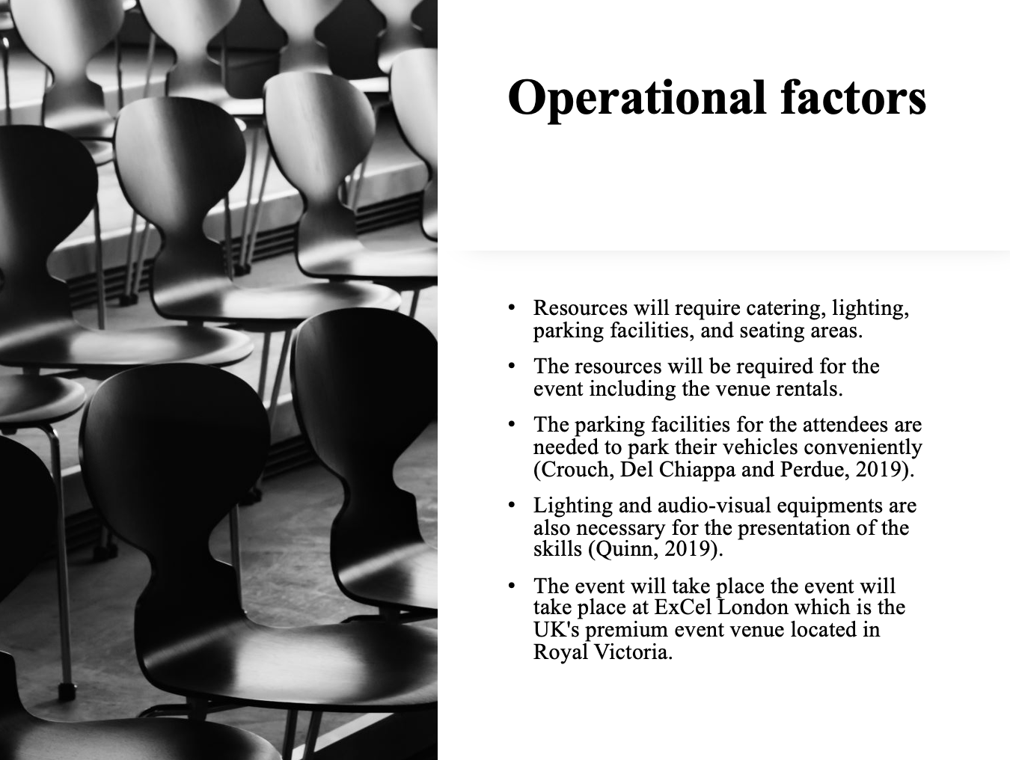
- Right lighting, catering and equipment supplies are also essential to maintain the smooth operations of the event.
- Security measures will be implemented to safeguard the attendees.
- Staff training will be apparent with clearly defined rules, roles and responsibilities necessary to handle the emergency situations effectively.
- The operational factors will be crucial for the success of the event including planning and execution of the logistics, registration process, and flow management.
- This will also provide technical support and effective communication channels to be established to give the information to speakers, sponsors, participants, and mentors.
- Ensuring integration of technology throughout the event will be part of the contingency plans as well.

Cont..
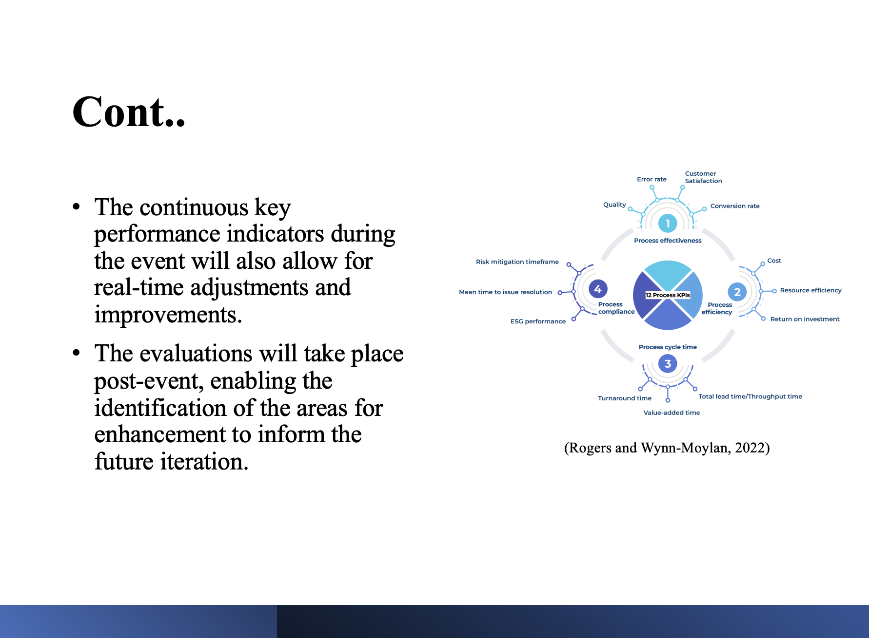
- The ability to effectively communicate with the vendors, attendees and fellow staff members to convince the information results in resolving the issues. Venue availability for the TechHospitality Summit event will be confirmed in the first week of July. Skills required for the staff will ensure that the event is successful.
- These critical skills include communication, problem-solving, customer service, adaptability, attention to detail, teamwork and technical analysis.

Cont..
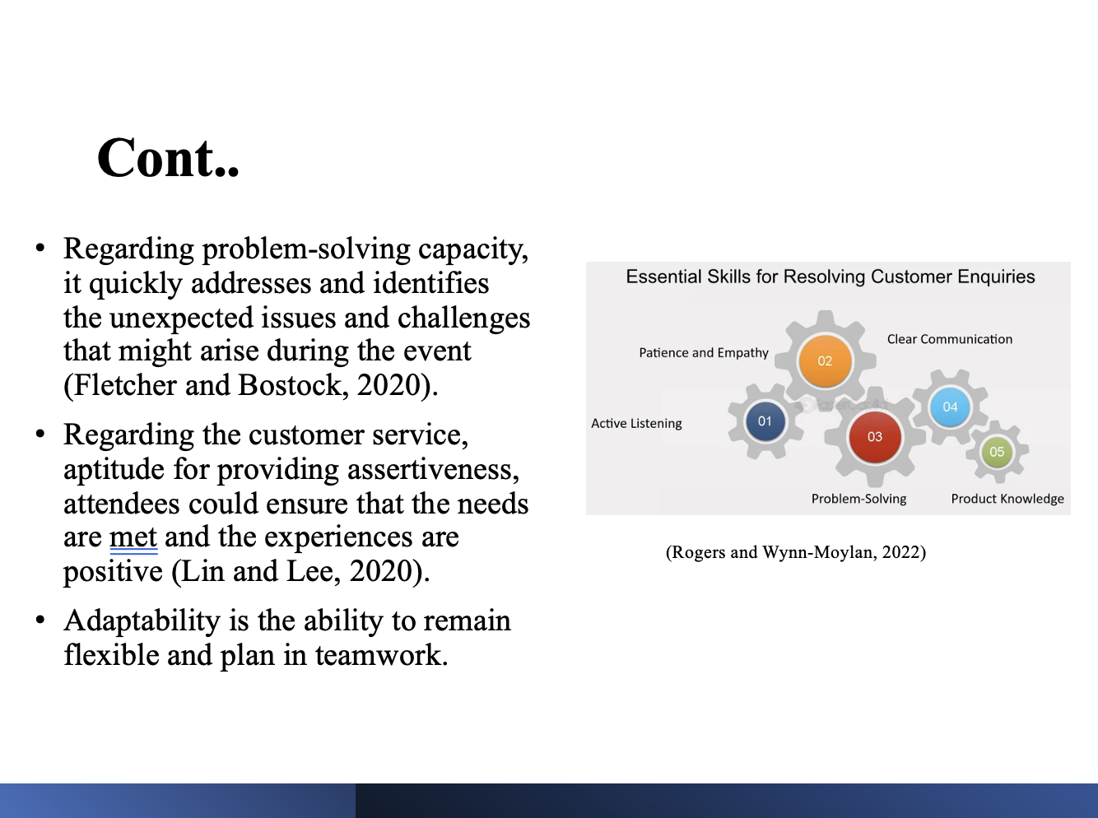
- In terms of technical proficiency and familiarity with the event technology, equipment troubleshooting is important when the technical issues arise.
- Hence, the venue is suitable for TechHospitality Summit event. The capacity to collaborate effectively with the staff members will be essential to achieve the common goals of delivering seamless event experiences. In terms of attention to detail, rigorously ensuring that all the aspects of the event from execution to setup are executed with accuracy and precision is crucial.

Financial factors
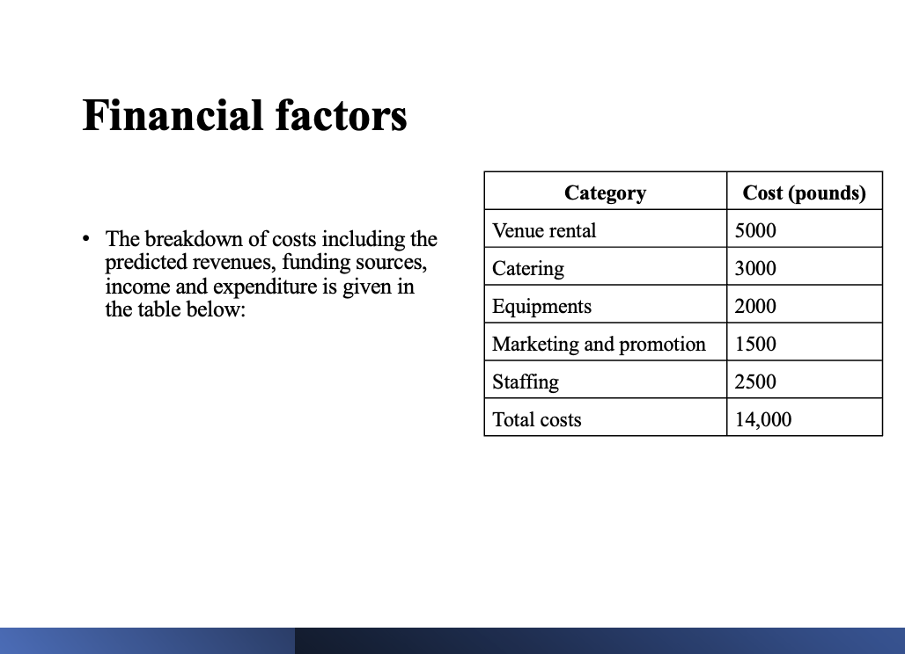
- The breakdown of costs including the predicted revenues, funding sources, income and expenditure is given in the table below:
Category | Cost (pounds)
Venue rental | 5000
Catering | 3000
Equipments | 2000
Marketing and promotion | 1500
Staffing | 2500
Total costs | 14,000

Cont..
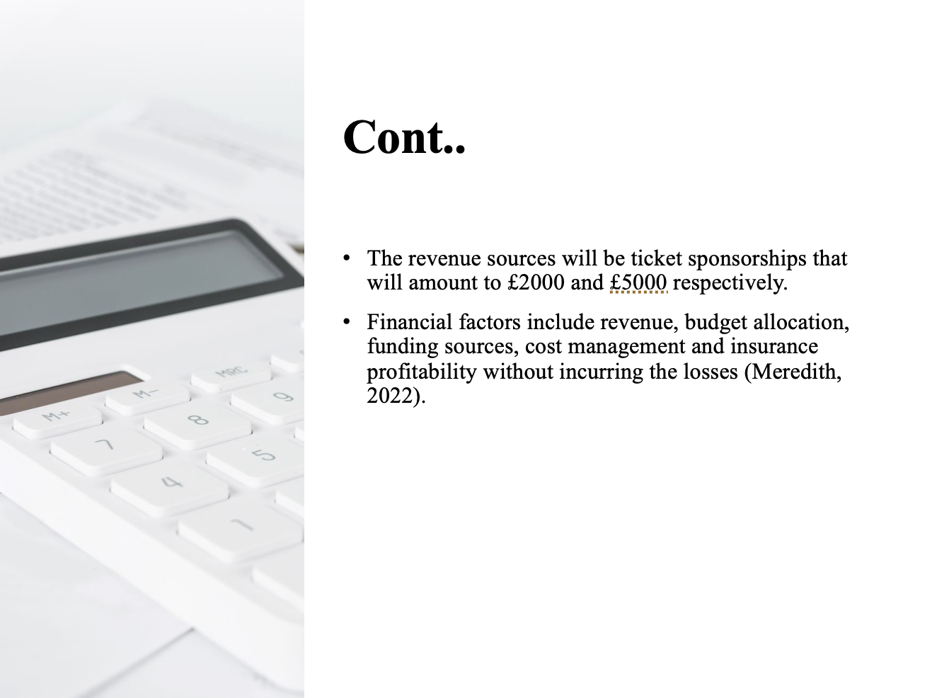

These factors encompass revenue streams, causing control budgeting and positive event outcomes. The income will be from the total revenues and cost with £25000 and £14000, respectively, amounting to a total income of £11000. This breakdown of the cost results in the income from the event.

Cont..
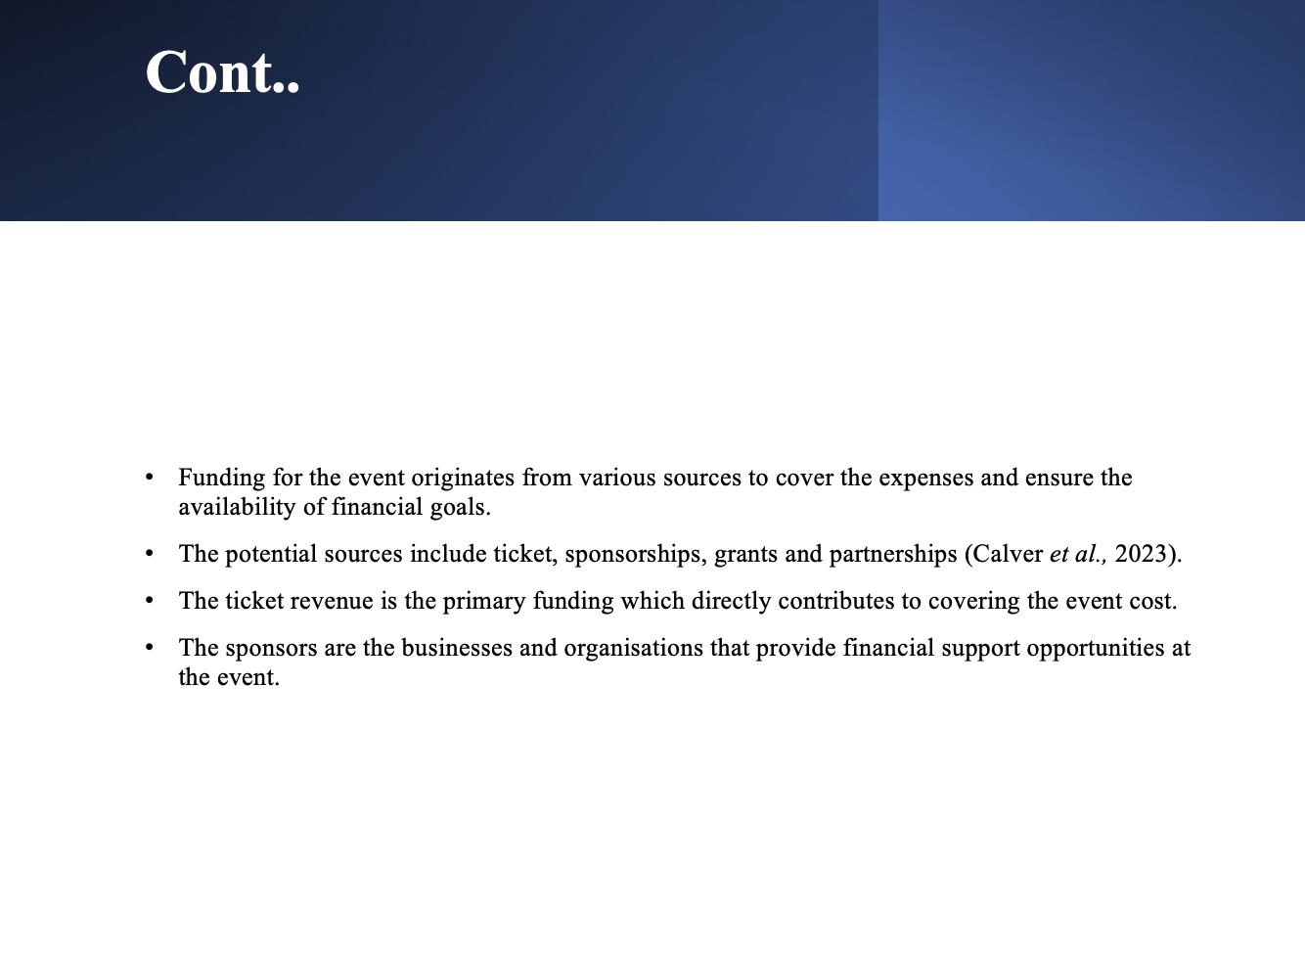
- In terms of ticket sales, it is essential to understand that ticket options will be offered at varying prices, based on the access level.
- It reinforces the incentives of the tiered ticket options, incentivising the attendance to purchase the higher price ticket for the premium experience.
- In terms of grants, applying to government agencies, foundations and relevant organisations provides financial assistance.
- These specifically lead to allocating hosting the event. In terms of partnerships and collaborations, a strategic partnership interests the objectives of the event, resulting in finding the possibilities of resource allocation.
- The revenue will be generated for the event with several strategies such as ticket sales, sponsorships, exhibited fees and merchandise sales.

Cont..
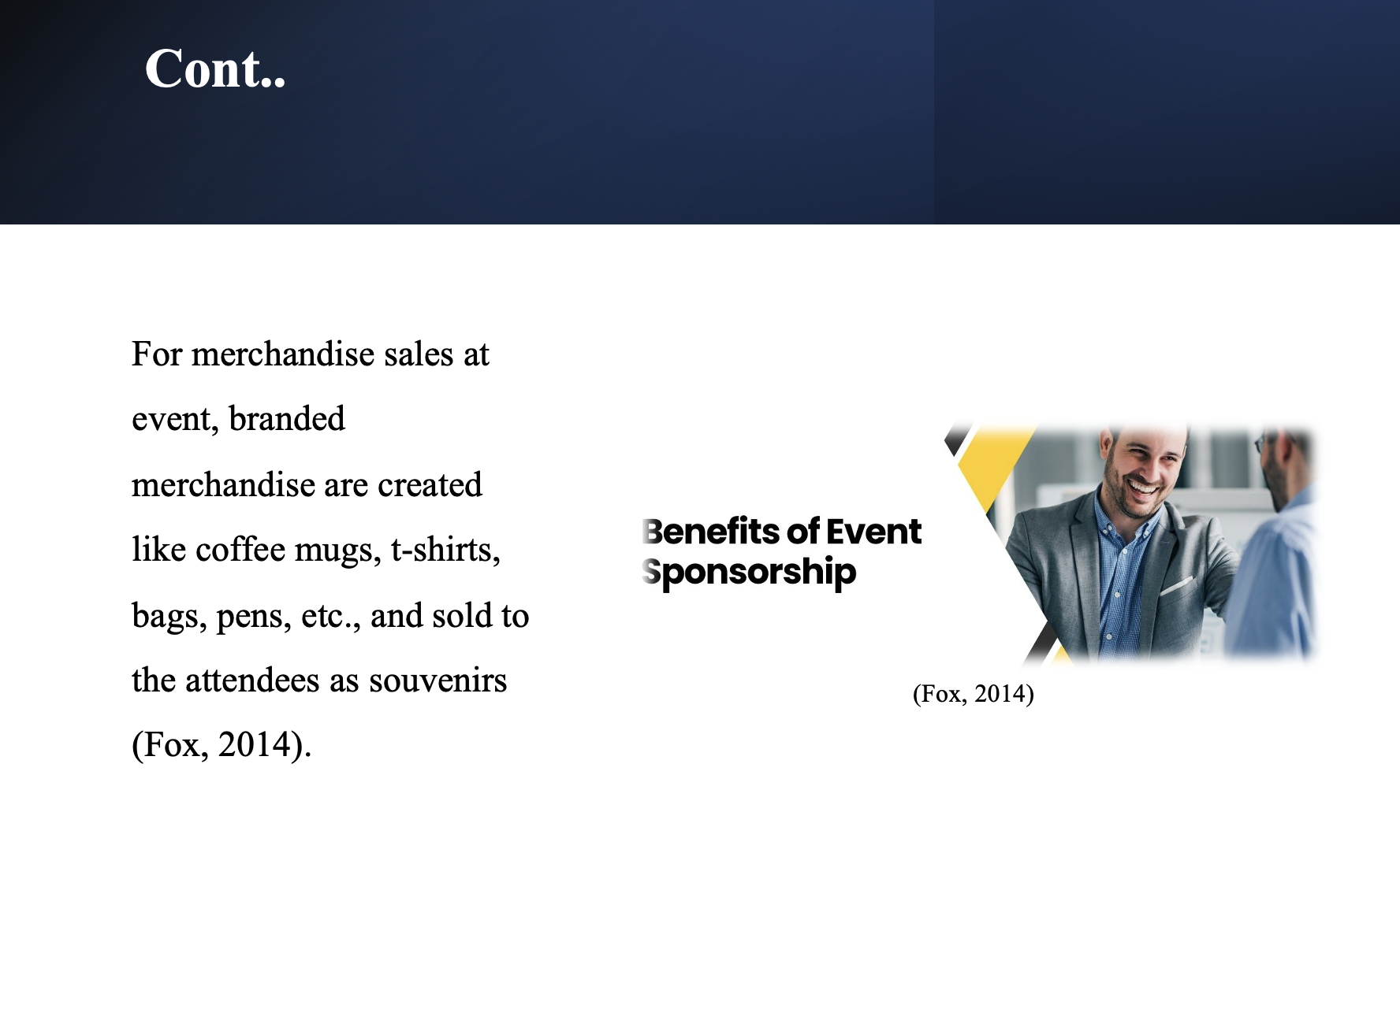
- Regarding sponsorships, the businesses secure these by reaching the event, offering them brand opportunities for financial support.
- Exhibited fees charge on exhibitions to showcase their products and services at the event, providing them with direct access to potential customers.

Conclusion
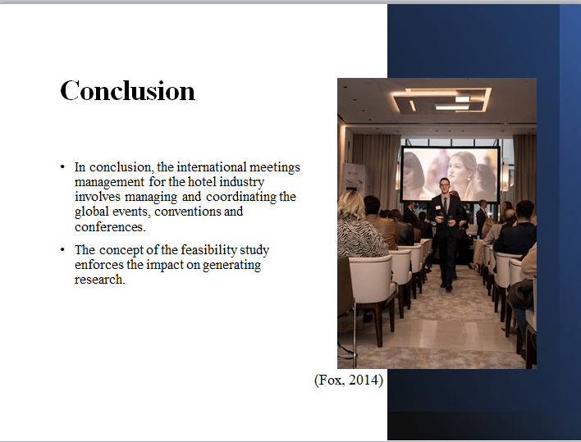
- The market, operational and financial factors have also been discussed.
- Moreover, the competition in the target market, demands, supply, venues and skills have been known and discussed in depth.
- TechHospitality Summit event is where the industrial leaders, hospitality professionals and technology innovators will explore the opportunities.

References
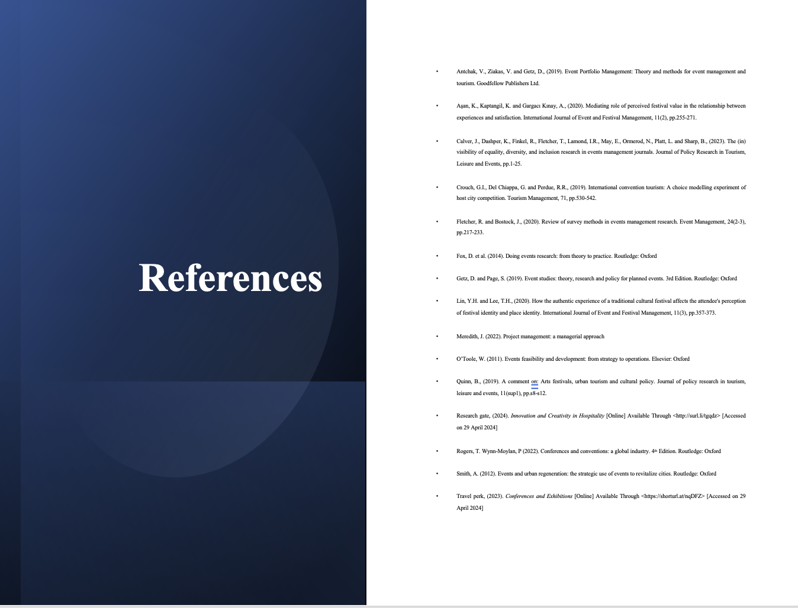
Antchak, V., Ziakas, V. and Getz, D., (2019). Event Portfolio Management: Theory and methods for event management and tourism. Goodfellow Publishers Ltd.
Aşan, K., Kaptangil, K. and Gargacı Kınay, A., (2020). Mediating role of perceived festival value in the relationship between experiences and satisfaction. International Journal of Event and Festival Management, 11(2), pp.255-271.
Calver, J., Dashper, K., Finkel, R., Fletcher, T., Lamond, I.R., May, E., Ormerod, N., Platt, L. and Sharp, B., (2023). The (in) visibility of equality, diversity, and inclusion research in events management journals. Journal of Policy Research in Tourism, Leisure and Events, pp.1-25.
Crouch, G.I., Del Chiappa, G. and Perdue, R.R., (2019). International convention tourism: A choice modelling experiment of host city competition. Tourism Management, 71, pp.530-542.
Fletcher, R. and Bostock, J., (2020). Review of survey methods in events management research. Event Management, 24(2-3), pp.217-233.
Fox, D. et al. (2014). Doing events research: from theory to practice. Routledge: Oxford
Getz, D. and Page, S. (2019). Event studies: theory, research and policy for planned events. 3rd Edition. Routledge: Oxford
Lin, Y.H. and Lee, T.H., (2020). How the authentic experience of a traditional cultural festival affects the attendee's perception of festival identity and place identity. International Journal of Event and Festival Management, 11(3), pp.357-373.
Meredith, J. (2022). Project management: a managerial approach
O’Toole, W. (2011). Events feasibility and development: from strategy to operations. Elsevier: Oxford
Quinn, B., (2019). A comment on: Arts festivals, urban tourism and cultural policy. Journal of policy research in tourism, leisure and events, 11(sup1), pp.s8-s12.
Research gate, (2024). Innovation and Creativity in Hospitality [Online] Available Through <http://surl.li/tgqdz> [Accessed on 29 April 2024]
Rogers, T. Wynn-Moylan, P (2022). Conferences and conventions: a global industry. 4th Edition. Routledge: Oxford
Smith, A. (2012). Events and urban regeneration: the strategic use of events to revitalize cities. Routledge: Oxford
Travel perk, (2023). Conferences and Exhibitions [Online] Available Through <https://shorturl.at/nqDFZ> [Accessed on 29 April 2024]

