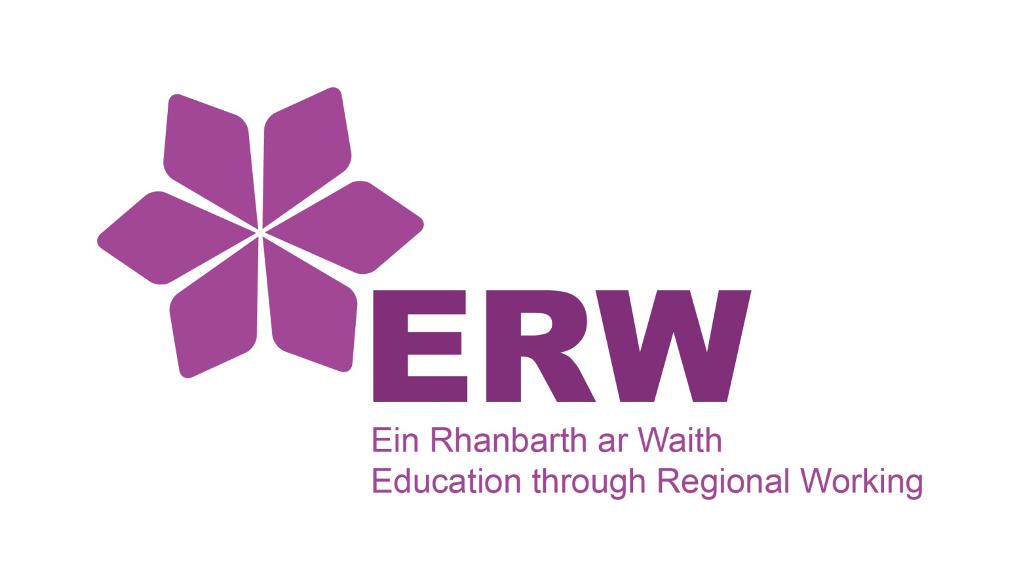 | GCSE Mathematics &  Numeracy Scheme of Work
Foundation Tier
Scheme of Work Overview

Topic: | Numeracy | Mathematics
Multiples and Factors
Whole Numbers
2-D and 3-D Shapes
Decimal Numbers
Fractions 1
Estimation and Using a Calculator 1
Fractions, Decimals and Percentages 1 – Equivalence
Negative Numbers
Indices, Standard Form and Using a Calculator 2
Basics of Algebra
Using Coordinates
Length, Area and Volume
Fractions, Decimal and Percentages 2
Graphs and Charts
Angles
Units of Measure
Ratio and Proportion
Fractions 2
Scale Diagrams and Maps
Averages
Time, Timetables and Travel
Graphs and Compound Measures
Real Life Finances
Scatter Diagrams
Equations
Probability 1 – Theoretical Probability
Angles of Polygons
Probability 2 – Relative Frequency
Transformations

