The Impact of Resources and Support Available to Individuals with Dementia, including those also available to their Families and Carers.


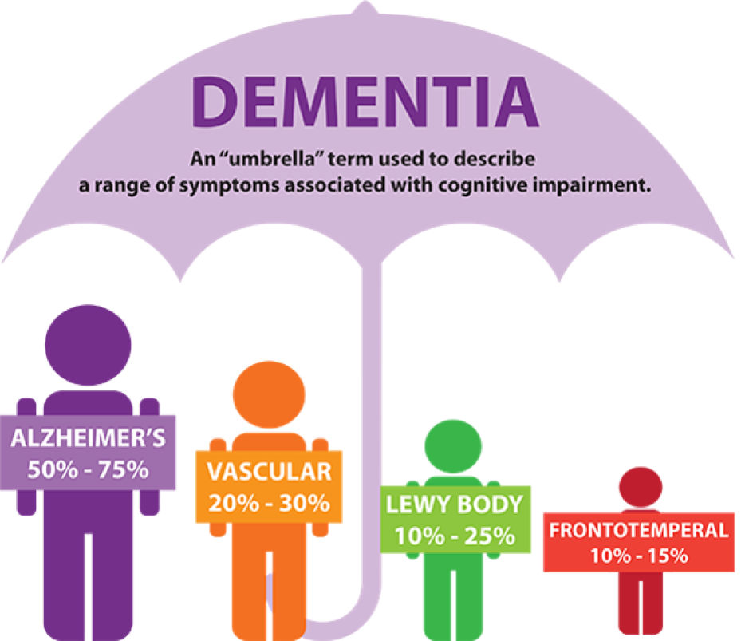

By Allessi Lloyd
14th March 2019

Contents Page

Abstract & Introduction | Page 3
Main Body: Person-centred Care | Page 4
Respite Care | Page 4 & 5
Community Dementia Groups | Page 5
What the Government and NHS Say | Page 6
Conclusion, Recommendations & Appendix | Page 7
References | Page 8 & 9

Abstract
The aim of this report is to research and critically evaluate the impact of a variety of support that individuals will need when faced with dementia patients. within this report will be mentioned strategies to help people deal and care for them with dementia, comparisons made of three resources of support for dementia with relevant resources to back up points made. Points are made about what the Government suggest about support for dementia and recommendations made. It is shown that there are many different types of support for dementia patients and their families, person-centred care allows individuals with dementia to be treated equally and with respect by encouraging them to take part with their own care plans, whether it is at home or within residential care. Respite care is commonly known for giving family member or caregivers the chance to relax and focus on their own lives for a temporary period of time. Also allowing the dementia patient to socialise with others. Community dementia groups are mentioned also; these allow time for various activities for dementia patients, again allowing them to socialise with others and giving them confidence.

Introduction
Dementia is not just one specific disease; it is an overall term that describes a variety of signs and symptoms linked with a decrease in memory recall or other skills involving thinking serious enough to decline an individual’s ability to complete everyday tasks. The most common type of dementia is Alzheimer’s disease which is made up for approximately 60 to 80 percent of dementia cases (Alzheimer’s Association 2019). Dementia is caused by the brain cells decaying and dying, the brain cells are unable to send information correctly due to the damage done to them. When brain cells are unable to receive information, this can effect people’s behaviour, feelings and thoughts (NHS 2017). Prince et al (2014) state that it is estimated that there are 700,000 people that have some form of dementia; 2 out of 3 of them being women. This report will examine and have critical evaluations of different types of dementia support, including support available for the individual, their family and carers. A comparison will be created for two approaches of support available.

Main Body
PERSON-CENTRED CARE PLANNING
One main aspect of support when caring for an individual with dementia is to engage person-centred care. The Alzheimer Europe Office (2009) state that people with dementia often feel as though they have lost their independence when having care involved, in many cases family members and carers will find it easier to do the job for that individual instead of allowing time for the person to complete it themselves. Person-centred care allows for the individual to become involved with their own care plan, it gives the individual a chance to still enjoy life for as long as possible while remaining safe within their own homes (Alzheimer’s Society 2019). Person-centred care also shows the person with dementia that they are being respected and still allowing them to gain confidence and maintain their independence (The Health Foundation 2016). The individual is involved with choices for their own care from being diagnosed with dementia until their last day of life.
Person-centred care benefits the individual as it allows them to maintain their independence and increasing their confidence about their care. By allowing dementia patients continue to do what they love, it will gain trust between that individual and help them to live their best until the day they die (Brownie and Nancarrow 2013). According to Kim and Park (2017), when individuals begin to take a person’s independence away, this can cause them to become increasingly distant towards others and feel insecure and vulnerable. Another strength for person-centred care is that it can sometimes improve the clinical outcomes, getting involved in your own care plan may improve the adherence to medication (Dementia UK 2019).

RESPITE CARE
Respite care is a form of temporary care given to an individual to give the main caregiver a rest. Caring for an individual with dementia can become a very demanding and stressful role; respite care gives the caregiver a chance to relax and relieve stress for a short period of time. Stress and frustration may cause the caregivers physical, mental and emotional health to decrease (Alzheimer’s Research UK 2018). Not only does respite care benefit the carer, but also the individual with dementia – this allows the individual to engage with different people that have gone (or going through) similar experiences, also the dementia patient is encouraged to take part in a variety of activities that best suit their needs while in respite care (Alzheimer’s Association 2018). Agespace (2019) imply that there are different types of respite care that can be given to an individual; these are at home, by a friend, another family member or voluntary or paid services, and another form of respite care is going into a care setting such as an adult day centre or a residential facility.
Respite care benefits mainly the caregiver of the individual with dementia, whether it is a family member, or paid or voluntary care service. According to Saunders House (2015), using respite care services gives the caregiver a temporary break and allows them to have time for their own lives, being a full-time carer can be a very challenging role. Individuals that care for others can also become highly isolated from their own friends, family and lives; so therefore, respite care is a great opportunity to receive that break. Not only do the caregivers benefit from respite care, the individual has the opportunity to meet and socialise with new people having similar experiences to them. The individual with dementia will also feel as though they are in a safe, nurturing environment while receiving respite care (Prime Life 2019).
In contrast with the person-centred care, respite care is similar as it offers the individual with dementia and the family a piece of mind and healthy well-being by both of these support methods allowing the individual carry out tasks they always loved to do. For example, person-centred care may allow the individual to keep doing the hobbies they have always loved doing and respite care also offer those same activities to carry on in their own home or in a residential home. Another similarity between these methods of support is that they are used within one another; when planning respite care for an individual, whether it is at their own home or in a residential home, the family and respite care consider person-centred care for the dementia patient. Families and caregivers will plan with the individual what care is best for them and what aspects in care will encourage healthy well-being and happiness for them. Despite the similarities between respite and person-centred care, there are differences also; respite care focuses on mainly the family or caregivers of the individual and it is about giving them time for their own lives and having a short period of time to relax. Whereas person-centred care focuses on the individual with dementia and how they can be a part of their own care, also what they would like to happen in the future; whether the care is delivered at home or within a residential home.
COMMUNITY DEMENTIA GROUPS
Dementia groups within the community is another strategy of support for dementia patients. There are many organisations that offer community support for dementia patients, such as Age UK, the Alzheimer’s Society, and Dementia Friends (Age UK 2019). Community groups for individuals with dementia are held to take the pressures off the caregivers for a while and also to ensure the person with dementia is living their life to the full (Dementia Care Central 2018). Dementia community groups encourage the participation of a variety of different activities for the dementia patient, some of these including:
- Singing for the brain
- Dancing for dementia
- Art for dementia
- Seated exercise
- Memory cafes, and
- Day trips and outings
Walton et al (2015) suggest that this method of support for dementia allows for the growth and confidence boost the individual with dementia may need, it gives them a chance to socialise with new people and enjoy their lives to the full. The Alzheimer’s Universe (2019) state that the dementia community groups also prepare activities that stimulate the brain and memory; this can help support the dementia patient by allowing them the extra time to work on their memory with activities such as puzzles, art, quizzes, etc.
Similar to respite care, community dementia groups benefit both the caregiver and the individual with dementia, it can offer the chance to allow the caregiver a rest and have time to themselves, as well as encouraging the individual to participate in the activities held by the group. Community groups give carers a chance for respite, again linking the two types of support together to benefit the caregivers and the individual with dementia. Community dementia groups is linked together with person-centred care as this could be an outcome of the care the individual with dementia choses to receive, the individual may enjoy participating in group activities help by the community groups, therefore, will participate in the activities held by the dementia community groups.

What the Government and NHS Say
The Government are aware that dementia is a huge problem within the UK today and try to maintain the range of support out there for dementia patients and their families. The Government spend an estimated of £26.3 billion on dementia alone (Appendix 1). The Government aim to lower the risks of being diagnosed with dementia by encouraging knowledge and understanding about dementia to everyone, including young children, families, professionals, etc. This way everyone will be aware of dementia and understand activities that could prevent, protect and promote dementia (Gov.uk 2018). The Government have set out a National Dementia Strategy; this strategy is about the Government’s plans for bettering health and social care services for everyone with dementia and their carers’. This strategy aims to have services for dementia that meets every person’s needs no matter of their age, social status or ethnic group. The strategy is a 5-year plan that helps mainly people with dementia, carers, anyone affected by dementia and health and social care professionals. The National Dementia Strategy is broken into 3 key stages to ensure that people with dementia and their carers have an increased quality of life. The main 3 stages are ensuring early diagnosis, treatment and support for individuals with dementia, their families and carers’, ensure better knowledge for dementia and reduce or remove the stigma, and the last stage is to develop services to meet the changing needs more effectively (Department of Health 2009).
The South Tees Hospitals Foundations NHS Trust (2013) have also set up a 5-year strategic plan that reflect from the aims of the National Dementia Strategy. This strategy is put in place to help improve the experience and care for individuals with dementia that are admitted or attending to acute and community hospitals. The Trust’s objectives for this strategy are to modernise their methods to communicating, seeking and working on feedback from individuals with dementia and their caregivers, to become a dementia friendly organisation with processes and environments that do not cause any harm to the dementia patients, to encourage the delivery of person-centred care that supports the individual with dementia and their family or carer, to increase partnership to improve overall care outcomes, and the last objective of this strategy is to develop an effective and skilled workplace unafraid and able to overcome compassionate person-centred care.

Conclusion
Within this report, different types of support for dementia patients and their families were assessed and evaluated. The findings have shown that there are a range of different support available for individuals with dementia and their families. It was found that person-centred care plays a huge factor when caring for individuals in general, especially with dementia patients. it allows individuals to feel respected and confident when choosing the right path for their care plan. Person-centred care can change the lives of dementia patients massively just by involving them in their own care. The results of the findings shown that respite care is very common in dementia cases as it allows the time for caregivers and families of individuals with dementia to have a break from caring. This can result in caregivers becoming less stressed and become more focused afterwards when caring for an individual with dementia. Community care groups gives the opportunity for dementia patients to communicate to others and extra learning activities to help work the brain and memory giving those the ability to feel self-worth and achievement. Contrasts of the different dementia support methods were made throughout the report, also explaining the strengths and weaknesses of the specific support approach. Government and NHS strategies are put in place to ensure the improvement on health and social care services regarding dementia care, they are working towards increasing a better understanding and knowledge for dementia in everyone.

Recommendations
- To increase the awareness and understanding of dementia in all ages
- Allow for more community events to take place for dementia patients and their families
- Ensure all dementia-based care includes person-centred care where applicable

Appendix

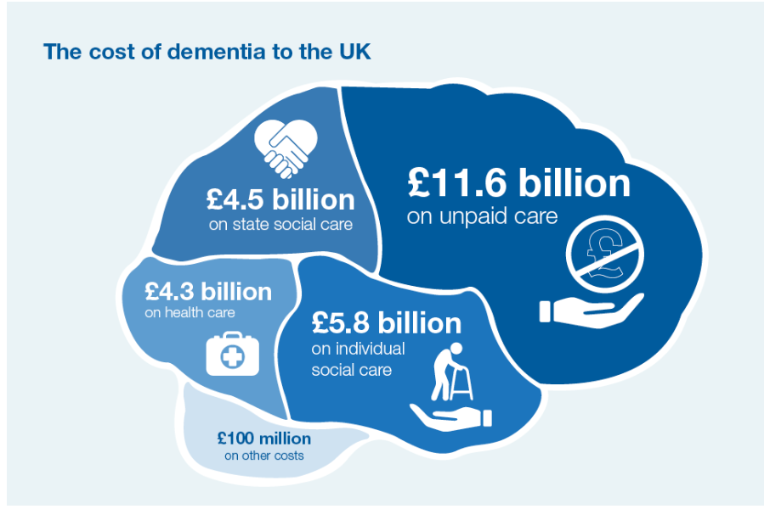
References
Agespace (2019) Elderly Respite Care. Available at: https://www.agespace.org/care/respite-care [accessed 14th March 2019]
Age UK (2019) Dementia Support – Group support. Available at: https://www.ageuk.org.uk/services/in-your-area/dementia-support/# [accessed 17th March 2019]
Alzheimer’s Association (2018) Respite Care. Available at: https://www.alz.org/help-support/caregiving/care-options/respite-care [accessed 15th March 2019]
Alzheimer’s Association (2019) ALZHEIMER’S AND DEMENTIA. What is Dementia? Available at: https://www.alz.org/alzheimers-dementia/what-is-dementia [accessed 14th March 2019]
Alzheimer Europe Office (2009) Independent Living, The onset of the disease. Available at: https://www.alzheimer-europe.org/Living-with-dementia/Caring-for-someone-with-dementia/The-onset-of-the-disease/How-will-Alzheimer-s-disease-affect-independent-living#fragment1 [accessed 14th March 2019]
Alzheimer’s Research UK (2018) support for people affected by dementia. Available at: https://www.alzheimersresearchuk.org/about-dementia/helpful-information/support-for-carers/ [accessed 15th March 2019]
Alzheimer’s Society (2019) Person-Centred Care. Available at: https://www.alzheimers.org.uk/about-dementia/treatments/person-centred-care [accessed 14th March 2019]
Brownie, S and Nancarrow, S. (2013: Pp 3-8) Effects of person-centred care on residents and staff in aged-care facilities: a systematic review. 8 (2).
Dementia Care Central (2018) How Support Groups Work. Available at: https://www.dementiacarecentral.com/caregiverinfo/careforcaregivers/support/ [accessed 17th March 2019]
Dementia UK (2019) Planning now for your future – Advance Care Planning. Available at: https://www.dementiauk.org/understanding-dementia/advice-and-information/planning-ahead/planning-now-for-your-future-advance-care-planning/ [accessed 15th March 2019]
Department of Health (2009: Pp 6-12) Living well with dementia: A National Dementia Strategy. 2 (1).
Gov.uk (2018) Dementia: applying All Our Health. Available at: https://www.gov.uk/government/publications/dementia-applying-all-our-health/dementia-applying-all-our-health [accessed 17th March 2019]
Kim, S and Park, M (2017: Pp 381-397) Effectiveness of person-centred care on people with dementia. 12 (3).
NHS (2017) Dementia guide. About dementia. Available at: https://www.nhs.uk/conditions/dementia/about/ [accessed 14th March 2019]
Prime Life (2019) Our Services – Respite Care. Available at: https://www.prime-life.co.uk/our-care-services/#respite-care [accessed 17th March 2019]
Prince, M, Knapp, M, Guerchet, M, McCrone, P, Prina, M, Comas-Herrera, A, Wittenberg, R, Adelaja, B, Hu, B, King, D, Rehill, A and Salimkumar, D (2014: Pp 4-5) Dementia UK. 2nd Edition, London: Alzheimer’s Society.
Saunders House (2015) 7 Benefits of Respite Care: A Physical and Emotional Oasis for Caregivers. Available at: https://www.saundershouse.org/article/3/4/2015/7-benefits-respite-care-physical-and-emotional-oasis-caregivers [accessed 14th March 2019]
The Alzheimer’s Universe (2019) Benefits of Joining an Alzheimer’s Support Group. Available at: https://www.alzu.org/blog/2015/02/01/benefits-of-joining-an-alzheimers-support-group/ [accessed 17th March 2019]
The Health Foundation (2016) Why person-centred care is important. Available at: https://personcentredcare.health.org.uk/person-centred-care/overview-of-person-centred-care/why-person-centred-care-important [accessed 14th March 2019]
The South Tees Hospitals NHS Foundation Trust (2013) Dementia Strategy. Available at: https://www.southtees.nhs.uk/content/uploads/Dementia-Strategy.pdf [accessed 17th March 2019]
Walton, J, Ryan, N, Crutch, S, Rohrer, J and Fox, N. (2015) The importance of dementia support groups. 2 (1).

