Luke Morgan
2413884
COnstruction Fundamentals
Assignment 1

Contents
Offsite Construction 2
Brick and Block Drawings 3
Brick and Block Drawings 4
Timber Frame Drawings 5
Timber Frame Drawings 6
SIPS Drawings 7
SIPS Drawings 8
My Recommendation 9
Reference List 10

Offsite Construction
Offsite construction is when components for the building are produced off site, such as staircases, walls and rooms. It tends to be broken down into four categories, Modular, Panelised, Component, Hybrid.
Modular is the quickest way of assembling a building and they are pre made rooms which can come pre insulated. The walls, ceilings, roof and walls will be made off site and its just a case of using a crane to lift them into position. These are commonly used for hotels and big office buildings. Due to the building detached this would be a viable and suitable option for the client, this would speed up build time and would also cause less disruption for the nearby homes due to the rooms being built off site.
Panelised systems are very similar to modular but instead of the rooms coming to site pre built they are flat packed rooms meaning you have to assemble the floor, roof and walls together. This would work hand in hand with modular construction as you could use two walls with the modular room to create another room, which would then be a hybrid system.
Component sub assembly systems are used on most construction projects. These are smaller construction components such as pre assembled roof trusses, ductwork and staircases. This creates a time saving on labour as it’s a case of fixing the staircase to the correct building instead of building it on site. I would strongly recommend component sub assembly systems to be incorporated to this project as obtaining an off site made to measure stair case would save labour time as it would be off site construction and also I would recommend having the roof trusses made off site, this would help with labour times and also will prevent any possible injuries of someone cutting and making them fit on site.
Hybrid systems are the most effective and efficient way of forming a house, this incorporates modular and panelised systems. By using the both together you can use modular systems for rooms such as bathrooms and then can used pre built walls to make another room in between two modular rooms. This allows us to be efficient and also maintains flexibility. Hybrid systems are the way forward if you want a efficient and an effective project, the client can design exactly the way she would like the building to be then it can be craned into position this would be a cost effective and efficient option.

Brick and Block Drawings
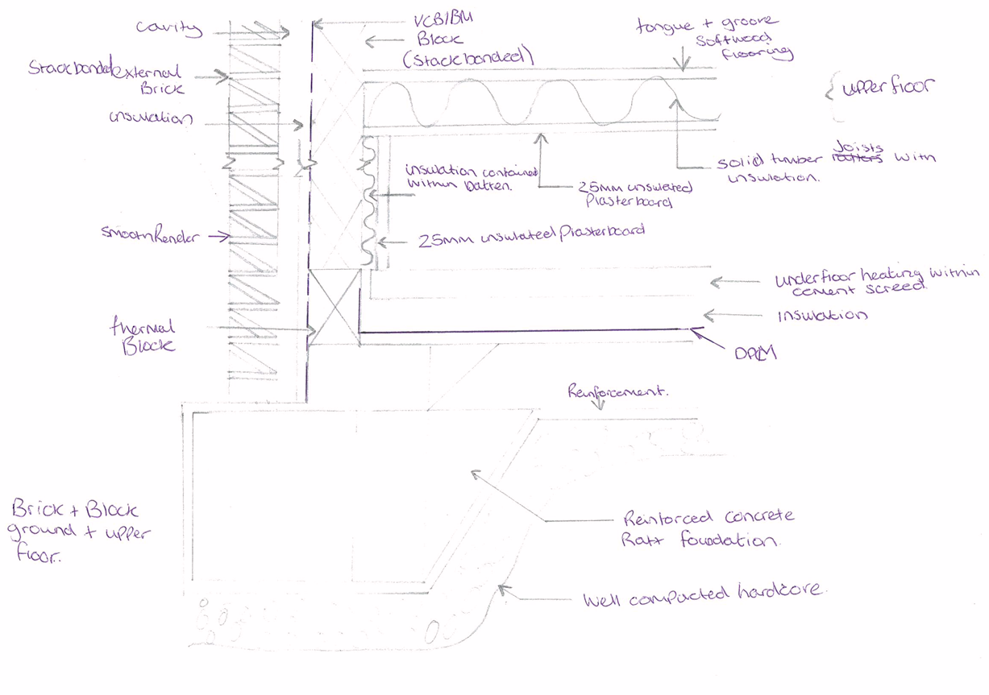
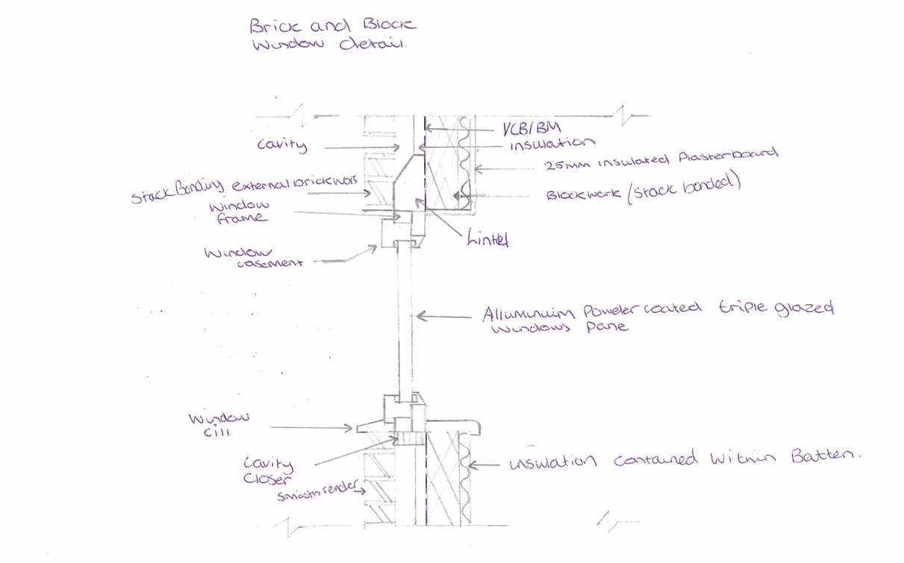

Brick and Block Drawings

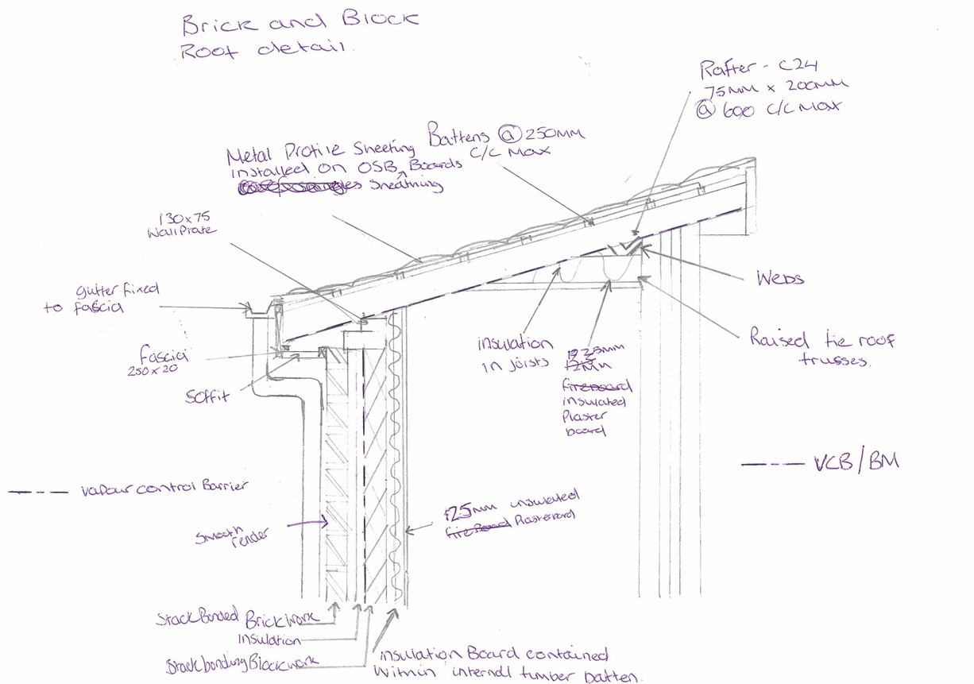

Timber Frame Drawings
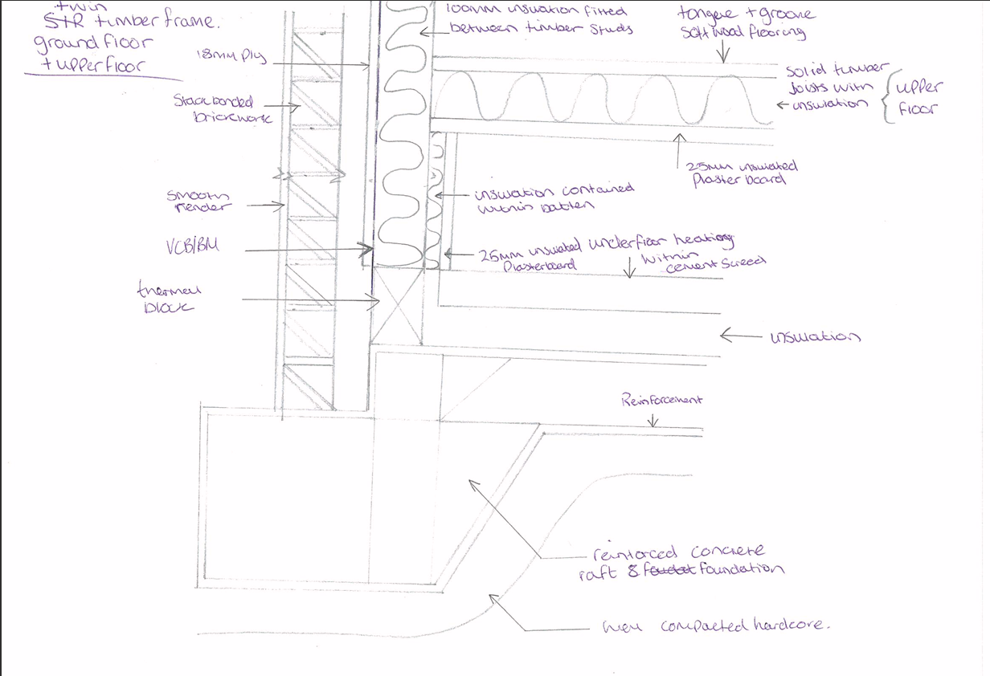
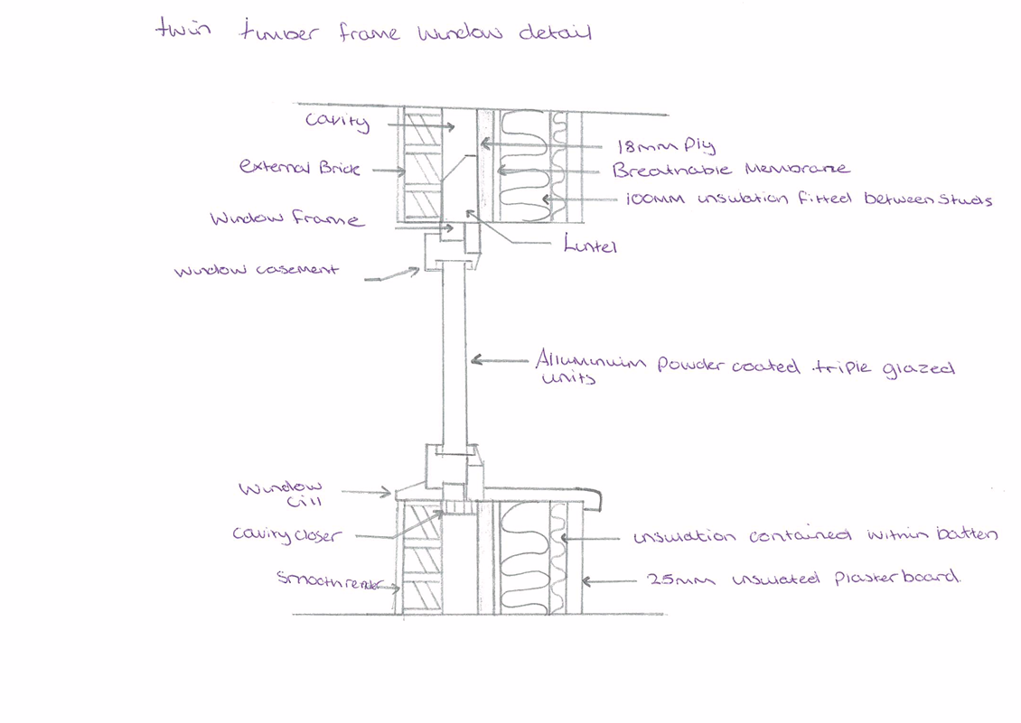

Timber Frame Drawings

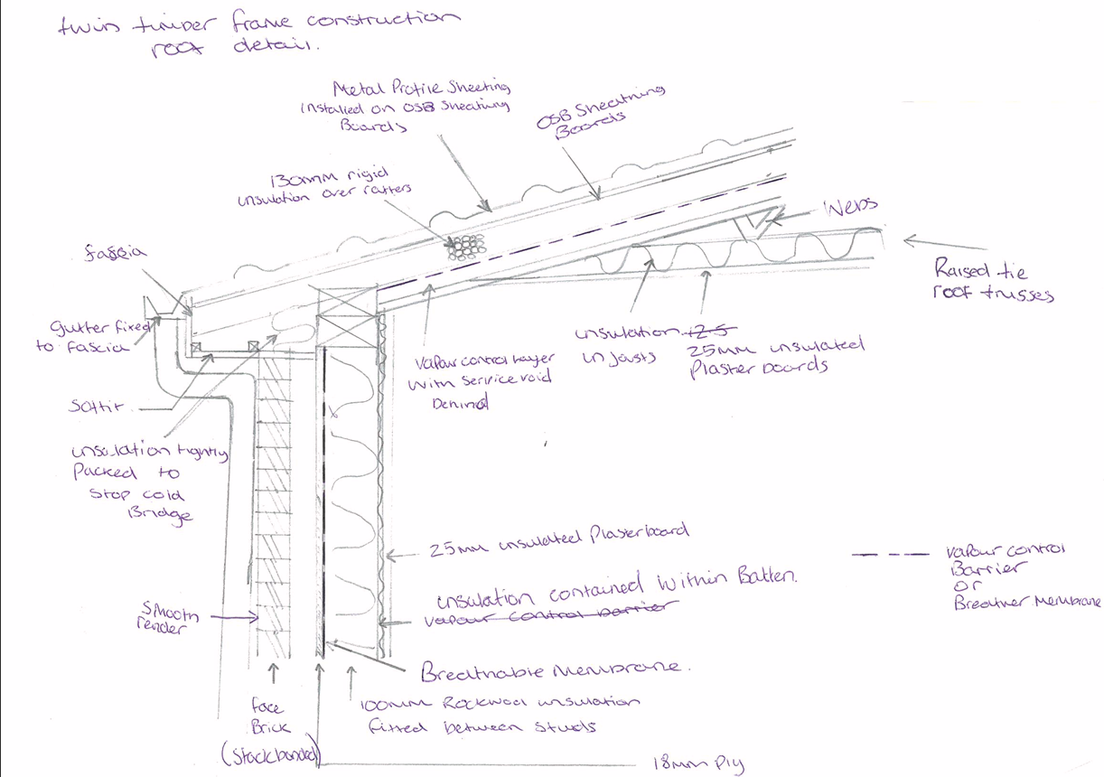

SIPS Drawings
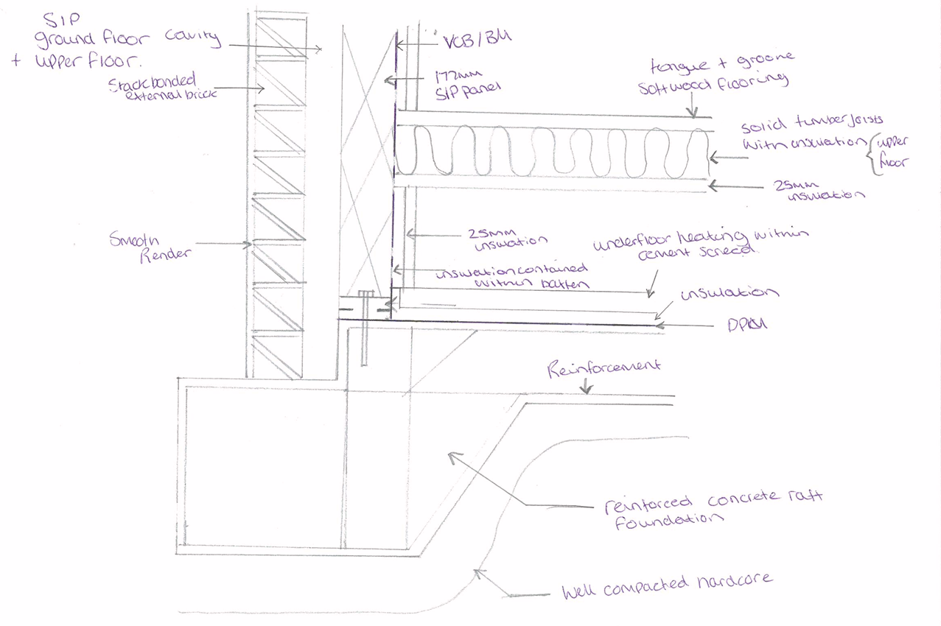
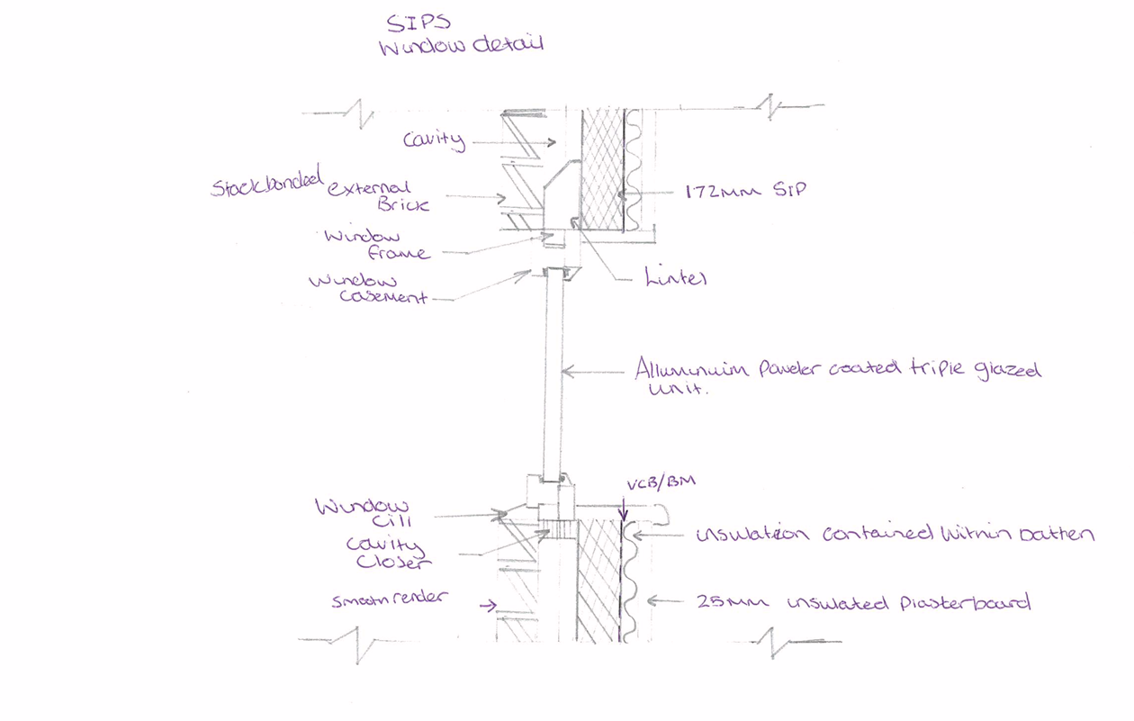

SIPS Drawings

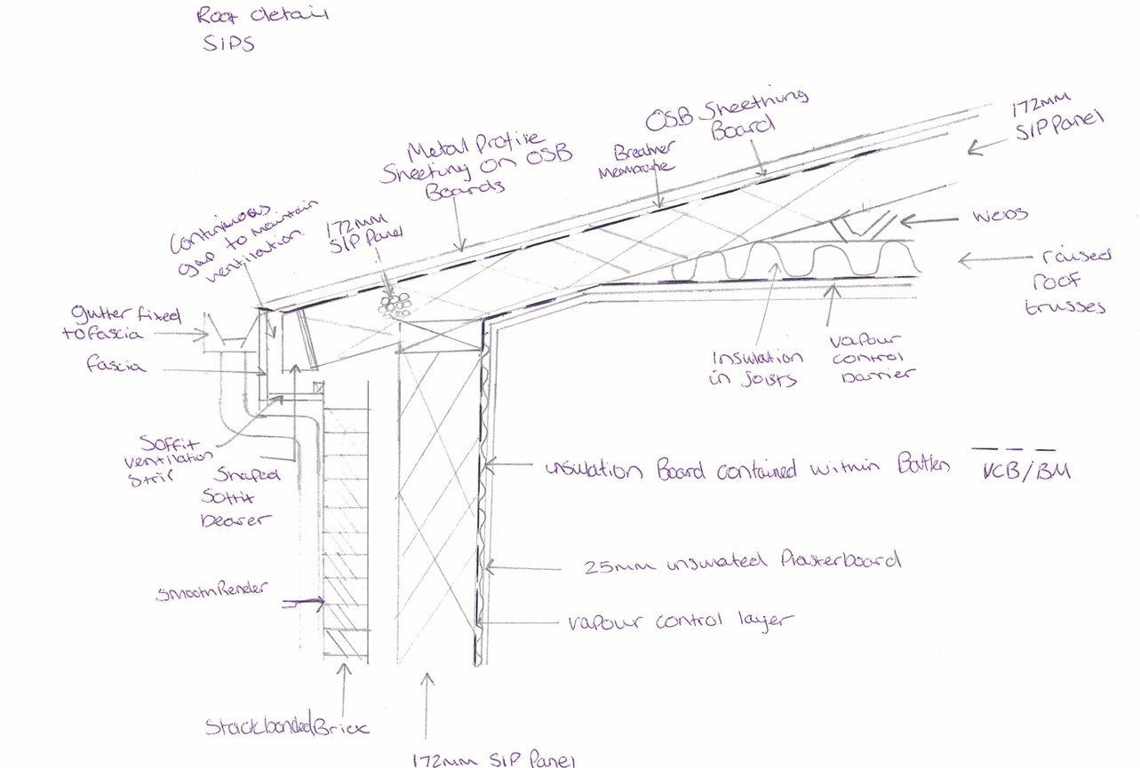

My Recommendation
My recommendation would be to use SIPS because they are the most suitable construction method that will suit the client. Compared to traditional or twin timber framed SIPS have a high insulation values as they create a tighter building envelope therefore reducing heating and cooling costs. It is also a panelised system meaning that the walls can be constructed off site, this means that we will reduce the on site labour and a reduction in build time up to 50% traditional and twin timber frame require a lot of onsite work.
SIPS also offer outstanding strength to weight ratio. Meaning it can serve as structural and insulating components, as well as insulating they also offer excellent air tightness and acoustic performance, SIPS naturally reduce air leakage therefore you will gain better air quality and sound proofing in the building. SIPS are also more eco-friendly than traditional and twin timber frame.

Reference List
What is Offsite Construction? (2020). https://theconstructor.org/building/offsite-construction-features-methods/38319/.
Admin and Admin (2023) What is Offsite Construction? https://www.constructionplacements.com/offsite-construction/.
Hillside Group (no date) SIPS explained | Thermal insulation | Structural insulated panels. https://www.sipbuildingsystems.co.uk/sips-explained.php.
Corfield, A. (2022) Structural Insulated Panels: What are the Pros and Cons? https://www.homebuilding.co.uk/advice/structural-insulated-panels.

