Critical Thinking Activity Booklet
Today, you’ll be applying critical thinking to two everyday items: the bags shown below. While bags may seem like simple objects, choosing one often involves careful thought—considering design, function, style, and purpose.
By practising critical thinking with these bags, you’ll strengthen the skills needed to analyse and evaluate more complex materials, like the texts and sources you’ll encounter in your assignments. If you can think critically about these bags, you can apply the same approach to any reading and writing!
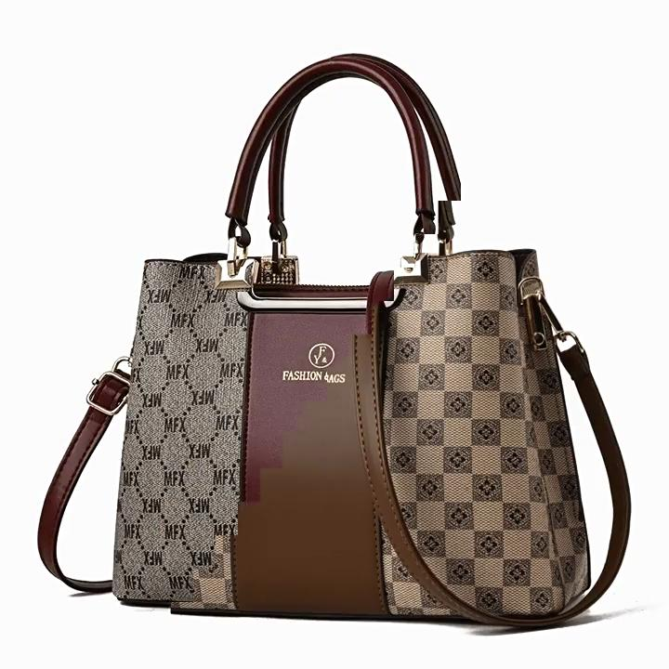
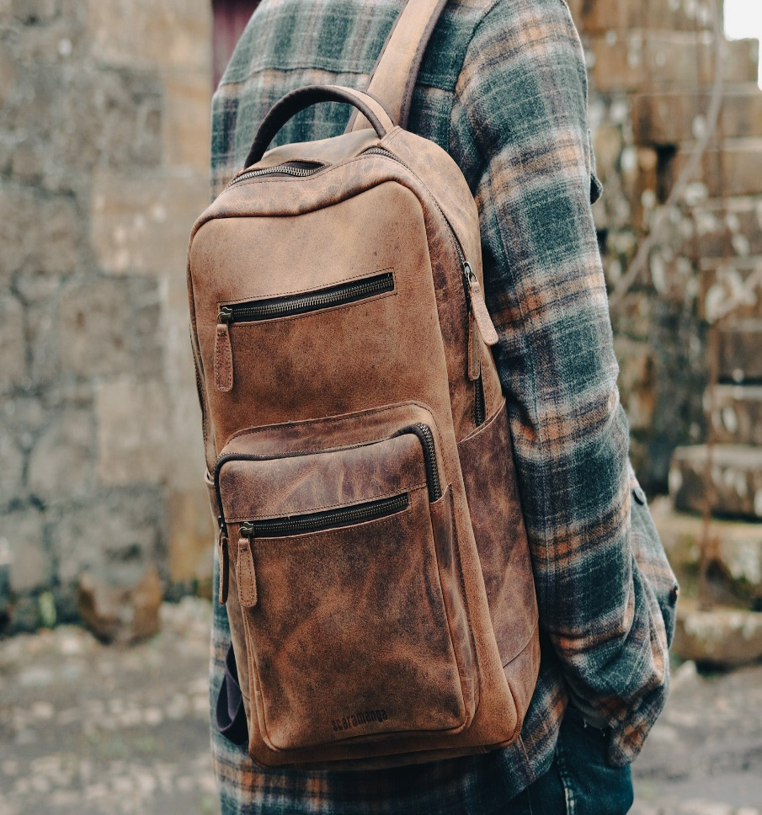

Analysis
For this activity, you are going to analyse both bags, and to help you analyse them, below you will a set of questions which will help prompt you to develop your analytical thinking:
- What is the main idea or purpose of each bag?
- What is each bag designed for? (e.g., travel, school, fashion, work)
- Who is the intended user or audience?
- What are the strongest parts or features of each bag
- What features stand out? (e.g., durability, compartments, waterproofing, style)
- What materials or design elements make each bag effective?
- How do the parts relate to each other in each bag?
- How do the straps, zippers, pockets, and compartments work together
- Is the layout practical and user-friendly?
- What different interpretations could there be?
- Could the bags be used in ways
- than their intended purpose?
- Might different users (e.g., students vs. professionals) see the bags differently?
- What patterns or themes emerge when comparing the two bags?
- Are there common design trends or brand choices?
- Do both bags reflect a certain style, function, or value (e.g., eco-friendliness, minimalism)?

Evaluation
For this activity, you are going to evaluate both bags, and to help you analyse them, below you will a set of questions which will help prompt you to develop your analytical thinking:
- Which features stand out most (e.g. comfort, durability, design)?
- What makes each bag especially useful or appealing?
- What are the weaknesses or limitations?
- Are there any design flaws or missing features?
- Is anything about the bag inconvenient or poorly made?
- Are there any gaps, errors, or inconsistencies?
- Do the features match the product description or expectations?
- Are there any quality control issues (e.g. stitching, zippers, materials)?
- How does each bag compare to similar products?
- How do these bags compare to others in the same price range or category?
- Do they offer better or worse value than alternatives?
- What are the differences between the two bags?
- How do they differ in size, style, function, or materials?
- Which one is more suitable for specific needs (e.g. travel, school, work)?
- What be improved or done differently?
- Are there design changes that would make the bag more functional or
- ?Could the materials, layout, or features be upgraded?
- What is your overall or judgement?
- Which bag do you prefer, and why?
- Which one would you recommend to others?
- Why do you think that?
- What evidence or experience supports your opinion?
- How do your needs or preferences influence your judgement?

Counter Argument
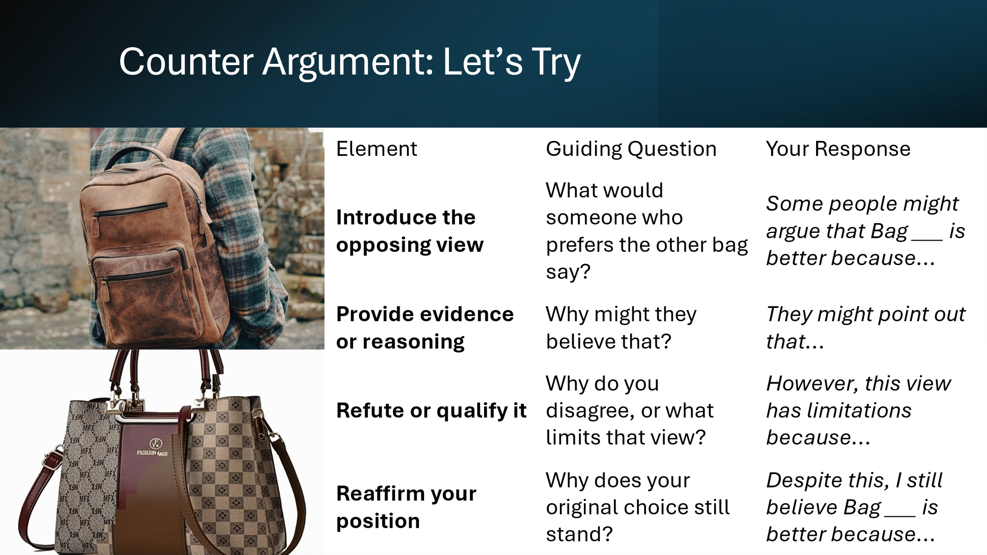

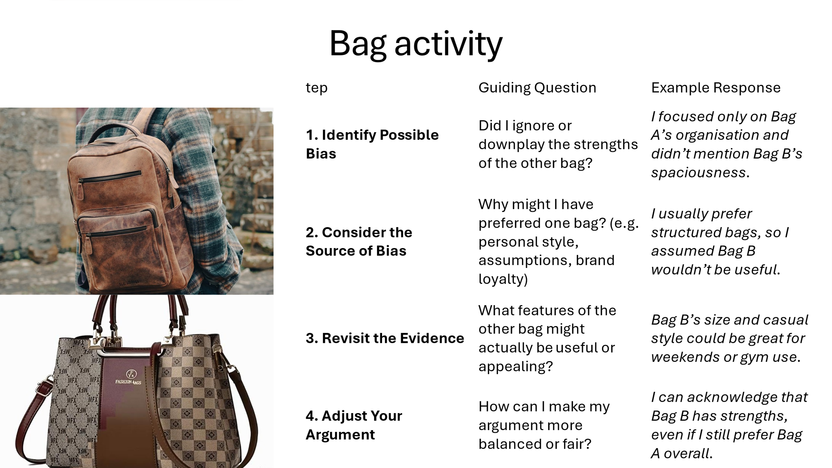
Bias

