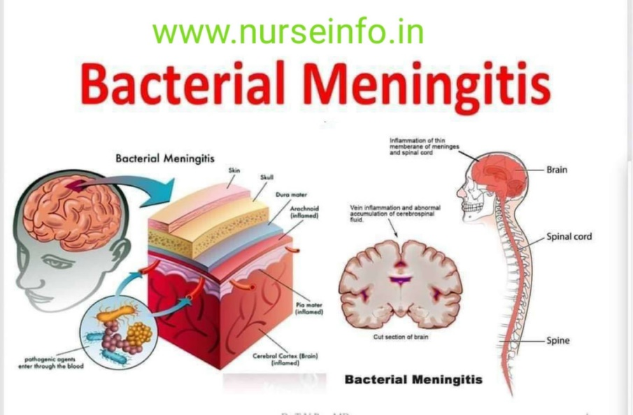

Introduction
Infected layers who cover the brain and spinal cord are called "meninges," and meningitis is an infection of those surfaces. Anyone is at risk, but infants, kids, teens, and young people are most vulnerable. Without prompt medical attention, meningitis can be fatal. It can lead to irreversible brain or nerve injury and even death due to blood infection (sepsis). Meningitis is characterised by quick onset of symptoms such as fever, nausea, vomiting, headache, neck pain, sensitivity to light, confusion, sleepiness, and even convulsions (fits). (NHS website, 2022)
Different organisms spread diseases in different ways. Most bacteria that cause meningitis, like meningococcus, pneumococcus, and Haemophilus influenzae, live in the nose and throat. They move from one individual to another through coughs, sneezes, and sore throats. Group B streptococcus is often found in the gut or vagina and can be passed from parent to child around the time of birth. Meningitis outbreaks are still occurring over the world, notably in sub-Saharan Africa. Although bacterial meningitis A and B vaccines have been available for many years, not everybody is able to get them. The United States has a lower risk of meningitis compared to many other countries, although the disease is nonetheless occasionally contracted here. (Cafasso, 2022)
Vaccination against meningitis is the best strategy to lessen the disease's impact and spread while also providing long-term safety. Prevention of meningococcal and group B streptococcus infections also makes use of antibiotics in high-risk populations. Meningococcal meningitis epidemics can be contained with a combination of vaccine and medications. Immunization against diseases caused by meningococcal bacteria, pneumococcal bacteria, and Haemophilus influenzae have already been commercially accessible for several years. There have been three distinct vaccines that can be administered:
-Polysaccharide-protein conjugate vaccines (conjugate vaccines)
-Protein based vaccinations against serogroup B.
-Polysaccharide vaccinations are completely safe and effective when administered to children and adults, but they offer only a moderate degree of protection to babies.
In accordance with a statement by the UK Health Security Agency, the number of cases of meningitis B within students from England has risen dramatically and is now higher than it was before the outbreak. The number of reported cases of IMD rose during September and November 2021, with the prevalence of group B disease among teenagers and young people skyrocketing to levels previously seen before the pandemic. During that time span, those between the ages of 15 and 19 made up 41.5% of all meningitis cases, up from 11.8% in 2018 and 14.3% in 2019, according to the report. (Gregory, 2022)
Main Body
Government agencies of public health play a vital role in the management of meningococcal illness by facilitating the implementation of effective disease preventive and monitoring programmes, limiting the spread of infection through connection tracing, and responding swiftly to and controlling outbreaks. Health Protection Teams in England, Scotland, and Northern Ireland are responsible for documenting all global health responses to confirmed instances of communicable diseases on HPZone, a web-based platform designed specifically for this purpose. The PHE Health Protection Team should make sure that there are procedures in place that acknowledge the corporate responsibilities of the NHS, preferably into a structure like a service level commitment. Policies should make sure that: cases were recorded promptly to the Health Protection Team; incidents are investigated correctly in hospitals; contacts are tracked down and given the necessary data; suitable strongly suggested and vaccinations are public evidence can be spiralled to others, as necessary, such as general practice, school systems, educational authorities, National Health Service helplines, and meningitis C (and family) confidentiality. Most cases roughly 97%—are infrequent. The danger to relatives is minimal, but the persons who stay in the same home as a meningococcal disease patient are at the biggest overall and relative risk. But after outbreak, this risk is at its peak for the first seven days before rapidly declining. The idea behind giving medicines as prophylactic antibiotics to tight relationships of people with IMD is to get rid of people who are already carrying the disease inside the proximity group and stop it from spreading. This strategy cuts the chance of secondary cases in people who live in the same house by up to 89%. (Public Health England, 2019)
Personal friends of those with meningococcal disease, such as relatives, day care workers, or anyone who came into close interaction with the patient's saliva, are at a high risk of getting the disease as well. In non-epidemic situations, antiviral chemoprophylaxis works to stop secondary cases among close contacts by stopping nasopharyngeal carriage if it is given quickly after the index case is found. In many countries, this kind of intervention might not be possible. Research lab monitoring data are needed to record the transmission of strains that are less likely to be killed by antibiotics and to help guide the random selection of antimicrobial agents. Resistance to antibiotics has been found in all three bacteria that cause meningitis, which changes how patients are treated and how close contacts are protected. (Meningitis Lab Manual: Methods for Diagnosis | CDC,2011)
Meningitis can happen to anyone, but young children are most likely to get it. Group B streptococcus is the most dangerous for new-born infants. Meningococcus, pneumococcus, and Haemophilus influenzae are more dangerous for small kids. Illness is more likely to happen to teenagers, even as pneumococcal disease is more likely to happen to people over 65. All adolescents between the ages of 11 and 18 are encouraged to get the MenACWY vaccine, per CDC recommendations. Preteens between the ages of 11 and 12 should see a doctor for a single dose and other preventative care. The CDC advises getting a booster shot at 16 years old because immunity wanes over time. This ensures that adolescents can maintain their protection during the years when they are most vulnerable. Serogroup B meningococcal (MenB) vaccines are approved for use in people aged 16 to 23, while they are most effective when given between the ages of 16 and 18. Vaccination is recommended for healthy adolescents and young adults but requires two doses of the same vaccine. (Age as a Risk Factor for Meningococcal Disease | CDC. 2022)
Meningococcal illness is a serious health concern, also many countries require that institutions warn prospective students and on-campus residents about the dangers of contracting the disease. Teenagers in some regions and at some schools and universities are required to show proof of meningococcal vaccination or submit a vaccination waiver. Depending on the situation, meningococcal conjugate (MenACWY) or meningococcal serogroup B (MenB) vaccinations may be necessary. Meningitis is an infection that can affect anyone, anywhere in the world. The African Meningitis Belt is an area in sub-Saharan Africa that is particularly vulnerable to meningococcal and pneumococcal meningitis outbreaks and has the greatest disease in the world. The danger increases when people are crammed together, as in a large crowd, a refugee camp, a packed apartment, a military barracks, or a school. Smoking, both actively and passively, as well as body's immune defects like HIV infection or complement insufficiency, and immunosuppression can all increase the risk of meningitis. People are more likely to get sick when they live close together, like at large events, in refugee camps, in group homes, or in student, army, or other work settings. Various kinds of meningitis can be caused by problems with the immune system, such as HIV or a lack of supplement. Autoimmune reactions and direct or indirect tobacco could also raise the risk. Meningococcal illness is far more prevalent, and outbreaks are frequent in the meningitis belt than they are in the US. The dry season is when the illness is most prevalent in these nations (December through June). The danger of illness is higher for visitors who interact frequently with locals, particularly during epidemics. (Meningitis, 2021)
However, even with prompt treatment, meningitis can have lasting consequences. Meningitis is usually brought on by a bacterial or viral infection. In comparison to other forms of meningitis, bacterial meningitis is both more lethal and more likely to leave long-lasting effects on the patient. On the other hand, every form of meningitis has the capacity to be extremely dangerous, even fatal, and to have long-lasting effects. Inflammation of the meninges and the cerebrospinal fluid (CSF) produces meningitis, which typically manifests with headaches, fevers, and extreme tiredness. Serious meningitis can include seizures, cerebral impairments, and systemic complications (such sepsis or organ failure). Caused by microorganisms, inflammatory diseases, or even some medications, this syndrome might strike at any time (such as brain radiation). Consequences from severe meningitis may linger long after the first stages of inflammation or infection have subsided. There may be early warning signs that the illness will have long-lasting consequences even in the acute stage. Meningitis is less likely to have permanent effects unless it is severe or lasts for a long time. Complications are more likely if treatment is delayed or if there is an underlying medical condition. Meningitis can cause long-lasting symptoms like fatigue, inability to focus, migraines, anxiety, and light sensitivity (photophobia) (discomfort when looking at light), effects on equilibrium and concentration, deficiencies in behaviour, learning, memory, or intelligence. The acute stage of an illness might cause temporary hearing loss. Your healthcare worker may check your hearing months after your infection has cleared up to see if you have any lasting damage. Infections or inflammations in the brain can trigger seizures. Fever seizures are another symptom of meningitis in small children (seizures associated with a high fever). Seizures are treatable once meningitis clears up, but there is a chance of chronic seizures that may need to be kept under control with anti-epileptic medications (AEDs). Consequences during the acute stage of meningitis, which might include brain trauma, increase the likelihood of long-term repercussions. Inflammation caused by severe meningitis may spread and eventually restrict cerebrospinal fluid (CSF) flow if the infection persists for a long enough time. Hydrocephalus, when fluid builds up in the skull and brain, can be the result of this condition. Occasionally, meningitis can migrate to the brain. Encephalitis is inflammation or a disease of the brain, and it is more serious than meningitis, often leading to irreversible brain damage. Meningitis-causing infections have been linked to septicaemia. Sepsis is a life-threatening inflammatory response to an infection that has spread throughout the body. There is a higher incidence of these complications with bacterial meningitis compared to other forms. (Long-Term Effects of Meningitis, 2021)
When a fungus in another portion of the body gets to the brain, it causes fungal meningitis. Those who have recovered from fungal meningitis can face some long-term consequences, such as hydrocephalus, discomfort, amnesia, and confusion. Meningitis that is not caused by an illness bacterium, like a fungus, but by a condition or a medicine is called non-infectious meningitis. Meningitis that isn't caused by an infection could be caused by a blow to the head, brain surgery, cancer, lupus, or a drug that lowers the immune system. The bacteria or virus that causes meningitis can be spread from person to person through close personal contact such as coughing, sneezing, kissing, or the sharing of eating utensils, a toothbrush, or a cigarette. To avoid contracting meningitis, please adhere to these recommendations. Among the most effective strategies to prevent the spread of disease is to fully wash your hands after using the restroom. Kids should be taught to frequently clean their hands, particularly before meals, when they use the bathroom, before handling animals, or when they are in a crowded public area. Show children how to properly wash their hands. (Long-Term Effects of Meningitis, 2021)
Do not permit others to use your toothbrush, toothpaste, lip balm, or other personal hygiene items. Instruct young people and teenagers to not share these goods with others.

Conclusion
Government agencies of public health play a vital role in the management of meningococcal illness by facilitating the implementation of effective disease preventive and monitoring programmes, limiting the spread of infection through connection tracing, and responding swiftly to and controlling outbreaks. The danger to relatives is minimal, but the persons who stay in the same home as a meningococcal disease patient are at the biggest overall and relative risk. Meningococcal illness is far more prevalent, and outbreaks are frequent in the meningitis belt than they are in the US. In comparison to other forms of meningitis, bacterial meningitis is both more lethal and more likely to leave long-lasting effects on the patient. In the other hand, every form of meningitis has the capacity to be extremely dangerous, even fatal, and to have long-lasting effects.

REFERENCES
Age as a Risk Factor for Meningococcal Disease | CDC. 2022. https://www.cdc.gov/meningococcal/about/risk-age.html
Cafasso, J. (2022b) What Is the Fatality Rate of Meningitis? https://www.healthline.com/health/meningitis-fatality-rate.
Gregory, A. (2022) Meningitis B cases rising sharply among students in England, study finds https://www.theguardian.com/society/2022/jan/19/meningitis-b-cases-rising-students-england-study.
Long-Term Effects of Meningitis (2021). https://www.verywellhealth.com/long-term-effects-meningitis-5120622.
Meningitis (2021). https://www.who.int/news-room/fact-sheets/detail/meningitis.
Meningitis Lab Manual: Methods for Diagnosis | CDC (no date). https://www.cdc.gov/meningitis/lab-manual/index.html.
NHS website (2022b) Meningitis https://www.nhs.uk/conditions/meningitis/.
Public Health England (2019) Meningococcal disease: guidance on public health management: https://www.gov.uk/government/publications/meningococcal-disease-guidance-on-public-health-management.

