LCBB5005 PROJECT MANAGEMENT  Assignment 2  Name: NICOLETA POPESCU  1808468  LCBB5005  GULNAR ALI | 0

Table of Contents
Introduction ................................................................................................................................ 2
- Evaluating the execution of the project as well as control management as per PMI approach
.................................................................................................................................................... 2
  - Project starting.................................................................................................................. 2
  - Project initiation ............................................................................................................... 2
  - Project direction ............................................................................................................... 3
  - Controlling of stages ........................................................................................................ 4
  - Management of delivery................................................................................................... 5
  - Management of boundaries of stages ............................................................................... 5
  - Project closure .................................................................................................................. 6
- End of Project Reporting ....................................................................................................... 6
  - Project objectives and assessing the completion of the project ....................................... 6
  - Analysing the benefit gained from the project ................................................................. 6
  - Evaluating project scope .................................................................................................. 7
  - Analysing the changes that took place as well as their impact ........................................ 7
  - Summary of learning and areas requires improvement as well as recommendation ....... 8
  - Critically analysing the risk determined........................................................................... 8
Conclusion ................................................................................................................................. 9
Reference List .......................................................................................................................... 10

1

Introduction
Project management is the process to instigate the procedural format of developing a perspective analysis of managing the system of development and the project modulation. In this study, PMI has been incorporated to analyse the project developing perspective and other forms of management agendas related to the development of the customer management system for Harrods in London. Thus, the development of the project has been based on the PMI developing perspective, where Harrods, a Luxury Department Store of London has been analysed to develop the project management system that can meet its customer relationship prospectus.
- Evaluating the execution of the project as well as control management as per PMI approach
  - Project starting
Project start is the foremost step of the project where the focus is led to develop a system which can build sustainable growth of the project integrity. As opined by Radujković and Sjekavica (2017), developing a project meets the core role and goal that can be effective in delivering a wider prospectus of aim that has been determined previously. In this context, PMI has been considered for developing reliable customer relationship management system, which can bring sustainable growth for Harrods.
After completion of the project, it needs to be scrutinised by the management team of Harrods that can develop a systematic analysis of the major developing arena. In the start of the project, the management team has developed a schedule of the project. This, in turn, is effective in delivering core role and prospects that could meet demands of the project regarding developing a customer relationship management system for better customer satisfaction in Harrods.
  - Project initiation
Development of the project is based on the second most important step which is the project initiation step where the main focus has been taken into consideration for a better developing agenda that can meet every program of the project in a correlative manner. As suggested by Sanchez and Terlizzi (2017), the project initiation step resembles the determination of risk factors, objectives, deliverables, as well as possible opportunities that can be introduced within the project system. Based on that, the management team of Harrods have initiated the plan of developing the program schedule for relating the customer relationship management (CRM) system for the organization that meets the core project developing program.
2

Through this system, a team of management needs to deploy the resources and analyse their viability which can meet the CRM system development within its periphery. As stated by Freferet al. (2018), analysing strategies that can bring effective management format for the strategy coagulation is the aspect of the management role that a company must meet to develop a system for the organisation. Based on this perspective, the management team has predeveloped the analysing factors that can provide a sustainable answer for the project to be more reliable and coordinated in nature.
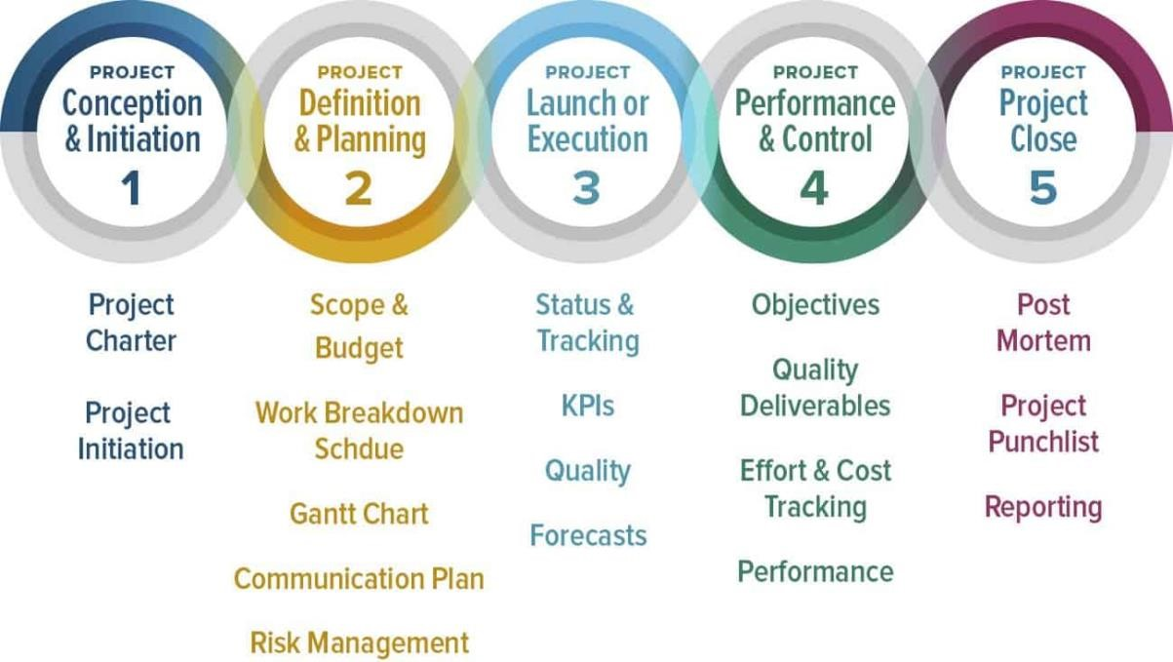
Figure 1: PMI approach to project development
(Source: Based on the ideas of Badewi, 2016)
1.3 Project direction
Direction of the project develops the most reasonable section of deploying core roles that project meets. This particular stage is responsible for stating the productive initiation or the reliable field that will coordinate the developing team to bind the system with a strategic decision. As per the views of Nyadzayo and Khajehzadeh (2016), management of the system or developing the decision-making process for the project for a sustainable period of development and the direction of the project susceptibility is the prime aim of the project direction stage. This is represented through the Gantt chart, where time and stages of developing CRM policy for Harrods have been stated.
 | Objectives | Qtr. 1 |  |  | Qtr. 2 |  |  | Qtr. 3 |  |  | Qtr. 4
 | Objectives | Jan | Feb | Mar | Apr | May | Jun | Jul | Aug | Sep | Oct | Nov | Dec
 | 3

Policies of the project
Project scope determination
Requirement of the stakeholder
Analysing the human and
financial resources
Developing the documents required for the project
Evaluating the requirement of the resources
Identification of sequences
Risk assessment
Risk mitigation strategies
Figure 2: Gantt chart
(Source: Taking ideas from Nyadzayo and Khajehzadeh, 2016)
1.4 Controlling of stages
Management is strategic, and for developing the system of effective management policy, utmost controlling system is required. As stated by Rahimi and Kozak (2017), a system that
4

can meet the core role and goal of the policy developing the project is the control system of the project. In this perspective, the project manager or the sales head is required to specify reliable and cognitive strategies that the sales team will follow to establish sustainable management of the control system of the CRM project. In this process of developing a CRM system for Harrods, the management team needs to control every stage of the project development. This is, however, possible through a reliable and sustainable format that meets project developing prospectus (Hill Jr and Nelson, 2019). This stage is delivering a wider step in cognitive management through sustainable and reliable strategies.

1.5 Management of delivery
In this particular stage, the management team of the project development is liable to deliver the outcome of the project group that has been developed based on the organisational needs. Based on that, the core management team is sustainable in cognitive analysis of the system that meets the daily needs of the project group. As stated by Dewnarain et al. (2019), delivering a wider range of project groups with sustainable outcomes is the prime focus of this stage in the execution system of the project. Harrods’s system of developing CRM projects needs to personify agencies and proposed to grow up format such that customers will be more engaged in the business. In this program of developing CRM policy for Harrods, the prime focus is to gain a susceptible format of analysing the output that the project has gained from the management team.

1.6 Management of boundaries of stages
Managing boundaries of the stages within a project is designated with two different forms of perspective where the first one is for managers. In this first step, the project manager is to be responsible for developing the criteria, resources and updating the information regarding the project. They are also responsible for overviewing the project and developing the performance indicating agendas that meet the analytical prospectus of the project (Thakur and Workman, 2016). The management team responsible for CRM system implementation in Harrods need to specify the subjective notation and other forms of development.
On the other hand, the project system management can develop systems that can establish information development that has been coordinated to the other members of Harrods that can establish systematic scrutiny of the project. This will be effective in delivering a wider approach for the management team to understand the reliable and loophole factors of the project.

1.7 Project closure
This is the final loop of the project development where the project is scrutinised, and the end program is developed for the better personification of data within a specified section. As stated by Bakhshi et al. (2016), project closure is the system where the main focus remains regarding a reliable project closing perspective for the sustainable gain of the subject of the project. This can be developed based on two programmable aspects such as the premature closure as well as planned closure. Through the project of developing CRM for Harrods has been based on progressive development, there is no need for premature closure, and planned closure will be effective for the sustainable gain of the project. Thus, Harrods has developed the planned closure of the project regarding the CRM policy deploying within its strategic format. This has installed a cognitive base for the organisation to be effective in developing plans that meet the core role and goal in subjective matters.

End of Project Reporting

Project objectives and assessing the completion of the project
The world of innovation has led to wider growth of marketing variability and based on that core prospectus of business has been taken into consideration. Thus, meeting the demand of the customer is the prime aim of the organization to gain a sustainable base and competitive advantage that can be effective to rely on the whole contextual method of development. As per the statement provided by Varajão et al. (2017), CRM strategy is deployed to develop a strong customer base that meets the objectives of the organisation.
Based on that, the prime role as played by the management system has taken a wider role model in developing strategies which can meet every program strategically. Objectives that have been developed by the project management team of Harrods is based on the PMI approach. One of the significant reasons behind this is that PMI methodology assures the systematic management of a project (Radujković and Sjekavica, 2017). This is, therefore, effective in delivering the right attributes of human resources as well as financial capabilities that have installed a wider form of approach building for better management policy. This particular approach has led to a sustainable form of approach building that has a tentative form of delivering susceptible growth of environmental policy for Harrods.

Analysing the benefit gained from the project
Maintaining a tangible form of relationship among the customer is the prime goal that is effective to develop a systematic binding for the organization to grow. Based on the views of Palma et al. (2018), the CRM project provides a reliable schedule of development and approach that meets the competitive advantage of the market. In this particular policy has held a cognitive base that has met the possible attributes to follow entities that meet the demand of the market. The concerned project has helped Harrods to deploy its own strategies that meet the demand and responsibility it pertains in the market. In addition to that, this particular policy has adopted a wider base and has met all-round methods. These, in turn, are effective for the organisation to build a tangible form of decision making (de Freitas et al. 2019). This particular strategy has imbibed a significant approach of delivering systematic outsourcing technique as well as management technique which can be effective for the organization to grow. Harrods’s project management team has included CRM strategy through the PMI technique. This is because it is effective in reliable establishment of management roles that can develop a sustainable plan for the organisation to gain in this competitive market and attract diversified customers.

Evaluating project scope
The scope of the project is to develop clear vigilance that meets the competitive structure developed by the organisation. In this context, Harrods has utilised the PMI techniques and methodologies to develop the CRM plan for itself that can meet the ever-changing demand of customers for its competitive advantage in the market of London. As stated by Hill et al. (2019), delivering the right scope meets the organisation's cognitive field of approach where the main focus of the organisation remains to develop its own plan for business. Harrods management team has manifested with a prime aim of delivering the attributes or the feedback that is provided for further incorporation of strategies as per the want of the potential customers. This has elaborated a wider base for Harrods to meet every single prospectus of demand to bring sustainability in its business process. To develop customised goods, PMI policy has been installed. Here, data would be perceived by customers from online platforms or physical stores for the betterment of Harrods’ business policy.

Analysing the changes that took place as well as their impact
Innovation has changed the lives of humans, and based on that, the world of business is changing daily with certain manifestations. The changing market policies with a sustainable role and goal has been the prime focus of business in this present world. This PMI technique has been incorporated to determine the cognitive role of changing policies (du Plessis, 2019). CRM policy development, as taken by Harrods, helps to determine the specific agendas of meeting the demand and responsibility to the market. This marketing system, as installed by PMI, has an integrated form of approach building policies that can install strategic incorporation of development within the organisation. Sustainable gain with utmost policy encryption is the prime role and goal of the organisation that has an effective base in this changing format of project management. This has installed susceptible management policies which can illustrate the customer relation technique that brings effective development for Harrods. This has manifested to deploy the tangible form of policy inclusion by the management team of Harrods in a strategic sense. This has formulated systematic coordination that has met with respective modes of development.

Summary of learning and areas requires improvement as well as recommendation
While managing a project, the entire PM team goes through a systematic and reliable analysis policy which in turn helps the members to gain knowledge on various attributes of development. As opined by Radujković and Sjekavica (2017), systematic growth of the project management leads to significant analysis of the report regarding the vindictive policy of deploying effective management tools. These particular aspects have led the organisation's workforce to understand roles as well as susceptible goals that a project held in the system of management. This management system development through PMI ideologies or techniques has led the workforce to understand the core prospectus of business and the possible way to develop strategies and budget for the project. Moreover, this particular project of CRM of Harrods has led the team to summarise the flaws of the report as well as possible integrated recommendations that will be effective for further analysis of the project regarding CRM in Harrods.

Critically analysing the risk determined
Every business management system has its own risk factors and its own form of a susceptible management system which requires a wider class of governing policy for overall growth. As opined by Frefer et al. (2018), delivering right attributes that determine the risk factors as well as determine the contingency plan along with risk mitigation is the prime role of the project management b team. This PMI has captured a systematic portfolio of determining the project risk regarding the development of CRM policy of Harrods. Upon those risk factors, a risk mitigation plan is developed so that the project can run effectively to meet goals as specified by the organisation. Breakdown of the goals of the project, specification, along with loss of coordination and collaboration among various project teams are being identified as the prime risk aspects that Harrods CRM project may face. Therefore, to deliver the right objectives that can resolve and mitigate such issues, a better personification of risk analysis has been taken into consideration.

Conclusion
From the above discussions, it can be concluded establishing stability and gain a competitive advantage in this competitive international market requires a strategic market plan. This particular plan will bring up strategic enforcement of the resources as well as strategic reliability of the workforce. To maintain a standard relationship with customers, who are said to be the prime role model of the business, there is a requirement of a strategic plan that can meet every program of the business in a susceptible manner. Thus, delivering a CRM strategy is effective for Harrods to develop a standard business prospectus through PMI techniques. Therefore, it is estimated that on successful completion and delivery of the project, Harrods will succeed in improving its customer service.

Reference List
Badewi, A., (2016). The impact of project management (PM) and benefits management (BM) practices on project success: Towards developing a project benefits governance framework. International Journal of Project Management, 34(4), pp.761-778.
Bakhshi, J., Ireland, V. and Gorod, A., (2016). Clarifying the project complexity construct: Past, present and future. International Journal of Project Management, 34(7), pp.1199-1213. deFreitas, M.D., de Araujo, F.C.C. and França, S.L.B., (2019). Comparative analysis of project management methodologies pmbok and agile–A case study with companies of the Brazilian energetic sector. Revista GEINTEC-Gestão, Inovação e Tecnologias, 9(3), pp.4993-5007. Dewnarain, S., Ramkissoon, H. and Mavondo, F., (2019). Social customer relationship management in the hospitality industry. Journal of Hospitality, 1(1), pp.1-14.
du Plessis, H., (2019). Facilitation of construction project management through building contracts: A South African perspective on the locally developed suites of contracts. ActaStructilia, 26(1), pp.120-147.
Frefer, A.A., Mahmoud, M., Haleema, H. and Almamlook, R., (2018). Overview success criteria and critical success factors in project management. Industrial engineering & management, 3(2), pp.2169-0316.
Hill Jr, A.T. and Nelson, M.L., (2019). Application of the Project Management Body of Knowledge (PMBOK) in an Interdisciplinary Capstone: The AISC Steel Bridge
Competition. International Journal of Engineering, 3(1), pp.17-24.
Nyadzayo, M.W. and Khajehzadeh, S., (2016). The antecedents of customer loyalty: A moderated mediation model of customer relationship management quality and brand image. Journal of Retailing and Consumer Services, 3(6), pp.262-270.
Palma, F.E., Fantinato, M., Rafferty, L. and Hung, P.C., (2018), September. Enhancing Project Management for Cyber-physical Systems Development. In 2018 Federated Conference on Computer Science and Information Systems (FedCSIS) (pp. 747-750). IEEE.
Poston, R.S. and Richardson, S.M., (2019). Designing an academic project management program: A collaboration between a university and a PMI chapter. Journal of Information Systems Education, 22(1), pp.6-9.
Radujković, M. and Sjekavica, M., (2017). Project management success factors. Procedia engineering, 19(6), pp.607-615.
Rahimi, R. and Kozak, M., (2017). Impact of customer relationship management on customer satisfaction: The case of a budget hotel chain. Journal of Travel & Tourism Marketing, 34(1), pp.40-51.
Sanchez, O.P. and Terlizzi, M.A., (2017). Cost and time project management success factors for information systems development projects. International Journal of Project Management, 35(8), pp.1608-1626.
Thakur, R. and Workman, L., (2016). Customer portfolio management (CPM) for improved customer relationship management (CRM): Are your customers platinum, gold, silver, or bronze?. Journal of Business Research, 69(10), pp.4095-4102.
Varajão, J., Colomo-Palacios, R. and Silva, H., (2017). ISO 21500: 2012 and PMBoK 5 processes in information systems project management. Computer Standards &
Interfaces, 5(6), pp.216-222.

