PROBLEM-SOLVING AND DECISION MAKING
Name of the Student: Lidia Rezmuves
Student ID: 2129389
Module Code:(BMSW4004_LON)
Lecturer’s Name:Akinseye Aluko
Task 2
Table of content

Introduction 3
The issue observed in Tesco's workplace including its scope and impact 3
Analysing Information 4
Applying situational analysis models for evaluation of the range of solution 5
SWOT analysis of Tesco 5
PESTEL Analysis of Tesco 6
Range of Alternative Solutions 8
Communication Plan with Stakeholders 9
Monitoring and Review Techniques 11
Conclusion 12
References 13

Task 2: Report

Introduction
It has been observed that at present there are several types of problems that have been observed and faced by business organisations in the United Kingdom and one such organisations is Tesco. This study has been conducted in order to focus on the problems that are faced by Tesco in making effective decisions for their organisation. After analysing the problems the study also provides several types of solutions including a situational analysis model, stakeholder communication, and monitoring and reviewing techniques. It has been hoped that all these solutions will help Teeco to overcome the problems and make effective decisions for the organisation's success and achievements.

The issue observed in Tesco's workplace including its scope and impact
Tesco is one of the well-known Supermarket chains in the United Kingdom and also all over the world but the employees of the organisation are facing several changes regarding health and safety satisfaction. There are a number of complaints received from employees regarding the unsafe and unhealthy environment of the workplace (Tannock, 2015). It has been observed that the employees complain that they need to work for a long time which is not usual to their working hours and this additional working hour causes frustration for them. Sometimes it happens that if the employees are offered a healthy and peaceful as well as safe environment for their work then they even agree to work for a long time and they can work enthusiastically and efficiently but it has been observed that Tesco is not even able to provide such an environment to the Employees. The employees of Tesco said that they need to work for long hours even without any sort of break and as a result of this they feel fatigued within themselves and they cannot focus on their work (Payne et al., 2023) As employees need to work continuously without any break they face break down both mentally and physically. Along with these problems, there is another type of problem observed within the organisation which is causing this satisfaction for the employees and this is the issue regarding proper and appropriate equipment to do their work and lift heavy objects. Because of the lack of appropriate equipment, several types of injuries happened to the Employees and it is a red alert for the employees because as an employee they deserve health and safety measures from the organisation (Ali and Grant, 2023). As a result of all these difficulties now, the organisation is facing issues of employee dissatisfaction and increasing absenteeism within the company.

Analysing Information
Unsafe and unhealthy environment
It has been observed that when an employee decides to work in a workplace they are not only concerned about their job responsibility and salary offered by the organisation but at the same time they are also concerned about the safety and well-being provided to them by the company. A similar thing happened to the employees of Tesco. They expect a healthy and safe environment in the company but Tesco is not able to provide them with such an environment because there is much ignorance that has been observed in the management team of the company (Lehn, 2020). As a result of which they are not able to create a safe environment for their employees and this causes dissatisfaction and an unhappy atmosphere for the employees. Unsafe and unhealthy environments also include the relationship among the employees who are working in the company but sometimes conflict takes place within the organisation and also a sort of unhealthy relationship is observed among employees because of diverse cultures.
Overload of work without a break
It is quite common that sometimes in some organisations workload increases as a result of which employees need to work for a longer time than usual. Similar things are observed in the company Tesco. The employees complain that they need to work for longer hours and they need to fulfill the burden of workload sometimes. Though it is not a fact for them to work for a long time, the main concern is they are not allowed to take rest or break in between their working hours as a result of which they lose their patients and get frustrated out of their responsibility (Priporas et al., 2023). It directly affects their mental dissatisfaction and the breakdown of the employees. The employees cannot focus on their work and it causes a lack of productivity and inefficient outcome of the organisational performance.
Lack of appropriate pieces of equipment
The employees are facing several challenges because of the lack of equipment within the company. This lack of appropriate equipment leads to serious health and safety issues. For example, when employees work in the warehouse or stockroom they may need to lift heavy boxes or equipment which can cause some serious injury if proper lifting equipment is not used. It can also affect the productivity of the employees as they will not be able to work within the organisation at their full capacity because of the lack of necessary equipment (Chen, 2022). Along with this, employees may be required to work in areas with poor ventilation or lighting which can lead to health issues such as respiratory problems, eye strain, and headaches.

Applying situational analysis models for evaluation of the range of solution

SWOT analysis of Tesco
Strengths
Focusing on the strengths of the company it can be said that Tesco has a strong brand reputation and a wide range of products and services offered by company. It has an extensive supply chain that helps the company to keep the products always in stock and rich the products towards their customers within time (Tesco, 2023).
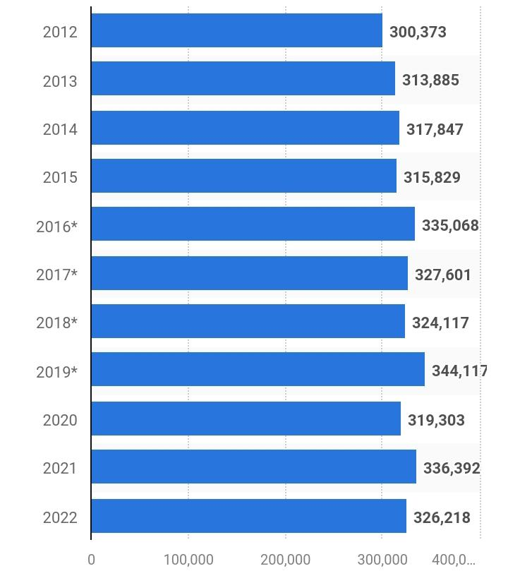
Figure 1: Employment rates in Tesco
Source: (Statista, 2023).
Weaknesses
Considering the weaknesses of the company it has been observed that Tesco has a lack of innovation. It also lacks employee relationships and Limited presence in some markets. As it has been discussed above it has been observed that the major weakness of the company is the lack of a safe and healthy environment within the workplace for its employees (Chen, 2022).
Opportunities
The opportunities that have been observed for Tesco include developing E-Commerce strategies using which they will be able to implement several innovative approaches within the organisation that can attract maximum customers towards the company (Utama et al., 2022). Along with this, it has the opportunity to expand its business into emerging markets and it can also invest its capital in technology.
Threats
However, there are some threats also observed in the company and some of the threats are intense competition in the market, the economic downturn, and the changing preference of the customers.

PESTEL Analysis of Tesco
Political
PESTEL analysis is the most effective tool to focus on the external environment and situation of the company. The first factor of this tool includes various political aspects that the company Tesco needs to face. There are several types of government policies imposed on business organisations in the United Kingdom and it needs to follow those policies properly in order to avoid any sort of challenges. Along with this other political aspects are taxation law and trade agreements that the company needs to focus on (Noonan and Plekhanova, 2020).
Economical
The economical factors of the company include several aspects such as recession, level of inflation, and Employment rates. Focusing on the employment rates it can be said that almost 354,000 employees work in the company all over the world (Statista, 2023). The generated revenue by this company in 2021 was 56.4 billion British pounds (Statista, 2023).
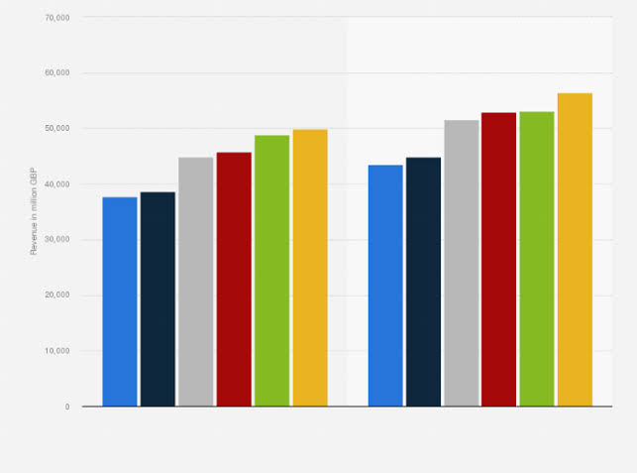
Figure 2: Generated Revenue of Tesco
Source: (Statista, 2023).
Social
The social factors include several aspects such as changes in customer behaviour, lifestyle choices, and demographics. As time is going on and along with time the preference of customers have been changing regarding their products it is quite obvious that they can change their preferences from the company Tesco to another company. Along with this, the company also needs to bring changes within their products all of a sudden which may cause huge losses (Fernie and Sparks, 2018).
Technological
Technology has become an important and mandatory aspect of business and for this reason, Technology has a significant impact on the achievements of the company. It is because, with the help of technology, Tesco will be able to bring advancement within the company and make its products more innovative.
Environment
At present sustainability is another important factor within business organisations and environmental approaches of the business organisations help in bringing sustainability within the workplace. For this reason, Tesco also undertakes some effective initiatives toward the environment that can help in reducing the footprint of carbon emissions from the atmosphere and provide a healthy environment (Morgan et al., 2017).
Legal
Legal factors within the company Tesco include the regulations regarding the health and safety of the employees, consumer protection law, and equal rights of every employee. As it has been already discussed that the employees of Tesco are not satisfied with the health and safety rules and environment created by the organisation it is necessary that they need focus on these factors and follow the health and safety rules imposed by the government (Priporas et al., 2023).

Range of Alternative Solutions
Solution 1: Provide appropriate pieces of equipment
The problems that Tesco employees are facing the need to be resolved and one of the alternative solutions for these issues is to arrange the appropriate equipment for the employees within the organisation. For heavy boxes, Tesco needs to provide a lifting machine using fridge employees to easily lift the boxes and avoid injury (Marr, 2015). Along with this while the employees are working in poor ventilation the organisation needs to take proper measurements so that the employees can avoid problems and health issues.
Solution 2: Promote a health and safety program
As the employees complain about the poor and unsafe environment within the workplace of Tesco, the company needs to face several criticisms. In order to avoid both the challenges of employee health and criticism the company can promote health and safety programs. Several types of Health and safety programs are followed by the business organisations that can be analysed by Tesco and depending on their own problems and convenience they can adopt any of the health and safety programs (Pandey et al., 2020). It will not only help the employees to work in a better and safer workplace but it will also help the company to achieve a reputation among the people and stick to the competitive market.
Solution 3: Offer flexible working
Employees are tired and frustrated with taking on the burden of excessive workload but they are compelled to perform their job responsibility. In this situation, one of the most effective solutions is that Tesco can offer its employees flexible working or remote working (Alam and Raut-Roy, 2019). The company can allow its employees to work from home so that they can do their work in their comfort zone and also according to their time and convenience. Because of this flexible working opportunity, employees will not only be influenced to pay attention and accomplish their work with efficiency overcoming their depression but they can also be able to bring a balance between their working and family life.

Communication plan with stakeholders
Employees
Employees are the most important part of the organisation and for this reason, it is necessary to communicate all the plans with the employees so they can perform their job responsibilities according to the needs of the organisation.
Consumers
Consumers are the main source of success and income for Tesco. For this reason, it is necessary that the organisation must communicate its aims and objectives with its customers so that they can feel enthusiastic to purchase its production services.
Investors
Investors are responsible to invest their capital in the project and plan of the company and for this reason, it is important to explain the plan to the investors appropriately (Brest et al., 2018).
Suppliers
Suppliers are responsible to supply the necessary materials to the company and without effective communication of the plan suppliers will not be able to provide effective materials to the companion.
Government bodies
The government bodies make sure that Tesco is following all the laws and legislations.

Stakeholders | Interest | Key Interests and Issues | Communication Vehicle | Frequency | Comments
Employees | High | The employees are not feeling safe in the organisation. | Emails | Emails | Employees will feel important and happy.
Customers | High | Customers are searching for Ethically responsible organisations. | Social media and emails | Ads are shown on TV | Enhance brand loyalty among customers.
Government Bodies | Low | Government bodies enable the organization to be legally aware and informed. | Press Releases | Twice a year | Give the company free from legal issues and conflicts.
Suppliers | Medium | They provide the materials to the organisation within time. | Emails and direct | Every month | Provide the best quality product from the best places.
Investors | High | They invest in order to enhance their productivity. | Direct | Once a year | Get an amount of profit from a single product.
Table 1: Stakeholders' Communication Plan
Source: (Self-designed)

Monitoring and Review Techniques
ADKAR model will help in monitoring and reviewing the problems that are faced by the employees within Tesco.
Awareness
The manager of Tesco is responsible to be aware of all the factors that cause dissatisfaction among the employees.
Desired
The employees are desired to get a safe and healthy environment at Tesco.
Knowledge
The manager needs to know what are the aspects that are responsible for the lack of a safe and healthy environment within the organisation (Shamsuddin et al., 2015).
Ability
After analysing the aspects that are responsible for the health and safety issues of the employees the manager must be able to solve those problems with effective strategies.
Reinforcement
With effective solutions and initiatives, Tesco will be able to overcome the problems and make their employees happy and satisfied.

Conclusion
From this entire report, it is clear that the employees are not happy and satisfied with the workplace environment of Tesco. Even the company is criticized for its inability to provide a healthy and safe environment to its employees. As a result of their inability the productivity of the employees is also decreasing. To solve this problem various solutions have been provided in this report and it has been expected that by undertaking these solutions the company will be able to overcome the challenges.

References
Alam, S. and Raut-Roy, U., 2019. Evaluating the Effectiveness of Reward Strategy at Tesco. Indian Journal of Industrial Relations, 55(1), pp.105-120.
Ali, M. and Grant, C., 2023. Corporate Social Responsibility and Coping with COVID-19 Pandemic in the Global Health Service Institutions: The United Kingdom. In Corporate Social Responsibility in the Health Sector: CSR and COVID-19 in Global Health Service Institutions (pp. 219-242). Cham: Springer International Publishing.
Brest, P., Gilson, R.J. and Wolfson, M.A., 2018. Essay: How investors can (and can't) create social value. J. Corp. L., 44, p.205.
Chen, J.J., 2022. Tesco Plc. In International Cases of Corporate Governance (pp. 27-44). Singapore: Springer Nature Singapore.
Fernie, J. and Sparks, L. eds., 2018. Logistics and retail management: emerging issues and new challenges in the retail supply chain. Kogan page publishers.
Lehn, D.V., 2020. Digitalization as “an Agent of Social Change” in a Supermarket Chain: Applying Blumer's Theory of Industrialization in Contemporary Society. Symbolic Interaction, 43(4), pp.637-656.
Marr, B., 2015. Big Data: Using SMART big data, analytics and metrics to make better decisions and improve performance. John Wiley & Sons.
Morgan, E., Tallontire, A. and Foxon, T.J., 2017. Large UK retailers' initiatives to reduce consumers' emissions: a systematic assessment. Journal of Cleaner Production, 140, pp.227-238.
Noonan, C. and Plekhanova, V., 2020. Taxation of digital services under trade agreements. Journal of International Economic Law, 23(4), pp.1015-1039.
Pandey, S., Singh, R.K., Gunasekaran, A. and Kaushik, A., 2020. Cyber security risks in globalized supply chains: conceptual framework. Journal of Global Operations and Strategic Sourcing.
Payne, J., Lloyd, C. and Jose, S.P., 2023. ‘They tell us after they've decided things’: A cross‐country analysis of unions and digitalisation in retail. Industrial Relations Journal, 54(1), pp.3-19.
Priporas, C.V., Nagarajan, D.V. and Kamenidou, I.E., 2023. A technology-people-integrated toolkit for retail care management during a crisis. Journal of Retailing and Consumer Services, 73, p.103304.
Priporas, C.V., Nagarajan, D.V. and Kamenidou, I.E., 2023. A technology-people-integrated toolkit for retail care management during a crisis. Journal of Retailing and Consumer Services, 73, p.103304.
Shamsuddin, K.A., Ani, M.N.C., Ismail, A.K. and Ibrahim, M.R., 2015. Investigation the Safety, Health and Environment (SHE) protection in construction area. International Research Journal of Engineering and Technology, 2(6), pp.624-636.
Tannock, S., 2015. Bad attitude? Migrant workers, meat processing work and the local unemployed in a peripheral region of the UK. European Urban and Regional Studies, 22(4), pp.416-430.
Statista. (2023). Employment rate of Tesco. Available at. https://www.statista.com/statistics/490882/tesco-group-united-kingdom-uk-number-of-employees/ (Accessed 1 January 2023)
Statista. (2023). Generated Revenue of Tesco. Available at. https://www.statista.com/statistics/386598/tesco-sales-percentage-change-great-britain-uk/ (Accessed 1 January 2023)
Tesco. (2023). Tesco. Available at. https://www.tesco.com/ (Accessed 1 January 2023).
Utama, A.G.S., Verma, M., Ng, J.Y., Kee, D.M.H., Nga, C.S., Izzati, N.N., Ng, Y.X. and Khoiruwnia, F., 2022. A Research on Tesco's Consumer Purchasing Behavior towards E-Commerce during the Pandemic Period. International Journal of Accounting & Finance in Asia Pasific (IJAFAP), 5(1), pp.53-63.

