Critical Evaluation of Braun’s Multiplier and Wallace Tree Multiplier Using VHDL



Nathan Evans
Electrical and Electronic Engineering / Electronics 2
Submitted to: Jenifer Prince Devaraj
UWTSD – Waterfront Campus
17/04/25

Contents Page:

The following report will contain the listed sections below:

 | Page Number
- Title/Contents Page | 1-2
- Introduction | 3
- Literature Review | 4-7
- VHDL Screenshots | 8-37
- Critical Evaluation / Conclusion | 38-41
- Code Appendices / References | 42-72

The work of this report completed under the supervision of (Jenifer Prince Devaraj I declare that this report is the product of my own work and is not being submitted for any other degree.

N. Evans

Introduction
In computer arithmetic, embedded systems, and digital signal processing, multiplication is a basic operation. Therefore, one of the most important aspects of designing digital hardware is still designing and optimising efficient multiplier architectures. The Wallace Tree multiplier and the Braun multiplier are two traditional parallel multiplier architectures that are compared in this research. Using Vivado as the main development and simulation environment, the report analyses their structural differences and focusses on assessing their performance in terms of timing delays, critical path analysis, and power efficiency.
Multiplication is a fundamental function in digital signal processing, embedded systems, and computer arithmetic. Therefore, creating and refining effective multiplier architectures remains one of the most crucial parts of building digital hardware. This study compares two conventional parallel multiplier architectures: the Wallace Tree multiplier and the Braun multiplier. The report examines their structural differences and emphasises on evaluating their performance in terms of timing delays, critical path analysis, and power efficiency.

Literature Review: Background research on Multipliers

There are multiple different types of multiplier architectures that have been developed over the years. Scientists and engineers have worked hard to design basic level architectures; constantly working to improve these. During this section of the report, the analysis of modern multipliers will be undertaken, discussing examples such as approximate multipliers and hybrid multipliers. Discussing their function, architecture, techniques, where they are used. The report will also discuss traditional multipliers, which helps understand the modern types. The design original design was between 1947-1949 by Alec Robinson, who worked as an engineering apprentice at the university on Manchester, where he developed a hardware multiplier for the mark 1 computer. The fundamental operation of this was repeated shifts and accumulation of partial results, written using “loop unwinding”. [1]

Multiplier Architectures:
Brauns Tree
The Brauns has a standard layout in comparison to other multipliers, this means that it is easier for engineers to implement the design into their systems. Being standard design, this also means it is slower that most of its competitors. It hosts a parallel array which can perform binary multiplication. The Brauns uses AND gates fir partial product generation, consisting of a grid of adders ( Half adders and Full adders) to generate results. The Brauns is referred to by engineers as a ‘carry/save’ multiplier due to its uncomplex structure and flow of bits. [2]

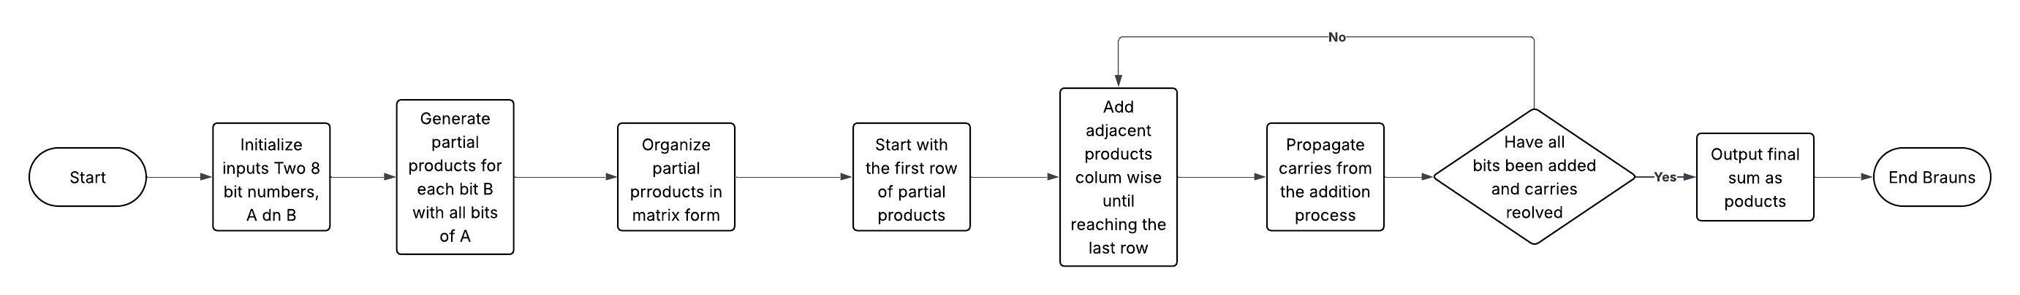

Figure (1) Shows a flowchart of the Brauns Tree multiplier operation

Wallace Tree
The Wallace tree Is faster than the Brauns but its main flaw is the irregular layout. It is more power efficient than the Brauns making it overall a better option. It is designed to group and then reduce partial products using carry/save adders. This intern reduces the number of sequential additions. Instead of using partial products, like the Brauns does. The Wallace tree uses a carry save adders to compress the matrix as quickly as possible, adding to its benefit of fast bit operations. Wallace is overall a better architecture when compared to the traditional Brauns, but this means that it is more complex to understand, needing a careful design phase. The Wallace is used in applications that rely heavily on performance such as DSP’S, CPU’S etc. [3]

Carry Save Adders
Carry save adders are digital adders used to create the sum of 2 or more binary numbers without outputting the carry. This differs to the ripple or a lookahead as these looks do create the sum and output the carry all in one go.[4] The carry saves adder holds the carry bit to add at a later point which improves the speed of their designated multiplier architecture.

Booth encoding
Booth encoding is a multiplier that is designed to reduce the number of partial products in a multiplier. It has been adopted into DSP and high performance computing. It uses carry look-ahead adders which is a type of adder that improves speed through the reduction in time taken to calculate carry bits[5]
This can be directly compared to a ripple adder. This kind of adder has to wait for the carry from the previous adder. This adder uses combinational logic to determine the carries, which enhances performance for large bit additions.

Recent Advancements In Architecture Design

Approximate Multipliers
Approximate multipliers are arithmetic circuits that are designed to perform multiplication operations, with a tolerable level of errors. [6] The premise of them is to significantly reduce power and delay in exchange for accuracy. These circuits are seen used in image and signal processing and wireless sensor networks. [7]
As stated before, Accuracy in conventional multipliers like Brauns and Wallace tree multipliers, is the main priority. However, because of the numerous logic gates and connections needed to execute precise computations, they have long critical paths, high power consumption, and substantial hardware costs
The world has a growing need for energy-efficient computing, particularly in AI and low-power embedded devices. Systems can achieve significant energy and area reductions with little to no impact on output quality by carefully adding approximations in non-critical paths or lower significance bits [8].
Hybrid multipliers
Hybrid multiplier circuits play a crucial role in high-performance applications such as digital signal processing (DSP), image processing, and machine learning. These multipliers face a challenge in simultaneously optimizing speed, power consumption, area, and accuracy. Traditional multiplication architectures like array, Booth, and Wallace tree multipliers each offer specific trade-offs. The design of a hybrid multiplier aims to tackle those trad offs.
To overcome these limitations, hybrid multiplier designs have emerged as a practical solution. These architectures combine features from multiple multiplier types, such as integrating Booth encoding with Wallace tree reduction, or incorporating approximate computing elements in less critical regions of the circuit to save power [9].
To conclude, Hybrid multipliers host a range of advantages such as, performance optimization, power and area efficiency.

Computational techniques in VHDL-based FPGA designs
Computational techniques in VHDL-based FPGA designs refer to the hardware structures and methodologies used to effectively implement arithmetic operations (such as addition, multiplication, and shifting). These methods have a direct impact on a design's power consumption, resource utilisation, and performance. The following computational techniques are important methods, frequently used for putting high-performance multipliers into practice.
Pipelining is a method that involves breaking down operations into smaller stages. This is achieved by registers holding intermediate results. This turn increases the clock speed of the multiplier which is a good advantage. Flip-flops are used to split each step, enabling the processing of various multiplication operation components in parallel. Throughput is increased and the critical path delay is decreased with this method. To make sure that the overall performance gains balance the additional complexity, pipelining adds latency and necessitates precise pipeline stage management.[10] Wallace tree multipliers use pipelining frequently to increase their overall speed.
Another method commonly used is parallelism. This method involves multiple operations being executed at once. This increases overall output performance when compared to basic shift/ add method but can have a toll on the logic resources. [10]
One final method is resource sharing. This method involves the utilization of common multiplier components, spanned across multiple operations. This helps save vital FPGA resources by sharing components, those being adders or multipliers. This massively helps reduce the area required for a multiplier design. Architectures like the Brauns would benefit from this as the area is a lot bigger than the Wallace for example. [10]

Brauns Screenshots
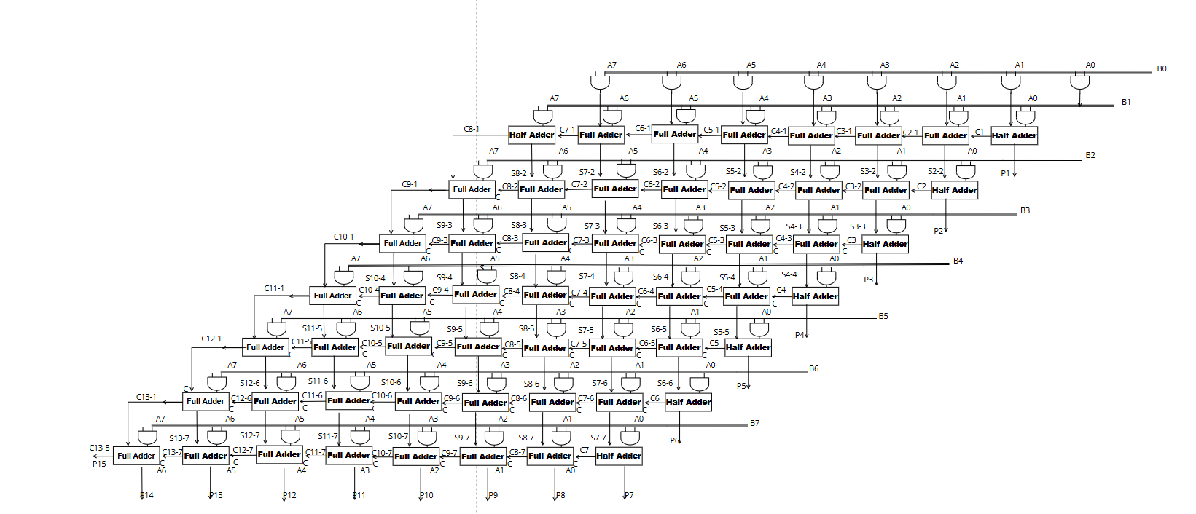

Brauns Sample 1 Inputs: A= 77 B=66
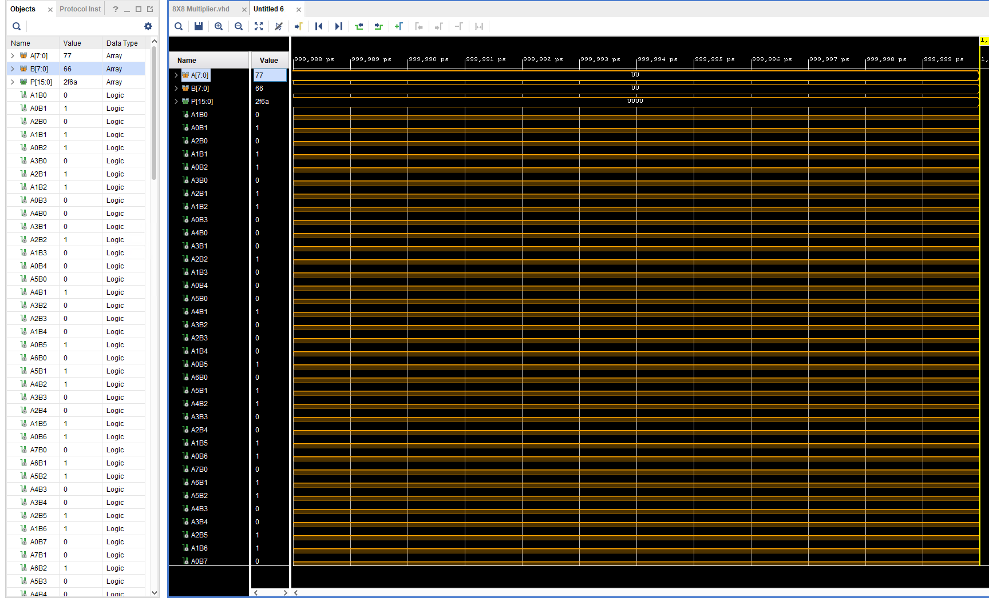

Brauns Sample 2 Inputs: A= d4 B= 4d
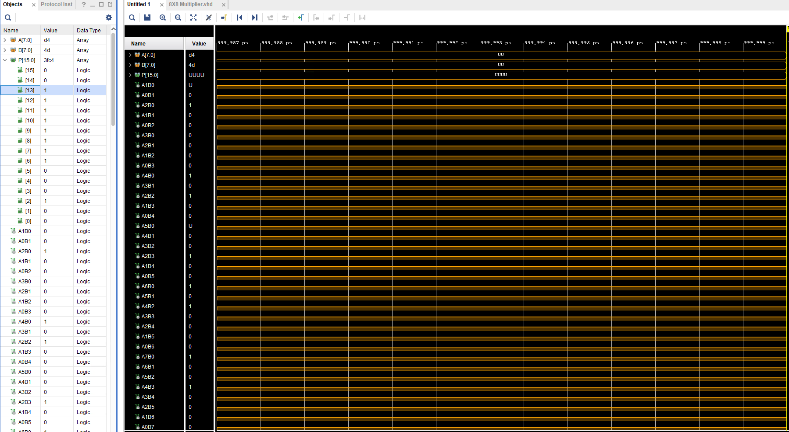

Brauns Sample 3 Inputs: A= 77 B= cc
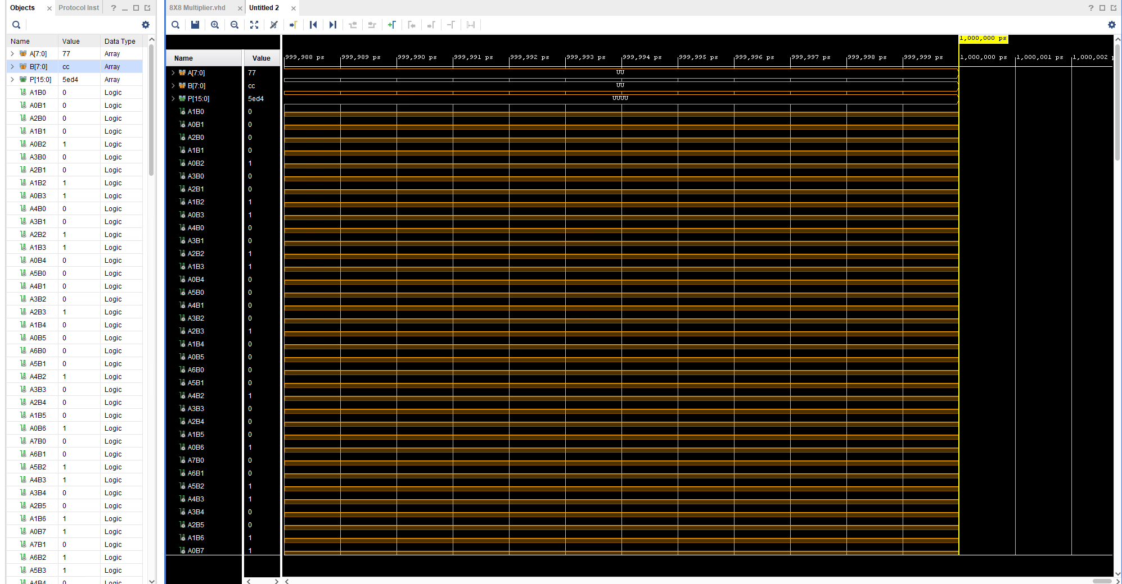

Brauns Sample 4 Inputs: A= ff B= ff

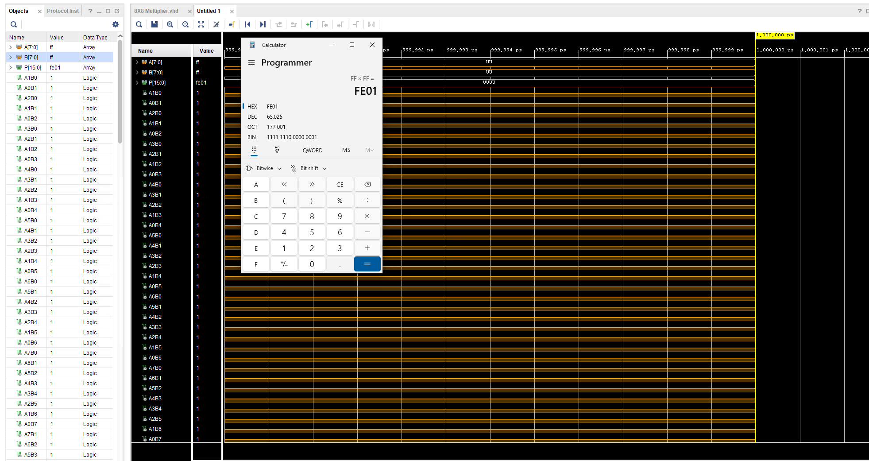

Brauns Implementation Schematic
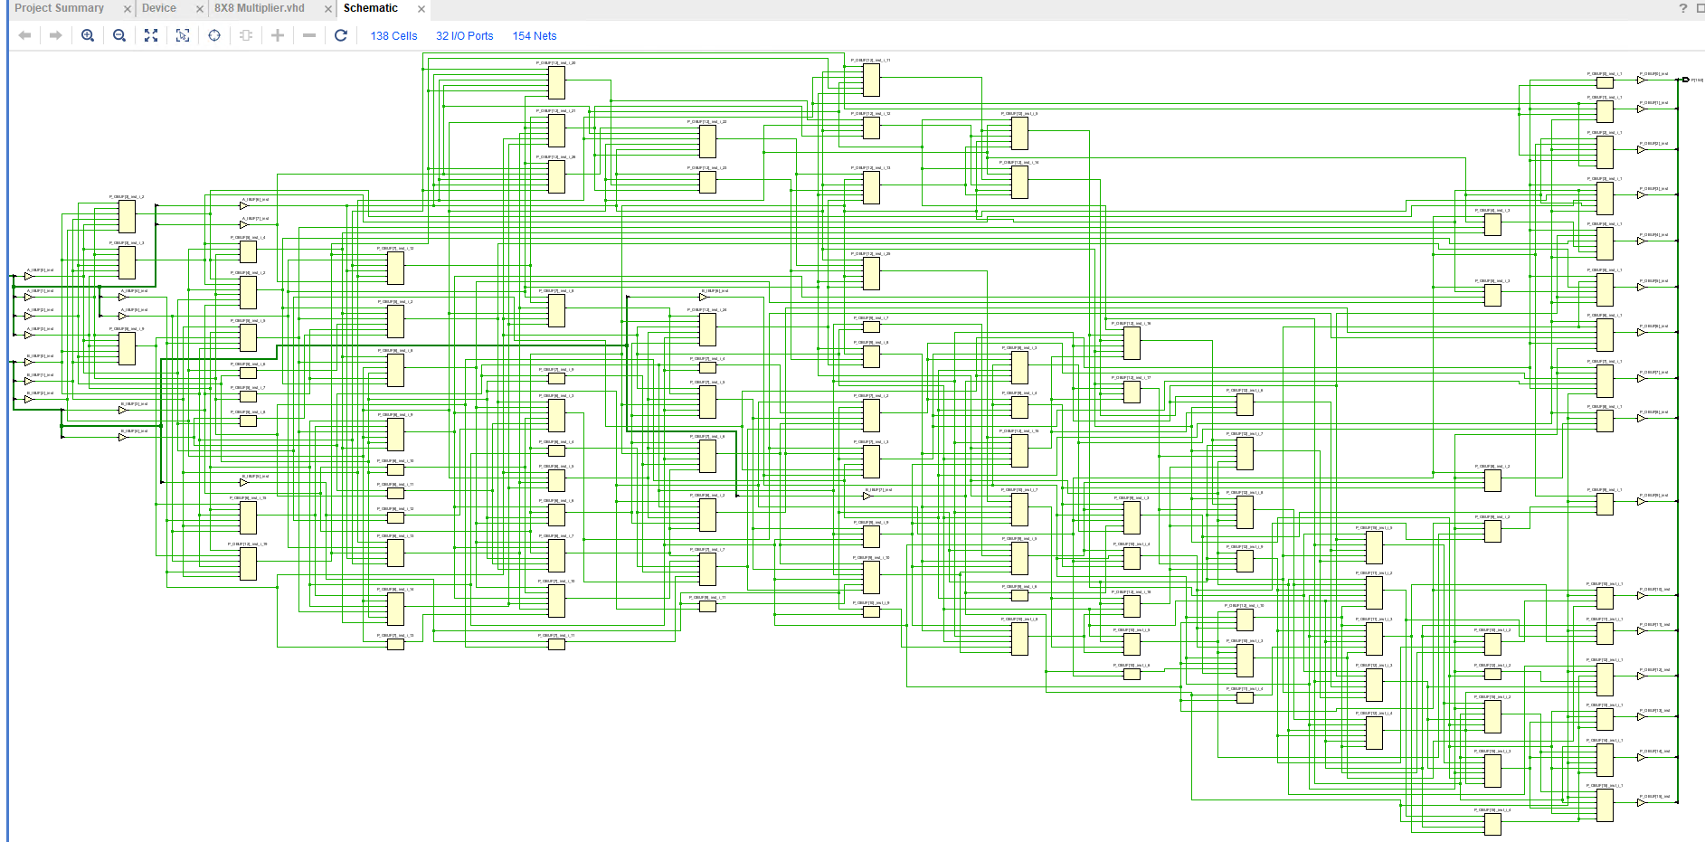

Brauns RTL Design

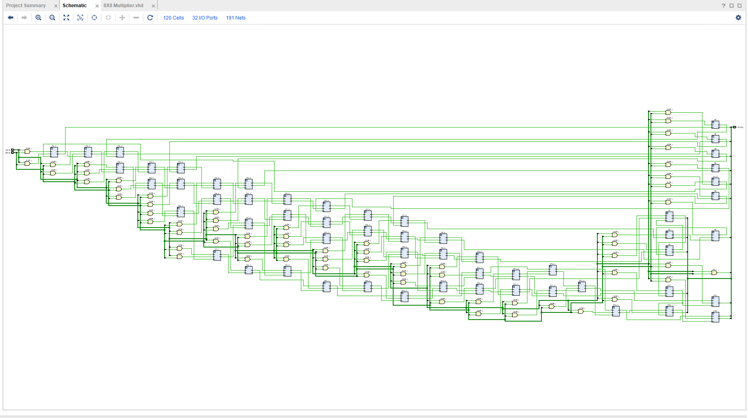

Brauns Device Screenshot

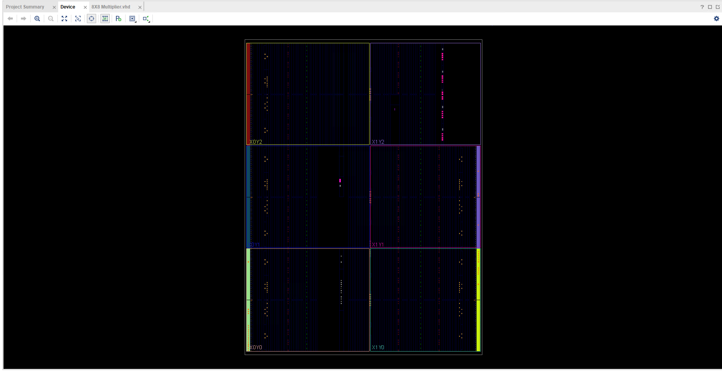

Brauns I/O Planning
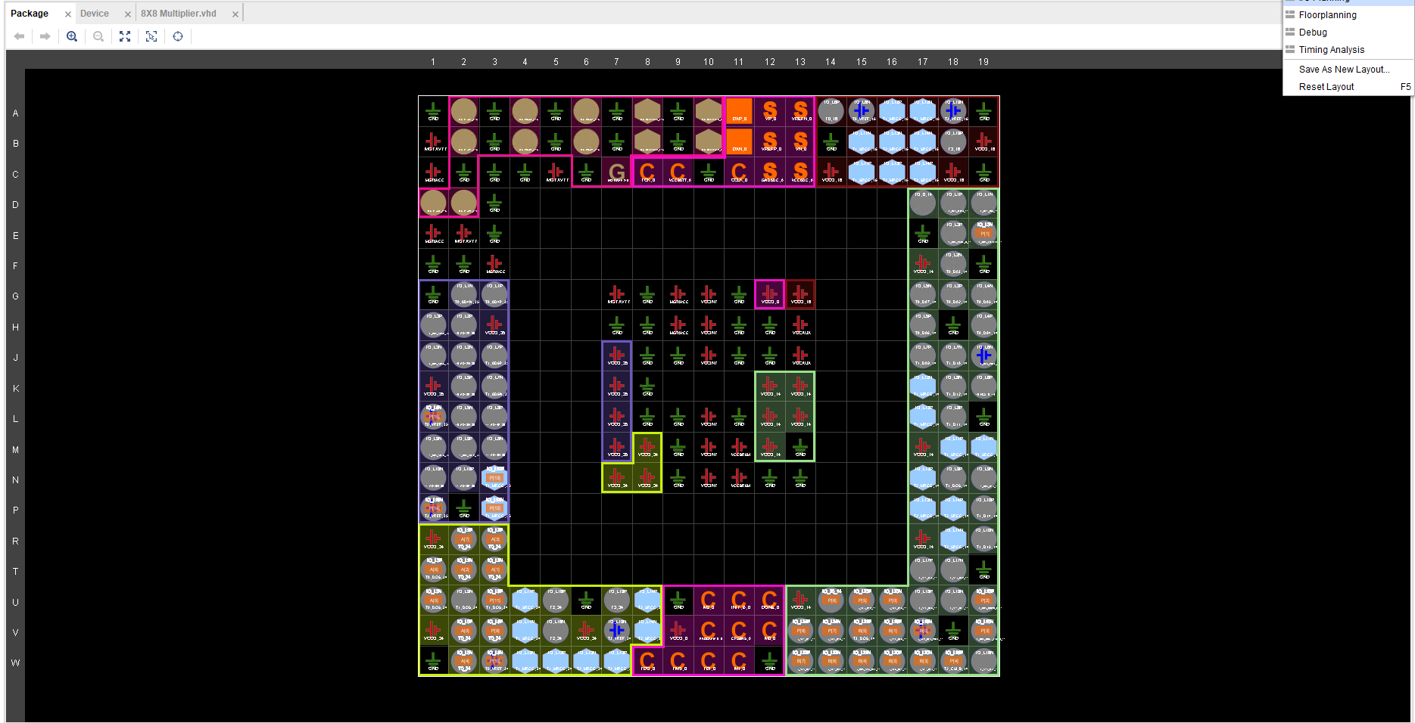

Brauns Design Timing summary
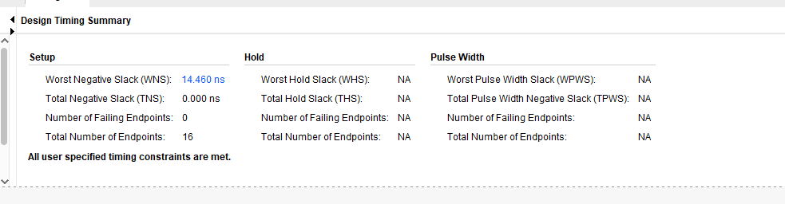
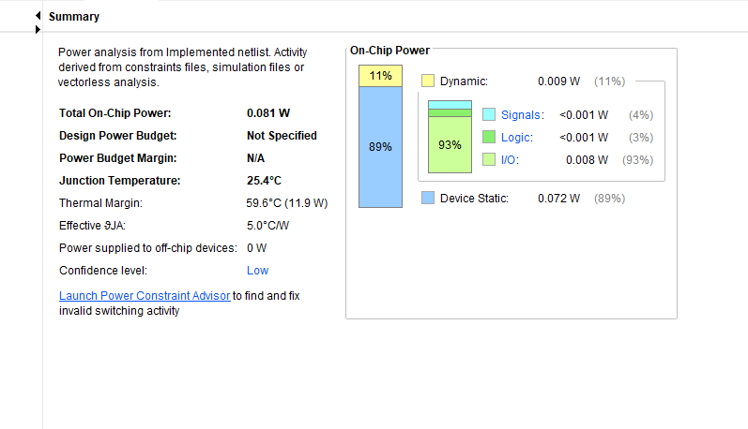

Combinational Delays Brauns
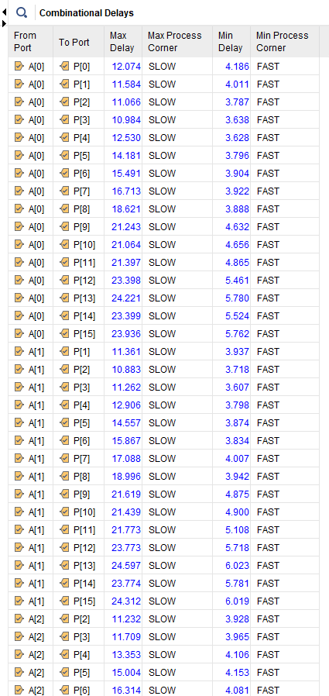

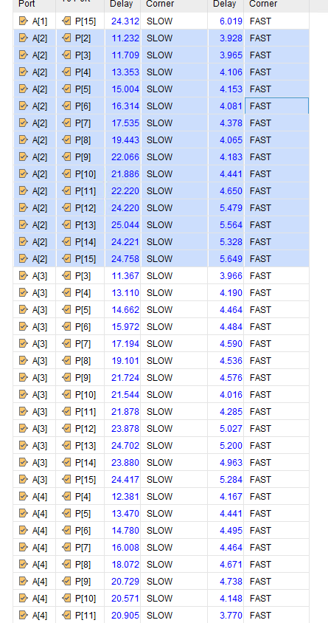

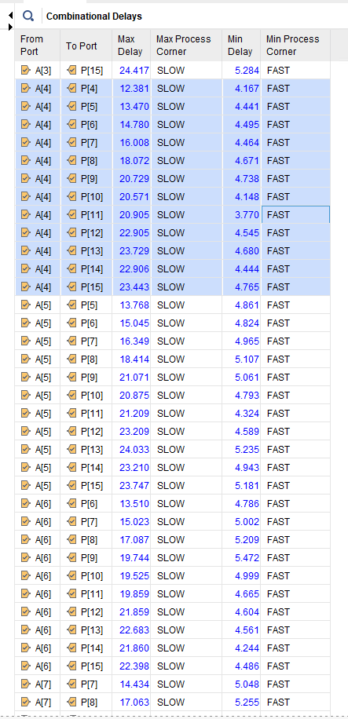

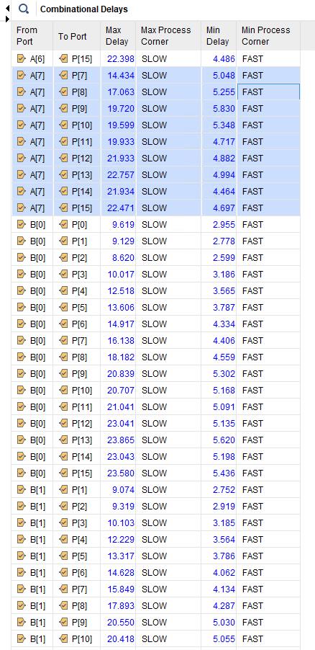
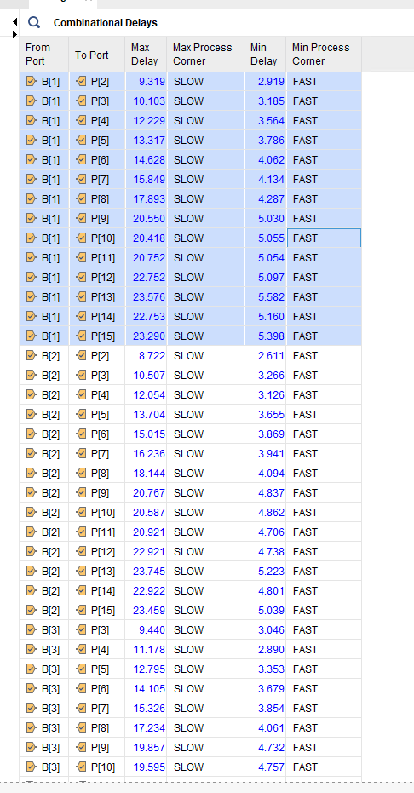
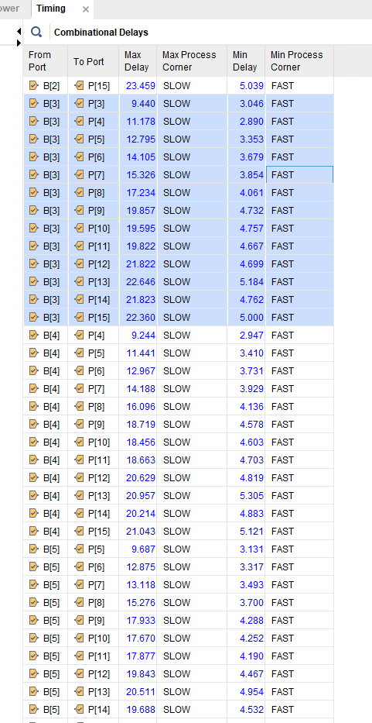
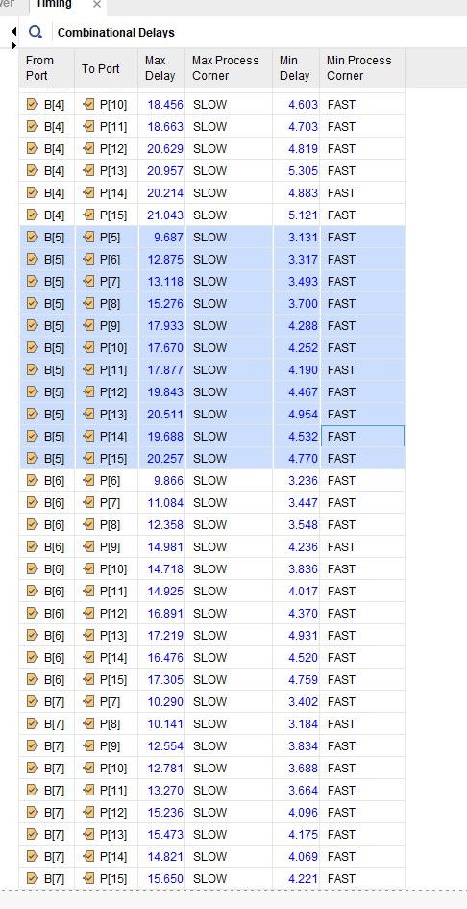
Brauns Project Summary

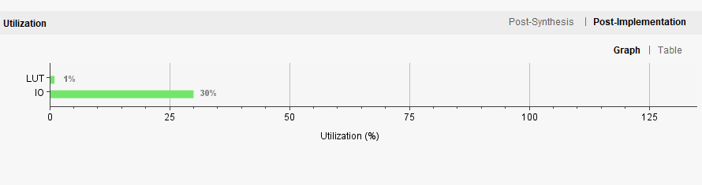

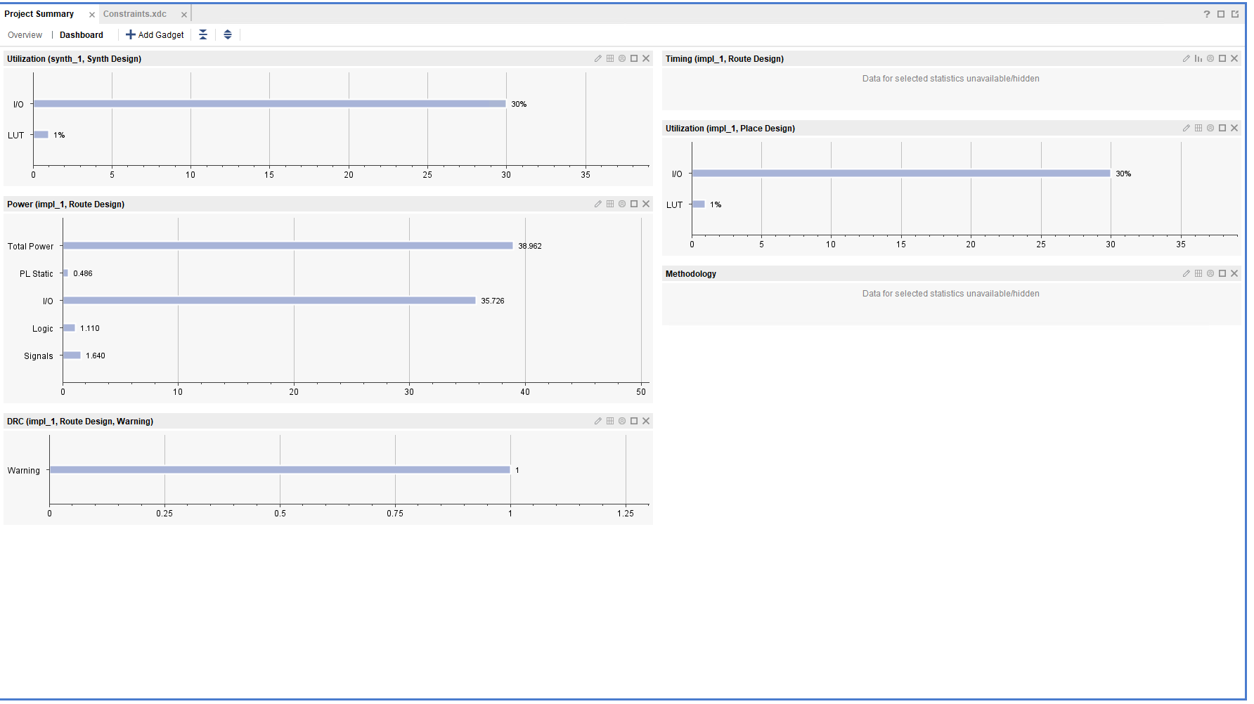

Brauns Basys 3 Screenshot – 80x7f

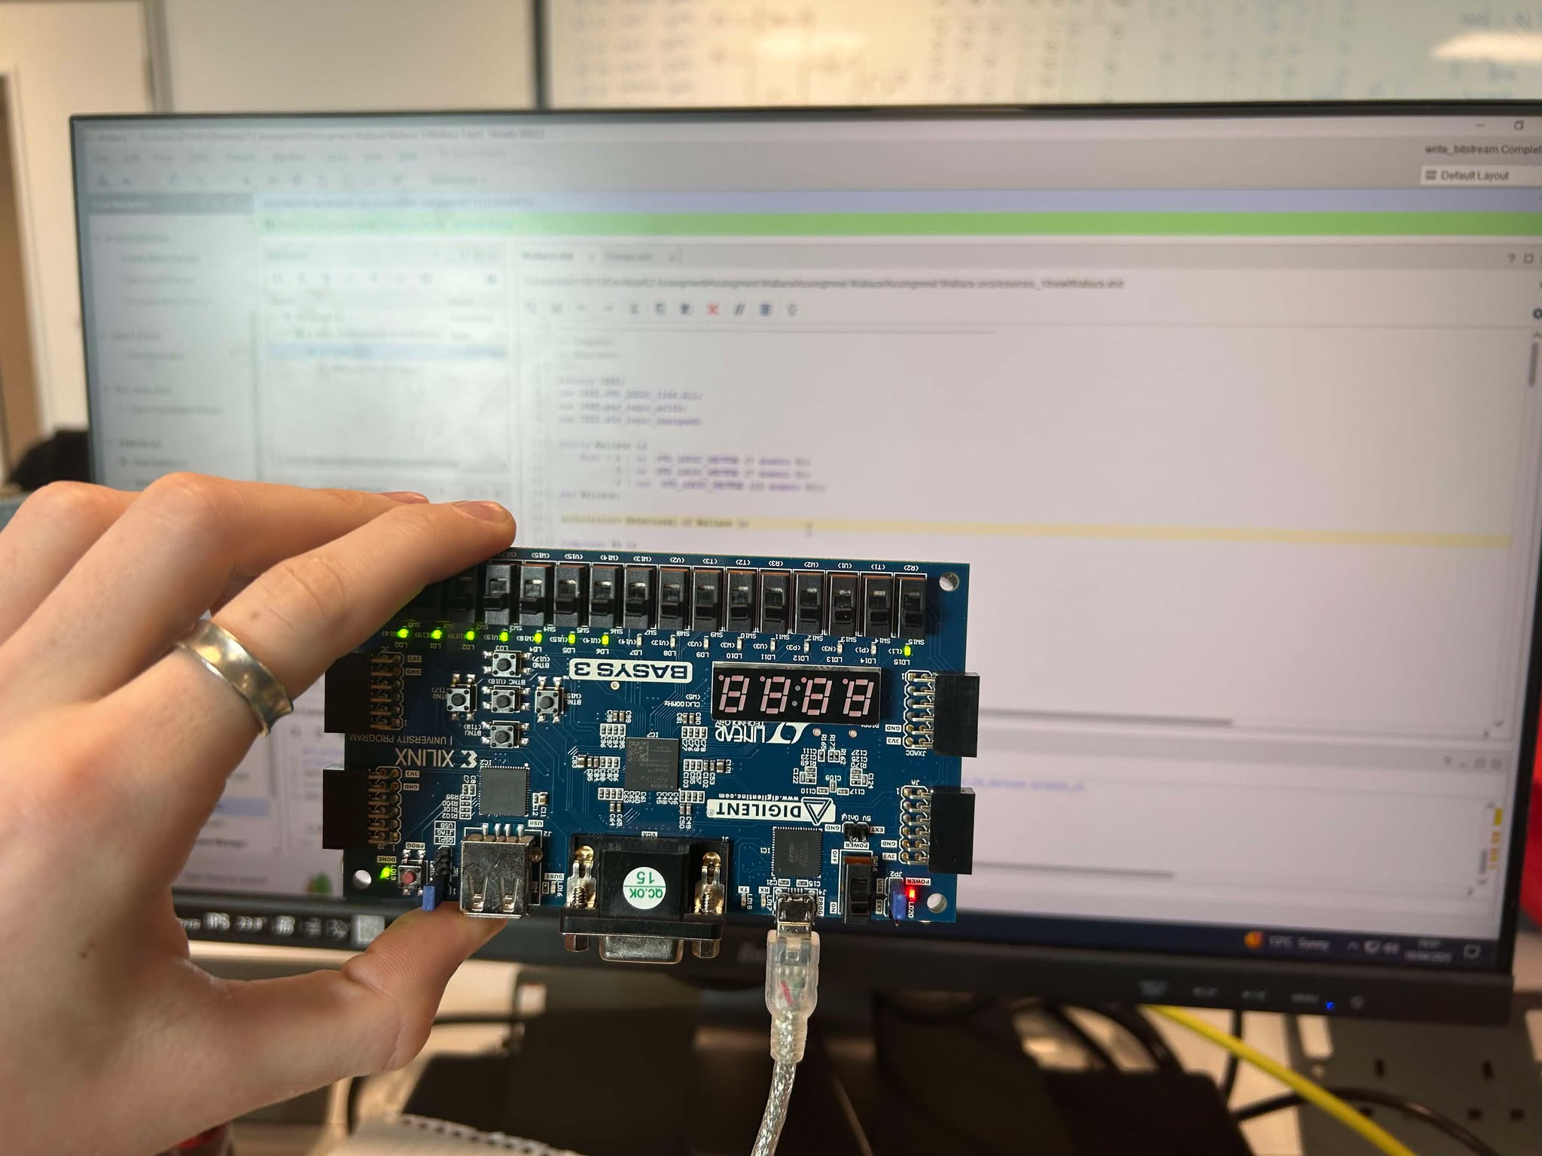

Wallace Tree Screenshots
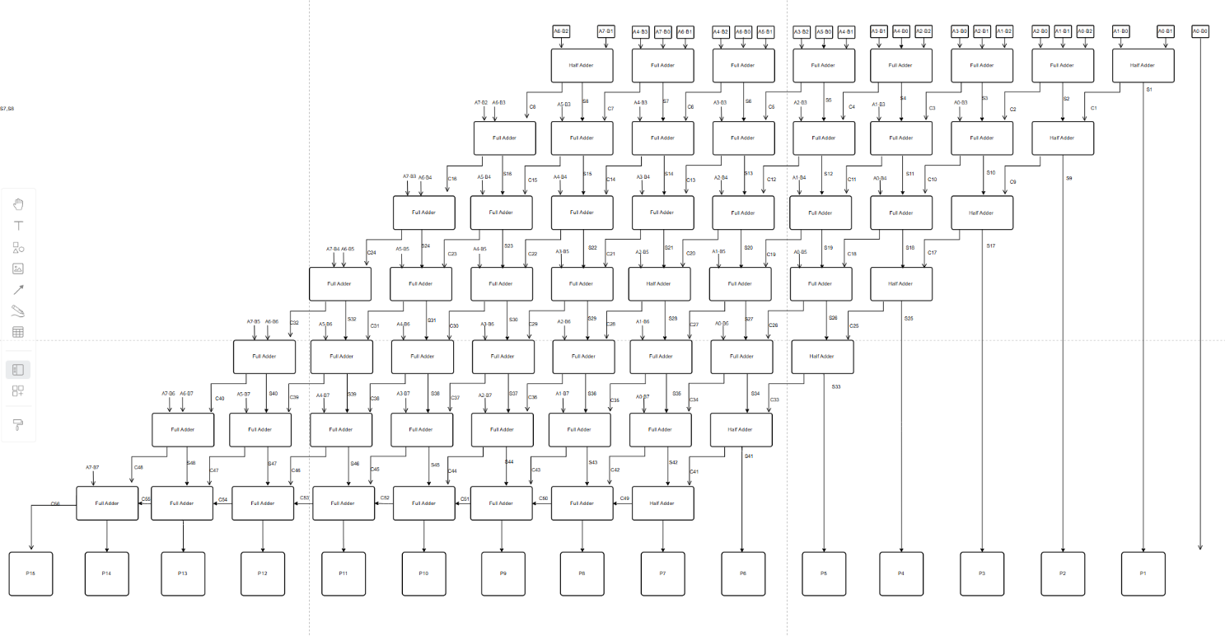

Wallace Sample 1 Inputs: A= 77 B=66
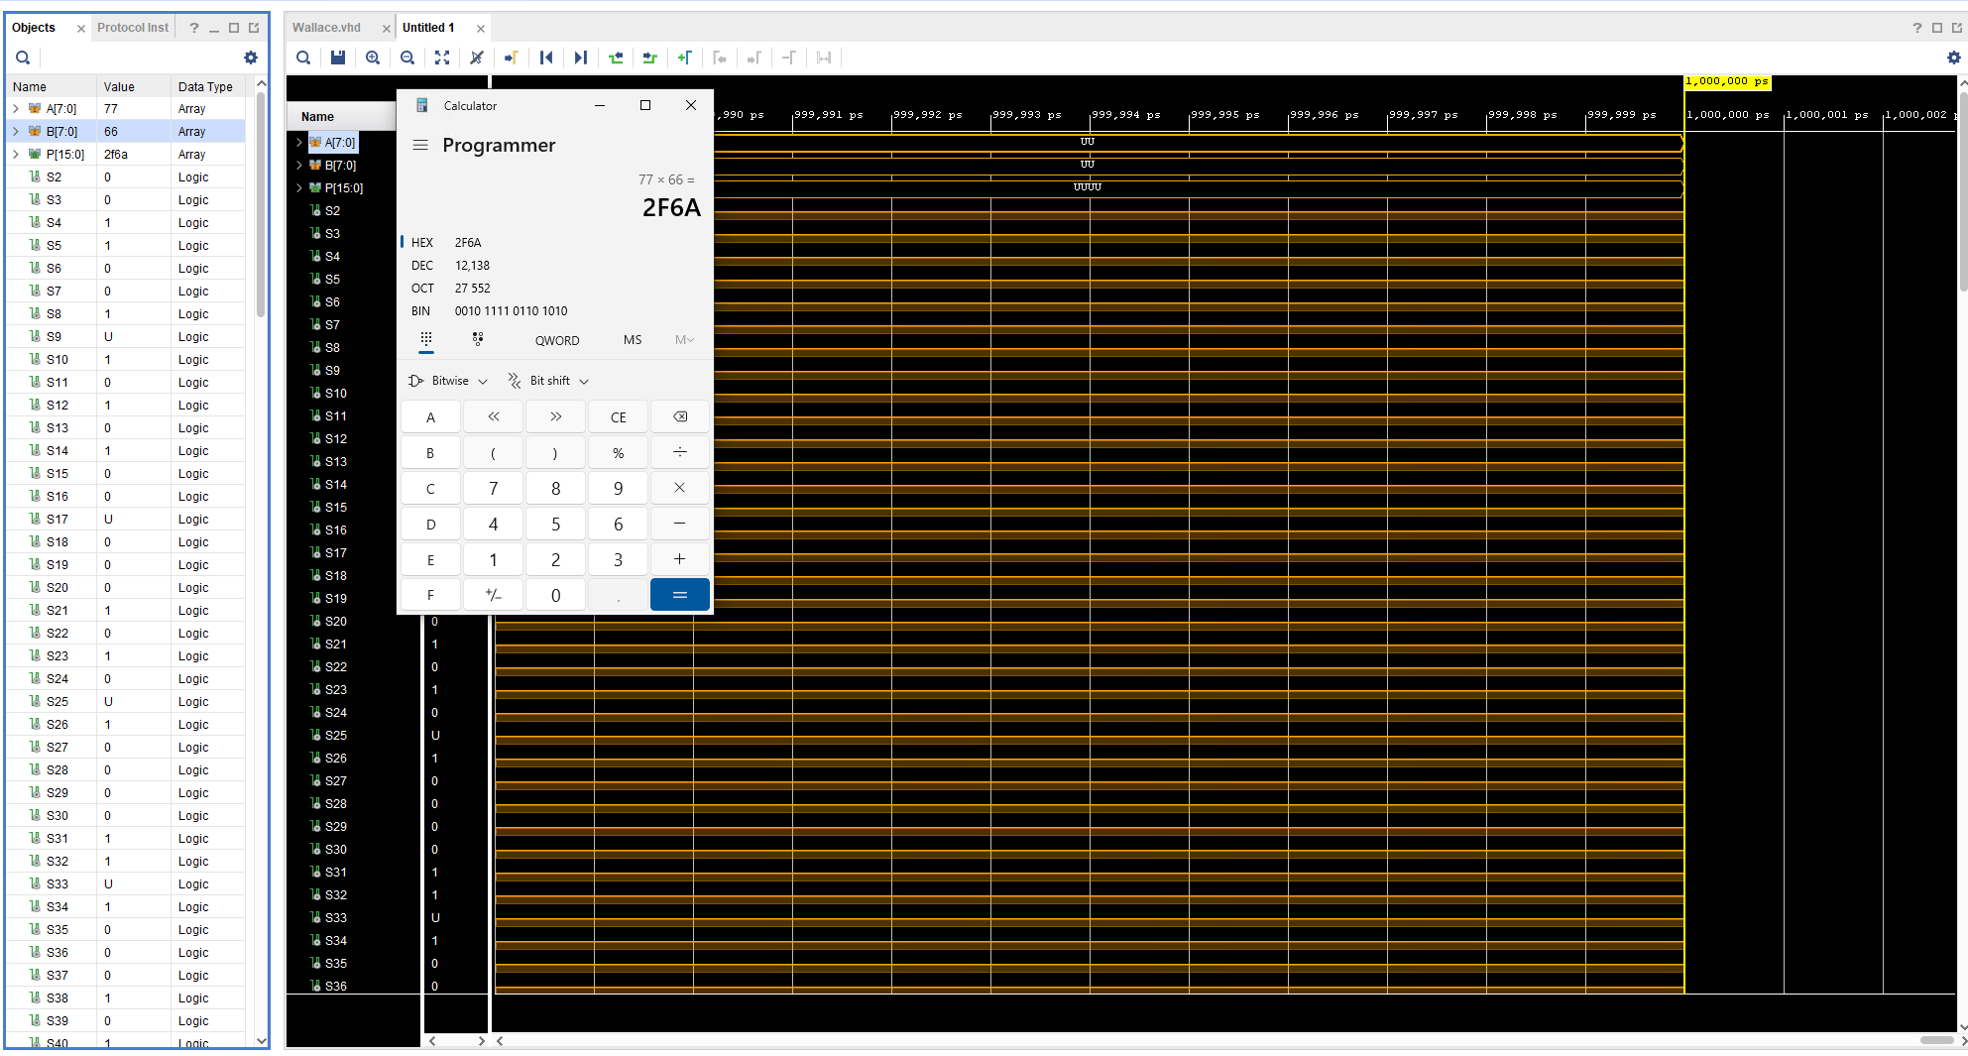

Wallace Sample 2 Inputs: A= d4 B=4d
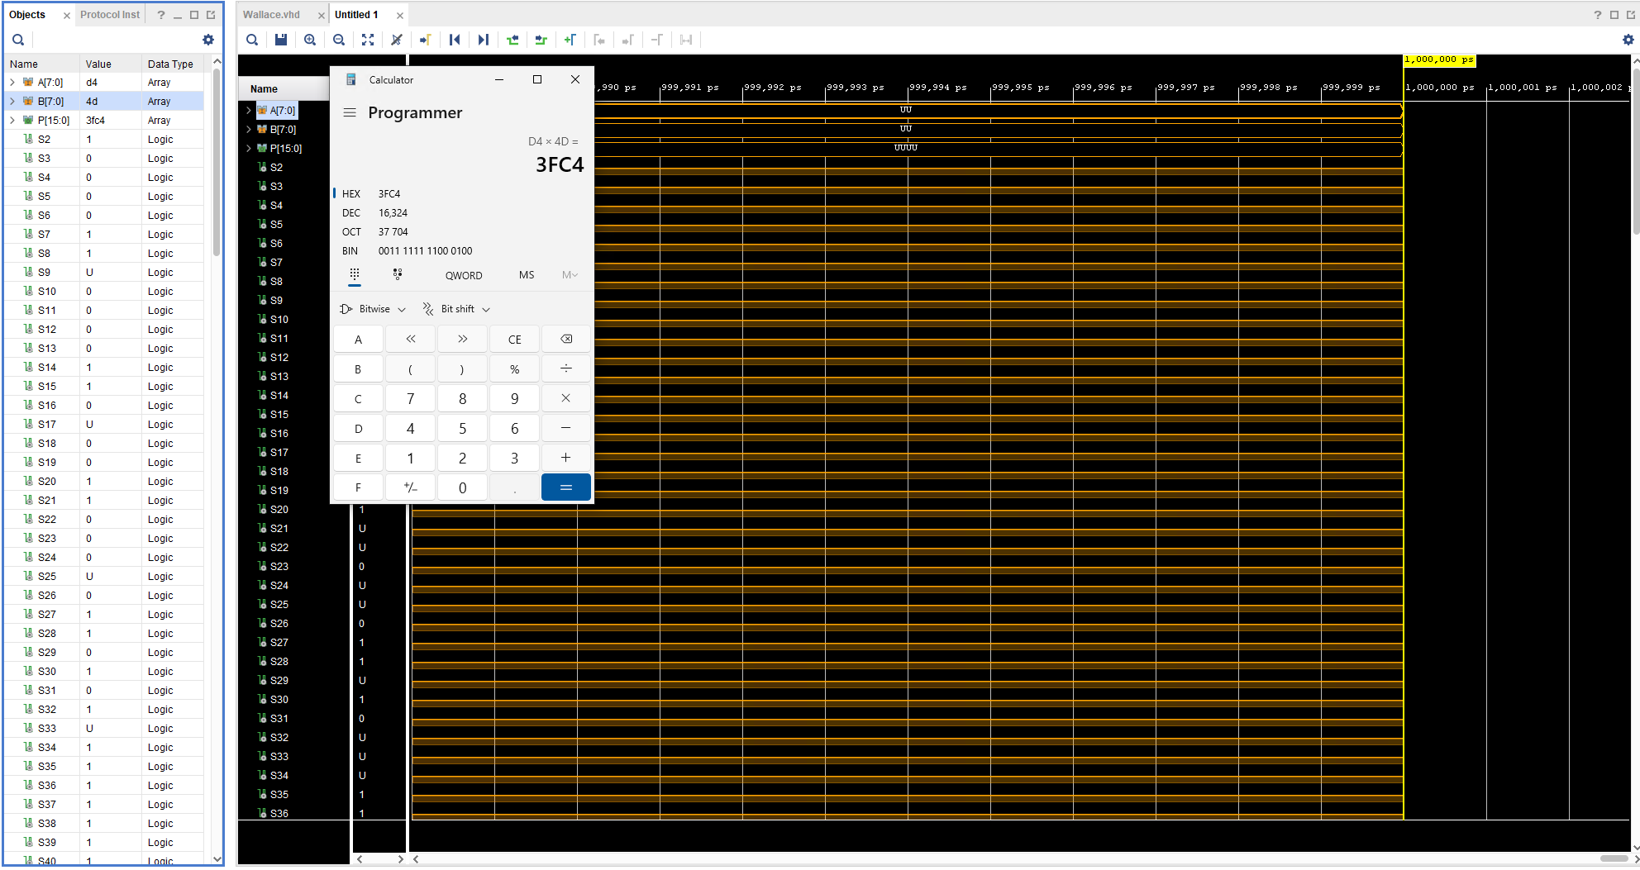

Wallace Sample 2 Inputs: A= 77 B=cc
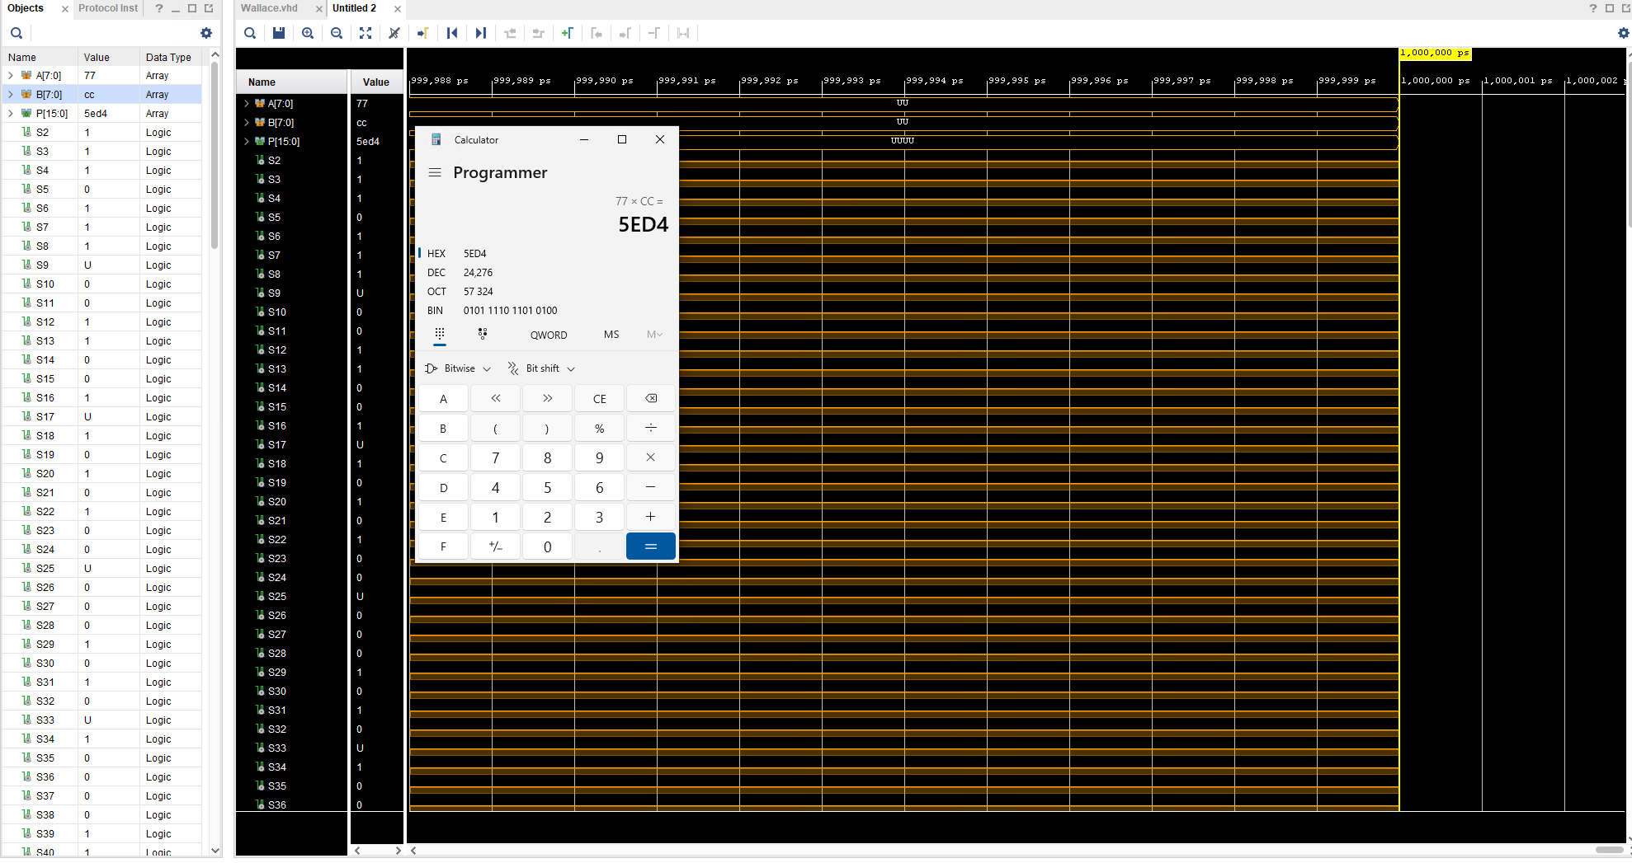

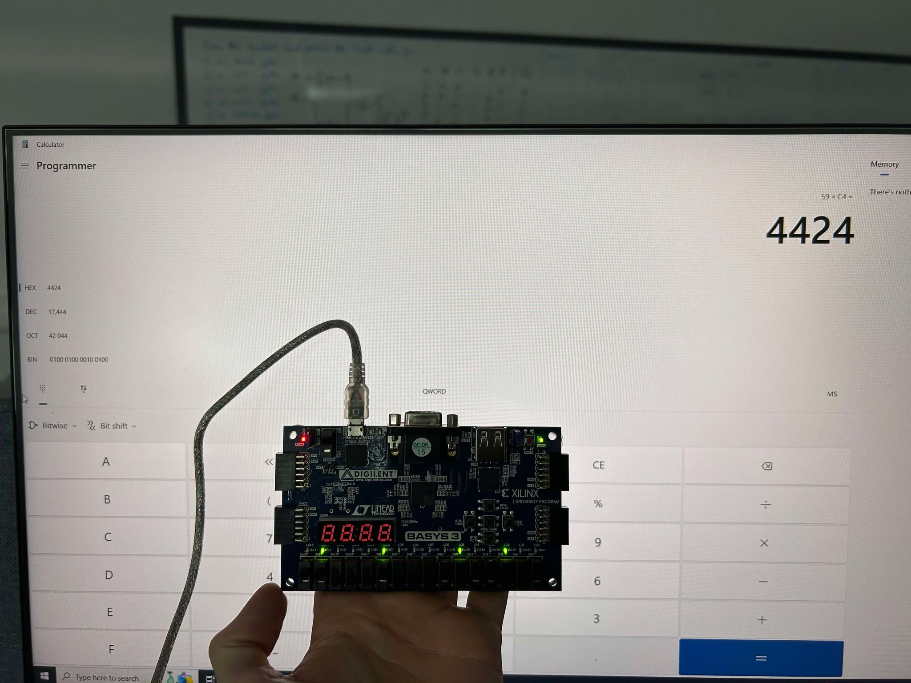
Wallace Basys Screenshot – 59xC4
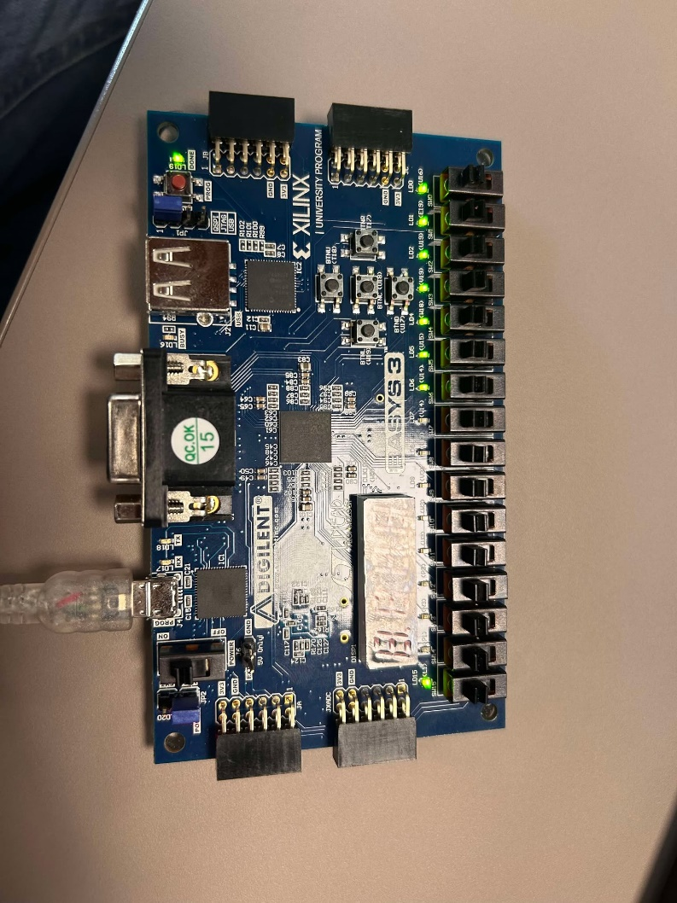
Wallace basys Screenshot – 80x7f

Wallace Sample 2 Inputs: A= ff B=ff

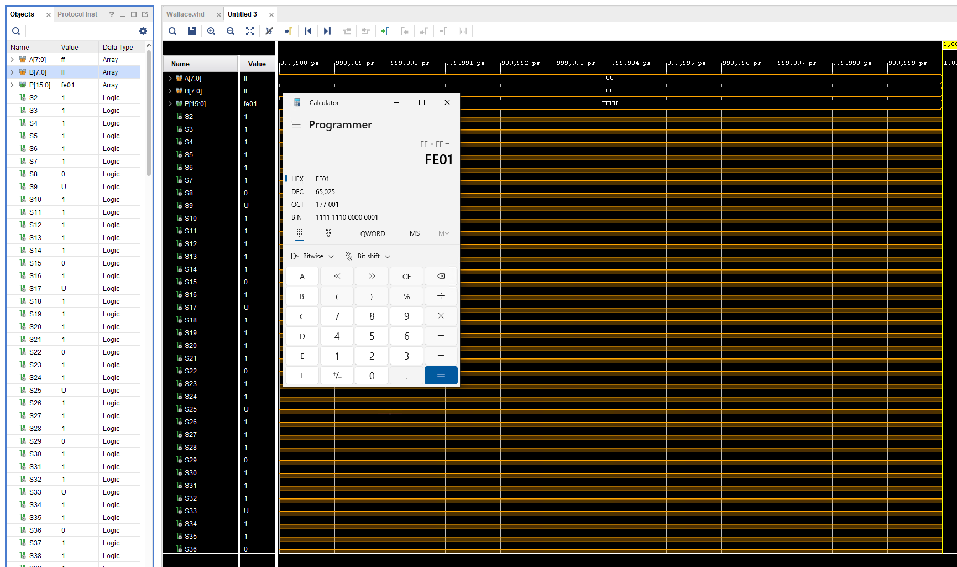

Wallace Device Screenshot
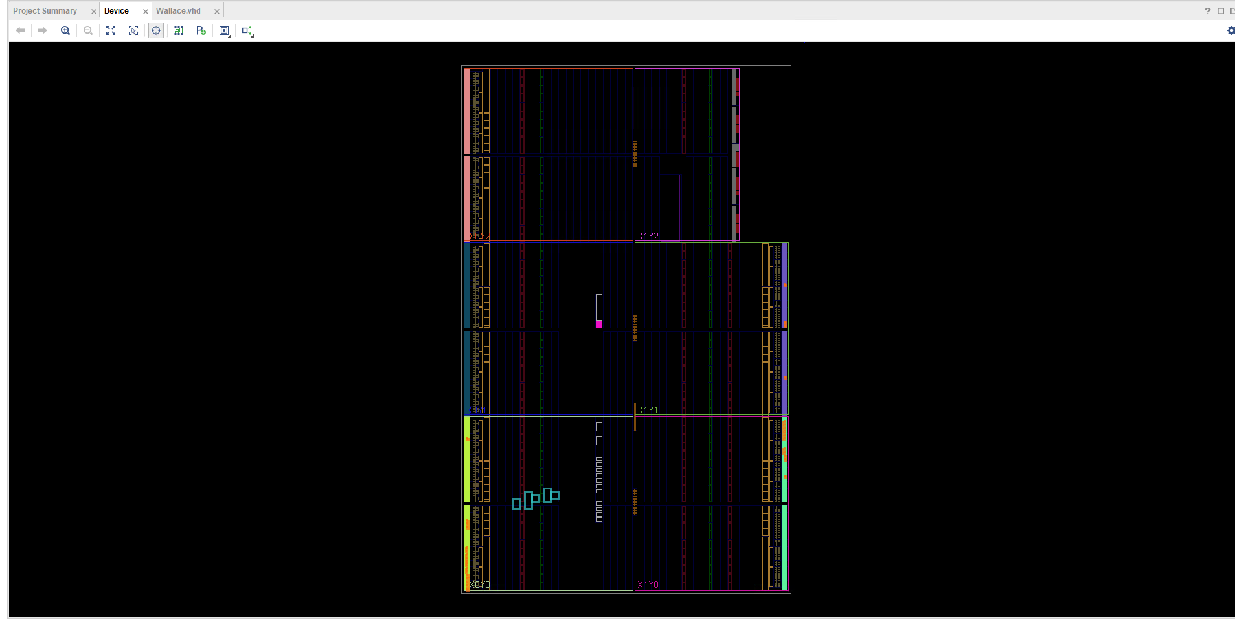

Wallace Schematic
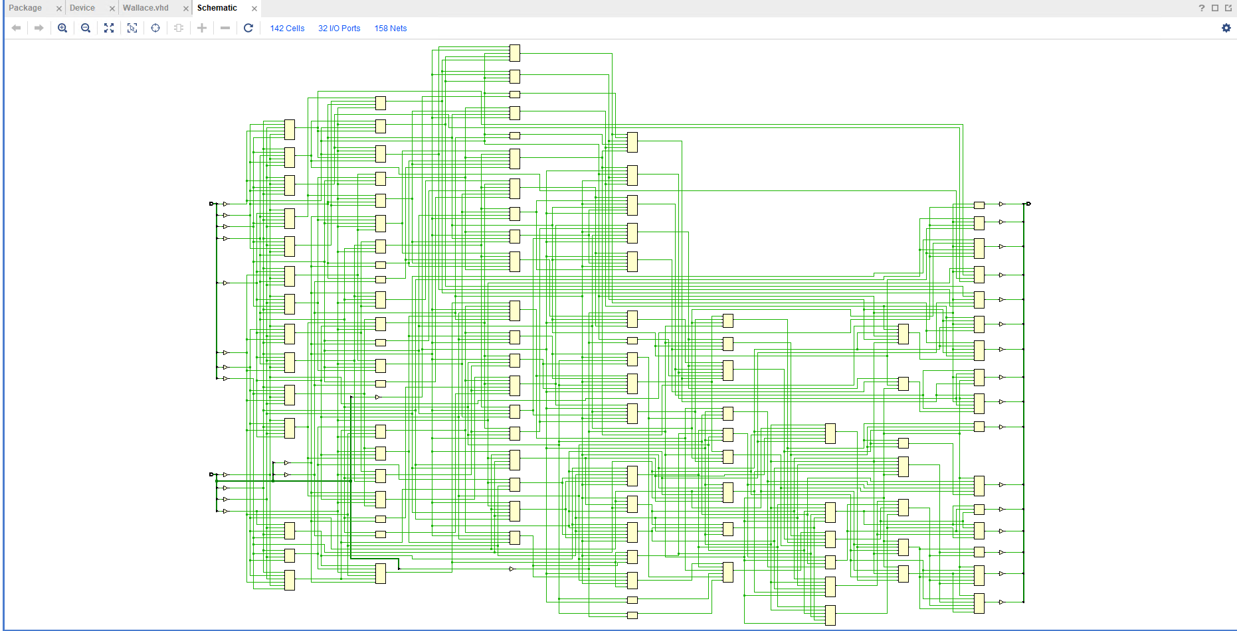

Wallace RTL Design
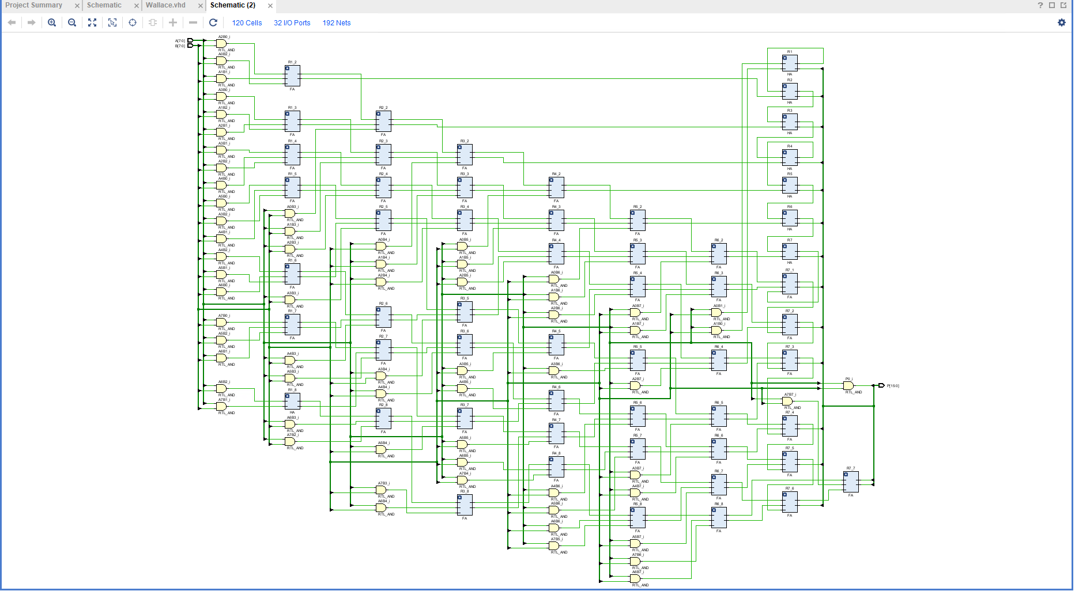

Wallace I/O Planning

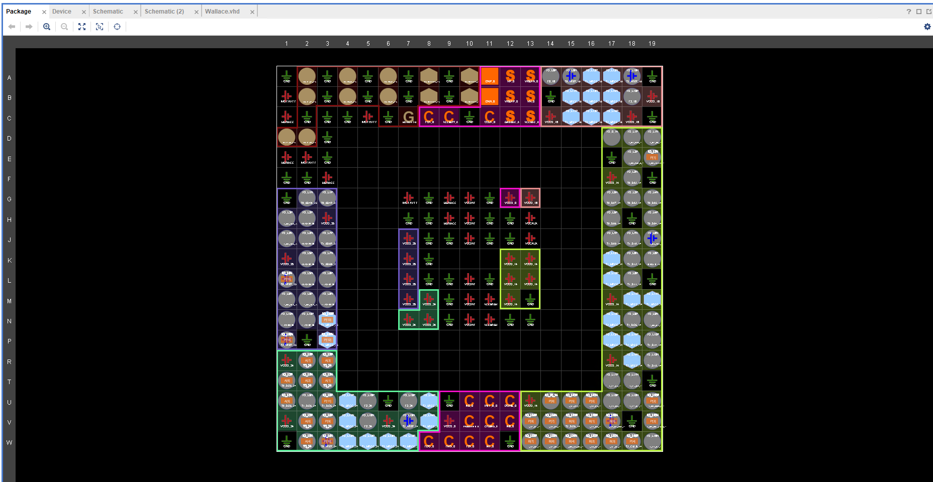

Wallace Design Timing Summary
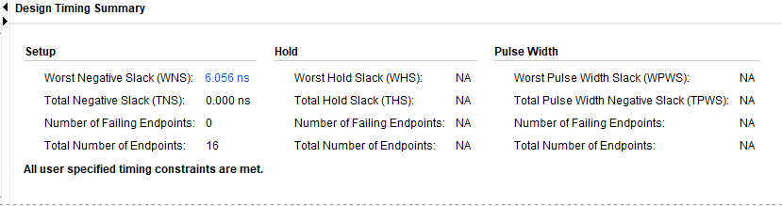

Report Utilization
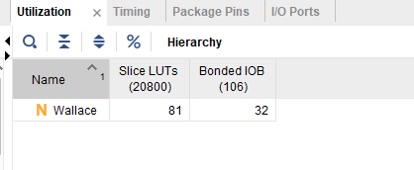

Wallace Project Summary
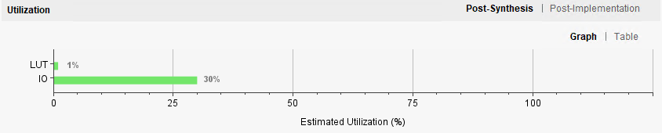
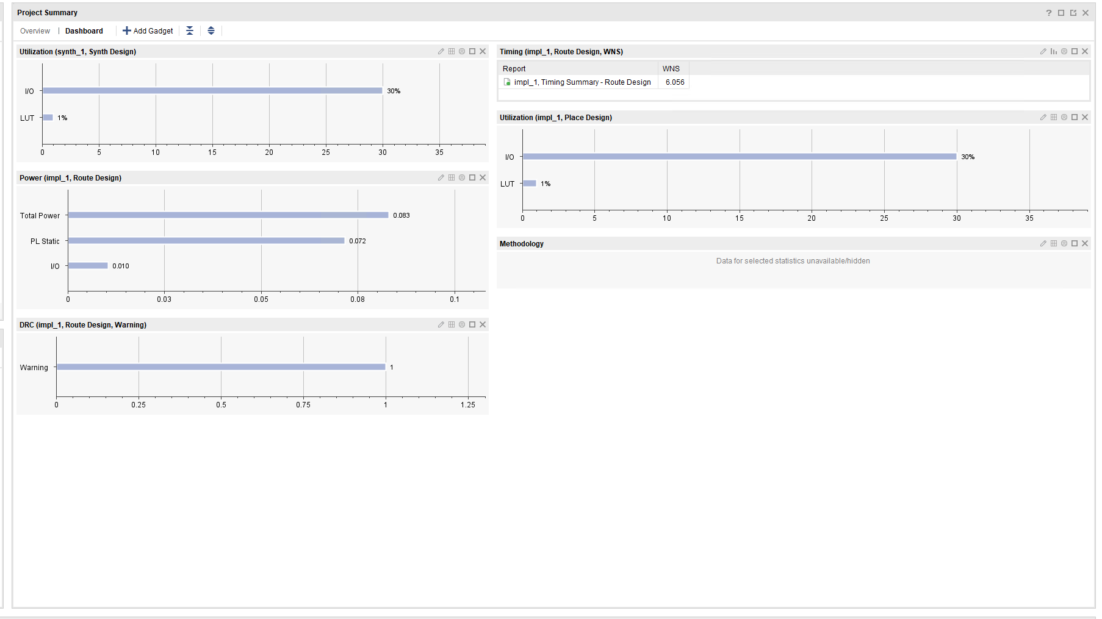

Wallace Combinational Delays
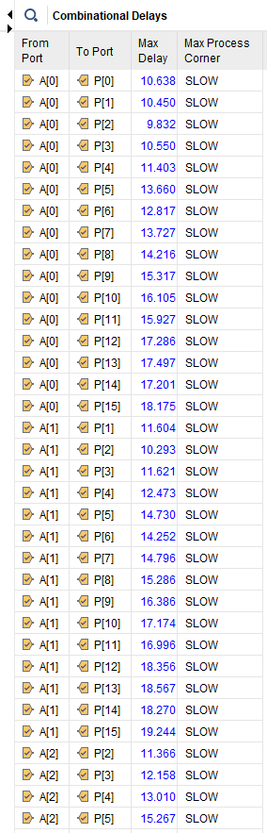

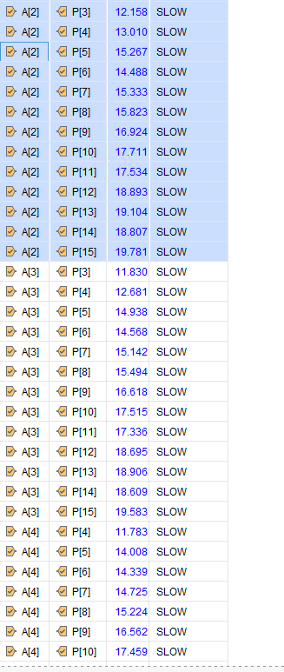

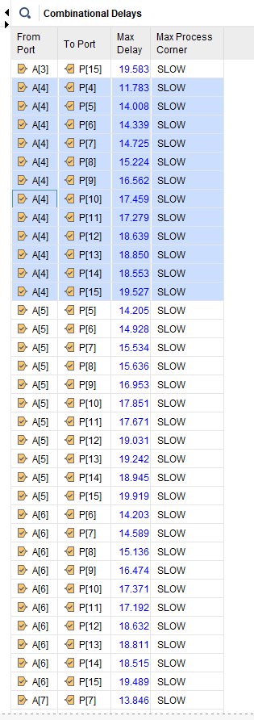
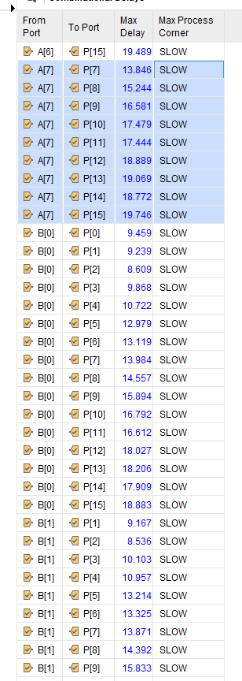

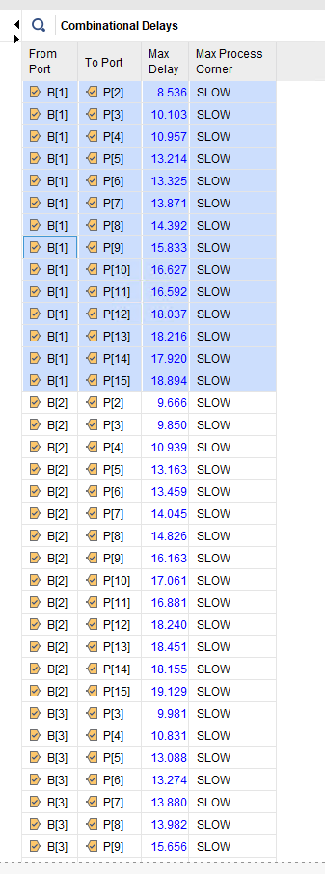

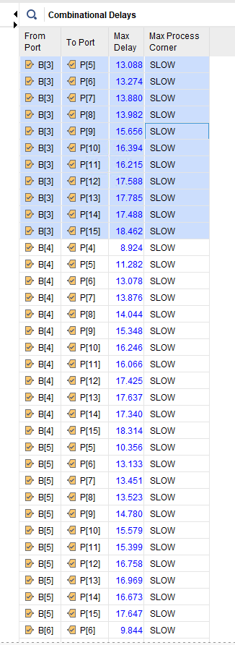

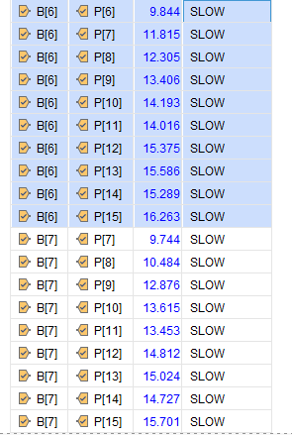

Wallace Power Report

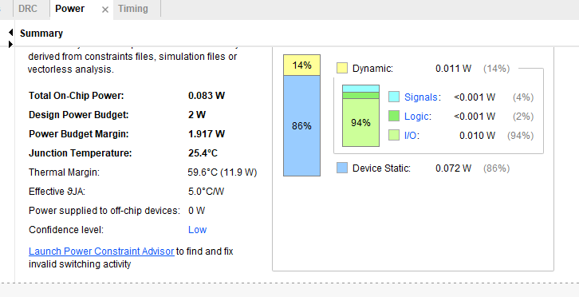

Critical Evaluation on the performance of each multiplier
Overall, it is concluded that the Wallace tree multiplier is faster and calculations than the Brauns as seen in the design timing summary screenshots. When compared, both figures show that the Wallace has a WNS of 6.05ns and the Brauns has 14ns. Meaning the Wallace is more than double the speed.
The longest delay for both multipliers was calculated by the student with the following formula - 1ns +20*(2ns). The first 1ns is the delay of the first and gate as seen in the tree multiplier diagrams. The 20 is the number of gates crossed on the longest path. The final 2ns is the standard delay for an adder. The diagram below shows the longest delay path. The red line indicates the adders that the longest delay crosses.
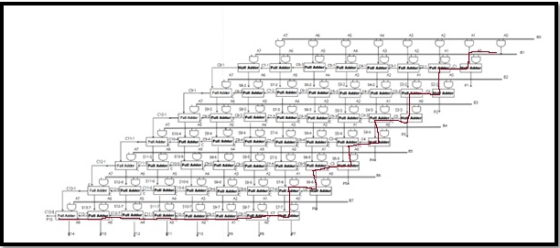
The Wallace tree excels in designs that are based on performance with high-speed processing units. Wallace tree is used for DSP which is the use of digital computers that take signals such as video and audio and the manipulate them mathematically. DSP uses add, subtract, divide and multiply to operate.
The Brauns multiplier is larger than the Wallace tree, as the adders are connected in series which means that there are more steps for the adder inputs/outputs to go through. This is due to the Brauns having a linear path which will always be slower than the Wallace’s logarithmic path. This has a direct effect on the power usage. As stated before, the Brauns consumes more power than the Wallace, due to its linear path. It is also important to note that the Brauns design has a much larger meaning that the Brauns will naturally host some disadvantages. This will limit how well the multiplier can fit into certain designs, It will usually increase the power consumption of the design as the more gates there are means the more switching that is required. Along with this, the large designs are also susceptible for power leakages which adds to its main disadvantage of being uneconomically friendly.

While the Wallace is faster and more economical, it contains a more complex design and debug is more complex, this can create issues when scaling to high bit widths.
The power consumption results for the report don’t match the general hypothesis of the Wallace being more economical than the Brauns. Bothof the students designs have a total power usage of 0.8w. While this is a good level of power consumption, it was discovered through background research that the Wallace is meant to consume less power than the Brauns, meaning that the results from my designs aren’t entirely accurate to the hypothesis.

Future Improvements
As with anything, there is always room for improvement. Through analysis of the Brauns and Wallace tree results shown throughout the report and with the assistance of background research into other architecture types, a range of improvements came to light. The combination of Wallace and booth encoding would work well together as they would reduce the number of partial products at the beginning. The Wallace design could see some major improvements through the addition of pipelining. This would have further increased its overall speed.
The design of approximate multipliers would also assist in seeing better performance/ results, but only when used in areas such as development of AI.

Conclusion
The design, implementation, and performance comparison of the Wallace and Braun Tree multipliers utilising Vivado has been successfully demonstrated in this report. Each architecture's advantages and disadvantages were carefully assessed using background research, simulation, synthesis, and timing analysis. While the Braun multiplier provided a more regular structure and reduced complexity, making it well-suited for applications with limited power and space, the Wallace Tree multiplier showed higher speed performance because of its logarithmic reduction of partial products.
The report examined a variety of multiplier architectures and adder designs, including Booth Encoding, Hybrid Multipliers, Approximate Multipliers, Carry Look-Ahead Adders, and Carry Save Adders, in addition to practical design work. These bits of information increased the students understanding of how various different types of multipliers architectures are designed, alongside their advantages and disadvantages.
All things considered, the project demonstrated how crucial it is to base architectural decisions on application-specific specifications. The Braun multiplier still works well in simpler, embedded designs, while the Wallace Tree is best suited for high-speed systems. Additionally, the paper set the groundwork for future advancements through power-aware optimisations, hybrid designs, and pipelining.

Code Appendices Brauns
----------------------------------------------------------------------------------
-- Company:
-- Engineer:
--
-- Create Date: 03.03.2025 15:04:43
-- Design Name:
-- Module Name: 8X8 Multiplier - gate_level
-- Project Name:
-- Target Devices:
-- Tool Versions:
-- Description:
--
-- Dependencies:
--
-- Revision:
-- Revision 0.01 - File Created
-- Additional Comments:
--
----------------------------------------------------------------------------------

library IEEE;
use IEEE.STD_LOGIC_1164.ALL;
use IEEE.std_logic_arith.ALL;
use IEEE.std_logic_unsigned.ALL;

entity Brauns is
Port ( A : in std_logic_vector (7 downto 0);
B : in std_logic_vector (7 downto 0);
P: out std_logic_vector (15 downto 0));

end Brauns;

architecture gate_level of Brauns is
signal A1B0 : std_logic;
signal A0B1 : std_logic;
signal A2B0 : std_logic;
signal A1B1 : std_logic;
signal A0B2 : std_logic;
signal A3B0 : std_logic;
signal A2B1 : std_logic;
signal A1B2 : std_logic;
signal A0B3 : std_logic;
signal A4B0 : std_logic;
signal A3B1 : std_logic;
signal A2B2 : std_logic;
signal A1B3 : std_logic;
signal A0B4 : std_logic;
signal A5B0 : std_logic;
signal A4B1 : std_logic;
signal A3B2 : std_logic;
signal A2B3 : std_logic;
signal A1B4 : std_logic;
signal A0B5 : std_logic;
signal A6B0 : std_logic;
signal A5B1 : std_logic;
signal A4B2 : std_logic;
signal A3B3 : std_logic;
signal A2B4 : std_logic;
signal A1B5 : std_logic;
signal A0B6 : std_logic;
signal A7B0 : std_logic;
signal A6B1 : std_logic;
signal A5B2 : std_logic;
signal A4B3 : std_logic;
signal A3B4 : std_logic;
signal A2B5 : std_logic;
signal A1B6 : std_logic;
signal A0B7 : std_logic;
signal A7B1 : std_logic;
signal A6B2 : std_logic;
signal A5B3 : std_logic;
signal A4B4 : std_logic;
signal A3B5 : std_logic;
signal A2B6 : std_logic;
signal A1B7 : std_logic;
signal A7B2 : std_logic;
signal A6B3 : std_logic;
signal A5B4 : std_logic;
signal A4B5 : std_logic;
signal A3B6 : std_logic;
signal A2B7 : std_logic;
signal A7B3 : std_logic;
signal A6B4 : std_logic;
signal A5B5 : std_logic;
signal A4B6 : std_logic;
signal A3B7 : std_logic;
signal A7B4 : std_logic;
signal A6B5 : std_logic;
signal A5B6 : std_logic;
signal A4B7 : std_logic;
signal A7B5 : std_logic;
signal A6B6 : std_logic;
signal A5B7 : std_logic;
signal A7B6 : std_logic;
signal A6B7 : std_logic;
signal A7B7 : std_logic;

signal C1 : std_logic; --P2
signal S2_2 : std_logic;

signal C2_1 : std_logic; --P3
signal S3_2 : std_logic;
signal C2 : std_logic;
signal S3_3 : std_logic;

signal C3_1 : std_logic; --P4
signal S4_2 : std_logic;
signal C3_2 : std_logic;
signal S4_3 : std_logic;
signal C3 : std_logic;
signal S4_4 : std_logic;

signal C4_1 : std_logic; --P5
signal S5_2 : std_logic;
signal C4_2 : std_logic;
signal S5_3 : std_logic;
signal C4_3 : std_logic;
signal S5_4 : std_logic;
signal C4 : std_logic;
signal S5_5 : std_logic;

signal C5_1 : std_logic; --P6
signal S6_2 : std_logic;
signal C5_2 : std_logic;
signal S6_3 : std_logic;
signal C5_3 : std_logic;
signal S6_4 : std_logic;
signal C5_4 : std_logic;
signal S6_5 : std_logic;
signal C5 : std_logic;
signal S6_6 : std_logic;

signal C6_1 : std_logic; --P7
signal S7_2 : std_logic;
signal C6_2 : std_logic;
signal S7_3 : std_logic;
signal C6_3 : std_logic;
signal S7_4 : std_logic;
signal C6_4 : std_logic;
signal S7_5 : std_logic;
signal C6_5 : std_logic;
signal S7_6 : std_logic;
signal C6 : std_logic;
signal S7_7 : std_logic;

signal C7_1 : std_logic; --P8
signal S8_2 : std_logic;
signal C7_2 : std_logic;
signal S8_3 : std_logic;
signal C7_3 : std_logic;
signal S8_4 : std_logic;
signal C7_4 : std_logic;
signal S8_5 : std_logic;
signal C7_5 : std_logic;
signal S8_6 : std_logic;
signal C7_6 : std_logic;
signal S8_7 : std_logic;
signal C7 : std_logic;

signal C8_1 : std_logic; -- P9
signal C8_2 : std_logic;
signal S9_3 : std_logic;
signal C8_3 : std_logic;
signal S9_4 : std_logic;
signal C8_4 : std_logic;
signal S9_5 : std_logic;
signal C8_5 : std_logic;
signal S9_6 : std_logic;
signal C8_6 : std_logic;
signal S9_7 : std_logic;
signal C8_7 : std_logic;

signal C9_1 : std_logic; --P10
signal C9_3 : std_logic;
signal S10_4 : std_logic;
signal C9_4 : std_logic;
signal S10_5 : std_logic;
signal C9_5 : std_logic;
signal S10_6 : std_logic;
signal C9_6 : std_logic;
signal S10_7 : std_logic;
signal C9_7 : std_logic;

signal C10_1 : std_logic; --P11
signal C10_4 : std_logic;
signal S11_5 : std_logic;
signal C10_5 : std_logic;
signal S11_6 : std_logic;
signal C10_6 : std_logic;
signal S11_7 : std_logic;
signal C10_7 : std_logic;

signal C11_1 : std_logic; --P12
signal C11_5 : std_logic;
signal S12_6 : std_logic;
signal C11_6 : std_logic;
signal S12_7 : std_logic;
signal C11_7 : std_logic;

signal C12_1 : std_logic; --P13
signal C12_6 : std_logic;
signal S13_7 : std_logic;
signal C12_7 : std_logic;

signal C13_1 : std_logic; --P14
signal C13_7 : std_logic;

signal C13_8 : std_logic; --P15

component FA
port (A : in std_logic;
B : in std_logic;
Cin : in std_logic;
S : out std_logic;
Cout : out std_logic);
end component;

component HA
port (A : in std_logic;
B : in std_logic;
S : out std_logic;
Cout : out std_logic);
end component;

begin
A1B0 <= A(1) and B(0);
A0B1 <= A(0) and B(1);
A2B0 <= A(2) and B(0);
A1B1 <= A(1) and B(1);
A0B2 <= A(0) and B(2);
A3B0 <= A(3) and B(0);
A2B1 <= A(2) and B(1);
A1B2 <= A(1) and B(2);
A0B3 <= A(0) and B(3);
A4B0 <= A(4) and B(0);
A3B1 <= A(3) and B(1);
A2B2 <= A(2) and B(2);
A1B3 <= A(1) and B(3);
A0B4 <= A(0) and B(4);
A5B0 <= A(5) and B(0);
A4B1 <= A(4) and B(1);
A3B2 <= A(3) and B(2);
A2B3 <= A(2) and B(3);
A1B4 <= A(1) and B(4);
A0B5 <= A(0) and B(5);
A6B0 <= A(6) and B(0);
A5B1 <= A(5) and B(1);
A4B2 <= A(4) and B(2);
A3B3 <= A(3) and B(3);
A2B4 <= A(2) and B(4);
A1B5 <= A(1) and B(5);
A0B6 <= A(0) and B(6);
A7B0 <= A(7) and B(0);
A6B1 <= A(6) and B(1);
A5B2 <= A(5) and B(2);
A4B3 <= A(4) and B(3);
A3B4 <= A(3) and B(4);
A2B5 <= A(2) and B(5);
A1B6 <= A(1) and B(6);
A0B7 <= A(0) and B(7);
A7B1 <= A(7) and B(1);
A6B2 <= A(6) and B(2);
A5B3 <= A(5) and B(3);
A4B4 <= A(4) and B(4);
A3B5 <= A(3) and B(5);
A2B6 <= A(2) and B(6);
A1B7 <= A(1) and B(7);
A7B2 <= A(7) and B(2);
A6B3 <= A(6) and B(3);
A5B4 <= A(5) and B(4);
A4B5 <= A(4) and B(5);
A3B6 <= A(3) and B(6);
A2B7 <= A(2) and B(7);
A7B3 <= A(7) and B(3);
A6B4 <= A(6) and B(4);
A5B5 <= A(5) and B(5);
A4B6 <= A(4) and B(6);
A3B7 <= A(3) and B(7);
A7B4 <= A(7) and B(4);
A6B5 <= A(6) and B(5);
A5B6 <= A(5) and B(6);
A4B7 <= A(4) and B(7);
A7B5 <= A(7) and B(5);
A6B6 <= A(6) and B(6);
A5B7 <= A(5) and B(7);
A7B6 <= A(7) and B(6);
A6B7 <= A(6) and B(7);
A7B7 <= A(7) and B(7);

P0 : P(0) <= A(0) and B(0);

P1_0 : HA port map (A=>A1B0 , B=>A0B1 , S=> P(1) , Cout=>C1); --P1

P2_1 : FA port map (A=>A2B0 , B=>A1B1 , Cin=>C1 , S=> S2_2 , Cout=>C2_1); -- P2
P2 : HA port map (A=>A0B2 , B=>S2_2 , S=>P(2) , Cout=>C2);

P3_1 : FA port map (A=>A3B0 , B=>A2B1 , Cin=>C2_1 , S=> S3_2 , Cout=>C3_1); --P3
P3_2 : FA port map (A=>A1B2 , B=>S3_2 , Cin=>C2 , S=> S3_3 , Cout=>C3_2);
P3 : HA port map (A=>A0B3 , B=>S3_3 , S=>P(3) , Cout=>C3);

P4_1 : FA port map (A=>A4B0 , B=>A3B1 , Cin=>C3_1 , S=> S4_2 , Cout=>C4_1); --P4
P4_2 : FA port map (A=>A2B2 , B=>S4_2 , Cin=>C3_2 , S=> S4_3 , Cout=>C4_2);
P4_3 : FA port map (A=>A1B3 , B=>S4_3 , Cin=>C3 , S=> S4_4 , Cout=>C4_3);
P4 : HA port map (A=>A0B4 , B=>S4_4 , S=>P(4) , Cout=>C4);

P5_1 : FA port map (A=>A5B0 , B=>A4B1 , Cin=>C4_1 , S=> S5_2 , Cout=>C5_1); --P5
P5_2 : FA port map (A=>A3B2 , B=>S5_2 , Cin=>C4_2 , S=> S5_3 , Cout=>C5_2);
P5_3 : FA port map (A=>A2B3 , B=>S5_3 , Cin=>C4_3 , S=> S5_4 , Cout=>C5_3);
P5_4 : FA port map (A=>A1B4 , B=>S5_4 , Cin=>C4 , S=> S5_5 , Cout=>C5_4);
P5 : HA port map (A=>A0B5 , B=>S5_5 , S=>P(5) , Cout=>C5);

P6_1 : FA port map (A=>A6B0 , B=>A5B1 , Cin=>C5_1 , S=> S6_2 , Cout=>C6_1); --P6
P6_2 : FA port map (A=>A4B2 , B=>S6_2 , Cin=>C5_2 , S=> S6_3 , Cout=>C6_2);
P6_3 : FA port map (A=>A3B3 , B=>S6_3 , Cin=>C5_3 , S=> S6_4 , Cout=>C6_3);
P6_4 : FA port map (A=>A2B4 , B=>S6_4 , Cin=>C5_4 , S=> S6_5 , Cout=>C6_4);
P6_5 : FA port map (A=>A1B5 , B=>S6_5 , Cin=>C5 , S=> S6_6 , Cout=>C6_5);
P6 : HA port map (A=>A0B6 , B=>S6_6 , S=> P(6) , Cout=>C6);

P7_1 : FA port map (A=>A7B0 , B=>A6B1 , Cin=>C6_1 , S=> S7_2 , Cout=>C7_1); --P7
P7_2 : FA port map (A=>A5B2 , B=>S7_2 , Cin=>C6_2 , S=> S7_3 , Cout=>C7_2);
P7_3 : FA port map (A=>A4B3 , B=>S7_3 , Cin=>C6_3 , S=> S7_4 , Cout=>C7_3);
P7_4 : FA port map (A=>A3B4 , B=>S7_4 , Cin=>C6_4 , S=> S7_5 , Cout=>C7_4);
P7_5 : FA port map (A=>A2B5 , B=>S7_5 , Cin=>C6_5 , S=> S7_6 , Cout=>C7_5);
P7_6 : FA port map (A=>A1B6 , B=>S7_6 , Cin=>C6 , S=> S7_7 , Cout=>C7_6);
P7 : HA port map (A=>A0B7 , B=>S7_7 , S=> P(7) , Cout=>C7);

P8_1 : HA port map (A=>A7B1 , B=>C7_1 , S=> S8_2 , Cout=>C8_1); --P8
P8_2 : FA port map (A=>A6B2 , B=>S8_2 , Cin=>C7_2 , S=> S8_3 , Cout=>C8_2);
P8_3 : FA port map (A=>A5B3 , B=>S8_3 , Cin=>C7_3 , S=> S8_4 , Cout=>C8_3);
P8_4 : FA port map (A=>A4B4 , B=>S8_4 , Cin=>C7_4 , S=> S8_5 , Cout=>C8_4);
P8_5 : FA port map (A=>A3B5 , B=>S8_5 , Cin=>C7_5 , S=> S8_6 , Cout=>C8_5);
P8_6 : FA port map (A=>A2B6 , B=>S8_6 , Cin=>C7_6 , S=> S8_7 , Cout=>C8_6);
P8 : FA port map (A=>A1B7 , B=>S8_7 , Cin=>C7 , S=> P(8) , Cout=>C8_7);

P9_1 : FA port map (A=>C8_1 , B=>A7B2 , Cin=>C8_2 , S=> S9_3 , Cout=>C9_1); --P9
P9_2 : FA port map (A=>A6B3 , B=>S9_3 , Cin=>C8_3 , S=> S9_4 , Cout=>C9_3);
P9_3 : FA port map (A=>A5B4 , B=>S9_4 , Cin=>C8_4 , S=> S9_5 , Cout=>C9_4);
P9_4 : FA port map (A=>A4B5 , B=>S9_5 , Cin=>C8_5 , S=> S9_6 , Cout=>C9_5);
P9_5 : FA port map (A=>A3B6 , B=>S9_6 , Cin=>C8_6 , S=> S9_7 , Cout=>C9_6);
P9 : FA port map (A=>A2B7 , B=>S9_7 , Cin=>C8_7 , S=> P(9) , Cout=>C9_7);

P10_1 : FA port map (A=>C9_1 , B=>A7B3 , Cin=>C9_3 , S=> S10_4 , Cout=>C10_1); --P10
P10_2 : FA port map (A=>A6B4 , B=>S10_4 , Cin=>C9_4 , S=> S10_5 , Cout=>C10_4);
P10_3 : FA port map (A=>A5B5 , B=>S10_5 , Cin=>C9_5 , S=> S10_6 , Cout=>C10_5);
P10_4 : FA port map (A=>A4B6 , B=>S10_6 , Cin=>C9_6 , S=> S10_7 , Cout=>C10_6);
P1 : FA port map (A=>A3B7 , B=>S10_7 , Cin=>C9_7 , S=> P(10) , Cout=>C10_7);

P11_1 : FA port map (A=>C10_1 , B=>A7B4 , Cin=>C10_4 , S=> S11_5 , Cout=>C11_1); --P11
P11_2 : FA port map (A=>A6B5 , B=>S11_5 , Cin=>C10_5 , S=> S11_6 , Cout=>C11_5);
P11_3 : FA port map (A=>A5B6 , B=>S11_6 , Cin=>C10_6 , S=> S11_7 , Cout=>C11_6);
P11 : FA port map (A=>A4B7 , B=>S11_7 , Cin=>C10_7 , S=> P(11) , Cout=>C11_7);

P12_1 : FA port map (A=>C11_1 , B=>A7B5 , Cin=>C11_5 , S=> S12_6 , Cout=>C12_1); --P12
P12_2 : FA port map (A=>S12_6 , B=>A6B6 , Cin=>C11_6 , S=> S12_7 , Cout=>C12_6);
P12 : FA port map (A=>S12_7 , B=>A5B7 , Cin=>C11_7 , S=> P(12) , Cout=>C12_7);

P13_1 : FA port map (A=>C12_1 , B=>A7B6 , Cin=>C12_6 , S=> S13_7 , Cout=>C13_1); --P12
P13 : FA port map (A=>S13_7 , B=>A6B7 , Cin=>C11_7 , S=> P(13) , Cout=>C13_7);

P14 : FA port map (A=>C13_1 , B=>A7B7 , Cin=>C13_7 , S=> P(14) , Cout=>C13_8); --P12

P15 : P(15) <= C13_8;

end gate_level;

Code Appendices Wallace
----------------------------------------------------------------------------------
-- Company:
-- Engineer:
--
library IEEE;
use IEEE.STD_LOGIC_1164.ALL;

entity Wallace is
Port ( A : in STD_LOGIC_VECTOR (7 downto 0);
B : in STD_LOGIC_VECTOR (7 downto 0);
P : out STD_LOGIC_VECTOR (15 downto 0));
end Wallace;

architecture Behavioral of Wallace is

component FA is
Port ( A : in STD_LOGIC;
B : in STD_LOGIC;
Cin : in STD_LOGIC;
S : out STD_LOGIC;
Cout : out STD_LOGIC);
end component;

component HA is
Port ( A : in STD_LOGIC;
B : in STD_LOGIC;
S : out STD_LOGIC;
Cout : out STD_LOGIC);
end component;

signal S2,S3,S4,S5,S6,S7,S8,S9,S10,S11,S12,S13,S14,S15,S16,S17,S18,S19,S20,S21,S22,S23,S24,S25,S26,S27,S28,S29,S30,S31,S32,S33,S34,S35,S36,S37,S38,S39,S40,S41,S42,S43,S44,S45,S46,S47,S48: std_logic;
signal C1,C2,C3,C4,C5,C6,C7,C8,C9,C10,C11,C12,C13,C14,C15,C16,C17,C18,C19,C20,C21,C22,C23,C24,C25,C26,C27,C28,C29,C30,C31,C32,C33,C34,C35,C36,C37,C38,C39,C40,C41,C42,C43,C44,C45,C46,C47,C48,C49,C50,C51,C52,C53,C54,C55,C56: std_logic;

signal A1B0 : std_logic;
signal A0B1 : std_logic;
signal A2B0 : std_logic;
signal A1B1 : std_logic;
signal A0B2 : std_logic;
signal A3B0 : std_logic;
signal A2B1 : std_logic;
signal A1B2 : std_logic;
signal A0B3 : std_logic;
signal A4B0 : std_logic;
signal A3B1 : std_logic;
signal A2B2 : std_logic;
signal A1B3 : std_logic;
signal A0B4 : std_logic;
signal A5B0 : std_logic;
signal A4B1 : std_logic;
signal A3B2 : std_logic;
signal A2B3 : std_logic;
signal A1B4 : std_logic;
signal A0B5 : std_logic;
signal A6B0 : std_logic;
signal A5B1 : std_logic;
signal A4B2 : std_logic;
signal A3B3 : std_logic;
signal A2B4 : std_logic;
signal A1B5 : std_logic;
signal A0B6 : std_logic;
signal A7B0 : std_logic;
signal A6B1 : std_logic;
signal A5B2 : std_logic;
signal A4B3 : std_logic;
signal A3B4 : std_logic;
signal A2B5 : std_logic;
signal A1B6 : std_logic;
signal A0B7 : std_logic;
signal A7B1 : std_logic;
signal A6B2 : std_logic;
signal A5B3 : std_logic;
signal A4B4 : std_logic;
signal A3B5 : std_logic;
signal A2B6 : std_logic;
signal A1B7 : std_logic;
signal A7B2 : std_logic;
signal A6B3 : std_logic;
signal A5B4 : std_logic;
signal A4B5 : std_logic;
signal A3B6 : std_logic;
signal A2B7 : std_logic;
signal A7B3 : std_logic;
signal A6B4 : std_logic;
signal A5B5 : std_logic;
signal A4B6 : std_logic;
signal A3B7 : std_logic;
signal A7B4 : std_logic;
signal A6B5 : std_logic;
signal A5B6 : std_logic;
signal A4B7 : std_logic;
signal A7B5 : std_logic;
signal A6B6 : std_logic;
signal A5B7 : std_logic;
signal A7B6 : std_logic;
signal A6B7 : std_logic;
signal A7B7 : std_logic;

begin
A1B0 <= A(1) and B(0);
A0B1 <= A(0) and B(1);
A2B0 <= A(2) and B(0);
A1B1 <= A(1) and B(1);
A0B2 <= A(0) and B(2);
A3B0 <= A(3) and B(0);
A2B1 <= A(2) and B(1);
A1B2 <= A(1) and B(2);
A0B3 <= A(0) and B(3);
A4B0 <= A(4) and B(0);
A3B1 <= A(3) and B(1);
A2B2 <= A(2) and B(2);
A1B3 <= A(1) and B(3);
A0B4 <= A(0) and B(4);
A5B0 <= A(5) and B(0);
A4B1 <= A(4) and B(1);
A3B2 <= A(3) and B(2);
A2B3 <= A(2) and B(3);
A1B4 <= A(1) and B(4);
A0B5 <= A(0) and B(5);
A6B0 <= A(6) and B(0);
A5B1 <= A(5) and B(1);
A4B2 <= A(4) and B(2);
A3B3 <= A(3) and B(3);
A2B4 <= A(2) and B(4);
A1B5 <= A(1) and B(5);
A0B6 <= A(0) and B(6);
A7B0 <= A(7) and B(0);
A6B1 <= A(6) and B(1);
A5B2 <= A(5) and B(2);
A4B3 <= A(4) and B(3);
A3B4 <= A(3) and B(4);
A2B5 <= A(2) and B(5);
A1B6 <= A(1) and B(6);
A0B7 <= A(0) and B(7);
A7B1 <= A(7) and B(1);
A6B2 <= A(6) and B(2);
A5B3 <= A(5) and B(3);
A4B4 <= A(4) and B(4);
A3B5 <= A(3) and B(5);
A2B6 <= A(2) and B(6);
A1B7 <= A(1) and B(7);
A7B2 <= A(7) and B(2);
A6B3 <= A(6) and B(3);
A5B4 <= A(5) and B(4);
A4B5 <= A(4) and B(5);
A3B6 <= A(3) and B(6);
A2B7 <= A(2) and B(7);
A7B3 <= A(7) and B(3);
A6B4 <= A(6) and B(4);
A5B5 <= A(5) and B(5);
A4B6 <= A(4) and B(6);
A3B7 <= A(3) and B(7);
A7B4 <= A(7) and B(4);
A6B5 <= A(6) and B(5);
A5B6 <= A(5) and B(6);
A4B7 <= A(4) and B(7);
A7B5 <= A(7) and B(5);
A6B6 <= A(6) and B(6);
A5B7 <= A(5) and B(7);
A7B6 <= A(7) and B(6);
A6B7 <= A(6) and B(7);
A7B7 <= A(7) and B(7);

P0 : P(0) <= A(0) and B(0) ;

R1 : HA port map(A=>A1B0,B=>A0B1,S=>P(1),Cout=>C1); -- row 1
R1_2 : FA port map(A=>A2B0,B=>A1B1,Cin=>A0B2,S=>S2,Cout=>C2);
R1_3 : FA port map(A=>A3B0,B=>A2B1,Cin=>A1B2,S=>S3,Cout=>C3);
R1_4 : FA port map(A=>A3B1,B=>A4B0,Cin=>A2B2,S=>S4,Cout=>C4);
R1_5 : FA port map(A=>A5B0,B=>A4B1,Cin=>A3B2,S=>S5,Cout=>C5);
R1_6 : FA port map(A=>A4B2,B=>A6B0,Cin=>A5B1,S=>S6,Cout=>C6);
R1_7 : FA port map(A=>A7B0,B=>A6B1,Cin=>A5B2,S=>S7,Cout=>C7);
R1_8 : HA port map(A=>A6B2,B=>A7B1,S=>S8,Cout=>C8);

R2 : HA port map(A=>C1,B=>S2,S=>P(2),Cout=>C9);
R2_2 : FA port map(A=>C2,B=>S3,Cin=>A0B3,S=>S10,Cout=>C10); --row 2
R2_3 : FA port map(A=>C3,B=>S4,Cin=>A1B3,S=>S11,Cout=>C11);
R2_4 : FA port map(A=>C4,B=>S5,Cin=>A2B3,S=>S12,Cout=>C12);
R2_5 : FA port map(A=>C5,B=>S6,Cin=>A3B3,S=>S13,Cout=>C13);
R2_6 : FA port map(A=>C6,B=>S7,Cin=>A4B3,S=>S14,Cout=>C14);
R2_7 : FA port map(A=>C7,B=>S8,Cin=>A5B3,S=>S15,Cout=>C15);
R2_8 : FA port map(A=>C8,B=>A6B3,Cin=>A7B2,S=>S16,Cout=>C16);

R3 : HA port map(A=>C9,B=>S10,S=>P(3),Cout=>C17);
R3_2 : FA port map(A=>C10,B=>S11,Cin=>A0B4,S=>S18,Cout=>C18); -- ROW 3
R3_3 : FA port map(A=>C11,B=>S12,Cin=>A1B4,S=>S19,Cout=>C19);
R3_4 : FA port map(A=>C12,B=>S13,Cin=>A2B4,S=>S20,Cout=>C20);
R3_5 : FA port map(A=>C13,B=>S14,Cin=>A3B4,S=>S21,Cout=>C21);
R3_6 : FA port map(A=>C14,B=>S15,Cin=>A4B4,S=>S22,Cout=>C22);
R3_7 : FA port map(A=>C15,B=>S16,Cin=>A5B4,S=>S23,Cout=>C23);
R3_8 : FA port map(A=>C16,B=>A6B4,Cin=>A7B3,S=>S24,Cout=>C24);

R4 : HA port map(A=>C17,B=>S18,S=>P(4),Cout=>C25); --row 4
R4_2 : FA port map(A=>C18,B=>S19,Cin=>A0B5,S=>S26,Cout=>C26);
R4_3 : FA port map(A=>C19,B=>S20,Cin=>A1B5,S=>S27,Cout=>C27);
R4_4 : FA port map(A=>C20,B=>S21,Cin=>A2B5,S=>S28,Cout=>C28);
R4_5 : FA port map(A=>C21,B=>S22,Cin=>A3B5,S=>S29,Cout=>C29);
R4_6 : FA port map(A=>C22,B=>S23,Cin=>A4B5,S=>S30,Cout=>C30);
R4_7 : FA port map(A=>C23,B=>S24,Cin=>A5B5,S=>S31,Cout=>C31);
R4_8 : FA port map(A=>C24,B=>A6B5,Cin=>A7B4,S=>S32,Cout=>C32);

R5 : HA port map(A=>C25,B=>S26,S=>P(5),Cout=>C33); --ROW 5
R5_2 : FA port map(A=>C26,B=>S27,Cin=>A0B6,S=>S34,Cout=>C34);
R5_3 : FA port map(A=>C27,B=>S28,Cin=>A1B6,S=>S35,Cout=>C35);
R5_4 : FA port map(A=>C28,B=>S29,Cin=>A2B6,S=>S36,Cout=>C36);
R5_5 : FA port map(A=>C29,B=>S30,Cin=>A3B6,S=>S37,Cout=>C37);
R5_6 : FA port map(A=>C30,B=>S31,Cin=>A4B6,S=>S38,Cout=>C38);
R5_7 : FA port map(A=>C31,B=>S32,Cin=>A5B6,S=>S39,Cout=>C39);
R5_8 : FA port map(A=>C32,B=>A6B6,Cin=>A7B5,S=>S40,Cout=>C40);

R6 : HA port map(A=>C33,B=>S34,S=>P(6),Cout=>C41); --ROW 6
R6_2 : FA port map(A=>C34,B=>S35,Cin=>A0B7,S=>S42,Cout=>C42);
R6_3 : FA port map(A=>C35,B=>S36,Cin=>A1B7,S=>S43,Cout=>C43);
R6_4 : FA port map(A=>C36,B=>S37,Cin=>A2B7,S=>S44,Cout=>C44);
R6_5 : FA port map(A=>C37,B=>S38,Cin=>A3B7,S=>S45,Cout=>C45);
R6_6 : FA port map(A=>C38,B=>S39,Cin=>A4B7,S=>S46,Cout=>C46);
R6_7 : FA port map(A=>C39,B=>S40,Cin=>A5B7,S=>S47,Cout=>C47);
R6_8 : FA port map(A=>C40,B=>A6B7,Cin=>A7B6,S=>S48,Cout=>C48);

R7 : HA port map(A=>C41,B=>S42,S=>P(7),Cout=>C49); -- ROW 7
R7_1 : FA port map(A=>C42,B=>S43,Cin=>C49,S=>P(8),Cout=>C50);
R7_2 : FA port map(A=>C43,B=>S44,Cin=>C50,S=>P(9),Cout=>C51);
R7_3 : FA port map(A=>C44,B=>S45,Cin=>C51,S=>P(10),Cout=>C52);
R7_4 : FA port map(A=>C45,B=>S46,Cin=>C52,S=>P(11),Cout=>C53);
R7_5 : FA port map(A=>C46,B=>S47,Cin=>C53,S=>P(12),Cout=>C54);
R7_6 : FA port map(A=>C47,B=>S48,Cin=>C54,S=>P(13),Cout=>C55);
R7_7 : FA port map(A=>C48,B=>A7B7,Cin=>C55,S=>P(14),Cout=>C56);

P_15 : P(15)<=C56;
end behavioral;

Reference List
[1]
“CS301: Binary Multipliers,” Saylor Academy. https://learn.saylor.org/mod/page/view.php?id=27115
‌[2]
“Design of Low power multipliers with Braun architecture using column bypassing multipliers” G.Balachandran*, N.Kandasamysuryaprakash, T.N.Devaprakash Department of ECE, Jeppiaar Engineering College, Chennai, India. https://www.jchps.com/issues/Volume%209_Issue%204/jchps%209(4)%20117%20Balachandran%202394-2397.pdf
[3]
vlsiverify, “Wallace Tree Multiplier - VLSI Verify,” VLSI Verify, Dec. 11, 2022. https://vlsiverify.com/verilog/verilog-codes/wallace-tree-multiplier/
‌ [4]
T. Agarwal, “Carry Save Adder : Circuit, Working, Advantages & Its Applications,” ElProCus - Electronic Projects for Engineering Students, Aug. 21, 2023. https://www.elprocus.com/carry-save-adder/
‌[5]
linus, “Booth Multiplier,” Blogspot.com, Jul. 03, 2016. https://linus5.blogspot.com/p/design-and-implementation-of-efficient.html (accessed Apr. 17, 2025).
‌ [6]
C. Liu, J. Han, and F. Lombardi, “A low-power, high-performance approximate multiplier with configurable partial error recovery,” Design, Automation & Test in Europe Conference & Exhibition (DATE), 2014, Jan. 2014, doi: https://doi.org/10.7873/date.2014.108.
‌ [7]
L. Sayadi, S. Timarchi, and A. Sheikh-Akbari, “Two Efficient Approximate Unsigned Multipliers by Developing New Configuration for Approximate 4:2 Compressors,” IEEE Transactions on Circuits and Systems I: Regular Papers, vol. 70, no. 4, pp. 1649–1659, Apr. 2023, doi: https://doi.org/10.1109/tcsi.2023.3242558.
‌

[8]
V. gupta, “Low-Power Digital Signal Processing Using Approximate Adders,” IEEE Transactions on Computer-Aided Design of Integrated Circuits and Systems, 2013. https://www.academia.edu/88957549/Low_Power_Digital_Signal_Processing_Using_Approximate_Adders (accessed Apr. 17, 2025).
‌
[9]
K. Dwivedi, R.K. Sharma Sharma, and Ajay Chunduri, “Hybrid Multiplier-Based Optimized MAC Unit,” Jul. 2018, doi: https://doi.org/10.1109/icccnt.2018.8493886.
‌
‌
[10]“How To Design a High-Performance Multiplier on an FPGA - RunTime Recruitment,” RunTime Recruitment, Aug. 21, 2024. https://runtimerec.com/how-to-design-a-high-performance-multiplier-on-an-fpga-2/ ‌

