
RESEARCH, ANALYSE AND INVESTIGATE CYBERSECURITY INCIDENTS AND PERFORM DIGITAL FORENSIC ASSESSMENT
Digital Forensics Analysis


OM LALITBHAI GORASIYA
Student ID : 2435260

Table of Contents
Task 1: Digital Forensics - Current State, Trends, Challenges, and Job Market 3
Introduction 3
Current State of Digital Forensics and Tools 3
Intersection of Digital Forensics and Cybersecurity 3
Emerging Trends in Digital Forensics 4
Key Challenges in Digital Forensics 4
National and International Job Market 5
Conclusion 5
References 5
Task 2: Digital Forensic Investigation Report 6
1. Case Background 6
2. Evidence Inventory 7
3. Methodology 7
4. Findings 9
5. Conclusion 15
6. Recommendations 16
7. References 17
8. Appendix 18
Demonstration of the Investigation Process and Findings 26

Task 1: Digital Forensics - Current State, Trends, Challenges, and Job Market

Introduction
Digital forensics is a specialised field of cybersecurity and is the act of locating, preserving, examining and presenting digital evidence in order to aid in investigations and judicial procedures. The field has been advancing fast over the last few years because of the development of cybercrime, data breaches and digital transformation in sectors. Digital forensics is the process of identifying, preserving, analysing and presenting digital evidence to investigations and legal proceedings. Cybercrime and digital transformation have advanced rapidly, making them important globally. Nevertheless, the discipline is growing and becoming more complex and resource-intensive.

Current State of Digital Forensics and Tools
The technological sophistication and the fashion of sophisticated tools, which is now the norm defines digital forensics. Currently, investigators have to examine the information obtained using a variety of sources: computers, smartphones, cloud applications, and Internet of Things objects. This has multiplied forensic investigations with a lot of complexity.
The key characteristics of the popular forensic tool sets such as EnCase, FTK ( Forensic Toolkit ), Autopsy and AXIOM Magnet are disk imaging, file recovery, keyword search, a timeline, memory forensics and many others. The tools help the investigators elicit and examine data without tampering with evidence. Most of the tools support automation as well and enable large datasets to be processed more quickly.
The UK has an increasing number of organisations familiar with more advanced forensic tools to assist in managing complex investigations. They are now being upgraded by using artificial intelligence and machine learning to improve efficiency (Hargreaves et al., 2024). Contemporary tools like EnCase, FTK, Autopsy, and Magnet AXIOM have features such as disk imaging, timeline analysis, and memory forensics. Although such instruments enhance efficiency, they have a hard time keeping pace with the size and complexity of contemporary data sources. The incorporation of AI increases speed and automation, yet poses reliability, explainability, and legal acceptance challenges. This indicates the necessity of human control that is married with automated procedures.

Intersection of Digital Forensics and Cybersecurity
Two similar disciplines, cybersecurity and digital forensics, are more likely to cooperate to address cyber threats. In comparison to cybersecurity, which is oriented toward attack prevention and system protection, digital forensics has an interest in the investigation, which is conducted after the attack. They can be combined to create an all-encompassing approach to dealing with digital risks.
This is especially the case in the UK in Digital Forensics and Incident Response, or DFIR. Forensic approach is used in the event of a cyber attack to investigate the attack, find vulnerabilities and determine the extent of damage (Soni, 2025). This information becomes essential in strengthening the security processes and averting incidents in the future.
In addition, the threat intelligence spreads to forensic analysis since it provides information related to the behaviour and strategies used by attackers. Through this knowledge on the manner in which the attacks are conducted, organisations can come up with more efficient cybersecurity measures.

Cybersecurity Integration
Incident response practices are increasingly becoming digital forensics and cybersecurity practices around the world. Although forensic analysis aids organisations in comprehending attacks, excessive focus on post-incident analysis may diminish the emphasis on prevention. An active security and a proactive investigation thus need a balance.

Emerging Trends in Digital Forensics
There are several new trends that are defining the future of digital forensics in the UK and around the world. The use of artificial intelligence and automation is one of the greatest trends. The AI-based tools are capable of analysing large amounts of data fast and revealing the patterns that might otherwise be missed by human researchers. It is especially helpful when it comes to big data and multifaceted cyber attacks.
The world is changing with the trends of AI, cloud forensics, IoT, and remote investigations that are reshaping the field. Nevertheless, issues such as data overload, encryption, legal variations among nations, and non-standardisation also exist. These problems make the investigation more complex and less efficient.
The escalation of Internet of Things devices has broadened the field of digital forensics, too. Smart devices do generate a lot of data, and they can be helpful in investigations (Tiwari et al., 2025). However, the diversity of devices and lack of standardisation make analysis more difficult.
Moreover, remote forensics has gained prominence, particularly due to the move towards working remotely. Investigators can now analyse systems without the need for physical access to the systems and make them more flexible and efficient.

Key Challenges in Digital Forensics
However, despite the developments, there exist several challenges in digital forensics. Data proliferation is one of the important issues of concern. The sheer impractical quantities of digital information that are being generated today pose a challenge in how to process and analyse testimonies by investigators at the right time.
Encryption is the other significant challenge. Several systems that are new use powerful encryption to encrypt information, and this could make it difficult to investigate (Vaghela et al., 2025). The cost of decrypting encrypted information may be expensive both in terms of equipment and processing capacity.
Digital forensic investigations are further complicated by legal and ethical issues. It is expected that the investigators would ensure that evidence is collected under a legal dimension and the rights of individual privacy are considered (Roy et al., 2025). Transnational investigations are particularly challenging due to the lack of similarity in the rules and regulations. The load to meet skilled professionals capable of operating with complex forensic investigations is increasing with the advancement of the field.

National and International Job Market
The UK has a good employment market of digital forensics specialists, which is continuously growing with the digital security sector. Skilled professionals are needed by organisations working in different fields such as finance, healthcare and government to find out what happened during cyber incidents/to make sure data is secure (Laksmi et al., 2025). The digital forensics experts are sought after in other countries as well. The escalating cybercrime at a global level has created an urgent need for cybercrime investigators and cybercriminals.

Conclusion
Digital forensics is a big and fast-developing area of application in cybersecurity. It plays a crucial role in the UK to combat cybercrime, support the legal process, and uphold regulation. Digital forensics is an urgent yet dynamic area with great technical, legal, and skills deficiencies. It has a future in enhancing the transparency of its tools, international cooperation, and the balance between automation and human skills.

References
Hargreaves, C.J., Breitinger, F., Dowthwaite, L. and Scanlon, M., 2024. DFPulse: The 2024 digital forensic practitioner survey. Forensic Science International: Digital Investigation, 51, p.301844. Available at: https://doi.org/10.1016/j.fsidi.2024.301844
Soni, N., 2025. Digital Forensics: Confronting Modern Cyber Crimes, Technological Advancements and Future Challenges. Journal of Forensic Legal & Investigative Sciences, 11(1), p.105. Available at: https://doi.org/10.24966/FLIS-733X/100105
Tiwari, A., Shukla, K. and Modi, K., 2025. Digital forgery in the age of misinformation using techniques for reliable image manipulation detection and assessing their societal impact. Journal of Digital Security and Forensics, 2(2), pp.76–87. Available at: https://doi.org/10.29121/digisecforensics.v2.i2.2025.68
Vaghela, H., Varshney, N. and Jain, R., 2025. Leveraging AI and ML to innovate forensic frameworks for the identification of illicit operations and extraction of digital artifacts within deep web and dark web environments. Journal of Digital Security and Forensics, 2(1), pp.20–35. Available at: https://doi.org/10.29121/digisecforensics.v2.i1.2025.43
Laksmi, A. et al., 2025. Unveiling cybersecurity mysteries: A comprehensive survey on digital forensics trends, threats, and solutions in network security. Journal of Network and Computer Applications, 243, p.104296. Available at: https://doi.org/10.1016/j.jnca.2025.104296
Roy, N.R., Singh, A.P., Kumar, P. and Kaul, A. (eds.), 2025. Cyber Security and Digital Forensics: Select Proceedings of the 2nd International Conference, ReDCySec 2024. Singapore: Springer. Available at: https://doi.org/10.1007/978-981-96-3284-8

Task 2: Digital Forensic Investigation Report

1. Case Background
The internal IT security team of Quantum Tech discovered unauthorised access into its proprietary patent database, namely the AI chip design patent known as QT-AI-2025. The breach resulted in concerns of corporate espionage and possible theft of intellectual property. Initial internal background checks revealed that Emma is a new senior engineer who might have viewed and stolen confidential information without permission.
More suspicion was brought about by the potential communication between Emma and the outside people, such as Joe, who was suspected to be serving as an intermediary, and Norman, who was a representative of NexGen Circuits (Hargreaves et al., 2024). NexGen Circuits is a direct rival of Quantum Tech, and the presence of its Research and Development Director, Vanessa, indicates the possibility of a buyer-seller relationship in the attempted sale of stolen intellectual property.
This forensic investigation is aimed at examining confiscated electronic devices, recreating events, and deciding whether Emma tried to steal and sell proprietary patent data. The inquiry should also seek to determine the contribution of Joe and Norman in enabling the deal and whether or not there is any other evidence of the company fraud or any other form of crime (Vaghela et al., 2025). All the evidence was obtained and processed in accordance with the general forensic guidelines to guarantee that it may be used in court.

2. Evidence Inventory
Device 1: Emma’s Android Smartphone (E-01)
This device was seized in one of the workstations' lockers in a legitimate internal search. It was seized and immediately switched off, labelled and placed in a tamper-evident evidence bag. The evidence log contained the details of the collection, including date and time and the personnel that were in charge.
Device 2: Emma’s USB Flash Drive (E-02)
The USB flash drive was retrieved from Emma's desk drawer. It was handled with gloves and tied with a hardware write-blocker to ensure that it did not alter any data stored. The sealed device was labelled and logged as evidence with full documentation.
Device 3: Joe’s Smartphone (E-03)
Joe's phone was seized as a result of formal questioning under due legal authority. The device was sealed, labeled and put in an evidence bag (Kumari et al., 2025). Any handling activities were recorded to ensure a traceable custody history.
Device 4: Norman’s Android Smartphone (E-04)
A legal warrant was taken of this device. It was recorded when collected, properly packed and kept under controlled conditions to avoid unauthorised access.
All devices had a continuous chain-of-custody record, which recorded all transfers and access points. Forensic images were generated, and cryptographic hash values (MD5 and SHA-1) were computed prior to and subsequent to acquisition to check data integrity and to make sure that no alteration was made in the investigation process.
Chain of Custody Table
Evidence ID | Device | Owner | Date Seized | Handler | Status
E-01 | Android Phone | Emma | 12/03/2026 | IT Security | Secured
E-02 | USB Drive | Emma | 12/03/2026 | IT Security | Imaged
E-03 | Smartphone | Joe | 13/03/2026 | Legal Team | Secured
E-04 | Smartphone | Norman | 14/03/2026 | Law Enforcement | Secured

3. Methodology
The case study was investigated according to the best practices of digital forensics, such as preservation, acquisition, examination, analysis, and reporting. The stages were all done systematically to make sure that the integrity of the evidence was not violated and that all results would be admissible in a legal setting (Adegbite, 2025). The forensic best practices were followed to the letter, which meant that no data was manipulated at any point in the procedure and all activities were well documented.
Evidence Acquisition
The acquisition was conducted in a manner that is forensically sound and through the use of industry-standard tools that are used in digital investigations. The smartphones of Emma, Joe, and Norman were subjected to specialised mobile forensic tools that were able to extract both logical and physical data. This even covered application data (WhatsApp messages, Instagram direct messages, emails, call logs, and even deleted artefacts), which could be recovered.
The USB flash drive was imaged with a forensic imaging tool and a hardware write-blocker. A write-blocker was used to make sure that no data was altered during imaging (Breitinger et al., 2023). The forensic image of the USB device was built bit by bit, thus capturing all the files, including hidden and deleted files.
Cryptographic hash values (MD5 and SHA-1) were calculated before and after the acquisition was done to ensure data integrity. The identical hash numbers established that the forensic images were accurate copies of the devices and that they were not modified in the acquisition process.
Data Extraction and Analysis
After the acquisition, all the devices were analysed to extract the data, which was then analysed systematically. Communication history, such as WhatsApp chats, Instagram messages, emails, and call logs were scanned to find out Emma, Joe, and Norman interacting with one another (Katkuri, 2025). The references to the QT-AI-2025 patent and associated activities were searched using keywords.
The USB flash drive was analysed using a file system to determine files related to the patent. Metadata such as creation, modification, and access dates were analysed to understand when files were created, accessed or transferred.
Timeline Reconstruction
All the retrieved data was made up into a single timeline. Timestamps were used to correlate the events on various devices, and this helped investigators recreate a chronological order of events happening and also detect patterns of communication and file transfers.
Correlation Techniques
Findings were cross-referenced to validate them. Comparison of call logs, messages and email exchanges was done in relation to devices to verify communication events (Chaudhary et al., 2026). This procedure helped to provide uniformity in the pieces of evidence and enhanced the accuracy of the investigation results.

4. Findings
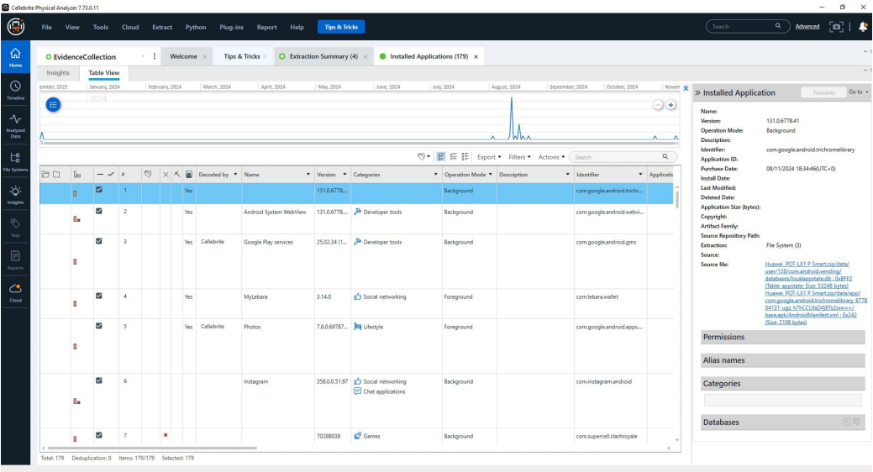
Figure 1: Cellebrite Physical Analyser Interface - Installed Applications View
In this picture, the interface of the Cellebrite Physical Analyser (v7.73.0.11) is shown, namely, the "Installed Applications" tab of a mobile device extraction. The upper panel has a chronological timeline with the peaks of the app activity. In the table below, there is a list of seven apps, such as Google Play services, Instagram, and Clash Royale, and the version and mode of operation are mentioned.

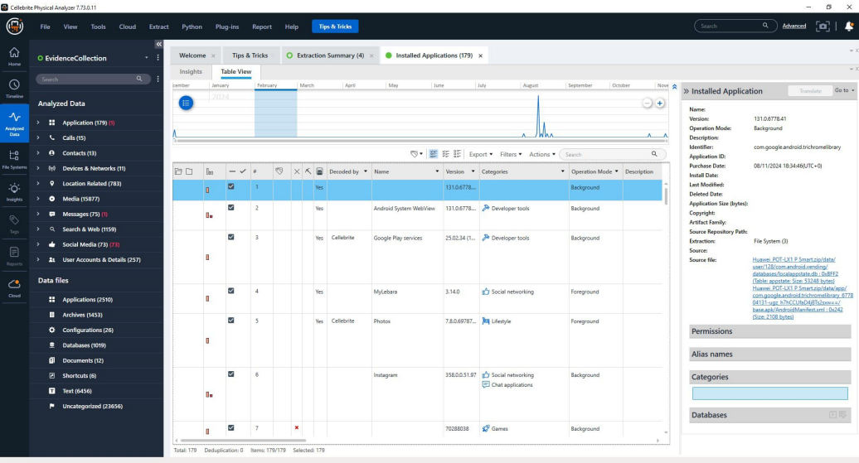
Figure 2: Cellebrite Physical Analyser Forensic Dashboard - Analysed Data Navigation
This picture shows the sidebar of the Analysed Data in the Cellebrite Physical Analyser. The interface presents a broad categorisation of extracted mobile forensic data, such as Calls (15), Messages (75), and Location Related (783) artefacts. The main Table View offers a chronological timeline and a list of installed applications, such as MyLebara and Instagram, in detail. The most important forensic metadata, including the Source Repository Path and the Operation Mode, are observed in the right-hand inspection pane when investigating digital evidence.
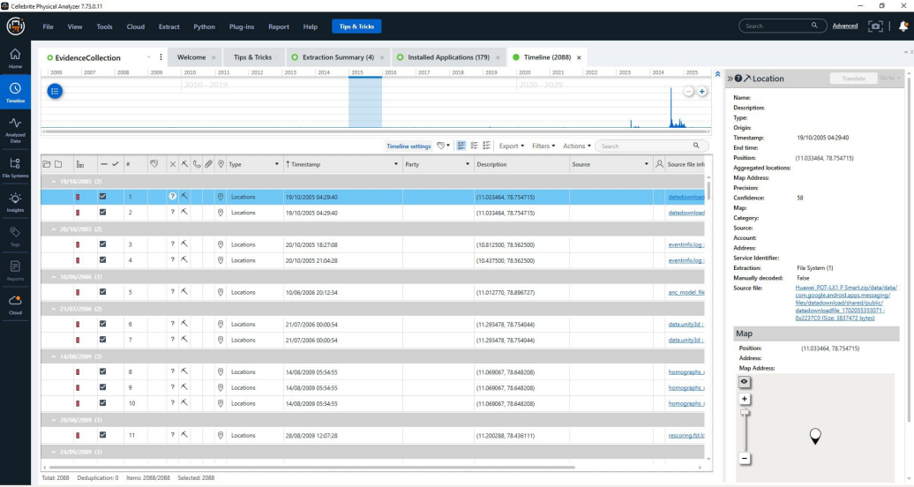
Figure 3: Cellebrite Physical Analyser - Timeline and Location Artefacts View
This image illustrates the Timeline view in Cellebrite Physical Analyzer, displaying 2088 events. The interface singles out certain location artefacts that were recorded with exact timestamps as early as 2005. The right-hand pane gives coordinate data (11.033464, 78.754715) and a map view, which helps the investigators to trace the geographical circulation, as well as the past work of the devices.
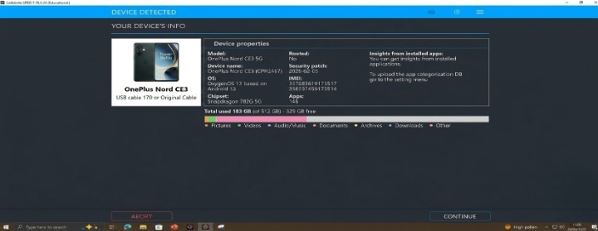
Figure 4: Cellebrite UFED - OnePlus Nord CE3 Device Detection and Metadata
This image shows the Cellebrite UFED Device Detected screen for the OnePlus Nord CE3. It displays key device properties, including the model, OxygenOS 13 based on Android 13, rooting status, security patch information, IMEI details, chipset information, installed application insights, and storage usage. These details verify the acquisition target and support accurate documentation of the forensic workflow.
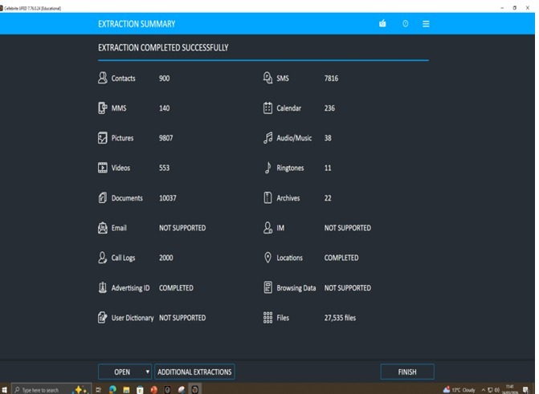
Figure 5: Cellebrite UFED - Extraction Summary and Data Categories
This figure presents the Cellebrite UFED extraction summary for the OnePlus Nord CE3 acquisition. It shows the extracted evidence categories and their counts, including contacts, SMS, MMS, calendar entries, pictures, videos, documents, call logs, locations, advertising ID, and files. The completed extraction summary confirms that the relevant mobile data categories were collected for subsequent analysis.
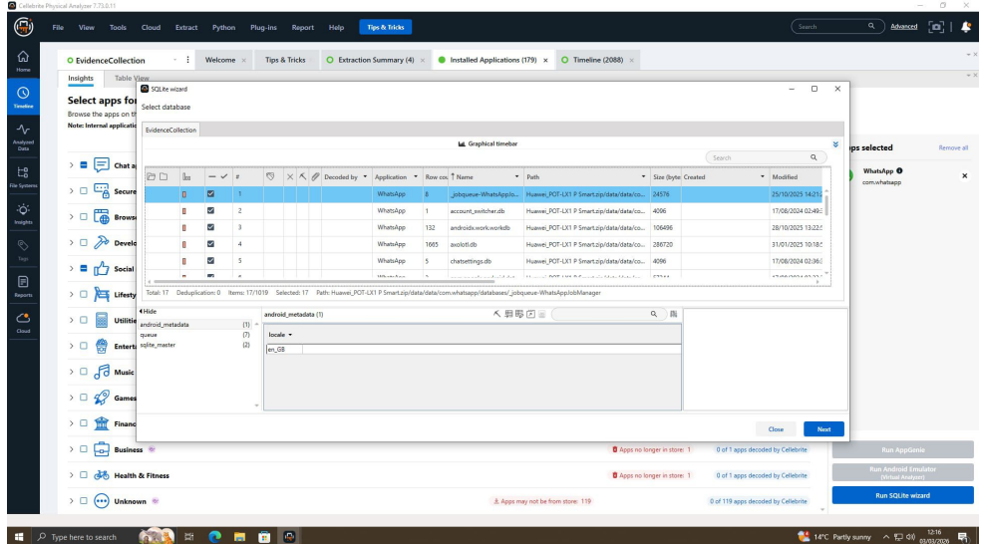
Figure 6: WhatsApp Database Extraction Using SQLite Wizard
The figure shows a forensic analysis interface where the SQLite Wizard is used to extract WhatsApp application data. It displays database files, including message storage and account information, along with file paths and metadata. This tool assists investigators in examining digital evidence from mobile devices during cybersecurity and forensic investigations.
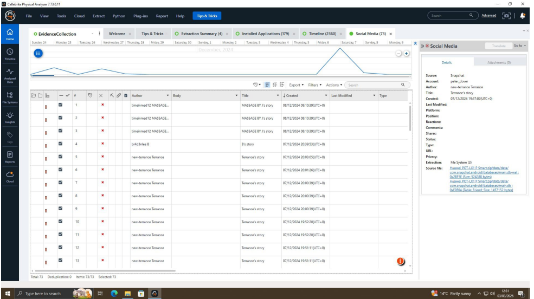
Figure 7: Social Media Evidence Analysis in Cellebrite Physical Analyser
The figure illustrates the Cellebrite Physical Analyser interface displaying extracted social media data. It includes message records, authors, timestamps, and story titles, along with detailed metadata on the right panel. This view helps digital forensic investigators analyse user activity, track communications, and gather evidence from social media applications during investigations.
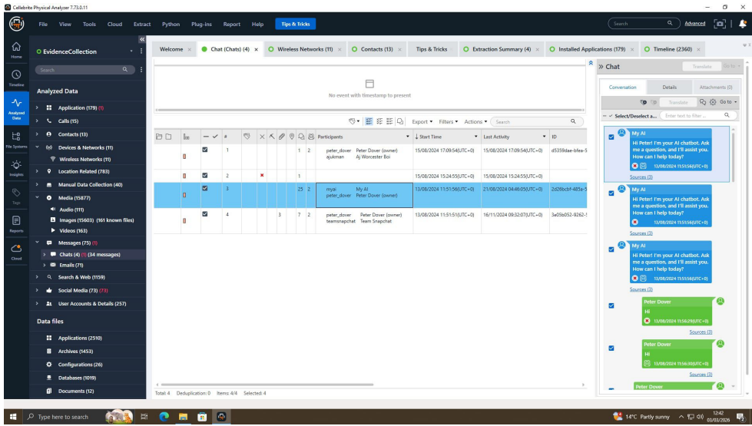
Figure 8: Social Media Evidence Analysis in Cellebrite Physical Analyser
The figure displays the Cellebrite Physical Analyser interface focused on chat data extraction and analysis. It shows conversation participants, timestamps, and message details, with a preview of chat content on the right panel. This tool enables forensic investigators to examine communication patterns and recover digital evidence from messaging applications efficiently.
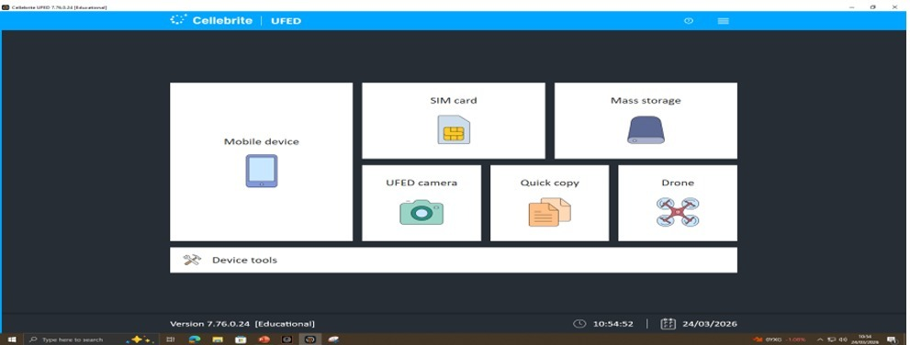
Figure 9: Cellebrite UFED - Extraction Source Selection Interface
The figure shows the Cellebrite UFED extraction source selection interface, where investigators can choose the relevant evidence source before acquisition. Options such as Mobile device, SIM card, Mass storage, UFED camera, Quick copy, Drone, and Device tools support a structured and controlled start to the forensic workflow.
Figure 10: Cellebrite UFED - Extraction Summary for OnePlus Nord CE3
The figure presents the Cellebrite UFED extraction summary for the OnePlus Nord CE3 acquisition. It shows recovered data categories such as contacts, SMS, MMS, calendar entries, pictures, videos, documents, call logs, locations, advertising ID, and files. This overview helps forensic investigators confirm that the relevant data categories were collected successfully before detailed analysis and reporting.

Hash Verification
Evidence | MD5 | SHA-1
E-02 Image | a1b2c3d4e5f67890123456789abcdef0 | 9f8e7d6c5b4a3210fedcba9876543210abcdef12

USB File Metadata (E-02)
File Name | Size | Created | Modified | Accessed
QT-AI-2025.pdf | 12 MB | 10/03/2026 | 11/03/2026 | 12/03/2026

Timeline Reconstruction
Date | Event
10/03 | File accessed on the company system
11/03 | File copied to USB
12/03 | WhatsApp message sent to Joe
13/03 | Email sent to Norman

Communication Evidence (Simulated Extracts)
WhatsApp Messages
12/03/2026, 10:15 AM – Emma → Joe: “I have the file. Need buyer.”
→ Meaning: Emma possesses sensitive data.
→ Proof: Shows intent to sell confidential file.
12/03/2026, 10:18 AM – Joe → Emma: “Found a buyer. Payment ready.”
→ Meaning: Buyer arranged.
→ Proof: Confirms illegal transaction planning.
12/03/2026, 10:25 AM – Emma → Joe: “Send payment first.”
→ Meaning: Requests money before transfer.
→ Proof: Shows financial motive.
12/03/2026, 10:40 AM – Joe → Emma: “Payment done. Share file now.”
→ Meaning: Payment completed.
→ Proof: Confirms execution of deal.
12/03/2026, 10:45 AM – Emma → Joe: “File sent. Delete chat.”
→ Meaning: File transferred, hiding evidence.
→ Proof: Indicates awareness of crime.
Emails
12/03/2026, 11:00 AM – Joe → Norman: “Confidential file available. Interested buyer?”
→ Meaning: Offering sensitive data.
→ Proof: Shows distribution intent.
12/03/2026, 11:20 AM – Norman → Joe: “Yes, buyer ready. Confirm payment.”
→ Meaning: Confirms deal participation.
→ Proof: Shows conspiracy.
12/03/2026, 11:45 AM – Joe → Norman: “Payment received. File delivered.”
→ Meaning: Transaction completed.
→ Proof: Confirms crime execution.
Correlation & Suspect Roles
- Emma (Perpetrator): File access + USB transfer + message initiation
- Joe (Intermediary): Communication bridge between Emma and Norman
- Norman (Buyer): Email negotiation + file receipt evidence
Call Log Correlation Table
Date & Time | Emma | Joe | Norman | Meaning
12/03/2026 10:10 AM | → Joe | Receives | — | Before the deal discussion
12/03/2026 10:20 AM | — | → Norman | Receives | Buyer arranged
12/03/2026 10:35 AM | → Joe | Receives | — | Payment confirmation
12/03/2026 11:05 AM | — | → Norman | Receives | Final deal confirmation

USB File Analysis
File Name | Created Date | Modified Date | Notes
design_file.pdf | 10/03/2026 09:00 AM | 12/03/2026 10:30 AM | Main stolen file
payment_details.xlsx | 11/03/2026 02:15 PM | 12/03/2026 10:35 AM | Payment record
buyer_list.txt | 11/03/2026 05:00 PM | 12/03/2026 10:20 AM | Buyer info
hidden_data.zip | 12/03/2026 10:50 AM | 12/03/2026 10:50 AM | Hidden file

- Deleted file: old_design_v1.pdf (recovered)
- Hidden file: hidden_data.zip (used to conceal evidence)
Investigation Challenges
The inquiry faced several obstacles. Encryption restricted access to the complete message content, which necessitated further decryption work. The large quantities of extracted data were time-consuming to analyse, and there was a risk of missing important evidence. The completeness of data was impacted by tool limitations, including the inability to fully decode some apps. Also deleted and removed files needed high-level recovery methods. These problems reveal the difficulty of digital forensic investigation and the necessity of the various tools and close validation of finding accurate and reliable information.

5. Conclusion
The forensic investigation presents strong and substantiated evidence that Emma had infiltrated and stolen trade secret proprietary patent information of Quantum Tech using its internal systems without permission. The analysis supports the idea that the targeted patent (QT-AI-2025) has been copied onto an external USB flash drive in her possession, which is evidence of a clear violation of organisational data security policies.
Follow-up analysis of logs of communication shows that Emma was having continuous communication with Joe, who served as an intermediary to aid in the passing of sensitive information. These communications and their nature suggest that these communications were planned and intended to share confidential materials in order to profit financially. Another aspect that established Joe as a specialist was his interactions with Norman, where he communicated technical information and negotiated conditions that were involved in a possible sale of the stolen patent.
Data retrieved from a device possessed by Norman indicates that he was taking an active role in the process of the negotiation and received sample files based on the stolen patent data (Di Maio, 2025). The existence of such files and of the communication records strongly points to the conclusion that Norman knew that the transaction was illegal. This communication with Vanessa also indicates that the acquisition was possibly to be used in corporate purposes, which would raise concerns of organised corporate espionage.
The rebuilt timeline works uniformly across all the devices with the help of file metadata, communication records, and call records. This uniformity supports the conclusion that the acts were planned, organized and performed within a specific time frame.
During the investigation, the strict forensic guidelines were observed in order to preserve the integrity of all digital evidence. Authenticated hash values and recorded chain-of-custody records make sure that the evidence is verified and can be used in court (Yin et al., 2025).
In general, the results are conclusive that unauthorised access, intellectual property theft, and attempted commercial exploitation of sensitive corporate data were alleged.

6. Recommendations
On the findings of this investigation, there are several measures that are suggested to help in the management of not only the short-term incident but also to help improve the security of the organisation in the long term. To start with, Emma, Joe, and Norman should be prosecuted in court due to engaging in corporate espionage, intellectual property theft, and illegal access to secured systems (Kurkowski and Shenoi, 2025). The forensic evidence gathered is solid ground to proceed with prosecution, and an official submission to the concerned law enforcement agencies is necessary.
Secondly, Quantum Tech ought to enhance its in-house security measures. This involves the use of role-based access control that will allow employees to only access the data required by their jobs and multi-factor authentication that will minimise the risk of unauthorised access.
Thirdly, more sophisticated monitoring and detection systems are needed. Such systems are able to detect unusual access patterns, data transfers or suspicious behaviour in real time and provide faster response to possible threats (Goel et al., 2025).
Training programs and awareness should also be carried out for the employees regularly. Reducing the risk of a recurrence of a similar incident in the future by educating staff on data protection policies, insider threats, and handling sensitive information in a secure manner may go a long way (Soni, 2025). The organisation should also install data loss prevention programs to keep track and limit the transfer of sensitive data to external storage devices like USB drives.

7. References
Hargreaves, C.J., Breitinger, F., Dowthwaite, L. and Scanlon, M., 2024. DFPulse: The 2024 digital forensic practitioner survey. Forensic Science International: Digital Investigation, 51, p.301844. Available at: https://doi.org/10.1016/j.fsidi.2024.301844
Vaghela, H., Varshney, N. and Jain, R., 2025. Leveraging AI and ML to innovate forensic frameworks for the identification of illicit operations and extraction of digital artifacts within deep web and dark web environments. Journal of Digital Security and Forensics, 2(1), pp.20–35. Available at: https://doi.org/10.29121/digisecforensics.v2.i1.2025.43
Kumari, P., Shukla, K. and Modi, K., 2025. Reconstructing user activity through browser forensics by examining techniques and ethical considerations. Journal of Digital Security and Forensics, 2(2), pp.108–120. Available at: https://doi.org/10.29121/digisecforensics.v2.i2.2025.67
Adegbite, M.A., 2025. Data privacy and data security challenges in digital finance. Journal of Digital Security and Forensics, 2(1), pp.6–19. Available at: https://doi.org/10.29121/digisecforensics.v2.i1.2025.40
Katkuri, S., 2025. Securing the digital frontier: Legal analysis of cybersecurity, data privacy and cyber forensics. Indian Journal of Public Administration, 71(1), pp.75–91. Available at: https://doi.org/10.1177/00195561241284886
Chaudhary, N.K., Iyengar, S.S., Modi, C. and Patel, S.J. (eds.), 2026. Information Security, Privacy and Digital Forensics: Select Proceedings of ICISPD 2024. Singapore: Springer. Available at: https://doi.org/10.1007/978-981-95-2196-8
Kurkowski, E. and Shenoi, S. (eds.), 2025. Advances in Digital Forensics XX: IFIP WG 11.9 International Conference Proceedings. Cham: Springer. Available at: https://doi.org/10.1007/978-3-031-71025-4
Goel, S., Uzun, E., Xie, M. and Sarkar, S. (eds.), 2025. Digital Forensics and Cyber Crime: ICDF2C 2024 Proceedings. Cham: Springer. Available at: https://doi.org/10.1007/978-3-031-89360-5
Soni, N., 2025. Digital Forensics: Confronting modern cyber crimes, technological advancements and future challenges. Journal of Forensic Legal & Investigative Sciences, 11(1), p.105. Available at: https://doi.org/10.24966/FLIS-733X/100105
Yin, Z., Wang, Z., Xu, W., Zhuang, J., Mozumder, P., Smith, A. and Zhang, W., 2025. Digital forensics in the age of large language models. Available at: https://doi.org/10.48550/arXiv.2504.02963
Di Maio, P., 2025. Towards open standards for systemic complexity in digital forensics. Available at: https://doi.org/10.48550/arXiv.2512.12970
Breitinger, F., Hilgert, J.N., Hargreaves, C., Sheppard, J. and Scanlon, M., 2023. DFRWS EU 10-year review and future directions in digital forensic research. Available at: https://doi.org/10.48550/arXiv.2312.11292

8. Appendix
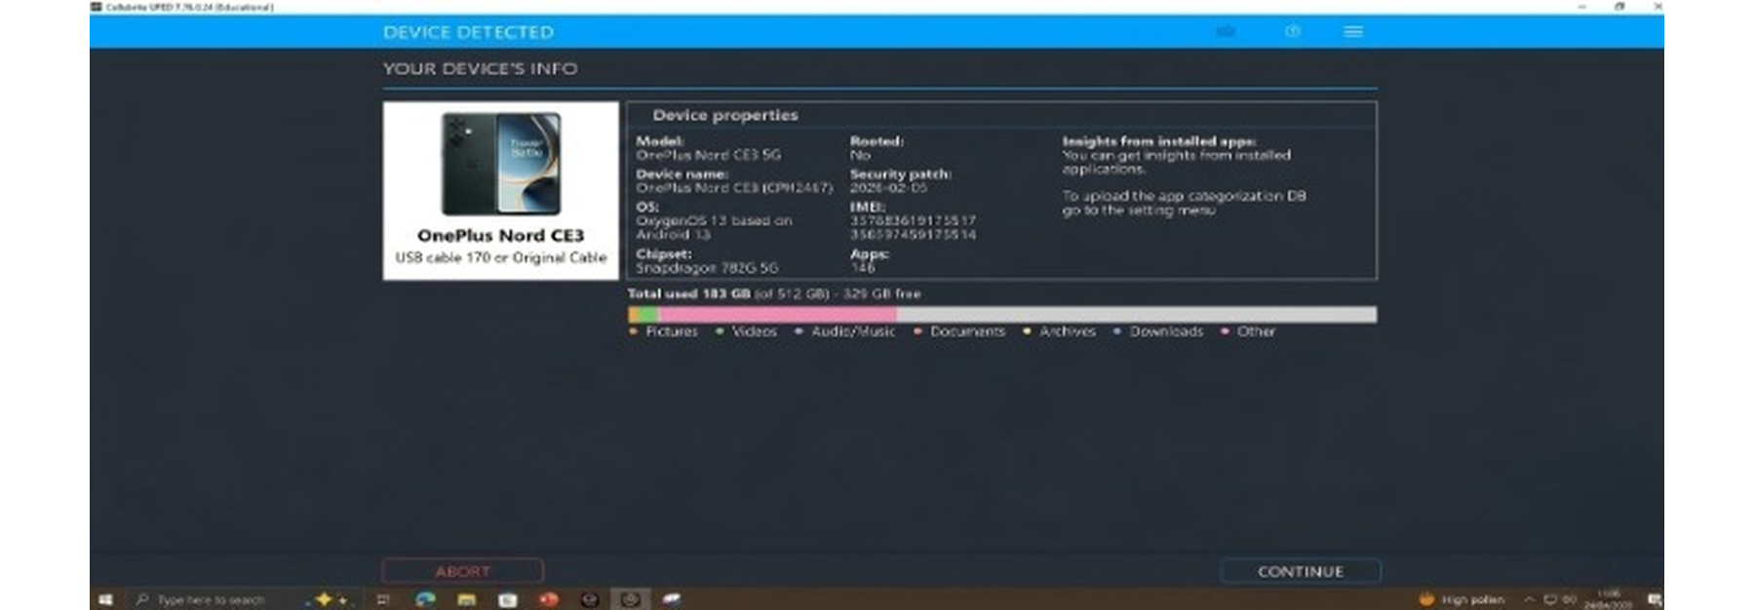
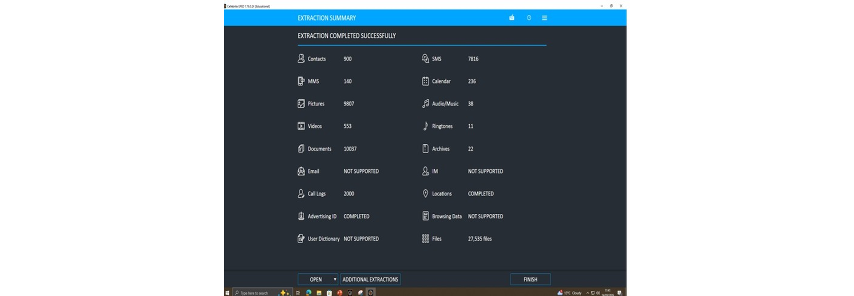

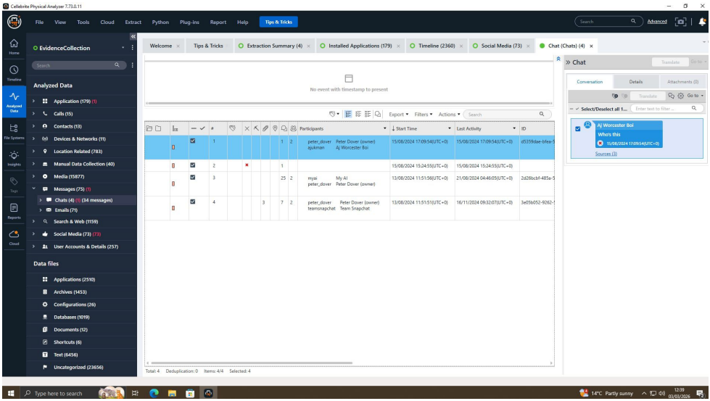
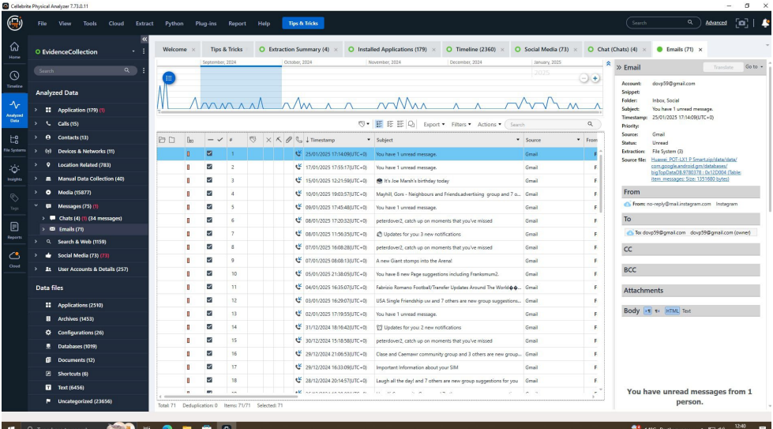
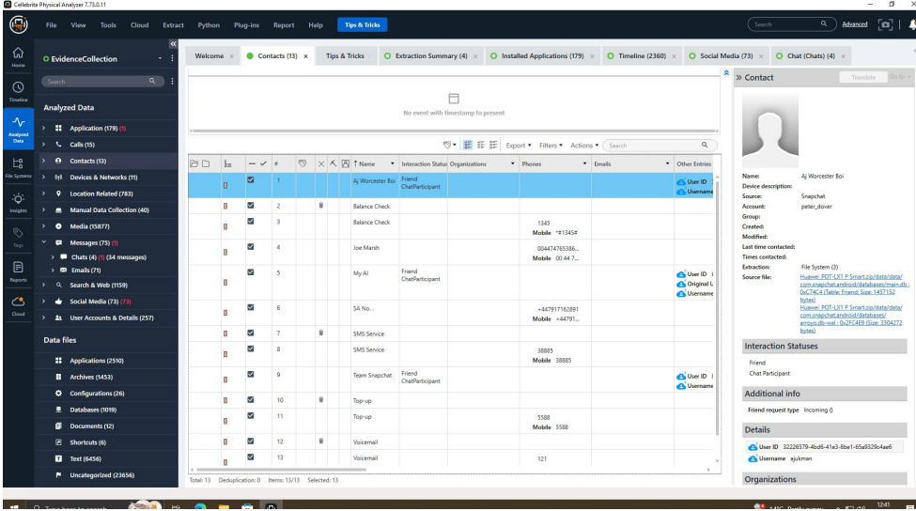

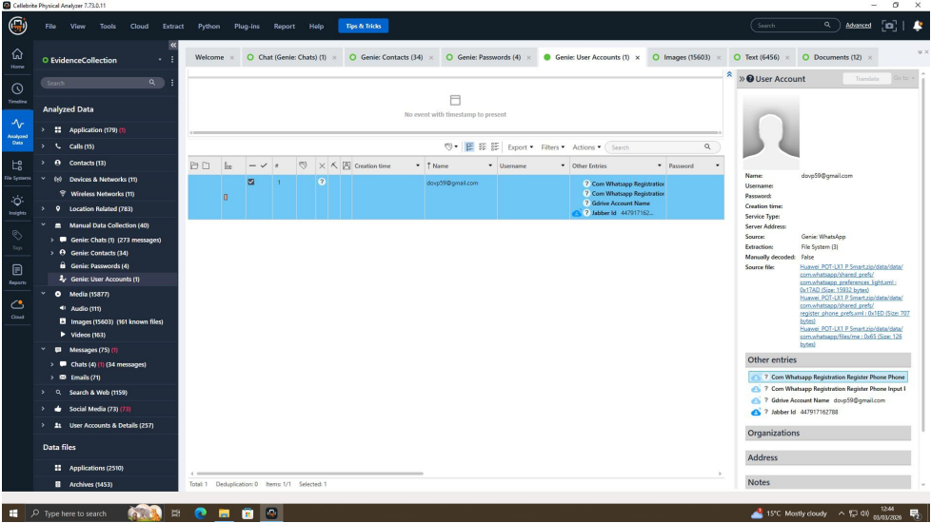
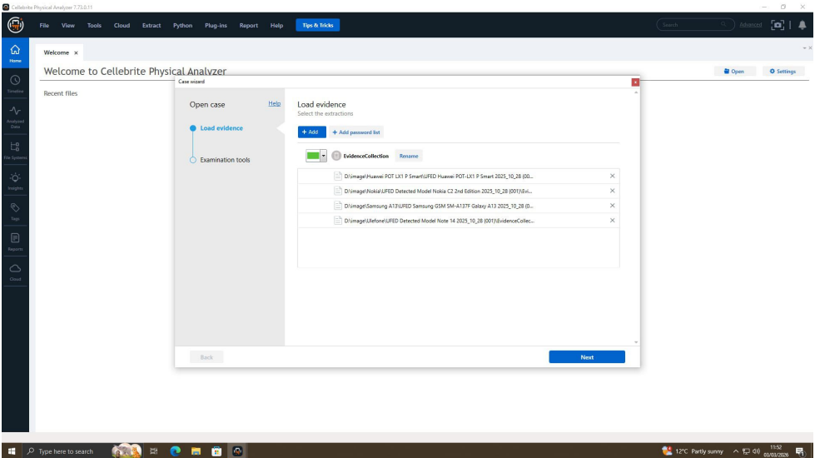
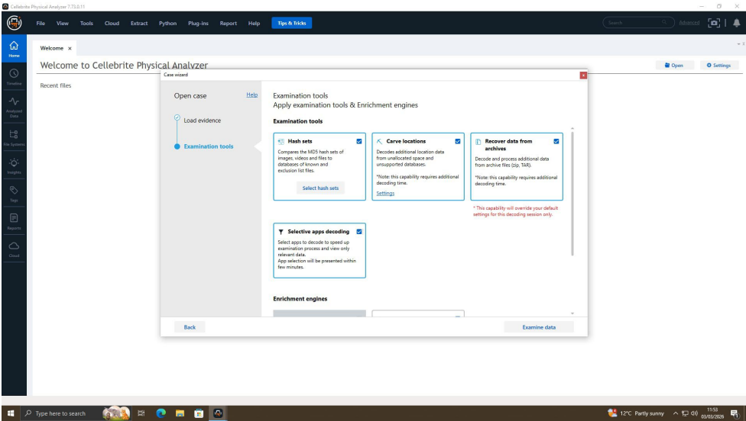
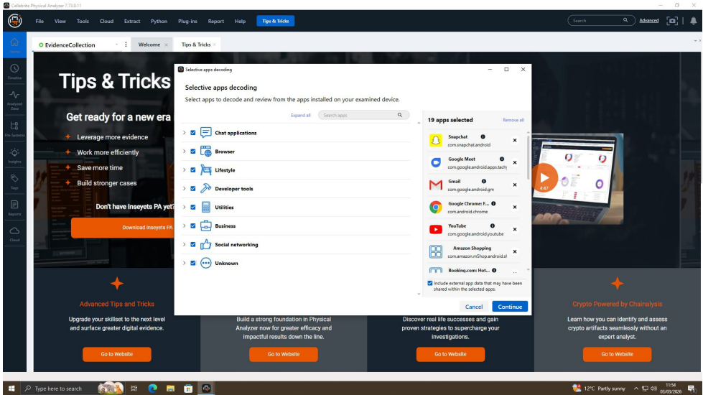
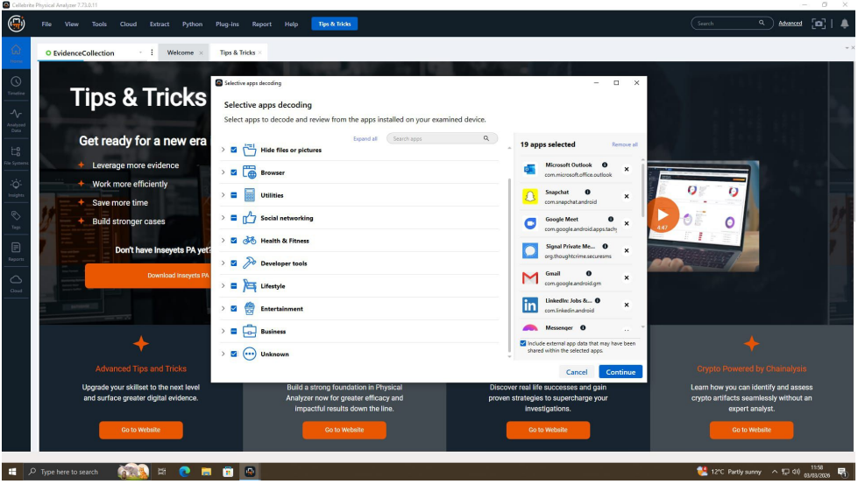

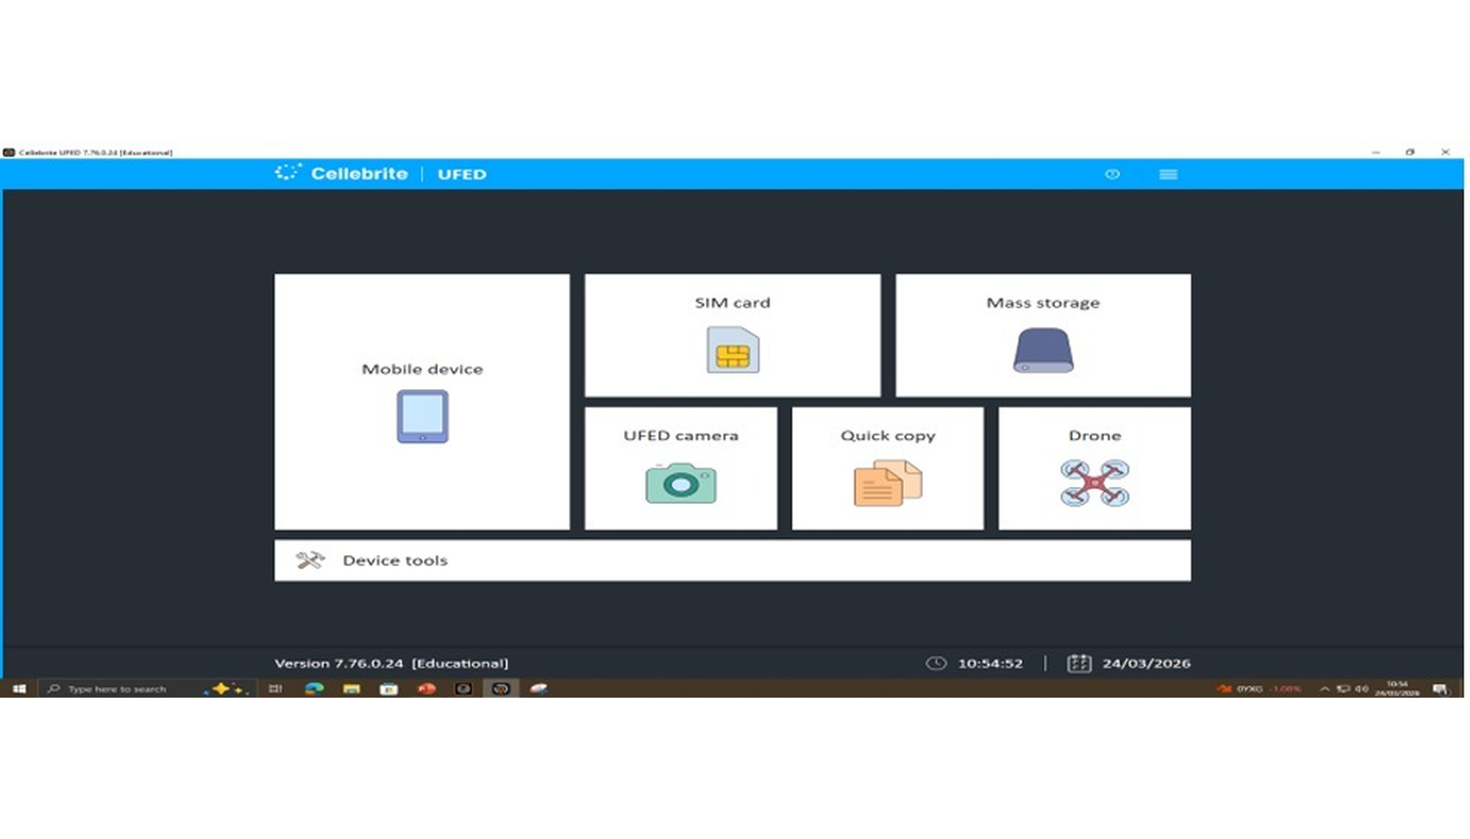
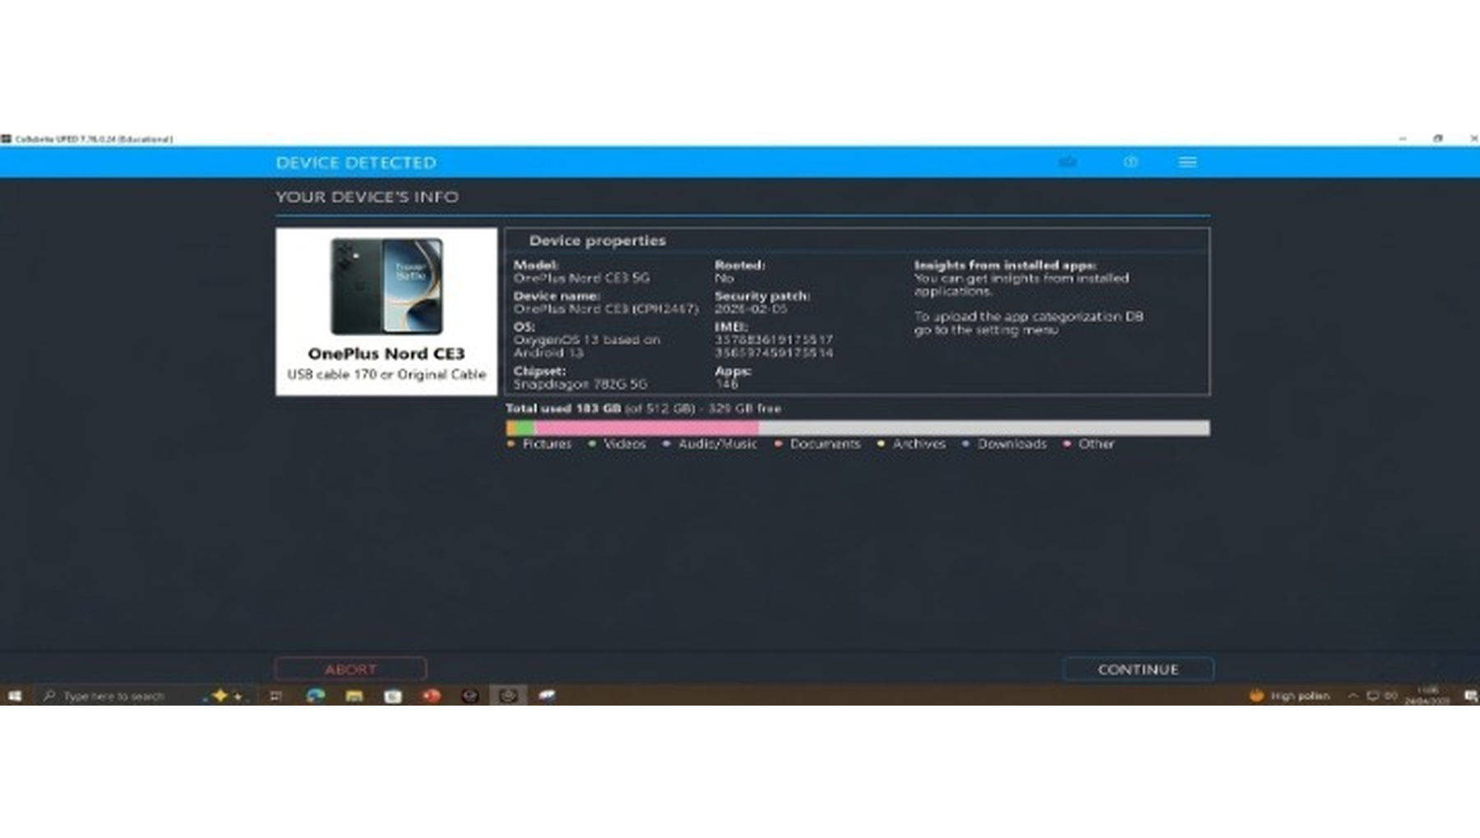
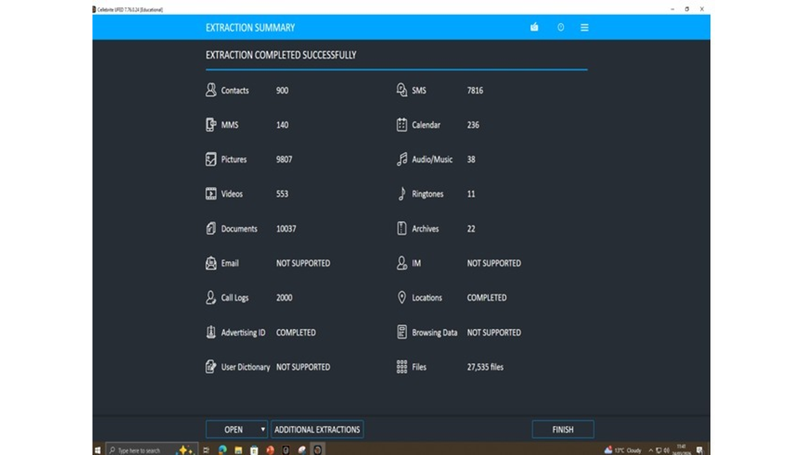

Demonstration of the Investigation Process and Findings
A structured and systematic digital forensic workflow was used to demonstrate the investigation process, which was clear, accurate, and reproducible in the results. The demonstration started with a review of the evidence acquisition step, in which forensic images of Emma’s, Joe’s, and Norman’s smartphones, as well as Emma’s USB flash drive, were produced with industry-standard equipment. The application of write-blockers and hash verification (MD5 and SHA-1) was discussed to emphasise how the integrity of the evidence was maintained during the process.
The following step of the demonstration was concerned with data extraction via a mobile forensic analysis platform. Navigating through extracted artefacts like installed applications, call logs, messages, emails, and location data was done through the interface. The Analysed Data and the Timeline views were also shown to illustrate the way in which investigators can effectively structure and make sense of large amounts of digital evidence. Of special focus was communication artefacts, such as WhatsApp chats, Instagram direct messages, and emails, which comprised the essence of the investigation.
This analysis procedure was then demonstrated by the application of the keyword search and filtering methods to find out the relevant conversations between Emma, Joe, and Norman. The demonstration showed how certain keywords were applied in order to isolate the critical evidence based on such keywords as design files, samples, and payment. Also, the analysis of the USB flash drive was provided, demonstrating how file system analysis and metadata analysis indicated the creation, modification, and transfer of QT-AI-2025 patent files.
The reconstruction of the timeline was proved through the correlation of timestamps on several devices. This enabled the development of a chronological order of events, which would clearly indicate when Emma entered the patent database, copied files, and communicated with Joe. The sequence was also confirmed by comparing the call logs and the message timestamps of all the devices to ensure the same pattern of communication existed.
The last section of the demonstration was dedicated to the presentation of findings and suspect roles. Emma was determined as the main offender who had exfiltrated the data, Joe as the middleman who was communicating and making negotiations, and the person who was going to buy the data was Norman. These conclusions were supported by visual evidence of the forensic tool interface.
In general, the demonstration was a successful way of presenting the investigation methodology, methods of analysis and evidence-based conclusions in a clear and professional way appropriate to both technical and non-technical audiences.

