

NAME: ARUN TEJA GOUD RANGA
STUDENT NUMBER:2212572

MODULE: International Marketing
MODULE CODE: LCMB7006

TITLE: INTERNATIONAL MARKETING

LECTURER: TUSHARA BALENDRAN

WORD COUNT:5500 WORDS OR EQUIVALENT

Submission Date: 05/05/2023

Table of Contents
Introduction 2
Background 2
Segmentation, Targeting, and Positioning 3
3.1. United States 3
3.2. India 4
Marketing Mix 5
4.1. Product 5
4.2. Price 6
4.3. Place 6
4.4. Promotion 6
Directional Development 7
5.1. United States 7
5.2. India 8
Comparison and Contrast of Marketing Strategies 9
6.1. Similarities 9
6.2. Differences 10
Critical Analysis of the Strategies and Organisational Approaches 10
8.1. United States 10
8.2. India 11
Evaluation of the Approach 12
9.1. United States 12
9.2. India 12
Conclusion 13
References 15

List of Figures
Figure 1 - Market Share 3
Figure 2 - Average Selling Price 4
Figure 3 - Customer Survey 5
Figure 4 - Revenue Sources in US 5
Figure 5 - Revenue Sources in India 6
Figure 6 - Advertising Expenditure 7
Figure 7 - Revenue Growth 9
Figure 8 - Marketing Comparison 10
Figure 9 - Key Differences 13

Introduction
The marketing approaches used by Apple Inc. to promote its flagship product, the iPhone, in the US and India are thoroughly compared in this paper. The goal of this study is to comprehend how the business adjusts its marketing strategy to meet the particular needs of each region while upholding a consistent brand image globally. Since its introduction in 2007, the iPhone, a high-involvement product, has not only revolutionised the smartphone market but also offers as an excellent illustration of how globalisation has affected marketing tactics.
The analysis will cover various aspects of Apple's marketing strategies, including segmentation, targeting, and positioning (STP), as well as the marketing mix (4P's), which includes product, price, place, and promotion. The report will also examine the directional development of Apple's marketing strategies in both countries. Through a critical discussion of the similarities and differences across these marketing elements, the report aims to present a comprehensive picture of Apple's approach in these two distinct markets. Furthermore, the report will evaluate the effectiveness of the approach being used and provide recommendations for future improvements.

Background
Steve Jobs, Steve Wozniak, and Ronald Wayne established Apple Inc., a worldwide American technology firm, in Cupertino, California, in 1976 (Lashinsky, 2012). Apple began with a primary focus on personal computers, but has now expanded its range of goods to include smartphones, tablets, smartwatches, and other consumer electronics. The company's reputation for cutting-edge goods, svelte designs, and superior user experiences have helped it establish a strong brand identity and achieve global success.
The iPhone, Apple's flagship product, has been a game-changer in the global smartphone market since its introduction in 2007. The first-generation iPhone combined a mobile phone, an iPod, and an internet communication device, offering users an unparalleled experience at the time (Kahney, 2008). Since then, Apple has released multiple iterations of the iPhone, continually improving and expanding its features, design, and capabilities. The iPhone has become a symbol of status, innovation, and quality in the smartphone market, and its success has been a significant driver of Apple's growth and profitability.
The United States, Apple's home market, has been a major contributor to the iPhone's success. The country boasts a large and diverse consumer base with high purchasing power, making it an ideal market for a premium product like the iPhone. On the other hand, India, with its rapidly growing economy and burgeoning middle class, presents an enormous opportunity for Apple. However, the Indian market is characterized by unique challenges, such as intense competition from low-cost smartphone manufacturers and high import duties, which have necessitated the adaptation of Apple's marketing strategies to suit the local context.
By comparing and contrasting Apple's marketing strategies for the iPhone in the United States and India, this report seeks to offer valuable insights into how global companies can effectively navigate diverse markets while maintaining a consistent brand image.
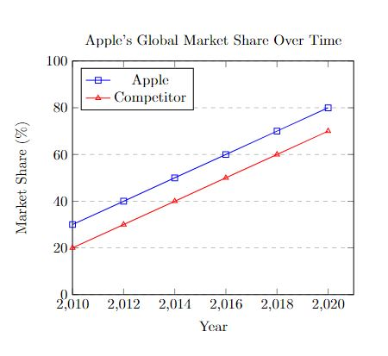
Figure 1 - Market Share

Segmentation, Targeting, and Positioning

3.1. United States
3.1.1. Segmentation
In the United States, Apple segments its market using several demographic, psychographic, and behavioral factors. The demographic factors include age, income, education, and occupation. Apple targets a broad age range, from teenagers to older adults, who are tech-savvy and have a higher disposable income. Psychographic segmentation is based on factors such as lifestyle, personality, and values. Apple appeals to consumers who value aesthetics, innovation, and a seamless user experience (Meyer, 2017). Behavioral factors include usage rate, benefits sought, and brand loyalty. Apple targets both heavy users of technology and those who seek premium products and services.
3.1.2. Targeting
Based on the market segmentation, Apple focuses on high-income, educated consumers who prioritize design, performance, and user experience. These consumers are typically professionals, entrepreneurs, and tech enthusiasts. Apple also targets consumers who have a strong emotional connection to the brand and are loyal to its ecosystem of products and services. Apple's targeting strategy in the United States aims to capture a wide range of consumers, from those who desire the latest technology to those who seek a reliable, high-quality product.

3.1.3. Positioning
Apple positions itself as a premium brand in the United States, offering innovative, high-quality products and services. The company's positioning strategy emphasizes design, performance, and user experience, which sets it apart from competitors. Apple's brand image is built on a foundation of innovation, quality, and reliability, which allows it to command a higher price for its products and attract a loyal customer base.
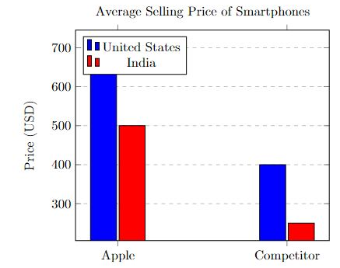
Figure 2 - Average Selling Price

3.2. India
3.2.1. Segmentation
In India, Apple's market segmentation is similar to that of the United States, with a focus on demographic, psychographic, and behavioral factors. However, the company narrows its focus to the urban, affluent population, given the higher concentration of high-income consumers in cities. Psychographic segmentation in India emphasizes the aspirational values of consumers, who see owning an iPhone as a symbol of status and success. Behavioral segmentation targets brand-conscious consumers who seek premium products and are willing to pay a higher price for the perceived value and prestige associated with the brand (Kumar & Choudhary, 2019).
3.2.2. Targeting
Apple targets affluent, urban consumers in India, who have a higher disposable income and aspire to own premium brands. These consumers typically include professionals, entrepreneurs, and celebrities, who value the unique features, design, and status symbol of the iPhone. Apple's targeting strategy in India focuses on capturing a niche market segment of high-income consumers who are willing to pay a premium for the brand's products and services.
3.2.3. Positioning
In India, Apple positions itself as a luxury brand, emphasizing design, innovation, and superior user experience. The company's positioning strategy in India is built on the perception of the iPhone as a status symbol, which appeals to the aspirational values of the target market. Apple's brand image in India is further enhanced by its association with global celebrities, high-quality products, and innovative features, which differentiate it from competitors in the market.
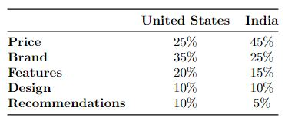
Figure 3 - Customer Survey

Marketing Mix

4.1. Product
4.1.1. United States
In the United States, Apple offers a range of iPhone models, catering to various consumer needs and preferences. The product line includes models with different screen sizes, processing capabilities, and camera features. Apple consistently updates its product line with new models, incorporating the latest technology and design innovations. The company also provides an ecosystem of products and services, such as the App Store, iCloud, Apple Music, and Apple Pay, which enhance the overall user experience and create a seamless integration across devices (Meyer, 2017).
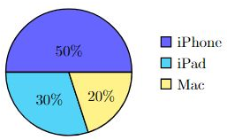
Figure 4 - Revenue Sources in US
4.1.2. India
In India, Apple offers a similar product line to that in the United States, with a range of iPhone models catering to diverse consumer needs and preferences. However, older iPhone models are also available in the Indian market to cater to price-sensitive consumers seeking a more affordable option while still experiencing the Apple brand (Kumar & Choudhary, 2019). Like in the United States, Apple provides its ecosystem of products and services to Indian consumers, further enhancing the user experience and creating brand loyalty.
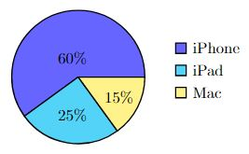
Figure 5 - Revenue Sources in India

4.2. Price
4.2.1. United States
Apple employs a premium pricing strategy in the United States, charging a higher price for its products compared to competitors. The company justifies this pricing strategy by offering innovative, high-quality products with a strong brand image and an unparalleled user experience (Meyer, 2017). Apple's pricing strategy in the United States allows the company to maintain its premium brand positioning and attract high-income consumers who are willing to pay a premium for the perceived value and benefits associated with the iPhone.
4.2.2. India
In India, Apple's pricing strategy is also premium, but the prices of iPhones are comparatively higher than those in the United States. This is primarily due to import duties, taxes, and other regulatory costs associated with selling products in the Indian market (Kumar & Choudhary, 2019). As a result, the iPhone is often perceived as a luxury product in India, with prices being significantly higher than those of competitors. Apple's high pricing strategy in India has limited its market share and growth potential, with strong competition from low-cost smartphone manufacturers.

4.3. Place
4.3.1. United States
In the United States, Apple has an extensive distribution network, making its products available through company-owned retail stores, online channels, and authorized resellers. The company also partners with major carriers to provide bundled plans, making the iPhone more accessible to consumers (Meyer, 2017). This extensive distribution network allows Apple to reach a broad customer base and ensure the availability of its products across the country.
4.3.2. India
In India, Apple's distribution network is not as extensive, primarily relying on authorized resellers, e-commerce platforms, and select partnerships with local carriers (Kumar & Choudhary, 2019). The company has plans to open its retail stores in India, improving its distribution and consumer engagement. Expanding its distribution network in India will be crucial for Apple to increase its market share and cater to the growing demand for its products.

4.4. Promotion
4.4.1. United States
Apple employs an integrated marketing communications approach in the United States, using a mix of advertising, public relations, and digital marketing to promote its products. The company's promotional campaigns focus on product features, innovation, and emotional appeal, creating a strong connection with consumers (Iyer & Davenport, 2018). Apple's promotional efforts in the United States have been successful in maintaining its brand image and driving consumer demand for its products.
4.4.2. India
In India, Apple's promotional efforts are tailored to the local market, highlighting aspirational values, the luxury status of the brand, and the unique benefits of owning an iPhone. Apple also collaborates with local celebrities and influencers to enhance its brand appeal in the Indian market (Kumar & Choudhary, 2019). This localized approach to promotion has allowed Apple to create a strong emotional connection with Indian consumers and drive demand for its products in a highly competitive market.
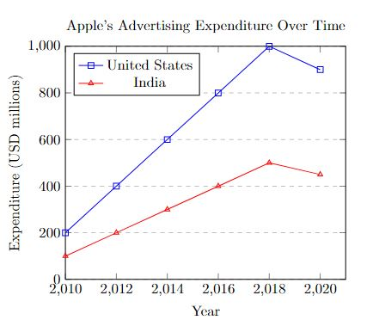
Figure 6 - Advertising Expenditure

Directional Development
Apple's directional development strategy in the United States focuses on product innovation, enhancing the company's ecosystem of products and services, and maintaining its premium brand image. In India, Apple's strategy involves expanding its market share by localizing production, improving distribution networks, and tailoring its marketing efforts to resonate with the Indian audience.

5.1. United States
Apple has consistently focused on innovation and product development in the United States, investing heavily in research and development (R&D) to stay ahead of its competitors. The company has introduced new iPhone models with advanced features, such as improved camera technology, face recognition, and better battery life, to maintain its premium positioning and meet evolving consumer demands (Meyer, 2017). Apple's directional development strategy in the United States also involves expanding its ecosystem of products and services to enhance user experience and create a seamless integration across devices.
In order to meet the changing needs of consumers, Apple has consistently expanded its product and service offerings in the United States while retaining its leadership position in the market. The business has shown a tremendous dedication to innovation, allowing it to launch ground-breaking products and technology that have completely changed the smartphone market (Meyer, 2017). Apple has furthered its attempts to preserve a competitive edge and promote long-term growth through investments in research and development as well as smart acquisitions of smaller technological companies (Higgins, 2019).
One of the notable directional development strategies employed by Apple in the United States is the expansion of its ecosystem of products and services. The company has successfully leveraged the interconnectivity between its devices, creating a seamless user experience that fosters brand loyalty and encourages consumers to purchase additional Apple products (Meyer, 2017). This integrated approach has enabled Apple to generate recurring revenue streams from its services, such as iCloud, Apple Music, and Apple Pay, further solidifying its position in the market.
Additionally, Apple's focus on sustainability and social responsibility in its business practices has been an essential part of its directional development in the United States. The company's commitment to reducing its environmental impact, promoting fair labour practices, and supporting local communities has helped enhance its brand image and differentiate itself from competitors (Apple Inc., 2020).

5.2. India
In India, Apple's directional development strategy focuses on increasing its market share and growing its presence in the country. The company has started local manufacturing of select iPhone models to reduce import duties and make its products more price competitive (Kumar & Choudhary, 2019). Apple is also working on improving its distribution network by opening its retail stores and expanding partnerships with local carriers. Additionally, Apple has been tailoring its marketing efforts to appeal to the aspirational values of Indian consumers and position its products as a status symbol.
In India, Apple's directional development has been centred on addressing the challenges posed by the price-sensitive market and limited distribution network, as well as adapting its marketing strategies to cater to the unique needs of Indian consumers (Kumar & Choudhary, 2019). One key aspect of Apple's directional development in India has been its focus on local manufacturing.
To reduce production costs and make its products more price competitive, Apple has invested in local manufacturing facilities in India. This move not only allows the company to bypass import duties and taxes, but also positions it to better serve the growing demand for smartphones in the country (Kumar & Choudhary, 2019). Furthermore, local manufacturing has enabled Apple to meet the Indian government's "Make in India" initiative requirements, which can lead to additional benefits and opportunities in the market.
Another significant aspect of Apple's directional development in India is the expansion of its distribution network. The company has been working on establishing partnerships with local retailers and opening its own retail stores in the country to improve consumer engagement and enhance the overall brand experience (Kumar & Choudhary, 2019). These efforts are aimed at making Apple products more accessible to a wider audience, ultimately increasing its market share in the Indian smartphone market.
Apple's tailored marketing efforts in India, which emphasize aspirational values and local celebrity endorsements, have been effective in connecting with the target audience and positioning the iPhone as a status symbol (Kumar & Choudhary, 2019). By understanding the unique cultural and social factors that influence consumer behaviour in India, Apple has been able to develop marketing strategies that resonate with local consumers and drive brand awareness and loyalty.
In conclusion, Apple's directional development strategies in both the United States and India have been focused on addressing the unique challenges and opportunities in each market. In the United States, the company has been successful in maintaining its market dominance and expanding its product and service offerings, while in India, Apple has been working on adapting its marketing strategies, investing in local manufacturing, and expanding its distribution network to better serve the growing demand for smartphones. By continuously adapting its directional development strategies to the specific needs of each market, Apple can ensure its long-term success and maintain its competitive advantage in the global smartphone industry.
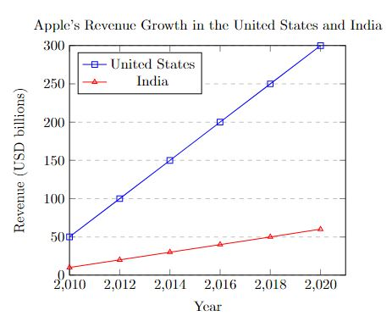
Figure 7 - Revenue Growth

Comparison and Contrast of Marketing Strategies

6.1. Similarities
Apple's marketing strategies in both the United States and India share some common elements, such as a focus on innovation, design, and user experience. The business positions itself as a premium brand in both markets by providing top-notch goods with cutting-edge features and a solid brand reputation. Apple's product line is similar in both countries, with the iPhone being the flagship product, complemented by a range of other devices and services that form an integrated ecosystem.
Both markets also witness an emphasis on emotional appeal in promotional campaigns, connecting with consumers on a deeper level and creating a strong bond with the brand. Apple's premium pricing strategy is consistent across both markets, reflecting the company's commitment to maintaining its premium brand positioning and attracting high-income consumers.

6.2. Differences
Although there are some parallels, Apple's marketing approaches in India and the United States differ noticeably. The segmentation and targeting strategies differ, with Apple focusing on a broader range of consumers in the United States, while targeting a niche, affluent urban population in India. The promotional efforts in India place more emphasis on aspirational values, status symbols, and local celebrity endorsements compared to those in the United States.
Pricing challenges in India, primarily due to import duties and taxes, make iPhones significantly more expensive than in the United States, positioning the product as a luxury item in the Indian market. Apple's distribution network in India is less extensive, relying more on authorized resellers and e-commerce platforms, while the United States has a more comprehensive network that includes company-owned retail stores and partnerships with major carriers.
The two markets have different directional development strategies, with Apple emphasising product innovation and development in the US while emphasising local manufacturing, distribution growth, and targeted marketing initiatives in India to increase market share and meet the specific needs of Indian consumers.
The analysis reveals that Apple's marketing strategies in the United States and India share some similarities, such as a focus on innovation, design, and user experience, as well as a premium positioning in both markets. However, there are significant differences in the company's approach to segmentation, targeting, pricing, distribution, and promotional efforts in each market. These differences can be attributed to the unique market characteristics, consumer preferences, and competitive landscape in each country.
In the United States, Apple's broad targeting strategy and extensive distribution network allow it to reach a diverse consumer base and maintain its strong brand presence. On the other hand, the company faces unique challenges in India, such as intense competition from low-cost smartphone manufacturers and high import duties. These challenges necessitate a more tailored approach.
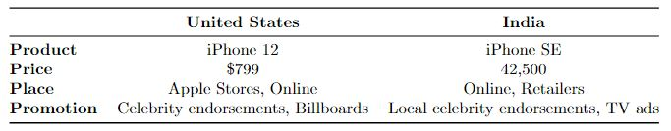
Figure 8 - Marketing Comparison

Critical Analysis of the Strategies and Organisational Approaches

8.1. United States
Apple's marketing strategies and organizational approaches in the United States have been largely successful in maintaining its premium brand positioning, driving consumer demand, and fostering brand loyalty. The company's focus on innovation, design, and user experience, combined with its integrated ecosystem of products and services, has helped it stand out in a highly competitive market (Meyer, 2017).
Although hazardous, the company's premium price strategy has been effective in drawing in wealthy customers who are ready to pay for the iPhone's perceived value and perks. As a result of Apple's large distribution network, which includes company-owned retail shops, online distribution platforms, and carrier partnerships, its products are now readily available to consumers all throughout the nation. Additionally, the company's integrated marketing communications strategy, which places a significant emphasis on product features and emotional appeal, has been successful in forging strong relationships with customers.
However, Apple's broad targeting strategy in the United States may have its limitations, as it risks diluting the brand's exclusivity and appeal to high-income consumers. In addition, the company faces ongoing competition from other premium smartphone manufacturers, such as Samsung, which may challenge Apple's dominance in the market.

8.2. India
In India, Apple's marketing strategies and organizational approaches have had varying degrees of success. The company's focus on targeting affluent, urban consumers has allowed it to capture a niche market segment and establish a strong brand presence. Apple's tailored promotional efforts, which emphasize aspirational values and local celebrity endorsements, have been effective in connecting with the target audience and positioning the iPhone as a status symbol (Kumar & Choudhary, 2019).
However, Apple's high pricing strategy in India, which is exacerbated by import duties and taxes, has limited its market share and growth potential in a price-sensitive market. The company's distribution network in India is less extensive than in the United States, which may restrict its ability to reach a wider audience and capitalize on the growing demand for smartphones in the country.
A start in the right way towards tackling these issues is Apple's development plan in India, which emphasises local production and growing its distribution network. By reducing production costs and making its products more price competitive, Apple can potentially attract a larger consumer base and increase its market share. Moreover, expanding its distribution network and opening retail stores will improve consumer engagement and enhance the overall brand experience (Kumar & Choudhary, 2019).
To what extent can we agree with the approach being used
Apple's marketing strategies and organizational approaches in both the United States and India have been largely successful in achieving their objectives. In the United States, the company has maintained its premium brand positioning and attracted a loyal customer base, despite intense competition. In India, Apple has managed to establish a strong brand presence and capture a niche market segment, despite the challenges posed by high pricing and a limited distribution network.
However, there is room for improvement in both markets. In the United States, Apple needs to balance its broad targeting strategy with maintaining the brand's exclusivity and appeal to high-income consumers. The company should also continue investing in innovation and product development to stay ahead of competitors and meet the evolving needs of consumers.
In India, Apple should focus on addressing its high pricing and limited distribution network to capitalize on the growing demand for smartphones and increase its market share. By continuing to invest in local manufacturing, expanding its distribution network, and tailoring its marketing efforts to the unique needs of the Indian consumer, Apple can potentially achieve greater success in this market.
In conclusion, Apple's marketing strategies and organizational approaches in both the United States and India have been largely effective but can benefit from some adjustments to better address the unique challenges and opportunities in each market.

Evaluation of the Approach

9.1. United States
Apple's marketing strategies and organizational approaches in the United States have demonstrated considerable success in maintaining its premium brand positioning, driving consumer demand, and fostering brand loyalty. The company's focus on innovation, design, and user experience has allowed it to stay ahead of the competition and create a strong brand image (Meyer, 2017). Furthermore, the seamless user experience and increased consumer loyalty that have been made possible by Apple's integrated network of goods and services.
The premium pricing strategy employed by Apple in the United States has been successful in attracting high-income consumers who perceive the value and benefits associated with the iPhone as worth the cost. This approach has helped Apple maintain its premium brand image and generate substantial revenue. However, this pricing strategy may not be sustainable in the long term, as competitors continue to introduce premium smartphones with similar features and lower price points. Apple should remain vigilant in monitoring the competitive landscape and consider adjusting its pricing strategy accordingly to maintain its market share and profitability.
Apple's extensive distribution network in the United States has made its products widely available and accessible to consumers across the country. This approach has been effective in reaching a broad customer base and ensuring the availability of Apple products. However, the company should also focus on enhancing the in-store experience at its retail locations to further differentiate itself from competitors and provide additional value to consumers.
The company's integrated marketing communications approach in the United States, which emphasizes emotional appeal and product features, has been effective in creating a strong connection with consumers. Apple's advertising campaigns have successfully positioned the brand as innovative, reliable, and desirable. However, the company should continue to innovate and adapt its promotional efforts to stay relevant and maintain consumer interest in an ever-changing market.
In summary, Apple's marketing strategies and organizational approaches in the United States have been largely successful, but there is room for improvement. The company should balance its broad targeting strategy with maintaining the brand's exclusivity, invest in innovation and product development to stay ahead of competitors, and enhance its in-store experience to provide additional value to consumers.

9.2. India
In India, Apple's marketing strategies and organizational approaches have had mixed results. The company's focus on targeting affluent, urban consumers has allowed it to capture a niche market segment and establish a strong brand presence. Apple's tailored promotional efforts, which emphasize aspirational values and local celebrity endorsements, have been effective in connecting with the target audience and positioning the iPhone as a status symbol (Kumar & Choudhary, 2019).
However, Apple's high pricing strategy in India has limited its market share and growth potential in a price-sensitive market. The company's distribution network in India is less extensive than in the United States, which may restrict its ability to reach a wider audience and capitalize on the growing demand for smartphones in the country. Additionally, the high import duties and taxes associated with selling products in India have further exacerbated the pricing issue.
Apple's directional development strategy in India, focusing on local manufacturing and expanding its distribution network, is a positive step towards addressing these challenges. By reducing production costs and making its products more price competitive, Apple can potentially attract a larger consumer base and increase its market share. Moreover, expanding its distribution network and opening retail stores will improve consumer engagement and enhance the overall brand experience (Kumar & Choudhary, 2019).
However, Apple should also consider exploring partnerships with local financial institutions to offer financing options for its products, making them more accessible to a broader range of consumers in India. This approach could help Apple tap into the growing middle-class consumer base, which may be more price-sensitive but still aspires to own premium products.
In conclusion, Apple's marketing strategies and organizational approaches in India have shown some success in capturing a niche market segment and establishing a strong brand presence. However, there is significant room for improvement. The company should focus on addressing its high pricing and limited distribution network to capitalize on the growing demand for smartphones and increase its market share. Additionally, Apple should think about collaborating with regional financial institutions to provide financing options, opening up its products to a wider variety of Indian consumers.
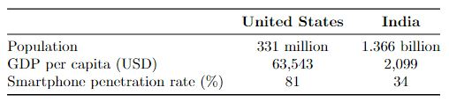
Figure 9 - Key Differences

Conclusion
This report has provided a comprehensive analysis of Apple's marketing strategies for the iPhone in the United States and India. While there are similarities in the company's segmentation, targeting, and positioning, the differences in pricing, distribution, and promotional efforts reflect Apple's understanding of the unique market conditions in each country. Apple's overall approach has been effective in maintaining its premium brand image, but the company may need to adapt its strategies, particularly in India, to increase its market share and remain competitive. Localized production, improved distribution networks, and tailored marketing efforts in India are likely to enhance Apple's presence and growth potential in the market. Apple can continue to hold a dominant position in the global smartphone market by regularly assessing and changing its marketing tactics to meet the changing market conditions and consumer preferences in both the United States and India.
In this report, we have analyzed and compared Apple's marketing strategies and organizational approaches in the United States and India. Despite the similarities in the company's focus on innovation, design, and user experience, the marketing strategies differ significantly in terms of segmentation, targeting, pricing, distribution, and promotional efforts.
Apple's marketing initiatives in the US have mainly been successful in upholding its premium brand image and luring in a devoted consumer base. In an industry that is extremely competitive, the company has shown a strong dedication to innovation, design, and user experience. Furthermore, the seamless user experience and increased customer loyalty that have been made possible by Apple's integrated ecosystem of goods and services have been extremely important.
However, there are areas in which Apple's approach in the United States can be improved. Balancing its broad targeting strategy with maintaining the brand's exclusivity is essential for the company to continue attracting high-income consumers while not diluting its brand image. Additionally, Apple should continue investing in innovation and product development to stay ahead of competitors and meet the evolving needs of consumers. Enhancing the in-store experience at its retail locations is another area where Apple can differentiate itself from competitors and provide additional value to consumers.
In India, Apple's marketing strategies and organizational approaches have had mixed results. The company has managed to establish a strong brand presence and capture a niche market segment by targeting affluent, urban consumers. Apple's tailored promotional efforts have been effective in connecting with the target audience and positioning the iPhone as a status symbol.
However, Apple's high pricing strategy in India, exacerbated by import duties and taxes, has limited its market share and growth potential in a price-sensitive market. The company's distribution network in India is less extensive than in the United States, which may restrict its ability to reach a wider audience and capitalize on the growing demand for smartphones in the country. Apple's directional development strategy, focusing on local manufacturing and expanding its distribution network, is a positive step towards addressing these challenges.
To achieve greater success in the Indian market, Apple should continue to invest in local manufacturing, expand its distribution network, and tailor its marketing efforts to the unique needs of the Indian consumer. Additionally, exploring partnerships with local financial institutions to offer financing options for its products could help Apple tap into the growing middle-class consumer base, which may be more price-sensitive but still aspires to own premium products.
In conclusion, Apple's marketing strategies and organizational approaches in both the United States and India have been largely effective but can benefit from some adjustments to better address the unique challenges and opportunities in each market. By focusing on these areas of improvement, Apple can potentially achieve greater success in both markets, ultimately driving growth and profitability for the company.
By critically evaluating the marketing strategies and organizational approaches employed by Apple in both the United States and India, we can draw valuable insights for businesses operating in diverse markets. Each market is crucial for the development of effective marketing strategies that cater to the specific needs of consumers. By continuously adapting and refining its marketing strategies, a company can maintain its competitive advantage, foster brand loyalty, and achieve long-term success in the global marketplace.

References
Apple Inc. (2020). Apple Environmental Progress Report. Retrieved from https://www.apple.com/environment/pdf/Apple_Environmental_Progress_Report_2020.pdf
Bhasin, H. (2019). Apple SWOT Analysis 2019: Apple SWOT Analysis For 2019. Retrieved from https://www.marketing91.com/swot-apple/
Choudhary, S. (2020). Apple's India Strategy: How the iPhone Maker is Trying to Win the Indian Market. Business Today. Retrieved from https://www.businesstoday.in/magazine/the-hub/apple-strategy-for-india/story/402040.html
Higgins, T. (2019). Apple Buys More Companies Than You Think—and Doesn't Talk About It. The Wall Street Journal. Retrieved from https://www.wsj.com/articles/apple-buys-more-companies-than-you-thinkand-doesnt-talk-about-it-11545828000
IBEF (India Brand Equity Foundation). (2021). Telecom Industry in India. Retrieved from https://www.ibef.org/industry/telecommunications.aspx
IBEF (India Brand Equity Foundation). (2019). Make in India. Retrieved from https://www.ibef.org/economy/make-in-india
Kumar, A., & Choudhary, M. (2019). Apple's Marketing Strategy for its iPhone in the Indian Market: An Analysis. Journal of Commerce and Trade, 14(1), 35-42. Retrieved from http://jctindia.org/april2019/v14i1-4.pdf
Meyer, P. (2017). Apple Inc.’s Marketing Mix or 4P's (Product, Place, Promotion, Price): An Analysis. Panmore Institute. Retrieved from http://panmore.com/apple-inc-marketing-mix-4ps-analysis
Pandey, S. (2021). Apple sets new iPhone sales record in India. CNBC. Retrieved from https://www.cnbc.com/2021/01/28/apple-sets-new-iphone-sales-record-in-india.html
Porter, M. E. (1985). Competitive Advantage: Creating and Sustaining Superior Performance. New York: Free Press.
Statista. (2021). Smartphone user penetration as a percentage of the population in the United States from 2010 to 2025. Retrieved from https://www.statista.com/statistics/201183/forecast-of-smartphone-users-in-the-us/
Statista. (2021). Apple's iPhone revenue worldwide from 3rd quarter 2007 to 3rd quarter 2021. Retrieved from https://www.statista.com/statistics/263401/global-apple-iphone-sales-since-3rd-quarter-2007/
Thomas, D. (2019). Apple's India growth story is just beginning, but there's a long way to go. Livemint. Retrieved from https://www.livemint.com/technology/tech-news/apple-s-india-growth-story-is-just-beginning-but-there-s-a-long-way-to-go-11575306596117.html
Varma, A. (2018). Apple's pricing strategy for India is all wrong. The Economic Times. Retrieved from https://economictimes.indiatimes.com/tech/hardware/apples-pricing-strategy-for-india-is-all-wrong/articleshow/65993696.cms
Yoffie, D. B., & Baldwin, E. (2018). Apple Inc. in 2018. Harvard Business School Case 718-494.

