Assignment- Brief Project Proposal
Name: Lewis Duggan
Student ID: 1902571
Course: Computer Games Design Bachelor Arts

Game Environment/ Level is the most important aspect in Game Design
Introduction
Environmental design lies are the foundation of what game design is. Providing the correct resources and materials to do my research I can justify why this is so important. This research is worth doing because I believe environmental artists such as myself needs to present their hard work ethic, they must help create AAA games. It's an interesting topic because environmental artists can be undervalued at times. By providing secondary research from websites articles and books, I will help people understand the principle of this role within this industry. As this industry is very competitive yet friendly, this topic is very controversial throughout this field of study. As others may imply that animators, sound technicians, game developers in general, or even the individuals which code the game used in unreal are just as important or if not more. Through my experience, I believe they are all incompatible with each other and how old predominant in their fields.
Background
Whilst undergoing secondary research using the Internet, I found a very useful source on what exactly an environmental modeler/ environmental artist does and what the job entails. Not only this it lists how you can gain experience going into this industry. The phrase 'sometimes they use photographs, or their own imagination' explains they take the initiative to build the foundation just using what they know. they can manipulate different structures or even characters using their mind. A review of a current artist working for Ubisoft as a level artist/ level designer provided a 5-star review from working at Ubisoft back in October 2018. The person stated, 'delivers on many levels, such as an easy working environment, lots of party gatherings, and open us to speak your mind, being creative, sharing in many similar interests and having many perks to boost!'. It provides a positive response for the industry and the artists themselves whilst working for the right company. In the same review section, another employee also stated the producer power was an issue. this is where it relates to being undervalued in the industry. they mention' it would be hard to get work on those big-name big bonus tiles if you do not have the friend connection referral.' Although this is from a different workplace but for the same company, it provides evidence that location can also be key for who shines whilst working in this area of study.
Research Hypothesis
To prove that a gaming environment is one of the vital components in games design/ game development to keep the player immersed in the selected game they are playing. (3D worlds only)
Research Objectives
To develop knowledge, gain information and statistics to show evidence towards my research hypothesis being proved.
To evaluate my hypothesis critically using secondary research such as online sources e.g., videos and websites for tutorials to help further with my skills creating a basic set environment for my game with the intended demographic and type of game. E.g., art style, mechanics, and timeline (futuristic or medieval, etc).
To compare the secondary resource methods (websites and possible survey results) to conclude on which gaming element they prefer or would think is most important. This could be from mechanics such as attacking animations, audio, user interface or environmental design, etc.
The main aim of this project is to undergo a series of sequences that will effective and accurate to achieve the given outcome towards my project. The project outline is to tunnel vision upon the environment within the games specifically zoning in on how the environmental movements, audio, and visual aspects are a vital component to keep the player immersed whilst playing. The main purpose of making a AAA game is to ensure that the player must feel as immersed as possible during their experience. Otherwise, if the player tends to get bored very quickly all the game is repetitive and does not live up to its name then they will stop playing. The replay value will go down and therefore eventually sales.
Project Design
My project is going to contain a small world created by myself using Unreal Engine to map out the basis and terrain for my environment. I will then provide foliage such as grass using Photoshop and then will be innovating different fabrics models and environmental assets using software such as Maya 2020, substance painter, and possibly Zbrush. Unreal Engine contains a tool to erode, build or take away terrain so I will be focusing on experimental mode after beginning with a basic overview of my level will include everything stated above along with possible audio design to help keep the player immersed. secondary research will be my main priority to help collect different methods for my objectives and what my intentions are with the data I have gathered. The data I intend to gather will be purely based on facts statistics. An example of this would be the reviews from employees and the gaming community to help understand how much looks in the game can captivate a bigger audience. I will also be using reviews from ex/ current employees on the working environment throughout different development companies such as Ubisoft or Rockstar to find out or discover what it's like to work there. Lastly, I will provide links to tutorials I will use to help me gain the knowledge and understanding to create this project. At the end of this, I will also compare certain research methods to figure out which was most effective and to see if any controversial topics can still be discussed. Some of the limitations I will encounter during this project will be to do with software management and the hardware that I own. This is because software such as Maya tends to crash, and my hardware may not handle some of the high-end renders or work in Unreal Engine. To deal with this I will ensure that my Polycount is very low on models and textures will be 2048x 2048 and no more. This is because it's very intense on my CPU and GPU therefore it could end up crashing and lose my work. Some of the legal issues I will encounter would be using other people's work as references and not citing them I will give them full credit in the bibliography to provide evidence for the research.
Resources and Planning
The main resources I will require for this project would be my computer system which is high-end specifications to try and ensure my level will be running smoothly and my models will have a good outcome etc. On top of this as mentioned above, I will be using, Maya 2020. This is a modeling software to help me with my assets dotted around the map such as buildings framework and also possibly foliage. I would also be using a substance painter. substance painter is a program that allows me to provide Intricate detail to certain models to ensure they look realistic and accurate towards my reference images. Zbrush is a sculpt in tool/ software which can allow me to create high-end Poly models as far as possible vehicles characters or foliage such as rocks. This is an easy and effective way to gain the outcome I want for the environment I'm creating. Unreal Engine provides coding software and programming languages such as C++ to piece the level together and ensure it has a start and an end. This program helps me with the user interface, audio, animations, and mechanics to ensure my level is inadequate.
Gantt Chart
A Gantt Chart is a simplistic yet effective way of using time management to ensure there is no little detail left out until use your time effectively. This also means that you can double-check what work/ tasks you have already completed on which ones you need to do. This helps save a lot of time meeting you would not do the same task twice. Along with scheduling projects who they help assess how long a project should be. It also helps determine which resources I will need to complete the project and generally helps monitor my production phase.
below is my version of the gang chart production tool:
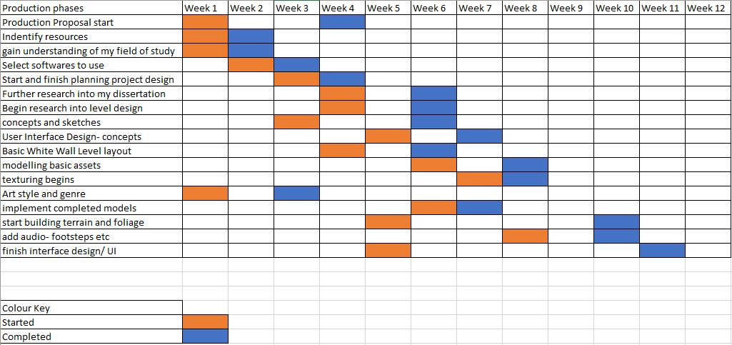

As shown above, this is my complete Gantt chart up until the Christmas period. The outline of this ensures that I have a full understanding of my project and not when I have to complete the deadlines. They started with an introduction to my proposal and finishes with the basic layout and alpha version of my gaming environment. I may switch this up ever so slightly due to time issues. such as the white wall layout of my level may be set back by a week. This does not mean I will lose track of time and I will continue to stay on top of my work.

Bibliography
ScreenSkills. 2021. Environmental Artist. [online] Available at: <https://www.screenskills.com/starting-your-career/job-profiles/games/art/environment-artist/> [Accessed 18 October 2021].
Ca.indeed.com. 2021. Working as an Artist at Ubisoft: Employee Reviews | Indeed.com. [online] Available at: <https://ca.indeed.com/cmp/Ubisoft/reviews?fjobtitle=Artist> [Accessed 18 October 2021].
Thacker, J., 2021. Five Expert Tips to Improve Your Games Environment Art. [online] Gnomon — School of Visual Effects, Games & Animation. Available at: <https://www.gnomon.edu/blog/five-expert-tips-to-improve-your-games-environment-art> [Accessed 18 October 2021].

