Component 1: Coursework: Written Report

Strategic Management and Sustainability
LCBB6004

Student Name: Izabela Ioana Stanescu
Student ID:2025868
Lecturer: Abdi Rehman
Table of Contents
1. Executive Summary 3
2. Introduction to the Strategy 4
3. Overview / Background of the Firm 5
4. Strategic Intent 6
5. The Company’s Current Performance 7
6. Strategy Analysis 8
7. Strategy Formulation 11
8. Conclusion and Recommendation 14
References 15
List of Figures
Figure 1: LIDL 5
Figure 2: BCG Matrix 11

1. Executive Summary
This report is a strategic analysis of Lidl GB, which is the UK's leading discount supermarket operator. The positioning of Lidl was discussed along with recommendations regarding the sustenance of growth and competitive advantages. Lidl's low-priced business model and cost-efficient supply chain have helped the company's financial success in sustaining its grocery market share at 7.6%. Two major factors that cause external threats to the company are Aldi with increasing competition, market pressure, and consumer awareness regarding sustainability. The report uses a wide range of strategic tools, such as Porter's Five Forces, SWOT, VRIO, and Value Chain Analysis, to analyse the internal and external environment of Lidl. It suggests a hybrid strategy, integrating both cost leadership with various means of digital transformation and sustainability efforts. Major proposals include entering e-commerce, upgrading customer experience, and improving environmental practices for greater consumer patronage. Through such ventures, Lidl will be able to maintain leadership in the marketplace, maximise profits, and have a sustainable future within the UK retail market. These strategies are meant to entrench long-term growth and productivity while keeping up with the changing trends within the industry.

2. Introduction to the Strategy
Strategic management refers to the definition of an organisation's direction and the decisions taken regarding the allocation of resources and the implementation of actions to achieve long-run objectives (White, 2017). Competitive business, Lidl GB needs strategic management to respond to market changes, pressures from competitors as well as preference changes in consumers. Strategic management enables businesses to foresee what lies ahead and provides opportunities through proactive planning. The success of this type of strategic management is that it ensures growth and profitability while supporting sustainably clear competitive advantage. Lidl will always be regarded as a leading low-cost retailer with drives innovation and efficiency by optimising resources and market realities aligned with business objectives (Rothaermel, 2019). This report will analyse the strategic position of Lidl GB in the UK retail sector with a proposed future strategy that has both internal capability and market-related options. This evidence-based analysis will count on various strategic tools to critically examine Lidl's performance at the moment, as well as the competitive environment in which it competes. Recommendations drawn from this report will strengthen Lidl's market position, ensure operational efficiencies, and enable profitability in the long term. The report has been divided into several key sections. This report begins discussing Lidl GB, providing company background, products, and sector. Then, a discussion about the strategic intent: vision, mission, and objectives of Lidl follow. Further, current performance is assessed, followed by a detailed analysis of the competitive environment with the help of Porter's 5 Forces models, and internal tools such as SWOT, VRIO, BCG and Value Chain Analysis. The report concludes with formulating strategic choices and recommending a new strategy for Lidl's future growth and sustainability. It falls well within the structured method to ensure a complete evaluation of Lidl's strategic management practices.

3. Overview / Background of the Firm
Lidl GB is the largest discount supermarket chain operating in the UK; it is a business that provides good offerings of goods, ranging from groceries and fresh produce to household items and seasonal goods. It offers quality products at competitive prices that generate a preference from cost-conscious consumers. Lidl boasts itself as having sourcing commitments to locales, with more than two-thirds of products sourced from British suppliers that help the national economy and contribute freshness to its offerings.
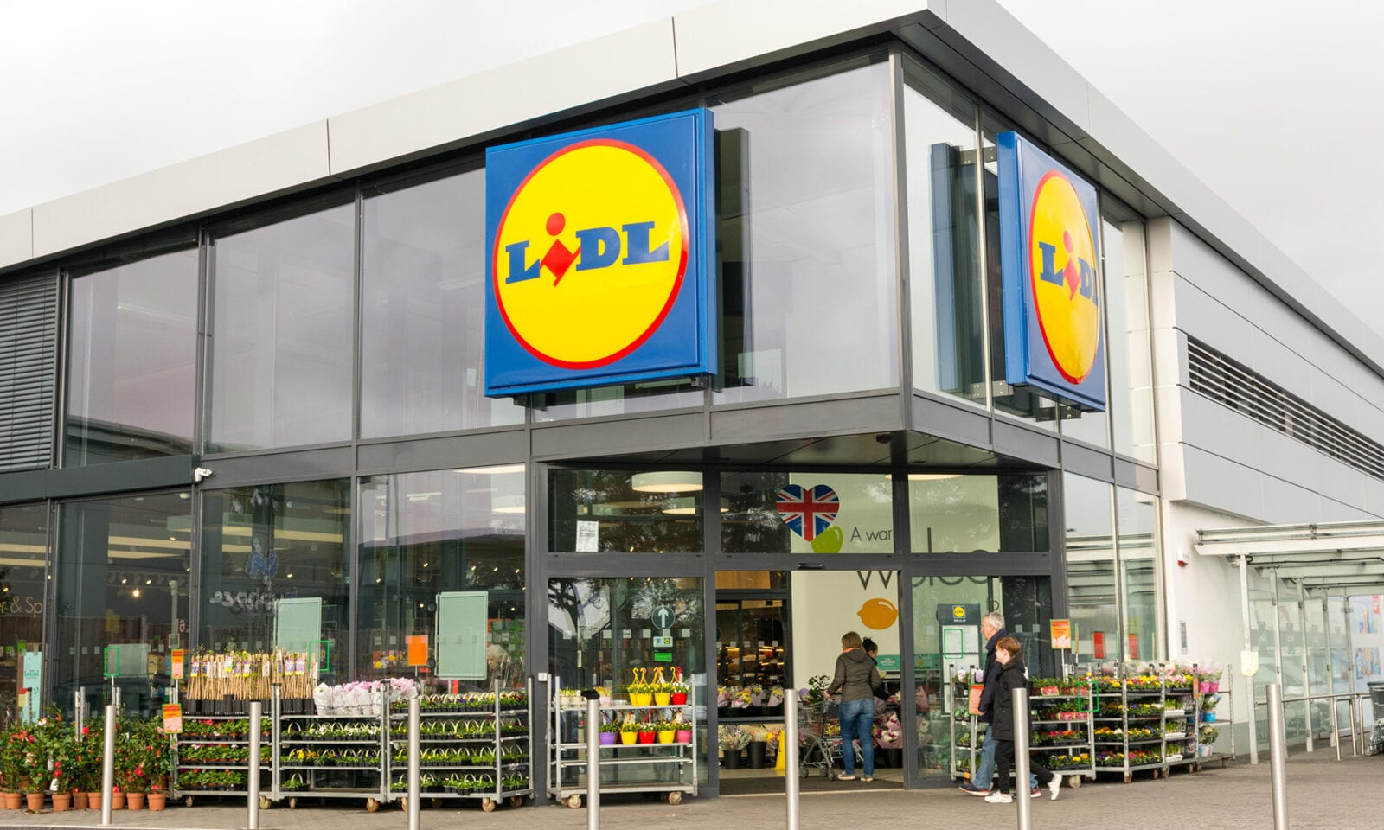
Figure 1: LIDL
Source: (www.themanc.com, 2021)
Lidl targets the food retail market in a very competitive retail industry. Since opening its first UK store in 1994, Lidl has grown to over 960 stores in Britain, with 14 regional distribution centres, ensuring seamless logistics and supply chain effectiveness. Lidl's business strategy is all about simplicity and operational efficiency to ensure savings are passed along to customers without product quality. It is because Lidl has set a precedent for a reason in emphasising affordability, and sustainability, sourcing local products, and spreading consciousness on the need for sustainability to become a great player in the UK grocery retail sector.

4. Strategic Intent
Vision:
"To be the best value retailer in the UK, focusing on delivering quality, sustainability, and affordability to customers." This vision unveiled the commitment of the company to sustain its leadership status as a low-price retailer and offer good value along with great products in a sustainable business environment.
Mission:
Lidl's mission is "To deliver high-quality products at the lowest possible prices while ensuring customer satisfaction and supporting local sourcing." This mission underlines Lidl's core focus on cost and customer service, as well as its efforts to source more than two-thirds of its products locally from British suppliers, supporting the local economies and also ensuring freshness and reliability (Shaikh, Karjaluoto, and Häkkinen, 2018).
Objectives:
Lidl should dramatically increase its UK store coverage and fill a large number of customers with greater coverage and access. Another reason is to achieve efficiency in its supply chain through technology innovation and sustainability to decrease the cost along with the carbon footprint. Lidl will also look into strengthening its sustainable initiatives in terms of ecological packaging, less waste food, and responsible sourcing. These are critical long-term development and competitiveness for Lidl in the United Kingdom market.

5. The Company’s Current Performance
Financial Performance
Lidl GB has enjoyed an unprecedented wave of financial growth over the last few years and has benefited from its strong value proposition – serving quality products at low prices. Lidl remains a market share gainer in the very competitive UK retail market, with 7.6% of the grocery market. Lidl's low-cost business model has helped it sustain profit even at uncertain economic times. It appeals well to consumers who are going for low-priced products as more and more people can afford them in times of high inflation and economic recession. Lidl achieves consistent value with healthy margins due to its local sourcing approach and efficient supply chain (Ahmed, 2021).
Operational Performance
Lidl's operational performance is an important success factor. Efficacious supply chain management practices have helped allow it to keep operational costs at a minimum while maintaining a steady supply of products. Central distribution centres combined with the just-in-time inventory approach of Lidl reduce overhead costs and wastage. Thus, the local sourcing approach of the company would have helped sustain both British suppliers and the sustainability initiatives of Lidl, through the establishment of shorter supply chains, lower transportation costs, and environmental burdens. Operational streamlining and passing the savings along to customers made Lidl a more aggressive competitor in the UK retail market.
Challenges
Challenges are ahead for Lidl, though. Lidl also faces increased competition from discounting competitor Aldi, as well as traditional players Tesco and Sainsbury's, both of which fight for market share against the major operators. On the economic front, however, Brexit has created a challenge in terms of trade, labour, and supply costs that need to be tackled. Inflation continues to pose a challenge to Lidl's promise of low prices. Over and above this, increasing demand for sustainability will confront Lidl with the challenge of improving its environmental and ethical practices, such as combating plastic usage and reducing food waste. Overcoming these challenges will be vital in continuing the momentum that has been set for the following years.

6. Strategy Analysis
6A. External Environmental Audit (Porter’s 5 Forces):
Porter’s 5 Forces:
1. Competitive Rivalry (High): The company will face the highest level of rivalry from discount food stores, Aldi and full-service grocery retailers which include Tesco, Sainsbury's, and Asda. There will be a boost in the level of rivalry in terms of prices, product variety, and store locations because competitors will seek to enhance offerings if there is a loss in the share of the market.
2. Threat of New Entrants (Low): The retail grocery market itself is quite a barrier to entry due to the massive capital required for establishing store networks along with the setting up of supply chains and brand establishments. Economies of scale further empower established firms like Lidl, which makes it difficult for new entrants to compete on price and scale (Gerard and Bruijl, 2019).
3. Bargaining Power of Suppliers (Low): Lidl's high volume as well as local purchasing policy gives the company considerable bargaining power during negotiations with its suppliers. The group sources from several suppliers, which makes it less dependent on any single supplier and cures it of the potential supplier's powers.
4. Bargaining Power of Buyers (Moderate): While Lidl emphasises low prices and quality in maintaining customer loyalty, customers have choices for groceries. Thus, buyers can easily shift to competitors if the price or product quality declines and their bargaining power is moderate.
5. Threat of Substitutes (Moderate): The retailing threat of lower prices from non-food retailers such as convenience stores and online platforms can be measured as moderate because e-retail is gaining momentum. That threat can be somewhat mitigated though, given Lidl's better value and in-store experience (Boafo, Kraa, and Webu, 2018).
B. Internal Environmental Audit (SWOT, VRIO, BCG, Value Chain):
SWOT Analysis:
- Strengths: Lidl's low-price model, efficient logistics, and excellent brand reputation make it an easy retailer that maintains high-quality products at competitive prices. This situates Lidl as a market leader in the UK grocery sector (Puyt, Lie, and Wilderom, 2023).
- Weaknesses: The company's smaller range of premium products and smaller store formats may reduce its appeal to the more high-priced consumers and limit product range compared with larger competitors.
- Opportunities: New opportunities may be exploited by Lidl through geography expansion and an increased store base. The sustainability measures, like waste minimisation and environmentally friendly operations, will also help the company since the market trend is changing toward being eco-friendly (Gurl, 2017).
- Threats: Severe competition could be a threat while a significant increase in inflation levels and changing preferences of the consumer will likely drive its pricing policy and its market share.
VRIO Analysis:
- Valuable: Lidl's cost leadership strategy source of value with efficient logistics and supply chain management is very valuable. The company can offer goods of excellent quality at attractive price levels, a crucial reason for success in the competitive retail market. Lidl makes savings trickled down from low operational costs to customers, which enhances its value proposition (Ariyani and Daryanto, 2018).
- Rare: That the kind of operational efficiency in this way can be sustained by Lidl is extremely rare in the industry. Very few competitors can achieve such a balance between low prices, high quality, and local sourcing. It only serves as a distinctive advantage in the discount supermarket segment.
- Inimitable: The logistics system of Lidl is very efficient and not easy for competitors to replicate. It creates a big hassle for rival firms regarding the huge and efficient nature of operation along with the brand reputation that has been built through time.
- Organised: Lidl is perfectly positioned to take advantage of these benefits, embracing high technologies and efficient processes with which to make its cost leadership and operational efficiency translate into strong, continuing competitive success. Its structure allows for long-term profitability and market leadership (Lopes da Costa et al., 2019).
Value Chain Analysis:
Firm Infrastructure: A centralised management structure supports cost efficiency, with streamlined decision-making processes for quick market adaptation and cost control.
Human Resource Management: Focus on lean staffing, with employee training on efficiency, ensuring productivity while minimising labour costs across stores and distribution centres (Bratton et al., 2021).
Technology Development: Investment in automated systems, supply chain technology, and store efficiencies supports Lidl’s low-cost strategy and improves overall operational performance.
Procurement: Strong supplier relationships and local sourcing ensure cost-effective procurement, reducing logistics and material costs while maintaining product quality.
Inbound Logistics:  Efficient procurement processes and strong supplier relationships, with over two-thirds of products sourced locally. | Operations:  Streamlined, cost-efficient store formats with a focus on simplicity and automation. | Outbound Logistics:  Centralised distribution centres with a just-in-time inventory system, ensure product availability while minimising stockholding costs (Liberatore and Miller, 2016). | Marketing & Sales:  Focus on value-based marketing emphasising low prices and high quality, using minimal advertising compared to competitors. | Service:  Basic but effective customer service, focusing on quick checkouts and efficient store operations.
Table 1: Value Chain Analysis
Source: (Author, 2024)

BCG Matrix
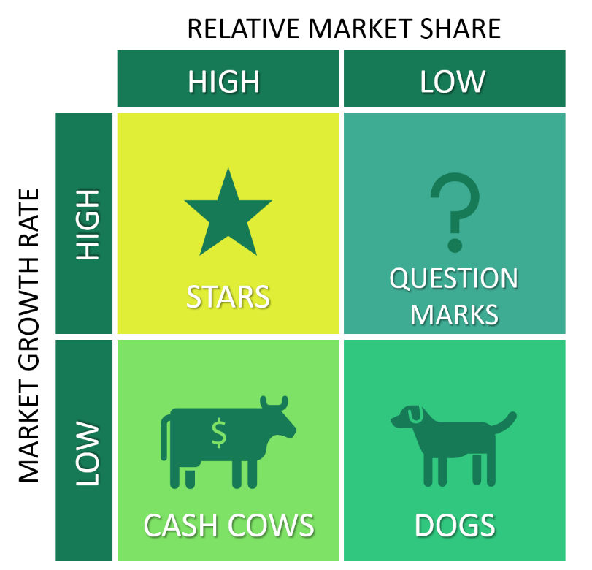
Figure 2: BCG Matrix
Source: (www.business-to-you.com, 2018)
Stars: Stars also feature fresh fruits and vegetables and everyday grocery items in the chain, the latter of which, according to the company, commands a high market share in an expanding discount retail sector.
Cash Cows: They are private-label products, especially nonperishable groceries; a good cash cow generates consistent revenue with low investment.
Question Marks: Expansion into premium product lines and non-food items such as household goods represent question marks as their future growth is uncertain (Mohajan, 2017).
Dogs: Some of them may be seasonal offerings or the tail end of some special promotions that bring in little to no revenue and are therefore likely to contribute minimally to profitability.

7. Strategy Formulation
- Market Penetration:
Open more stores in under-penetrated areas. This way Lidl would be able to capture a larger pie of the grocery market and gain prominence over the competitors such as Aldi and Tesco. The rising cost of living means that such low-priced markets would attract more consumers- especially in deprived areas. Incorporation using increasing stores' sizes is low risk but significantly capitalised on supply chain-based improvements that will help maintain efficiency as the business continues to grow (Demirci and Erkip, 2024).
- Product Differentiation:
The other is to differentiate by-products. In this sense, the company can see scope for new product lines. For instance, Lidl can differentiate based on premium or organic products. Lidl is already excellent in offering value-for-money; extending into differentiated segments could attract more high-income consumers who might be willing to pay a little more premium to buy them (Loy and Weiss, 2019)..
- Cost Leadership:
The present cost leadership approach of Lidl has well catered to the UK market. The further strengthening of this approach will help create a robust competitive advantage for Lidl. Enhanced supply chain efficiency, better deals with suppliers, and increased economies of scale would enable Lidl to continue its price leadership advantage while offering better margin returns.
Proposed New Strategy:
To beat the new market environment, Lidl needs to become a hybrid company and combine cost leadership with digital transformation as well as sustainability. A hybrid strategy shall assist Lidl cope with the current requirements to meet the pressure of increasing competition, green turbulence, and shifting consumer preferences.
- Digital Transformation:
E-commerce is changing the retailing landscape, and therefore Lidl must be included in an expansion of its presence digitally. For example, Lidl can capitalise on the increasingly popular online groceries by developing a strong online platform. This will make the business accessible to customers who prefer the digital channel and also enable it to compete with other retailers such as Tesco and Sainsbury's, which have already established an online platform. The business can also incorporate sophisticated data analytics for enhanced personal experience of customers, optimised inventory management, and amplified marketing efforts. Second, it can open up more benefits for its customers through services such as click-and-collect service or home delivery (Vial, 2021).
- Sustainability Initiatives:
Sustainability is a very important criterion to consumers, and Lidl can take the opportunity of this by enhancing the company's environmental practice. Its efforts to reduce plastic usage, improve energy efficiency in stores, and source more eco-friendly products will complement consumers who are demanding increasingly more sustainable things. Lidl can also invest in sustainable packaging and undertake a net-zero carbon supply chain.
- Improving Customer Experience:
Although Lidl caters to the low-income mass market, if the actual shopping experience inside its stores is improved, it could maintain and attract customers. Lidl can innovate the layout of its stores to make them more convenient and aesthetically pleasant, with potential smooth traffic flow and enjoyment for customers. Digital in-store solutions such as self-checkout stations or mobile applications meant to compare prices would give a modern look to Lidl's stores and appeal to the technologically more advanced customer.

8. Conclusion and Recommendation
Strong reasons why Lidl has a strong competitive position in the UK retail sector include a cost leadership strategy, an efficient supply chain, and value-focused offerings. But it is the adaptation to new challenges such as rising competition, changing consumer preferences, and sustainability pressures that can determine Lidl's ability to sustain future growth and remain competitive in an evolving market. Expansion into the yet-underserved areas will help Lidl gain a better opportunity to capture a wider share of the market since technology can assist in digital transformation and increased operational efficiency can ensure better customer service and cut down operational costs. Sustainability initiatives and community-driven efforts would also play a very crucial role in building brand loyalty, considering the growing consumer demand for environmentally friendly and socially responsible businesses. These strategic moves will also enable Lidl to develop a sustainable competitive advantage and facilitate growth for a long time in the UK market.

References
Ahmed, M., (2021). An analysis of the Impact of Brand Image on Consumer Purchase Behavior: The case of Lidl, Sweden.
Ariyani, W. and Daryanto, A., (2018). Operationalization of internal analysis using the VRIO framework: Development of scale for resource and capabilities organization (Case study: XYZ company animal feed business unit). Asian Business Research Journal, 3, pp.9-14.
Boafo, N.D., Kraa, J.J. and Webu, C.G., (2018). Porter’s five forces impact on the performance of companies in the banking industry in Ghana. International Journal of Economics, Commerce and Management, 6(8), pp.14-28.
Bratton, J., Gold, J., Bratton, A. and Steele, L., (2021). Human resource management. Bloomsbury Publishing.
Demirci, E.Z. and Erkip, N., (2024). Integrating efforts for product development and market penetration. European Journal of Operational Research, 312(3), pp.927-937.
Gerard, H. and Bruijl, T., (2019). The relevance of Porter's five forces in today's innovative and changing business environment. SSRN.
Gurl, E., (2017). SWOT analysis: A theoretical review.
Liberatore, M.J. and Miller, T., (2016). Outbound logistics performance and profitability: taxonomy of manufacturing and service organizations. Business and Economics Journal, 7(2), p.1000221.
Lopes da Costa, R., Geraldes, R. and Geraldes, J., (2019). VRIO: Static or dynamic?. Proceedings of the 2019 European Academy of Management:(EURAM 2019).
Loy, J.P. and Weiss, C., (2019). Product differentiation and cost pass‐through. Journal of Agricultural Economics, 70(3), pp.840-858.
Mohajan, H., (2017). An analysis on BCG growth sharing matrix.
Puyt, R.W., Lie, F.B. and Wilderom, C.P., 2023. The origins of SWOT analysis. Long Range Planning, 56(3), p.102304.
Rothaermel, F.T., (2019). Strategic management. McGraw-Hill.
Shaikh, A.A., Karjaluoto, H. and Häkkinen, J., (2018). Understanding moderating effects in increasing share-of-wallet and word-of-mouth: A case study of Lidl grocery retailer. Journal of Retailing and Consumer Services, 44, pp.45-53.
Vial, G., (2021). Understanding digital transformation: A review and a research agenda. Managing digital transformation, pp.13-66.
White, C., (2017). Strategic management. Bloomsbury Publishing.

