Knowledge and Information Management Skills for the Workplace
BMSW 5106

Name: Mihaiela Petreanu

Student ID: 2030622

Lecturer name: Dr. Toyin Adisa

ROLE & EXTENT OF KNOWLEDGE & INFORMATION MANAGEMENT IN CONTEMPORARY ORGANISATIONS

Executive Summary

The study highlights the knowledge management activities of Amazon, which is considered as the largest online retailer across the world. Furthermore, the study highlights the overview of the organisation and the main participant’s in the KM activities.

Furthermore, the KM approaches of the organisation and the importance of KM activities are analysed through a model. After that, the potential challenges, the operating cost and the legal requirements, which are important for KM activities are analysed in this study.
The plan to promote the KM process and sustain the position in the market is elaborated also.
Table of Contents
1.0 Introduction 3
1.1 Overview of the Organization 3
2. Participants in the contribution and collection of Knowledge 5
3. Evaluation of KM approaches of the organization and its impact on success 6
3.1 Knowledge protection 6
3.2 SECI model of Knowledge management 8
4. Explanation of the importance of KM activities in the organization 8
5. Potential challenges and opportunities to enhance the utilization of KM Strategy 10
6. Impact of new sources of knowledge 12
7. Operating costs and proper legal requirements 13
8. Plans to promote the KM Process 15
9. Conclusion 16
References 17
Task 2: Poster Presentation 20

1.0 Introduction
The study is all about one of the largest online retailers across the world Amazon. Furthermore, the study will analyse the overview and KM activities of Amazon. Furthermore, the participants of contribution and collection of knowledge will analyse in this study. In addition, the KM approaches of Amazon and the impact of KM initiatives will highlight in the study.
On the other hand, the potential challenges and the opportunities of KM system will be highlighted in this study. Furthermore, the impact of the new sources of knowledge and the operating cost, and the legal requirements will discuss. Furthermore, the panning to promote the KM system will analyse in this study.

1.1 Overview of the Organization
Amazon, Inc is the multinational American and most popular technological organization, which focuses on e-commerce, online advertising, AI, cloud computing, and many others (Bawack, et al., 2022). Furthermore, the organization was founded on 5th July 1994. In addition, the main products of this organization are any kind of electric products, watches, books, dress apparel, shoes, cards, and many others.
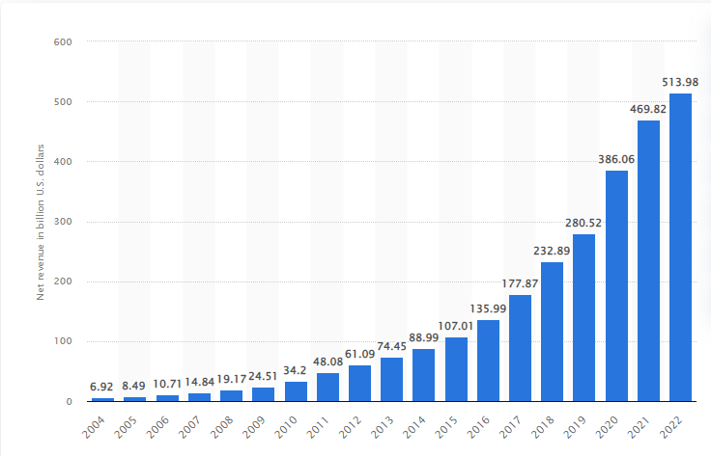
Figure 1: Amazon’s annual net sales growth from 2004-2022
(Source: Statista, 2023)
As per the above graph, the net sales of Amazon enhances gradually from 2004. Furthermore, in 2022, the net sales of it reached almost $514 bn, which increased from $470 bn in 2021 (Statista, 2023). Therefore, it can be said that it is the largest retailer in the world. In addition, for its effective knowledge management strategies, the number of employees is enhanced rapidly, which can become the key factor of its success.
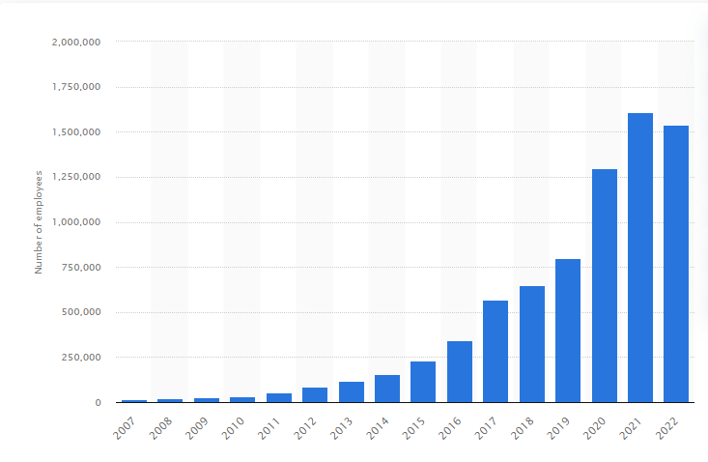
Figure 2: Total Number of employees of Amazon from 2007-2022
(Source: Coppola, 2023)
As per the above graph, the employee base of this organization getting stronger rapidly. In 2022, the total number of employees of Amazon was almost 1,541,000, which dropped down from 1,608,000 in 2021 (Coppola, 2023). Furthermore, the organization has an effective KM strategy but it is important to maintain those strategies for sustaining its position in the global market.
On the other hand, open innovation is one of the most important KM activities of Amazon. This organization supports various innovative practices, which can change the retail industry across the world. Furthermore, the innovation of the prime option on the platform of the organization helps customers to connect with various products of other organizations in the retail industry (Mostaghel, et al., 2022). Apart from that, “Prime guarantees users” free shipping for almost 1000 items, which makes Amazon a reputed and global brand. Furthermore, the development of the website of this organization makes shopping easier or smoother. On the other hand, the innovation of the dash button of the organization provides a unique online shopping experience to the customers.
Furthermore, it can be said that the external KM strategy helps Amazon to promote its business operations through the innovative system. Furthermore, cloud computing is another important innovation of Amazon, which helps the organization develop its web services (Borge & Poonia, 2020). In addition, it can be said that open innovation is the External knowledge management approach of this organization, which helps it to maintain its position in the global market.

2. Participants in the contribution and collection of Knowledge
There are various people, who have a major role in the collection and the contribution of knowledge. Furthermore, knowledge managers of an organization become accountable for the management and the acquisition of various internal and external knowledge (Lam, et al., 2021). Therefore, in Amazon, the role of the knowledge manager is to set the proper strategies or standards, or goals to enhance the efficiency of the business operations. Furthermore, in Amazon, the knowledge manager looks after the administrative function of the knowledge based on the various categories.
On the other hand, the knowledge manager also focuses on the innovation rate of Amazon and tracks the progress or the performance of the employees to achieve the goal and sustain the position in the market. Furthermore, knowledge managers also gather relevant or authentic knowledge regarding the market trend or the customer demand for enhancing the performance of the employees. On the other hand, Knowledge navigators are responsible for knowing the location where the knowledge can be utilized for the sake of the development of the organization (Konno & Schillaci, 2021). Furthermore, the knowledge managers or navigators gather the data of the user's experience on the development of the business operations. In addition, implementing the core KM principles is also the role of the knowledge manager to enhance the efficiency of the KM strategies.

3. Evaluation of KM approaches of the organization and its impact on success
Knowledge management is a proper approach to organizing, properly identifying, and storing information within the organization (Oliva & Kotabe, 2019). Furthermore, three are three main factors of knowledge management such as storing, sharing, and accumulating knowledge. There are various pros and cons of KM, which have an impact on the business operation of an organization. This strategy helps the organization to enhance its decision-making ability and innovation rate.
Furthermore, KM helps to enhance the communication skill of employees and develop the business process. On the other hand, the major cons of it are it needs huge time and up-to-date to become effective, which sometimes creates a problem for the organization. Amazon has various KM approaches, which ensure its success in the global market.

3.1 Knowledge protection
Amazon properly employs encryption, which helps it to maintain a positive relationship with its customers. Furthermore, this organization maintains electronic, physical, and procedural safeguards in the proper connection to the collection, disclosure, and storage of the personal data of the users (Tadayon, 2020).
Furthermore, this organization uses various rigorous processes, which handle the privacy of the confidential information of the customers. In addition, the formal and informal networks of the organization help it to achieve a competitive advantage in the market.
On the other hand, Amazon uses various advanced technologies, which ensure the success of it.
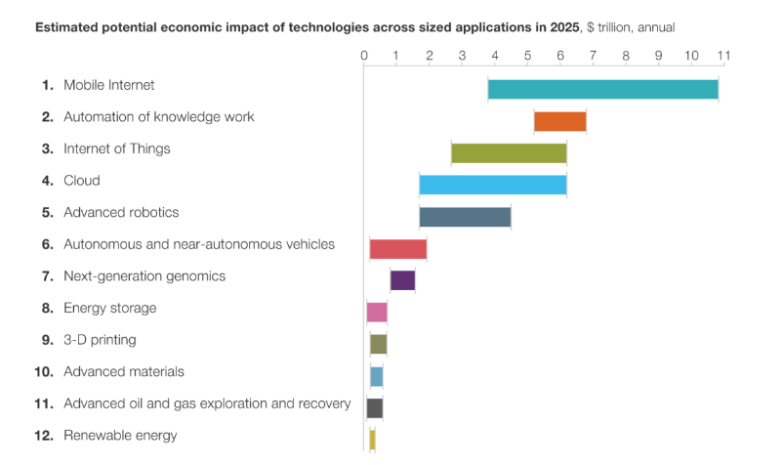
Figure 3: Advanced Technologies used by Amazon
Source: (Swannell, 2020)
As per the above graph, it is highlighted that Amazon uses IoT, Mobile Internet, cloud computing, and various autonomous and near-autonomous vehicles for enhancing its innovation rate, which is a significant factor in the knowledge management approach. On the other hand, this organization uses AI in their various services and products such as prime video or e-commerce marketplace, which ensures the success of Amazon.
Furthermore, Amazon Dash, which is an internet-enabled button helps this organization to understand the buying behaviour of its customers (Nijhawan & Dahiya, 2020). On the other hand, this organization has an approach to invest more in various intangible assets like algorithms, Alexa and many others help it to gain a competitive advantage in the global market. Furthermore, “Amazon Web Services” is an important infrastructure as a service provider.
Furthermore, it was launched in 2006 and for that reason, the organization became popular as the first one in the market with an advanced cloud infrastructure, which helped the organization to become more competent than its competitors. In recent times, Amazon has taken another KM approach, which ensures the success of it. Furthermore, this organization develops “delivery drones”, which can fly almost 15 miles and can deliver packages of almost 5 pounds to customers in less than 30 minutes (Alkouz, et al., 2021). It is considered the most important and biggest innovation of Amazon. It helps the organization to minimize its dependency on the third party to deliver the products. Furthermore, it is observed that in 2019, this firm filed more than 2000 patents for various autonomous vehicles and drones through its patent portfolio.

3.2 SECI model of Knowledge management
The SECI model can analyze the knowledge management approaches of Amazon through its various steps. Furthermore, this model has four important steps through which an organization can manage the knowledge. The first factor is socialization which defines how to share knowledge through imitation, practice, participation in various formal and informal ways, and observation within the organization (Adesina & Ocholla, 2019). Furthermore, through formal and informal practices, Amazon manages the information of the customer properly.
On the other hand, Amazon devises various strategic approaches to externalize the information into its knowledge system and this step is known as externalization. Therefore, in the third step, the firm integrates the relevant information into the knowledge system, which is known as combination (Sardjono & Firdaus, 2020). Finally, the last step of this model, internalization helps Amazon to gather the relevant information and embody the explicit into the tacit knowledge.

4. Explanation of the importance of KM activities in the organization
There are various incentives to participate in KM activities for the further development of the organization. Furthermore, incentives and other rewards are properly designed by Amazon to encourage the performance of students and it also helps in the participation rate in the KM activities (Hur, et al., 2021).
Furthermore, the incentives are based on employee performance, profitability, promotion requirements, competitive rankings, and many others. Furthermore, Amazon specifies that those who Excel to achieve the game goals can receive high-performance ratings and promotions. On the other hand, the organization needs to ensure that knowledge-sharing behaviours become consistently demonstrated in the higher-level position.
The HRM department of Amazon helps the organization to reward or provide incentives such as money or prizes to the contributors, leaders, and top employees who achieve targets. Incentives are defined to provide attention, admiration, and respect to others, especially leaders, managers, and top employees. The leaders of the organization sometimes provide various non-financial recognition for the contributions of the employees (Chi, et al., 2023).
On the other hand, competitive rankings are another incentive program within the workplace. Therefore to gain the advantage of the competitive nature a proper incentive system needs to be implemented to award points for the proper and desired behaviours. This point awarded needs to be used for the recognition or demonstrating achievement of the goals for the review of the performance and promotions. Furthermore, Amazon provides various gift cards to employees and customers, which boosts the morale of employees and smooths payment disbursement.
The organization needs to invest in the knowledge project for the further improvement of the business operations. Knowledge management helps the organization maintain a collaborative culture, which helps to motivate employees to enhance their performance. On the other hand, knowledge management allows the organizational teams to get access to relevant information and authentic resources to enhance their business operational skills and maintain their position in the global market (Abusweilem & Abualoush, 2019).
Furthermore, the investment in knowledge project helps the organization to retain knowledge for future use, which enhance the working experience of the employees. Therefore, it reduces the number of repetitive works, which increases business efficiency. Amazon invests in “Amazon Web Services”, and makes it the leader in the cloud infrastructure.

Figure 4: Global Cloud Market
(Source: Richter, 2023)
As per the above graph, almost 32% market share of AWS makes it the leader in the market share of cloud infrastructure (Richter, 2023). Furthermore, Amazon invests more in AWS for the further development of the Knowledge Project. On the other hand, AWS dominates the cloud infrastructure market, which makes Amazon the most unique brand in the retail industry.

5. Potential challenges and opportunities to enhance the utilization of KM Strategy
An organization needs to develop the knowledge management process for the further development of the business operation. Furthermore, there are some challenges, which prevent the use of KM for the development of an organization.
The unavailability of adequate employee motivation is one of the most significant challenges to using KM in the business process of an organization (Bitkowska, 2020).
Furthermore, sometimes, it becomes difficult to motivate the employees to share their opinion or knowledge within the group portal. The organization needs to ensure the culture within the workplace to motivate the employees. On the other hand, employee resistance to implementing or adopting the new technology is another major challenge to the use of KM. The employees can resist implementing the new technologies within the KM system, which can hamper the development of this approach.
Furthermore, to implement the KM, a huge amount of time is required, which is the most effective challenge for the organization. Furthermore, it needs huge effort to maintain and be up-to-date always, which becomes challenging sometime to handle. On the other hand, organizational culture creates major challenges to implementing the effective knowledge management process for the development of business operations. Furthermore, the organization needs to maintain a collaborative culture and reward the employees for their performances, which helps to motivate them and ensure success.
An organization needs to develop the knowledge management process for the further development of the business operation. Furthermore, there are some challenges, which prevent the use of KM for the development of an organization.
Apart from that, the implementation of knowledge management provides the opportunity to maximize profitability. Furthermore, the use of KM helps the organization to design properly the business operations and team. Therefore, it enhances the decision-making ability and team management skills of the organization (Abubakar, et al., 2019).
On the other hand, KM helps an organization to establish a collaborative attitude within the workplace, which enhances the speed of innovation for the further success of the business operation. Therefore, setting a clear goal and helping to achieve it is the biggest opportunity for the use of KM. On the other hand, the most important opportunity, that the use of KM provides is the enhancement of problem-solving skills.
Furthermore, the development of the problem-solving skill of the organization helps to enhance the innovation rate and the performance of the employees. In addition, the knowledge management approach provides the employees with extra knowledge through the effective practices of knowledge capture. Furthermore, by using effective KM, the organization can easily find information and track all the progress and operations of the business. Furthermore, these factors help Amazon to have an effective KM system for the further development of the organization. Amazon uses various user experiences to maintain the needs of the employees and develop its business operations (West, 2019). It is one of the most significant KIM approach and the tendency of Amazon to entertain the feedback or suggestions from customers and employees across the world make it a unique retailer across the world. The Unique KM of Amazon helps to maintain its brand image in the competitive global market.

6. Impact of new sources of knowledge
There are various tools, through which new products can be identified in Amazon. Furthermore, “Product Opportunity Explorer” is a proper tool, which assists the sellers of Amazon to generate new ideas for the new product as per the demand of customers (Amazon, 2023). Furthermore, this tool helps the organization to identify the behaviour of the customers and the opportunity of the new product. Furthermore, through the use of the advanced tool, the organization always gets up-to-date regarding the market trend or customer demand.
Therefore, this tool provides the sellers of the organization with more data to expand properly the catalogue. Furthermore, the organization wants to make sure to simplify the process for the sellers so that the sellers can get authentic or accurate data. Furthermore, it is also stated that this organization uses the aforementioned tool in various ways. In addition, Amazon uses this tool for finding new opportunities and make the proper market plan for the brand image.
On the other hand, this tool uses niches to gather various terms and products, which represent the demand or need of a specific customer group (Amazon, 2023). On the other hand, “customer review insights” reviews the customer's opinion, and the organization can understand the love of the customers for the features of the product. Furthermore, Insights helps to understand the definite dynamic in the niche, the potentiality of the new products, and the customer experiences.
On the other hand, Amazon uses a “direct distribution strategy” to distribute its products to clients, stakeholders, or various business partners. Furthermore, this organization sells its products to customers through its websites directly, which helps to maintain the customer engagement process properly. Furthermore, the organization has a huge and effective network of warehouses and other fulfilment centres, which help it to ship new products smoothly to customers across the world.
Furthermore, the “intensive distribution strategy” of Amazon helps to launch the new product and distribute it to the stakeholders to enhance the existing offerings, which can attract new potential customers (Geiger & Gross, 2021). Furthermore, through various distribution strategy, the organization maintains its brand value and provide the products or services to the customers at the proper time.

7. Operating costs and proper legal requirements
Knowledge management is considered to be a framework that can facilitate the financial health of companies through a systematic exploration of ideas. In the case of e-retailing and e-commercial activities, the involvement of the employees is considered to be a potent factor for the companies. It is noted that satisfiability representation (SAT) is a major factor that is followed by Amazon in the process of developing business strategies and excelling in the application of ANN (Amazon Neural Network) (Zamri, et al., 2020).
As a result, the application of retention policies is considered to be a major factor that can stabilize the operational costs and expenses for the companies. Employee values and corporations are considered to be a major factor that can ensure the position of the companies and assist to retain their economic standings. Knowledge management is considered to be the primary support that can control employee churn and manage the systematic progression of performance through assessing employee participation. The influence of data management and transferable opinion to the management through analysis is considered to be the major factor that is followed by Knowledge management frameworks that are adopted by the companies (Abbas & Kumari, 2021) .
No such exception is seen in the case of Amazon, where a passive contribution of knowledge management is seen to lower the operational cost through retaining employees. Therefore, the KM application is considered to play a docile role in the process of resolving the operational cost burdens of Amazon.

It is further noted that prediction and forecasting are also considered to be a major factors that can ensure the development of the companies. The analysis of the market, the trend, and the predictive decisions related to the efficiency of the companies are mainly developed through the application of advanced data-driven options. For example, the Big Data application to take market decisions and take proactive expansion processes through calculating risks are considered to be a part of the business strategy of Amazon (Wang, et al., 2021).
Bridging the gap through maintaining the algorithmic bias is considered to be a major factor that is followed by Amazon which determines its development through data analysis. The application of a knowledge management framework to control development is mainly done through sharing real-time data and assessing the data by distributing them to the delegated employees. It is noted that knowledge management is considered to be a major process that can ensure development through a systematic data development process (Manesh, et al., 2020).
Therefore, the data-driven application is considered to be a major factor that can reduce operating risks and therefore, lower the cost of the companies.
On the other hand, there are some legal requirements, which are important for implementing knowledge management for the development of the organization.
Furthermore, the legal department of Amazon maintains and improves the report guidelines for the employees and takes action against those who want to violate the guidelines. Furthermore, equal opportunity and reducing discrimination is the major legal policy of the organization to enhance the efficiency of KM (Van Knippenberg, et al., 2020).
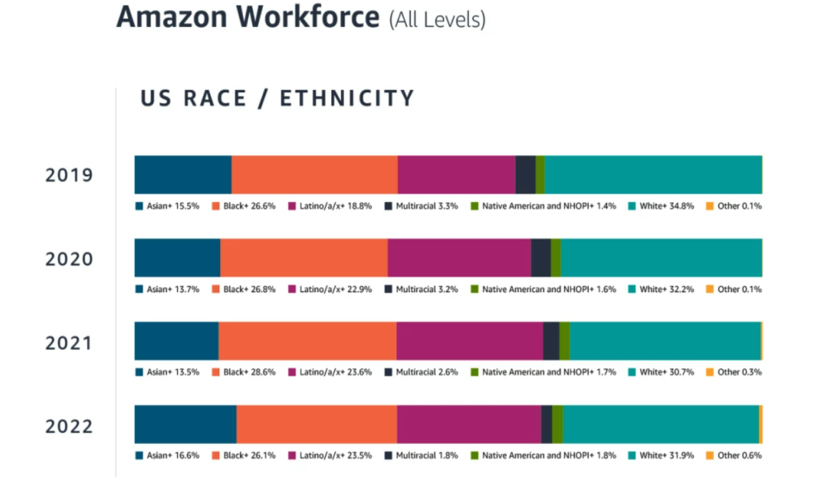
Figure 5: The Workforce of Amazon
Source: (Amazon, 2023)
As per the above image, various people differ in various religions and have a connection with the Amazon. It is noted that by maintaining the legal policy, the organization wants to maintain a multicultural attitude for enhancing the innovation rate for the further development of the business operation. Amazon provides a healthy and safe positive environment to the employees. Furthermore, the organization also makes a policy that employees cannot provide any illegal payments to various government officials through a third party.

8. Plans to promote the KM Process
Amazon has a unique knowledge management strategy, which makes it the leading e-commerce sector across the world. Furthermore, the investment of this organization in the KM process helps it to enhance the innovation rate for further development. On the other hand, Amazon needs to take some effective strategies to sustain the strategy to mitigate future challenges. Furthermore, the organization needs to keep things smooth and simple for the stakeholders or business partners, which helps to understand the business process and the product can easily reach out to the customers.
On the other hand, Amazon needs to involve the employees in the process of the KM to enhance its efficiency. Furthermore, the feedback or the suggestion of the employees, who belonged to various culture helps the organization to get innovative idea for sustaining the KM strategy (Mahdi & Nassar, 2021). Therefore, the organization tries to maintain a cross-culture attitude within the workplace, and for that reason, Amazon needs to set up proper guidelines and minimize cultural barriers. It helps to maintain a positive knowledge-sharing environment for the development of the organization. In the future, it helps to mitigate the challenges and achieve a competitive advantage in the global market.
Furthermore, Amazon entertains the feedback of the customers, which helps to identify the flaws of the business operations and rectify those (Wankhade, et al., 2022). In that case, the organization needs to maintain consistency to entertain feedback or suggestion, through the development of advanced technology; the organization needs to enhance its website for attracting potential customers by sharing information regarding the innovation.

9. Conclusion
Amazon has a unique KM strategy, which helps to sustain its position and brand image. Furthermore, the unique distribution channels help to maintain the KM strategy in the global market. Therefore, open innovation, AWS, Amazon Dash, and many other KM approaches help to maintain the brand image of the organization. In addition, through the cross-culture attitude, the organization can enhance the innovation rate to sustain the KM approaches.

References
Abbas, J. & Kumari, K., 2021. Examining the relationship between total quality management and knowledge management and their impact on organizational performance: a dimensional analysis. Journal of Economic and Administrative Sciences, 39(2), pp. 426-451.
Abubakar, A., Elrehail, H., Alatailat, M. & Elçi, A., 2019. Knowledge management, decision-making style and organizational performance.. Journal of Innovation & Knowledge,, 4(2), pp. 104-114..
Abusweilem, M. & Abualoush, S., 2019. The impact of knowledge management process and business intelligence on organizational performance.. Management Science Letters, 9(12), pp. 2143-2156.
Adesina, A. & Ocholla, D., 2019. The SECI Model in Knowledge Management Practices: Past, Present and Future.. Mousaion, 37(3).
Alkouz, B., Shahzaad, B. & Bouguettaya, A., 2021. Service-based drone delivery.. In 2021 IEEE 7th International Conference on Collaboration and Internet Computing (CIC), pp. 68-76.
Amazon, 2023. Identify new product ideas and improve product offerings with Product Opportunity Explorer. [Online]
Available at: https://sell.amazon.com/blog/product-opportunity-explorer
[Accessed 7.8.23 August 2023].
Amazon, 2023. Our workforce data. [Online]
Available at: https://www.aboutamazon.com/news/workplace/our-workforce-data
[Accessed 7.8.23 August 2023].
Bawack, R., Wamba, S., Carillo, K. & Akter, S., 2022. Artificial intelligence in E-Commerce: a bibliometric study and literature review.. Electronic markets, 32(1), pp. 297-338..
Bitkowska, A., 2020. The relationship between Business Process Management and Knowledge Management-selected aspects from a study of companies in Poland. Journal of entrepreneurship, management and innovation,, 16(1), pp. 169-193..
Borge, S. & Poonia, N., 2020. Review on amazon web services, google cloud provider and microsoft windows azure. Advance and Innovative Research,, p. 53.
Chi, H., Vu, T., Nguyen, H. & Truong, T., 2023. How financial and non–financial rewards moderate the relationships between transformational leadership, job satisfaction, and job performance. Cogent Business & Management, 10(1), p. 2173850..
Coppola, D., 2023. Number of Amazon.com employees from 2007 to 2022. [Online]
Available at: https://www.statista.com/statistics/234488/number-of-amazon-employees/
[Accessed 7.8.23 August 2023].
Geiger, S. & Gross, N., 2021. A tidal wave of inevitable data? Assetization in the consumer genomics testing industry. Business & Society, 60(3), pp. .614-649.
Hur, J., Lee-Yoon, A. & Whillans, A., 2021. Are they useful? The effects of performance incentives on the prioritization of work versus personal ties. Organizational Behavior and Human Decision Processes, Volume 165, pp. .103-114.
Konno, N. & Schillaci, C., 2021. Intellectual capital in Society 5.0 by the lens of the knowledge creation theory. Journal of Intellectual Capital, 22(3), pp. 478-505..
Lam, L., Nguyen, P., Le, N. & Tran, K., 2021. The relation among organizational culture, knowledge management, and innovation capability: Its implication for open innovation. Journal of Open Innovation:Technology, Market, and Complexity, 7(1), p. 66.
Mahdi, O. & Nassar, I., 2021. The business model of sustainable competitive advantage through strategic leadership capabilities and knowledge management processes to overcome covid-19 pandemic.. Sustainability, 13(17), p. 9891.
Manesh, M., Pellegrini, M., Marzi, G. & Dabic, M., 2020. Knowledge management in the fourth industrial revolution: Mapping the literature and scoping future avenues. IEEE Transactions on Engineering Management, 68(1), pp. 289-300..
Mostaghel, R., Oghazi, P., Parida, V. & Sohrabpour, V., 2022. Digitalization driven retail business model innovation: Evaluation of past and avenues for future research trends. Journal of Business Research,, Volume 146, pp. 134-145..
Nijhawan, G. & Dahiya, S., 2020. Role of COVID as a Catalyst in increasing adoption of OTTs in India: A Study of evolving consumer consumption patterns and future business scope. Journal of Content, Community and Communication,, 12(6), pp. 298-311.
Oliva, F. & Kotabe, M., 2019. Barriers, practices, methods and knowledge management tools in startups. Journal of knowledge management, 23(9), pp. .1838-1856.
Richter, F., 2023. Big Three Dominate the Global Cloud Market. [Online]
Available at: https://www.statista.com/chart/18819/worldwide-market-share-of-leading-cloud-infrastructure-service-providers/
[Accessed 7.8.23 August 2023].
Sardjono, W. & Firdaus, F., 2020. Readiness model of knowledge management systems implementation at the higher education. ICIC Express Letters, 14(5), pp. 477-487..
Statista, 2023. Annual net sales revenue of Amazon from 2004 to 2022. [Online]
Available at: https://www.statista.com/statistics/266282/annual-net-revenue-of-amazoncom/
[Accessed 7.8.23 August 2023].
Swannell, R., 2020. Case study on Amazon’s approach to innovation and competition in the knowledge economy. [Online]
Available at: https://rogerswannell.com/blog/case-study-on-amazons-approach-to-innovation-and-competition-in-the-knowledge-economy/
[Accessed 7.8.23 August 2023].
Tadayon, A., 2020. Preservation Requests and the Fourth Amendment. Seattle UL Rev., Volume 44, p. 105.
Van Knippenberg, D., Nishii, L. & Dwertmann, D., 2020. Synergy from diversity: Managing team diversity to enhance performance. Behavioral Science & Policy, 6(1), pp. 75-92..
Wang, R. et al., 2021. Bridging physics-based and data-driven modeling for learning dynamical systems. In Learning for Dynamics and Control, pp. 385-398).
Wankhade, M., Rao, A. & Kulkarni, C., 2022. A survey on sentiment analysis methods, applications, and challenges. Artificial Intelligence Review, 55(7), pp. 5731-5780.
West, E., 2019. Amazon: Surveillance as a service.. Surveillance & Society,, 17(1/2), pp. 27-33.
Zamri, N. et al., 2020. Amazon employees resources access data extraction via clonal selection algorithm and logic mining approach.. Entropy, 22(6), p. 596.

Task 2: Poster Presentation


