

Cover Page

BSc Health and Social Care
Module: Changemakers: Creativity and Value Creation
Module code: BMHP5014
Student: Arlette Kanga
Student Number: 2420910
Lecturer:
Internal Verifier:
Dr Eleni Koutsogeorgou-Andreau
Assignment Title:
Component 1: Online
Portfolio of Set Exercises
Word equivalent): count for 2,000 words (+/-10%)
Submission deadline: Monday 6 July 2026 14:00 (2PM) - (Week 9)
Return date provisional marks & written feedback: of Monday 3rd August 2026

Task 1 – Concept Map
Create a concept map that outlines the relationship between creativity, value creation, and health and social care improvement. Within the concept map explain how these concepts interact in a health and social care context (250 words).
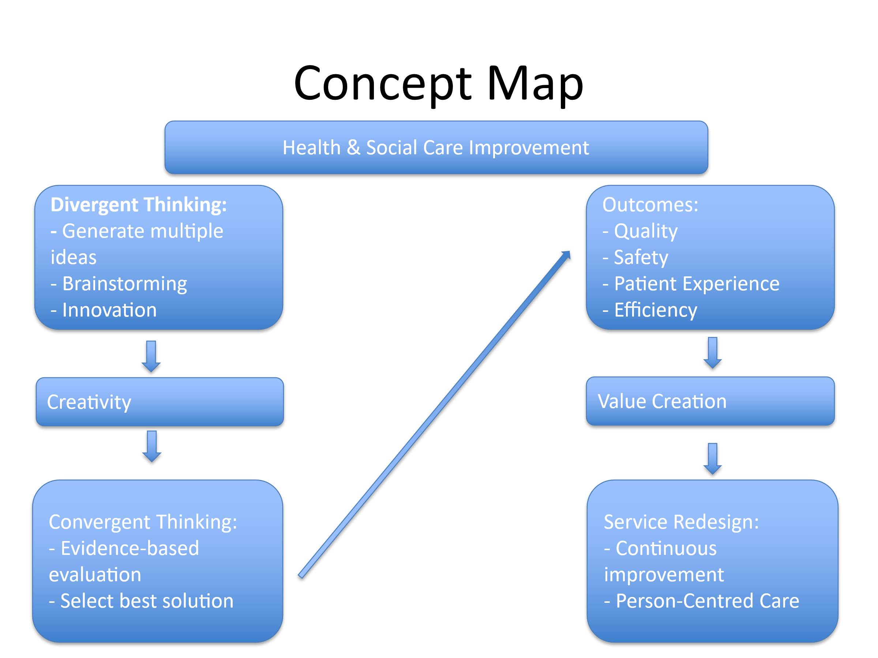

Creativity is a key driver of innovation within health and social care, enabling organisations to develop effective solutions to complex challenges. It involves both divergent and convergent thinking, which work together to support problem-solving and service improvement. Divergent thinking encourages practitioners to generate a wide range of ideas, explore different possibilities and consider innovative approaches to care delivery. This process promotes creativity, flexibility and the identification of new opportunities for improvement. Convergent thinking, in contrast, involves evaluating these ideas through critical analysis, professional judgement and the use of evidence to determine the most effective and practical solution (West et al., 2017).

The combination of these thinking processes contributes to value creation by improving patient outcomes, enhancing service quality and increasing organisational efficiency. Value creation is an important objective within contemporary health and social care because services are expected to provide high-quality, person-centred care while making the best use of available resources. Through creative and evidence-based decision-making, organisations can develop interventions that meet the needs of service users and improve overall performance.
Research suggests that organisations with supportive and innovative cultures are more likely to achieve improvements in care quality and organisational effectiveness (West et al., 2017). Furthermore, value creation in healthcare has been linked to innovation, collaboration and organisational learning, all of which contribute to sustainable service improvement (Peng et al., 2022). Therefore, creativity and value creation play a significant role in driving continuous improvement across health and social care services.

Task 2 - Self-Reflection of Group Activity
Complete a self-Reflection on the Convergent/Divergent paperclip thinking class activity using a reflective model (250 words, 1 source)

Using Gibbs' Reflective Cycle (1988), this reflection explores my experience of the convergent and divergent paperclip thinking activity.
During the activity, my group was asked to generate as many uses as possible for a paperclip before selecting the most practical ideas. Initially, we used divergent thinking, which encouraged creativity and the free generation of ideas without criticism. Team members suggested both conventional and unconventional uses for a paperclip, ranging from fastening papers to creating small tools and craft items. This stage demonstrated how creativity can help generate multiple solutions to a single problem.
I found the activity enjoyable and engaging because it allowed everyone to contribute ideas. However, I noticed that some participants were hesitant to share unusual suggestions at first, possibly due to a language barrier or fear of being judged. As the discussion progressed, the group became more confident and collaborative.
The activity highlighted the importance of balancing divergent and convergent thinking. While divergent thinking enabled us to produce a wide range of ideas, convergent thinking was necessary to evaluate those ideas and identify the most realistic and effective options. This process reflected how decisions are often made within health and social care, where creative solutions must be assessed against evidence, practicality and service user needs.
Overall, the activity improved my understanding of problem-solving and teamwork. In future group activities, I will encourage open discussion during the creative stage while ensuring that ideas are later evaluated systematically to support effective decision-making (Gibbs, 1988).

Task 3 - Case Study of a UK innovation
Write a concise case study analysis of an innovative project or initiative within the NHS or UK social care. Focus on how creativity was used to drive change and the value it created for patients or service users (400 words, 2 sources).

Case Study Analysis: The NHS App as an Innovation in Health and Social Care
The NHS App is a significant digital innovation that has transformed how patients access healthcare services across England. Developed as a digital ‘front door’ to the NHS, the app allows users to book and manage appointments, order repeat prescriptions, view health records and access test results through a single platform. This initiative demonstrates how creativity can be used to address longstanding challenges within health and social care, including accessibility, communication and service efficiency (GOV.UK, 2024).
Creativity played a central role in the development of the NHS App by reimagining how healthcare services could be delivered in a more convenient and patient-centred way. Rather than relying on traditional methods such as telephone calls, letters and face-to-face administrative processes, the NHS introduced a digital solution that empowers patients to manage aspects of their own care. This innovative approach reflects divergent thinking through the generation of new ideas for service delivery and convergent thinking through the selection and implementation of a practical, evidence-based solution.
The value created by the NHS App is evident in both patient and organisational outcomes. Patients benefit from greater control over their healthcare, improved access to information and increased convenience when managing appointments and prescriptions. The app has also helped reduce pressure on healthcare services by decreasing administrative workloads and enabling patients to access services independently. According to NHS England, millions of patients now use the app to view appointments, prescriptions and health records, helping to improve productivity and reduce missed appointments (NHS England, 2026). Furthermore, the expansion of app-based services has supported more efficient use of staff time and resources across NHS organisations (GOV.UK, 2024).
In conclusion, the NHS App demonstrates how creativity can drive meaningful change within health and social care. By introducing a digital and patient-centred approach to service delivery, the initiative has created value for both patients and healthcare providers. This case study highlights the importance of innovation in improving service quality, accessibility and efficiency within modern healthcare systems.
Task 4 - Research Task
Identify a current issue in health and social care (e.g. e.g., mental health stigma, access to care for vulnerable populations). Find two pieces of academic research (journal articles) that explain the reason for this problem. Paraphrase the findings of each article (300 words, 2 sources).

A critical issue within contemporary health and social care is mental health stigma, which continues to create barriers to care-seeking, devalues service users and compromises overall care quality. To understand the underlying mechanisms driving this problem, two academic sources were evaluated.

The first study, by Henderson et al. (2013), investigated the structural and social roots of mental health stigma. The researchers found that stigma operates in multiple ways, including public stigma from the general population and self-stigma experienced by the individual. Their findings indicate that fear of social exclusion and negative stereotyping can cause individuals to delay or avoid seeking professional mental health support. This can lead to worsening conditions and an increased long-term burden on health services.
The second study, by Knaak et al. (2017), examined mental health stigma among healthcare providers. The research found that health and social care professionals may hold implicit biases towards individuals with mental illness. The authors suggest that these attitudes may be influenced by limited behavioural skills training, workplace burnout and negative clinical cultures. This form of internal healthcare stigma can contribute to diagnostic overshadowing, where physical symptoms are wrongly attributed to a person’s mental illness, leading to poorer outcomes and reduced trust in services.
Together, these studies show that stigma is not merely a social issue but a systemic barrier embedded within both communities and healthcare institutions. This demonstrates the need for targeted cultural, educational and behavioural interventions within health and social care practice.

Task 5 - Podcast
Record a two-minute Podcast introducing your idea for component 2 using https://www.rev.com/onlinevoicerecorder The MP3 audio must be downloaded and embedded as a file (see guidance video on how to do this here: https://www.youtube.com/watch?v=D21isId0agw) or an accessible OneDrive link if using a chromebook (make accessibility – anybody) before inserting into your portfolio. Check the accessibility of the link before submitting.

Link to audio: https://www.rev.com/app/file/NmE0YTgzODk5YjU2NzcyOTA4NDVkMmRleDY2Q3BIUUNLV2wy

Task 6 - NHS Leadership Framework Analysis
Write a short summary (200 words) explaining the key components of the NHS Leadership Framework. Then, choose one component and describe (150 words) how a leader might use it to encourage creativity and improve care in the NHS (2 sources).

Part 1: Summary of the NHS Healthcare Leadership Model
The NHS Healthcare Leadership Model outlines the core behavioural dimensions required to deliver high-quality, compassionate care across the health system. The model is structured around nine interconnected dimensions: Inspiring Shared Purpose, Leading with Care, Evaluating Information, Connecting Our Service, Sharing the Vision, Engaging the Team, Holding to Account, Developing Capability and Influencing for Results (NHS Leadership Academy, 2013).
Rather than viewing leadership as a trait limited to senior executives, the model presents leadership as a shared responsibility for staff at all levels. It shifts attention away from rigid top-down command structures towards distributed and relational leadership. The dimensions emphasise self-awareness, emotional intelligence, collaboration and service improvement. Ultimately, the model serves as a behavioural framework to guide decision-making, strengthen teamwork and support the delivery of patient-centred care.

Part 2: Application to Encourage Creativity and Improve Care
A healthcare leader can apply the dimension of Engaging the Team to encourage creativity and improve care within the NHS. To support creative problem-solving, a leader must create a psychologically safe environment in which team members feel confident sharing new ideas without fear of criticism. This helps staff contribute openly to service development and quality improvement.
For example, when redesigning a discharge pathway, a leader could bring together nurses, doctors, social workers, patients and administrative staff to co-produce improvements. This collaborative approach values different perspectives and helps transform creative suggestions into practical and evidence-based solutions. In this way, leadership can support innovation while also improving patient experience and service quality (NHS Leadership Academy, 2013; West et al., 2017).
Task 7 - Self-Reflection Journal Entry
Write a short journal entry about what you learned in this module. Focus on how your understanding of creativity and value creation withing H&SC has changed and how it has informed your professional practice (200 words).

Reflecting on my journey through the Changemakers: Creativity and Value Creation module, my understanding of innovation within health and social care has developed significantly. Initially, I viewed creativity as an artistic trait or as something separate from professional practice. However, through the weekly lectures and seminar activities, I now understand that creativity is a structured and valuable tool for change, shaped by the interaction between divergent and convergent thinking (West et al., 2017).
Completing the portfolio tasks has influenced the way I think about professional practice. Task 2, the paperclip activity, showed me the importance of collaborative idea generation, while Task 3, the NHS App case study, demonstrated that digital innovation must also be practical and person-centred in order to create value. In addition, researching mental health stigma in Task 4 highlighted that deep-rooted problems in care often require creative, compassionate and system-wide solutions.
Moving forward into my future career in care, I will challenge rigid attitudes such as “we have always done it this way”. I intend to use the NHS Healthcare Leadership Model to help create open and collaborative environments in which team members feel safe to contribute ideas, with the aim of continuously improving care and creating lasting value.

Reference List
- Gibbs, G. (1988) Learning by doing: A guide to teaching and learning methods. Oxford: Oxford Polytechnic.
- GOV.UK (2024) The NHS App: Groundbreaking technology expands its reach. Available at: https://www.gov.uk/government/case-studies/the-nhs-app-groundbreaking-technology-expands-its-reach (Accessed: 1 June 2026).
- Henderson, C., Evans-Lacko, S. and Thornicroft, G. (2013) ‘Mental health-related stigma in high-income countries’, The Lancet, 382(9894), pp. 815–824.
- Knaak, S., Mantler, E. and Szeto, A. (2017) ‘Mental illness-related stigma in healthcare: Barriers to access and care and approaches to stigma reduction’, Healthcare Management Forum, 30(2), pp. 111–116.
- NHS England (2026) Hospital patients can now check appointments in the NHS App. Available at: https://www.england.nhs.uk/2026/04/hospital-patients-can-now-check-appointments-in-the-nhs-app/ (Accessed: 1 June 2026).
- NHS Leadership Academy (2013) The Healthcare Leadership Model: The nine dimensions of leadership behaviour. Leeds: NHS Leadership Academy
- Peng, Y., Wu, T., Chen, Z. and Deng, Z. (2022) ‘Value cocreation in health care: Systematic review’, Journal of Medical Internet Research, 24(3), e33061.
- West, M., Eckert, R., Collins, B. and Chowla, R. (2017) Caring to change: How compassionate leadership can stimulate innovation in health care. London: The King’s Fund.

