5/5/2024
Assessment
Portfolio Report on Contemporary Software Applications for Business


Student Name:Brandon Balanta
Student ID:2508004

Module NaMe: Software solutions for business
Module Code: ACCA 4026
Lecturer: Koushik Modak
Trinity saint david University of Wales (London Campus)

Table of Contents
Introduction 2
Main Body 2
Task 1 2
e-Commerce Website builders/software solutions 2
Task 2 2
Mind-map of Contemporary Software Applications 2
Task 3 3
Office Applications for Creating, Storing, Presenting, and Analysing Data 3
a. 3
b. 3
Task 4 3
Communication and Collaboration applications 3
a. 3
b. 4
Conclusion 4
References 4

In an increasingly digital environment, software solutions are essential for organisations to function effectively and maintain their competitiveness. Our business-focused software solutions are made to facilitate data-driven decision-making, increase productivity, and streamline processes.We develop and implement dependable, expandable, and secure software that is suited to certain organisational needs. Our solutions, which range from automation and digital platforms to specialised applications and system integrations, match technology with business objectives.We assist companies in optimising processes, cutting expenses, and swiftly responding to shifting market needs by concentrating on quality.

Custom Software Development
Custom software is developed to meet specific business needs. These solutions help improve effectiveness, accuracy, and overall performance by supporting daily business operations.
Web and Mobile Applications
Web and mobile applications allow businesses to manage services and communicate with customers easily. These applications are designed to be user-friendly and accessible on different devices.
Business Process Automation
Automation software reduces repetitive tasks and minimizes errors. This helps businesses save time, reduce costs, and focus on important activities.
System Integration and Data Management
Software solutions integrate different systems to ensure smooth data flow. Proper data management supports better decision-making and improves operational efficiency.
Security and Maintenance
Security measures are implemented to protect business data. Regular maintenance ensures that software systems remain reliable and up to date.

Task 1

e-Commerce Website builders/software solutions
Shopify, Wix, BigCommerce, and Weebly are among the most widely used e-commerce website builders, trusted by millions of entrepreneurs and businesses worldwide. These platforms have become popular because they offer user-friendly design tools, reliable hosting, and powerful features that allow people to create and manage online stores with little to no technical experience. Whether a business is just starting out or expanding to reach a global audience, these e-commerce solutions provide the flexibility, support, and functionality needed to succeed in today’s digital marketplace.
Among these platforms, Shopify stands out as one of the most reliable and widely adopted e-commerce solutions. It is designed to support businesses of all sizes by offering an all-in-one, cloud-based platform that simplifies running an online store. Shopify’s intuitive interface and drag-and-drop builder make website creation quick and easy, even for users with limited technical knowledge. Key features include inventory management, multiple payment options, order and shipping administration, mobile-responsive themes, and access to a large app marketplace that allows businesses to extend functionality as needed. [1]
One of Shopify’s biggest strengths is its ease of use. Users can set up and launch an online store without needing advanced coding skills. Shopify also handles hosting, security, and software updates, which helps ensure reliability and scalability as a business grows. However, Shopify does have some limitations. These include monthly subscription fees, additional transaction costs when using third-party payment gateways, and fewer customisation options compared to open-source platforms. Some advanced features also require higher-priced plans or paid apps.
Despite these drawbacks, Shopify remains a popular choice for small and medium-sized businesses seeking a dependable, scalable, and easy-to-use e-commerce platform.
Weebly is a modern e-commerce website builder that allows users to create online stores using a simple and intuitive drag-and-drop interface. It is designed to help individuals and small businesses build professional-looking websites without needing advanced technical skills or coding knowledge. Some of Weebly’s key features include product listings, shopping cart functionality, basic inventory management, mobile-responsive templates, and integration with popular payment methods such as PayPal and credit cards.
One of the main advantages of Weebly is its ease of use. The platform is very beginner-friendly, making it ideal for users who are new to e-commerce or have limited experience in website development. Setting up an online store is straightforward, and the visual editor allows users to design and update their websites quickly. In addition, Weebly offers affordable pricing plans, which makes it a cost-effective option for startups and small businesses working with a limited budget. [2]
Despite these advantages, Weebly does have some limitations. One of the main drawbacks is its lack of scalability. As a business grows, users may find that Weebly does not offer enough advanced e-commerce features to support larger or more complex operations. The platform provides limited customisation options and fewer third-party integrations compared to more advanced e-commerce solutions. It also lacks advanced tools such as detailed analytics, complex inventory management, and extensive automation features.
Weebly is a practical and reliable solution for small-scale e-commerce websites. It works well for simple online stores and beginners, but it may not be the best choice for businesses that plan significant long-term growth or require advanced functionality.

Task 2

Mind-map of Contemporary Software Applications
Mind mapping is a visual method of organising information and ideas by placing a central topic in the middle of a blank page and creating branches that represent related ideas, subtopics, and connections. Unlike traditional note-taking methods, which rely on linear lists of information, mind maps use a branching structure that reflects how the human brain naturally processes and associates ideas. This visual format makes it easier to see relationships between concepts, generate new ideas, and simplify complex information so it is easier to understand and remember. [3]
In business operations, mind mapping has become an increasingly valuable tool for improving creativity, planning, collaboration, and communication. One of the most important benefits of mind mapping is its ability to boost creativity and idea generation. Mind maps are especially useful during brainstorming sessions and strategic planning because they encourage non-linear thinking. By allowing ideas to flow freely from a central theme, mind mapping helps uncover connections that might otherwise be overlooked when using traditional methods. This approach supports innovative thinking and enables teams to explore solutions more openly.
Another significant advantage of mind mapping is its positive impact on teamwork and communication. Because mind maps present ideas visually on a single shared platform, team members can clearly see objectives, responsibilities, and connections between tasks. This shared visual reference makes it easier for individuals to communicate their ideas, understand different viewpoints, and reach agreement. As a result, misunderstandings are reduced, and teams are better aligned when working toward common goals. Mind maps can also be easily updated and modified, making them ideal for collaborative environments where ideas continue to evolve. [4]
Mind mapping also improves memory retention and focus. The use of colours, keywords, images, and structured layouts creates multiple mental cues that support learning and recall. This makes mind mapping particularly useful in training sessions, planning meetings, and presentations, where remembering detailed information is essential. Instead of reading through long documents, users can quickly understand key points at a glance.
In addition, mind mapping encourages flexibility and confidence in idea development. Because there are no strict rules, users feel free to explore ideas without fear of making mistakes. This open structure promotes creative thinking and allows new ideas to be added easily as they emerge. In group settings, this flexibility supports collaboration by giving everyone an equal opportunity to contribute visually.
Another benefit is efficiency. Mind maps can present a large amount of information on a single page, saving time and helping users stay focused on the bigger picture while still managing details effectively.
Mind mapping is an adaptable and practical tool in business operations. It supports creativity, organisation, collaboration, and clear communication, making it an effective method for tackling complex challenges and improving overall team productivity.

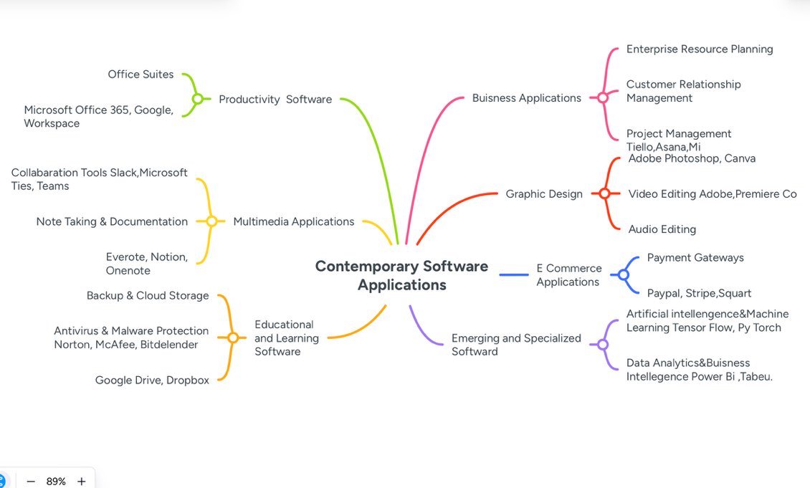
https://mm.tt/map/3894187914?t=4FBFnuX6Xm

Task 3

a.
Microsoft Word is one of the most widely used word-processing applications in business environments, valued for its reliability, flexibility, and ease of use. It is commonly used to create, edit, and format text-based documents such as reports, letters, proposals, contracts, and internal memos. Because of its familiar interface and wide range of tools, Microsoft Word plays a central role in everyday business communication and documentation.
One of Word’s strongest features is its extensive formatting capability. Users can easily adjust fonts, styles, spacing, headings, and layouts to produce professional-looking documents in a short amount of time. Built-in templates further simplify this process by providing ready-made formats for common business documents. Word also supports the insertion of tables, images, charts, and hyperlinks, allowing users to present information clearly and visually. Tools such as spell check, grammar suggestions, and formatting guidance help improve the quality and accuracy of written content.
Collaboration is another major advantage of Microsoft Word in business operations. Features such as Track Changes and Comments allow team members to review, edit, and provide feedback on documents without losing earlier versions. With integration into cloud storage services like OneDrive and SharePoint, documents can be accessed from multiple devices and locations. Real-time co-authoring enables several users to work on the same document simultaneously, making Word especially useful in remote or hybrid work environments where teamwork and fast communication are essential.
In recent years, Microsoft Word has also incorporated AI-assisted tools that support content creation and refinement. These features can suggest clearer wording, improve tone, and help users generate or revise text more efficiently. This not only saves time but also helps ensure consistency and professionalism across business documents.
Despite its many benefits, Microsoft Word does have some limitations. It is primarily designed for text-focused tasks and is not well suited for heavy data analysis, complex calculations, or large-scale data management. For such tasks, spreadsheet or database software is more appropriate. Additionally, very large documents containing numerous images, graphics, or embedded elements can become slow to load and difficult to manage, particularly on older devices. While Word’s collaboration tools are effective, they are not as dynamic as those found in dedicated project management or communication platforms. [5]
Another consideration for businesses is cost. Access to the most advanced features typically requires a Microsoft 365 subscription, which involves ongoing licensing fees. While this investment is often justified by Word’s capabilities and integration with other Microsoft tools, it may be a factor for smaller organizations with limited budgets.
Overall, Microsoft Word remains a powerful and versatile tool for business operations. It excels in document creation, communication, and collaboration, making it an essential application for most organizations despite its limitations.
Microsoft PowerPoint is a widely used presentation software that helps businesses communicate ideas in a clear, visual, and engaging way. It is commonly used for meetings, training sessions, marketing presentations, and strategic briefings. By allowing users to combine text, images, charts, videos, and animations into a structured slideshow, PowerPoint enables complex information to be presented in a format that is easier for audiences to understand and remember.
One of PowerPoint’s key strengths is its wide range of features designed to support effective communication. These include professionally designed slide templates, customizable layouts, animations, transitions, and multimedia integration. Charts, graphs, and diagrams can be added to visually represent data and trends, making information more accessible than long blocks of text. PowerPoint also includes collaboration tools that allow multiple users to edit and comment on presentations, especially when integrated with cloud services such as OneDrive and Microsoft Teams. This makes it particularly useful for businesses with remote or hybrid teams, as presentations can be easily shared, updated, and delivered through video conferencing platforms.
The main benefit of PowerPoint in a business setting is its ability to simplify and summarize complex information. Lengthy reports can be condensed into key points, visual diagrams can explain processes or strategies, and charts can highlight performance trends or forecasts. This helps align teams around shared goals and ensures that important messages are communicated clearly. PowerPoint presentations also help engage audiences by combining visual elements with spoken explanations, which can improve understanding and retention compared to verbal communication alone.
However, PowerPoint does have limitations that businesses need to consider. One common issue is the overuse of animations, transitions, or excessive text, which can distract or overwhelm audiences rather than enhance the message. Effective presentations require careful planning, strong content structure, and good design judgement. Without these, slides may appear cluttered, unprofessional, or confusing. In addition, the quality of a presentation depends heavily on the accuracy and clarity of the content entered by the user. [6]
PowerPoint is also not designed for in-depth data analysis or heavy numerical processing. While it can display charts and summaries, the underlying data usually needs to be created and analyzed using other tools such as Microsoft Excel or business intelligence software. As a result, PowerPoint works best when used alongside other applications rather than as a standalone data tool.
Microsoft PowerPoint remains an essential tool in business communication. When used effectively, it makes complex ideas more accessible, supports collaboration, and enhances audience engagement, making it a valuable asset for modern organizations.
Microsoft Excel is one of the most widely used spreadsheet applications in business, valued for its ability to organize, analyze, and present data efficiently. Across many industries, Excel plays a central role in day-to-day operations by helping businesses manage numbers, track performance, and support informed decision-making. Its flexibility and wide range of features make it suitable for both simple tasks and more advanced analytical work.
Excel offers a powerful set of tools, including formulas, built-in functions, pivot tables, charts, and data filtering options. These features allow users to perform calculations quickly, summarize large amounts of information, and identify patterns or trends within data. For example, financial teams rely heavily on Excel for budgeting, forecasting, profit and loss analysis, and reporting. By automating calculations and linking data across worksheets, Excel helps reduce manual effort and improves efficiency.
One of Excel’s major strengths in business is its ability to support data visualization. Charts, graphs, and dashboards make complex data easier to understand and communicate to stakeholders. Managers and executives can quickly review performance metrics, compare results over time, and spot areas that need attention. This visual approach improves clarity and supports faster, more confident decision-making. [7]
Excel is also widely used in operational roles. Businesses use it for inventory tracking, scheduling, key performance indicator (KPI) monitoring, and workforce planning. In marketing, Excel helps analyze campaign results and customer data, while in human resources it supports payroll calculations, employee records, and performance tracking. This broad usability across departments finance, HR, marketing, and supply chain highlights Excel’s adaptability and importance in business environments.
Despite its many advantages, Excel does have limitations. For beginners, the software can feel complex and overwhelming, particularly when working with advanced formulas or pivot tables. Errors in formulas are another concern, as small mistakes can lead to inaccurate results that may spread across linked worksheets if not carefully checked. Additionally, Excel is not designed to handle unstructured data or extremely large relational datasets. When files become too large, performance may slow, making the software less efficient.
Microsoft Access is a database management system designed to help businesses store, organize, and retrieve structured data in an efficient and reliable way. It is commonly used by small to medium-sized organizations that need a flexible solution for managing data without the complexity of enterprise-level database systems. As part of the Microsoft Office suite, Access integrates easily with applications such as Excel, Word, and Outlook, making it a practical choice for many business environments.
One of the key strengths of Microsoft Access is its range of built-in features. These include tables for storing data, queries for searching and filtering information, forms for user-friendly data entry, and reports for presenting information in a clear and professional format. Access also supports automation through macros, allowing businesses to reduce manual effort by automating routine tasks such as opening forms, running queries, or generating reports. These tools help improve efficiency and accuracy across business processes.
In a business context, Access is often used to support everyday operational needs. It can be applied to contact and customer management, project tracking, inventory control, and even simple customer relationship management (CRM) systems. Its ability to link and join related data from multiple tables ensures consistency and enables more complex analysis across datasets. This relational structure helps businesses avoid data duplication and maintain better data integrity. Access also includes templates and step-by-step wizards, which allow users to build functional database applications quickly, even with limited technical experience. [8]
Despite these benefits, Microsoft Access does have limitations that businesses must consider. One of the main challenges is scalability. Access databases have a file size limit of around 2 GB and can struggle with performance when handling very large datasets or many simultaneous users. This makes it less suitable for large enterprises or systems that require high transaction volumes. Additionally, Access lacks the advanced security, cloud-native architecture, and scalability features offered by server-based solutions such as SQL Server or modern cloud databases.
Overall, Microsoft Access remains a valuable tool for small to medium-sized businesses. It is especially useful for rapidly developing custom data solutions without the need for complex programming, making it a practical and cost-effective option for managing structured data efficiently.

b.
Mail Merge in Microsoft Word is another valuable feature that supports efficiency and accuracy in business communication. Mail Merge allows organizations to create multiple personalized documents such as letters, invoices, labels, and emails by combining a standard document template with data from an external source, usually an Excel spreadsheet or a database. Instead of creating each document individually, businesses can produce hundreds of customized documents in just a few steps.
The main advantage of Mail Merge is its ability to save time while maintaining a personal touch. Each recipient receives a document that includes their specific details, such as name, address, or account information, which improves professionalism and customer engagement. Mail Merge also helps reduce errors, as information is pulled directly from a data source rather than being typed repeatedly. This ensures consistency and accuracy across all communications. [9]
The IF function in Microsoft Excel is a logical tool that helps businesses make decisions based on specific conditions within their data. It works by testing whether a condition is true or false and then returning different results depending on the outcome. This makes the IF function especially useful for analyzing performance, automating decisions, and organizing large datasets in a meaningful way. For example, a business can use the IF function to compare actual sales figures against targets and automatically label results as “Target Achieved” or “Below Target.” This reduces the need for manual checks and ensures consistent evaluation across the organization.
One of the key benefits of the IF function is its ability to save time and reduce errors. Instead of manually reviewing data and making individual judgments, Excel can apply the same logical rule to hundreds or thousands of rows instantly. This is particularly valuable in areas such as finance, sales, and human resources, where accuracy and efficiency are critical. The IF function also supports better decision-making by highlighting exceptions or areas that require attention, such as underperforming products or employees. [10]
Together, the IF function and Mail Merge demonstrate how Microsoft Office tools can streamline business operations. Excel supports data-driven decisions through logical analysis, while Word enhances communication through automation and personalization. When used effectively, these tools help businesses work more efficiently, reduce mistakes, and improve overall productivity.

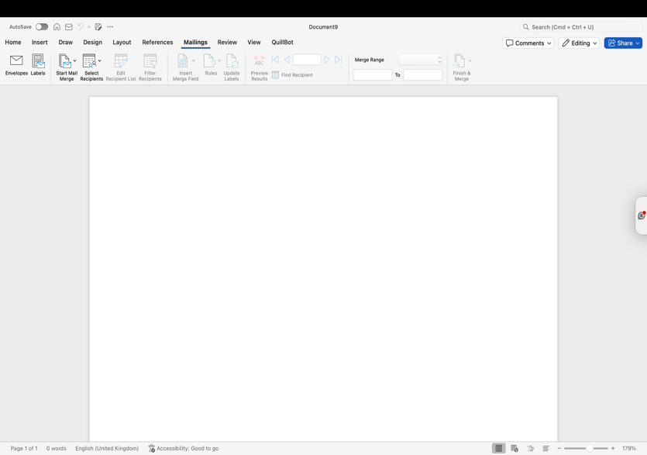
1.Open Microsoft Word On the Tab Press Mailings

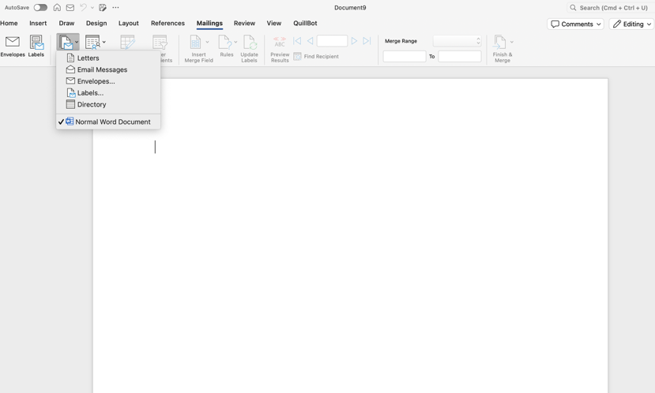
2. Click “Select Recipients” → “Use an Existing List” and choose an Excel file containing recipient names, addresses, or other data.

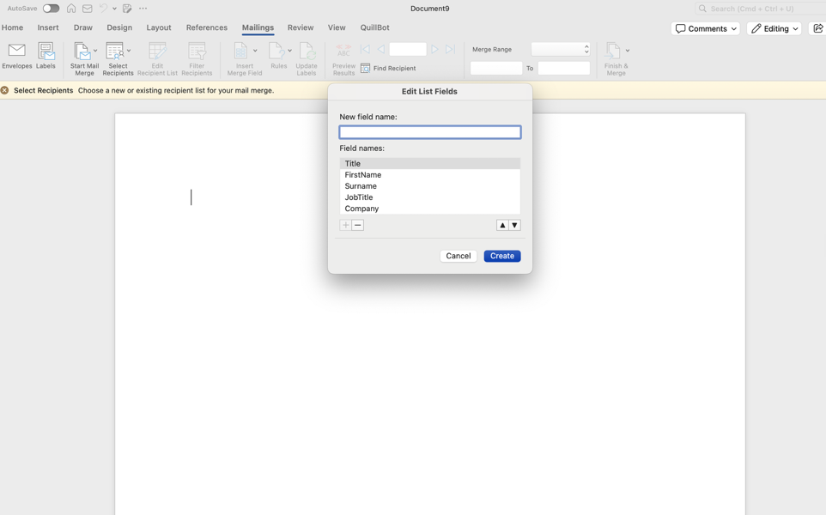
3. Insert placeholders (merge fields) into the letter by clicking “Insert Merge Field” (e.g., Name, Address).

The IF function in Microsoft Excel is a logical tool that allows businesses to make decisions based on specific conditions by returning different results depending on whether a condition is true or false. It is commonly used to analyze data, monitor performance, and automate decision-making processes. For example, a company can use the IF function to identify sales that meet or fall below targets, categorizing employees as “Target Achieved” or “Below Target.” Its benefits include saving time, reducing errors, and enabling efficient analysis of large datasets, while it can also be combined with other functions for more complex business calculations.
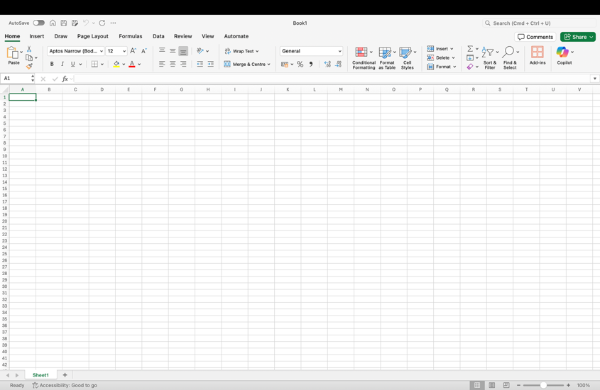

1.Open Excel and enter your data. For example, create a tablewith Employee Names and Sales.

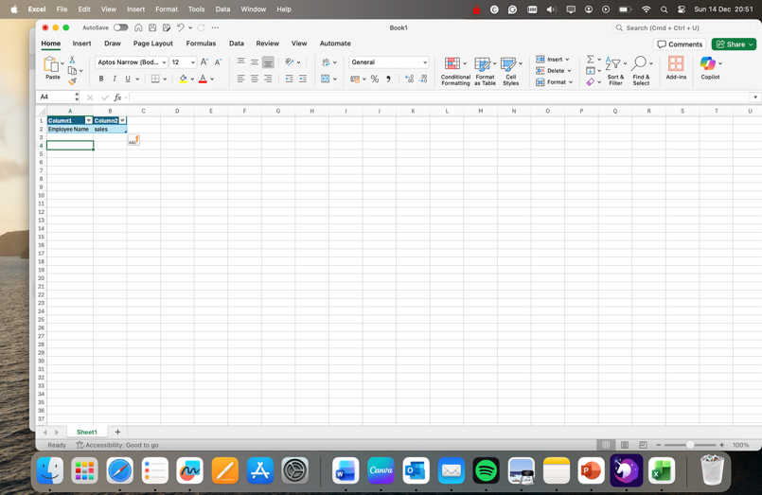

2.Enter data needed

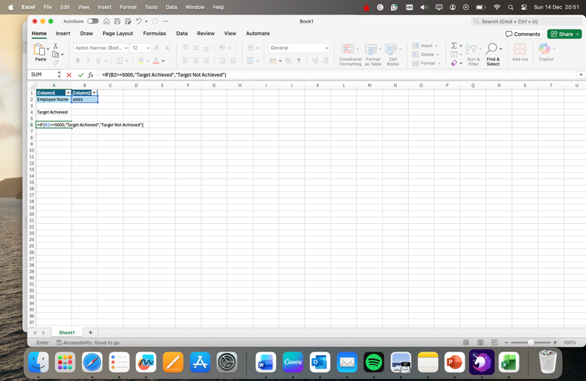

3. Select an empty column and type the formula:
=IF(B2>=5000,"Target Achieved","Target Not Achieved")
Here, B2 contains the sales figure.
Press Enter, then drag the formula down the column to apply it to all rows.
Excel will display “Target Achieved” or “Target Not Achieved” based on the condition.

Task 4
a.
In today’s fast-paced business environment, effective communication and collaboration are crucial for organisational success. Two widely used tools that support these functions are Gmail, as a contemporary communication application, and Microsoft SharePoint, as a collaboration platform. Both play distinct yet complementary roles in modern business operations.
Email remains one of the most essential communication tools in business, enabling organisations and individuals to send, receive, and manage messages electronically. Platforms such as Microsoft Outlook or Gmail for business offer features that go beyond simple message exchange. Users can attach documents, images, and spreadsheets, schedule meetings through integrated calendars, manage tasks, and organise contacts. Email is particularly valuable for formal communications with both internal teams and external clients, allowing businesses to maintain a written record of correspondence that can be archived and referenced when needed. One of the key benefits of email is efficiency; messages can be delivered instantly to multiple recipients, which is vital for time-sensitive communications such as announcements, meeting invitations, or policy updates. It also supports accessibility, as emails can be sent and received from various devices, including desktops, laptops, and smartphones, facilitating remote work and global business operations. Despite these advantages, email has some limitations. Security remains a concern, as phishing, spam, and data breaches are potential risks if proper security measures are not in place. Additionally, the tone and context of written messages can sometimes be misinterpreted, leading to misunderstandings. Information overload is another challenge, as employees may struggle to manage large volumes of emails, potentially delaying responses or missing critical messages. [11]
Microsoft SharePoint, in contrast, is primarily a collaboration and document management platform. It allows businesses to create team sites, intranets, and document libraries that centralise information and enable structured storage of organisational data. SharePoint supports real-time co-authoring of documents, which helps teams work simultaneously on reports, presentations, or proposals without version control issues. Its integration with other Microsoft 365 applications, such as Teams, OneDrive, and Power Automate, enables workflow automation, streamlining processes such as document approvals and task tracking. The benefits of SharePoint are substantial. By providing a centralised repository for documents, it reduces duplication and confusion, ensuring that all team members have access to the latest information. It also enhances collaboration, as multiple users can access and edit content simultaneously, improving productivity and efficiency. SharePoint’s robust security features, including user permissions and encryption, protect sensitive business information, helping organisations meet regulatory compliance requirements. However, SharePoint has limitations as well. New users may face a steep learning curve due to its complexity, and navigating large datasets can be challenging without clear governance. Additionally, while SharePoint Online offers flexibility, some customisation options are limited compared to on-premises versions, which may affect organisations with specific workflow or design needs. [12]

Gmail

1.Open Gmail: Log in to your Gmail account.This screenshot demonstrates the main Gmail interface, which includes inbox, sent mail, and folders for organizing emails.


2.Compose a New Email: Click the “Compose” button to start a new email. Shows where the recipient email address, subject line, and message body are entered.


3.Add Recipients: Enter one or multiple email addresses or use a contact group.Email with multiple recipients added. Demonstrates how Gmail can reach multiple users simultaneously, useful for team or client communication.

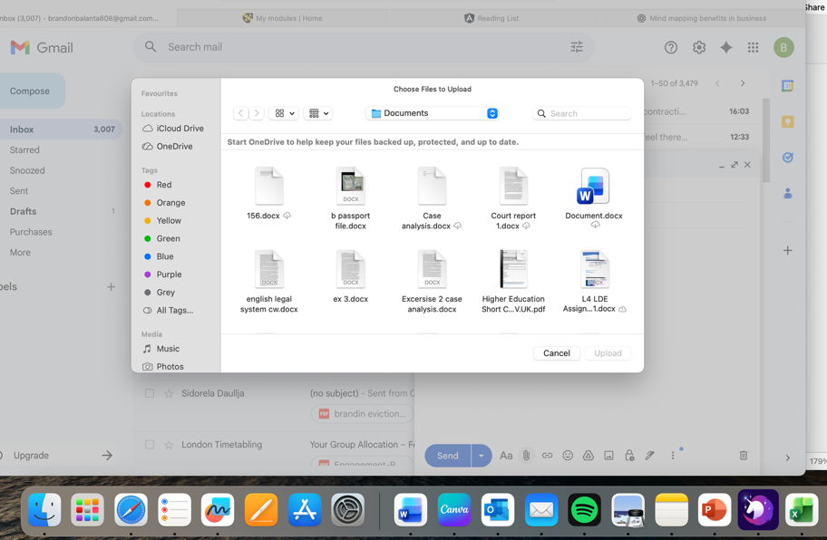
Insert Attachments: Click the paperclip icon to attach files like reports, presentations, or images.Email with an attached file. Shows how Gmail allows users to share documents efficiently.

Microsoft Teams

1. Open Microsoft Teams: Log in with a free Microsoft account or Microsoft 365 account.
Teams dashboard showing channels, chats, and teams.Shows the main interface where team members can interact and access shared files.


2.Start a Chat: Click “New chat” to message a team member or a group. Chat window with a message typed. Shows instant messaging capability, allowing quick clarification of tasks or questions.


3. Share a File: Click the “Attach” button to share a document.File shared in a Teams chat.Demonstrates how Teams enables document collaboration without sending emails. Start a Video Meeting: Click “Meet now” or schedule a meeting in the calendar.

In conclusion Software solutions for business assessment enable organizations to make data-driven decisions, improve efficiency, and respond quickly to market changes. By providing clear insights into performance, operations, and customer trends, these tools help businesses optimize resources, identify growth opportunities, and maintain a competitive edge. Adopting such solutions ensures smarter strategies and sustainable success.

Bibliography

[1] | “ R. U. F. P. a. P. &. C. F. 2. [. A. h.-r. [. D. 2. :. Forbes Advisor UK.
[2] | TechRadar, “Weebly website builder review,” Tech Radar, nov 2025. [Online]. Available: https://www.techradar.com/reviews/weebly. .
[3] | “mind mapping,” dec 2025. [Online]. Available: https://www.mindmapping.com/mind-map..
[4] | S.Peek S. Weiss, “The benefits of Mind Mapping for busy professionals,” dec 2024. [Online]. Available: https://www.business.com/articles/benefits-of-mind-mapping-for-professionals/..
[5] | A.Adler J.C.Nash and S.Noel, “evaluating and implenting a collaborative office document system,” vol. 25, pp. 665-682, 2006.
[6] | S. Kernbach, S. Bresciani, and M. J. Eppler, “Slip-Sliding-Away: A Review of the Literature on the Constraining Qualities of PowerPoint,” vol. 78, no. 2015, pp. 292-313, 2015.
[7] | R. O’Donnell, N. Stokes and L. Della Mea, “Utilizing and teaching data tools in Excel for exploratory analysis,” vol. 63, no. 2010, pp. 191-206, 2010.
[8] | G. C. Correa, “Microsoft Access: everything you need to know to manage,” rsd Jounal, 2023. [Online]. Available: https://rsdjournal.org/rsd/article/view/41324..
[9] | Microsoft Support, “Use mail merge for bulk email, letters, labels, and envelopes,” 2025. [Online]. Available: https://support.microsoft.com/en-gb/office/use-mail-merge-for-bulk-email-letters-labels-and-envelopes-f488ed5b-b849-4c11-9cff-932c49474705.. [Accessed dec 2025].
[10] | IONOS, “What are if-then statements in Excel and how to use them,” 2024. [Online]. Available: https://www.ionos.co.uk/digitalguide/online-marketing/online-sales/excel-if-then-statements/. [Accessed dec 2025].
[11] | T. W. J. M. F. a. P. C. E. Russell, “Getting on top of work-email: A systematic review of 25 years of research to understand effective work-email activity,” J. Occup. Organ. Psychol, vol. 97, pp. 74-103, 2024.
[12] | S. Khumalo and M. Mearns, “harePoint as enabler for collaboration and efficient project knowledge sharing,” 2019. [Online]. Available: https://sajim.co.za/index.php/sajim/article/view/1044. [Accessed 2025].

