BMSW 4004
FINAL REPORT

Name: Nimra Malik
Student ID: 2123954
Module: Problem Solving and Decision Making
Lecturer: Dr. King Omeihe

EXECUTIVE SUMMARY

Problem solving and decision making are important skills for business and life.It is the act of choosing between two or more courses of action.This report is more focussed on Pestle analysis and cause and effects of the case study of TM Lewin. And the alternative solutions to the problems faced by TM Lewin for the business.

1.0 INTRODUCTION
TM Lewin fell into administration for the second time in 2 years was evident during the pandemic.The covid-19 epidemic has significantly changed how we operate.There is ambiguity on how much work will be done remotely by whom and where in the medium term as working from home rules are reduced.
In comparison to 2019 the sales rate volume decreased by 1.9% in 2020,the worst yearly declined ever.
T. M. Lewin Shirtmaker, commonly known as TM Lewin, is a British online menswear retailer.It was started in 1898 by Thomas Mayes Lewin who opened his first shop on London’s Panton Street and later moved to Jermyn Street, renowned as a base for formal shirts. TM Lewin started out making shirts but later started to sell suits, outerwear, knitwear, jackets, chinos, ties and accessories for men.
By 2020, it had over 150 stores worldwide. TM Lewin went into administration on 30 June 2020, closing its 66 UK stores. Stonebridge Capital bought the company's assets in a pre-pack deal.
TM Lewin faced many problems during the pandemic in 2020 lockdown.It lost so many employers and had to close his shops world wide as people started working from home.It was national lockdown and people started wearing more casual dresses than the formal dresses.This effected TM Lewin business.
In this report,a plan is discussed to solve the complex problem faced by TM Lewin during the pandemic.A Pestle Analysis,SWOT, cause and effect,a fish bone diagram to explain the case study of TM Lewin.
The next section will proceed to PESTLE Analysis of TM Lewin:

2.0 PESTLE ANALYSIS:
What is PESTLE Analysis?

PESTLE analysis sometimes referred to as PEST analysis, is a concept in marketing principles. This concept is used as a tool by organizations to keep a track of the external factors impacting the organization. PESTLE is a mnemonic which in its expanded form denotes P for Political, E for Economic, S for Social, T for Technological, L for Legal, and E for Environmental. On the basis of the organization, it can be reduced to PEST or additional areas can be added (such as Ethical).

PESTLE analysis forms a much more comprehensive version of the SWOT analysis. This form of analysis is then compared with the company’s internal strengths and weaknesses via a SWOT analysis. This aids in determining the future scope of action and in developing measures for strategic management.

Why is PESTLE analysis used?

Businessmen and entrepreneurs often turn towards business analysis tools for aiding them in making suitable decisions for their firm. Before any business venture, the business owners often remain doubtful regarding its outcome and how it would be received. Pestle analysis is adopted for determining an answer to these questions. This analysis involves asking questions that give the analyst an idea about the things to keep in mind. These questions are:

- What is the political situation of a country and what is its effect on the markets?
- What are the prevalent economic factors?
- How is culture affecting the markets and what are its determinants?
- What are the technological inventions that are trending and what are other future possibilities in this field?
- What are the current legislations that regulate the industry and if they need to be changed?
- What are the environmental concerns for the industry?

Analysts find answers to these questions and try to cover all the aspects through this analysis. The PESTLE analysis is more than just understanding the market. This framework represents one of the backbones of strategic management by not only defining what a company should do but also accounting for an organization’s goals and the strategies strung to them.

Factors of PESTLE Analysis:
Each of the factors mentioned above, from Political, Economic, Social, Technological, Legal to Environmental, have an impact on an organization. Yet the significance of each of these factors may differ based on the different kinds of industries

2.1 POLITICAL:
The second time in less than two years, the shirt manufacturer TM Lewin has requested administrators, making them the newest casualty of the widespread transition to working from home.Before the epidemic, the company ran 150 stores, but since initially calling in administrators in June 2020, it has only operated an online operation. In addition to its area of expertise, shirts, it also sells suits, knitwear, coats, and accessories like ties.

2.2 ECONOMIC :
The cost of living, minimum wage, working hours, local and national unemployment, interest rates, currency rates, inflation, and pay rates are all considered economic issues. These variables affect a company immediately and have long-lasting repercussions on the success of the economy.For instance, a rise in any economy's inflation rate would have an impact on how much businesses charge for their goods and services. Additionally, it might disrupt the demand/supply models for that economy and have an impact on consumer purchasing power.

2,3 SOCIAL:
Social factors tend to be more difficult to quantify than economic ones. They refer to shifts or evolutions in the ways that stakeholders approach life and leisure, which in turn can impact commercial activity. Examples of social factors include:
- Demographic considerations
- Lifestyle trends
- Consumer beliefs
- Attitudes around working conditions
Social factors may seem like a small consideration, relative to more tangible things like interest rates or corporate taxation. Still, they can have a shockingly outsized impact on entire industries as we know them. Consider how trends towards healthier and more active lifestyles have ushered in the evolution of connected fitness technologies, as well as many changes to the nature of food products we consume and how these food products are packaged and marketed.
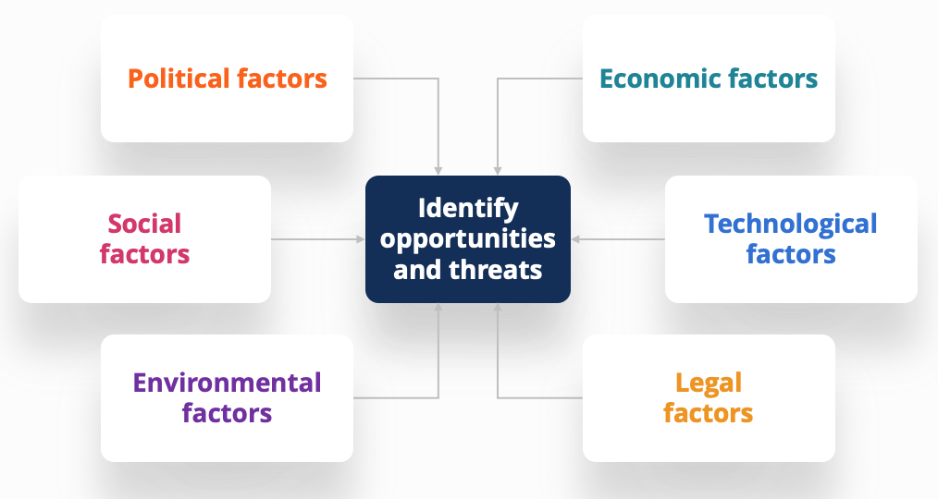
2.4 TECHNOLOGY:
In today’s business landscape, technology is everywhere – and it’s changing rapidly. Management teams and analysts alike must understand how technological factors may impact an organization or an industry. They include, but are not limited to:
- Automation
- How research and development (R&D) may impact both costs and competitive advantage
- Technology infrastructure (like 5G, IoT, etc.)
- Cyber security
The speed and scale of technological disruption in the present business environment are unprecedented, and it has had a devastating impact on many traditional businesses and sectors – think Uber upending the transportation industry or the advent of e-commerce revolutionizing retail trade as we know it.

2.5 ENVIRONMENTAL:
Environmental factors emerged as a sensible addition to the original PEST framework as the business community began to recognize that changes to our physical environment can present material risks and opportunities for organizations. Examples of environmental considerations are:
- Carbon footprint
- Climate change impacts, including physical and transition risks
- Increased incidences of extreme weather events
- Stewardship of natural resources (like fresh water)
Environmental factors in a PESTEL analysis will overlap considerably with those typically identified in an ESG (Environmental, Social, and Governance) analysis. In fact, it’s widely believed that the addition of environmental factors to the PESTEL framework evolved from the growing popularity of movements such as CSR (Corporate Social Responsibility) and ESG.
2.6 LEGAL FACTORS:
Legal factors are those that emerge from changes to the regulatory environment, which may affect the broader economy, certain industries, or even individual businesses within a specific sector. They include, but are not limited to:
- Industry regulation
- Licenses and permits required to operate
- Employment and consumer protection laws
- Protection of IP (Intellectual Property)
Regulation can serve as a headwind or a tailwind for operators. An example headwind might be increased capital requirements for financial institutions; an example tailwind is if regulation is so heavy in a particular industry (let’s say food production) that it may serve as a protective moat for established operators, creating an additional barrier preventing potential new entrants.

PESTEL and Financial Analysis
Combined, the above six factors can have a profound impact on risks and opportunities for firms. It’s imperative that the analyst community recognize these and attempt to quantify them in their financial models and risk assessment tools.
In the next step we will discuss cause and effect and how it effect TM Lewin:
3.0 CAUSE AND EFFECT ANALYSIS:
Cause and Effect analysis is a technique for identifying all the possible causes associated with a problem.It is focussing on causes not symptoms and providing a picture of why the problem is happening.
The Fish Bone diagram shows the result of the analysis and is constructed in steps.It connects effect and cause

Pandemic Poor management operation of factor
Insolvence

Economic Adaptation failure People

PANDEMIC;
Furlough and the pandemic restrictions are the some of the causes of the TM Lewin business.it also includes sickness and deaths as during the pandemic there was huge numbers of deaths and the TM Lewin lost some of his employers and then there was less people to work for his business.

ECONOMIC FACTORS:
Some of the economic factors which effected TM Lewin business are supply change,high operational cost,high inflation and low purchases.As during the pandemic there was lockdown and people were working from home.Everything was gone expensive and there was low purchases which effected TM Lewin business.

ADAPTATION FAILURE:
The adaptation failure includes poor investment in technology and poor response to the external factors.

PEOPLE:
As during the pandemic people were working from home and many people lost there jobs and the business was unable to pay all of their employers and there was law suites from the employers against the TM Lewin business which was and effect for the TM Lewin business drop too.
In the next session the SWOT Analysis will be discussed;

4.0 SWOT ANALYSIS:
SWOT stands for Strengths, Weaknesses, Opportunities, and Threats.
Strengths

The first element of a SWOT analysis is Strengths.
- Things your company does well
- Qualities that separate you from your competitors
- Internal resources such as skilled, knowledgeable staff
- Tangible assets such as intellectual property, capital, proprietary technologies, etc.

Weaknesses
Once you’ve figured out your strengths, it’s time to turn that critical self-awareness on your weaknesses.
- Things your company lacks
- Things your competitors do better than you
- Resource limitations
- Unclear unique selling proposition

Opportunities
Next up is Opportunities.
- Underserved markets for specific products
- Few competitors in your area
- Emerging needs for your products or services
- Press/media coverage of your company

Threats
The final element of a SWOT analysis is Threats – everything that poses a risk to either your company itself or its likelihood of success or growth.
- Emerging competitors
- Changing regulatory environment
- Negative press/media coverage
- Changing customer attitudes toward your company

5.0 SOLUTION:
The best solution is to automate processes and diversify the products of company.Automation will cut costs and satisfy consumer needs.Customers want to shop online and employees to work from home.

6.0 CONCLUSION:
In conclusion to this report,as TM Lewin has faced many challenges in the time of Pandemic.The lockdown issue and supply chain effected the business.Pressure of inflation and high cost of living squeeze impacting consumer spending,caused less profit to the company.By looking at all the issues faced by TM Lewin there is Pestle and SWOT analysis for the business and the best solution for the business to build up again.So the company needs to automate the process and diversify the products.

REFERENCE:

"TM Lewin confirms rescue deal and online relaunch - Retail Gazette". 11 April 2022.

