‘Describe a learning event which has happened during your recent school experience. Reflect upon what took place, connecting events to theories of learning and teaching. Make recommendations about how you could improve your own practice in the light of this. Produce a poster to illustrate how you would develop the elements of an effective learning environment.’

Introduction

This essay will focus on the significant learning event that stood out during two bridging days I spent observing at a Primary School. Specifically, what stood out was a Focus Task that was teacher led and how Learning Theories underpinned certain elements such as Scaffolding. This is part of the Triangle of Provision (ToP) which is illustrated in Figure 1 and demonstrates the most effective platform for active learning in the Foundation Phase. The school and pupils will remain anonymous throughout this report for safeguarding and ethical considerations in accordance to the BERA Ethical Guidelines for Educational Research (2018) guidelines, but some basic background information of the school is necessary for context.
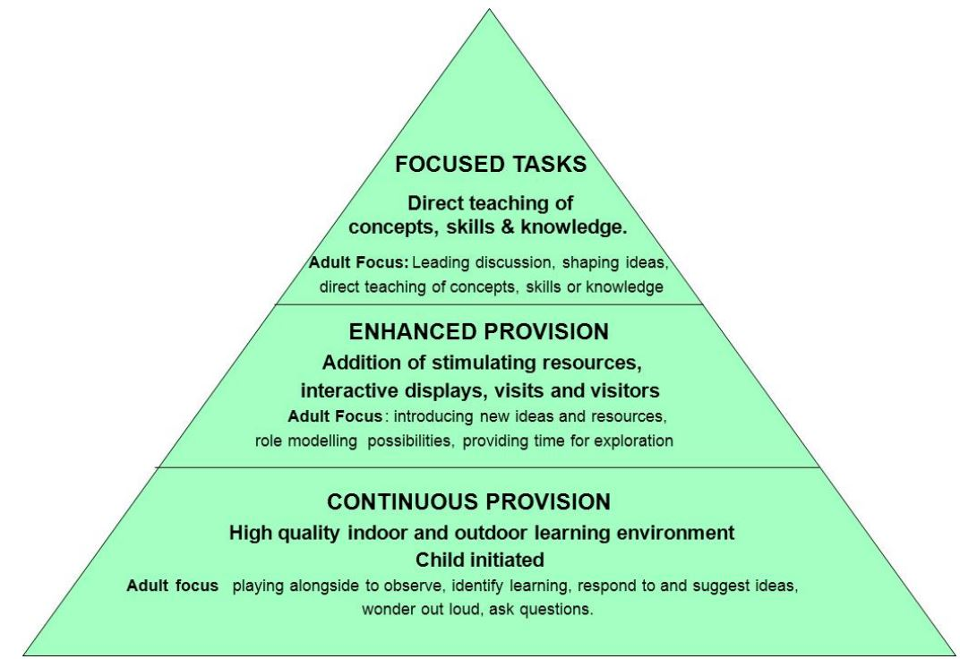
Figure 1. The Triangle of Provision for Play in the Foundation Phase (Welsh Government, 2013).
For the purpose of this study, the pupils will be referred to as simply ‘pupil’ and staff as ‘teacher’ or ‘teaching assistant’ (TA). The School that was observed is located in a large, urban welsh town. In 2017 the statistics published by Welsh Government shows that the: number of pupils was 417; the schools average free school meals ratio using the previous three years was 26% (which is just above the 21% average within Wales); the pupil to teacher ratio was 23%; the attendance during the year was 94%; the budget per pupil was £3286; the pupils achieving the expected outcome in Foundation Phase was 74% and at Key Stage 2, 89.8% (Mylocalschool.wales.gov.uk, 2018). The latest inspection by Estyn done in 2014 rated the school’s performance as good and the school’s prospect for improvement also as good (Estyn.gov.wales, 2018).

Vignette

Education in Wales is currently heading in an exciting direction with the implementation of Graham Donaldson’s Successful Futures Report well underway (Donaldson, 2015). The four main purposes of the curriculum are outlined in Figure 2 for further context. The Foundation Phase (FP) was also introduced in 2010, throughout Wales, to replace the previous Key Stage 1 (KS1). This has continued to progress with the introduction of a new Foundation Phase Assessment Tool for the Baseline Assessment (the FP Profile) in 2015. The movement away from KS1 was to encourage children to be creative and imaginative whilst making learning more enjoyable and effective (Welsh Government, 2015). This marked a radical departure from the more formal, competency-based approach associated with the previous KS1 National Curriculum. Both these recent changes need to be taken into consideration while observing, as most classrooms are currently adapting and changing to the recommendation in both documents.
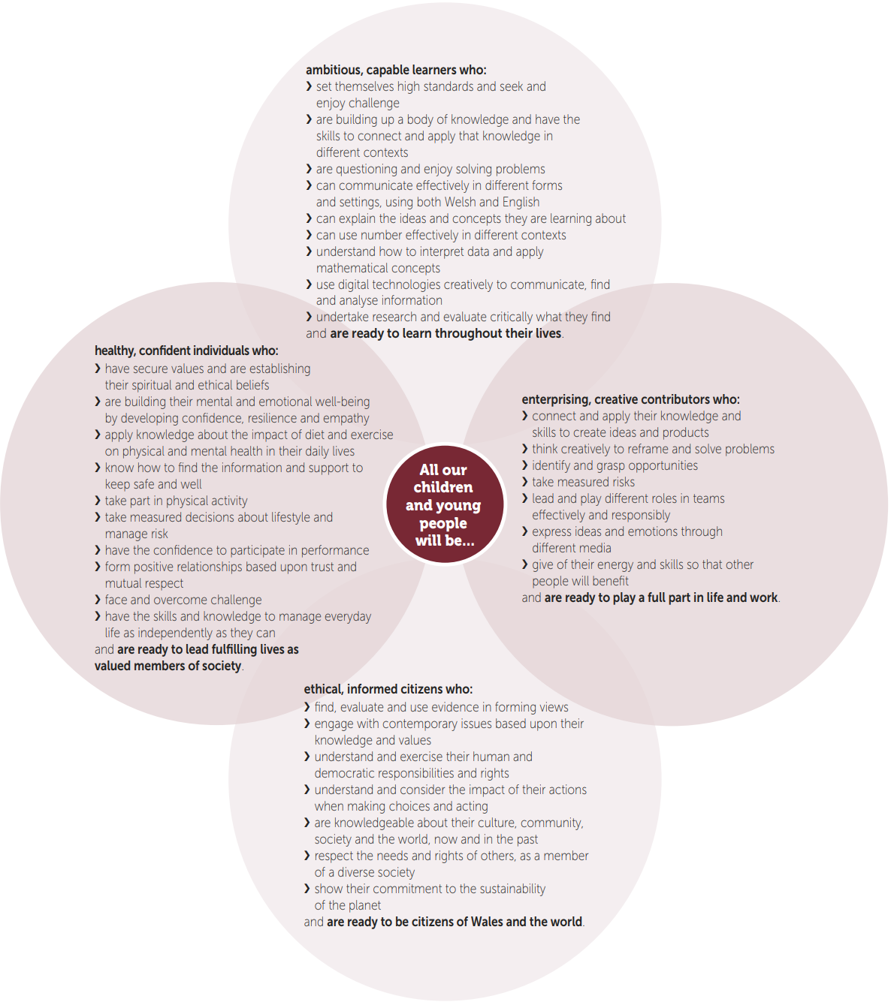

Figure 2. The four purposes of the curriculum and the key characteristics outlined by Graham Donaldson in the Successful Futures Report (Donaldson, 2015).
While in class it must be noted I focused purely in an observational role with the class functioning in its normal routine. Due to the class having some pupils that did not have photographic consent I chose to take detailed time stamped notes to allow me to pick the most significant event after the two days spent in the school. These notes were as detailed as possible to allow me to recall the important information from the observation at the time of writing. In evaluation it would have been more effective using video recording or imagery as this would have been easier to reflect in more detail at a later date and to also look at things in a different perspective. However, the pupils were not used to having somebody recording the lessons, so this could have acted as a distraction which has been discussed in the literature as the Hawthorne Effect (Merrett, 2006) and they could have acted differently because of this. I feel for this reason, along with the consent issue, that my choice of written observation was the most effective option to me at the time. I was able to take some photographs of the classroom set-up while the pupils were on break to help me recall key information. I tried to position myself whilst notetaking as unobtrusively as possible, mindful that I was not a regular member of the class so that observations could happen as naturally as possible. My observation techniques were in line with Brookfields Theory of Reflection using the four lenses of observation: teacher; TA’s; pupils and observer (Brookfield, 2005).

I used any available class downtime to discuss my observations with the class teacher and TA’s which I felt was vital to understanding my observations and furthering my understanding of the classroom dynamics. On both days I arrived at the class before the pupils to ensure I did not miss any key information and to get to grips with the layout of the classroom and the planned structure of the day.
My first day I was placed in a Reception/Year 1 class. This class had nineteen reception pupils and twelve Year 1 pupils consisting of sixteen boys and fifteen girls, there were also three TA’s based in this class. It was while I was in this class that the significant learning event took place. This event was based around Foundation Phase play and the Triangle of Provision (ToP). While I am going to mainly focus on a specific part of this ToP, it is clear that all three need to work in a holistic way. As the Evaluating the Foundation Phase Report (Welsh Government , 2015) states - the majority of learning occurred when an array of different activities are constantly available to provide a continuous learning provision, this needs to then be enhanced by the occasional provision of specific activities to provide enhanced learning and very occasionally focussed learning activities are provided to ensure particular learning tasks are achieved which can be in many ways including Vygotsky’s Scaffolding techniques.
Immediately after the pupils entered the classroom at the start of the day there was a mixed carousel of Continuous Provision (CP) and enhanced provision (EP) set up by the teacher and TA’s in advance. It is suggested that CP needs to be child-initiated learning that uses high quality indoor and outdoor environments set up by the teacher. The teacher or TA’s play alongside the pupils to observe and identify learning, respond to and suggest ideas and ask questions to further support learning. This term refers to the use of resources that are continuously available to use independently. These resources should be specific to the pupil’s development and interests to consolidate and extend learning (Estyn, 2017). Two examples of this in the classroom were in the form of a block building/lego station and the sand area.
At the next level EP should enhance certain CP by adding stimulating resources, interactive displays, visits, or visitors. The teacher or TA’s should introduce new ideas and resources while role modelling which can be referred to as adult directed learning. These resources help move learning forward, by practising new skills or learning new ways of working. They can be linked to focused teaching; promote interest in a new topic; or explore a current one in more depth. This can still be child-initiated learning if the pupils choose the resources themselves (Estyn, 2017). This was evident in the form of the water play enhanced as a ‘car wash’ or a role play area themed around a kitchen.
The significant learning event I focused on in more detail is based around the ‘Focus Task’ (FT) which is the top level within the ToP. It is suggested that FT should be where the teacher or TA’s now lead the learning. They should directly teach skills, concepts and knowledge and use open-ended, exploratory questioning to engage the pupils in conversations and prompt their creative thinking (Estyn, 2017). This was demonstrated throughout the FT, the teacher introduced a handwritten letter on a large flip-chart that was shown as being written by a character from ‘The Everywhere Bear’ the pupils were in a circle on the carpet during this introduction. This letter encouraged the pupils to pick three key items from a picnic box that was placed on top of a picnic blanket. As a whole group, the teacher asked pupils with their hands up to share an item they would choose first to access their understanding of the task before further exploring this in the main FT in smaller groups.
The pupils returned to the carousel allowing the teacher to pick three mixed ability pupils at a time to further explore this FT in more depth. The pupils then picked a personal list of three items they would take on the picnic from the previously introduced items. The teacher used scaffolding through exploratory questions such as “Why would you like to take this item over this?”, “Is food more important than this item?” and “Would you like to change your mind now you have considered this?’’ These exploratory questions accessed the pupil’s current knowledge before offering support which Chiu (2004), found was the key factor in how effective support was whilst working in groups, this is a key factor in allowing scaffolding to occur. The scaffolding theory will be explored in more detail in next section of this essay but for the purpose of this observation it will be briefly touched upon. Scaffolding is a metaphor for when the teacher offers temporary support personalised to the learner, that therefore allows them to complete a task that would have not been possible on their own (Wood, Bruner and Ross, 1976). Research has suggested that most teachers provide immediate support rather than exploring the current knowledge of the learners (Pol, Volman and Beishuizen, 2011, Lockhorst, Wubbels and van Oers, 2010). In this case, the teacher did not fall into the pitfall that the research suggests most do, instead, the teacher assessed the pupils understanding of why they thought the items selected were important and why, before offering any sort of support to encourage a problem-solving approach to the task. Classrooms with scaffolding regularly occurring to support learning and thinking by the teacher have been found to lead to high quality instructional interaction (Yates and Yates, 1990) which was the case during this observation.
In line with Vgotsky’s (1978) theory which will be explored further later - the teacher acted as the More Knowledgeable Other (MKO) within the Zone of Proximal Development (ZPD). Learning occurs within this ZPD through the MKO bridging the gap between what the pupil can do independently versus with help (Hogan and Pressley, 1997). This process is illustrated in Figure 3, demonstrating where the teacher is acting as the MKO and using the scaffolding process to support the pupils, which will therefore greatly increase what the pupils can do for themselves. The pupils were able to firstly, choose their preferred list, secondly justify it and finally adapt it through critical thinking if necessary, allowing the reflective process to occur. This was made possible by the teacher assisting and playing a key role in creating opportunities for learning by enquiring, asking exploratory questions and offering feedback. With this support being within the pupils ZPD and responsive to their existing understanding, the literature suggests, this will be beneficial to effective learning and engagement (Gillies, 2013; Gillies et al., 2012, La Paro, Pianta and Stuhlman, 2004).
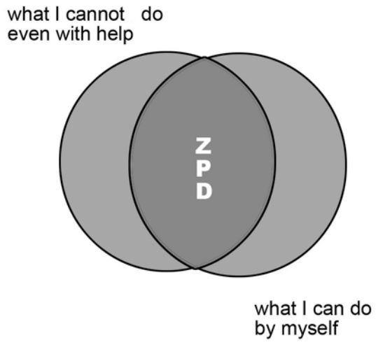
Figure 3. The Zone of Proximal Development & The ZPD after Teaching Has Occurred (Shabani, Khatib and Ebadi, 2010).
We can see how significant the teacher’s role in FT’s is when effective scaffolding is used but how this whole process just forms the top layer of the ToP within the FP continuum. It is vital that the whole spectrum of this ToP is evident and in the correct proportions for learning through play to facilitate the best active learning to happening in the classroom.

Learning Theories

Learning theories have always been prominent within educational research with a range of literature available supporting the different ways to achieve optimum learning. At the forefront have been many key figures such as Pavlov, Piaget and Vygotsky who have all demonstrated different beliefs and approaches to enhance learning which has therefore, contributed to our understanding of how children develop and learn best (Pound, 2008).

One of the main approaches within learning theories is Behaviourism which based upon a belief that behaviour is developed and learnt from a stimulus-response relationship. Pavlov developed a theory based upon classical condition. This form of learning is based around a conditioned stimulus becoming associated with an unrelated unconditioned stimulus to produce a behavioural response known as a conditioned response. This conditioned response is the learned response to the previously neutral stimulus (Pavlov, 1927).

Critics of behaviourism feel the theory does not consider innate feelings and thoughts of the children who often complete tasks for the intrinsic reward and enjoyment rather than just for a promised reward. Despite this, behaviourists believe children are viewed as being uninvolved in their own development and have very little or no role to play in their learning. The learning was passive and controlled (Halpenny and Pettersen, 2014). To summarize, the learner starts off with a clean slate and behaviour is shaped through positive or negative reinforcement (Watson, 2013). There is no real evidence of a behaviourist approach to learning in my observation apart from a few behaviour management techniques that offered no relevance to my observation that is worth discussing.

Due some of the limitations discussed for behaviourism many believe in the constructivist way of learning. This approach is based on teachers not giving the learners knowledge but more the learners exploring their understanding and drawing their own conclusions. They support or scaffold learning which was introduced in the previous section by breaking down tasks into smaller pieces which children can manage on their own (Grigg, 2015). Piaget, one of the most renowned in this field for his theory of cognitive development was concerned with the journey of the children arriving at what they know rather than prior knowledge. Active learning was key and was achieved through questioning, exploring and testing in the process to construct their own knowledge rather than receiving instructions from adults, which he thought was vital to learning (Piaget, 1972). The teacher should provide these opportunities through experiences that intrinsically motivate the children and match their needs and interests (Grigg, 2015). Piaget has been criticized for how much emphasis is placed on what children cannot do and the manner in which he conducts his research (Childs, 2004). Despite this, his influence is clearly seen within the current curriculum, especially within the six areas of learning in the FP. Most classrooms have play areas, classifying and sorting activities, areas for constructional work and paints for symbolic representation of the world (Grigg, 2015).

This was clearly seen within my observation. The teacher set up the classroom in-line with the ‘Triangle of Provision’ (ToP) which is illustrated in Figure 1 and was discussed in the previous section. It is clear that the bottom two sections of the triangle have a constructivist focus within this classroom with plenty of opportunities to explore and learn through free play with teacher/TA support which is heavily featured within the Foundation Phase (FP) curriculum document (Welsh Government, 2015). Despite this being a relatively new document, it has been discussed in the literature for much longer. Bruner et al. (1977) felt that often play is relegated to activities children can choose after completing their work. How often does the teacher get engaged with the play themselves as part of their teaching role? Sylva et al. (1980) advocated how important this teacher interaction and intervention at opportune moments is to ensure optimum learning through play. Children’s self-initiated play is advocated to provide the best learning environment (Tamburrini, 1982) and through the observation the pupils had free-flow access to a carousel of activities that encouraged both free play and teacher enhanced provisions such as the themed kitchen area or the water play enhanced as a car wash. The TA’s were also utilised to engage learning throughout these provisions and flash cards with ideas to guide and enhance the pupils current learning.

Language and social interaction however were neglected within Piaget’s work. His view that children were ‘lone scientists’ came under criticism for them being alone in their learning endeavour (Pritchard, 2013). This led to social constructivism emerging which was based on learning occurring through shared experiences. Knowledge is constructed by interacting with others. The belief is childhood is not just a natural stage of development but a social construct that is subject to different interpretations. Unlike the previous constructivist approach children are active in making sense of their environment and language is key to progressing their knowledge and this is often determined by what they have been told rather than from their own experiences. This shared responsibility to work collaboratively to solve problems is clearly seen within the new curriculum and has been shaped by this social constructivist approach (Grigg, 2015).

One of the main proponents of this branch was Lev Vygotsky who argued social interaction is key and learning should be a collaborative process with social interaction being a fundamental role in cognitive development. Vgotsky’s (1978) Zone of Proximal Development (ZPD) that was outlined in the last section is significant to explaining this (see Figure 3). This describes gaps between what a child can achieve working independently versus what is potentially possible by working with someone more skilled or experienced, such as a teacher or another child. Considering that children develop and progress at different speeds a whole class approach to teaching the same content at the same time is unlikely to be effective (Grigg, 2015) Instead, Vygotsky felt learners were better working alongside somebody slightly more knowledgeable than themselves. Dialogue is where ideas are considered, shared and developed. This is where the ‘More Knowledgeable Other’ (MKO) that was discussed in the last section is considered. One drawback of this was that it was found that in fact interactions between children with similar levels of knowledge still led to learning occurring (Cowie and van der Aalsvort, 2000). This does not need to be a teacher, or even in a school context – any social interaction with anyone can lead to learning. This sharing of thoughts and ideas in a discussion, in any context usually leads to one or even both developing a greater understanding of the topic (Pritchard, 2013). This also links with Scaffolding which was explored earlier. The teacher acts as the ‘MKO’ and guides and supports the dialogue in a planned direction for knowledge to be obtained by the learners through this process of scaffolding. Vygotsky’s ZPD supports and helps demonstrate the role of the teacher and the process of differentiation by supporting the learner in the theoretical ZPD space that is just above the learner’s capabilities that would not be possible without the support. Sewell (1990) summarises it as ‘a point at which a child has partly mastered a skill but can act more effectively with the assistance of a more skilled adult or peer’. The downside to this approach to learning is that there are times and situations where a quieter individual way of working can be effective, but this would go totally against the socially constructed learning approach.

I believe the teacher within the focused task which formed the main part of my observation can be mainly be described as learning with a social constructivism approach. There are overlaps with constructivism but there was clear social interaction between the teacher and the focus group of pupils. The teacher used scaffolding techniques through exploratory questioning which have been discussed throughout this essay and acted as the ‘MKO’. This social interaction between the teacher and learners developed on the pupils existing knowledge and the pupils having similar levels of understanding combined to facilitate learning as Cowie and van der Aalsvort (2000) found in their study. This discussion within the group clearly developed the pupils understanding as the pupils acted as scaffolding unconsciously, expanding their ‘ZPD’ as Fernandez et al. (2015) found, helping to critique their choices, which prompted them to either back up their initial decision or change it based on this dialogue. Unlike what Piaget believed within constructivism, social interaction was the main facilitator in this learning event.

Upon reflection on the observation, in future I will focus on both the constructivist approach and social constructivist approach for different elements of my teaching. I will take a constructivist approach to continuous and enhanced provisions and make them always available. This will encourage the learners to explore and learn through child led play with the encouragement and support of peers and adults which is supported in the curriculum and research (Welsh Government, 2015, Tamburrini, 1982). This support will be through simple prompts such as flash cards or themes bolted onto existing continuous provision. I will however not dismiss social interaction which Piaget came under criticism for. This peer and teacher interaction at opportune moments will ensure optimum learning (Sylva et al., 1980). I will ensure that I take Vygotsky’s approach to supporting learning by accessing pupil’s current knowledge before offering support (Chiu, 2004) rather than offering immediate support. This scaffolding using exploratory questioning has been shown to lead to high quality instructional interaction (Yates and Yates, 1990). This will bridge the gap between what could not be done independently versus by expanding the ZPD through the MKO (Hogan and Pressley, 1997) which has been shown to be beneficial to effective learning and engagement (Gillies, 2013; Gillies et al., 2012, La Paro, Pianta and Stuhlman, 2004).

Learning Environment

Learning environments can have a significant impact on children’s learning. Throughout history, classrooms were often reported by inspectors as cubic boxes with often poor conditions, cramped writing conditions and were not conductive to quality learning (Grigg, 2015). Therefore, it is key to provide a learning environment that children feel comfortable within, that allows the freedom and creativity to be active learners. Therefore, the following section will consider some key themes within my ideal learning environment that I feel will help provide a positive learning environment within the Foundation Phase (FP) provision.

The layout of the classroom is important in providing opportunities and support for consistently high quality, personalised learning to be present throughout the day. Jenson (2000) found that poor temperature and light, uncomfortable sitting with poor vision to the learning stimulus such as an interactive whiteboard can lead to pupils not showing an interest and disengaging in the lesson. Schools are currently adapting in line with the Successful Futures Report (Donaldson, 2015) and Foundation Phase Framework (Welsh Government, 2015) to flexible classroom set-ups. The Steer Report (2005) emphasises the importance of lighting and acoustics throughout the classroom to support learning and that seating should re-arranged to support the activity type rather than be fixed. Ideally, my classroom would have windows the circumference of the room just above the level of displays and a glass ceiling to encourage a connection to the outside world that can be explored through outdoor learning. This will allow quality light into the room which has been shown to facilitate learning (Jenson, 2000) and can be used to set up activities based on weather and the outside world for example, which I feel is important as the classroom should not feel like an isolated, fixed environment. The windows and ceiling would have electronic shutters for when low light is necessary for Wellbeing and Mindfulness sessions which forms part of the new curriculum (Donaldson, 2015).

As suggested above, the learning environment would be adapted to the type of learning event occurring. Within the FP there is a strong emphasis on the inclusion of Continued Provision (CP), Enhanced Provision (EP) and Focus Tasks (FT) throughout the classroom. This has been discussed extensively and its role within the Triangle of Provision outlined in the previous sections (see Figure 1). This CP and EP will always be readily available to the pupils and will be themed around the class topic to encourage child-initiated learning. This has been proven to promote higher quality active learning (Welsh Government, 2015). This will be set up in a carousel fashion with smaller FT’s taking place with the Teacher and TA’s. Within this carousel, ‘Role Play’ will feature tailored to the class topic to ensure continuity within the EP. I feel role play is important as it is it allows the children to be ‘Creative Contributors’ which is one of the four purposes of the Successful Futures Curriculum (See Figure 1). These real world or fantasy situations allow them to be imaginative and creative. Less outgoing children can be encouraged to express themselves by taking confidence from the role they are practising (Ladousse, 1987). Rogers and Evans (2008) found this facilitated children’s wellbeing while developing a social competence while resolving conflicts in an authentic context in both a cognitive and social way.

Within the classroom a large clearable space would be available for carpet activities such as a whole-class introduction or smaller group discussions where children have an option of how they would like to sit. For example: bean-bags, yoga-balls, posture-controlled seating and horseshoe tables that all promote wellbeing and give the children freedom in how they best learn. Traditionally children would sit in rows or rectangular tables to encourage group discussions, however, horseshoe tables have been shown to double the work rate within children who are more easily distracted (Hastings, 2001). It has been proven that classroom design and use of space impacts on attitudes towards learning and a child centred choice of seating promotes this as children learn best when comfortable (Epsey, 2008). The key message is that seating arrangements should be tailored around the task and be different for small focused group discussion compared to a quiet individual art activity for example as rearranging furniture does not take long when weighed up against the positives.

The ‘Pupil Voice’ theme with the flexible seating and classroom layout/provisions continue throughout the classroom which help the learners to be more active in their learning, encouraging them to engage with each other rather than just relying on the teacher student (Black et al., 2011). Whiteboard paint would be used on the walls and desks can be written on. This would encourage the children to write down ideas as they are working or encourage collaborative work when working in groups or developing key themes such as topics they would like to know more about on the wall for example. The children would feel more invested in things that they are interested in learning about and feel they have had an input in designing. Teachers began to appreciate learning is not a process of passive reception of knowledge but with the learners active in creating their own understanding. Learning cannot be done for the student despite exam expectations but must be done by the student (Black et al., 2011). This links back to the social constructivist approach to scaffolding children’s learning that has been discussed in detail in the previous sections. The children through this process take responsibility for their own learning and assessment.
The children should play a key role in designing and organising displays as their purpose is to help with learning, encourage creative thinking and to celebrate their achievements (Grigg, 2015).

With the digital world evolving every day and the new curriculum and Digital Competency Framework (Donaldson, 2015) introducing cross-curricular responsibilities to all subjects within the classroom, it is clear that there needs to be a strong focus on accessible ICT throughout the classroom for this to succeed. Another of the four purposes of the Successful Futures Report is to ‘develop enterprising, creative contributors, ready to play a full part in life and work’ (Donaldson, 2015). This is to prepare our children at a young age for the future where there will be a need to use these ICT skills developed in most aspects of their lives. Leask and Meadows (2000) identified a range of political, personal and professional needs for ICT competency and why it should be prominent in Primary Schools. The question is not whether ICT should be in our classrooms but how they can be used most effectively to enrich children’s learning (Poulter, 2008) With the focus on preparing these children for the working world there should be areas in the classroom that encourage this, that are enriched with a digital tool of their choice for example an iPad and green screen area. Offering variety is key as in the real world there will be a range of different hardware and software that people are expected to be competent with. ICT used in this way has been shown to be a great tool in bridging the gap between the classroom and real world (Herrington, 2006) but we have to remain cautious to including it in every classroom scenario instead of just critically when it will enhance learning.

Outdoor learning features prominently in the Foundation Phase Framework (Welsh Government, 2015) in Wales, where learning is encouraged outside of the classroom. I would encourage a seamless transition between both the indoor and outdoor classroom, to allow skills developed from either to be transferable between both. As the name suggests outdoor learning has no set boundaries, therefore, ideas can be explored in the classroom, taken to the outdoor element of the classroom before extending this to a real-world location such as a castle for example.
Research suggests most children ‘learn by doing’ and there is support for active learning (Silman, 2011) which Continuous and Enhanced Provisions discussed in previous sections of the essay encourage, but despite this there has been a decline in outdoor play (Curtis, 2013). Learning built up from these outdoor experiences have been shown to be retained in the memory for much longer in contrast to the traditional classroom (Rickinson et al., 2004). This could be down to the fact the children have had a chance to use these skills in a real-word situation that can be used again, which therefore makes it transferable and ties into the Donaldson beliefs discussed previously (2015).

Conclusion

Reference List
Black, P., Harrison, C., Lee, C., Marshall, B. and Wiliam, D. (2011). Assessment for learning. Berkshire: Open University Press.

British Educational Research Association (2018) Ethical Guidelines for Educational Research, fourth edition. London: British Educational Research Association.
Brookfield, S. (2005) Becoming a Critically Reflective Teacher. San Francisco. Jossey Bass.
Bruner, J. S., Jolly, A. and Sylva, K. (1977) Play: Its Role in Development and Evolution. Harmondsworth: Penguin.
Child, D. (2004) Psychology and the Teacher. London: Continuum.

Chiu, M. (2004) Adapting Teacher Interventions to Student Needs During Cooperative Learning: How to Improve Student Problem Solving and Time On-Task. American Educational Research Journal, 41(2).
Cowie, H. and van der Aalsvort, G. (2000) Social Interaction in Learning and Instruction. Oxford: Pergamon.
Donaldson, G. (2015) Successful Futures: Independent review of curriculum and assessment arrangements in Wales. Cardiff: Crown.
Estyn.gov.wales. (2014) St Thomas Community Primary School. [online] Available at: https://www.estyn.gov.wales/provider/st-thomas-community-primary-school [Accessed 4 Oct. 2018].
Estyn (2017) Active and experiential learning. Cardiff: Crown.

Epsey, M. (2008) ‘Does space matter? Classroom design and team-based learning’, Review of Agricultural Economics, 30(4).
Fernandez, M., Wegerif, R., Mercer, N. and Rojas-Drummond, S. (2015) ‘Re-conceptualizing “Scaffolding” and the Zone of Proximal Development in the context of symmetrical collaborative learning’ Journal of Classroom Interaction, 50(1).

Gillies, R. (2013) Productive academic talk during inquiry-based science. Pedagogies: An International Journal, 8(2).

Gillies, R., Nichols, K., Burgh, G. and Haynes, M. (2012) The effects of two strategic and meta-cognitive questioning approaches on children's explanatory behaviour, problem-solving, and learning during cooperative, inquiry-based science. International Journal of Educational Research, 53.

Grigg, R. (2015) Becoming an outstanding primary school teacher. Harlow: Pearson.

Halpenny, A. and Pettersen, J. (2014) Introducing Piaget. Hove: Routledge.

Hastings, A. (2001) cited by Moorhead, J. ‘Back to front’, The Guardian, 23 January 2001.

Herrington, A. and Herrington, J. (2006) Authentic learning environments in higher education. London: Information Science Publishing.

Hogan, K. and Pressley, M. (1997) Scaffolding Student Learning: Instructional Approaches & Issues. Advances in Teaching and Learning Series. Cambridge: Brookline Books.

Jensen, E. (2000) Brain-Based Learning. San Diego, CA: The Brain Store.

Ladousse, G.P. (1987) Role Play. Oxford: Oxford University Press.

La Paro, K., Pianta, R. and Stuhlman, M. (2004) The Classroom Assessment Scoring System: Findings from the Prekindergarten Year. The Elementary School Journal, 104(5).

Leask, M. and Meadows, J. (2000) Teaching and Learning with ICT in the Primary School, London:RoutledgeFalmer.

Lockhorst, D., Wubbels, T. and van Oers, B. (2010) Educational dialogues and the fostering of pupils' independence: the practices of two teachers. Journal of Curriculum Studies, 42(1).

Mylocalschool.wales.gov.uk. (2017) My Local School. [online] Available at: http://mylocalschool.wales.gov.uk [Accessed 4 Oct. 2018].
Pavlov, I. P. (1927) Conditioned reflexes: An investigation of the physiological activity of the cerebral cortex. London: Oxford University Press.
Piaget, J. (1972) To understand is to invent. New York: The Viking Press
Pol, J., Volman, M. and Beishuizen, J. (2011) Patterns of contingent teaching in teacher–student interaction. Learning and Instruction, 21(1).
Poulter, T. (2008) ‘ICT in the early years foundation stage’ in Basford, J and Hodson, E. Teaching Early Years Foundation Stage, Exeter: Learning Matters.
Pritchard, A. (2013) Ways of learning. London: Taylor & Francis.
Pound, L. (2008) How children learn. London: Step Forward.

Rogers, S and Evans, J. (2008) Inside role-play in early childhood education: Researching young children’s perspectives. London: Routledge.
Sewell, D. (1990) New tools for new minds: a cognitive perspective on the use of computers with young children. Hemel Hempstead: Harvester Wheatsheaf.
Shabani, K., Khatib, M. and Ebadi, S. (2010) Vygotsky's Zone of Proximal Development: Instructional Implications and Teachers' Professional Development. English Language Teaching, 3(4).
Steer, A. (2005) Learning Behaviour: The Report of the Practitioners’ Group on School Behaviour and Discipline, Nottingham: DfES
Sylva, K., Roy, C. and Painter, M. (1980) Child Watching at Playgroup and Nursery School. London: Grant McIntyre.
Tamburrini, J. (1982) Play and the role of the teacher. Early Child Development and Care, 8(3/4).
Vygotsky, L.S. (1978) Mind in society: The development of higher psychological processes. Harvard University Press: Cambridge.
Watson, J. B. (2013) Behaviorism. Chicago: Read Books Ltd.
Welsh Government (2013) Evaluating the Foundation Phase: Policy Logic Model and Programme Theory. Cardiff: Crown.
Welsh Government (2015) Evaluating the Foundation Phase: Final Report. Cardiff: Crown.
Welsh Government (2015) Foundation Phase Framework (Revised 2015). Cardiff: Crown.
Wood, D., Bruner, J. and Ross, G. (1976) The Role of Tutoring in Problem Solving. Journal of Child Psychology and Psychiatry, 17(2).
Yates, G. and Yates, S. (1990) Teacher Effectiveness Research: towards describing user‐friendly classroom instruction. Educational Psychology, 10(3).

