CRISIS MANAGEMENT REVIEW

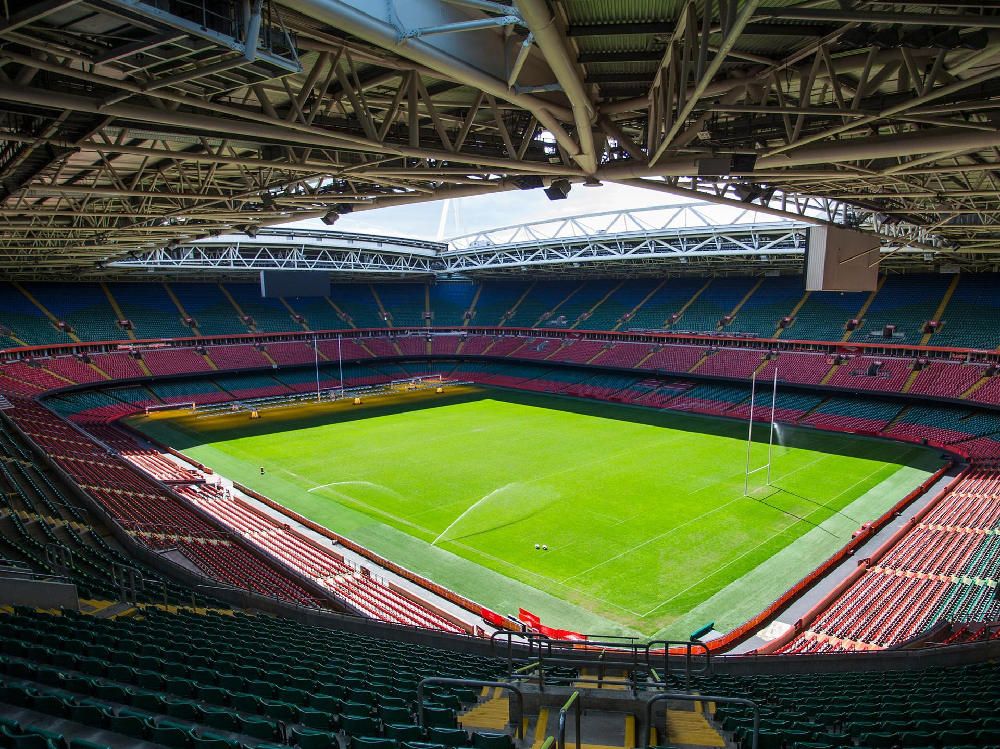

Sandra Galisteo

2008290

Table of Contents

Executive summary 3
INTRODUCTION 4
1- Comparative analysis between the crisis management efforts in the case study of the UEFA and other real-world scenarios 6
2- Risk Models applied to the case study 8
Conclusion 12
Recommendations 13
References 14

Executive summary

The study case examines the crisis management efforts during the 2017 UEFA Champions League Final in Cardiff, Wales. The report provides a critical review of different emergency scenarios that were planned for and analyses the effectiveness of the Gold, Silver, and Bronze teams' responses to hypothetical scenarios as well as how they performed during the actual emergency in some attacks occurred around the world. The report also provides recommendations for improving future emergency response plan as the crisis management efforts during the 2017 UEFA Champions League Final were effective in ensuring the safety and security of participants and spectators, but there were areas where improvements could have been made.

INTRODUCTION

Crisis management is the process of preparing for, responding to, and recovering from a crisis or emergency situation. It involves identifying potential crises, developing strategies to prevent or mitigate their impact, establishing protocols for responding to crises, and taking immediate action to contain and resolve the crisis (González, 2008).

Effective crisis management involves close coordination and communication among all participants, including employees, customers, suppliers, regulators, and the media. It also requires a clear understanding of the potential risks and vulnerabilities facing an organisation, and the ability to respond quickly and decisively to mitigate those risks (He, W., 2017).

The task is to conduct a thorough and critical evaluation of the crisis management involved in case scenario of the UEFA Champions League in Cardiff. Crisis management is an essential aspect of large-scale events, such as the Champions League final, and the emergency response plan needs to be properly structured, adequately resourced and coordinated.

In the study case scenario, in 2017, the final of the Champions League was held in Cardiff, Wales, and featured a match between two of Europe's top teams: Liverpool FC and FC Bayern Munich. The match was held the 3rd of June 2017, at the Principality Stadium in Cardiff, with an estimated global audience of over 300 thousand people to watch the game. The crisis management efforts for the 2017 Champions League Final in Cardiff were effective in ensuring the safety and security of the participants and spectators, however there were some areas where improvements could have been made which will be highlighted in the critical review report (Drennan, 2015).

In this report, it will be conducted a critical review of the different scenarios that it was conducted in the case study during the Champions League final: Royal family & prime minister, the bomb threat in Cardiff Castle, fans fighting with flares, fake tickets, series of 999 calling as a council van is parked on west gate street in the ring of steel. Within the report will be a comparison between this scenario with the actual events that unfolded on that day, analysing the shortcomings and successes of the crisis management response, and provide recommendations for improving future emergency response plans.

As part of this plan, three different response teams, Gold, Silver, and Bronze, were established, each with a unique set of responsibilities and protocols to follow in each scenario. The Gold team was responsible for overall strategic direction and decision-making, while the silver team focused on tactical coordination and implementation of the response plan. Finally, the bronze team was responsible for carrying out specific tasks and providing support to the silver team (Phatak, 2015).

These teams were trained to respond to a range of scenarios, including potential terrorist attacks, fires, and medical emergencies. This critical review will examine the effectiveness of the gold, silver, and bronze teams' responses to hypothetical scenarios, as well as it will be analysed some of the attacks that happened around the world (Kozlowski, 2019).

CAPACITY

Overall (Seated) | 73,931 Spectators
Upper Tier | 35,151 Spectators Level 6
Middle Tier | 15,626 Spectators Levels 4 & 5
Lower Tier | 23,154 Spectators

(Principality Stadium Wales, 2019)

Comparative analysis between the crisis management efforts in the case study of the UEFA and other real-world scenarios

The security and safety of individuals in public places is a key concern for authorities around the world. In 2017, Cardiff hosted the UEFA Champions League final, which attracted a large number of football fans and high-profile individuals from around the world, while London experienced a terror attack on London Bridge (BBC News, 2017).

In response to the event, a comprehensive security plan was put in place by the authorities, which included measures such as road closures, increased police presence, and the deployment of sniffer dogs and explosive detection teams, despite the large crowds and potential for security risks, the event passed without any significant incidents or breaches of security (BBC News, 2017).

On the same day, a terrorist attack occurred on London Bridge in which a van was driven into pedestrians, followed by a knife attack in nearby Borough Market, Anderson, 2017), which was planned to happen in Cardiff instead but due to the well security management team and the procedures in place in Cardiff they attacked London (Class confidential information).

The attack resulted in the deaths of 8 people and 48 injured. In response to the attack, the authorities immediately activated their crisis management plan, which included deploying armed police officers and setting up a cordon around the affected areas. The police were able to neutralise the attackers within 8 minutes of receiving the first emergency call, but the response was not without criticism, as some individuals argued that the police could have acted within a shorter period of time to neutralise the threat (BBC News, 2019).

A van collided with a group of pedestrians during the Champions League final in Cardiff, causing widespread panic and confusion among the spectators (BBC News, 2017). Both in the real-life scenario and the case study, the emergency response teams effectively handled the situation by taking measures such as monitoring CCTV footage, keeping the spectators away to prevent further panic, and contacting the Council to identify the driver of the vehicle, but, it is important to highlight that in the case study, it would have been more beneficial for the teams to prioritise determining the origin, type, and authenticity of the bomb, as this could have saved time and improved the overall management of the situation (Michal Titko, 2018).

The terrorist attack in Manchester just weeks before the final was well-planned and demonstrated the importance of being prepared for potential threats. The emergency services, including the police, ambulance, and fire departments, did not respond as quickly as they should as had some delays especially in getting medical assistance to those in need. The local authorities instead provided regular updates to the public to ensure they were aware of the situation and what actions were being taken (Manchester, 2017).

The response to the Manchester attack demonstrated the importance of preparedness and the need for effective crisis management protocols (Hwang, B., 2019). The experience gained from this event was likely incorporated into the planning for the Champions League final in Cardiff, which contributed to the success of the response efforts during the final. “The highest state of alert enveloping the United Kingdom after the attack at the Manchester Arena had forced Welsh Police to cancel fan zones at the Champions League final” (Marca, 2017).

The case study presented a similar situation to the Paris attack, where the attackers had used fake tickets to gain access to the stadium. In Paris, the attackers were prevented from entering the stadium due to the detection of their explosive vests during a routine security check. In the case study, the emergency response teams had established protocols in place, but they failed to carry out a crucial step of checking the tickets three hours prior to the event, within the "Ring of Steel" area. This failure could have potentially allowed the attackers to enter in this area, making it more challenging for the teams to apprehend them and prevent chaos (White Paper, 2016).

According to White Paper (2016), the fake tickets used by the attackers were of poor quality and were easily distinguishable from genuine ones. It is unclear how the attackers obtained the fake tickets, but it is suspected that they may have been purchased on the black market or created using counterfeit printing technology.

During the Paris attack in November 2015, several mistakes were made which contributed to the success of the terrorist attack. One of the key mistakes was the failure of the French intelligence agencies to detect and prevent the attack despite receiving prior warnings of a possible attack. The security personnel at the stadium were not properly equipped to detect the attackers' explosive vests, and the screening of spectators entering the stadium was inadequate (White Paper, 2016).

The terrorist attack in Paris in 2015 serves as an example of inadequate crisis management. The attack exposed shortcomings in preparedness and response, including a lack of coordination among response teams and a failure to anticipate potential threats as happened in the case study scenario, highlighting in both cases the need for effective communication within the participants, employees and spectators (Laws, 2017).

The lessons learned from the Champions League Final in Cardiff can also be applied to other large-scale events, such as the terrorist attack in Paris. In such situations, the ability to respond quickly and decisively can mean the difference between life and death. “A culture of continual improvement, a growth mindset that focuses on learning from crises rather than apportioning blame from failings, and careful knowledge management are all necessary for crisis preparedness and resilience in the Tourism Sector” (World Travel, 2022).

Risk Models applied to the case study

The Gonzalez, Herrero & Pratt model (1995), three-stage is going to be apply to this case study to analyse each stage:

In the diagnosis stage, involves assessing the situation to determine the potential risks and vulnerabilities that the event faces. For example, the response to the bomb threat in Cardiff Castle was not timely enough, and this delay could have put the safety of the participants and spectators at risk. The successful of taking the VIPs into the stadium shows that the response teams were familiar with their responsibilities but did not have well-defined evacuation plans, as at the end of the match, bronze team should have evacuated the VIPs the first ones instead of keeping them at the stadium waiting for everyone else as they are the main public figures for the country (Kozlowski, 2016).

In the Planning stage, a comprehensive plan should have been developed to address the problems identified in the diagnosis stage. For example, in the case of the last scenarios the teams wasted a lot of time and the tensions at the stadium started to increase, gold spent a lot of time with bronze and did not communicate with Silver enough, bronze team felted that they were left behind when was one of the gold strategies to avoid panic and just left them to deal with the inside of the stadium. Team work did fall out in this scenario when it was the most needed, effective teamwork requires good communication, cooperation, coordination, and mutual support among team members (Phatak, A.,2015).

Finally, in the Adjusting to Change stage, the plan is implemented, and any necessary adjustments needs to be made as the situation evolves. In the case of Champions League final 2017, the response of taking the Royal family into the stadium demonstrated the effective adjustment to a changing situation. The team had extra security outside the area, the roads were closed to stop any transport to the castle, kept quiet to not panic until it was confirmed which shows that the team had a good control of the situation and knew the protocols that needed to follow at that time (Lin, 2018).

Fink (1986) model is going to be apply for this case study into the four different stages of crisis management:

The prodromal stage is the period leading up to the crisis, where warning signs or precursor events may be detected. In the case of the Champions League final the teams were trained to respond to a range of scenarios, including potential terrorist attacks, fires, and medical emergencies, but the preparation was not fully comprehensive, as there were some areas where improvements could have been made like better preparation prior to the event (Carter, 2018).

The acute stage is the period when the crisis has occurred, characterised by intense activity and rapid decision-making. During the Champions League final, several crises occurred, such as the bomb threat, fans fighting with flares, and 999 calls due to a council van parked on West Gate Street in the ring of steel. The response of gold, silver and bronze teams varied, with some demonstrating prompt and effective action, while others had shortcomings in communication and coordination (Phatak, A.,2015).

The chronic stage is the period when the crisis persists. In the case of the Champions League final, regular training can be implemented to refine the response to different hypothetical scenarios and real situations. There were some areas where the response could have been improved, such as in the case of the 999 calls due to the parked van, where it took longer as the issue was not addressed from the beginning or like in the last scenario when time was wasted and communication failed (Hwang, 2019).

The resolution stage is the period when the crisis has ended, and efforts must be made to restore normality. This includes analysing the response, identifying lessons learned, and making necessary changes to prevent future crises. In the case of the Champions a critical review was conducted to analyse the shortcomings and successes of the crisis management response and provide recommendations for improving future emergency response plans (Burnett, R. D., 1998).

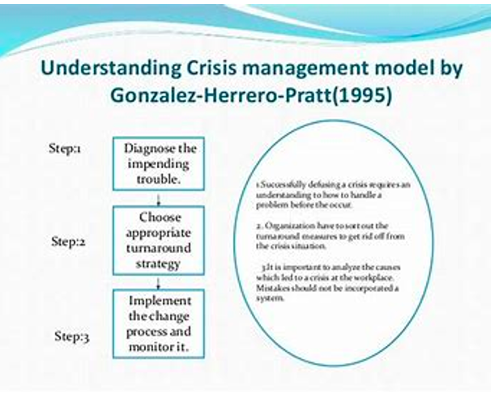
(Crisis management model, 2019)

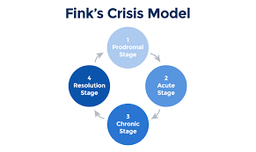

(Andy Marker, 2020)

Conclusion

Crisis management is a crucial component of event planning, and the effectiveness of response plans can make the difference between a successful and safe event and a disastrous one. The 2017 Champions League final in Cardiff showcased the importance of continuous risk planning and a streamlined response to address potential crises and this critical review highlights the importance of evaluating and continuously improving emergency response plans to ensure their effectiveness in addressing potential crises.

The analysis of real-world scenarios and the comparison with the response plan provides valuable insights and recommendations for future emergency response planning. Crisis management is a crucial component of event planning, and the effectiveness of response plans can make the difference between a successful and safe event and a disastrous one.

The establishment of Gold, Silver and Bronze teams was an important step in this direction, but needs continuous training and updating, as well as identifying areas of improvement and taking corrective actions which are necessary for effective and timely response to emergencies.

Recommendations

- Conducting a comprehensive analysis and risk assessment to identify potential threats and vulnerabilities.

- Establishing clear goals and objectives and ensuring that all response teams are fully prepared and trained to handle different scenarios.

- Improving communication and coordination among the different response teams and stakeholders, including law enforcement agencies, emergency services, and event organizers.

- Regularly reviewing and updating emergency response plans to ensure that they are effective and up-to-date.

- Conducting regular training and drills to ensure that all response teams are fully prepared and capable of responding to different scenarios.

- Establish a system for continuous evaluation and improvement of the emergency response plan based on feedback and lessons learned from past incidents.

References

Andy Marker. (2020) Crisis Management Models & Theories L Smartsheet, Smartsheet. Available at: https://www.smartsheet.com/content/crisis-management-model-theories (Accessed: 5 May, 2023).

David Anderson (2017) Home Office. Attacks in London and Manchester: Available at: https://assets.publishing.service.gov.uk/government/uploads/system/uploads/attachment_data/file/664682/Attacks_in_London_and_Manchester_Open_Report.pdf. (Accessed: 2 May, 2023)

BBC News. (2017) Champions League final: ‘Cardiff hosts football's biggest game’. https://www.bbc.co.uk/news/uk-wales-39058810 (Accessed: 2 of May 2023).

BBC News. (2017) Champions League final: ‘Cardiff responds to terror threat’. https://www.bbc.co.uk/news/uk-wales-south-east-wales-40144714 (Accessed: 2 May 2023).

BBC News. (2019) London Bridge attack: ‘What we know so far’. https://www.bbc.co.uk/news/uk-50594810 (Accessed: 3 May 2023.

Burnett, R. D. (1998) Reliability and validity of a burnout measure for student leaders: A Burnout and Anticipatory Socialization Perspective. College Student Journal, 32(4), 602-608.

Cardiff fan zones in a mess (2017) MARCA in English. Available at: https://www.marca.com/en/football/real-madrid/2017/05/26/5927f72b268e3e77638b465e.html (Accessed: 5 May, 2023).

Crisis management model (2019) Available at: https://www.managementstudyguide.com/crisis-management-model.htm (Accessed: 1 May, 2023).

Fink, S. (1986). Crisis management: Planning for the inevitable Journal of Business Continuity & Emergency Planning, 11(2), 173-181.

Drennan, McConnell, A., & Stark, A. (2015) Risk and crisis management in the public sector (Second edition). Routledge. https://doi.org/10.4324/9781315816456

González‐Herrero, A., & Smit, S. (2008) Crisis communications management on the web: how internet‐based technologies are changing the way public relations professionals handle business crises. Journal of Contingencies and Crisis Management, 16(3), 143-153.

Gonzalez, C. & Pratt, C. (1995) A Proposed Model for Emergency Management. International Journal of Mass Emergencies and Disasters, 13(3), 281-295.

He, W., & Yang, L. (2017) Enhancing communication and learning in global virtual team collaboration. Journal of Business Research, 70, 449-453.

Hwang, B., & Lee, S. (2019) Crisis management teams: role definition, decision sharing, and team effectiveness. Quality Management Journal, 26(3), 40-52.

Kozlowski, S. W., & Bell, B. S. (2013) Work groups and teams in organizations: review update. Human resource management review, 23(3), 246-255.

Laws, Prideaux, B., Chon, K., & Prideaux, B. (2007) Crisis management in tourism. CABI.

Lin, B., & Huang, Y (2018) Managing the aftermath of a crisis: The role of organizational learning. Journal of Business Research, 91, 196-208.

Local Government Association (2017). Lifecycle of an Emergency. Available at: https://www.local.gov.uk/sites/default/files/documents/10.27%20Lifecycle%20of%20an%20emergency_02_1.pdf (Accessed: 2 May 2023).

London, M., & Smither, J. W. (2019). Feedback seeking in crisis management: Insights for coaches and practitioners. Consulting Psychology Journal: Practice and Research, 71(1), 23-38.

Manchester Arena bombing: ‘Main lessons that have been learnt’ (2017) Available at: https://counteriedreport.com/articles/manchester-arena-bombing-main-lessons-that-have-been-learnt/ (Accessed: 3 May, 2023).

Michal Titko, Holla, K., Ristvej, J., & Titko, M. (2018). Crisis management: theory and practice (Holla, J. Ristvej, & M. Titko, Eds.). IntechOpen.

Phatak, A., Bhaskarabhatla, A., & Kashyap, R. (2015). Teamwork and effective communication as tools for efficient crisis management: A study on the 2008 Mumbai terrorist attack. Management and Labour Studies, 40(4), 471-483.

Principality Stadium. (2019) Available at: https://www.principalitystadium.wales/2019/08/ (Accessed: 3 May, 2023).

Regester, Larkin, J., & Regester, M. (2008). Risk issues and crisis management in public relations a casebook of best practice (4th ed.) Kogan Page.

Roulet, T., & Gill, M. J. (2020). All hands-on deck: Navigating the challenges of crisis management. Harvard Business Review, 98(3), 44-51.

Schmitt, M. J., & Gruman, J. A. (2017). Teams in crisis: Guidelines for effective team decision-making during a crisis. Consulting Psychology Journal: Practice and Research, 69(3), 139-158.

UEFA.com. "Champions League final: The road to Cardiff." Accessed: 1 May 2023) https://thehardtackle.com/blogs/2017/06/03/juventus-vs-real-madrid-uefa-champions-league-final-the-road-to-cardiff/.

White Paper the attacks on Paris: Lessons learned. (2016) Available at: https://publicpolicy.pepperdine.edu/hsac/content/hsac-paris-lessons-learned_whitepaper.pdf (Accessed: May 5, 2023).

World Travel & Tourism Council (WTTC): Travel & Tourism Representative Council. (2023) World Travel & Tourism Council. Available at: https://wttc.org/ (Accessed: 3 May, 2023).

Yan, A., & Wu, Y. J. (2020) The relationship between teamwork and crisis management: A moderating effect of organizational culture. Journal of Business Research, 116, 136-144.

