Contemporary Challenges Making a Difference
Module Code – ECIE4010
Group Video Presentation.

Video link: https://youtu.be/v9RZ23mgDPU


Slide 1
On looking at the difficulties it became clear that formal settings were not the best and easiest place to discuss your most distressing memories. Schools can be too noisy, too busy and can lack connection and a CAMHS (Child and Adolescent mental health service) has a specific criterion to meet and lengthy waiting lists (Edwards et al.,2023). What if we could target those trauma related difficulties with something as simple as a wellbeing café? A café with staff trained as trauma informed practitioners where you could come and chat to people that understand over a tea, coffee or squash in an environment that promotes connection not correction. Peter Levine once said” Trauma is not what happens to us, it’s what we hold inside in the absence of an empathetic listener”. Providing that empathetic listener in a relaxed, enriching environment could be the key to creating a more balanced emotional state.

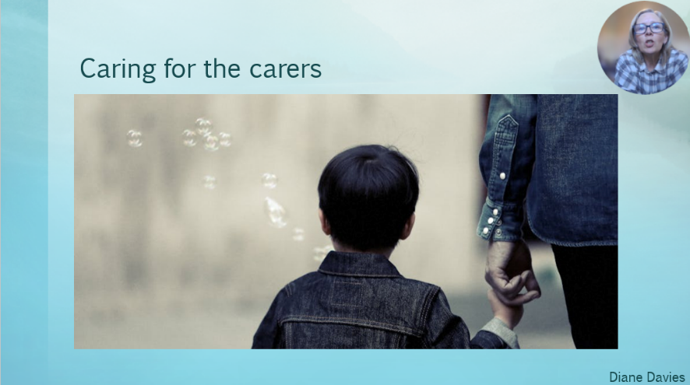
Slide 2
So how can we ensure we are reaching all those that need support? We invite those that provide the immediate care to those that are at most in need to ensure we are providing a consistent approach when meeting the needs of our clients. Families play a pivotal role in supporting the mental health of those in need in fact “a well-functioning family may, under prolonged stress or increased vulnerability, express maladaptive responses but should be able to rebalance as a system over time” (Gail Wiscarz Stuart, 2005). By teaching our strategies in a relaxing environment it will ensure a continuum of care for the vulnerable clients we are supporting and provide wellbeing strategies for those who support them at home. It’s estimated that “the number of carers of people with a mental health problem in Wales is about 48,000” (Handout 2 Background and briefing paper on caring for someone with a mental illness, n.d.) and yet of the unpaid carers who look after their relatives more than a quarter (27%) have bad or very bad mental health (Carers UK, 2023).

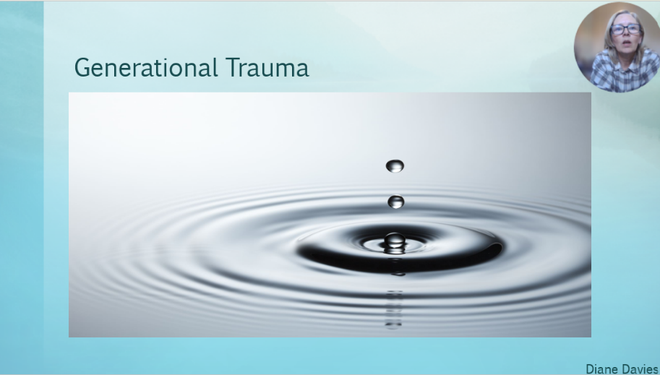
Slide 3
Humans often suppress overwhelming feelings associated with trauma (Dogan, 2019) which is why we see so many cases of generational trauma. So how can we help those that have unknowingly passed on the effects of trauma? Well, “because trauma tends to affect behaviour in ways that are unconscious and/ or habituated, the first step in trauma healing is to see traumatic retentions and recognise what activates them” (Cabeen, 2023). Our beliefs at The Wellbeing Café are that by using a trauma informed approach, we can help unburden an event that may have caused significant upset in your life. Dr Noel Larson quotes “If something is hysterical, then it’s usually historical” (Resmaa Menakem, 2021) and here at The Wellbeing Café we can help you make sense of past events to help create brighter beginnings for you and those around you.

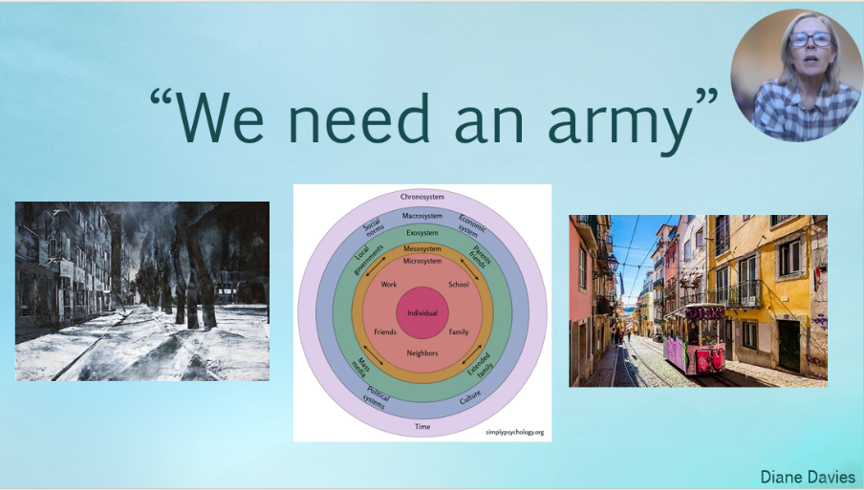
Slide 4
How can an outsider affect our mental wellbeing and how does our mental wellbeing affect our society? Bronfenbrenner shows us how a child can be affected by their relationships and society. One research study showed that just listening to 130,000 people talk about their painful childhood experiences reduced GP visits the following year by 35% and A&E visits by 11 percent (Education Forum and Education Technology Forum, 2021). Just listening brings stress levels down (Bell, 2011) and that’s what we at The Wellbeing Café will be here for.

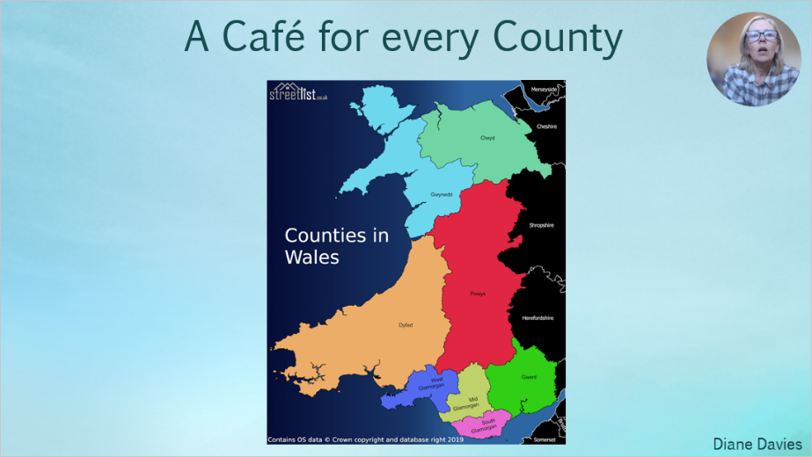
Slide 5
Our vision is to have at least one Wellbeing Café in every county in Wales that will be accessed by an immediate referral from a health professional or ALNCo. This could significantly reduce the non-urgent referrals to CAMHS, improve children and adolescents’ wellbeing and ensure we are meeting the needs of children throughout Wales. As of February 2024, there were 115 children in Wales on the waiting list for specialist mental health support (statswales.gov.wales, n.d.) however even though the number of children waiting has decreased, the criteria that needs to be met in order to be seen has been significantly tightened. This means only the most severe cases of children’s mental health issues will be able to access the service. What happens to those that don’t meet the criteria? The Wellbeing Café’s will fulfil that missing piece of the jigsaw.

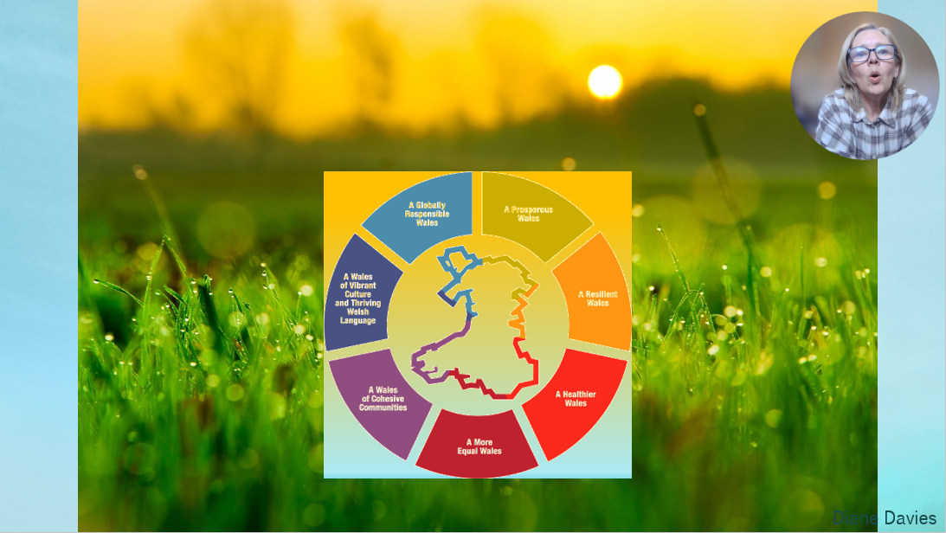
Slide 6
When we work together the future is brighter and that’s exactly what we intend to do. By working with other service providers, we will be able to provide a support service that will help support the mental health and wellbeing of our children and their support network. This will in turn reduce the generational trauma, improve learning outcomes and better future mental stability. Let’s support the children in Wales “For people, for our planet, for now and for our future” (Welsh Government, 2015).

References

Atkinson, C., Squires, G., Bragg, J., Muscutt, J. and Wasilewski, D. (2013). Facilitators and barriers to the provision of therapeutic interventions by school psychologists. School Psychology International, 35(4), pp.384–397. doi:https://doi.org/10.1177/0143034313485849. [accessed 07/04/2025]

Bell, C.C. (2011). The Impact of Early Life Trauma on Health and Disease: The Hidden Epidemic. JAMA, 306(5). doi:https://doi.org/10.1001/jama.2011.1078.
‌Cabeen, C. (2023). Trauma Responses in Social Choreography: Accessing Agency and Opportunities for Healing through Mindful Embodiment. Arts, 13(1), pp.4–4. doi:https://doi.org/10.3390/arts13010004. [accessed 11/04/2025]
Carers UK (2023). State of Caring Survey 2023 - The impact of caring on: health. [online] Carers UK. Available at: https://www.carersuk.org/reports/state-of-caring-survey-2023-the-impact-of-caring-on-health/. [accessed 11/04/2025]
Dogan, (2019). Out-of-the-box advice to deal with traumatic experiences. ; Monmouth Junction, [online] pp.14–15. Available at: https://www.proquest.com/docview/2352331936?accountid=130472&parentSessionId=PA9bMVNqF5rGCa1crfJB5oJbWexEw9ThnJoktqP6MSg%3D&pq-origsite=primo&sourcetype=Trade%20Journals. [accessed 11/04/2025]
Education Forum and Education Technology Forum. (2021). A trauma-informed approach to supporting mental health in schools. [online] Available at: https://education-forum.co.uk/briefing/a-trauma-informed-approach-to-supporting-mental-health-in-schools/. [accessed 11/04/2025]
‌Edwards, D., Carrier, J., Csontos, J., Evans, N., Elliott, M., Gillen, E., Hannigan, B., Lane, R. and Williams, L. (2023). Review: Crisis Responses for Children and Young People – a Systematic Review of effectiveness, Experiences and Service Organisation ( CAMH‐Crisis ). Child and Adolescent Mental Health, [online] 29(1). doi:https://doi.org/10.1111/camh.12639. [accessed 07/04/2025]
‌Gail Wiscarz Stuart (2005). Handbook of psychiatric nursing. St. Louis, Missouri: Elsevier/Mosby. [accessed 11/04/2025]
Guy-Evans, O. (2024). Bronfenbrenner’s Ecological Systems Theory. [online] Simply Psychology. Available at: https://www.simplypsychology.org/Bronfenbrenner.html. [accessed 07/04/2025]
‌Handout 2 Background and briefing paper on caring for someone with a mental illness. (n.d.). Available at: https://socialcare.wales/cms-assets/documents/hub-downloads/Handout_2_____Carers_Briefing_Paper.pdf [Accessed 11 Apr. 2025].

‌ Layard, R. and Ward, G. (2021). Can we be happier? [online] Lse.ac.uk. Available at: https://www.lse.ac.uk/research/research-for-the-world/health/can-we-be-happier [Accessed 11 Apr. 2025].
‌Levine, P.A. (2010). In an unspoken voice: How the body releases trauma and restores goodness. Berkeley, California: North Atlantic Books. [accessed 11/04/2025]
‌ Resmaa Menakem (2021). My Grandmother’s Hands. Penguin UK.

statswales.gov.wales. (n.d.). sCAMHS patient pathways waiting for a first appointment by month and grouped weeks. [online] Available at: https://statswales.gov.wales/Catalogue/Health-and-Social-Care/Mental-Health/specialist-child-and-adolescent-mental-health-services-scamhs/first-appointment-waiting-times/scamhspatientpathwayswaitingforafirstappointment-by-month-groupedweeks. [accessed 11/04/2025]

Welsh Government (2015). The Well-being of Future Generations. [online] GOV.WALES. Available at: https://www.gov.wales/well-being-of-future-generations-wales. [accessed 07/04/2025]
‌www.streetlist.co.uk. (n.d.). Streetlist. [online] Available at: https://www.streetlist.co.uk. [accessed 11/04/2025]
‌

‌

