
Case Study
Commercial Building in Swansea

February 13, 2018
p146593
Jamie Stearman-Phillips

Contents
1.0 Introduction 3
2.0 Case Study 4
2.1 Annual Payment 4
2.2 Data 4
2.2.1 Purchase Price 5
2.2.2 Salvage Value 5
2.2.3 Insurance 6
2.2.4 Operation Factor 6
2.2.5 Useful Life 6
2.2.6 Working Hours 7
2.2.7 Fuel Prices 7
2.2.8 Fuel Consumption 8
2.2.8 Oil Costs 8
3.0 Fixed Costs 8
4.0 Variable Costs 9
5.0 Renting Costs 10
6.0 Buy or Hire 10
7.0 References 12

Table of Figures
Figure 1 - Fixed & Variable Costs 3
Figure 2 - Doosan Price 5
Figure 3 - Scrap Metal Guide UK 6
Figure 4 - Fuel Costs UK 7
Figure 5 - Rental Doosan 10

1.0 Introduction
Before the start of any construction job, there will need to be a schedule of work prepared. In this schedule of work there will be specific plant and equipment identified for each process in the job. Depending on the duration of the project, the cost of the plant there will be highlighted suggesting purchasing or hire the plant. From previous experience on buildings with basements I am aware that a Doosan 225 Excavator will be a suitable excavator for the task ahead. This is why I will be choosing this excavator to discuss in this report.
When purchasing plant there will be 2 costs involved, variable and fixed.
“Fixed costs are costs that are independent of output. These remain constant throughout the relevant range and are usually considered sunk for the relevant range (not relevant to output decisions). Fixed costs often include rent, buildings, machinery, etc.
Variable costs are costs that vary with output. Generally variable costs increase at a constant rate relative to labour and capital. Variable costs may include wages, utilities, materials used in production, etc.” (Economics.fundamentalfinance.com, n.d.)
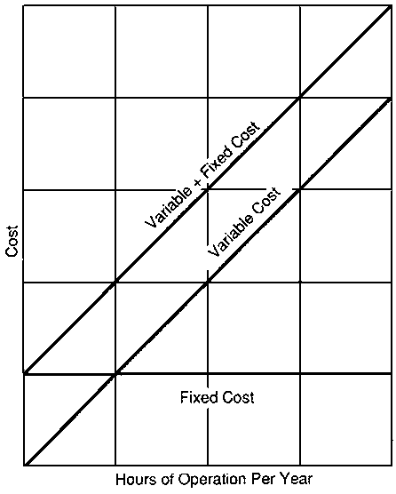(Total Cost Diagram, 2013.)
Figure 1 - Fixed & Variable Costs

2.0 Case Study

2.1 Annual Payment
$$P=C x (\frac{\left(1+i\right)n-1}{i\left(1+i\right)n})$$

$$194,034=C x (\frac{\left(1+0.05\right)15-1}{0.05\left(1+0.05\right)15})$$

$$C= \frac{194034}{1.99}=£97,504$$

2.2 Data
Table 1 - Data
Price | £194,034
Salvage | £19,250
Insurance | £3,000/Year
Operation Factor | 50%
Useful life | 15 Years
Working Hours | 2080 Hours/Year
Fuel Price | £2.475/Gallon
Fuel Consumption | 0.04 x 167 x 8
Oil Cost | 10% of Fuel Cost
Interest Rate | 5%

To work out the figures in the above table there are many different processes that need to be carried out, below I have listed many of the processes and explain how I achieve the results

2.2.1 Purchase Price
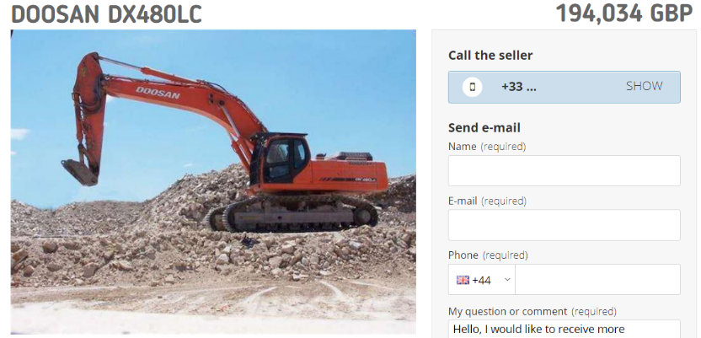
Firstly, we need to establish how much to pay for the excavator, to avoid any furture problems I believe buying a fairly new excavator will prove to be a good soulution as the cost of repairs will be dramaically reduced as the likeliness of the machine breaking is lower as well as some parts will still be under warrenty.
Figure 2 - Doosan Price

(MachineryZone, 2015)
After some research, the proposed cost for an excavator is £194,034.

2.2.2 Salvage Value
The next step will be to establish what the salvage value of the excavator is, the salvage value is “the estimated resale value of an asset at the end of its useful life. Salvage value is subtracted from the cost of a fixed asset to determine the amount of the asset cost that will be depreciated. Thus, salvage value is used as a component of the depreciation calculation.” (Bragg and Bragg, 2017)
From the table attached we can see that scrap stainless steel is going for between £0.55 - £1.00.
For an estimate idea we can use a figure in between these two numbers to give a rough idea of how much scrap metal is going for, then to find out how much the excavator would be worth, we would multiply the worth of the weight of steel into the total weight of the excavator.
For this report, I will be using the scrap metal price as £0.77

Figure 3 - Scrap Metal Guide UK

(Scrap Sales, n.d.)
$$0.77 x 1000=£770 per tonne$$
As I am aware that the excavator weighs 25 tonnes I can multiply these together to give the estimated salvage value.
$$770 x 25=£19,250$$
The estimated salvage value for this excavator is £19,250

2.2.3 Insurance
Now we need to calculate the insurance for the use of the excavator, from previous experience on Mynydd Y Gwair Wind Farm in 2017 (Dawnus Construction) I am aware that for an estimate, on a Doosan 225 the insurance will be £3,000 per year. This obviously depends on working hours, location of works etc.

2.2.4 Operation Factor
The operation factor for plant is the percentage of time that the machine is at maximum output. The excavator on this site will not be working at 100% output as there will be times that the excavator is waiting for dumpers to load. For this reason, the operation factor is given as 50%

2.2.5 Useful Life
Useful life is “an estimate of the average number of years an asset is considered useable before its value is fully depreciated.” (AssetWorks, n.d)
For plant and machinery this can be estimated at around 15 years.

2.2.6 Working Hours
The working hours on site are the total hours that the plant will be working, this will be given as hours over the year. This project will take 18 months to complete. 18 Months is equal to 72 weeks.
If this site is working 8 hours per day and 5 days a week then this suggests that the working hours for this plant is going to be 2880s per year.
6 additional months will work 1440 more hours.
For the duration of this job the plant will work 4320 Hours

2.2.7 Fuel Prices
Fuel price can be estimated using the current prices of fuel via a graph like the one attached, this graph suggests that the price of fuel will be £0.55/Litre
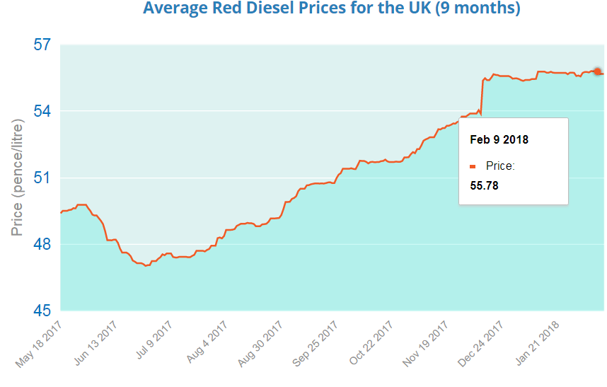
Figure 4 - Fuel Costs UK

(Boiler Juice, 2017)

2.2.8 Fuel Consumption
To workout the fuel consumption, diesel engines are given at a 0.04/gallon operating under standard conditions. We would use this figure and multiply it by the HP of the excavator and then multiply that by the working hours for the day.
$$0.04x167x8=53.44$$
The excavator would use 54 Litres of fuel per day.
We can multiply this fuel consumption into the cost of fuel to give a cost of £29.39 per day for the excavator.

2.2.8 Oil Costs
As a rule, when it comes to working out the costings of oil for plant and machinery we can say that the cost for oil and lubricant is 10% of the cost of fuel.
$$\frac{10}{100}*53.44=£5.34$$
The cost of oil will be £5.34/Day
Once all identified costs have been listed, we can split them into fixed costs and variable costs.

3.0 Fixed Costs
Useful Life in Hours = 2080 x 15 = 30600 Hours
Interest/Hour = $\frac{194,034 x 0.05 x 15}{2 x 30600}$ = £2.37
Depreciation = £194,034 - £19,250 = £174,84
Depreciation / Hour = 174784 / 30600 = £5.71/hour over 15 years
Depreciation can be worked out using many different methods, however I believe that the Sum of Years method will give a true value of deprciation.
Here is an example to work out the Depreciation of the first year using the Sum of Years Depreciation method:
$$(\frac{15-1+1}{15(15+1)÷2})x(194034-19250) = £21848$$

Table 2 - Depreciation over 15 years
Year | Sum of Years | Deprciation | Book Value
0 | 0 | 0 | 194,034
1 | 15/120 | 21,848 | 172,186
2 | 14/120 | 16,568 | 155,618
3 | 13/120 | 14,773 | 140,085
4 | 12/120 | 13,090 | 126,995
5 | 11/120 | 9,876 | 117,119
6 | 10/120 | 8,155 | 108,964
7 | 9/120 | 6,728 | 102,236
8 | 8/120 | 5,532 | 96,704
9 | 7/120 | 4,518 | 92,186
10 | 6/120 | 3,646 | 88,540
11 | 5/120 | 2,887 | 85,653
12 | 4/120 | 2,213 | 83,440
13 | 3/120 | 1,604 | 81,836
14 | 2/120 | 1,043 | 80,793
15 | 1/120 | 512 | 80,218

The above table indicates the book value of the excavator during its useful life.
Insurance / Hour = 3000 / 2080 = £1.44
Total Fixed Cost/Hr = £9.52

4.0 Variable Costs
Fuel Cost/Hour = 167 x 0.5 x 0.04 x 2.5 = £8.35
Lubrication Cost/Hour = £0.835
Total Variable Cost/Hour = £9.18
Total Ownership Costs/Hour = FC + OC = £18.70

5.0 Renting Costs
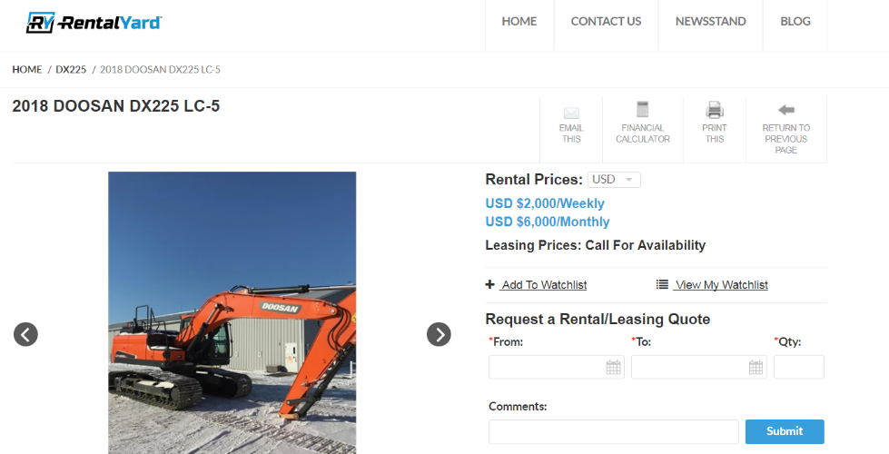
Figure 5 - Rental Doosan

(Rental Yard, 2018)
As you can see from the attached image, the costing is given in USD $. At today’s rate $1 = £0.72. Giving these rates the monthly rental cost would be £4320.
To work out the duration that we would need the excavator we need to look at the volume of material needed to be excavated. From the drawings we can see that the area needed to be excavated is 2000m2 x 6m. This indicates that there is 12,000m3 of material to be excavated.
If the excavator, we were using had a bucket of 0.5m3 then it would be removing the material at a rate of 33m3 every hour.
This means that 264m3 will be excavated every day.
12,000/264 = 45.45 Days to complete the whole excavation.
To allow for any delays we would allow for 60 days using the excavator.
This results in a total cost for the excavator as £8640 for 2 months

6.0 Buy or Hire
From analysing the total costs of hiring and purchasing the plant I have concluded that to purchase the plant it would cost a total of £80,784 for the total period of the job, or it would cost £8640 to hire the excavator for the duration of the works.
If I were to buy the excavator, there would be additional costs as I would need to pay the balance of the excavator, find storage and ensure that I will have further use for the plant.
If I was hiring the plant then as soon as the job has finished I can get rid of the excavator, not to worry about storing it and if there is work that the machine can go to.
For this reason, I have decided that hiring the excavator will be more viable for this job, there is less risk involved with the hiring of plant and I can invest the money elsewhere.

7.0 References
Asset Works (n.d) [online]. Available at: https://www.assetworks.com/useful-life-and-depreciation/ [Accessed 13 Feb. 2018].

Boiler Juice (2017). Red Diesel Prices. [image] Available at: https://www.boilerjuice.com/red-diesel-prices/ [Accessed 13 Feb. 2018].

Bragg, S. and Bragg, S. (2017). Salvage value. [online] AccountingTools. Available at: https://www.accountingtools.com/articles/what-is-salvage-value.html [Accessed 13 Feb. 2018].

Economics.fundamentalfinance.com. (n.d.). Variable Cost & Fixed Cost - Economics. [online] Available at: http://economics.fundamentalfinance.com/micro_costs.php [Accessed 13 Feb. 2018].

MachineryZone (2015). Doosan Excavator. [image] Available at: https://www.machineryzone.eu/used/track-excavator/1/9171/doosan/dx225lc.html [Accessed 13 Feb. 2018].

Rental Yard (2018). Doosan 225 For Hire. [image] Available at: https://www.rentalyard.com/listings/construction-equipment/for-rent/23641209/2018-doosan-dx225-lc-5 [Accessed 13 Feb. 2018].

Scrap Sales (n.d.). Scrap Metal Prices. [image] Available at: http://www.scrapsales.co.uk/ [Accessed 13 Feb. 2018].

Total Cost Diagram. (n.d.). [image] Available at: http://www.fao.org/docrep/T0579E/t0579e05.htm [Accessed 13 Feb. 2018].

