Enhancing your grades. 2 Thinking about sectors. Finding common factors for all three. Industry specialism. Geographic specialisms. Size (Big v Small).
13 January 2022
Creating a general theme might allow you to analyse more deeply since each blog can be related to each other. One could build on work developed for another.
Be careful. Assignment does NOT require any comparative analysis. However, a few references to how other sectors might do things could be inserted. Do not let this divert you from the main task of analysing the organisation. Major comparisons are not needed and will reduce your space for deeper analysis of each individual organisation.

The main enhancements would be in reviewing CSR as a concept in each organisation as covered in sections 1 & 2 above. What follows are some possible things to put a ‘flavouring’ into your work. They are the extra soy sauce, NOT the main ‘meat and vegetables’ of this assignment meal…. sorry if this metaphor does not work for you. I am writing this when hungry!
3. Focusing on an industry?
In our session we agreed that this was not compulsory, although it means you could apply the same industry pressures to adopt CSR to all three.
We also agreed that if you have organisations in different sectors, this is also ok, so long as you analyse the different industry pressures, if you think there are any.
If you choose one industry. See articles uploaded on the textile/fashion industry.
You might be able to use the same industry critique for all three types of organisation, private, public and NFP.
For example, textile and fashion operations are often criticised for using low wage (even “slave” labour, see article on the implementation of anti-modern slavery laws).
You could review this in:
- an international clothing manufacturer (private), -use of sweat shops part of large supply chains in developing countries where workers have no choice to avoid poverty, https://labs.theguardian.com/unicef-child-labour/

- a government welfare service provider (public)- use of the same workshops to get clothing or using government contracts to help friends (see the PPE scandal of the UK government purchasing for anti-COVID-19 health service workers. An anti-corruption author believes this is ‘cronyism’…looking after your friends with public money. https://ukandeu.ac.uk/britains-ppe-procurement-chumocracy-cronyism-corruption/ An embarrassing story for the UK in the NY Times https://www.nytimes.com/interactive/2020/12/17/world/europe/britain-covid-contracts.html . The allegation is that contracts were given to friends of the government and were too expensive or poor quality,
and
- a charity providing free clothing for poor people (NFP), how do they select the beneficiaries? Is there a religious requirement or need to agree with certain ideas? Do they give choice and high quality? A fraud of ‘charities’ collecting donated clothes but selling them to make profit and not give benefits to poor people. https://www.civilsociety.co.uk/news/fundraising-regulator-issues-public-warning-over-charity-bags.html There were even some connections o slave labour investigations.

4. Focusing on a size of operation?

- Big v Small
There are many arguments saying that small and big organisations can be more or less ethical.
You could look at either small or big in relation to the three organisations you must study. In other words, small private, public and NFP. OR large private, public and NFP. You can then use the general arguments for and against being big or small in all three.
Big organisations tend to have well developed policies, the resources to develop good CSR, hire quality staff and have specialised departments to run the operations. HOWEVER, big can sometimes mean bureaucratic systems ignoring people. Their systems are complicated and difficult to investigate or understand. They may dictate to workers, regions, stakeholders even governments to get what they want, with no real consultation.
Small can mean being very close to customers, suppliers and all other stakeholders, building strong mutually supportive relationships. HOWEVER, small can mean short term operations to make money and get out quickly, “to make a quick buck”, NOT developing long term relationships, even being guilty of breaking the law since small operations can be difficult to police by industry bodies, consumer groups even governments may not catch those who break the law. (See Caroline and Steve’s article on SME Ethics in a separate tile).
WARNING. Small organisations may be so small they do not produce good or detailed documents, websites or policy documents. Just because you cannot find them does not mean they have no CSR or ethics. It is one of the problems of researching small organisations. The researcher must use other ways to discover how small operate. I will advise on this.
These ideas about size and impact on CSR, may work in any sector, private, public or NFP.
- Domestic v International
This may link to small or big. However, all three blogs could be based in one country OR be international.
Domestic means dealing with a narrower range of cultures and the same set of laws.
International means having to manage many competing ethical cultures and often different laws.
See the article on IKEA, which unusually criticises it for being a moral relativist particularly in relation to the role of women in countries where women’s rights are not protected.
5. Focusing on a country?
This is the same as the point about Domestic above. Easier and more familiar? However, make sure there is enough material for you to quote. Sometimes textbook examples are easier. Do try to update things you read in them. Textbooks are always out of date.

THEORETICAL ANALYSIS OF MANAGING CORPORATE SOCIAL RESPONSIBILITY IN DEVELOPING COUNTRIES
Huguette Bura Sifa ; Corneille Luboya Tshiunza
Chung-Li: Educational Research Multimedia & Publications
International journal of information, business and management, 2020-05-01, Vol.12 (2), p.185-208
A Corporate Social Responsibility, generally noted by "CSR", refers to a corporation's initiatives to assess and take responsibility for the company's effects on environmental and social well-being. It generally applies to efforts that go beyond what may be required by regulators or environmental protection groups. Governments seeking to advance sustainable development are increasingly turning to policies and strategies that encourage, support, mandate, or directly demonstrate more socially and environmentally sound business practices. A central component of these policies involves promoting increased transparency of economic activities. The purpose of this study is to analyze how companies in developing countries manage their business processes to produce an overall positive impact on society. This is to evaluate the sustainability, social impact and ethics, and done correctly should be about core business and to determine how companies make their money, not just add-on extras such as philanthropy. The documentary research is the most method used to conduct this study. The results showed that CSR in developing countries is a rich and fascinating area of enquiry, which is becoming ever more important in managing a CSR theory and practice. The findings also showed that managing CSR in developing countries is a tremendous opportunity for improving knowledge and getting a profoundly understanding about social responsibility of an organization or a corporate.

How institutions affect CSR practices in the Middle East and North Africa: A critical review

DimaJamali^{a1}TanusreeJain^{b1}GeorgesSamara^{cd1}EdwinaZoghbi^{d} Journal of World Business
Volume 55, Issue 5, August 2020, 101127
https://doi.org/10.1016/j.jwb.2020.101127Get rights and content
https://www-sciencedirect-com.ezproxy.uwtsd.ac.uk/science/article/pii/S1090951620300559?via%3Dihub

Abstract
This systematic literature review integrates the Varieties of Institutional Systems (VIS) framework and Patchwork Institutions lens to unpack how institutional heterogeneity in the Middle East and North Africa (MENA) impacts the practice of Corporate Social Responsibility (CSR). Our review of 154 articles published between 1995–2017 extracts the variegated nature of institutions in MENA countries and sheds light on how country-specific institutional forces affect CSR. Doing so, we take the first step to move away from a monolithic understanding of the institutional effects on CSR in MENA, acknowledging the role that collective actors play in shaping the institutional realities affecting CSR.

6. Focusing on a theme?
WARNING. This may be dangerous since you still need to look at wider stakeholder concerns.

- Engagement with stakeholders.
This could be part of your review of who the organisations identify as stakeholders but also how they engage/communicate and whether it changes organisational policy. Linked to sections 1 and 2 above. All organisations say they do engage, but does your analysis show this is the reality? What does engagement look like?
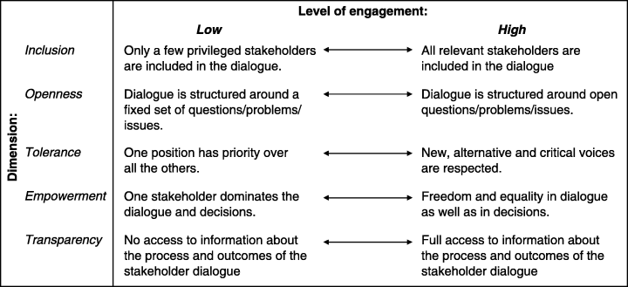
Source: Pedersen, E.R. (2006) Making Corporate Social Responsibility (CSR) Operable: How Companies Translate Stakeholder Dialogue into Practice, Business and Society Review, 111(2):137 – 163

The process. Crane et al (2016) show how it should be done.
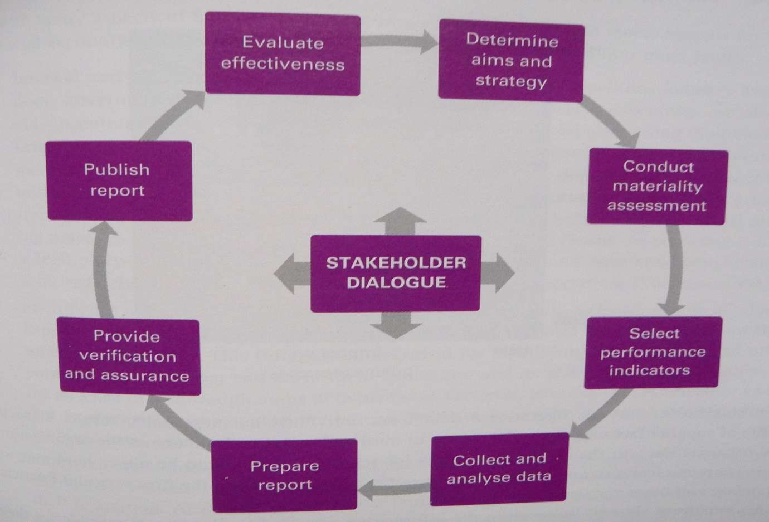
Source: Crane et al. (2026) Stakeholder dialogue, P205
They give an example of The Body Shop.
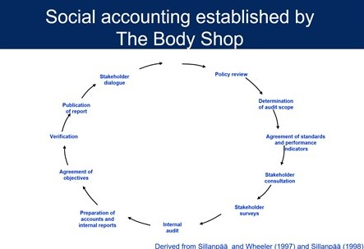

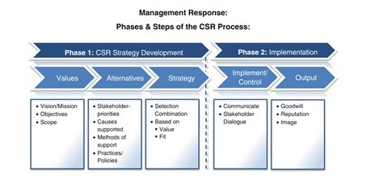
O’Riordan (2013) shows how it should integrate with policy and produce good outcomes.

- Drivers of CSR
Pressures on organisations to adopt CSR Policies. This might be relevant to the development of CSR. Were they forced to adopt it, or did they choose to be ethical and more socially responsible?
Does it really matter what the motive was and why they did it?

Remember when drawing stakeholder maps, many different versions might be drawn by different people with different priorities.
Just admitting that STAKEHOLDERS are important is some commitment to the broad view of CSR. Narrow interpretations would really only respect responsibly to the STOCKHOLDERS or owners.

Identify ways in which each stakeholder might try to impact on the organisation. Decide what they would want and how they might do it.
Discuss how the organisation might respond to this pressure. What priorities would they establish, what policies might they change and how might they communicate this.

Are all stakeholders equal? See this stakeholder map drawn by a previous class for Coca Cola. Many would disagree with parts of it.
This picture has not transferred I will load up this and others made by the class on the tile in Moodle.

DISTRIBUTORS
}
KEY O/C’S
HOTELS
BARS
RESTAURANTS
LOCAL SHOPS
INTERNATIONAL
COMMS
COMMUNITY –
ACTION GROUPS
WELL BEING COKEØ
INDUSTRY REGULATORS
SPONSORS
TRADING STANDARDS/LEGAL/POLITICAL

MEDIA &
ADVERTISING
TAX & AUDITORS
COLLABORATION WITH OTHER ORGS -
STRATEGIC ALLIANCE
COMPETITORS
- PEPSI
SUPPLIERS
- INGREDIENTS
- PACKAGING
EMPLOYEES
CUSTOMERS
B2B
B2 PEOPLE
FRANCHISE
OUTLETS
MANUFACTURERS
SHAREHOLDERS
SUB-CONTRACTORS
COCA COLA

Use this diagram below to identify the most important stakeholders. 2 sources for the Mendelow diagram.

Power/Interest Grid for Stakeholder Prioritization
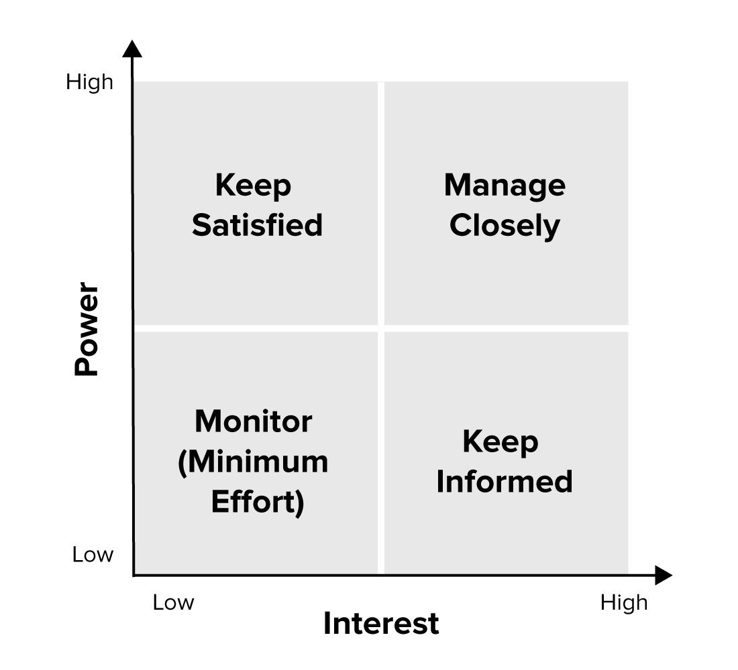
Adapted from Mendelow, A.L. (1981). 'Environmental Scanning - The Impact of the Stakeholder Concept,' ICIS 1981 Proceedings, 20.

What is important? The ones you ought to consider or Important the ones who you respond to because they have power, influence or can hurt you if you do not???
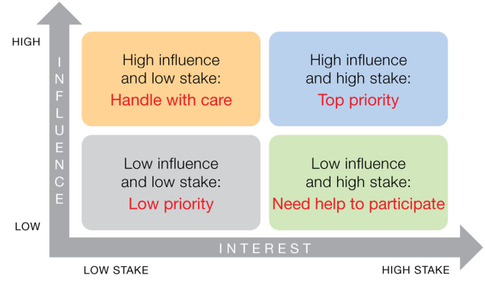
https://www.revolutionlearning.co.uk/stakeholder-analysis-the-powerinterest-grid/

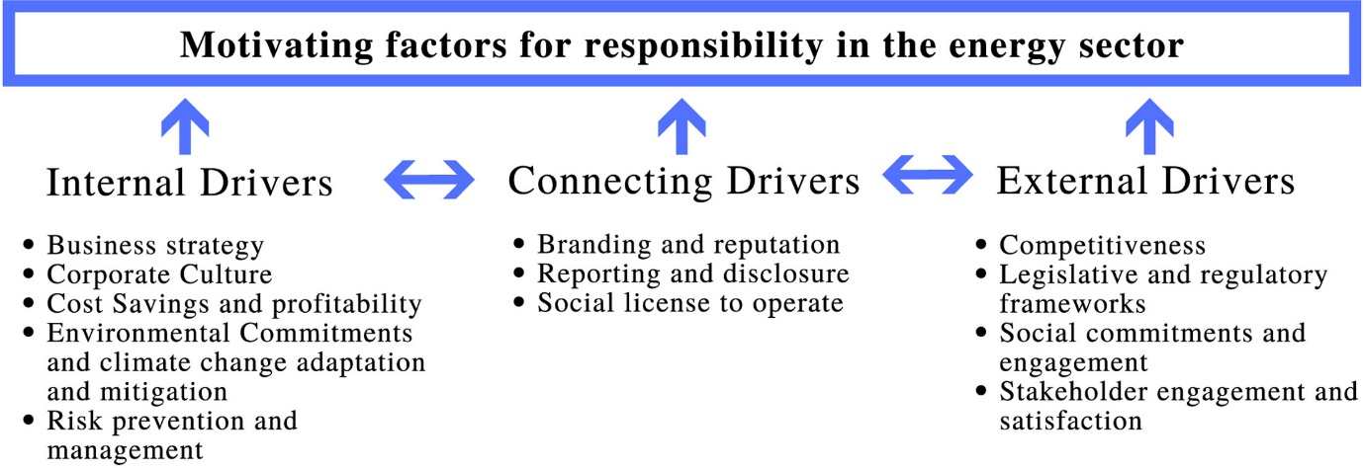

Source: Mauricio, A. & Latapi, A. (2020) Drivers that motivate energy companies to be responsible. A systematic literature review of Corporate Social Responsibility in the energy sector, Journal of Cleaner Production, Vol. 247, 20 February 2020.

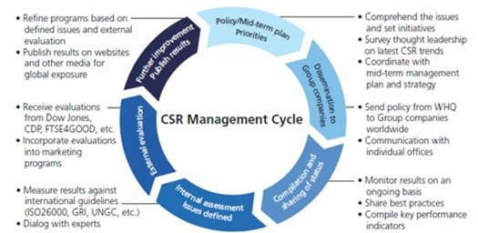

The CSR cycle of drivers, engagement and policy formation. Note External evaluations measuring results, ISO26000, GRI, UNGC etc. Do you know what these mean? Check them out.
- External evaluations measuring results.

There will be concern by large organisations to get external verification of their CSR quality standards, ISO and other external audit schemes.

There are many.

Environmental standards from Crane et al (2016)

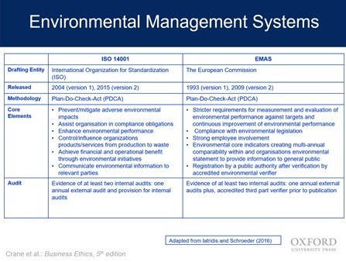
Global Reporting Initiative (GRI)
Example:
2002 Reporting Assurance, AA 1000S, consistent with GRI Sustainability reporting guidelines, assuring public reporting of processes, principles, competencies against set definitions and principles of stakeholder engagement.

https://www.nefconsulting.com/our-services/evaluation-impact-assessment/prove-and-improve-toolkits/aa1000-assurance-standard/

- Leadership

You may already have studied leadership styles, qualities, and whether good leaders can be trained or are they born?
Generally, the readings suggest a more collaborative, interactive, normally described as transformational, makes CSR easier and more likely to happen. However, this style requires many things to be in being before it can work.
There are also many examples of autocratic/undemocratic leaders who force organisations to be more ethical and adopt CSR policies.
Some types of leadership models:

- Democratic Leadership.
- Autocratic Leadership.
- Laissez-Faire Leadership.
- Strategic Leadership.
- Transformational Leadership.
- Transactional Leadership.
- Coach-Style Leadership.
- Bureaucratic Leadership.

https://blog.hubspot.com/marketing/leadership-styles

What seems to be true in the literature is that organisations led by corrupt and unethical leaders will struggle to become ethical. Workers need to be led and organised to become ethical.

“If the boss is corrupt, why shouldn’t I be?”
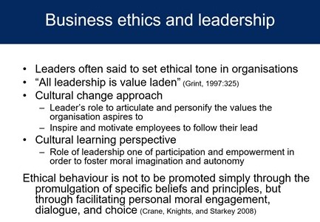
Source: Crane et al (2016)

Article uploaded:
Leadership Styles and CSR Practice: An Examination of Sensemaking, Institutional Drivers and CSR Leadership Tamsin Angus-Leppan Louise Metcalf Sue Benn

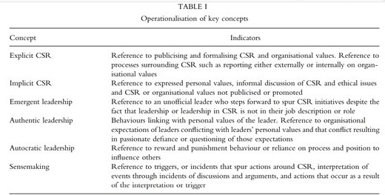
Source: Article uploaded:
Tamsin Angus-Leppan Louise Metcalf Sue Benn- Leadership Styles and CSR Practice: An Examination of Sensemaking, Institutional Drivers and CSR Leadership

Last comment on leadership.
There are some interesting ideas on “Why we follow toxic leaders”. I will upload a short article I have written on this.
Somehow in many contexts not just business, many of us end up following leaders who we can see are bad, ethically wrong, destined to make a mess, probably going to hurt the company, society and us. Yet we still obey and work for them. There is a whole literature on this. I do not think it is linked to any specific culture since there are examples from all over the world. Adolph Hitler, Pol Pot, Mussolini, choose your favourite dictator?

- Cultural factors

- Religion- influences of Buddhism, Islam, Christianity, Hinduism, Sikhism, Animism etc.
- Political systems- Western, Asian, democracy, communist, war torn, theocracies, anarchy.
- Lifestyle- single lifestyles. Asia’s falling marriage and birth rates.
South Korea https://www.straitstimes.com/asia/east-asia/til-death-do-i-stay-single-south-koreas-nomarriage-women
Japan https://www.npr.org/2019/12/24/791132555/japans-births-decline-to-lowest-number-on-record?t=1610513548762
- Social relationships- family friendly, gay, (see the “pink pound” or dollar, sexual choices, etc), state involvement/regulation etc.
- Women and Men (and others? Trans?)- equal rights, equal opportunities, MeToo movement,
- Gen X, Y, Z, Alpha may impact employment, social relationships, consumerism, participation, political involvement etc.
- Media power
- Internet power
- Environmental concerns
- Population movement. Country to the city. Migration. Refugees. Leisure relocation.
A typical abstract of an article co-authored by my friend, Jun Li: https://www.essex.ac.uk/people/lijun81900/jun-li

Population and lifestyle trend changes in China: implications for environmental quality
Nicholas Apergis & Jun Li, Volume 48, 2016 - Issue 54 Pages 5246-5256

ABSTRACT
Demographic changes have considerable impacts on a country’s long-term growth trajectory through the savings, consumption and labour market channels. Population changes, including ageing, migration and urbanization, as well as lifestyle shifts may affect growth for fast-growing countries like China. Rural population migrating to cities consumes more energy services and produces larger emissions since urban lifestyles are generally more energy- and carbon-intensive. Household structures also keep changing across the majority of Chinese cities. Migration and urbanization together drive China’s energy consumption, CO₂ emissions upwards and environmental quality downwards if the current trend continues over time. It is, thus, necessary for China to draw useful lessons from experiences in other countries by reconciling population development and environmental changes. This study provides insights into the challenge of environmental sustainability, resulting jointly from population and lifestyle changes in China over the period 1978–2012. The empirical analysis generates empirical findings documenting that population changes and consumption behavioural changes contributed significantly to increased carbon emissions over the last three decades. The modelling results are highly relevant for policymakers who seek to adopt new policies to mitigate lifestyle change-driven environmental challenges that China has to cope with in the foreseeable future.

- Networking.
All cultures have elite groups who look after each other.
- Guanxi- I will share my presentation made to the Wales Exporters Association. You may not agree.

- The UK has “the old boys’ network” or the “old school tie” …see how many of the present UK government went to one school, Eton College. Also most seem to have been to Oxford or Cambridge Universities.

- Japan has Keiretsu. Keiretsu is a Japanese term referring to a business network made up of different companies that have close relationships and sometimes take small equity stakes in each other, all the while remaining operationally independent.

- Spain has redes de negocios, this seems mainly business networking.

- Nigeria Ubuntu ethics.

African conception of ubuntu as an ethical construct. We attempt to use ubuntu to countermand the current dominant social paradigm (DSP) of hatred, intolerance, abuse of human rights, dehumanization, exploitation, authoritarianism, poverty, and oppression that plague the human race at the national and international levels. This work proposes a conception of ubuntu as a value system built upon the application of some key moral and democratic values for liberation and transformation. Specifically, ubuntu ethics is defined as a set of values central among which are reciprocity, common good, peaceful relations, emphasis on human dignity, and the value of human life as well as consensus, tolerance, and mutual respect. These features are to operate at the national level. We also argue for a possibility utilizing ubuntu ethical correlates as materials for establishing stable and viable human relations within the international system or global order. Our aim is to conceptualize ubuntu as an ethical idea and praxis, as well as to situate it as an ethical ideal all with a view to making humans better and thus tackling in a systematic manner, our natural and man-made existential predicaments.

Elitism.
- This might be OK. An elite of well-educated dedicated managers can have great impact. Elite sports people are most likely to win gold medals in the Olympic Games. However, it is also good to have sport for all, for general health and enjoyment.

- An elite group which is simply powerful people helping themselves to exploit their power, would be unfair to those outside who may have more ability or better ideas.

Networking.
For example, Keiretsu.
- Good because it shows a network of supportive people or organisations. Toyota applies the Keiretsu principle. It looks after its supply chain as a network, giving good contracts and building collaborative relationships. In return it demands high quality, trust and just in time delivery.

- Bad if the network is used to exclude good organisations or people, in an unfair way. Principles of access, equal opportunities would be threatened if networks or elites are used in this way.

Critics of networks and elites can sometime become conspiracy theorists, sometimes this is not rational or based on facts. See Donald Trump and the QAnon conspiracy https://news.sky.com/story/what-is-qanon-the-bizarre-pro-trump-conspiracy-theory-growing-ahead-of-the-us-election-12033874
Sometimes these critics simply want to impose their own conspiracy to take power.
A good discussion by a recognised professor is:

Niall Ferguson, 2018, The Square and the Tower: Networks and Power, from the Freemasons to Facebook, London, Penguin

Do not waste too much time on this but it is interesting,



Me and my copy of the book.

Steve

