

LCBB5001 Entrepreneurship

Adrian Iulian Susanu
Student id: 2019938
Module code: LCBB5001

Table of Contents
Introduction 3
1. Description of the Business 3
2. Analysis of the online teaching industry 3
3. Team plan for operations and management 6
4. Marketing plan for the business 6
6. Market research for the online teaching application 8
Conclusion 10
References 11

Introduction
The business is launching an application for online learning systems in the UK. The study focuses on developing marketing strategies along with the financial plan and proper market research for developing the business in the competitive market of the UK. it also helps to understand the UK market and its competitiveness as well. The mission of the business is to make the online learning system more convenient for students along with working professionals. The company provided separate classes according to the student’s preferences and requirements. The language classes will be provided at the weekend for the working professionals that can help them to attend the class without any disruption from anywhere at any time that day.

1. Description of the Business
In the century of digitalisation, almost every aspect gets transformed with the help of digital platforms. This study focuses on the business related to online learning, which become a great opportunity for leaders during the COVID pandemic (Adedoyin and Soykan, 2020). The business is to launch an online learning application and the name of the business decision is “Online wing” for the business. It will be comprised of young group of people, who will be experienced teaching professionals. It will help to learn the school and college goers along with the working professionals, who could not able to enroll themselves in a regular course. Special language courses will also be available in this application along with “search engine optimisation (SEO)” Courses. The mission of the business is to make the online learning system more convenient for students along with working professionals.
The company provided separate classes according to the student’s preferences and requirements. The language classes will be provided at the weekend for the working professionals that can help them to attend the class without any disruption from anywhere at any time that day. The company also provide free courses for students, whose financial condition could not allow them to adhere to learning. One of the important features of this company is that learners can enroll themselves in different courses for a single course fee.
The privacy of the courses will be protected through the copyright act, recording without prior permission and the business authority will prohibit authority. The audio-visual content along with the course materials are also will be protected through the copyright protection act. The unique services of the business or any innovative approach of them toward the learners also will be protected through formation of the patent. It will help to safeguard the exclusiveness of the services of the business. The company also will use trademarks to protect its services and stop other companies from using the same content or idea for

2. Analysis of the online teaching industry
After the pandemic, the use of digital platforms along with the expansion of the internet and telecom usage rose very significantly. It also has a great effect on the industry of e-learning, the concerns related to safety and security make the online learning platform more impactful and demanding as well. The E-learning market size in the year 2021 was 315 billion (Global Market Insights, 2022). The industry of online learning grows between 2018 and 2020. The UK market has observed a great selling rate in this industry during the pandemic.
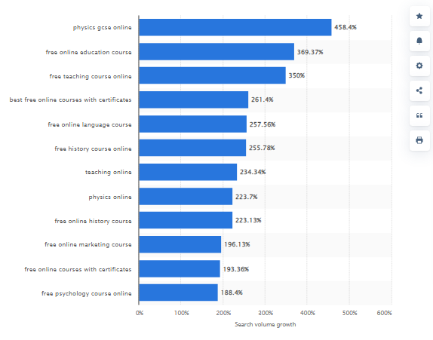
Figure 1: Growth of online learning systems in the UK
(Source: Statista, 2022)
From the above figure, it can be stated that the industry of the online education system along with free courses for the learners as well (Statista, 2022). The UK market has observed great growth in both cases, which helps to develop the industry in the competitive market of the UK.
Using the model of “porter's five forces” to understand the industry of online learnings more effectively.
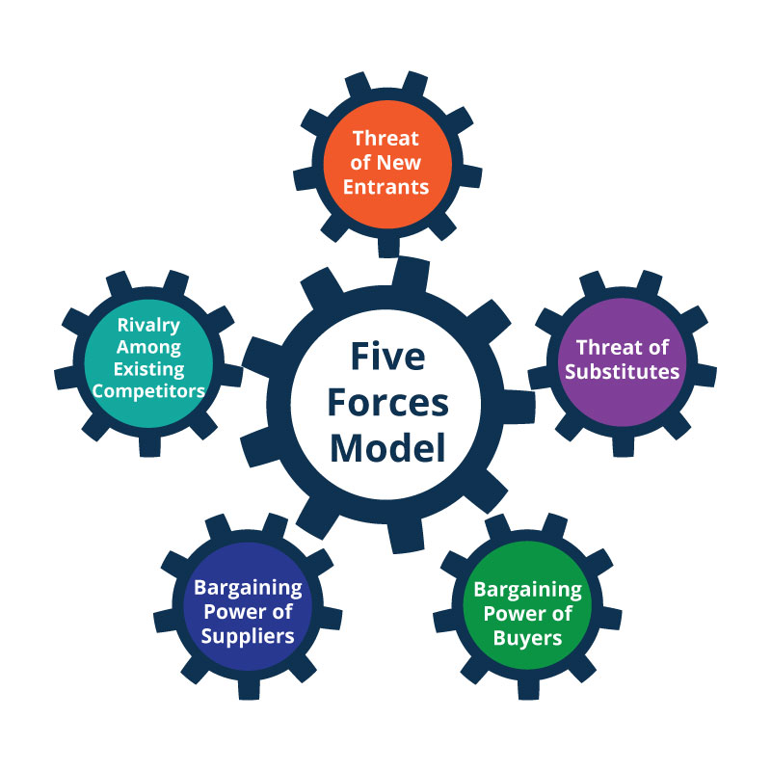
Figure 2: Porter’s five forces model
(Source: Bruijl and Gerard, 2018)
According to Bruijl and Gerard (2018), the model of porter's five forces helps to understand the market competitiveness of the online learning industry within the UK along with determining the weaknesses and the strengths of the industry as well as the existing market.
“Bargaining power of suppliers”
The suppliers of the “learning wing” needs to be skilled and experienced, which can help the company serve better services to the customers. Skilled and knowledgeable suppliers will have the power high in case of engaging in a job, which they could serve with utmost possible effort.
“Bargaining power buyers”
“Learning wing” will serve various types of customised services based pon the requirements and demands of the customers. Therefore, it makes the fact clear that the power of the buyer is high in the case of this company. It can help the company to grow and develop in the competitive market of the UK.
“Threats of the substitution company”
In the last two to three years the demand for online learning programmes get very high that influencing the market with some of the start-up companies in this context. Learning wing is also one of the online learning platforms, which is going to launch in the UK market. Some of the competitors of the company are “Metaverse”, “Future learns”, “Sparx” and so on. These are start-up companies that are trying to improve their customer base in the market. However, “Learning wing” has exclusive and attractive offerings for its customers that help it to avoid the threat of substitution companies.
“Threats of new entrants in the same market horizon”
The above mention company has done great market research before entering into the market or taking the decision to enter into the online learning industry. The threat of new entrants is also almost none in the case of the learning wing.
“Rivalry among the existing rivals in the market”
This company has been launching in the market with separate strategies and offerings from the existing competitors that help the company avoid rivalry with the existing companies.

3. Team plan for operations and management
Keeping the priority in mind, the team and the operations need to plan accordingly. The first initiative is to decide the types of courses and the target customers as per the offered courses. The company need to recruit a team of technological management for helping the business to run smoothly along with an HR manager. It also needs to recruit experienced and skilled staff for conducting online classes. Then comes the most crucial part, which is deciding the fee structure of the courses along with appointing a financial teams for the company to ensure the investments and development as well.
The company will be comprised of a management team with founders, an HR manager, one Quality assurance manager, and one reporting team, leaders for the staff, who will work under his guidance. The company also will be register with the proper documentation under the UK statutory law and will be totally fit for running their business on the digital platform with needed support of Intellectual property protections. Teams also have been divided as per the concerned responsibilities. The company also has made a sustainable plan for strategising the step for the business development. Market research has also been done on the existing issues of the UK market and its impacts on the business.

4. Marketing plan for the business
The company needs to design its marketing strategies very theistically to avoid any loss or failure in the competitive market of the UK. Using the framework of the 4P’s marketing mix the strategies for the company can be more effective and impactful.

Figure 3: Framework of 4P’s Marketing mix
(Source: Lahtinen et al., 2020)
Products of the company
“Learning wing” will provide their courses to learners from the school levels to the college-goers. It also provides some exclusive courses for the working professionals. It also will provide free courses for the learners, who are not capable financially. These can help the company to get huge customers in the UK market.
Pricing strategies of the business
Customers can enrol themselves in different courses with the payment of single fees for them. It is none of the advantages and great offers that the company is providing to the customers. It can help it to get potential customers in the competitive market of the UK.
Promotional mediums used by the business
The company will use various social media platforms to attract customers through its attractive approach. In the current scenario of the world, everyone is engaging with the digital medium, the company also uses the same to circulate its offerings to the customers.
Place selection for the product distribution
The products will be distributed through their application, which is being developed by the company for providing online education to customers. The application will be free to install on their mobile, laptop, or other electronic devices and it makes them able to attend the classes from any place, anytime.
5. Financial plan for the business
There can be mainly 6 types such as, “Cash flow lending”, “Invoice finance”, “Crowd funding”, “Angel Investors”, “Venture Capitalists”, and “Small Business Loans”. These can help to understand the diversifications of the financial stability of the business. The financing system of “cash flow lending” helps to acquire loans or funds for the short term. The application process for these funds needs minimum paperwork. In the case of “Invoice finance” is the format of paying the secured loans in case of secured loans. The 6-month expenditure and the budget of the company is as follows:
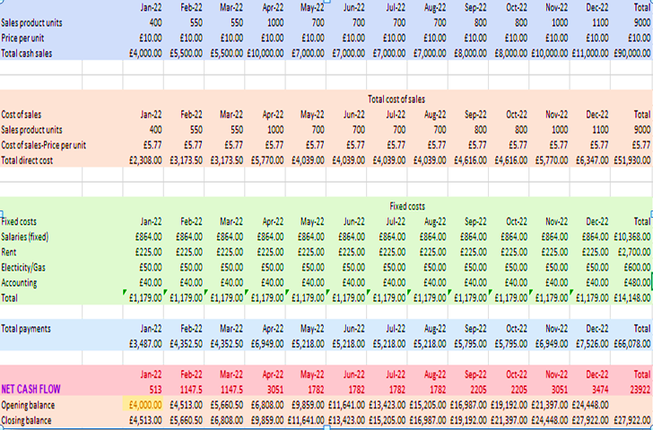

6. Market research for the online teaching application
The company has performed good research on the UK market along with developing an understanding of the current market situation. Perform PESTEL analysis to understand the UK market.
“Political factors (P)”
The UK market gets diverse due to the impact of Brexit (Thissen et al., 2020). Various rules and regulations are change due to the implications of the post-Brexit.
“Economic factors (E)”
Economic stability is also gets affected due to the changes in the GDP rate and the inflation rate of the current market.
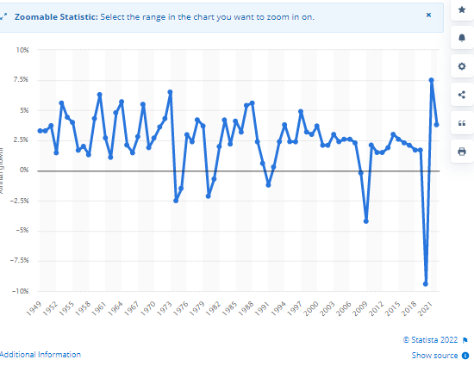
Figure 4: GDP rate of the UK 2022
(Source: Statista, 2022)
From the above figure, it can be stated that the GDP rate gets very down during 2021 and 2022 (Statista, 2022). However, the rate will not be the same in the future but the current scenario can hamper the market of the business.
“Social factors (S)”
After the pandemic, customers are not very interested in public interactions and activity, as the online platform can help to indulge them in the online learning system from any place anytime. No type of social restriction or boundary can hamper the business and its services.
“Technological factors (F)”
The country is very developed in terms of technology that can improve the functions of the business in the competitive market. Technology plays a great role in case of the business development of online learning applications.
“Environmental factors (F)”
The approach of the company in the case of providing the products and services to the customers follows the best possible responsibilities while provioding sustainable services.
“Legal factors (L)”
The company needs to incorporate legal considerations to protect the privacy and the exclusivity of the business. Copyright considerations along with trademarks can help to protect the content of the company.

Conclusion
From the above study, it can be stated that the company has been following all the procedures to form a legal and sustainable business on the digital platform. However, it needs some appropriate plan for the development and growth in the competitive market of the UK. The business is of providing online education to learners from school to college goers along with working professionals. The respondents of the business to formulate proper strategies for business development have done the market analysis. Teams also have been divided as per the concerned responsibilities. The company also has made a sustainable plan for strategising the step for the business development. Market research has also been done on the existing issues of the UK market and its impacts on the business.

References
Adedoyin, O.B. and Soykan, E., 2020. Covid-19 pandemic and online learning: the challenges and opportunities. Interactive learning environments, pp.1-13.
Bruijl, D. and Gerard, H.T., 2018. The relevance of Porter's five forces in today's innovative and changing business environment. Available at SSRN 3192207.
Global Market Insights, 2022. E-Learning Market Trends 2022-2028, Global Forecast Report. [online] Available at: <https://www.gminsights.com/industry-analysis/elearning-market-size> [Accessed 27 August 2022].
Lahtinen, V., Dietrich, T. and Rundle-Thiele, S., 2020. Long live the marketing mix. Testing the effectiveness of the commercial marketing mix in a social marketing context. Journal of Social Marketing.
Statista, 2022. E-learning keywords growth UK 2020 | Statista. [online] Available at: <https://www.statista.com/statistics/1211646/e-learning-search-term-growth-uk/> [Accessed 27 August 2022].
Statista, 2022. UK GDP growth 2022 | Statista. [online] Available at: <https://www.statista.com/statistics/281734/gdp-growth-in-the-united-kingdom-uk/> [Accessed 27 August 2022].
Thissen, M., van Oort, F., McCann, P., Ortega-Argilés, R. and Husby, T., 2020. The implications of Brexit for UK and EU regional competitiveness. Economic Geography, 96(5), pp.397-421.

