ALUN GRIFFITHS (CONTRACTORS) LIMITED

PROJECT: Caretaker Two Storey Home

METHOD STATEMENT NO. AGMS 034

SUBJECT: Engineering Surveyors RAMS

Originated by:  Dylan J Pugh  Date: 1st Oct 20 | Construction Approval:  Philip Holmes  Date: 2nd Oct 20 |  |  |  | Environmental Approval:  Dan Stevens  Date: 2nd Oct 20 |  |  | General Foreman  Approval:  Wayne Davies  Date: 1st Oct 20
P.M. Acceptance:  Leighton Rees  Date: 1st Oct 20 |  |  |  |  | Work to commence Approval:  Carwyn Davies  Date: 2nd Oct 20
Revision | Date | Change |  |  | Revision |  | Date | Change
0 | 1st Oct 20 | Issued for approval |  |  | 0 |  | 1stOct 20
 | AGCL |  |  |  | Clients (Representative |  |  | Other
Distribution: | Project Manager | Site Agent | General Foreman | Site Copy | Project Manager. | Supervisor |  | H & S File
This RAMS template I have used is from Alun Griffiths Contractors.
1.0 Introduction

The following Method Statement covers the procedures and activities carried out be an Engineer Surveyor.
Activities include:-
- Setting Out
- Surveying

2.0 Responsibilities

Name | Position | Emergency contact No.
Carwyn Davies | Contracts Manager  (AGCL) | 07977280468
Leighton Rees | Project Manager/Site- Agent  (AGCL) | 07966318155
Wayne Davies | General Foreman  (AGCL) | 07966658791
Darrel Pugh | Site Engineering Surveyor  (AGCL) | 07966981634
Dylan Pugh | Trainee Engineering Surveyor  (AGCL) | 07398167667
Mark Harrison | Covid Marshall/Ganger | 07966541257

AGC COVID-19 Procedures

A COVID-19 Marshall will be assigned to the Caretakers Two Storey Home. He/she will monitor and advice the site workforce to ensure that they are complying with the AGC COVID-19 Guidance’s.

How COVID-19 is spread
Because it is a new illness, we do not know exactly how COVID-19 spreads from person to person. Similar viruses are spread in cough droplets.

Stop COVID-19 from spreading
With the easing of the initial lockdown controls there is a possibility that local isolated breakouts of COVID 19 could occur. If a local lockdown is enforced in your area, the following will be reinforced:
1. shopping for basic necessities, for example food and medicine, as infrequent as possible
2. only one form of exercise a day, e.g. a run, walk, or cycle - alone or with members of your household
3. only leaving home for a medical need, or to provide care or to help a vulnerable person
4. only travelling to and from work, but only where this cannot be done from home.
To ensure that there is not a resurgence of cases in your area, do all you can to prevent the spread of the virus through maintaining social distancing measures, regular handwashing and observing the local controls that may be in effect in your area (e.g. wearing facemasks on public transport , or whilst entering shops)
If you do not follow guidance when not at work, you increase the risk spreading the virus to your work colleagues, some of which may have “at risk” family members.

How to stop infection spreading
There are things you can do to help reduce the risk of you and anyone you live with getting ill with COVID-19.
DO
• wash your hands with soap and water often, especially when entering site / home - do this for at least 20 seconds
• use hand sanitiser gel if soap and water are not available
• wash your hands as soon as you get back home
• cover your mouth and nose with a tissue or your sleeve (not your hands) when you cough or sneeze
• put used tissues in the bin immediately and wash your hands afterwards

DO NOT
• do not touch your eyes, nose, or mouth if your hands are not clean

What is social distancing? (General UK Government Guidance)
Social distancing measures are steps you can take to reduce social interaction between people. This will help reduce the transmission of COVID-19.
They are to:
1. Avoid contact with someone who has, or is displaying symptoms, of COVID-19. These symptoms include high temperature and/or new and continuous cough
2. Avoid non-essential use of public transport wherever possible (also applies when not in work)

3. Work from home, where possible.
4. Avoid large and small gatherings in public spaces, noting that pubs, restaurants, leisure centres and similar venues are currently shut as infections spread easily in closed spaces where people gather together.
5. Avoid gatherings with friends and family. Keep in touch using remote technology such as phone, internet, and social media.
6. Use telephone or online services to contact your GP or other essential services. Everyone should be trying to follow these measures as much as is practicable.
We strongly advise you to follow the above measures as much as you can and to significantly limit your face-to-face interaction with friends and family if possible, particularly if you:
• are over 70
• have an underlying health condition
• are pregnant

If you do not follow this guidance when not at work, you increase the risk spreading the virus to your work colleagues.

How long to self-isolate

If you have symptoms of COVID-19, you will need to self-isolate for 10 days. After 10 days:
• if you do not have a high temperature, you do not need to self-isolate
• if you still have a high temperature, keep self-isolating until your temperature returns to normal

You do not need to self-isolate if you just have a cough after 10 days. A cough can last for several weeks after the infection has gone.
If you live with someone who has symptoms
If you live with someone who has symptoms, you will need to self-isolate for 14 days from the day their symptoms started. This is because it can take 14 days for symptoms to appear.
If more than 1 person at home has symptoms, self-isolate for 14 days from the day the first person started having symptoms.
If you get symptoms, self-isolate for 10 days from when your symptoms start, even if it means you are self-isolating for longer than 14 days.
Essential workers with the symptoms listed on the GOV.UK website can now apply for a coronavirus test online at https://www.gov.uk/apply-coronavirus-test-essential-workers
If you do not get symptoms, you can stop self-isolating after 14 days.
Getting an isolation note

If you have symptoms of COVID-19 and need to stay at home, use the 111-COVID-19 service to get an isolation note. Get an isolation note - https://111.nhs.uk/isolation-note/
If you cannot attend work due to symptoms, or have been in contact with someone exhibiting symptoms, inform your line manager, who must complete the on-line notification form to our HR department. COVID-19 Absence Notification Form: COVID-19 Absence Notification Form

NHS Test & Trace

If you've been in contact with a person who has coronavirus
If you're contacted by the NHS Test and Trace service that you've been in contact with a person who has coronavirus (COVID-19), then follow this advice:
• Stay at home (self-isolate) for 14 days from the day you were last in contact with the person – it can take up to 14 days for symptoms to appear
• Note: People you live with do not need to self-isolate if you do not have symptoms
• People in your support bubble do not need to self-isolate if you do not have symptoms - (A support bubble is where someone who lives alone (or just with their children) can meet people from 1 other household)
• If you live with someone at higher risk from coronavirus, try to arrange for them to stay with friends or family for 14 days.

If you get symptoms of coronavirus

If you get any symptoms of coronavirus (a high temperature, a new, continuous cough or a loss or change to your sense of smell or taste):
• Get a test to check if you have coronavirus as soon as possible. Follow this link to the NHS website - Get a Coronavirus test
• anyone you live with must self-isolate until you’ve been tested and received your result
• anyone in your support bubble must self-isolate until you’ve been tested and received your result

What to do when you get your test result

If you test negative (the test did not find coronavirus):
• keep self-isolating for 14 days from when you were last in contact with the person who has coronavirus – as you could get symptoms after being tested
• anyone you live with can stop self-isolating if they do not have symptoms
• anyone in your support bubble can stop self-isolating if they do not have symptoms

If you test positive (you have coronavirus):

• self-isolate for at least 10 days from when your symptoms started – even if it means you're self-isolating for longer than 14 days
• anyone you live with must self-isolate for 14 days from when your symptoms started
• anyone in your support bubble must self-isolate for 14 days from when your symptoms started
If you do not get symptoms of coronavirus

If you do not have any symptoms of coronavirus:
• you can stop self-isolating after 14 days
• you do not need to have a test

How NHS Test and Trace will contact you

You will be contacted by email, text, or phone. Text messages will come from “NHS tracing”. Calls will come from 0300 0135000.
Children under 18 will be contacted by phone wherever possible and asked for their parent or guardian's permission to continue the call.
You will be asked to sign into the NHS Test and Trace contact tracing website at
https://contact-tracing.phe.gov.uk/

Vulnerable persons

Members of staff
You are classed as vulnerable if you fall into any of these categories:
• are over 70
• have an underlying health condition
• are pregnant

Staff may also have been classed as “Extremely vulnerable” (those who were advised to be “shielded” and who previously received a letter from NHS notifying them as such).
Wherever possible, vulnerable workers should work from home to minimise the exposure risk to themselves.
If home working cannot be achieved, those members of staff who are classed as either vulnerable or extremely vulnerable shall inform their line management and HR department. They shall not attend any site or office facility until their fitness to work has been formerly assessed by the company appointed Occupational Health representatives.
Vulnerable workers will only be permitted to work on a site or at a permanent office once their situation has been individually risk assessed and approved following the OH review.

If you have symptoms and live with a vulnerable person
If you live with someone who is 70 or over, has a long-term health condition, is pregnant or has a weakened immune system, try to arrange for them to stay with friends or family for 14 days.
If you have to stay at home together, try to keep away from each other as much as possible.
DO
• try to keep 2 metres (3 steps) away from each other
• avoid using shared spaces, such as kitchens or bathrooms, at the same time as each other
• open windows in shared spaces if you can
• clean a shared bathroom each time you use it, for example by wiping the surfaces you have touched
• use a dishwasher if you have one - if you do not have one, use washing-up liquid and warm water and dry everything thoroughly.

DO NOT
• do not share a bed, if possible
• do not share towels, including hand towels and tea towels

NHS Test & Trace

If you've been in contact with a person who has coronavirus
If you're contacted by the NHS Test and Trace service that you've been in contact with a person who has coronavirus (COVID-19), then follow this advice:
• Stay at home (self-isolate) for 14 days from the day you were last in contact with the person – it can take up to 14 days for symptoms to appear
• Note: People you live with do not need to self-isolate if you do not have symptoms
• People in your support bubble do not need to self-isolate if you do not have symptoms - (A support bubble is where someone who lives alone (or just with their children) can meet people from 1 other household)
• If you live with someone at higher risk from coronavirus, try to arrange for them to stay with friends or family for 14 days.

If you get symptoms of coronavirus

If you get any symptoms of coronavirus (a high temperature, a new, continuous cough or a loss or change to your sense of smell or taste):
• Get a test to check if you have coronavirus as soon as possible. Follow this link to the NHS website - Get a Coronavirus test
• anyone you live with must self-isolate until you’ve been tested and received your result
• anyone in your support bubble must self-isolate until you’ve been tested and received your result

What to do when you get your test result

If you test negative (the test did not find coronavirus):
• keep self-isolating for 14 days from when you were last in contact with the person who has coronavirus – as you could get symptoms after being tested
• anyone you live with can stop self-isolating if they do not have symptoms
• anyone in your support bubble can stop self-isolating if they do not have symptoms

If you test positive (you have coronavirus):
• self-isolate for at least 10 days from when your symptoms started – even if it means you're self-isolating for longer than 14 days
• anyone you live with must self-isolate for 14 days from when your symptoms started
• anyone in your support bubble must self-isolate for 14 days from when your symptoms started

If you do not get symptoms of coronavirus

If you do not have any symptoms of coronavirus:
• you can stop self-isolating after 14 days
• you do not need to have a test

How NHS Test and Trace will contact you

You will be contacted by email, text, or phone. Text messages will come from “NHStracing”. Calls will come from 0300 0135000.
Children under 18 will be contacted by phone wherever possible and asked for their parent or guardian's permission to continue the call.
You'll be asked to sign into the NHS Test and Trace contact tracing website at
https://contact-tracing.phe.gov.uk/

Vulnerable persons

Members of staff
You are classed as vulnerable if you fall into any of these categories:
• are over 70
• have an underlying health condition
• are pregnant

Staff may also have been classed as “Extremely vulnerable” (those who were advised to be “shielded” and who previously received a letter from NHS notifying them as such).
Wherever possible, vulnerable workers should work from home to minimise the exposure risk to themselves.
If home working cannot be achieved, those members of staff who are classed as either vulnerable or extremely vulnerable shall inform their line management and HR department. They shall not attend any site or office facility until their fitness to work has been formerly assessed by the company appointed Occupational Health representatives.
Vulnerable workers will only be permitted to work on a site or at a permanent office once their situation has been individually risk assessed and approved following the OH review.

If you have symptoms and live with a vulnerable person
If you live with someone who is 70 or over, has a long-term health condition, is pregnant or has a weakened immune system, try to arrange for them to stay with friends or family for 14 days.
If you have to stay at home together, try to keep away from each other as much as possible.
DO
• try to keep 2 metres (3 steps) away from each other
• avoid using shared spaces, such as kitchens or bathrooms, at the same time as each other
• open windows in shared spaces if you can
• clean a shared bathroom each time you use it, for example by wiping the surfaces you have touched
• use a dishwasher if you have one - if you do not have one, use washing-up liquid and warm water and dry everything thoroughly.
DO NOT
• do not share a bed, if possible
• do not share towels, including hand towels and tea towels

(Note: If you have symptoms of COVID-19, you will need to self-isolate for 10 days, and not attend work) - Essential workers with the symptoms listed on the GOV.UK website can now apply for a coronavirus test online at https://www.gov.uk/apply-coronavirus-test-essential-workers

Living with vulnerable persons or if you are a carer for a vulnerable person

If you live with or care for a vulnerable person, you will need to assess the risk of how your work activities will potentially impact on their well-being. Any concerns will need to be raised with your line Manager and the HR department.
Those who are of the same household as those classed as extremely vulnerable shall inform their line management and shall not attend the site until their situation has been formerly assessed by the Occupational Health department.

Preventing the spread of COVID-19 in the workplace (Site / Office)

Risk Assessment
All working sites and permanent offices must be covered by a site-specific RA with multiple layers of control to mitigate any foreseeable risk to the workforce.
It is essential that the multiple layers of control within each Risk Assessment are followed in order for the assessment to be effective, and regular briefings to all staff shall be completed. The effectiveness of each RA and on-going control measures will also be continuously monitored by nominated members of staff (COVID-19 Marshalls) on site.
A copy of the COVID-19 Risk Assessment templates can be located following the link below (Please note: Each site must review content and ensure the controls listed and employed are specific to each individual site)
https://crhemea.sharepoint.com/griffiths/HS.RA.02
Permanent & site office facilities

All office facilities are required to be assessed prior to allow for social distancing controls, which will include the maximum level of permanent staff permitted, the office layout, implementation of one-way systems and controlled access to welfare areas. This will be included in the Risk Assessment for the office.
Dependant on the numbers of staff present the risk assessment may recommend use of an Infrared non-contact thermometer for persons entering site. This will determine if staff members have a high temperature whilst avoiding physical contact and maintaining social distancing measures.
Offices / sites will also be required to deliver a site specific COVID 19 induction to all staff and visitors in attendance detailing the expected controls at that facility.

Travel Arrangements (Griffiths staff)
Wherever possible employees should travel alone in vehicles e.g. one person per vehicle.
• Only in exceptional circumstances and where all other options have been considered and it is not possible to maintain one person per vehicle the following measures must be applied:
• Only specified vehicles may allow dual occupancy (See illustration below)
• Dual occupancy in specified vehicles must be authorised by the Regional Director in writing
• Cab screens must be fitted to separate the driver from the passenger, these must be fitted or authorised by Adrian Davies - Plant and Transport Director.
• Journeys should be shared with the same individuals and with the maximum number of two people including the driver at any one time
• The passenger must sit in the rear seat furthest away from the driver
• Good ventilation (i.e. keeping the windows open) and facing away from each other may help to reduce the risk of transmission

•All company vehicles that are used and shared by individuals and shifts must have in place a frequent cleaning regime that cleans touchpoints, namely door handles (inside & out), gear lever, glove compartment, switches and control panels, steering wheel etc.
• All occupants must clean their hands thoroughly with clean water and soap and/or sanitiser before entering the vehicle and as soon as possible after leaving it.
• Sites should also consider:
• Parking arrangements for additional vehicles and bicycles
• Other means of transport to avoid public transport e.g. cycling
• Providing hand cleaning facilities at entrances and exits. This should be soap and water wherever possible or hand sanitiser if soap and water are not available
• How someone taken ill would get home. (This shall form part of the project specific risk assessment and will consider the logistics of each site).
• If a vehicle fitted with a screen does not have opening windows to allow for adequate ventilation, then the vehicle is not to be used for long duration journeys. This is especially relevant in hot weather.

Travel Arrangements (sub-contractors)

It is expected that sub-contractors will adopt and adhere to the Griffiths travel controls as detailed in section 10.3.
However, it is appreciated that that this cannot always be the case. Therefore, as a minimum, it will be expected that sub-contractors demonstrate that their travel arrangements meet the guidance issued by the Construction Leadership Council (CLC). Follow link to the current guidance: http://www.constructionleadershipcouncil.co.uk/

Site visitors and deliveries - relevant controls

Wherever possible, external visits to sites and offices should be reduced to an absolute minimum, and cold calling shall be prohibited.
For essential visits, the COVID-19 Champion shall be contacted prior to the visit, and the visitor briefed on the controls in place. All visitors shall also be required to complete a COVID-19 health questionnaire on arriving at site. Essential visits would include SHEQ Advisors, Clients , senior staff, material deliveries and representatives from Regulatory bodies (e.g. HSE / ORR)
Dependant on the site-specific Risk Assessment, (i.e. if regular visitors will be attending the site) it may be determined that further control measures are required. These may include:
• Use of an Infrared non-contact thermometer. This will determine if the visitor has a high temperature whilst avoiding physical contact and maintaining social distancing measures.
• Installation of a fixed screen in the reception / designated reporting area
• Designated segregated areas for material or parcel deliveries, including a cleaning or quarantine regime of all delivered packages and goods.

Site Access Points

 •Stop all non-essential visitors.
• Introduce staggered start and finish times to reduce congestion and contact at all time
• Monitor site access points to enable social distancing – you may need to change the number of access points, either increase to reduce congestion or decrease to enable monitoring
• Remove or disable entry systems that require skin contact e.g. fingerprint scanners
• Require all workers to wash or clean their hands before entering or leaving the site
• Allow plenty of space (two metres) between people waiting to enter site (e.g. mark out 2m where briefings take place)
• Regularly clean common contact surfaces in reception, office, access control and delivery areas e.g. scanners, turnstiles, screens, telephone handsets, desks, particularly during peak flow times
• Reduce the number of people in attendance at site inductions and consider holding them outdoors wherever possible
• Delivery drivers should remain in their vehicles if the load will allow it and must wash or clean their hands before unloading goods and materials. Where reasonably practicable a quarantined area for deliveries to be identified and maintained.
• Provide handing cleaning facilities at entrances and exits. This should be soap and water wherever possible or hand sanitiser if soap and water are not available.

• Determine the requirement of introducing staggered start and finish times to reduce congestion and contact at these points.
• Require all workers to wash their hands for 20 seconds using soap and water when entering and leaving the site
Determine the requirement of introducing staggered start and finish times to reduce congestion and contact at these points.

Hand Washing

• Provide additional hand washing facilities to the usual welfare facilities if a large spread out site or significant numbers of personnel on site
• Ensure soap and fresh water is readily available and kept topped up at all times
• Provide hand sanitiser (minimum 60% alcohol based) where hand washing facilities are unavailable
• Regularly clean the hand washing facilities and check soap and sanitiser levels
• Provide suitable and sufficient rubbish bins for hand towels with regular removal and disposal.

Sites will need extra supplies of soap, hand sanitiser and paper towels and these should be securely stored.

Toilet Facilities

• Restrict the number of people using toilet facilities at any one time
• Wash hands before and after using the facilities
• Enhance the cleaning regimes for toilet facilities particularly door handles, locks, and the toilet flush
• Portable toilets should be avoided wherever possible, but where in use these should be cleaned and emptied more frequently
• Provide suitable and sufficient “no touch” rubbish bins for hand towels with regular removal and disposal.

Canteens and Eating Arrangements

The Canteens and Eating areas shall be wiped down both before and after use. All areas used for eating shall be cleaned at the end of each break and shift.
If this cannot be applied, then the canteen or welfare unit shall be closed.
Where there are no practical alternatives, workplace canteens may remain open to provide food to staff with appropriate adjustments for social distancing. Canteens are to provide a takeaway service only providing pre-packed and wrapped food only. Workers are encouraged to bring their own food.
Whilst there is a requirement for construction sites to provide a means of heating food and making hot drinks, these are exceptional circumstances and where it is not possible to introduce a means of keeping equipment clean between use, kettles, microwaves etc. must be removed from use.
The workforce is required to stay within the confines of the project perimeter once they have entered it and not use local shops.
• Dedicated eating areas should be identified on site to reduce food waste and contamination
• Break times should be staggered to reduce congestion and contact at all times
• Hand cleaning facilities or hand sanitiser should be available at the entrance of any room where people eat and should be used by workers when entering and leaving the area

• The workforce should be asked to bring pre-prepared meals and refillable drinking bottles from home
• Workers should sit 2 metres apart from each other whilst eating and avoid all contact
• If catering is to be provided on site (e.g. Rail blockade), it should provide pre-prepared and wrapped food only
• Drinking water should be provided with enhanced cleaning measures of the tap mechanism introduced
• Tables should be cleaned between each use
• All rubbish should be put straight in the bin and not left for someone else to clear up
• All areas used for eating must be thoroughly cleaned at the end of each break and shift
• Crockery, eating utensils,

Changing Facilities, Showers and Drying Rooms

• Introduce staggered start and finish times to reduce congestion and contact at all times
• Introduce enhanced cleaning of all facilities throughout the day and at the end of each day
• Consider increasing the number or size of facilities available on site if possible
• Based on the size of each facility, determine how many people can use it at any one time to maintain a distance of two metres
• Provide suitable and sufficient rubbish bins in these areas with regular removal and disposal
Avoiding Close Working

As per UK Government guidelines Griffiths has restricted work within 2 metres. Social distancing shall be implemented and maintained throughout all activities, activities that require staff to encroach within 2 metres must be risk assessed by a competent person in conjunction with the SHEQ Department.
The control measures must be signed off by the
• Head of SHEQ and Regional Director

and countersigned by the
• Executive Director and Managing Director.

When undertaking a COVID-19 risk assessment, the assessor shall always apply ‘General Principles of Prevention’ and refer to the Hierarchy of Control in Figure 1.
Work that requires skin to skin contact is strictly prohibited.
As a reminder, the Board gives everyone direct authority to stop any activity that cannot be carried out safely.
Site Management and Supervision should remind the workforce (e.g. at daily briefings) of the specific control measures necessary to protect them, their colleagues, families, and the UK population.

Cleaning

Enhanced cleaning procedures should be in place across the site, particularly in communal areas and at touch points including:
• Taps and washing facilities
• Toilet flush and seats
• Door handles and push plates
• Handrails on staircases and corridors
• Lift and hoist controls
• Machinery and equipment controls
• Food preparation and eating surfaces
• Telephone equipment
• Keyboards, photocopiers, and other office equipment

Rubbish collection and storage points should be increased and emptied regularly throughout and at the end of each day.
Disinfectant the worksite after someone with suspected coronavirus (COVID-19)
• Cleaning an area with normal household disinfectant after someone with suspected coronavirus (COVID-19) has left will reduce the risk of passing the infection on to other people
• Wear disposable or washing-up gloves and aprons for cleaning. These should be double bagged, then stored securely for 72 hours then thrown away in the regular rubbish after cleaning is finished
• Using a disposable cloth, first clean hard surfaces with warm soapy water. Then disinfect these surfaces with the cleaning products you normally use. Pay particular attention to frequently touched areas and surfaces, such as bathrooms, grab-rails in corridors and stairwells and door handles
• If an area has been heavily contaminated, such as with visible bodily fluids, from a person with coronavirus (COVID-19), use protection for the eyes, mouth, and nose, as well as wearing gloves and an apron
• Wash hands regularly with soap and water for 20 seconds, and after removing gloves, aprons and other protection used while cleaning

Note: Further guidance in relation to Principles of cleaning after the case has left the area regards Personal Protective Equipment, Cleaning and Disinfection, Laundry & Waste can be found by following this link: GOV.UK COVID-19: cleaning in non-healthcare settings

Communication

Where site-based communications are controlled using the voice activated back to back radios (DECT Communications equipment), the sponge windsock shall be removed. The voice activated back to back radios shall be cleaned both before and after the shift by the individual who uses it. The voice activated back to back radios shall not be passed from person to person during the shift.
When planning jobs consisting of more than one shift, the number of voices activated back to back radios shall be increased to one per machine per shift.

Do not share voice activated back to back radios unless unforeseen circumstances dictate that this is necessary. Where employees are required to share or distribute voice activated back to back radios, these will be cleaned using sanitisation wipes before and after use.
If cleaning products are not available, voice activated back to back radios are not to be shared.

Vehicles and Plant/Machinery (Including on Track Plant/On Track Machines)

Griffiths have mandated the use of single occupancy for vehicles and plant.
For all plant operations, there should be where possible a policy of a dedicated operator for each machine, minimising the potential spread within the cab/platform area.
Where a change of operators needs to take place, then a thorough cleaning/sanitising procedure needs to be carried out each time. Normal handwashing procedures should be undertaken before approaching the machine.
Touch point components for accessing the cab/platform such as steps, handrails, handles, latches etc. should be treated as potentially contaminated and cleaned/sanitised using appropriate products e.g. sanitisers/wipes/detergents etc. before entering both the cab/platform and areas required to conduct pre-start checks. This is particularly important where others have accessed the machine.
Handles, levers, controls, steering wheels, switches, data screens, seat adjusting mechanisms, arm rests etc. within the cab/platform should further be cleaned/sanitised before starting and operating the machine. If gloves have been worn outside of the machine, they should be removed first before cleaning/sanitising takes place and only re-worn after the operator has left the machine.
Normal exclusion zone requirements apply meaning that direct supporting workers e.g. ‘banksman’ are clear of all moving parts of an operational machine, with non-supporting outside of the designated exclusion zone.
Where workers need to approach the cab/platform, once permitted to enter the exclusion zone by the operator, they should maintain the required distance (minimum of 2 metres) and not touch, lean or stand on any part of the machine during the conversation. Hand signals or radio communication should be the main communication method in maintaining segregation and distancing.

What to do if someone develops symptoms of COVID-19 on site

If anyone becomes unwell with a new, continuous cough or a high temperature in the business or workplace they should be sent home and advised to follow the stay at home guidance.
If they need clinical advice, they should go online to NHS 111 or call 111 if they do not have internet access. In an emergency, call 999 if they are seriously ill or injured or their life is at risk. Do not visit the GP, pharmacy, urgent care centre or a hospital.
If a member of staff has helped someone who has been taken unwell with a new, continuous cough or a high temperature, which has resulted in being within close proximity – then they also need to go home and self-isolate as per government guidance. (Close proximity: physical contact or within 2m distance of a person while they have been exhibiting symptoms. (This should be avoided wherever possible, but could be necessary to administer first aid, etc.)
It is not necessary to close the business or workplace or send any staff home unless government policy changes. Keep monitoring the government response page for the latest details.
This needs to assess on a case by case basis by Senior Management.

Emergency First Aid

In the event of emergency first aid, which requires close proximity between workers and where it is not possible to maintain a distance of at least 2m between workers for safety reasons, first aid may only be administered it if is for a short duration and the first aider wears the following PPE as a minimum:
• disposable coverall
• tight fitting FFP3 mask (Face fit tested) or powered respirator
• nitrile gloves (worn under protective gloves if required)
• eye protection (goggles, face-shield, or safety glasses)

PPE must be disposed of (or thoroughly cleaned if re-useable) as soon as possible once the task is completed.

CPR

If you are required to perform cardiopulmonary resuscitation (CPR), you should conduct a risk assessment (This is known as a “dynamic risk assessment”) and adopt appropriate precautions for infection control.
Where possible, it is recommended that you do not perform rescue breaths or mouth-to-mouth ventilation; perform chest compressions only. Resuscitation Council (UK) Guidelines 2010 for Basic Life Support state that studies have shown that compression-only CPR may be as effective as combined ventilation and compression in the first few minutes after non-asphyxia arrest (cardiac arrest due to lack of oxygen).
If a decision is made to perform mouth-to-mouth ventilation in asphyxia arrest, use a resuscitation face shield. These will be distributed to sites in due course.
Should you have given mouth-to-mouth ventilation there are no additional actions to be taken other than to monitor yourself for symptoms of possible COVID-19 over the following 14 days. Should you develop such symptoms you should follow the advice on what to do on the NHS website.

Blood or body-fluid spill

Keep people away from the area. Use absorbent paper rolls or materials from a site spill-kit if available. Use the PPE in the kit or PPE provided by the company and following the instructions provided with the spill-kit.
If no spill-kit is available, place paper towels/roll onto the spill, and seek further advice from emergency services when they arrive.

Mental Health & Wellbeing

Promotion of mental health and wellbeing for all staff is essential in order to support them during the Coronavirus outbreak.
Managers should actively engage teams on mental health issues and encourage reporting of COVID related concerns.
The employee assistance programme (EAP) is available to all employees, including those on furlough. Lifeworks are there to provide you with a free and completely confidential support and counselling service. The contact details for Lifeworks is published in the regular company COVID 19 updates.

Assurance checking

Management Assurance checks will be carried out by Management and/or the SHEQ Department to ensure that AGC is operating in compliance with this guidance, government advice and the approved risk assessment.
In addition to these checks, each site shall appoint nominated COVID 19 Compliance Marshals – each site must assess how marshals are required relevant to site numbers and work activities (e.g. potential to encroach within 2m social distance limits)
Assurance will be monitored and recorded via the COVID 19 Audit.
Before a reopened site can be deemed fully operational, the COVID 19 Audit must be conducted as part of the remobilisation process.
Go to the SHE Assure Portal (SHE Assure). A scoring of 75% on the COVID-19 Assurance Audit or more must be achieved to ensure that COVID-19 requirements are in place and ready before the site becomes operational.
Furthermore, each operational site will be required to be audited on a monthly basis to demonstrate ongoing compliance.

Related documents
COVID 19 Toolbox Talk
HA.RA.02 – Risk Assessment – Social Distancing
Bulletins and other information are available at Griffiths Intranet: COVID-19 Documentation

3.0 Method/Procedure
Prior to commencing the works:
- All operatives must undertake a site induction and familiarize themselves with AGC site rules. As well as signing in.
- All operatives must be briefed on task allocated to them and must attend toolbox talk or any health and safety alters in the morning.
- All workforce to be briefed on AGC COVID-19 Guidance and toolbox talks
- Workforce team will always be brief in their individual teams maintaining 2 M social distancing in a staggers fashion.
- Workforce will have to complete a COVID-19 questionnaire on arrival to site at every working day to check if they are showing any symptoms of COVID-19. If they are experiencing any symptoms, they will be immediately sent home on contacted by the AGC HR department.

Method of Work Procedure:

The sites engineers’ methods of work with differ to the task or stage of the project they are on.
The engineer will follow and do their methods of work to their standard and relevant to current regulations when doing certain tasks.

Substructure- All activities involving the substructure such as foundations, trenching and services the engineer will follow the relevant Risk Assessments and Control Measures put in place for those works.

When knocking pins or pegs in, the engineer must C.A.T scan the area for any services and must wear the correct PPE.

Working at Heights- Engineer will follow the health and safety control measures and Risk Assessments put in place for Working at Heights. Any equipment they need will be transported to the area before hand and with care as equipment is very expensive and delicate but must not be carried up by the Engineer on a ladder as it can become a risk.

Training:-

- Confined Spaces- The Engineer must be trained in Confined Spaces.
- Engineers must have a Gold Supervisors CSCS Card at Minimum.
- They must have up to date C.A.T and Genni Training.
- Any other Certifications they have must be valid and in date.

4.0 Environmental Procedure

- Noise levels shall be minimised where possible and within the site working hours.
- Spill kits to be on hand at all times.

5.0 Equipment

- Setting out/Surveying equipment – GPS, Optical Level, EDM, etc
- Lump Hammer
- PK Nails/Hilti Nails
- Yellow Chalk
- Pegs
- Profile Boards
- Fiberglass pins

6.0 COSHH

- Spray Paint

Refer to main COSHH assessment file in site office.

7.0 PPE Requirements

- Hard hats.
- Safety footwear. (Metatarsal supporting)
- High visibility clothing
- Gloves.
- Eye protection
- Ear defenders

8.0 Toolbox Talks

- AGC COVID-19 Guidance’s
- Environmental/Ecological Toolbox talks will be briefed to the workforce.
Engineer will attend all toolbox tools which are relevant to them and any safety stand downs and alters.

9.0 Appendices

Appendix A: Risk Assessment.
Appendix B: HS.S.22 Personal Protective Equipment
Appendix C: Method Statement Briefing Form.

APPENDIX A

RISK ASSESSMENT

Method Statement Name: Roof Tiling |  |  |  |  |  |  |  |  |  |  |  |  | Method Statement Number: AGMS 020
Contract: Caretaker Two Storey Home |  |  |  |  |  |  |  |  |  | Contract Number: TCD486
Originator Name: Dylan J Pugh |  |  |  |  |  |  |  |  |  | Approval Name: Leighton Rees
Signature: |  |  |  |  |  | Date: 1/10/20 |  |  |  | Signature: |  |  |  | Date: 2/10/20
KEY: |  | L = Likelihood  D.J.PUGH |  | S = Severity |  |  | R = Risk (Likelihood x Severity)  L.Rees
RISK RANKING: |  | 3= Likely  2= Possible  1= Unlikely |  | 3= Fatality  2= Major Injury  1= Minor Injury |  |  | 1 to 2 = Acceptable – Use basic control measures (PPE, Supervision, Tool- box talks etc.)  3 to 6 = Significant Risks, further control measures to be applied to reduce results to Acceptable  9 = Critical Risks – Not Acceptable
Ref No | Task/Element |  | Potential Hazards |  | Population at Risk |  |  | Risk Rating |  |  |  | Control Measures Specified |  |  | Revised Risk Ranking
1 | Working Area |  | Trips, slips, and falls |  | Employees |  |  | 2 | 3 |  | 6 | All working areas to be kept free of debris where possible with surplus tools and materials removed.  Only those involved in the working operations to be within the area.  Provide suitable fencing, signing, and guarding to the working area, as necessary.  2M Social distancing must be obtained by the workforce at all times. Works activities will be planned to ensure that 2M is obtained. |  |  | 2 | 1 | 2
2 | Plant/Vehicle Movements |  | Collision with employees, members of the public/ Collision with other vehicles |  | Employees  Public  Visitors |  |  | 2 | 3 |  | 6 | All deliveries & vehicular movements to be controlled by the Yard Foreman. All plant / site vehicles to have amber flashing beacons operating whilst in yard/compound area, all operatives, delivery drivers & visitors to wear Hi-Viz clothing whilst in this area. No plant or other vehicles to reverse without a banksman |  |  | 2 | 1 | 2
3 | Live Traffic |  | Collision with Employee |  | Employees  Public |  |  | 2 | 3 |  | 6 | Set up in a safe area and out of the way of people and when surveying on live traffic either have someone as a look out for you watching on coming traffic or can you do it a different day such as early morning or on the weekend when there’s less people out. |  |  | 2 | 1 | 2
4 | Working Alone |  | Unable to access support if an accident occurs. |  | Employees |  |  | 2 | 3 |  | 6 | Avoid working alone where possible. |  |  | 1 | 2 | 2
5 | Levelling Staff |  | Contact with overhead lines |  | Employee |  |  | 2 | 3 |  | 6 | Check area before work starts.  Use non-conductive staff.  Have the staff extended to what you need and nothing more. |  |  | 1 | 3 | 3
6 | Weil’s Disease |  | Placing staff in inverts of drainage or water courses |  | Employee |  |  | 2 | 3 |  | 6 | Clean staff after using it and hands.  Wear gloves when holding the staff |  |  | 1 | 3 | 3
7 | Knocking Pins and Pegs into ground |  | Service strike causing Electrocution  Splinters in hands  Hitting fingers with hammer |  | Employees |  |  | 2 | 3 |  | 6 | C.A.T. scan before knocking pins/pegs in.  Wear gloves to protect hands.  Be careful when knocking pins/pegs in and wear appropriate PPE. |  |  | 1 | 3 | 3
8 | Manual Handling  (Carrying Equipment) |  | Musculoskeletal injuries |  | Employees |  |  | 2 | 3 |  | 6 | Manual handling assessment to be undertaken. Operatives only to lift within their own capabilities and comfort. Check if the proper carrying straps are in working order. |  |  | 1 | 2 | 2
9 | Working at Heights |  | Falls  Falling Objects  Serious or Fatal Injury |  | Employees |  |  | 3 | 3 |  | 9 | Scaffolding will be erected by Castle Scaffolding and will be tagged and checked by them. As a handrailing will be set up as well at the top of the scaffolding. All below will be erected and done by Castle Scaffolding.  Toe boards will be placed to prevent any falling objects from hitting anyone passing by.  Debris netting will be set up to catch any falling debris such as tools and materials  Ladders will be secured to the scaffolding and fixed in place. |  |  | 2 | 3 | 6

 |  |  | Severity
 |  |  | Minor Injury  (up to 3 days absence) | Major Injury  (RIDDOR reportable, long term absence or health effects) | Death / multiple deaths
Likelihood | Unlikely  (difficult to see how this can occur) |  | 1 | 2 | 3
Likelihood | Possible  (but can’t be ruled out) |  | 2 | 4 | 6
Likelihood | Likely  (could happen at some stage) |  | 3 | 6 | 9

APPENDIX B - HS.S.22 Personal Protective Equipment
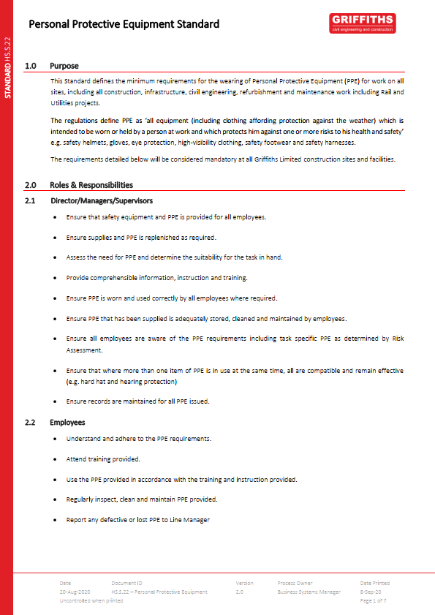
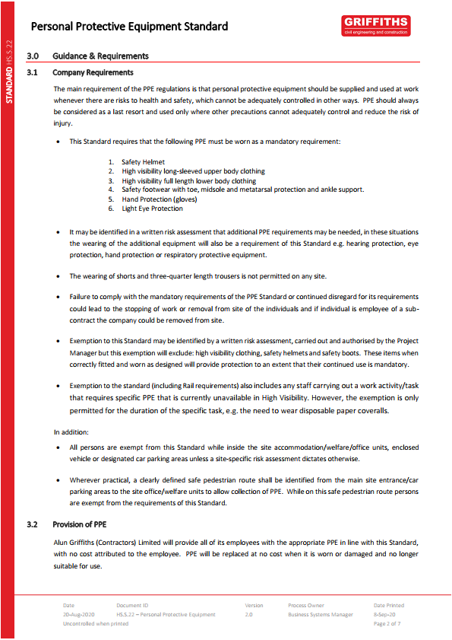
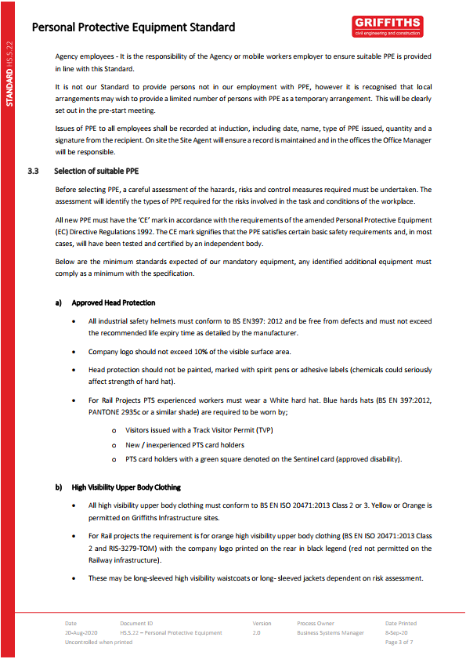
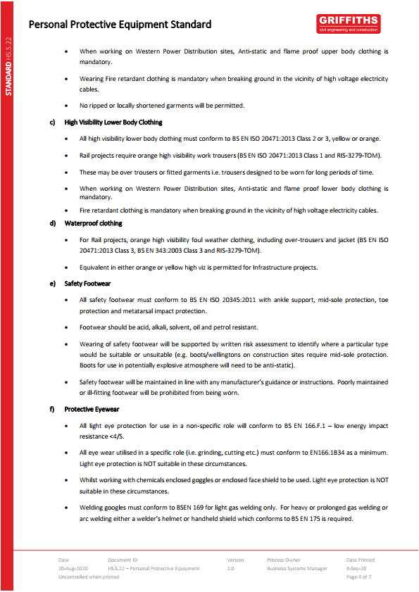
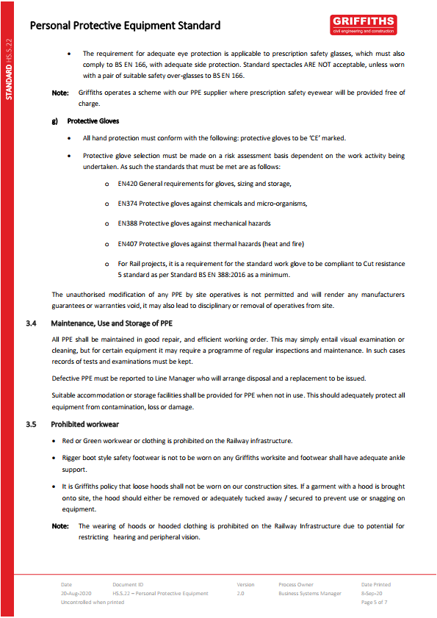
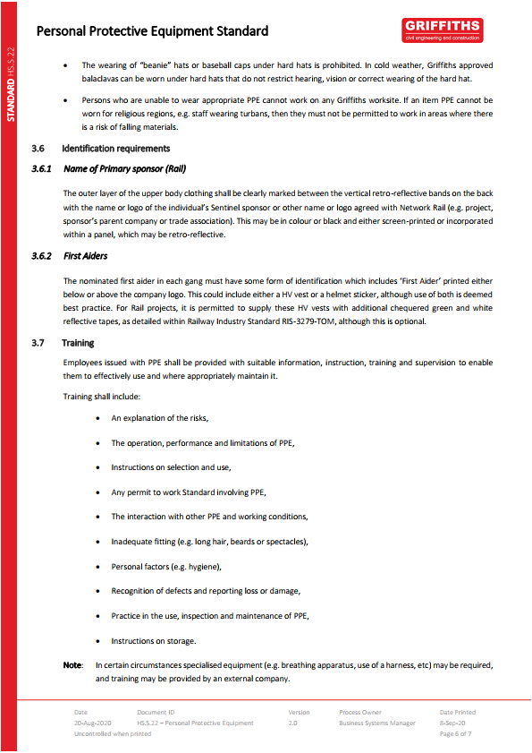
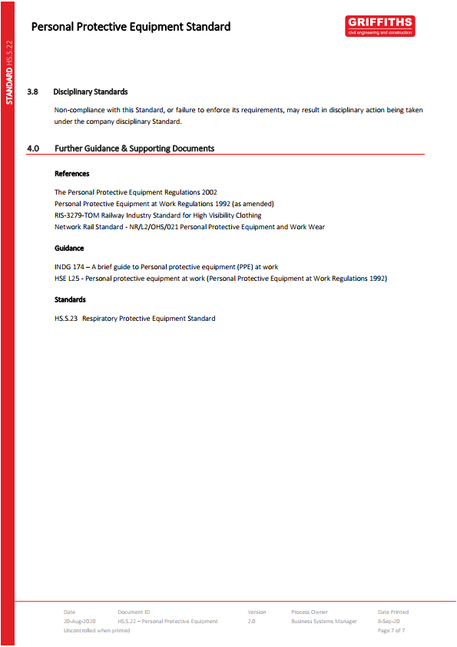
APPENDIX C - METHOD STATEMENT BRIEFING RECORD

METHOD STATEMENT EXPLANATION FORM

Method statement
Method Statement No. | AGMS 000
Date of explanation
Explanation given by
Topics covered: | Method statement explanation including toolbox talks on:  - Excavations  - Confined Spaces

No. | Attendee | Signature | No. | Attendee | Signature
1 |  |  | 14
2 |  |  | 15
3 |  |  | 16
4 |  |  | 17
5 |  |  | 18
6 |  |  | 19
7 |  |  | 20
8 |  |  | 21
9 |  |  | 22
10 |  |  | 23
11 |  |  | 24
12 |  |  | 25
13 |  |  | 26

Signature of person giving explanation: ………………………………………………

Signature of attendee confirms understanding of explanation given

