Student Name: Sophie Albangbe

Lecturer Name: Suneth Fernando

Module : BMSW4003-LON

Student Number: 1916094

Subject Title

DIGITAL SKILLS AND RESEARCH METHODS

The Impact of VLE (VIRTURAL LEARNING ENVIROMENT) on The Education Institutions in the UK

Introduction
Virtual Learning Environment is termed as a web-related system of software that is said to be designed in order to facilitate the process of learning as well as teaching with the utility of various tools as well as activities within the learning environment. Students utilizing VLE are enabled to complete their tasks as per their own pace, time, as well as location. They are further able to contribute both in forms of synchronous and asynchronous discussions so as to help to enhance the learning abilities of the students (Herrera Mosquera, 2017, p. 47). The present research report discusses the impact of Virtual Learning Environment (VLE) - Moodle on the learning experience of the students in education in institutional in the UK.
The research emphasize on the collected of empirical evidence from the given research work would help to understand the impact of the utility of VLE's on various aspects of student's experiences of learning such as their academic achievements, independent learning criteria, motivation, as well as their ability to tasks completion irrespective of their time and location (Atayero et al. 2017, p. 21). The research paper further lays down the opportunity to analyze Moodle as a large knowledge platform and establishes the utility of VLE in the process of knowledge development.

Aims and Objective.
The primary objectives of the research include:
- To analyze the use of VLE on student’s motivation to learning
- To evaluate the use of VLE as an effective knowledge platform for student’s learning experience
- To assess the impact of VLE on positive learning experience

Literature Review
The section of literature outlines the background as well as the development of VLE's in support of the teaching and learning process. It briefly delineates the historical background followed by the several impacts of utilizing VLE's within learning experiences.
Background
Universities of the UK have been utilizing computers as a source of learning since the period of the 1970s and it was in the year 2000 when the first commercialized VLE "Blackboard" was introduced. The software's utility increased the year of 2010 in more than 60 countries with over 3700+institutions availing the same. After Blackboard, the second-most popular VLE utilized is the Moodle that was introduced in the year of 200. Initially, it was developed to help teachers to formulate an online form of courses with an emphasis on interactive as well as collaborative content construction (Pallud, 2017, p. 46). In the present time, Moodle has users over 212 countries with near about 50,000 active sites that too in 75+ different languages. In the UK, stating the figure of institutions utilizing VLE’s hasrisen to a great extent.
There are a number of empirical studies available delineating the impact of VLE's on the learning experiences of the students. Stating some of them, in one of the empirical studies developed by Scardamalia and Bereiter in the year of 1996 found that VLE contributed in the development of understanding skills as well as analytical skills thereby improving the communication process among the teachers and the learners (Bereiter and Scardamalia, 1996, p. 48). In another research conducted within higher education aspects by Wernet et al. (2000), in the year of 2000 delineated learner’s motivation towards utilizing VLE’s led to satisfaction due to the dependence on exposure, access, technological availability, along with the other used tools (Wernet et al. 2000, p. 48). Various other empirical studies developed supporting the findings of this work. It can be said that a range of research work has reported positive impacts of VLE on student's learning experiences.
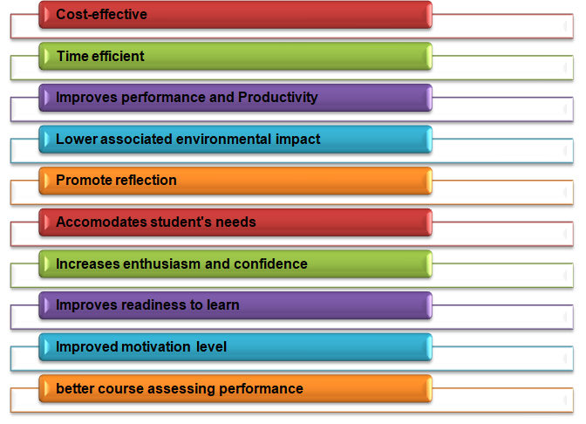
The Impacts of VLE on student’s learning experiences (Evidence-Based)
(Source: Zaharudin and Ting, 2019, p. 21)

Methodology
This section underlines the research methods or approaches utilized for the completion of the research report on the delineated topic. The current research utilized the research philosophy of “Realism” in order to take a scientific approach in the direction of knowledge development for the undertaken research topic. The other philosophical principles available would not have allowed taking an objective and scientific approach in the study of digital skills such as VLE on student’s learning experiences (Žukauskas et al. 2018, p. 121). The research approach considered is that of Inductive as the same permits process the research report in a bottom's up approach providing the flexibility to assess the general observations and develop sets of theory based on such observations after careful analysis of the available evidence. Further, the research collected both primary quantitative and secondary data related to the research topic.
The online survey was used to collect data on the students of University in the UK as a primary data collection tool, on the other hand, published research work on the undertaken topic is gathered as well as analyzed as tools of secondary data collection (Woo et al. 2017, p. 23). The target population is the students of the University of Wales Trinity Saint David London Campus and the sampling technique used is that of convenience sampling that relied on a collection of data from the population members who were available as per their convenience to participate within the study. 51 students' data were gathered, and the primary data collected were then processed for quantitative analysis so as to address the research objectives. The present research work was conducted following the ethical principles of privacy, confidentiality, and integrity of the participants and the gathered data. The participants were informed about the utility of the data and the purpose of the research work and Intellectual property rights along with the Data Privacy Act, 1998 were further implemented (gov.uk, 2020).

Primary Data Analysis
Primary quantitative data analysis would be performed in this research study. Moreover, this primary data analysis will be performed in order to evaluate the effective effect of VLE that is the effect of Moodle in the students of the University of Wales. A suitable survey process would be performed by selecting 51 students from various departments of the University and a set of 12- question questionnaire was administered in order to evaluate the impact (Jackson, 2017, p. 177). In this research, the quantitative data analysis has been performed as it helps to find an effective pattern of the behaviour of the research topic along with the overriding of the themes.
Survey Questions- (12-question questionnaire)
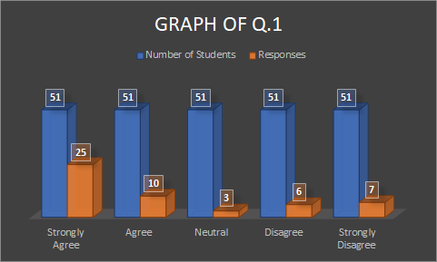
Figure 3: Response of Q.1
(Source: Developed by Researcher)
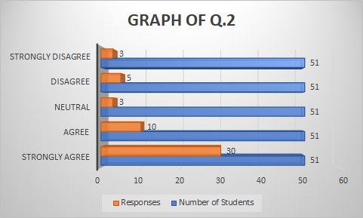
Figure 4: Response of Q.2
(Source: Developed by Researcher)
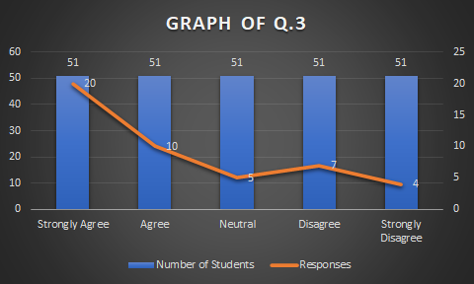
Figure 5: Response of Q.3
(Source: Developed by Researcher)
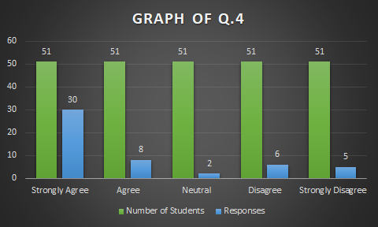
Figure 6: Response of Q.4
(Source: Developed by Researcher)
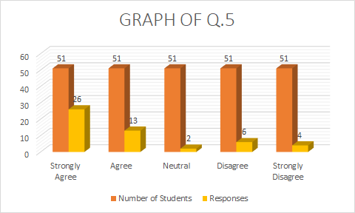
Figure 7: Response of Q.5
(Source: Developed by Researcher)
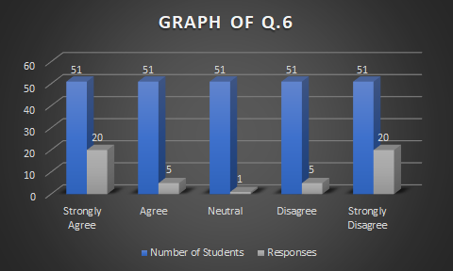
Figure 8: Response of Q.6
(Source: Developed by Researcher)
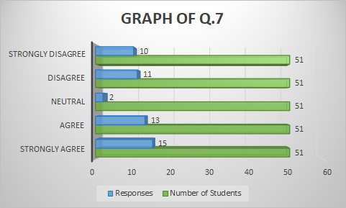
Figure 9: Response of Q.7
(Source: Developed by Researcher)
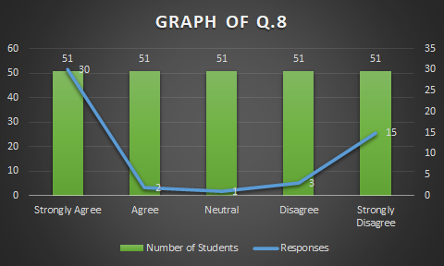
Figure 10: Response of Q.8
(Source: Developed by Researcher)

Figure 11: Response of Q.9
(Source: Developed by Researcher)

Figure 12: Response of Q.10
(Source: Developed by Researcher)

Figure 13: Response of Q.11
(Source: Developed by Researcher)

Figure 14: Response of Q.12
(Source: Developed by Researcher)
[Refer to appendix]
Analysis
Depending on the survey responses it has been observed that out of 51 students almost 25 to 30 students agreed about the facts that have been asked to them. Only a few students who are almost 10 to 15 do not agree about the asked facts. On the other hand, it has been observed that in question it has been asked whether Moodle is much efficient and productive or not like other VLEs. In that survey question, the response was almost 50% from both the end. Out of 51 students, 20 students agreed about the fact whereas another 20 students disagreed with the fact. Based on this specific response it can be concluded that the agreed students got many benefits from Moodle whereas the other disagreed students did not get any kind of facilities and due to this reason, those students require more training and proper guidance in order to handle the study culture of VLE. Out of 51 students, only some students that are almost 4-6 students remained neutral in their opinions as they are much confused about the implementation of Moodle in their respective university. From the above data it is clear that almost maximum percentage of the students have agreed that Moodle has strengthened their grasp over the various contents of learning in a better way and they even recommended the utility of VLE as an effective knowledge platform for every educational institution.
However, it is even observed that students perceive that there still exists a lot of scope in the aspect of improvement within the Moodle platform that would further make the process of learning easier. And also, almost 50 percent of the students preferred conventional methods of learning over VLE platform. Thus, it can be said that though students prefer VLE as a mode of learning still they perceive conventional modes to be better accepted. Thus, delineating the underlying statement that there still exists a lot scope of improvement in VLE learning process so that it is wholly gets preferred by students over any other teaching methods.

Secondary Data Analysis
In recent years, it has been observed that significant use of Moodle has been done in the academic areas of various universities. Observing from the perspective of VLE, a series of essential questions arises that is mostly associated with suitable teaching procedures along with the technological infrastructure. Apart from that several questions have been arisen regarding the proper design of the interaction of students with the faculties in the VLE (Filippidi et al. 2010, p. 2). Moodle normally acts as the Learning Management System (LMS) and it is a technological learning ambiance that mostly supports the online course. Apart from that, due to its much efficiency, this learning platform provides comprehensive synchronous and asynchronous services along with the suitable support of collaborative learning. Hence, based on this analysis, Moodle plays an essential role in the context of distance learning and due to the current pandemic situation; this PHP-based online learning platform is maximizing adopted in the University of Wales (Filippidi et al. 2010, p. 2). The main specification that differs from Online Learning from conventional learning ambiance is the suitable degree of the application and the usage of technology-based learning and the usual shifting of both regulation and responsibility. Depending on the primary data analysis, it has been observed that the effectiveness of Moodle is making an affirmative impact on the students of the University of Wales as it is helping the motivation of the students along with the proper educational orientation (Filippidi et al. 2010, p. 2).
Conclusion
According to the perspective of digital skills and research methods, this study mainly concludes the impact of VLE, which is the effect of Moodle in the students of the University of Wales of London Campus. Moreover, it concludes on the overview of the research along with suitable research questions and objectives. Besides that, this study also concludes the literature review of the research, and the research methodology has been properly considered based on the research requirements. Both the primary quantitative data analysis and the secondary data analysis have been performed and based on the responses of the survey appropriate conclusions have been developed along with improved recommendations.

Bibliography
Atayero, A.A., Ilori, O.A., and Adedokun, M.O., 2017. Cloud security and the Internet of Things: Impact on the virtual learning environment. London: Covenant University.
Badia, A., Martín, D. and Gómez, M., 2019. Teachers’ perceptions of the use of Moodle activities and their learning impact in secondary education. Technology, Knowledge and Learning, 24(3), pp.483-499.
Bereiter, C. and Scardamalia, M., 1996. Rethinking learning. The handbook of education and human development: New models of learning, teaching and schooling, 1, pp.485-513.
Coronado-Hernandez, J.R., Viloria, A., Arias-Perez, J.E., Mercado-Caruso, N.N., Lis-Gutiérrez, J.P. and Gaitán-Angulo, M., 2016. Impact of a Virtual Social Network of Learning in Academic Performance. International Journal of Control Theory and Applications. ISSN, pp.0974-5572.
Filippidi, A., Tselios, N. and Komis, V., 2010. Impact of Moodle usage practices on students’ performance in the context of a blended learning environment. Proceedings of Social Applications for Life Long Learning, pp.2-7.
gov.uk, 2020. Data-Protection. Available at: https://www.gov.uk/data-protection [Accessed on 10th July 2019]
Herrera Mosquera, L., 2017. Impact of implementing a virtual learning environment (VLE) in the EFL classroom. Íkala, Revista de Lenguaje y Cultura, 22(3), pp.479-498.
Jackson, E.A., 2017. Impact of MOODLE platform on the pedagogy of students and staff: Cross-curricular comparison. Education and Information Technologies, 22(1), pp.177-193.
Kulkarni, T.P., Toksha, B.G., Bhosle, S.P. and Deshmukh, B., 2019. Analysing the Impact of MOODLE and its Modules on Students Learning, a Case Study in Mechanical Engineering. Journal of Engineering Education Transformations, 32(3), pp.56-61.
McMaster, E., Moore, T., Onstott, D., Weathers, A. and Herrington, A., 2019, November. The Impact of Virtual Immersion in the E-Learning Environment. In E-Learn: World Conference on E-Learning in Corporate, Government, Healthcare, and Higher Education (pp. 668-672). Association for the Advancement of Computing in Education (AACE).
Pallud, J., 2017. Impact of interactive technologies on stimulating learning experiences in a museum. Information & Management, 54(4), pp.465-478.
Shahid, K., Yang, Q. and Xingqi, Z., 2019, August. Role of Technology in Multicultural Environment: Impact of MOODLE Learning System on Global Virtual Team Performance. In Proceedings of the 2nd International Conference on Big Data Technologies (pp. 187-191).
Wernet, S.P., Olliges, R.H. and Delicath, T.A., 2000. Postcourse evaluations of WebCT (Web Course Tools) classes by social work students. Research on social work practice, 10(4), pp.487-504.
Woo, S.E., O'Boyle, E.H. and Spector, P.E., 2017. Best practices in developing, conducting, and evaluating inductive research.
Zaharudin, R. and Ting, V.Y., 2019, March. Students' Learning Experiences towards the Use of Assessments in a Virtual Learning Environment (VLE). In 4th ASEAN Conference on Psychology, Counselling, and Humanities (ACPCH 2018). London: Atlantis Press.
Žukauskas, P., Vveinhardt, J. and Andriukaitienė, R., 2018. Philosophy and paradigm of scientific research. Management Culture and Corporate Social Responsibility, p.121.

Appendix

Appendix 1: Table of Survey Questions
Q1. Do you agree that the introduction of VLE made a revolutionary enhancement in the learning process of your university?
Responses | Number of Students | Responses
Strongly Agree | 51 | 30
Agree | 51 | 2
Neutral | 51 | 1
Disagree | 51 | 3
Strongly Disagree | 51 | 15

Q2. Do you agree that Moodle is the best learning management platform for online courses?
Responses | Number of Students | Responses
Strongly Agree | 51 | 30
Agree | 51 | 10
Neutral | 51 | 3
Disagree | 51 | 5
Strongly Disagree | 51 | 3

Q3. Do you observe any kind of error during the installation process of Moodle in your respective system?
Responses | Number of Students | Responses
Strongly Agree | 51 | 20
Agree | 51 | 10
Neutral | 51 | 5
Disagree | 51 | 7
Strongly Disagree | 51 | 4

Q4. Do you think that Moodle gives the maximum amount of facilities in the case of online learning?
Responses | Number of Students | Responses
Strongly Agree | 51 | 30
Agree | 51 | 8
Neutral | 51 | 2
Disagree | 51 | 6
Strongly Disagree | 51 | 5

Q5. Do you think that the introduction of Moodle increased the fundamental performance of the study?
Responses | Number of Students | Responses
Strongly Agree | 51 | 26
Agree | 51 | 13
Neutral | 51 | 2
Disagree | 51 | 6
Strongly Disagree | 51 | 4

Q6. Do you think that Moodle is much more productive and efficient than other VLEs like Google Classroom, Canvas?
Responses | Number of Students | Responses
Strongly Agree | 51 | 20
Agree | 51 | 5
Neutral | 51 | 1
Disagree | 51 | 5
Strongly Disagree | 51 | 20

Q7. Do you agree that Moodle helps in Student Motivation?
Responses | Number of Students | Responses
Strongly Agree | 51 | 15
Agree | 51 | 13
Neutral | 51 | 2
Disagree | 51 | 11
Strongly Disagree | 51 | 10

Q8. Do you agree that by using Moodle you can give better educational orientation?
Responses | Number of Students | Responses
Strongly Agree | 51 | 30
Agree | 51 | 2
Neutral | 51 | 1
Disagree | 51 | 3
Strongly Disagree | 51 | 15
Q9. Do you think that using Moodle has strengthened your grasp over learning contents in a better way?
Responses | Number of Students | Responses
Strongly Agree | 51 | 20
Agree | 51 | 15
Neutral | 51 | 1
Disagree | 51 | 3
Strongly Disagree | 51 | 12
Q10. Do you agree VLE should be utilized within every institution as an effective knowledge platform?
Responses | Number of Students | Responses
Strongly Agree | 51 | 23
Agree | 51 | 11
Neutral | 51 | 1
Disagree | 51 | 3
Strongly Disagree | 51 | 13
Q11. Do you think that there is further scope of innovation introduction in the utilization of the Moodle platform to greater ease the learning process available?
Responses | Number of Students | Responses
Strongly Agree | 51 | 13
Agree | 51 | 11
Neutral | 51 | 4
Disagree | 51 | 10
Strongly Disagree | 51 | 13
Q12. Do you think VLE should take over conventional learning methods as a permanent option?
Responses | Number of Students | Responses
Strongly Agree | 51 | 9
Agree | 51 | 13
Neutral | 51 | 4
Disagree | 51 | 13
Strongly Disagree | 51 | 12

Appendix 2: Screenshot of Survey Questions

