  Component One:  What are the key skills required when working in the housekeeping team? 750 words (+/- 10%)  Contribution to Overall Module Assessment: 25% | Student No: | 2208395
 | Module Title: | Operating Hotel Facilities
 | Module Code: | 4006
 | Lecturer: | Christopher Wilkin
A housekeeper is a person who performs cleaning and maintenance work in a commercial or residential establishment such as a hotel. Housekeepers contribute to the cleanliness of both public and private spaces. A competent housekeeper requires many essential qualities, including hard and soft talent. You can find work in this industry as you develop your knowledge of these skills. Housekeepers and cleaners need specific skills, called household skills, to do their job correctly. These skills range from customer service to communication and vary according to the housekeeper's role and profession. For example, a hospital may require housekeepers to follow strict hygiene rules to ensure that patients are always clean and healthy.

Time Management Skills - Housekeepers often complete various daily tasks alone or in small groups with other housekeepers. It is beneficial for housekeepers to arrange their work schedules to complete household chores on time effectively. Employees can arrive at the cleaning room on time and complete their work within the set time, effectively managing time and avoiding delays.

Attention to detail - Attention to detail benefits housekeepers by allowing them to do their jobs more effectively. To perform tasks like organizing various household items and cleaning floors and windows, these professionals pay attention to small details that may seem trivial to most people. The more experience a housekeeper has in his work, the more diligently he can perform his duties and responsibilities.

Communication skills - In a hotel, housekeepers interact with many guests daily and benefit from appropriate and courteous interactions. Housekeepers must also communicate clearly with the rest of the team to know when an employee has finished work or needs help. These professionals will take care of requests for personal items such as towels, soap, and toilet paper. In some cases, housekeepers may also assist in addressing concerns regarding amenities or services that do not meet guest expectations—interpersonal ability. Housekeepers frequently interact with customers to develop good working relationships with other professionals. Employers can look to housekeepers for interpersonal qualities such as reliability, teamwork, and a sense of responsibility. .
Organization - An organized housekeeper can organize things in a creative and orderly way. Towels should be neatly folded and hung. Setting up bars and other things helps the housekeeper keep the area tidy. A clean environment allows users to feel comfortable and relaxed.
Laundry Skills - With this skill, a housekeeper can wash and iron many clothes, sheets and towels daily. Some housekeepers wash guest belongings but are very careful not to damage them. The proper knowledge about laundry can significantly benefit your job and avoid unnecessary costs. Laundry services include washing, ironing and folding clothes.
Honesty - Housekeepers sometimes make mistakes and accidents on the job. Dishes and glasses may break while washing. Some sofas can be ripped, visitors' clothes can be damaged, and even the hotel they operate can be damaged. Admitting mistakes, clarifying problems, and taking measures to prevent recurrence are necessary. In a relapse, the on-call housekeeper may be more effective and discreet.
Active Listening - Listening to the house manager's instructions will make communication more accessible if you work as a housekeeper. A good housekeeper clearly understands instructions and knows when to ask for clarification.
Flexibility - Most businesses, especially those looking for housekeepers, prefer flexible employees. Housekeepers may be called to cook, clean, and look after children. A strict housekeeper can do chores after hours, while a flexible housekeeper will do her best to help.
Reliability - A good housekeeper is always trustworthy, obedient, and committed enough to produce excellent work for her employer. Utilising your prior work experience can help you work consistently. If you are dependable, your employer should have confidence in you, expect you to work hard, and be enthusiastic about your job.
Cleaning - A good housekeeper is always reliable, obedient, and dedicated enough to do an excellent job for her employer. You can get a stable position by using your previous work experience. If you are trustworthy, your employer will trust you and expect you to work hard and be passionate about your work. .
References:

- https://academy.whitbread.co.uk/local/skills/matrix.php?id=86&programld=191 [ Accessed on 08 June 2023 ]
- https://in.indeed.com/career-advice/career-development/housekeeping-skills [ Accessed on 06 June 2023]
- https://jobdescriptionandresumeexamples.com/top-15-housekeeping-skills-to-do-best-on-the-job/ [ Accessed on 6June 2023 ]
- Jones, T. (2010) Professional Management of Housekeeping Operations. London: Wiley.
- Mullins, L. and Dossor, P. (2013) Hospitality Management and Organisational Behaviour. 5th ed. Harlow: Pearson

Word Count | 726

Component Two:
Contribution to Overall Module Assessment: 25%
In this scenario – You have just been promoted to team leader for a floor within the hotel. A guest complains that on their arrival, their room had not been properly cleaned. Create an action plan and answer the following questions.

Problem | Why did it happen? | What are you going to do? | How will you prevent this from happening in the future? | What measures would you introduce to improve team effectiveness?
A guest came to desk complaining about our cleaning standards.  The desk had been undusted, and she found hair on the bath tube. | A new member of the staff cleaned the room. The day we received the complaint was one of the days when housekeeping department had few new starters. They are not properly trained, and the cleaning may not be up to the guest’s expectations. | We listen carefully to guest complaints and try to understand the problem. Ask as many questions as possible to clarify understanding and show empathy.  We apologize for the inconvenience and would like to inform you that we will do our best to resolve the issue.  Take pictures as evidence and discuss them with the housekeeping manager. .  We provide solutions that satisfy our guests. Ask someone to clean the bathroom and remove the dust immediately. If guests are unsatisfied, offer an upgrade.  We will then contact the guest to see if they are happy with the solution. This way he will know that you value his experience. | Investigate the problem and determine the cause.  When you get a new employee, you must ensure you have enough staff for the shift and don't let the new colleague clean the room without extensive training. Supervisors should meet regularly check rooms before assigning them to guests . | As a countermeasure, you can increase training days for new buddies.  After cleaning the room, ask your supervisor to do a detailed review.  Following the supervisor, the manager checks the room for any oversights. .

Component Three:
Contribution to Overall Module Assessment: 50%
Your task is to create and prepare a presentation following the detailed scenario provided below.

As the floor housekeeping manager and given the recent guest complaints you need to put together a basic training presentation for your colleagues within the housekeeping team to get the best out of them, ensure that brand standard is being achieved and that Health and Safety procedures are also being followed.

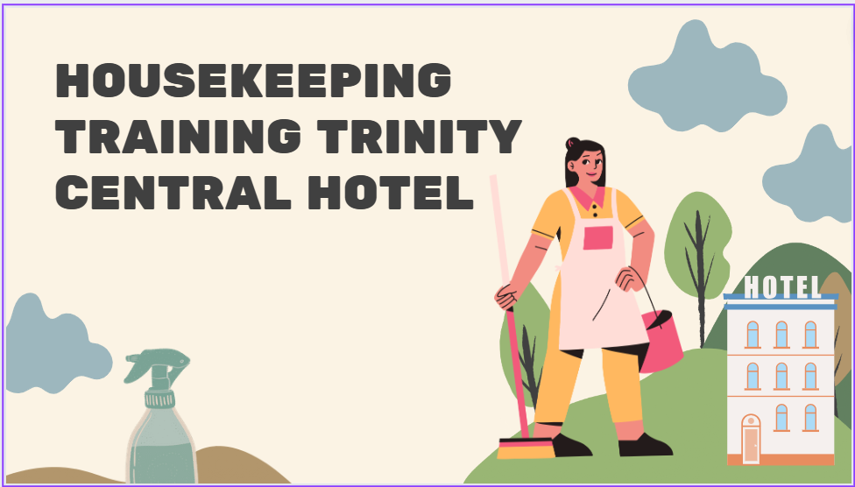

Training Notes:

We invite you to join our housekeeping training program at a 4-star hotel. Your role in our hospitality team is crucial to ensuring our guests have a convenient and comfortable stay.
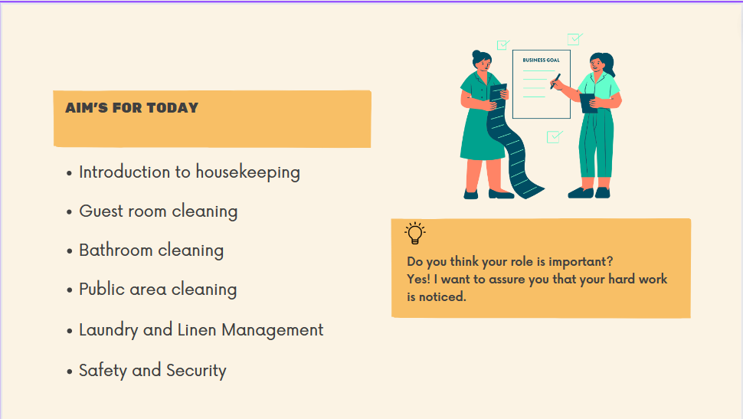

Training Notes:

Today we will discuss the following:
We are introducing housekeeping, guest room cleaning, bathroom cleaning, everyday area cleaning, laundry/laundry management, safety and security.
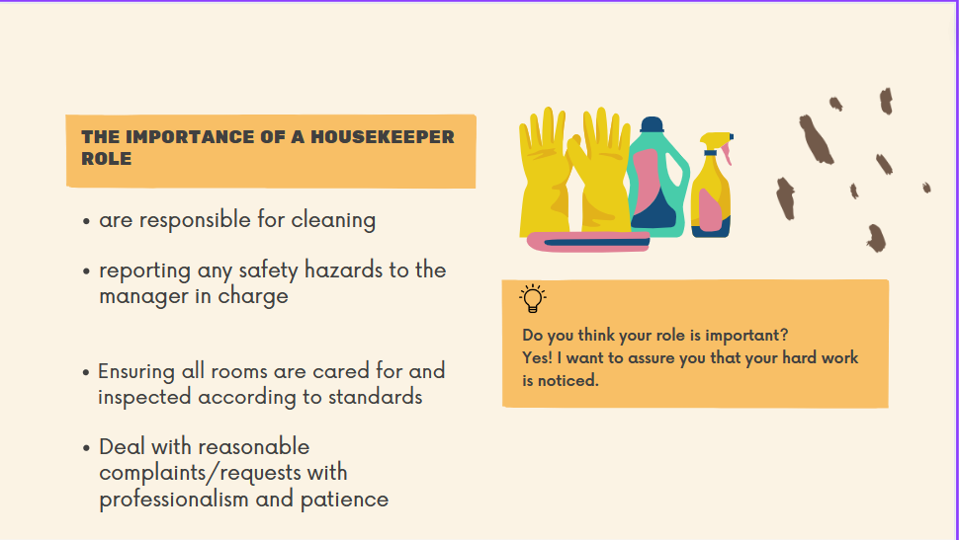

Training Notes:
A housekeeping team keeps all hotel rooms and public areas clean. Housekeeping not only prepares and cleans your rooms quickly but also cleans every hotel area, keeping it looking as new and attractive as it did the day it opened. The effort housekeeping puts in to ensure that guests get the room they want directly impacts their experience at the hotel. Housework can be a daunting task at times. Even though you may work long hours some days, we want to show that your hard work is appreciated and very important to Trinity Hotels.
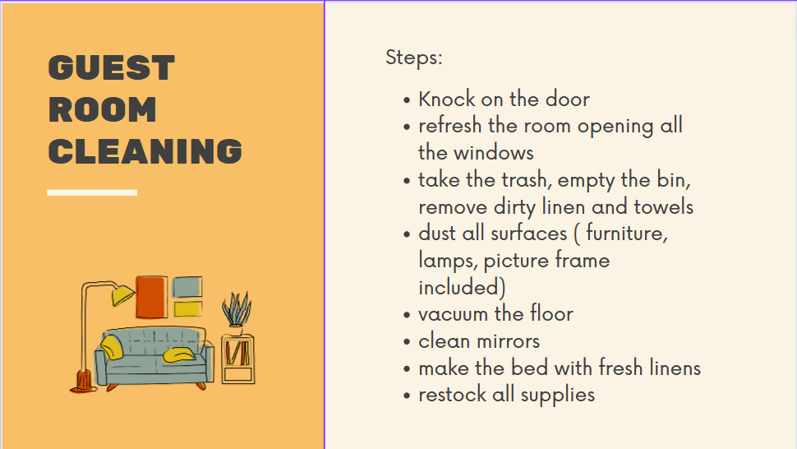

Training Notes:

Ensure the wagon is neatly packed with everything you need for your assigned room. This lets you focus on finishing the room instead of returning to the laundry room for additional tools and equipment. For safety and best practice reasons, carts should be placed opposite the door of the room you are working in. If that is impossible, try to assemble them as closely as possible.
Strip – Sanitize and Set Up. To sign up for the strip route, knock on your bedroom door twice in step 1, loud enough for your guests to hear each time. Step 2 - Put the kettle in the sink. Check out the shower curtain. If it is stuck, remove it. If not, wrap it up and leave it open to air dry. Step 3 - Go back to your bedroom and turn off the kettle. Empty the trash can in your bedroom before putting towels and trash in your trolley.. Step 4 – Remove all linen from the bed and check the mattress protector. Check the pillow bag and remove the pillow if the seal is broken.
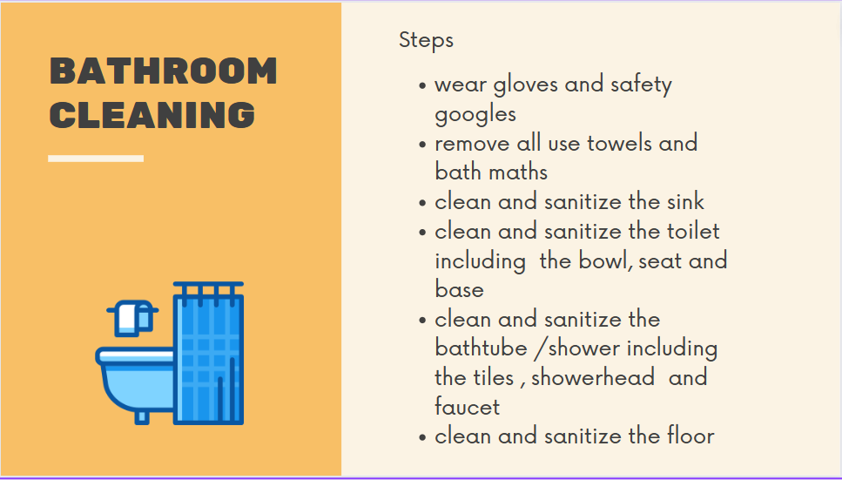

Training Notes:
Hygiene measures must always be adhered to so that standards are always adhered to, and nothing that may affect the guest experience is overlooked.
First, use the toilet brush to turn off the water in the toilet and pour the necessary chemicals into the bowl, as shown. Then attach the super mop to the wet redhead. Clean the bathroom tiles and shower cubicle glass with chemicals and pads. Then polish the chrome. Using the yellow cloth and necessary chemicals, clean the exterior of the toilet. Follow the instructions on your job card and always spray the chemical onto a cloth and not directly onto the surface to be cleaned, such as a bathtub, shower, or sink. Wipe down the sink, vanity, tub or shower, and shower tray with a red cloth and any required chemicals. Then polish the chrome with a dry red cloth. Finally, clean the bathroom trash can, the soap and shower gel bottles, the toilet paper dispenser and the baseboard. Switch to the blue Super Mop Head. Spray the chemical onto the pad and clean the bathroom door, shower stall glass and mirrors. To finish cleaning the bathroom floor, switch to the red super mop head and spray the pad with the desired chemical to clean. Remove the clean clothes from the caddy and place them on the trolley.

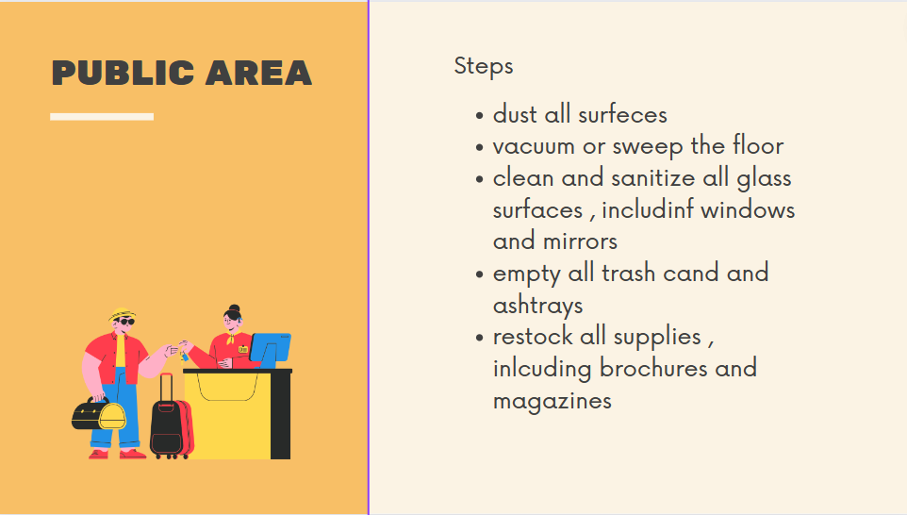

Training Notes:

Cleaning hotel common areas is different from cleaning guest rooms. All cleaning activities are scheduled during off-peak hours, as spaces cannot be closed for cleaning.
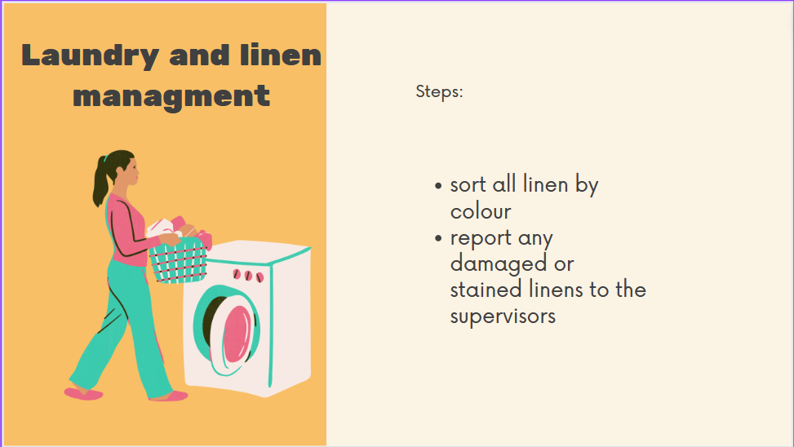

Training Notes:
You should follow the guidelines below to have enough clean laundry for your shift.
Within 24 hours, clean linen must be counted and stored - Do not store pure linen in cages - Use appropriate shelving for linen storage; the heaviest in the middle and lightest should be placed on top of each other - when storing and loading laundry, follow safe lifting procedures when transporting trolleys. Dirty laundry is a tripping hazard and looks messy to guests. Place all dirty laundry in the cart, and do not leave it on the floor. You can use a separate dirty laundry trolley for your dirty laundry or a regular laundry trolley compartment. These should be emptied into their appropriate cages periodically during service. Crowded trolleys are challenging to manoeuvre and dangerous. Please do not fill the cart more than it can safely move.
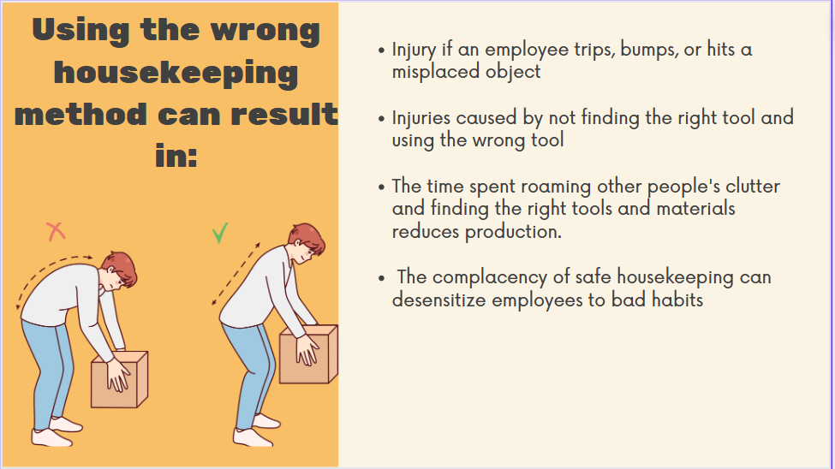

Training Notes
- injury if an employee trips, bumps, or hits a misplaced object
- Injuries caused by not finding the right tool and using the wrong tool
- The time spent roaming other people's clutter and finding the right tools and materials reduces production.
- Unfortunately, no more work due to poor quality reputation.
- Remember - The complacency of safe housekeeping can desensitize employees to bad habits, make them unaware of hazards, and put them at risk of injury.

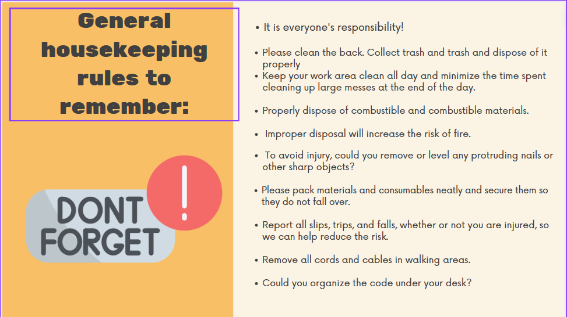

Training Notes:
- It is everyone's responsibility!
- Please clean the back. Collect trash and trash and dispose of it properly.
- Keep your work area clean all day and minimize the time spent cleaning up large messes at the end of the day.
- Properly dispose of combustible and combustible materials.
- Improper disposal will increase the risk of fire.
- To avoid injury, could you remove or level any protruding nails or other sharp objects?
- Please pack materials and consumables neatly and secure them so they do not fall over.
- Report all slips, trips, and falls, whether or not you are injured, so we can help reduce the risk.
- Remove all cords and cables in walking areas.
- Could you organize the code under your desk?

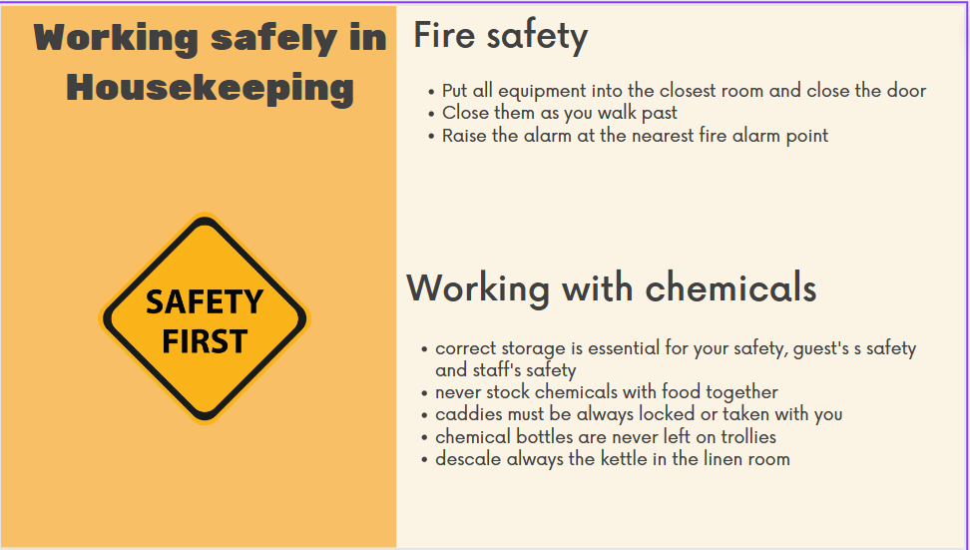

Training Notes:

Fire safety
What should you do with any equipment you have in the corridors? - Put all equipment into the closest room and close the door
What should you do if you see any other doors open as you evacuate? Close them as you walk past
What should you do if you discover a fire? - Raise the alarm at the nearest fire alarm point

Working with chemicals
- correct storage is essential for your safety, guest's s safety and staff's safety.
- never stock chemicals with food together
- caddies must be always locked or taken with you.
- chemical bottles are never left on trollies.
- descale always the kettle in the linen room

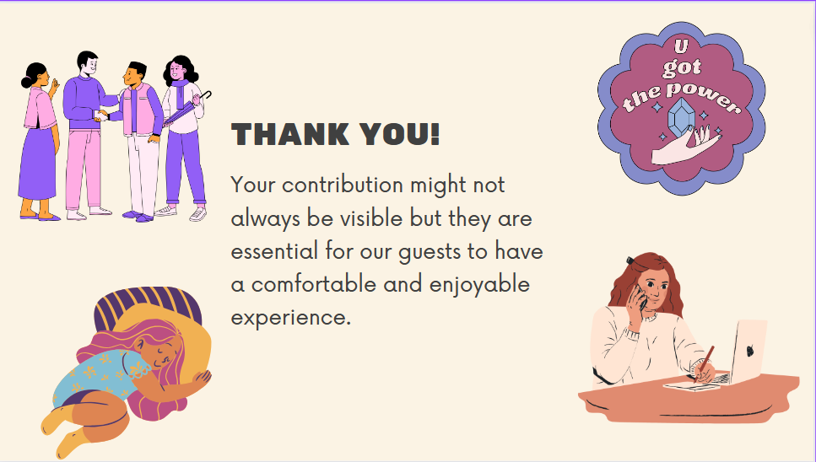

References:

- Casado, M. (2012) Housekeeping Management. London: Wiley
- Cottrell, S. (2019) The Study Skills Handbook. 5th ed. London: Red Globe Press.
- https://academy.whitbread.co.uk/
- https://cleaningbusinessboss.com/what-is-training-in-housekeeping-housekeeping-training-topics-list/ [Accessed on 9 June 2023]
- https://study.com/learn/lesson/housekeeping-hospitrality-industry-role-funtions-standards.html [Accesed on 05 June 2023]

