LUMINITA PLESAN
STUDENT ID-2216272
LECTURE NAME-LAILA MAAZOUZ
MODULE TITLE -INTRODUCTIONS TO LEADERSHIP &MANAGEMENT
MODULE CODE LCBB4008

ESSAY

Introduction
Amazon, founded by Jeff Bezos in 1994, began as an online bookstore but rapidly evolved into one of the largest and most diversified multinational corporations in the world. Headquartered in Seattle, Washington, it is now a key player in various sectors, including e-commerce, cloud computing, artificial intelligence , digital streaming, and logistics. Its unparalleled reach and disruptive innovations have transformed the global marketplace and influenced consumer in profound ways. This essay explores Amazon’s rise, its business model, market strategies, innovations, ethical concerns, and its role in the global economy.
Amazon started as a simple online retailer with a focus on selling books. Jeff Bezos chose books as the initial product due to their wide variety and low distribution costs. The company’s rapid growth was largely attributed to its customer-centric approach and use of technology to enhance the shopping experience. By the late 1990s, Amazon had expanded beyond books, adding electronics, clothing, and other consumer goods.
The company went public in 1997, which marked a critical milestone in its evolution. Despite operating at a loss for many years, Amazon continued to invest in infrastructure, technology, and new product categories, positioning itself for future growth. The "flywheel effect," a concept of reinforcing growth through reinvestment into improving customer experience, price, and selection, became a cornerstone of Amazon's strategy.

In the 2000s, Amazon diversified its business model, expanding into various new industries. One of its most successful ventures was Amazon Web Services (AWS), launched in 2006. AWS provided on-demand cloud computing services and revolutionized how companies manage data and scale digital services. AWS remains a dominant force in the cloud industry, contributing significantly to Amazon’s profits.
Amazon Prime, introduced in 2005, was another significant milestone. By offering free two-day shipping, exclusive content, and other perks for a yearly subscription fee, Prime created a loyal customer base and boosted recurring revenue. This service expanded over time to include video and music streaming, grocery delivery (Amazon Fresh), and more. Amazon Prime is now central to the company's strategy, with over 200 million global subscribers as of 2021.
Amazon’s acquisition strategy also played a critical role in its expansion. Notable acquisitions include Zappos (online shoe retailer), Whole Foods (grocery chain), and Ring (smart home devices). Each acquisition allowed Amazon to strengthen its presence in diverse markets and tap into new revenue streams.
Business Model and Strategies
E-commerce Dominance
Amazon’s e-commerce platform remains its most recognized and core business. Its success is based on several factors, including a vast product selection, competitive pricing, and a highly efficient logistics network. The company’s advanced data analytics and AI-driven recommendations system allow Amazon to anticipate customer preferences, thus enhancing user experience and boosting sales.

My personal experience
A personal experience as a leader often involves a journey of growth, challenges, and learning. As a team leader, at David Wood at Bakery-SCARBOROUGH ,NORTH YORKSHIRE I might encounter the responsibility of guiding a team toward achieving common goals. This as leader role requires clear communication, active listening, and adaptability. For example, managing a project with a diverse team means balancing different opinions, skill sets, and expectations. A successful experience often includes moments where, despite setbacks or disagreements, I help facilitate collaboration, foster a sense of trust, and empower team members .As a experience according to our experts Matrix is very important with delegation task for jobs.

An essential part of leadership is learning how to inspire and motivate, not just direct. For instance, when facing difficult decisions or tight deadlines, a leader can boost morale by staying calm, making informed choices, and supporting the team through challenges. It’s equally about giving credit where it's due, being open to feedback, and remaining accountable for both successes and mistakes. Leadership teaches the importance of empathy, resilience, and the ability to turn challenges into opportunities for personal and team development.
significant shift in retail operations.
Leaders must follow fundamental elements;
-Helping employees to achieve their goals
-Clearing away obstacles
-Offering appropriate rewards to keep the employees
Tannenbaum and Schmidt situational classified leadership into three categorise leadership styles;
Authoritarian
Democratic
Laissez-faire
democratic leadership emphasizes , collaboration, and shared decision-making. This style fosters a sense of belonging and engagement among participants, as everyone’s input is valued. Democratic leadership is particularly effective in environments where diverse perspectives are needed to navigate complex issues. Companies adopt a more democratic style may benefit from greater innovation and employee satisfaction. While Amazon has made strides in engaging with its vast workforce and customer base, the scale of its operations often limits the degree to which democratic principles can be fully implemented.
Laissez-faire leadership, which advocates for minimal interference and maximum autonomy, allows for high levels of creativity and innovation. This style is beneficial in settings where skilled professionals can thrive without micromanagement. However, it also risks leading to disorganization or lack of direction if not carefully managed. Amazon’s marketplace model can be seen as an example of laissez-faire principles at work, providing a platform for third-party sellers to operate with considerable independence. Yet, the success of this model also depends on Amazon’s ability to regulate and maintain standards, highlighting the balance required in a laissez-faire approach.
Amazon’s influence in our lives exemplifies how these leadership styles play out on a global scale. As a company, it operates with elements of all three styles, reflecting the complexities of leading in today’s interconnected world. Its authoritarian practices drive efficiency and market dominance, its democratic initiatives aim to engage employees and consumers alike, and its laissez-faire approach empowers sellers and fosters a vast, dynamic marketplace.
In our daily lives, these leadership styles can be seen in the choices we make, the organizations we interact with, and the technologies we use. Understanding the nuances of authoritarian, democratic, and laissez-faire leadership allows us to critically evaluate how power and influence are exercised around us. As consumers, employees, and citizens, we are all participants in these systems, shaping and being shaped by the leadership dynamics of our time. The case of Amazon underscores the importance of striking a balance between control, collaboration, and autonomy—a lesson that is increasingly relevant as we navigate the complexities of modern life.

4o

mazon’s focus on automation and robotics has also transformed its logistics operations. The use of robots in warehouses, combined with advanced software and algorithms, has increased efficiency and reduced delivery times. Its ongoing research into drone delivery (Amazon Prime Air)

At the heart of Amazon’s business model is its relentless focus on customer satisfaction. Jeff Bezos famously stated that Amazon is "obsessed" with customers rather than competitors. This focus is evident in the company’s emphasis on fast, reliable delivery, wide product selection, and user-friendly interfaces. Amazon continually invests in technology, data analytics, and customer service to enhance the shopping experience, further solidifying its position as the go-to online retail

As one of the largest global corporations, Amazon’s environmental impact is substantial. The company’s vast logistics network, heavy reliance on packaging, and energy-intensive data centers contribute significantly to its carbon footprint. While Amazon has pledged to reach net-zero carbon emissions by 2040 through its Climate Pledge initiative, environmental groups argue that the company’s current practices are not sustainable.
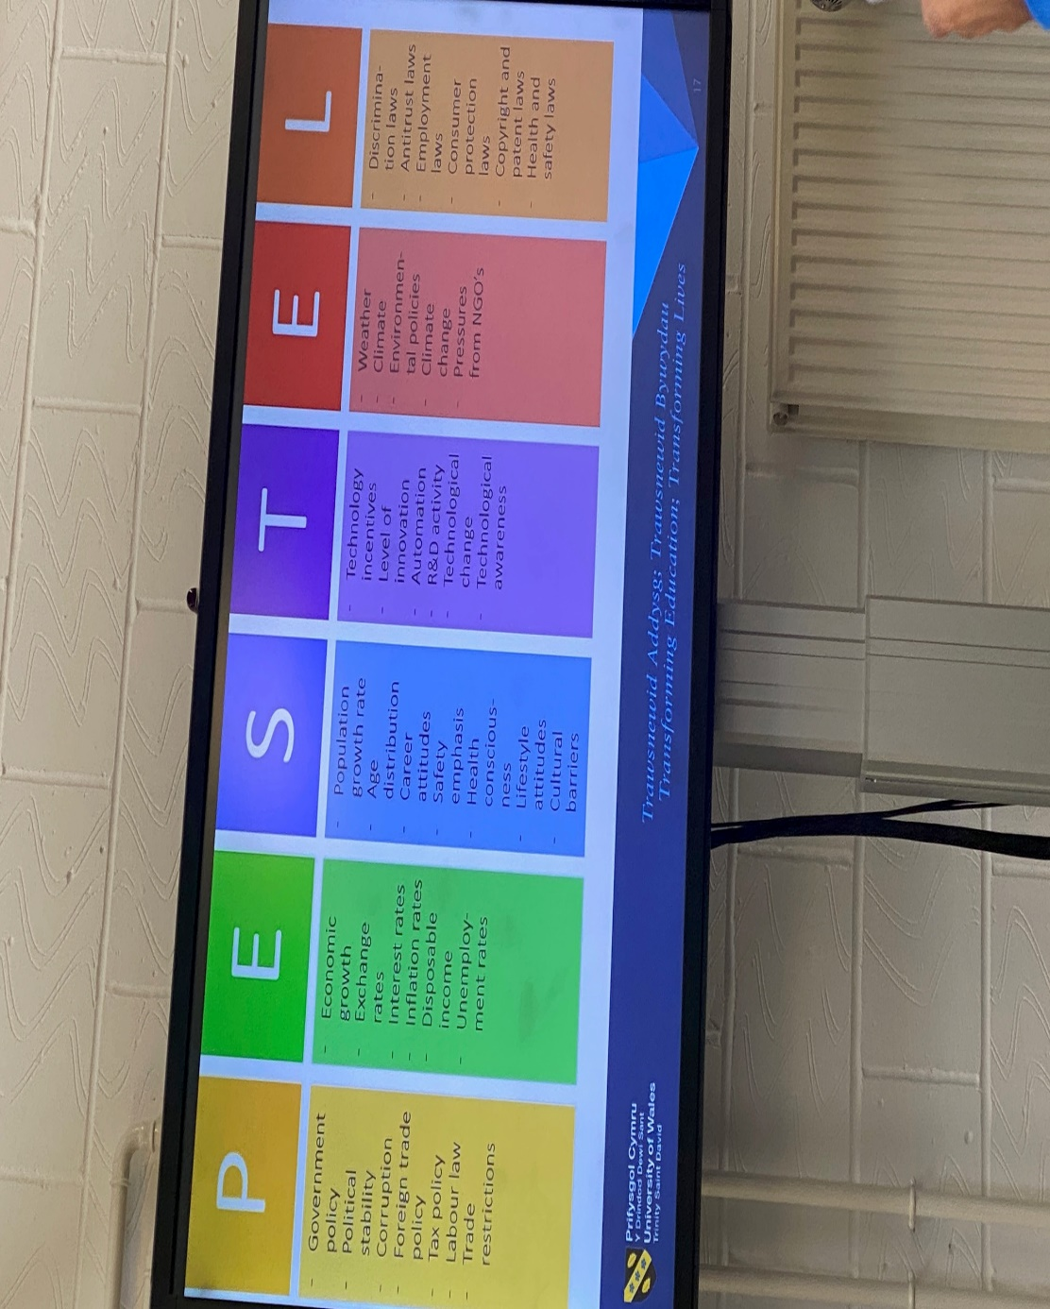
For a global giant like AMAZON ,PESTEL is not important is essential to understanding external environment and monitoring this factors Amazon can adapt strategies and PESTEL analysis is a vital tool in decision -making process
Economic Contributions
Amazon’s economic impact is undeniable. The company has created millions of jobs worldwide, not only through its direct operations but also by enabling the growth of third-party sellers and the gig economy (e.g., Amazon Flex drivers). Its innovations in logistics and cloud computing have spurred economic growth and allowed businesses of all sizes to thrive in the digital age.
Furthermore, AWS has played a crucial role in the digital transformation of various industries. By providing affordable, scalable cloud services, AWS has enabled startups, small businesses, and large enterprises to innovate and compete in the global market.
Amazon’s dominance in e-commerce has fundamentally changed consumer behaviour. The company’s focus on convenience, speed, and competitive pricing has shifted customer expectations, with consumers increasingly demanding fast, free shipping and seamless online shopping experiences. The rise of Amazon Prime, in particular, has set new standards for customer loyalty programs and subscription-based services.
Additionally, Amazon has influenced how consumers discover and consume media. With services like Prime Video, Audible, and Kindle, Amazon has reshaped the entertainment, audiobook, and publishing industries, offering consumers more choices and disrupting traditional media distribution channels.
Conclusion
Amazon’s evolution from a modest online bookstore to one of the world’s most powerful corporations is a testament to its relentless innovation, customer-centric approach, and diverse business model. Its impact on the global economy, technological innovation, and consumer behavior is immense. However, the company faces significant challenges related to labor practices, environmental impact, and regulatory scrutiny. As Amazon continues to grow and diversify, it must address these concerns to maintain its position as a leader in the global marketplace and foster a more sustainable and equitable future with democratic leadership, consulting with subordinates and evaluating their opinions before making a decision and this democratic style also called “shared leadership”or “ participate in decision -making .
References
Bezos, J. (2018). Invent and Wander: The Collected Writings of Jeff Bezos. Harvard Business Review Press.
Dumaine, B. (2020). Bezonomics: How Amazon Is Changing Our Lives and What the World's Best Companies Are Learning from It. Scribner.
Khan, L. M. (2017). "Amazon's Antitrust Paradox." Yale Law Journal, 126(3), 710-805.
Stone, B. (2013). The Everything Store: Jeff Bezos and the Age of Amazon. Little, Brown and Company.
Mattioli, D. (2021). Amazon Unbound: Jeff Bezos and the Invention of a Global Empire. Harper Business.
Statista. (2021). "Amazon Prime Subscribers Worldwide." [Online] Available at: https://www.statista.com/statistics/464983/amazon-prime-subscribers-world
Leadership Styles Explained (Kurt Lewin) - YouTube

