

Postgraduate/Distance Learning
Assignment coversheet & feedback form

THIS SHEET MUST BE THE FIRST PAGE OF THE ASSIGNMENT YOU ARE SUBMITTING (DO NOT SEND AS A SEPARATE FILE)

For completion by the student:
Student Name: Andrea Konrad

Student University Email: 1905426@student.uwtsd.ac.uk
Module code: HPCA7027  Module title: Sacred Skies | Student ID number:  1905426 |  |  | Educational support needs:  No
Assignment title: A Critical Examination of the Sky in relation to Material Culture

Assignment due date: 31 July 2022 (with DD 14 August 2022)
This assignment is for the 1st 2nd 3rd 4th 5th 6th module of the degree
I confirm that this is my original work and that I have adhered to the University policy on plagiarism.
Signed ……………………………………………………………
Email submission:if you are submitting this form via email, please tick this box X
(as a substitute for your signature) to confirm that you agree to the above declaration.
Assignment Mark
1st Marker’s Provisional mark
2nd Marker’s/Moderator’s provisional mark
External Examiner’s mark (if relevant)
Final Mark

NB. All marks are provisional until confirmed by the Final Examination Board.

For completion by Marker 1 :
Comments:

Marker’s signature: |  |  | Date:
For completion by Marker 2/Moderator:

Comments:

Marker’s Signature: |  | Date:
External Examiner’s comments (if relevant)

External Examiner’s Signature: |  | Date:

A Critical Examination of the Sky in relation to Material Culture
C. Measurement based on a physical site

Research question: Did the builders of the gothic chapel of Saint Mary at Schloss Eggenberg in Graz use phenomena in the sky to relate them to the design of the chapel?
Word count: xxx

This essay investigates the likelihood of celestial alignments of the gothic Chapel of Saint Mary, located within the central tower of Schloss Eggenberg in Graz, Austria. It will examine the context of the chapel, discuss previous scholarly work, looking at both theoretical thought in relation to the chapel, and methodological aspects, and report on my virtual and on-site field work.

Context

The gothic Chapel Capella Beate Marie Virginis sita in Castro Eckenperg, centerpiece and oldest part of Schloss Eggenberg in Graz/Austria is one of Austria’s earliest house chapels. It was built into a formerly existing medieval stand-alone structure that may have had purposes of fortification (indicated by loopholes in the walls) before the property was bought by Balthasar Eggenberger and adapted to a resicence with a private chapel before 1470. The original builder of the first structure is unknown. In the 17th century the tower became the central part of the baroque castle Schloss Eggenberg in the course of its modifications and extensions, as it is known today, as reported by Paul Schuster.

For the largest part, the archive of the Eggenbergian chieftains is lost. Therefore reliable primary sources with which the residence could be interpreted in more detail are missing today, as reported by Paul Schuster.
Research on the fabric of the building has shown that even the only image of the medieval structure, which is a city view of Graz, does not accurately depict it as it existed before its extension, as shown in the detail view (Fig. 1).

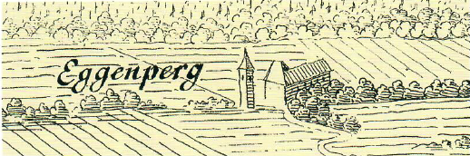
Figure 1. Wenzel Hollar and Laurenz van de Sype (c. 1620), Detail from a city view of Graz.

What however is known is that Balthasar Eggenberger (ca 1425-1493) was collected by Barbara Kaiser and Paul Schuster, as published in their Visitor’s Guide of Schloss Eggenberg: Balthasar was coin-master of emperor Friedrich III with a far-reaching commerce network, his family origin unknown, but through his profession equipped with enormous wealth. His business network spanned widely between Venice and Southern Germany. Coin minting and being a financial adviser to the emperor was a lucrative but very risky business, which Balthasar conducted during very turbulent times, filled with nature catastrophes and epidemics, and amongst inner and outer warlike conditions in the Habsburgian empire. The family Eggenberger, having no aristocratical background, represented money nobility, they appear to have been financial and social uprisers. In the view of Kaiser and Schuster, they were able to imitate the aristocratic lifestyle and by those means to exceed and override their social rank. According to them, building the ‘Castrum Eggenperg’ with its private and richly equipped private chapel contributed to this in large measure. On the other hand , religiosity, faith and devotion Were important parts in medieval life. Many rich people spent large amounts of their wealth supporting religious and charitable endeavors. Balthasar and his wife Radegundis sponsored a church and a hospital in Graz, and they aquired a Roman cardinal’s certificate of indulgence for their castle’s chapel, which was dated 30th April 1470 and mentioned the both of them as its sponsors. Following the regulations for their indulgence certificate, the Chapel was basically used privately, but at least on the three days of indulgence it had to be open for the public to visit the Holy Mass and receive their indulgence.

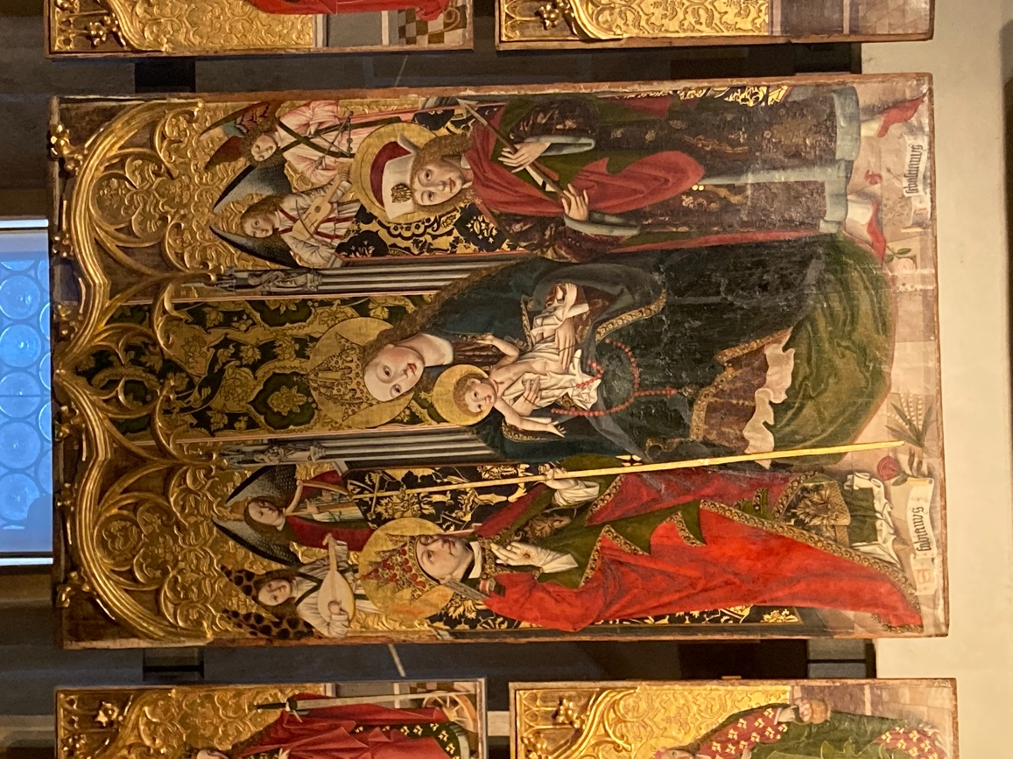
Figure 2. Unknown Artist, Eggenberger Retabel, central screen of winged altarpiece, Schloss Eggenberg, Austria. Image: A. Konrad

Mary and the Saints Sebastianus and Fabianus

The Chapel is devoted to Mary and two martyrs who share the same feast day: Fabianus and Sebastianus. They are depicted together on the chapel’s central altarpiece, which is viewed as the first and original one, and which is present in its original form side the chapel today (Fig. 2). According to Schuster, they are in sacra conversazione, in holy conversation, with Mary at the center being flanked by the two saints.

In the text on the Certificate of Indulgence, Schuster continued, the three days mentioned as indulgence days are the day of the chapel’s consecration (which is unknown), Assumption Day, and the feast day of Saints Fabianus and Sebastianus, which is January 20th. To Schuster, this is proof that the altarpiece was commissioned by Balthasar and Radegunde Eggenberger. The document goes on to mention Balthasar and his wife as the chapel’s sponsors, and it emphasises the importance of Mary the Mother of God, and of granting indulgence to churches devoted to the name of Mary. The text goes on to say that for devotees who will come to church service on the days of the chapel’s consecration and on the feast day of Saints Fabianus and Sebastianus, and who will contribute to the chapel’s preservation, will be granted an indulgence of 100 days.

The Saints Florian and Sebastian as patrons of sacral buildings in the time and region are however very rare. In her PhD dissertation on the chapel’s altarpiece, Sproger finds that although both saint have the same feast day, a combination of the two in visual representation seldom occurs, taken today’s possibilities of inquiry. In the Late Middle Ages it was much more common to depict the ‘black death patron’ Rochus as a counterpart to Sebastian.

In the light of this, she suggested the chapel’s altar screen to be a matrix of piety and identification for its sponsors Balthasar and Radegunde Eggenberger.

However, there is also the possibility to look at a sacral building’s orientation. As an example, McCluskey comments on orientations of churches, facing equinoctial east, or deviating from it. He mentions orientations like toward sunrise on the feast of the saint who gave the building its dedication, the layout of the structure’s foundation, or its feast.

In fact, in his PhD thesis, Dr. Paul Schuster indicated a possible alignment of the Chapel to a horizon point where the sun rises on a the celebration day of Saints Florian and Sebastian, who are depicted flanking Saint Mary on the central altarpiece. Following this indication, my aim was to take measurements in order to test the claim for which no detailed information had been published so far.

Furthermore, since Saint Mary is depicted at the center of the altarpiece, my second aim was to explore whether measurements would show further indications that the sky had been taken into account in any way with relation to Saint Mary. Third, the medieval tower with the Gothic chapel has been made the centerpiece of the later baroque calendar castle, with the castle built around it, following the exact alignment of the chapel as it exists until today. I explored further thoughts about if there were indications that could add to the knowledge about the importance the family gave the chapel.

To this purpose, I conducted onsite fieldwork in the chapel: location, altitude, measurements of the east and south windows incl. elevation in which sunlight can enter the chapel from various positions in the chapel. In addition I measured the altitude of the castle’s eastern roof ridge in order to determine if direct sunlight can still enter the Chapel’s eastern window and shine directly into the chapel at a possibly significant time of the year.

Methodology

Considering the role of the sun for the alignment and design of the Chapel , all measuring was related to the sun and its possibly significant positions throughout the year. Since the Marys Chapel in Eggenberg has been implemented in an existing tower -llike structure Which has not been erected by the builders of the Chapel themselves, intention of using the sky as a reference for the Chapel’s design can only be assumed if design elements that remain visible until today would indicate so. The known history indicates that tower had not been erected with a specific alignment for a sacral structure in mind, since the buyer who later built in the chapel was not its first owner. This would however not indicate that the Eastern alignment of the tower had not been known to Eggenberger at the time when it was decided which saints would become the patrons of the chapel.

In his dissertation Paul Schuster mentioned that an attempt to take measurements pointed to the idea that the Chapel could be aligned towards horizon point where the sun rises on the day of Saints Sebastianus and Fabianus, January 20th. :

The Chapel’s orientation and her east window respectively, points exactly in the direction in which the sun rises above the horizon on the patron’s day (Saints Fabian and Sebastian, 20th January).

Those two Saints are depicted flanking St. Mary on the central altarpiece of the Chapel. Since the source does not give any details as to how this perception was gained, my first aim was to test this claim by my own measurements. Secondly I aimed to explore if further measurements could also indicate any further connections of the chapel to sky events, and I therefore measured possible sun positions through the eastern window with me standing at different positions within the room.

As a preliminary it is important to point out that the sun is in different horizon rising positions throughout the year. On one hand its horizon position changes between the extremes of summer and winter solstices for sunrise and sunset. Her sunrise and sunset positions at a given place and date in the year will however be the same over a long period of time. (Ruggles? Wegen Horizon astronomy) Also the highest altitude the sun will reach changes over the year.

Furthermore, there are two possibilities of understanding horizon. There is an astronomical horizon which does not consider any given landscape, which is a more hypothetical approach and sunrise will in this case be predominantly symbolic. The second is an individual point of actual, observable sunrise, considering hills and other landscape over which the sun rises, as visible from the site under consideration. In their case study of eleven Welsh Cistercian abbeys, Brady, Gunzburg and Silva were successful in finding a pattern of alignments only with consideration of the actual individual sunrise azimuths in the landscape surrounding the abbeys.
Following their suggestion, I took an individual approach considering the known and unknown history of the structure and it's interior equipment, the liturgical calendar and the actual visible movement of the sun along the horizon and in the sky, in search of indications of intent to relate the built and equipped structure to sky events.

Measuring procedure (Theorie noch dazu)

Taking measures inside the gothic chapel and drawing meaningful conclusions was possible because the chapel itself has been restored as far as possible to its original medieval form. The walls and windows have remained unaltered in their positions, and the floor has been restored to its original medieval level. The winged altarpiece and mensa are in its original form, only the retable is not in situ any more. Therefore it Is not possible to determine the mounting height of the altarpiece reliably, so it is unclear how far it has originally covered the eastern window. With retables typically reaching up high, while also leaving space for sunlight to fall into the room, it seems reasonable to assume that sunlight was still able to illuminate the chapel from the eastern window, see Fig. 3 and 4.

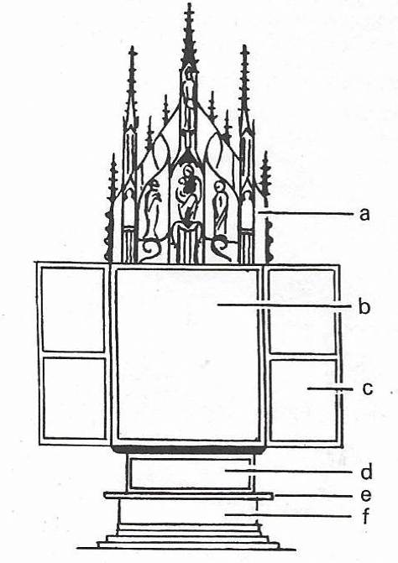
Figure 3. Scheme of gothic winged altarpiece (Baustilkunde of Wilfried Koch) Image: A. Konrad

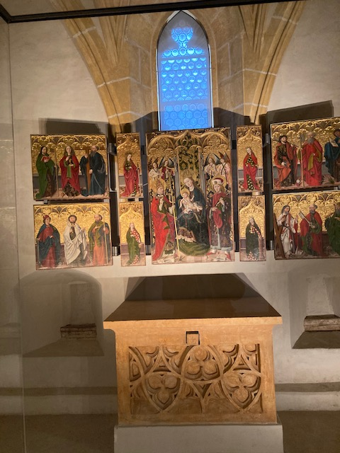
Figure 4. East side of chapel with winged altarpiece and mensa before the eastern four-centred window. Image: A. Konrad

All measurements of the total structure of Schloss Eggenberg in general were preliminary taken using Google Earth. The azimuth was measured 4 the general alignment off the Chapel . Since the structure of the castle has not been laid out exactly rectangular, and the tower that contains the Chapel has later been made the central part of the of the larger baroque castle, it was important to take more than one measure at different walls in order to get the most probable and exact alignment. Later on site, a Suunto Tandem device was used, which contains a magnetic compass for measuring azimuths, and a clinometer for altitudes. When using a magnetic compass, it will produce a magnetic azimuth degree, which also varies over time. For converting any measured magnetic azimuth into true azimuth using the exact date of the measurement is necessary, and I used the online declination calculator of the NOAA (National Centers for Environmental Information). (https://www.ngdc.noaa.gov/geomag/calculators/magcalc.shtml)

The altitude of the eastern roof ridge in relation to the Chapel has been determined using Google Earth for the elevation of both points and their distance from one another, and using a calculation spreadsheet provided by the University institute.

Google Earth was also used for determining the exact location of the Chapel in terms of longitude and latitude. The measurement taken with Google Earth proved to be the most exact one and was finally relied on. Using two GPS devices 4 elevation and location proved to be unsuccessful, presumably because of the thickness of the walls of the building. On site attempts for more exact measurements were made using the Garmin ETrex 32x, which did find its location only at around 15 meters next 2 the Chapel. The measuring did not get more exact using the Garmin GPSMAP 66sr with multi-band technology, which in open field reaches an exactness of up to 1,5m distance from any target, provided that there is average satellite coverage. Within the thick walls which have been kept intact ever since the castle’s existence , GPS devices proved to be of less use than Google Earth. This was the case for location measurement as mentioned, and also for elevation. With Google Earth it was possible not only to get the normal elevation of the place (ground level), but also elevation of the medieval Chapel and the castle roof ridge. So these measures were finally used.

In order to determine elevation and altitude of the panorama, which is important to calculate the visible sunrise at any given date, the free online service HeyWhat’sThat was used. With those measures the declination can finally be calculated.
From this it is then possible to calculate at which dates during the calendar year the sun will visibly rise over the given horizon line at exactly the azimuth of the structure’s alignment. In simpler words, this shows at which dates, including a level of uncertainty, the sunrise will happen exactly at the alignment of the structure that is measured.

Results and discussion

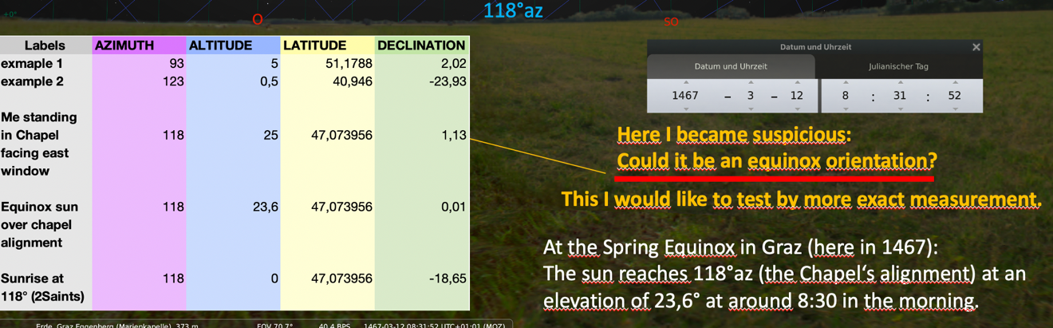

From the measurement results it can be assumed that sunrise indeed may occur on the feast day of Saints Fabianus and Sebastianus. There is of course a second time of year when the sun rises at the same declination, as mentioned above.

With regards of Saint Mary and the possible equinox connection McCluskey noted that ‘in the Middle Ages, however, even the term “equinoctial east” was ambiguous, for the date of the equinoxes – and hence the direction of equinoctial east – was not uniquely defined.

However, looking at the tables and virtual measurements for the chapel’s alignment, it can be assumed that equinox plays an important role for the chapel, and that this might connect the sky event with Saint Mary.

Following this, provided all measurement is correct, people who attended Holy Mass on the day of the Equinox would have experienced sunlight in a directly illuminating the chapel.

The importance of the gothic chapel for the later Calendar Castle

According to Schuster, the chapel’s orientation is central to the later orientation of the baroque castle, it defines its axis of symmetry. The fact that the whole new construction was planned and built around the chapel tower points to its importance.
Schuster locates many compromises and deviations from geometrical and symmetrical ideas.

My virtual measurements showed that in case that elevations and distance measures derived from Google earth are correct, the height eastern roof ridge is just low enough that the eastern castle roof does not barr the sunlight from shining directly into the chapel on equinox day, when it reaches its proper altitude, see schemes below.

Gleichgewicht als Motto, das fortgeführt wurde? (Kalenderschloss)

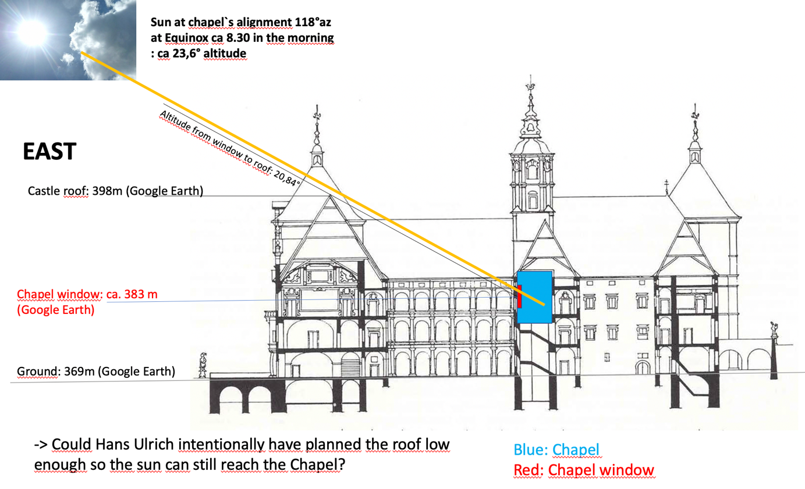

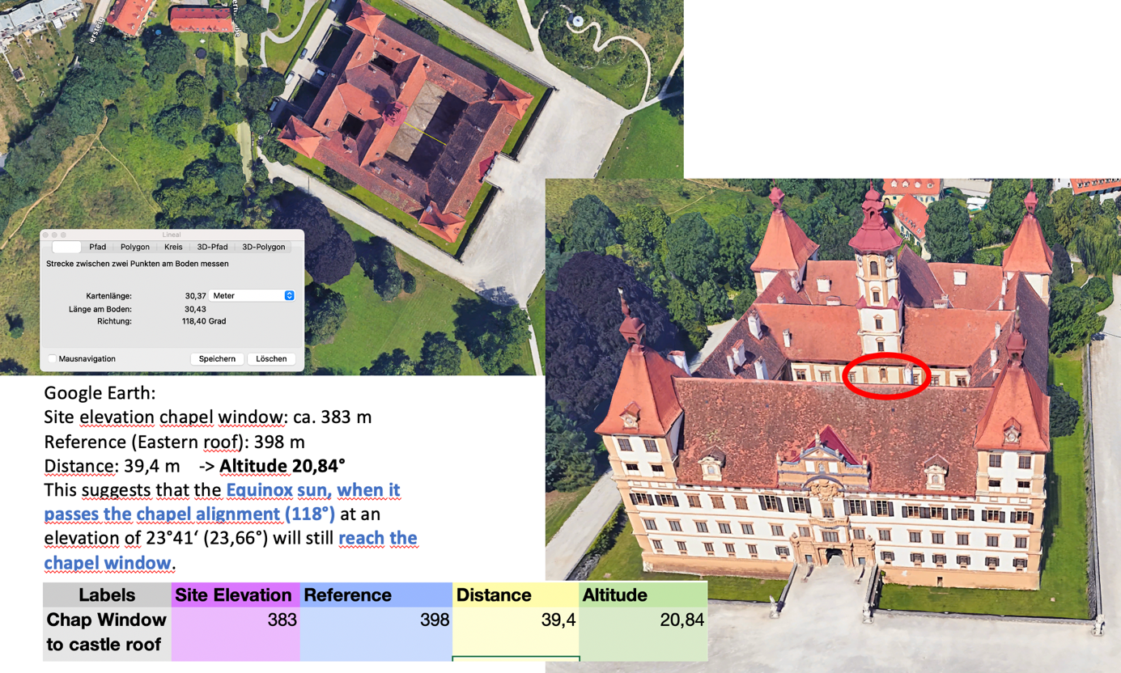

It seems reasonable to suggest that the idea of balance connected to the Equinox might find its continuation in interaction with the structure of the later calendar castle. Given the fact that the written family archive of the family Eggenberg is lost, it can only be raised as a question whether the planning of the castle’s eastern roof height might have taken the sun-chapel interaction at the equinoxes into consideration. It can be argued, however, that this would not be a very dissonant thought, if it was remembered that the measures and rhythms of the cosmos and of time play such an important role in the whole programme of Schloss Eggenberg, and such effort and constructional compromises were made to make the medieval chapel the centerpiece of the whole structure.

Conclusion

(time out … )

BIBLIOGRAPHY

Secondary Sources
Brady, Bernadette, Darrelyn Gunzburg, and Fabio Silva, 'The Orientation of Cistercian Churches in Wales: A Cultural Astronomy Case Study', Citeaux - Commentarii cistercienses (2017)
Kaiser, Barbara, and Paul Schuster, Schloss Eggenberg: Architektur Und Ausstattung. Besucherinnenführer. Vol. 2 (Graz: Universalmuseum Joanneum, 2018).
McCluskey, Stephen C., 'Calendrical Cycles, the Eighth Day of the World, and the Orientation of English Churches', in Skywatching in the Ancient World, ed. by Clive Ruggles and Gary Urton (University Press of Colorado, 2007)
———, 'Orientation of Christian Churches', in Skywatching in the Ancient World, ed. by Clive Ruggles and Gary Urton (University Press of Colorado, 2007)
Schuster, Paul, 'Capella Beate Marie Virginis Sita in Castro Eckenperg - Die Gotische Marienkapelle in Schloss Eggenberg' (Karl-Franzens-Universität, 2009).
———, 'Schloss Eggenberg - Eine Studie Zur Architektur, Bau- Und Funktionsgeschichte 1470-1717' (PhD, Karl-Franzens-Universität Graz, 2020).
Sproger, Sylvia, 'Das Eggenberger Flügelretabel Im Blickpunkt Seiner Bestimmung Als Frömmigkeits- Und Repräsentationsbeleg' (Karl-Franzens-Universität Graz, 2017).

Paul Schuster, 'Capella Beate Marie Virginis Sita in Castro Eckenperg - Die Gotische Marienkapelle in Schloss Eggenberg', (Karl-Franzens-Universität, 2009), p. 81.
Paul Schuster, 'Schloss Eggenberg - Eine Studie Zur Architektur, Bau- Und Funktionsgeschichte 1470-1717', (PhD, Karl-Franzens-Universität Graz, 2020), p. 131.
Schuster, 'Schloss Eggenberg - Eine Studie Zur Architektur, Bau- Und Funktionsgeschichte 1470-1717‘, p. 10.
Barbara Kaiser and Paul Schuster, Schloss Eggenberg: Architektur Und Ausstattung. Besucherinnenführer (Graz: Universalmuseum Joanneum, 2018), p. 21.
Kaiser and Schuster, Schloss Eggenberg: Architektur Und Ausstattung. Besucherinnenführer, pp. 14-23.
Schuster, 'Capella Beate Marie Virginis Sita in Castro Eckenperg - Die Gotische Marienkapelle in Schloss Eggenberg‘, p. 29.
Schuster, 'Capella Beate Marie Virginis Sita in Castro Eckenperg - Die Gotische Marienkapelle in Schloss Eggenberg‘, p. 66.
Sylvia Sproger, 'Das Eggenberger Flügelretabel Im Blickpunkt Seiner Bestimmung Als Frömmigkeits- Und Repräsentationsbeleg', (Karl-Franzens-Universität Graz, 2017), p. 106.
Sproger, 'Das Eggenberger Flügelretabel Im Blickpunkt Seiner Bestimmung Als Frömmigkeits- Und Repräsentationsbeleg‘, p. 66.
Stephen C. McCluskey, 'Orientation of Christian Churches', in Skywatching in the Ancient World, ed. by Clive Ruggles and Gary Urton (University Press of Colorado, 2007), p. 1703.
Schuster, 'Schloss Eggenberg - Eine Studie Zur Architektur, Bau- Und Funktionsgeschichte 1470-1717‘, p. 131.
Schuster, 'Schloss Eggenberg - Eine Studie Zur Architektur, Bau- Und Funktionsgeschichte 1470-1717‘, p. 131. Original German text: ‚Die Orientierung der Kapelle bzw. ihres östlichen Fensters weist exakt in jene Richtung, an dem die Sonne am Patroziniumstag (Hll. Fabian und Sebastian, 20. Jänner) am Horizont des Grazer Beckens erscheint.‘ (trans. A. Konrad)
Bernadette Brady, Darrelyn Gunzburg, and Fabio Silva, 'The Orientation of Cistercian Churches in Wales: A Cultural Astronomy Case Study', Citeaux - Commentarii cistercienses, (2017), p. 280.
McCluskey, 'Calendrical Cycles, the Eighth Day of the World, and the Orientation of English Churches', p. 336.
Schuster, 'Schloss Eggenberg - Eine Studie Zur Architektur, Bau- Und Funktionsgeschichte 1470-1717‘, p. 131.

