Q1- Explain the differences between preference shares and ordinary shares
The dividend on ordinary shares is uncertain and variable (high when the company does well, poor or non-existent when it does badly). Preference shareholders get a fixed dividend which, if not paid, usually accrues until it can be paid.

Each ordinary share usually carries a vote. Preference shares do not usually carry a vote unless dividends fall into arrears.

In the event of a winding up, preference shares are usually repayable at nominal value, and rank above the claims of ordinary shareholders

Preference shares may be issued with the right of conversion into ordinary shares, these are called convertibles

Most types of preference shares are liabilities of the company, rather than part of equity

This is because the company has an obligation to pay the dividend and may eventually have an obligation to redeem the shares

If this is the case, the preference shares are not included in share capital, but presented as non-current liabilities in the statement of financial position

Q2- How is basic EPS calculated?
Profit attributable to ordinary shareholders
Weighted average number of ordinary shares Outstanding during the period.

Q3-
 | 2017 | 2016
Profit attributable to shareholders for the year ending 31 December | 400,000 | 230,000
No of ordinary shares in issue on 31 December | 1,500,000 | 600,000
Required
Calculate the EPS for both years
2017: 400,000/1,500,000 = 0.267
2016: 230,000/600,000 = 0.383

Q4-
A company issued 200,000 shares at full market price (£2.00) on 1 April 2017.
 | 2017 | 2016
Profit attributable to shareholders for the year ending 31 December | 400,000 | 230,000
No of ordinary shares in issue on 31 December | 1,000,000 | 800,000
Required
Calculate the EPS for both years
2016
230,000/800,000 0.288
2017
Need to calculate the weighted average number of shares
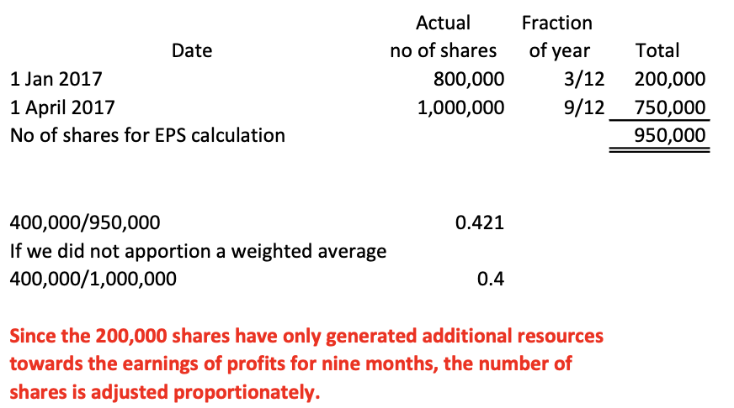

Q5-

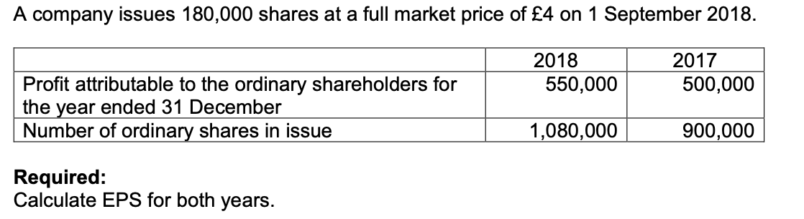
 | 2017
EPS | 500,000/900,000 | 0.556
 | 2018
 | Need to calculate the weighted average number of shares
 |  | Actual | Fraction
 | Date | no of shares | of year | Total
 | 1 Jan 2018 | 900,000 | 8/12 | 600,000
 | 1 September 2018 | 1,080,000 | 4/12 | 360,000
 | No of shares for EPS calculation |  |  | 960,000
EPS | 550,000/960,000 | 0.573
2018

