

RESULT

ASSIGNMENT DETAILS AND FEEDBACK
SOUTH WEST WALES CENTRE FOR TEACHER EDUCATION
Sections marked with * should be completed by module lead
Student name: |  | Student P number: | 1700188
Programme: * | PGCE Primary
Module: * | The Enquiring Teacher | Module Level (6 or 7):* | 7
Module code: * | M7X2152 | Contribution to Overall  Module Assessment (%): * | 100%
Module Lead:* | Catherine Morgan
Assignment Title:* | Write a critical and analytical essay that discusses your practitioner research ‘lesson study’ in relation to a chosen field. | Assignment No (x of x):* | 1/1
Start date:* | 09/01/18 | Submission deadline:* | 16/04/18
Return date of provisional marks & written feedback:*

Referencing: | In the main body of your submission you must give credit to authors on whose research your work is based. Append to your submission a reference list that indicates the books, articles, etc. that you have read or quoted in order to complete this assignment (e.g. for books: surname of author and initials, year of publication, title of book, edition, publisher: place of publication).
Submission: | All assignments must be submitted to Turnitin unless otherwise instructed by the Lecturer.  Note: the Turnitin version is the primary submission and acts as a receipt for the student. Late submission of the electronic version of the assignment will result in a late penalty. Penalties for late submission: Up to one week late, maximum grade D. Over one week late, Refer. Only the Extenuating Circumstances Panel may grant an extension. | Date: | 16/04/18

Module lead to tick to indicate if a hard copy version of the assignment must be submitted.* | YES
 | NO

Learning Outcomes tested  (from module syllabus) | Assessment Criteria: To achieve each outcome a student must demonstrate the ability to:
•Design and apply appropriate research methodologies demonstrating a critical understanding of the nature of educational research  •Conduct a small scale research enquiry to improve an aspect of personal practice and learner outcomes, showing some originality and rigour in the application of appropriate research skills  •Critically evaluate research evidence, showing sound judgement of complex data to support pedagogic decisions  •Critically reflect upon the importance of ethical procedures within classroom based research, and apply these procedures appropriately | - Discuss the intended professional data collection justifying its suitability and purpose;  - Support the study by referring to a range of relevant literature;  - Integrate theory and practice with regard to the pedagogic context;  - Undertake a critical evaluation of the study;  - Discuss the ethical issues that should be considered during the study  - Write a well-structured piece of work in a coherent writing style

TASK DESCRIPTION

Write a critical and analytical essay that discusses your practitioner research ‘lesson study’ in relation to a chosen field.

This should be 6000 words in length.

Further details regarding the structure of the work will be available on Moodle.

You will also be required to submit an Ethics Form as part of the assessment of this module. This will be submitted on the 28th February.

GUIDANCE FOR Students IN THE COMPLETION OF TASKS

NOTE: The guidance offered below is linked to the assessment criteria overleaf.

- Subject Knowledge and Understanding (which includes using research-informed literature and knowledge and understanding of the subject)

Your work must be informed and supported by scholarly material that is relevant to and focused on the task(s) set. You should provide evidence that you have accessed a wide range of sources, which may be academic and/or governmental; these sources may include academic journal articles, textbooks, current news articles, organisational documents, and websites. You should consider the credibility of your sources; academic journals are normally highly credible sources while websites require careful consideration/selection and should be used sparingly. Any sources you use should be current and up-to-date, mostly published within the last five years or so, though seminal/important works in the field may be older. You must provide evidence of your research/own reading throughout your work, using in-text citations in the main body of your work and a reference list that is alphabetical at the end of your work. Please use the Harvard referencing system.

Your work must demonstrate the growing extent of your knowledge and understanding of concepts and underlying principles associated with the subject area. Knowledge relates to the facts, information and skills you have acquired through your learning. You demonstrate your understanding by interpreting the meaning of the facts and information (knowledge). This means that you need to select and include in your work the concepts, techniques, models, theories, etc. appropriate to the task(s) set. You should be able to explain the theories, concepts, etc. meaningfully to show your understanding. Your mark/grade will also depend upon the extent to which you demonstrate your knowledge and understanding; ideally each should be complete and detailed, with comprehensive coverage.

- Intellectual Skills (Analysis)
Your work must contain evidence of logical, analytical thinking, evaluation and synthesis. For example, to examine and break information down into parts, make inferences, compile, compare and contrast information. This means not just describing what! But also justifying: Why? How? When? Who? Where? At all times, you must provide justification for your arguments and judgements. Evidence that you have reflected upon the ideas of others within the subject area is crucial to you providing a reasoned and informed debate within your work. Furthermore, you should provide evidence that you are able to make sound judgements and convincing arguments using data and concepts. Sound, valid conclusions are necessary and must be derived from the content of your work. There should be no new information presented within your conclusion. Where relevant, alternative solutions and recommendations may be proposed.

- Pedagogic and Professional Applications (Practical Application and Deployment)

You should be able to demonstrate how the subject-related concepts and ideas relate to pedagogic situations or a particular education context. How do they work in practice? You will deploy models, methods, techniques, and/or theories, in that context, to assess current situations, perhaps to formulate plans or solutions to solve problems, some of which may be innovative and creative. This is likely to involve, for instance, the use of pedagogic examples and cases, the application of a model within relevant educational context. You should show awareness of the limitations of concepts and theories when applied in particular educational contexts. Your work must provide evidence of the attributes expected in professional practice. This includes demonstrating your individual initiative and/or collaborative working. Where relevant, you should show awareness of any ethical issues that relate to your discussion.

- Key Transferable Skills (Skills for Professional Practice)
You must communicate effectively in a suitable format, which includes written and oral presentation. Work should be coherent and well structured in presentation and organisation.

marking criteria and Student FEEDBACK

This section details the assessment criteria. The extent to which these are demonstrated by you determines your mark. The marks available for each criterion are shown. Lecturers will use the space provided to comment on the achievement of the task(s), including those areas in which you have performed well and areas that would benefit from development/improvement.

Common Assessment Criteria Applied | Grade  awarded
1. Subject Knowledge and Understanding (which includes using research-informed literature and knowledge and understanding of the subject)
Extent of research and/or own reading, selection of credible sources, application of appropriate referencing conventions. Extent of knowledge and understanding of concepts and underlying principles associated with the discipline.
2. Intellectual Skills (Analysis)
Analysis, evaluation and synthesis; logic, argument and judgement; analytical reflection; organisation of ideas and evidence
3. Pedagogic and Professional Applications (Practical Application and Deployment)
Deployment of pedagogic methods, materials, tools and techniques; application of concepts; formulation of innovative and creative solutions to solve problems. Attributes in professional practice: individual and collaborative working
4.Key Transferable Skills
Deployment of appropriate media; presentation and organisation.

Assignment Grade (Assessment grades are subject to ratification at the Exam Board. These comments and marks are to give feedback on module work and are for guidance only until they are confirmed. ) | Late Submission Penalties (tick if appropriate)
 | Up to 1 week late | D Max
 | Over 1 week late | Fail

Level 7 | Assessment Criteria Descriptors for Primary PGCE with QTS  This format emphasizes the holistic nature of judgements to be made by markers. Equal weighting is given to each section. Plagiarism or non-submission will result in F (0%) grading.
Assessment Criteria | Fail - grade E | Weak pass– grade D | Pass – grade C | Pass – grade B | Pass – grade A
Assessment Criteria | Poor | Weak Pass | Satisfactory | Good | Excellent
Overall judgement | Poor understanding, unsystematic, incomplete and/or inaccurate | Understanding of main issues demonstrated | Satisfactory understanding demonstrated with satisfactory analysis | Good understanding of basic principles and relevant evidence, with a coherent and logical argument | Highly thoughtful answer informed by wider reading, showing clarity of thought, personal insight and some originality
Subject Knowledge and Understanding  (Conceptual)  (Reading) | Basic misunderstanding, misconceptions, or misinterpretations - Some superficial knowledge in places | Main concepts understood with limited evidence of critical insight | Sound understanding of concepts and critical engagement with ideas | Good understanding of key concepts; knowledge of wider implications; critical engagement | Engaged critically and systematically with the main concepts and theories: excellent engagement
Subject Knowledge and Understanding  (Conceptual)  (Reading) | Poor and/or inappropriate literature, lacking accuracy, unsound, limited/dated range of sources | Satisfactory range of reading overall although this may be limited in some way | Satisfactory range of reading drawn from the recommended list and other sources | Good range of relevant literature from a variety of sources beyond recommended list | Clear evidence of independent thinking informed by a selective range of reading from a variety of sources
Intellectual skills  (argument)  ( professional data collection: research design/data collection )  (presentation of findings/analysis)  (critical /reflective evaluation) | Little sense of an argument lacks coherence.  Generally descriptive or anecdotal | Argument is balanced with some differing viewpoints presented. Some questioning of assumptions | Argument presented shows satisfactory evidence of critical and analytical reflection. | Strong argument developed. Good evidence of critical and analytical reflection | A well-structured critical argument is presented with evidence of synthesis of viewpoints
 | Professional data collection is inappropriate/ flawed /not discussed | Professional data collection is mainly suited to purposed; beginnings of critical considerations | Professional data collection is suited to purpose and considered critically. | Professional data collection well suited to purpose, justified with clear identified focus | Professional data collection logical and sophisticated; comprehensive understanding of appropriate techniques
 | Findings presented with little or no framework or discussion; or discussion of findings is descriptive. Few conclusions are drawn or conclusions drawn are inappropriate. | Findings are presented with basic analysis and some limited but appropriate conclusions | Findings presented with some analysis and criticality with justified conclusions | Findings presented in a critical and analytical framework. Thoughtful conclusions, firmly based upon the evidence presented | Findings presented in a critical and analytical framework. Insightful conclusions, firmly based upon the evidence presented
 | Little or no evaluation attempted; no or limited reflection | Evaluation and reflection is present but may be limited | Satisfactory critical evaluation of study; satisfactory reflection | Good critical evaluation of study; good reflection | Critically reflective evaluation of work informed by excellent reflection.
Pedagogic and Professional applications  (linking theory to practice)  (professional reflection)  (working in a group)  (ethical conduct where appropriate) | Little or no evidence of engagement or superficial engagement and understanding with respect to the pedagogic and professional context(s) | Some engagement and understanding with respect to the pedagogic and professional context(s) | Sound engagement and understanding with respect to the pedagogic and professional context(s) | Good evidence of integration of theory and practice with respect to the pedagogic and professional context(s) | Excellent integration of theory and practice with respect to the pedagogic and professional context(s)
 | No evidence of reflection | Some evidence of reflection whilst beginning to make links with own practice and thinking | Satisfactory evidence of critical reflection whilst beginning to make links with own practice and thinking | Good evidence of critical reflection whilst making links with own practice and thinking | Demonstrates an excellent level of understanding of critical reflection as a learning process
 | Inability to work with others or works within a group but lacks self direction or group responsibility | Responsibility for planning and developing courses of action; shows awareness of group responsibility | Initiates and occasionally leads tasks/processes for won work and where appropriate for others. | Chooses goals and can self-direct; able to co-operate within a group and can take the lead | Accepts accountability for determining and achieving personal and/or group outcomes
 | Ethical issues not or superficially considered | Some awareness of ethical issues | Appropriate ethical issues raised and discussed; bias/prejudice not noted | Good, clear understanding of ethical issues; awareness of bias and prejudice | Ethical issues have been addressed effectively; bias/ prejudice discussion includes attempts to nullify this
Key/Transferable Skills  (presentation)  (spelling, punctuation and grammar)  (structure)  (referencing techniques) | Poor presentation of written work | Presentation of written work is weak | Satisfactory presentation of written work | Good presentation of written work | Excellent presentation of written work
 | Significant errors in spelling, punctuation or grammar | Some errors in spelling, punctuation or grammar | Spelling, punctuation and grammar are satisfactory; few errors in written language | Spelling, grammar and punctuation are good; very few errors in written language | Excellent standard of written language. No or very minor errors in written language
 | Poor structure with unclear writing style | Structure is present but may be underdeveloped, writing style is mostly coherent | Satisfactory structure with coherent writing style | Good structure with a coherent writing style | Effective structure and highly coherent writing style which fully engages the reader
 | No use or limited use of protocols and conventions including Harvard referencing | Some following of protocol and conventions of Harvard referencing | Satisfactory use of Harvard referencing protocols and conventions | Good use of Harvard referencing protocols and conventions | Harvard system used accurately, consistently and effectively with all sources

Student Self Evaluation Form

This section repeats in brief the common assessment criteria detailed on previous pages. The extent to which these are demonstrated by you determines your mark. Using these criteria, tick the box that best indicates the level of achievement you feel you have achieved with regard to each of them.

Common Assessment Criteria Applied
Common Assessment Criteria Applied | REFER |  | D |  | C |  | B | A
 | OUTRIGHT FAIL | UNSATISFACTORY | SATISFACTORY | GOOD |  | VERY GOOD |  | EXCELLENT
1. Subject Knowledge and Understanding (which includes using research-informed literature and knowledge and understanding of the subject)
2. Intellectual Skills (Analysis)
3. Pedagogic and Professional Applications (Practical Application and Deployment)
4. Key Transferable Skills

PLEASE COMMENT ON AREAS IN WHICH YOU FEEL THAT YOU HAVE PERFORMED WELL | PLEASE COMMENT ON AREAS you feel that you need TO DEVELOP
The lesson study was very insightful in working with fellow colleagues. | I feel that I need to develop creating an organised piece of writing that flows better.

Student’s Name | / | Date | 10/04/2018
Student’s Signature | /

PGCE PRIMARY

The Enquiring Teacher
ECPP6001-C & ECPP7001-C

How can we improve pupil’s level of response through the use of questioning?

1700188

Aims, focus and purpose of the research

This research project is aimed at looking at how teachers questioning is influential in improving children’s response. This issue particularly interested me as in the nursery class I was in during PTE1, the children were not ability grouped. When teaching in the nursery class, I felt that some children gave a better response when they were prompted through questioning. In my class, this issue would be interesting to research as the level of response given by the majority of children could be improved. Briefly during my PTE1 experience, I had the opportunity to extend pupils’ response to stimulus through levels of questioning. This gave an insight into how basic questioning led to an increase in quality of their response. A pupil’s level of involvement and participation in an activity has a positive correlation with the pupils achievement and behaviour (Florian et al, 2003).
We will use a small sample of pupils to gain a better understanding of how, as teachers, we can better use questioning techniques to aid planning.

Research context

Lesson one will take place within a large, modern school situated in the county of Bridgend. The school is the largest within its county with 542 pupils on roll in 19 mainstream classes. The school has the lowest budget per pupil compared with other schools in the borough (Estyn, 2011).
The class in which the first lesson study will be carried out is within the attached nursery, which has 53 full time children and 11 part-time rising threes. The staffing arrangement consists of one teacher, four full time teaching assistants and two part-time teaching assistants. The lesson will be conducted with one group and the research will be gathered upon three focus children of middle ability.

Lessons two and three will take place in a reception class in a large Vale of Glamorgan school. The school has 471 pupils on roll in 14 single year classes and four nursery classes and is currently a pioneer school working with the Welsh Government. (Estyn, 2017).

When discussing with my triad on what our research will be conducted upon, I was interested in finding more about how questioning can improve the quality of pupil response. Together, our research question is “How can we improve pupils’ level of response through the use of questioning?”.
My class will be the first lesson in the trio of lessons throughout the lesson study. The lesson will be based upon the book “What the Ladybird Heard”, written by Julia Donaldson. For my class, this means that they will be asked five questions from level one of Barrett's taxonomy. Lessons two and three will follow the same structure, but the children will be asked questions from levels two and three, and four and five respectively.

Short Overview of Relevant Literature

Walsh and Sattes (2017) suggested that although teachers spend most of the teaching day asking questions, the majority of questions asked are low level surface questions. In relation to Barrett’s Taxonomy, the questions Walsh and Sattes (2017) suggest that the teachers use, would be within the literal comprehension section. This reading supported our lesson studies in giving us a base upon which to begin the first lesson. The research suggests that the low-level questions used by teachers will be less likely to receive the best response from pupils. In our lesson study, using this evidence we predict that we will be less likely to achieve good responses from children from using these types of questions.
To put this into perspective, Walsh and Sattes (2017) also suggest that through prompting children’s responses with quality questions, teachers can focus attention and stimulate thinking to keep the pace of the lesson. With relation to our research question, Walsh and Sattes (2017) suggest that through the use of questioning, a teacher can boost pupils’ engagement and involvement. This piece of research supports our research question in finding out if the questions a teacher asks are influential in improving children’s response. Fusco (2015) further supports this by suggesting that through questioning, teachers can transform learning. The use of the word “transform” suggests that effective questioning is a form of active learning, wherein learners are fully engaged (Dewey, 1991). Through the lesson study, the research triad aims to transform pupil's learning and response through careful questioning. This is further supported by Pagliaro (2011) wherein it is suggested that through varying the depth of questioning, teachers can foster a child's ability to think independently about their learning.
Furthermore, Hilda Taba suggested that the use of questioning strategies is a key factor in developing students engagement and involvement (Fusco, 2015). This further supports our research question in the sense that questioning strategies are positively influential upon children's involvement. Welsh Assembly Government (2010) implies that through questioning, teachers are able to provide children with access to higher level responses through scaffolded questioning. In support to this statement, Wilen (1991) suggests that teachers may use questioning to improve student participation. Through improving students' participation, this may suggest that teachers could play an influential part in significantly improving pupil outcomes.
Francis (2016) implies that when a teacher asks a question, they are exploring how deeply their pupils are able to respond and share their learning. The process of exploring how well a pupil responds in relation to the questioning given gives a key link to the lesson study. The research triad intends to focus upon different level of questioning and evaluating how effective these are in emitting greater levels of response from nursery age children.
In support to this, Walsh and Sattes (2011) suggest that through questioning, a teacher’s goal is to engage all students in producing a valid response to questions. Through the use of different levels of questioning, the research triad hopes to engage all learners in scaffolding their response. In support of this, Pope (2013) also suggests that effective questioning models higher order thinking, includes staged sequences of questions as well as engaging all pupils to think for themselves. These key readings supported the research triad in refining the research question further through identifying some key areas to improve within classroom practice and questioning skills. An important factor for my class was ensuring that all pupils have access to higher order thinking with the correct scaffolding in place. This gives further links to the suggestion made by the Welsh Assembly Governments' wherein teachers must work towards providing all children with the correct scaffolding to access higher level responses. The "staged sequences of questions" suggested by Pope (2013) highlighted the possibility of using stages of questioning through the lesson study.
When researching possible stages of questioning, the research triad suggested the use of Barrett's taxonomy. Barrett's Taxonomy was highlighted during our research as a possible method of staging questions as the taxonomy is split into clear levels with clear descriptions of what children should understand (Educational Taxonomies, 2014). As a research triad, we felt that through using a clearly structured model such as Barrett's Taxonomy, this would allow us to create a series of three staged lessons.

All of the above reading supported the research triad in helping us to refine our research question through identifying the key areas that are improved as a result of effective questioning. The research has suggested that through effective questioning, children can provide higher level responses. This links closely to our proposed research question asking "How can we improve pupil response through questioning?".
Explanation of lesson study design

Throughout the research, the triad will use the method of lesson study. Lesson study research is a form of action research where teachers discuss together the concepts that the children need to learn and compare the pupils’ knowledge (Lewis et al, 2004). A study by Hourigan and Leavy (2017) found that through lesson study, the two participating teachers were able to promote mathematical development through raising awareness and developing expertise. Through this study, we hope to improve our practice as trainee teachers in looking at how questioning effects pupils' response. As previously stated, lesson one will be conducted in a nursery class in a school in Bridgend County and lessons two and three will be conducted in a reception class in a school in the Vale of Glamorgan.

Within each lesson, one member of the research triad will lead the lesson and the two remaining researchers will use the lesson observation record sheet to record responses from the three target pupils. Of the researchers observing and recording responses, one will focus on two target children and one researcher will focus on one target child. The researcher to record responses from two children or one will be decided randomly prior to the observation beginning. The lesson leader will be responsible for asking the children the key questions from Barrett's taxonomy as seen in appendices, as well as evaluating the children's learning and effectiveness of the lesson study through the interview questions.

To gain further insight into how the lessons could be improved for next time, the children will be asked a selection of short interview style questions after the lesson has been completed. The same questions will be asked after each lesson. The questions will include:
- What did you like about the lesson?
- What did you like about the story stones?
- What else could we use the story stones for?
- How did you feel about putting the stone sin order?
- How do you feel the story stones helped you remember?
- Did the questions help you to remember? Why?
- What did they help you remember?
- What could we do to make this more fun for next time?
The responses to these questions will be recorded by the observing researchers continuing on the observation response sheet and onto the back if needed.

Lesson Focus
The lesson of focus through the lesson study will be based on the book “What the Lady Bird Heard”, written by Julia Donaldson. The pupils will be asked to sequence story stones into the order of animal appearance in the story. Throughout the lesson, children will be asked varying levels of questions according to Barratts taxonomy.

The first lesson will consist of the pupils being asked five questions from level one of Barratt's taxonomy which relate to children's' recognition and recall of the story. These questions can be found in appendix one.
Throughout lesson two, the children will be asked ten questions which build upon those asked in lesson one. The questions will be from levels one, two and three of Barrett's taxonomy. These questions also focus upon children's' reorganisation and inferential skills. The questions are as follows in appendix two.
The questions asked in lesson three will build upon those asked in lessons one and two with the addition of five extra questions from levels four and five of Barrett's taxonomy. These additional questions will display children's evaluation and appreciation of the story. These questions can be found in appendix three.

Observation and Data Collection
During the lesson study, one member of the research triad will teach the lesson and the remaining two will observe and record pupil's responses to questions. The research triad felt that with two people recording data, more accurate and valuable data would be recorded. Chesterfield (1997) suggests that through recording observational data, teachers gain the opportunity to spot where expected outcomes did not occur and implement changes to improve lessons. This is particularly relevant to our lesson study wherein we will record pupil response through observation and prior to the next lesson; we will evaluate this data and implement improvements.
WAG (2008) suggests that the information gathered during an observation is key in developing a key picture of the child and what the child knows and understands. Through observation, practitioners can gain an understanding of how successful an activity has been and to move the children's learning forward. Prior to the lesson study, the research triad has created an observation record sheet (Appendix 4) to be used throughout the lesson study. The responses from each of the target children will be recorded upon their own individual sheet with their code at the top. Target children will be named A,B or C, followed by the lesson number.

Reflections
The method of reflection used within the lesson study will be the Assisted Reflection Model (ARC). The research triad decided together that this would be the best method of reflection to use as all three members are familiar with using the model during PTE1. The research triad felt that through using a familiar model of reflection, this would improve the overall quality of reflective practice. An ARC reflection will be completed after each lesson by the lesson leader (Appendix 5). To improve for further practice, the ARCs will be shared with all members of the research triad and further points added when discussed. Through sharing the ARC model between the research triad, this enables the lesson to be evaluated by three people rather than one. We felt that this was very important as to gain a thorough reflection of the lesson that incorporates others' points of view.

Focus Group Selection
Within lesson one, their class teacher selected the focus group of eight children as she recommended that group would be most likely to give the better responses. The class teacher also selected this group due to the children's good attendance and overall behaviour. Prior to the lesson, three children from the group will be chosen by the lesson leader and made known to the two observing researchers. The three target children will be chosen at random.
Within lessons two and three, the classroom teacher chose groups of children at random from the permission forms she had received back. From these groups, the lesson leaders will chose three target children at random.

Ethical Considerations

Throughout the research project, all members of the researchers are committed to upholding the guidelines in association with the university ethical committee and the British Educational Research Association Guidelines (BERA, 2011). Prior to commencing the research, all research partners have submitted an ethics form to the university ethical committee (Appendix 6).
Throughout the observations, children in lesson one will be referred to as 1A 1B and 1C. Children in lesson two will be referred to 2A, 2B and 2C; children in lesson three will be referred to as 3A, 3B and 3C. By referring to the children as these acronyms, their identity will be protected and their anonymity will remain. In line with the UN convention on the Rights of the Child, article 8 states that all children have the right to remain protected and their identity to be preserved (UNICEF, 1989).
Before commencing the research, parents were sent a consent form to sign and return to school with details of the proposed research. In addition to this and keeping in mind the children’s age and level of understanding, before commencing the research, the children will be asked to give assent. The children will be read a statement (Appendix 7) explaining, in simple terms, the proposed research study. Children will be asked to respond by giving a thumbs up if they agree to participate or a thumbs down if they do not wish to participate. Within the assent, it will be explained to the children that they are free to withdraw from the observation at any time. This is in accordance with Article two, which states no child, should be treated unfairly (UNICEF, 1989).

Lesson Study one and Analysis

Lesson 1 was very effective in gaining quality feedback to begin the lesson study. The children all listened carefully and thoroughly enjoyed the story. Through choosing a fun and interactive story, we feel that this had a positive influence upon their involvement. During lesson 1, children were asked questions from level 1 of Barrett's Taxonomy. These questions are focused upon recognition and recall. The responses given by the children were largely one-word responses (Appendix 8).

To further improve practice for the next lesson, the research triad suggested that we use questions suggested by the Welsh Assembly Government (2008) in evaluating and improving the lesson. The research triad evaluated the validity of the questions and proposed to use eight of the eleven questions suggested by the Welsh Assembly Government. (Appendix 9)
To ensure continuity in our evaluations and proposals of next steps, all members of the research triad will use the selected questions in evaluating the success of the lesson and identifying areas of improvement.
Throughout lesson 1, the research partner who was observing one child also noted key responses to the government suggested questions in how the lesson was progressing. These responses from the questions will be used to inform practice and implemented into the lesson plan for lesson 2 and 3.

We feel that the lesson was pitched appropriately. As all children had previously read the story I felt this may have put them at an advantage over the children in lessons two and three, however the children in lesson one are of nursery age and the children in lessons two and three are reception age. The research triad suggested that as the nursery children are quiet children and likely to share less, this may compensate for their advantage in previous knowledge of the story. Throughout the lesson, the children were engaged with the story and used prompts directed by the lesson leader to predict what happens next.

The main resources used throughout the lesson were story stones. Created by myself, the story stones (Appendix 10) were used by the children to aid retelling of the story. However, as the nursery children had not seen or used story stones before, we felt that the children could have made use of the story stones prior to the lesson. During lesson one, the children were very interested in touching and manipulating the stones, feeling the different textures and weights. Child A was able to describe beautifully how one stone was heavy and round. To overcome this initial interest within the story stones and to progress with the lesson, I decided to give the children time to play with the story stones before I explained how they were going to be used in the lesson. To improve provision for the children and sharing good practice, I relayed the information of the children's enjoyment in using story stones to the teacher and she intends to create her own sets for use in continuous provision.

To improve the lesson, the children could have interacted with the story stones when the story was being read aloud. In lesson two and three the children will each be given a character stone to hold during the story and will act out their animal when mentioned in the story. Raising Children Network (2007) suggest that storytelling and children's role in this is a key way of improving children's early literacy skills. An example of improving children's involvement would be when the phrase "and the cow said MOO" is read aloud, the child holding the cow stone would hold it in the air and make a cow noise. Through ensuring the children are interacting with the story, the research triad believes that the story will become more enjoyable.

During lesson one, the children were situated in their group space within the classroom. This space had ample room for all children to sit and listen to the story being read aloud. However, issues began to arise when the children were asked to sit in a circle and the story stones were introduced.
As previously mentioned, the children had not seen story stones before and were very excited to touch and manipulate the stones. This excitement and interest in the story stones made it very difficult for the children to want to sit and listen. Some children became excluded from the activity temporarily as other members of the group knelt forward to touch the story stones. The leading adult used positive reinforcement towards the children who had not knelt forward to touch the story stones. This use of positive reinforcement was successful in getting the children to sit again in the circle.
To overcome this issue in lessons two and three, the previously suggested method of giving children an active role in the story would overcome this as they would all have a stone to hold and manipulate.

During the course of the lesson, the researchers who were observing and recording the children's responses found it difficult to note down both the question that was asked by the lesson leader and the child's response. To overcome this, in lessons two and three, the observing researchers will record the question being asked by recording a number in the column instead of writing the question out in full.

From the experience of lesson one, we have put forward a list of suggestions to take into lesson two to make it more successful. The list of suggestions has been produced by using the researchers own observation and feelings towards the lesson, as well as the responses given from the children when asked the interview questions. The list of suggestions is as follows:
- We will give children time to manipulate the story stones prior to commencing the lesson. This will give the children ample time to explore the new materials properties before being taught how to use them.
- When the story is being read, the children will each hold an animal story stone and hold it in the air when their character is mentioned.
- The observing and recording researchers will note the question number in column one instead of writing it out in full to save time.

Lesson Study two and Analysis

As a research triad, we feel that lesson two was more successful than lesson one in having the children to achieve the lesson goals. Throughout lesson two, the responses provided by children in response to the questions asked have suggested that these questions have improved the answers given. Through their responses to question six (What has happened up to this point?), the children were able to discuss and show their understanding and engagement with the story.
Through question eight (what noise does a duck normal make and what noise does it make in the story?), the children were able to refer back to key events in the book. We felt that question eight allowed children to discuss freely and show their thinking as the question focuses upon one key area within the story. However, we felt that some children had some difficulty in remembering and recalling these specific events from the story. To overcome this and improve learning in lesson three, the children will be able to look at the book themselves and will be reminded by the lesson leader re-reading the page with the key information on.

As with lesson one, the children were very excited and intrigued to handle and manipulate the story stones. As regarded in the suggestions from lesson one, the lesson leader allowed the children time to handle and manipulate the story stones prior to being told what they would be used for. In addition to this, the suggestion from lesson one where each child was to hold a story stone throughout the story worked extremely well. The children were told that when the character on their story stone was mentioned in the story, they were to lift it up. The research triad believes this suggestion positively impacted the children's involvement and engagement throughout the story. Through this suggestion, we found that the children were listening carefully to the story for their animals part. By actively involving the children in the telling of the story through the use of the story stones, we feel that this has suggested there is a positive link between children's involvement and their overall engagement in the activity. As this suggestion has proven to be very successful in boosting the children's involvement and engagement, we will continue to use this suggestion into lesson three.

Throughout lesson two, the responses given by pupils were a mix of both one word answers and the majority being answers in sentences. This suggests small improvement from the majority of one word answers received in lesson one.
The responses given in lesson two (Appendix 11) show clearly more thinking has been present by the pupils. This is particularly evident wherein Child A answers "What noise does the dog normally make?". The child has responded and shown understanding of the normal noise for a dog, but the child has then improved their answer without prompts that in the story, the dog makes a different noise to trick the burglars. This answer shows clear understanding of the key evens within the story. In lesson two, Child B was able to show understanding and clear inferential skills where they were able to respond to "What does the phrase golly gosh mean?". Child B responded that the farmer would have been shocked. Child B also expanded their answer in giving a reason why and showing basic empathy towards the farmer.

During lesson two, we found that one child was very keen to answer questions. We believe this may have had a negative effect upon the responses of other children as they may not have ample time to think and respond. To overcome this issue in lesson three, the research triad suggests that we use an object such as a ball to give greater emphasis on turn taking. Through the use of a speaking ball, we hope that all children will have an equal opportunity to respond to questions and contribute to the lesson.

Suggestions of improvement to take forward into lesson three:
- Give children the opportunity to refer back to the book when asked questions.
- The lesson leader to re-read pieces of the story to improve responses and engagement.
- Make use of a talking ball, where children will pass the ball around to respond. This may improve the responses of some children who take longer to process questions and produce a response.

Lesson study 3 and analysis

After completing all three lessons, the research triad believe that lesson three has been most effective in improving the level of response given by children. In relation to this, Walsh and Sattes (2017) suggestion that low level questions are less likely to get a good response can be taken forward into the suggestion that higher levels of questions may produce a better response from children.

After comparing the results from all lessons, the results suggest that the children have produced better responses to the questions asked in lesson three(Appendix 12). Of all responses given from the target children in lesson three, the majority of them are sentence answers with expanded talk that goes beyond the question.
Arce (2013) suggests that by altering their level of questioning, the responses and learning that occurs is different. This expansion of their answers was evident in the response given by Child A when they were asked "How do you think the prize cow was feeling?". The Child responded by saying the cow would feel sad about being stolen. Child A also expanded their answer and displayed thinking skills and empathy where they went on t discuss about how the cow would be leaving his friends and he must stay in the farm with them.

Taking the suggestions from lesson two forward, we felt that the use of a talking ball helped to ensure that all children had their voices heard. As suggested by Mosley (2014), the use of a 'talking object' within an early years classroom has proven to be very efficient in showing whose turn it would be to speak. The talking ball eliminated any one child contributing more to the lesson than others. The use of a 'talking object' has also been highlighted by Grugeon et al (2012) as being an effective way of teaching chidlren turn taking. We felt this gave the quieter children a better chance of responding and thus making our observation records more accurate of the child's abilities while also giving them the opportunity to 'pass' if they did not have an answer.

To more forward into further practice, the children suggested that they would like to have more free play time with the story stones at the end of the lesson. As the children in all three lessons have shown such a keen interest in using story stones, both in lessons and in free play I will ensure to implement the use of story stones into my practice in PTE2.
In addition to this, the questions asked from levels 4 and 5 of Barretts' taxonomy produced very animated and thoughtful responses from the children. This was particularly evident where child A mad a scary voice and role played the burglars. Child A said "I'm going to get the cow!" and had engrossed other members of the group in this role play. In my further practice, to gain better responses, I will make use of the higher level questioning within my lessons.

Discussion of research findings in relation to related literature and research

The research findings have suggested that there may be a link between the levels of questioning and the responses given. This supports out question in finding out if a pupil's response can be improved through questioning.
Within lesson one, the children were asked questions from level one of Barrett's taxonomy. The children responded to the questions with a majority of one word answers like "neigh" or "yes". As the children were giving short answers, these may suggest that the questions did not encourage further thinking or reasoning.
The questions asked in lesson two were a mix of levels one, two and three of Barrett's taxonomy. The responses given by pupils to these questions were a mix of one word and sentence answers with the majority being one word answers. After comparing the two observation record sheets from lessons one and two, the answers recorded suggest that the questions asked in lesson two were more successful in improving pupils' level of response.
Throughout lesson three, the children were asked levels from all five levels of Barrett's taxonomy. The responses given by children were largely in full sentences and their answers were extended. The increase in response given within lesson three further supports a study by Willen (1991), which suggests that through questioning, teachers can improve participation. When responding to the questions in lesson three, the children were very animated and keen to share their ideas. When responding to the higher level questions, all three target children were able to talk about the story in depth and recall specific details from the story. These results support Walsh and Sattes (2017) suggestion that low-level questions are less likely to gather good responses. Through progressing through the levels of questions in Barrett’s Taxonomy, the research findings have suggested that there may be a link between the level of questioning used and the response gained. For me as a teacher, this means that the questions I ask children on a daily basis may be influential in the responses received.

Conclusion

The research concentrated on how questioning could be used to improve pupil response. In particular, the research focused upon the stages of questioning in Barrett’s Taxonomy. Through the research, the triad hoped to find evidence that suggests that teachers’ use of questioning is beneficial in gaining high level responses.

As a research triad, we feel that the lesson study method has worked extremely well for us in our research. As we were a research triad, this meant that the questions in Barrett's taxonomy could be staggered gradually through the lessons. This meant that as well as having two lessons to compare, we also had an extra middle lesson where perceived changes could be observed. This supports Walts and Sattes (2011) study, wherein practitioners must reflect upon their practice to engage all learners in providing a response. As such, we believe that the extra lesson gave us an advantage in improving our lessons as we were able to perform two points of reflection on our model.

When comparing the responses given throughout all lessons, side by side, the results suggest that there may be positive link between the level of questions asked and the pupil's involvement within the lesson. The research has suggested that through using higher-level questions of Barrett's Taxonomy, a teacher could improve the responses given by all pupils. This supports the Welsh Assembly Government (2010) wherein children need to be provided with scaffolded opportunities to reach higher-level responses. The study has suggested a significant improvement in children's thinking wherein the responses in lesson three have allowed children to deepen their understanding.
For me as a trainee teacher, this means that moving onto PTE 2, I am conscious of the effect that quality questioning has upon pupil response. To gain the best possible response and to scaffold children's thinking skills, I will be mindful throughout my continuing practice to use higher level questioning.

However, the methods used did not come without limitations. The method of observation used was improved moving from lesson one to lesson two where the research triad decided to code the questions rather than write them. Implementing this slight alteration did improve the effectiveness of the response recording as it minimised the time where the observers spent writing the questions. A further limitation to the written record method of gathering observation data includes the possibility that the researcher recording what is happening may have missed key answers while writing down something else. However, to help over come this during the research study, the research triad felt that the observation record sheet was effective in minimising time wasted and maximised good quality observation recording. In further research studies and pending on ethical approval, a suggestion moving forward would be to make use of an audio recording device. The use of an audio device would be beneficial to the researchers in allowing them to replay and pause the lesson any number of times.

If I did this lesson again, I would use the recommendations suggested through lessons one, two and three in incorporating the talking object and the level of questions given. If given a longer observation period, I could create a series of five lessons, each only focusing on one level of Barrett’s Taxonomy. Through this method, I would hope to see a steady rise in the quality of responses given.
In my further practice, I will aim to use the uppermost levels of questioning throughout lessons to gain the best response. This is supported by a Pagliaro (2011) study wherein it is suggested that the depth of questioning a teacher provides, improves the children’s ability to think. In my next school experience, I will provide opportunities to all learners to develop their thinking skills through higher-level questioning. This short research study has suggested that there is a positive link between the higher level questions being asked and the responses given by the children.

Recommendations

Throughout the research, it has been an important factor to remember that this was a small-scale study that has been constrained by time. Moving forward, it would be recommended that the findings of the research are to be shared with other professionals who would continue the research further. Sharing the findings with other professionals would allow the limited research in response to Barrett’s taxonomy (Barrett, 1976.) to be expanded and attainment in pupil response could potentially be raised. This further research could be influential in refining the known benefits of questioning upon pupil response. It would be recommended that any further research being conducted on this topic would be through lesson study. A further recommendation to further research would be for the sequence of lessons to each contain only one level of Barrett’s taxonomy (Barrett, 1976). The findings of this research may also be used to inform further research wherein a lesson study could be conducted where only the lower and uppermost levels of questioning are used in comparison to each other.
The findings of this research project could be used to inform further research through conducting a lesson study where only one level of questioning is used in each lesson. The use of higher level questioning has been suggested in this study to have a positive effect upon student’s response. These findings will help me move forward in using higher-level questioning to gain the best response from early years learners.
Sharing the good practice, it is suggested that through the use of higher level questioning in early years classrooms, practitioners are able to gain the best response from pupils. Through the use of higher level questioning, this research study has suggested that pupils gain a deeper understanding of the topic being questioned.

Reference list

Arce. E., (2013) Curriculum for Young Children. Belmont: Wadsworth.

Barrett, T. (1976). Taxonomy of Reading Comprehension. Increasing Reading Comprehension Using Information Literacy Skills.

British Educational Research Association (2011) Ethical guidelines for educational research 2011. London: BERA. Available at: https://www.bera.ac.uk/wp-content/uploads/2014/02/BERA-Ethical-Guidelins-2011.pdf?noredirect=1 [Accessed: 14th March 2018].

Chesterfield. R., (1997) Classroom Observation Tools. USA: U.S. Agency for International Development Bureau for Economical Growth, Agriculture and Trade Office for Education.

Dewey. J., (1991) cited in Fusco. E., (2015) Effective Questioning Strategies in the Classroom: A Step-by-Step approach. Columbia University New York.: Teachers College Press.

Educational Taxonomies (2014) Barrett Taxonomy. Available at: http://educationaltaxonomy.weebly.com/home/barrett-taxonomy [Accessed on: 04/04/2018].

Estyn. (2017) *School name removed to uphold confidentiality*. Cardiff: Estyn.

Estyn. (2011) *School name removed to uphold confidentiality*. Cardiff: Estyn.

Francis. E. M., (2016) Now that’s a good question!: How to promote cognitive rigor through classroom questioning. Virginia: ASCD.

Fusco. E., (2015) Effective Questioning Strategies in the Classroom: A Step-by-Step approach. Teachers College Press: Columbia University New York.

Grugeon. E., Hubbard. L., Smith. C., and Dawes. L., (2012) Speaking and Listening in the Primary School. Oxon: Routledge.

Lewis. C., Perry. R. & Hurd. J., (2004). A Deeper Look at Lesson Study; Educational Leadership: V62, n5

Mosley. J., (2014) Circle Time for Young Children. Oxon: Routledge.

Nedovic. S., (2017) Storytelling with babies and children. Raising Children Network. Available at: http://raisingchildren.net.au/articles/reading.html. [Accessed on 28/03/2018].

Pagliaro. M. M., (2011) Exemplary Classroom Questioning: Practices to Promote Thinking and Learning. Plymouth: Rowman & Littlefield Education.

Pope. G., (2013) Questioning Technique Pocketbook. New York: Management Pocketbooks.

Walsh. A. J., and Sattes. D. B., (2017) Quality Questioning: Research-Based Practice to Engage Every Learner. USA: Corwin.

Welsh Assembly Government (2010) How to develop thinking and assessment for learning in the classroom. Cardiff: Welsh Government

Welsh Assembly Government (2008) Observing Children. Cardiff: Welsh Government. Available at: http://learning.gov.wales/docs/learningwales/publications/140828-observing-children-en.pdf [Accessed on 28/03/2018]

UNICEF (1989) The United Nations Convention on the Rights of the Child. London: UNICEF.

Appendices

1- Questions used in lesson one
1. Who is this? -Lesson leader will point to a story stone character.
2.What did the ladybird do?
3.What noise did the cow make?
4.Who wanted to steal the cow?
5.What happened to Hefty Hugh and Lanky Len?

2- Questions used in lesson two
1.Who is this? Lesson leader will point to a story stone character.
2.What did the ladybird do?
3.What noise did the cow make?
4.Who wanted to steal the cow?
5. What happened to Hefty Hugh and Lanky Len?
6.What has happened up to this point in the story?
7.How many animals are in the story?
8.What noise does a duck normally make and what noise does it make in the tory?
9.What kind of animal is this?
10.Who does the phrase "golly gosh" mean?

3. Questions used in lesson three
1.Who is this?- Lesson leader will point to a story stone character.
2.What did the ladybird do?
3.What noise did the cow make?
4.Who wanted to steal the show?
5.What happened to Hefty Hugh and Lanky Len?
6.What has happened up to this point in the story?
7.How many animals are there in the story?
8.What noise does a duck normally make and what noise does it make in the story?
9.What kind of animal is this?
10.What does the phrase "golly gosh" mean?
11. Are all the animals noises real or not real? Fact or fiction?
12. Was it wrong for the burglars to try and steal the cow? Why?
13.How would you describe the feelings of the cow?
14.What would you do if you were the ladybird?
15.What do you think the burglars might have sounded like? Can you do their voices?

4- Observation Record Sheet

Child : ____________________

Questions Asked | Pupil Response | Prompt Needed | Level of Question | Verbal Response | Movement Response

Appendix 5- ARC Reflections

Model Beirniad Wedi Adfyfyrio (BWA)

Assisted Reflective Conclusions (ARC) Model
Dyddiad/Date: 27/04/2018
Digwyddiad critigol (Ffocws)/Critical incident (focus):
What the ladybird heard. – Julia Donaldson
Ordering story stones
Lesson 1/3.

Profiad/ Experience

Teimladau/  Feelings  Beth yw eich teimladau ynghylch y profiad?  “What are your feelings regarding the experience?” | I felt this lesson was very positive as the first in a series of three lessons. I eel the children enjoyed the lesson and the questions asked provided an excellent starting point for the research triad to base the research.
Cofio a Deall/  Remember and Understand  Allwch chi restru’r agweddau ar y profiad dysgu a aeth yn dda?  “Can you list the aspects of the learning experience that went well?”  Pa elfennau o’r profiad dysgi oedd yn siomedig?  “What were the elements of the learning experience that were disappointing?” | Aspects of the lesson that went well:  - All children were engaged  - Stone stones worked effectively to engage children  - The lesson was appropriately pitched  - All children were able to answer the questions  - Children able to recall events from story  Elements of the learning experience that were disappointing:  - Children wanted to play with story stones initially  - Due to interest in story stones, some children found it difficult to sit and pushed in front of others to see  - The children moving forward to touch the story stones excluded the children who sat and waited  - Some meaning from the lesson was lost due to interest in story stones.  Factors that influenced experience:  - Children were in a familiar environment  - Children were in their own group space  - Learning would have been better with larger space, but none available  - Lots of interest in story stones  Benefits of introduction:  - Children enjoy the story  - Ensures story is fresh in their mind for the activity  - Children could recall key events from the story  - Children could recall specific vocabulary used in the story “panda car”  During the main body of the lesson:  - Most children were able to order the stones  - All children were engrossed in the activity  - Most children were able to successfully answer questions  Resources impact on learning:  - All children very intrigued to use story stones  - Interest suggested they had not seen story stones before  - Story stones used accurate pictures from the books promoting continuity and making links.  An example of high motivation during this lesson was where child A was able to talk about the story and used key vocabulary with minimum prompting. During the introduction and first read of the story, all children were able to contribute to the story by making animal noises.  The learning could have been more effective if the children were able to use the story stones correctly. The interest the children had in manipulating the stones may have hindered their learning.
Gwerthuso a dadansoddi/  Evaluate and analyse  Beth fyddwch chi’n cadw’r un fath i sicrhau dysgu ac addysgu effeithiol yn y dyfodol?  “What will you keep the same to ensure effective teaching and learning in the future?”  Beth oedd achos yr elfen siomedig bwysicaf?  “What was the cause of the most important disappointing element?” | The main issue from today’s session was the children’s interest in the story stones that hindered their learning. To overcome this issue in lessons two and three, we will give children a couple of minutes at the beginning of the lesson to manipulate the story stones and explore the new resource.  To further help combat this issue, when reading the story each child will hold one story stone. During the story, the children will listen for the animal on their story stones part and will hold it up in the air during their animals part. Through giving the children an important part of telling the story, we hope to improve engagement.  The learning was very effective today as children were given the opportunity to contribute verbally to the story. The children were able to identify cues and predict what animal would come next.
Casgliadau a chamau gweithredu/  Conclusions and actions  Beth yw eich atebion posibl i’r materiaon siomedig a nodwyd?  “What are your possible solutions to the disappointing issues identified?”  Beth ydych yn mynd i’w wneud nesaf?  “What will you do next?” | The most important aspect of todays lesson that needs to be addressed is the appropriate use of the story stones. The suggestions above will be used in lessons two and three to overcome the issue.  A weakness of the learning environment today was that it was too small for the activity. However all larger spaces had been taken by an ongoing parent-school meetings.  If I could change one thing about the activities today, I would make it more clear what part of the story the children were going to reproduce using the story stones. To aid this, I would read the section of the story again and refer back to the story throughout.
Y profiad newydd / Transformed experience

Appendix 6- Ethics Form
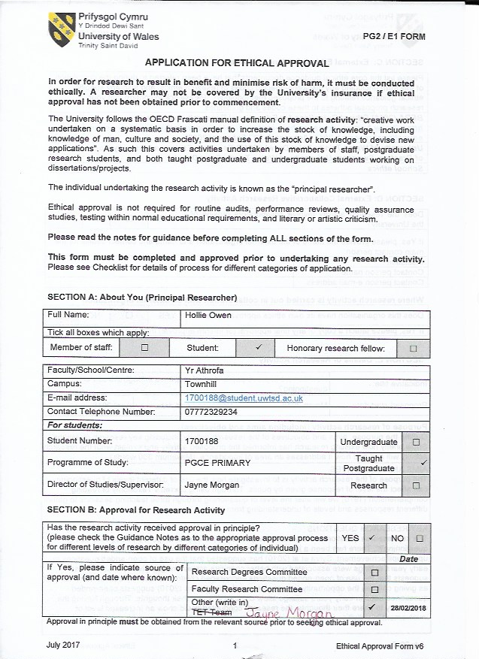
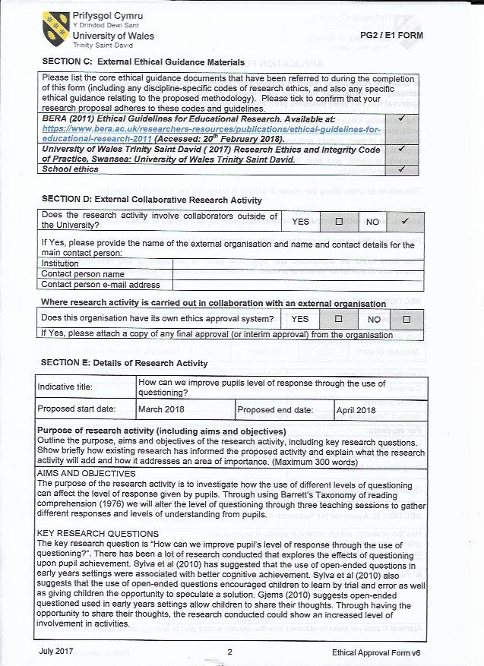
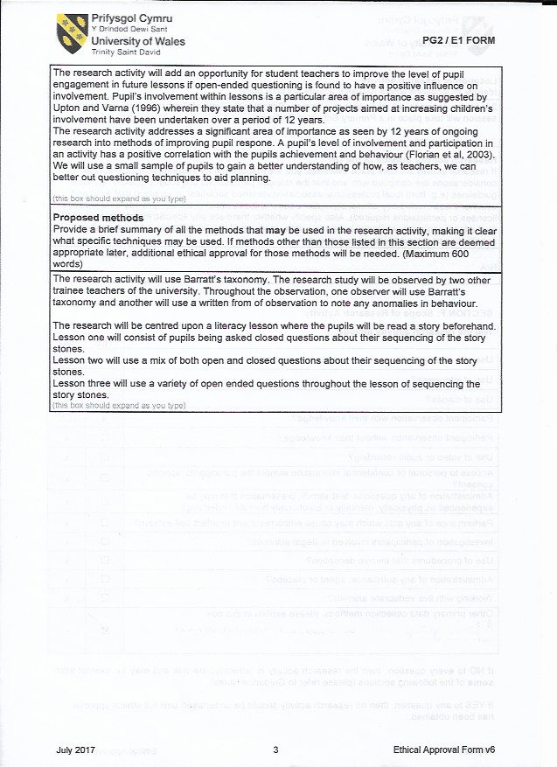
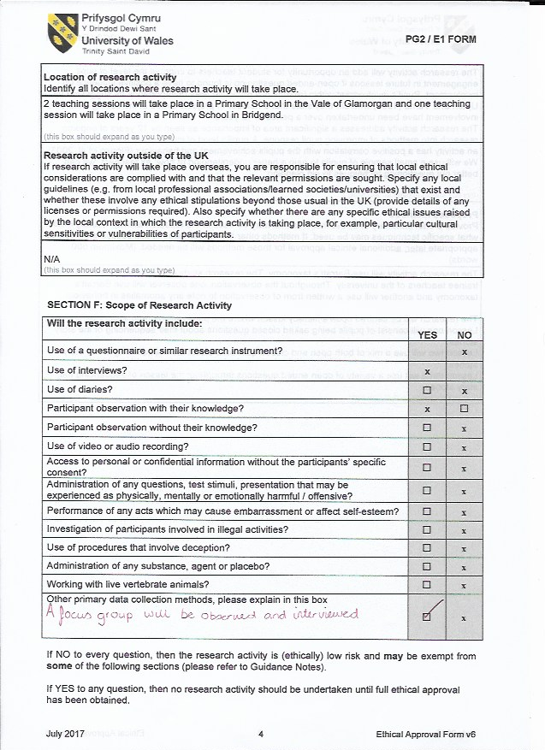
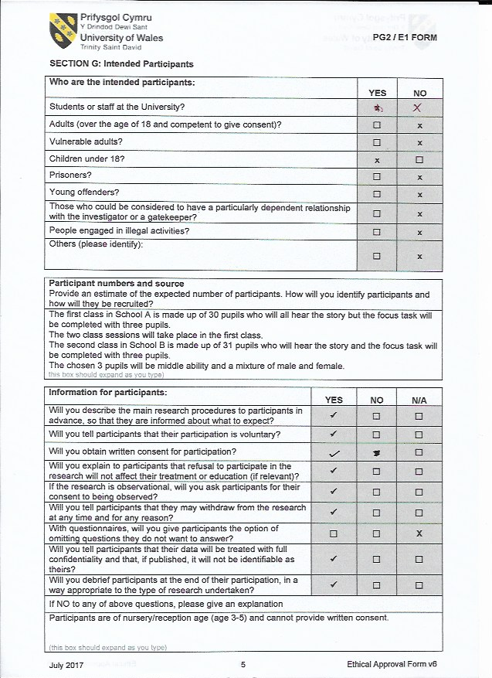

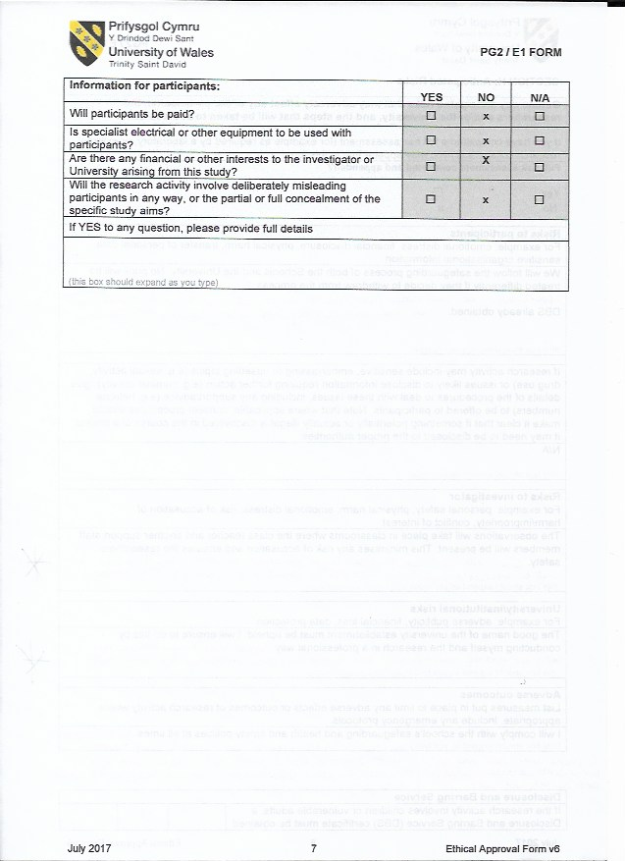
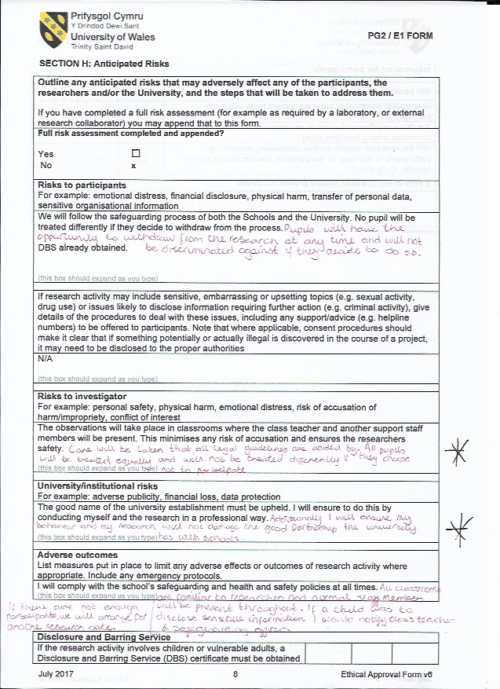

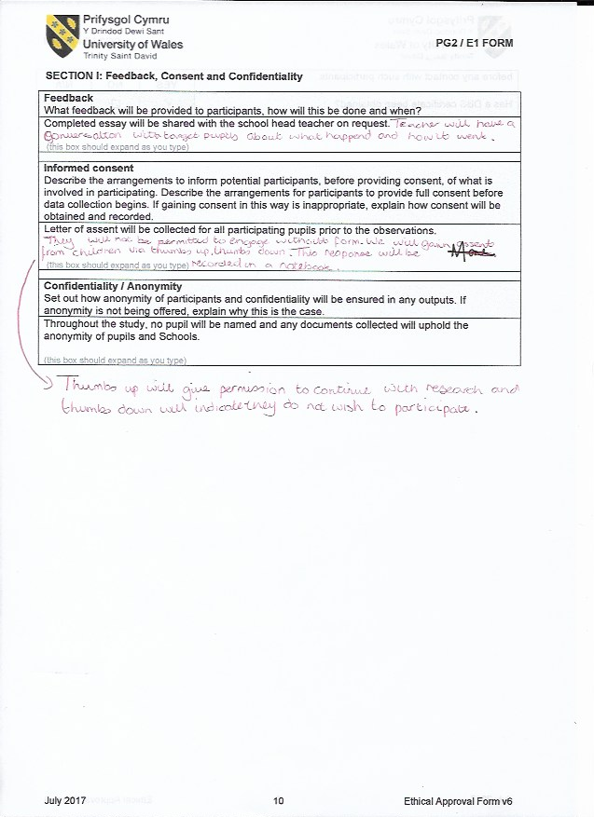
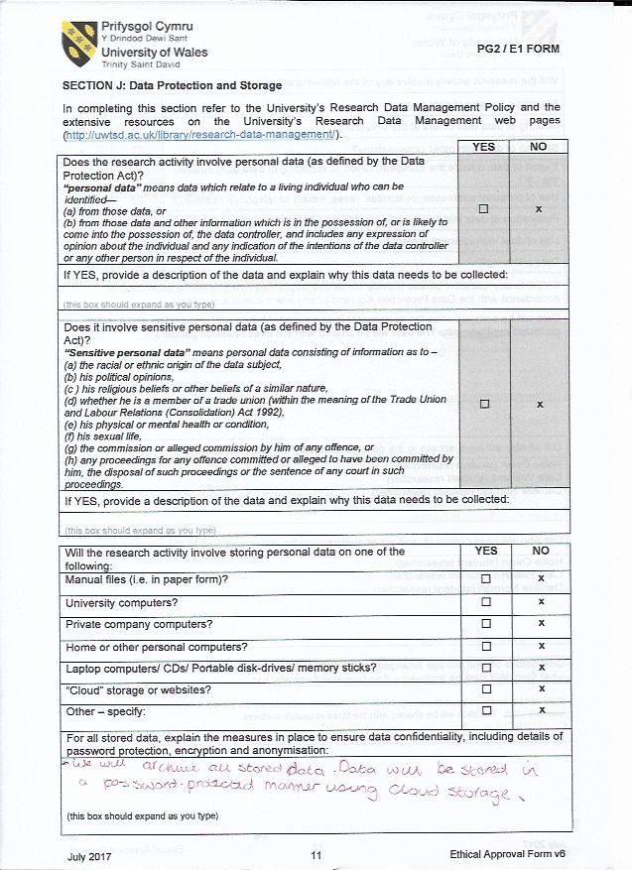
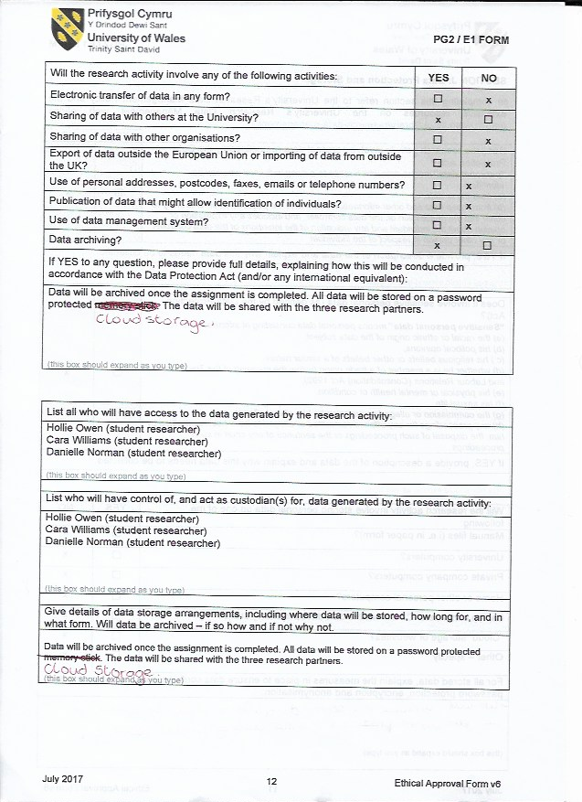
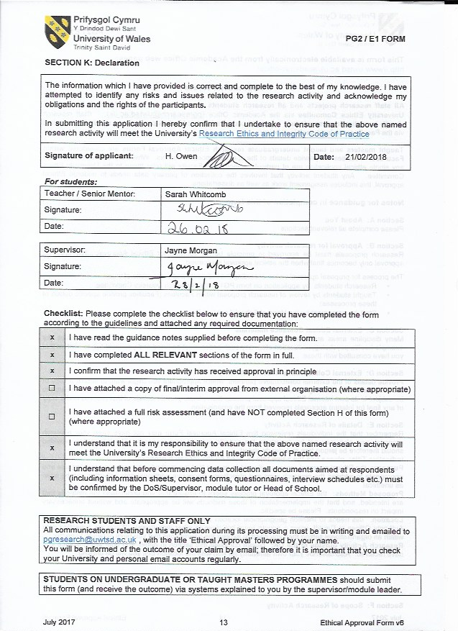
Appendix 7- Method for Assent
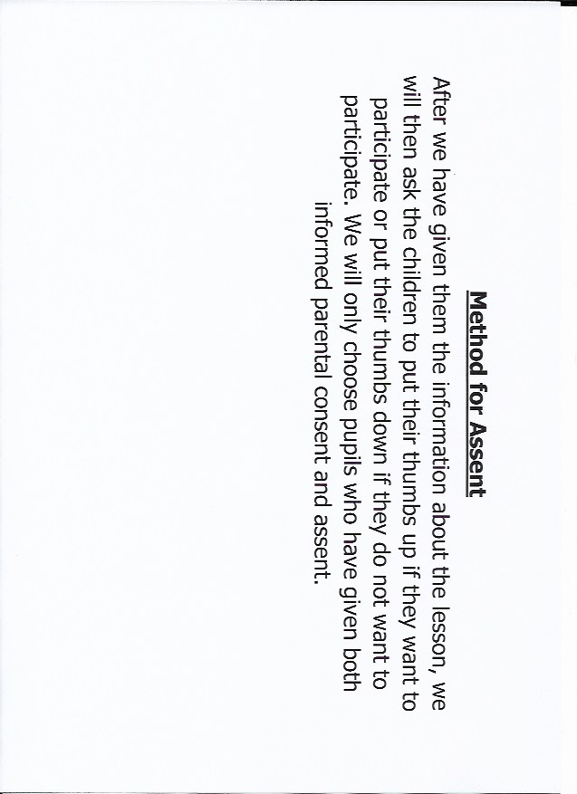
Appendix 8- Lesson 1 responses
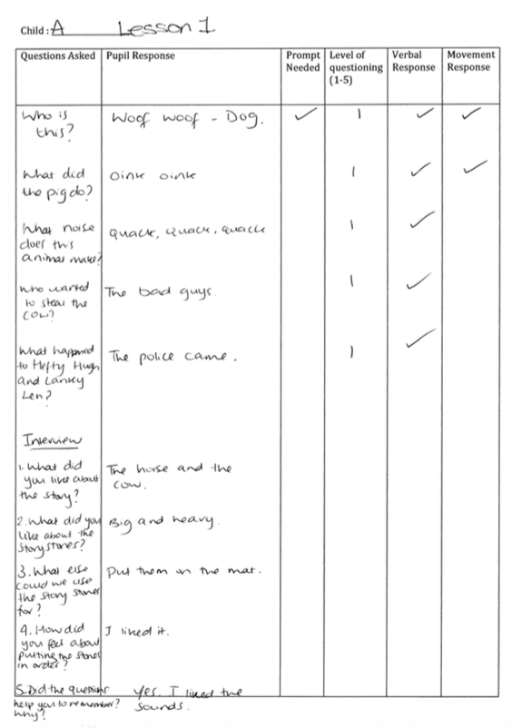

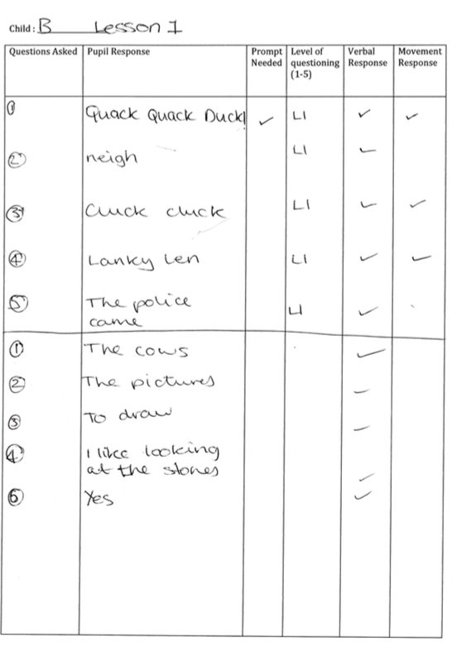

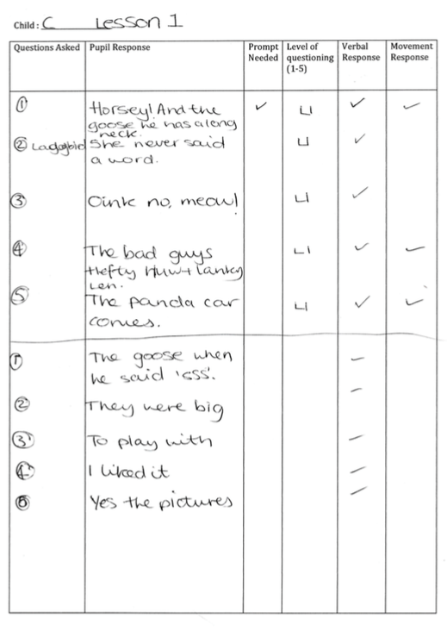
Appendix 9- WAG Questions
The selected questions include:
- Are the activities too easy or too difficult?
- How are the children using the resources
- Is there anything missing that the children need?
- Is sufficient time/space provided for the experience and consolidation?
- Are the children fully involved in the activity- if not, why not?
- How independent are the children in their learning?
- Are he children able to work/play alongside/in cooperation with other children?
- What needs to be done to move the learning on?
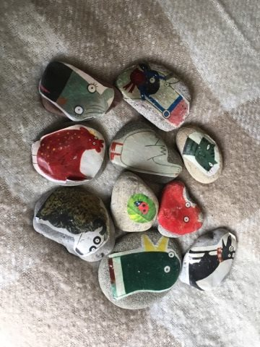

Appendix 10- Story Stones

Appendix 11- Responses from Lesson 2

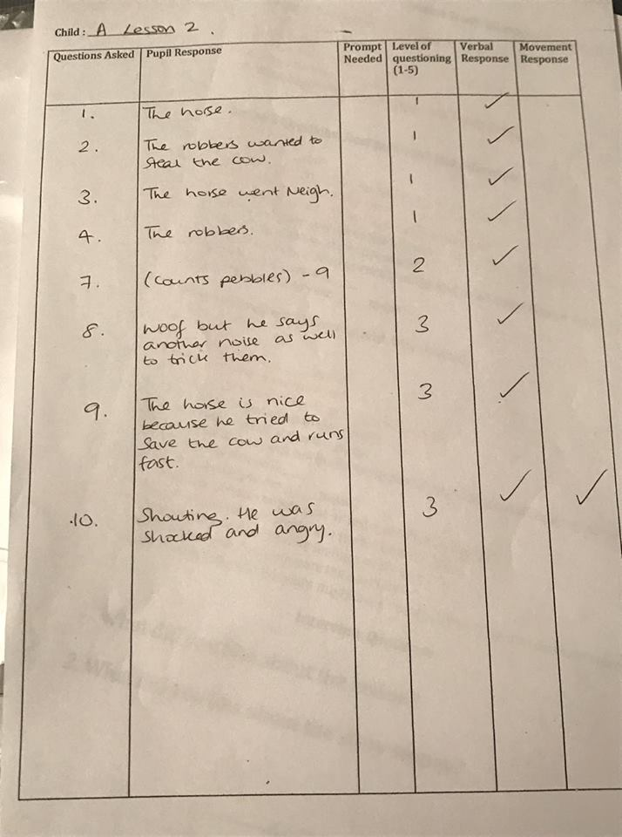

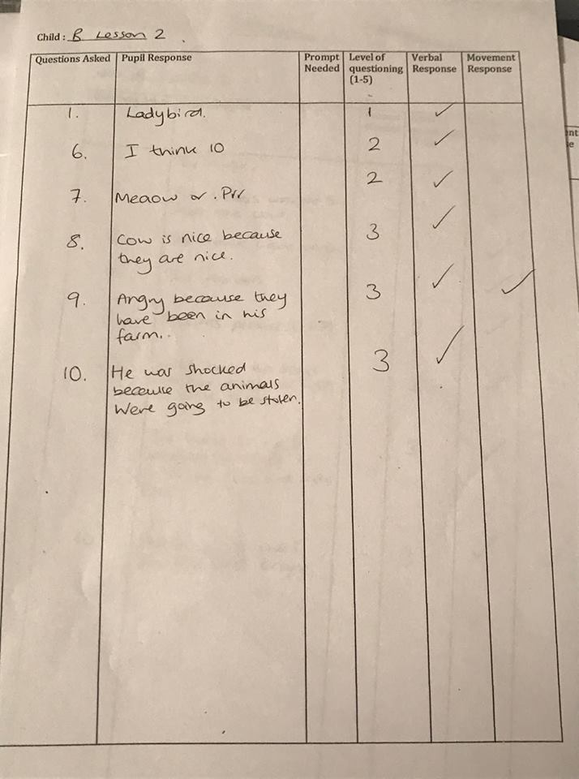

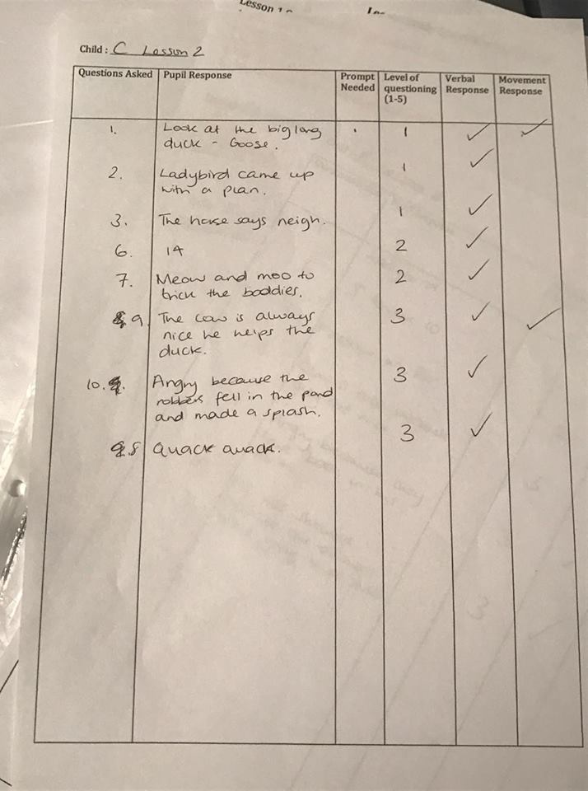

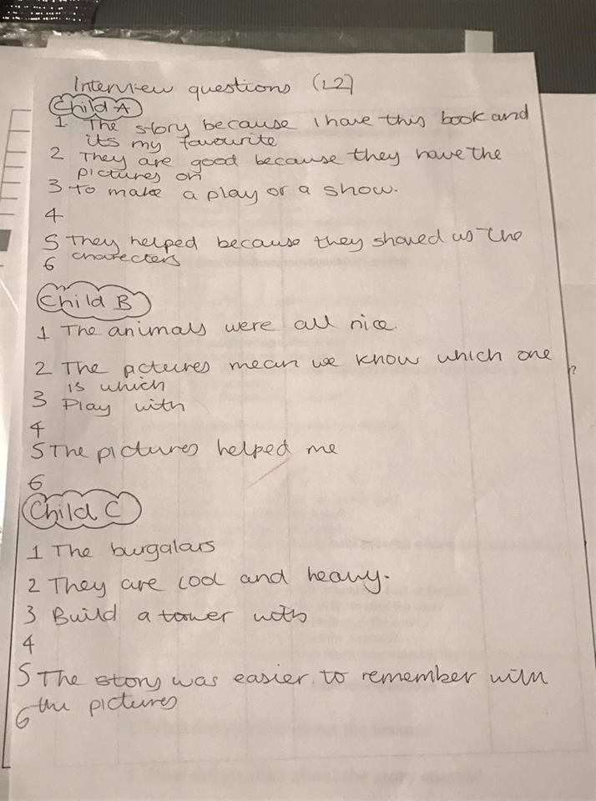

Appendix 12- Responses from Lesson 3.


