

School of Engineering
Can FEA replace physical testing?
Yitao Zhao
1904070
Automotive Engineering Beng
08/04/2020
Advanced Stress Analysis & FEA M6X00420

Catalog
1 Introduction 1
2 The background of FEA 1
3 Comparison between FEA and physical testing 2
3.1 Reasons for performing FEA with physical testing 2
3.2 How to correlate physical tests to finite element model 4
3.2.1 Finite element modeling ……5
3.2.2 Check the correlation 8
4 Whether physical testing can be replaced by FEA 11
5 Conclusion 13
6 References 14
1 Introduction
The advent of computers has largely changed the parts manufacturing industry, and more precise control methods can often deal with some problems that could not be solved by manual testing before. As one of the representative technologies, the finite element method is widely used in various major production fields, and it is particularly useful when producing some parts with more complicated stress conditions. This assignment will use a car frame as an example to show that how FEA plays a role in daily product development. By correlating the experimental results of the physical test and the finite element method, both advantages and drawbacks of the two methods will be analyzed, so as to find out which manufacturers need to perform a finite element analysis alongside the physical test the reason. Besides, the connection between FEA method and physical test will be shown, which helps to determine whether physical test can be replaced by finite element method.
2 The background of FEA
Finite element analysis (FEA) uses mathematical approximation to simulate real physical systems (geometry and load conditions). It prefers using a finite number of unknown elements (units) to approach an infinite unknown real system. The concept was first proposed in the 1960s and was applied to the aerospace industry at the beginning. However, with the development of computer technology and calculation methods, the finite element method has received more and more attention and application in the field of engineering design and scientific research.
There are usually three main steps for a FEA test: preprocessing, simultaneous solving and postprocessing.
In pre-processing part, based on the real body, the solved entity need to be defined, such as the frame model in the case study. Structural dispersion is the central task of finite element analysis, which is followed by parameter settings for unknown elements (units), including material properties, minimum dimensions and mesh type. Boundary conditions such as fixed points or faces and loads properties should also be specified at this time.
Simultaneous solving turns the discrete units into a continuous whole. Due to its large amount of calculation, this part usually needs to be completed in the computer. The quality of its solution mainly depends on the parameter settings and mesh type of the element.
Post-processing will get the final experimental data, which for the selected case is the torsional displacement.
In summary, the central ideas of the finite element method are ‘numerical approximation’ and ‘discretization’. However, without the vigorous development of high-performance computer technology, there can be no progress of finite element analysis. So author believes that the computer technology is the core of the development of finite element.
3 Comparison between FEA and physical testing
3.1 Reasons for performing finite element analysis with physical testing
As an experimental method, physical testing is usually inseparable from a solid object. Taking the component's force analysis as an example, the physical test needs to apply external force or moment to the specified position of the solid object, and at the same time fix some other positions of it in order to measure the relevant data such as stiffness, twist angle, bending displacement, etc. This testing method based on solid model may make the physical object deform to a certain extent after continuous testing, resulting in inaccurate experimental data. In addition, during the entire physical testing process, the experimental data can only be analyzed and improved after all results appear, which not only takes longer time, but also increases the risk of parts fatigue.
As a virtual test method, the finite element method has better intuitiveness and predictability than physical testing, which can be demonstrated as three aspects followed:
The first reason for performing FEA alongside physical testing is that the stress details of physical experiment can be shown. Meanwhile the 3D renderings allowed to view from any angle and size, which makes testing data easier to read and helps to realize the stress condition better. For the physical test in case study, the car frame was loaded at the front to find out its torsional stiffness. Although load magnitude and torsion angle could be read among the test, the stress distribution, as an important data, was unknown. With the help of FEA, the stress distribution on the frame structure was indicated in different colors, making the results clearly and more comprehensive. An example based on a bus chassis can prove that point:
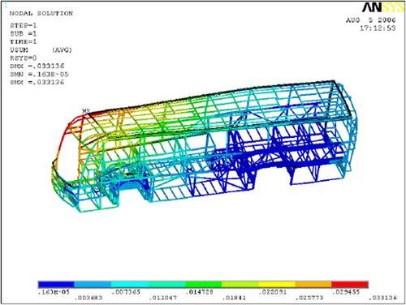
Figure-1 FEA of a bus chassis
The second reason is that the FEA can change experimental parameters more efficiently to match the experimental requirements than physical tests. For the case study, some crossbeams were installed at different parts of the solid body to measure the displacement and torsion angle. The fixed positions of these beams were adjusted multiple times in order to make sure all of them were in right places, which made the steps more complicated and errors easier to occur in the course of the experiment. However, in finite element analysis, just correcting the value of the parameter that needed to be modified and then recalculating in software, the final results would be renewed. Compared with traditional physical tests, the finite element method is not only faster and lower costing, but also has higher accuracy.
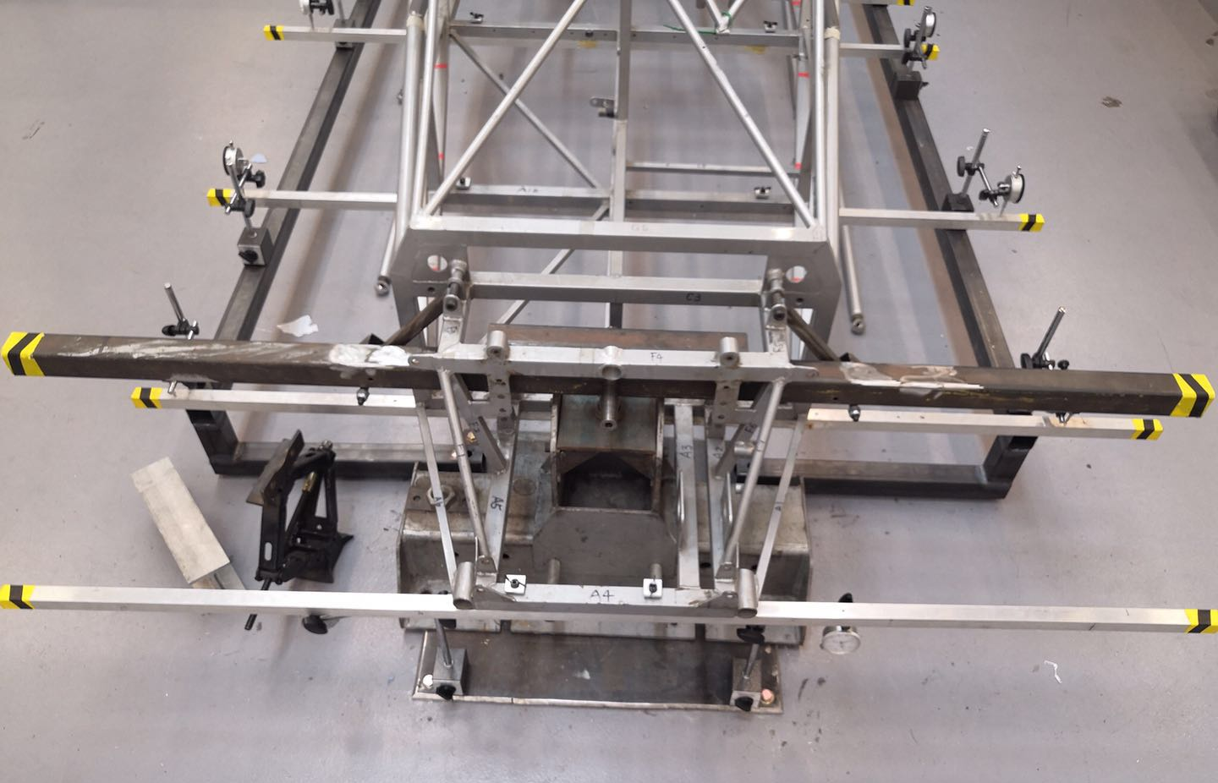
Figure-2 Fixed positions of crossbeams
The last reason is that finite element analysis can promote the improvement and perfection of design methods. In previous physical tests, whether the test method should be improved could only be determined when final results came out. But the FEA can show the whole process of the test and give the predicted phenomenon in a more intuitive and faster way such as reducing the number of repetitive steps and comparing results with physical tests by postprocessor. This advantage can greatly reduce the time required to improve the experimental design, especially for such a time-consuming experiment.
3.2 How to correlate physical tests to finite element model
In oder to realize how a physical test be correlated to a finite element model, based on physical components, a three-dimensional model was essential to build on the software.
3.2.1 Finite element modeling
With the main structure similar to the reference object, a simplified car frame was built by Solidworks. It could be seen that although some parts was omitted, the shape and size for FE model was close to the real one. 4130 steel was used as the frame material in order to obtain consistent mechanical properties:
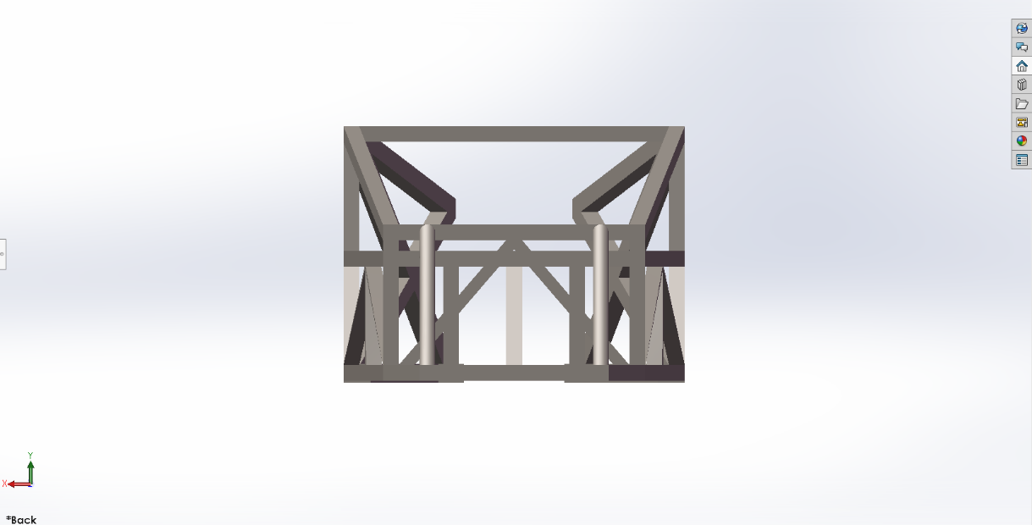
Figure-3 Front view of the FEA model
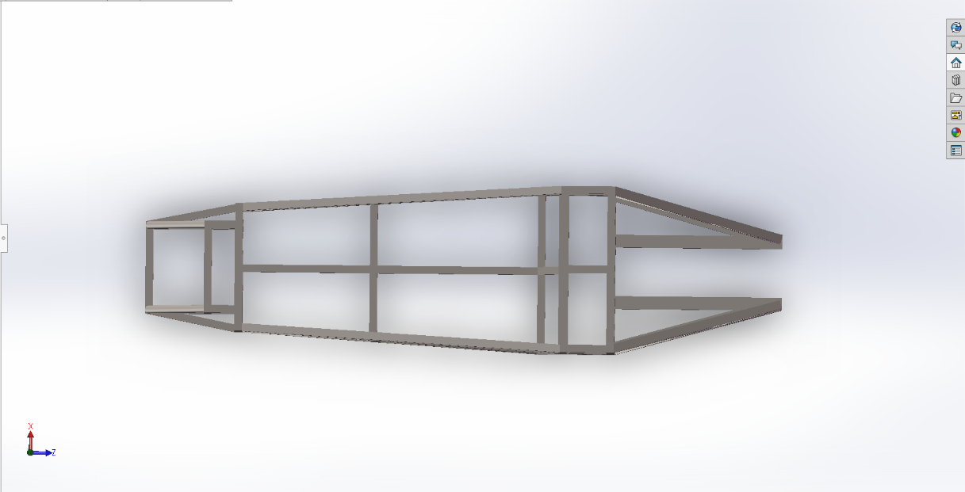
Figure-4 Top view of the FEA model
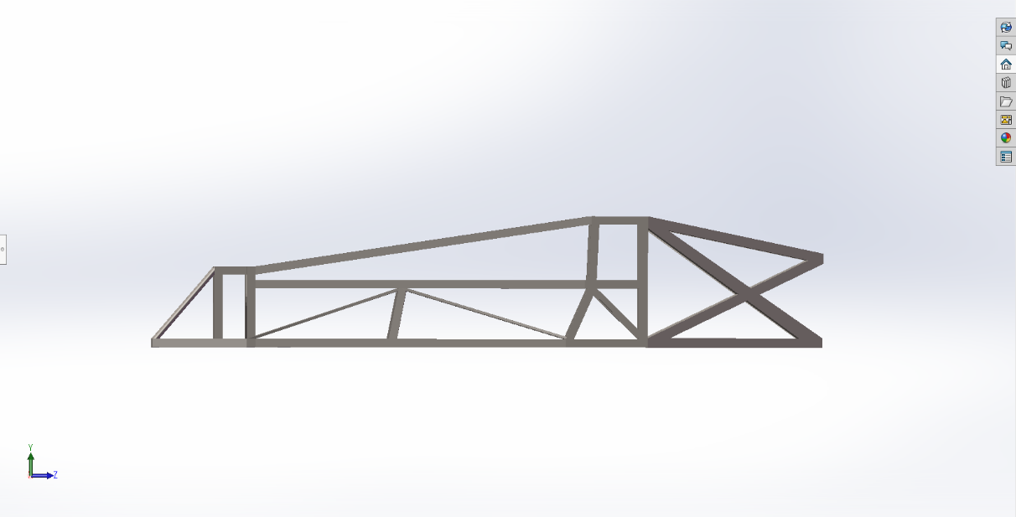
Figure-5 Side view of the FEA model
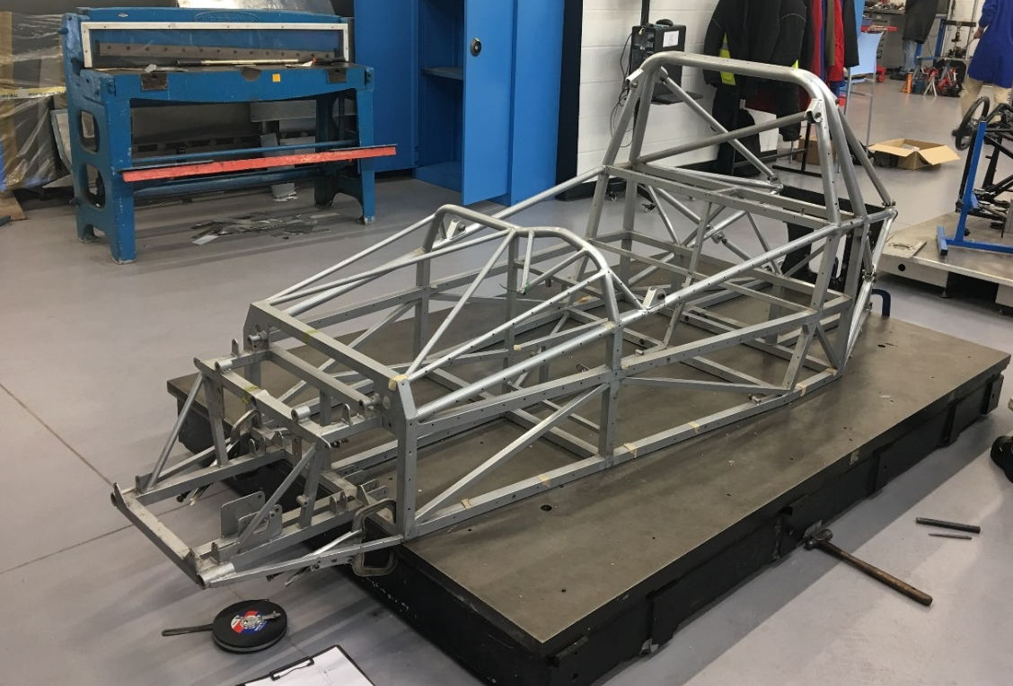
Figure-6 The original solid model
For mesh properties, because of the uneven stress distribution, curvatured-based mesh was applied to achieve a simulation closer to the actual situation. The boundary conditions for physical test also had the same effect as the finite element model. In the FE model, forces about 1550N were uploaded separately at each side:
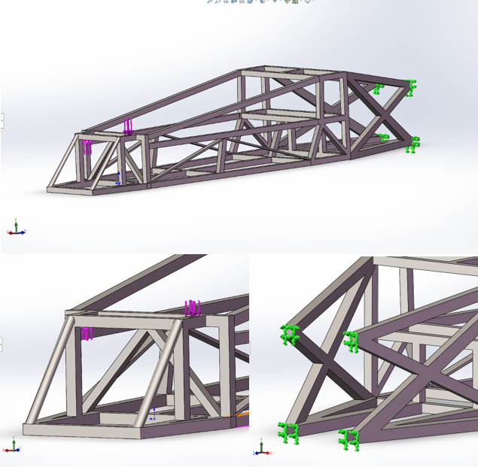
Figure-7 Loads acted on the FEA model
With the same fixed points, only one difference for loads parameter setting between physical test and finite element model should be noticed: in the entity model, only one force was loaded at the end of the main bar, which had farther distance to centerline. To keep the same torque acting on the chassis, the value of this force was calculated as 650N so that physical tests could be correlated to FEA settings.
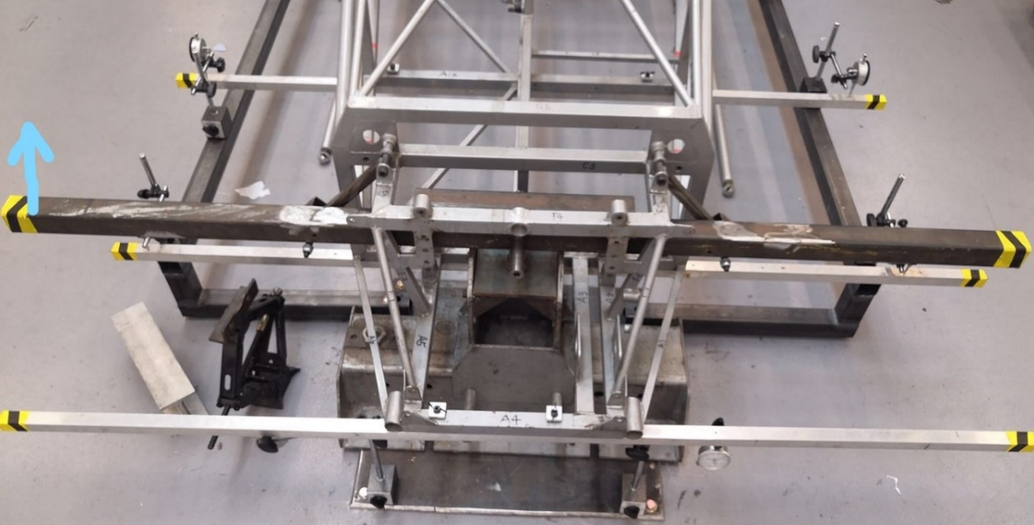
Figure-8 The real load point in physical test
3.2.2 Check the correlation
After quantities of setups for the FEA model, it would have a similar physical property as the entity frame, which meant that the parts modeled could match the parts tested in great condition. The test results below will illustrate the degree of correlation between the two models.
The first part is modal analysis. Since the vibration modes are inherent and integral characteristics of the elastic structure, through the modal analysis method, the properties of the structure’s main modes in a certain susceptible frequency range can be understood, and the actual vibration response generated by various internal or external vibration sources for the structure in this frequency band can be predicted. However, in the case study, only the finite element model was modal analyzed due to the restrict of the test equipment:
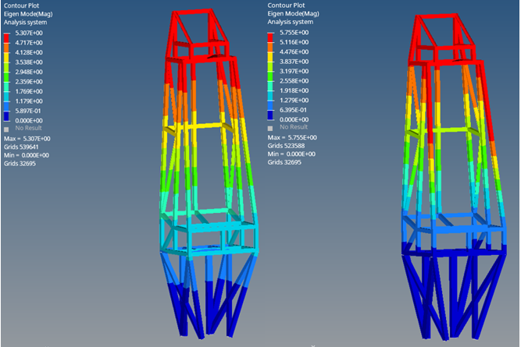
Figure-9 Modal analysis of the FEA chassis
1st order (left); 2nd order (right)
The results showed the difference that the first-order frequency was 16.758Hz and the second-order frequency was 51.75Hz. Calculated by finite element method, the results will be useful for NVH reduction in further researches.
The second part to compare is the maximum displacement. Due to there are some differences between the simplified model and the actual structure, the results of the two tests are somewhat different.
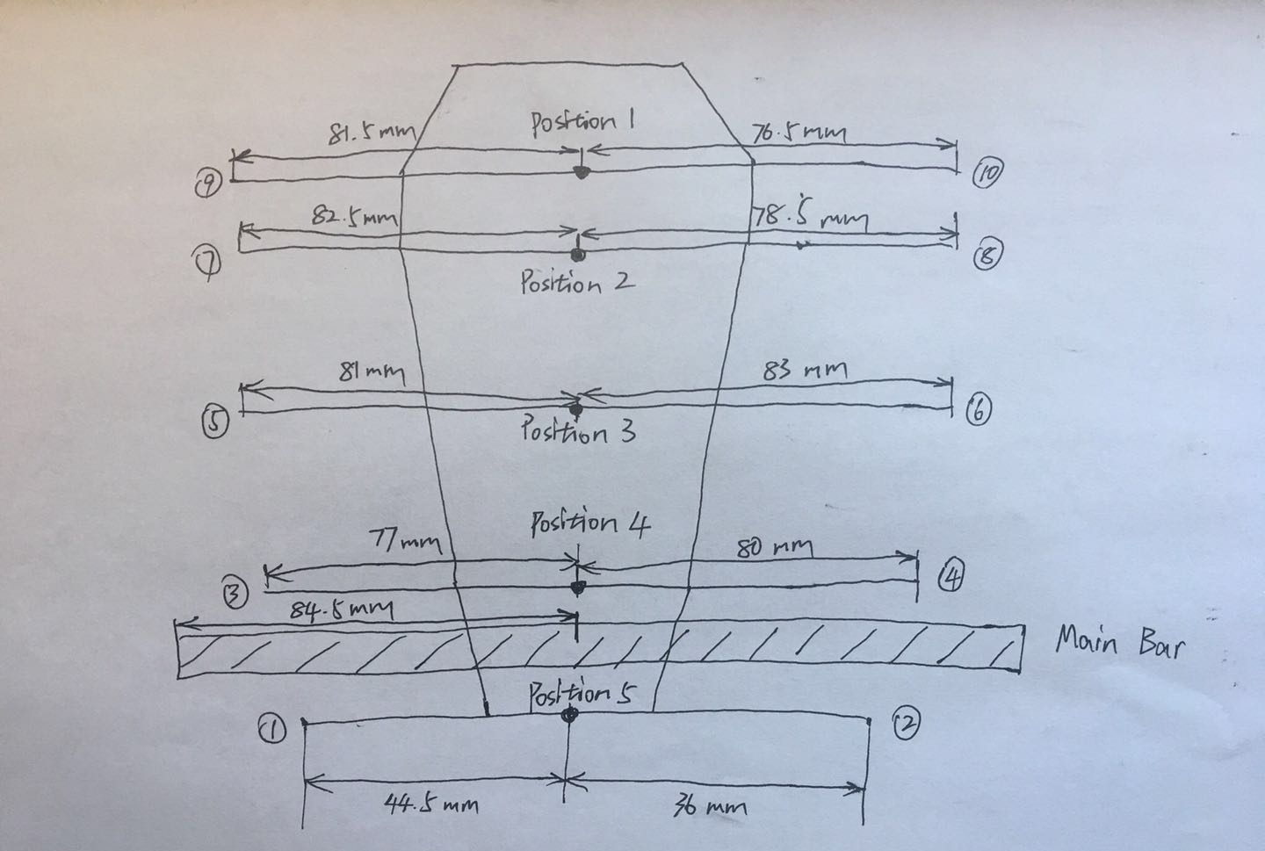
Figure-10 Ten testing points in the physical test
The figure above shows each position of the ten testing points in physical test, and each point had their own displacement and twist angle. The result showed that the crossbeam through position 4 had the biggest displacement:
Table-1 Part of the physical test results
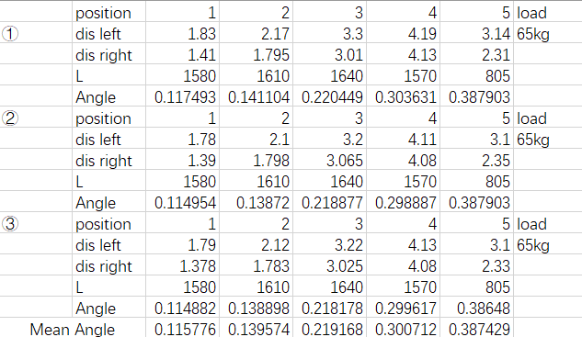
The maximum displacement was 4.19mm in the test, and displacement on the left-hand side was always a little bit bigger than the right-hand side because the load was acted on the left end of the main bar.
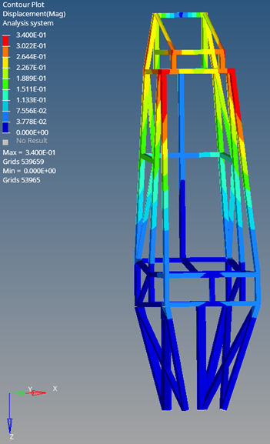
For the FEA model, the distribution of the maximum displacement showed a high degree of similarity to physical testing. As the distance from the main bar increased, the displacement of the tube became smaller and smaller. In addition, the maximum value point also occurred at the front upper corner, which was same as the physical testing results. But it should be noted that the maximum displacement of the finite element model was only 0.34 mm, which was less than one tenth of the physical test results.
Figure-12 Result of FEA displacement simulation
The last part to compare between physical testing and FEA simulation was twist angle.
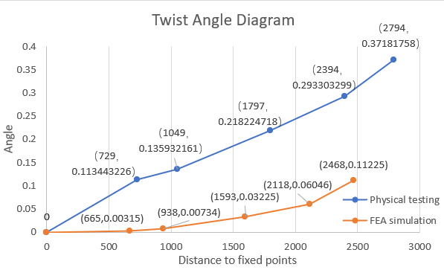
Figure-13 Twist angle diagram
From the diagram above, the twist angle in physical testing was much higher than that calculated by finite element method due to many reasons. Among the data, the difference in structure had the greatest impact on the test results, which was mainly reflected in the completely different angle growth rate of the two tests from the fixed point to the first test position. Not only that, the deformation after multiple tests of the real chassis and the accuracy errors caused by measuring instruments would also lead to inaccurate physical test results. For the finite element model, the structure and boundary conditions cannot be 100% restored was the root cause of the error. Nevertheless, in the next few intervals, twist angles in both groups began to increase at the same trend, which could proof that the correlation between physical testing and FEA model was not too bad.
4 Whether physical testing can be replaced by FEA
At this stage, author believes that finite element analysis cannot completely replace physical testing. Although advances in computer technology have made the finite element analysis more intuitive and efficient than physical experiments, FEA is just a tool helping to deal with complicated problems which is difficult to get results in actual tests.
First of all, physical tests are important references for finite element analysis. Due to the variability of the real environment, in many cases, computer-based simulations cannot contain all the situations under a certain experimental condition. During the case study, many efforts were made to correlate the FEA results to physical data, but things like the fatigue of tubes and the pipe wall unevenness due to manufacturing process are not taken into account. Besides, the simplification of the model can only verify whether they follow the same changing trend. That’s a reason why a physical test needed to be established for comparison.
In addition, the simulation methods of finite element analysis are derived from the empirical formulas which obtained from previous physical tests. Without physical theories as the basis, the finite element analysis methods cannot be generated out of thin air. For example, the idea about mesh types was inspired by uneven stress distribution, and all the material properties were calculated from physical tests about real parts. If physical tests are completely given up, the finite element method will stop developing as well.
Testing is the foundation of physics. All the concepts, laws and formulas of physics are based on objective tests, that physical theory can never be separated from the verification of the experimental results. When scientists put forward certain assumptions or foresights, physical experiments are necessary to verify the truth of their original thoughts. The experimental conditions are strictly controlled during this time because any change may cause a totally different theory. Judging from the role played by the subject, there is a big difference between physical tests and hypothesis. Physical testing turns hypothesis into theory, and theory promotes the development of technology.
As a computational method, finite element analysis is more like a hypothesis which predicts the test results in advance. Although it is more advantageous than physical testing in some aspects, the finite element method is unable to completely restore the complex test environment under real conditions. The core of the finite element analysis is ‘discretized approximation’, which uses combinations of simultaneous equations to ‘approximately’ replace the very complex original functions. Even if the accuracy will be further improved, the concept of finite element analysis illustrates that this method is only an infinite approximation to the actual test conditions, rather than a complete copy.
For the FEA test itself, an in-depth understanding of the physical characteristics of the solid components is also required in order to achieve a simulation result which is accurate enough to replace the physical test. Analysis based on simplistic assumptions about the real world will not provide a reliable basis for
understanding structure properties.
The modeling is also a serious job. Due to some additional structure, many solid models cannot be fully copied into the FEA software. For the frame in the case study, it was first simplified to some extent. What’s more, by reason of that five crossbeams went through the model at different positions to gather the experimental data, they could not be showed in the finite element model. Although these crossbeams were light enough and would not cause any trouble to the final results, the consistency of the test environment would be reduced.
To sum up, the right way to deal with physical tests and FEA is not replacing one with another, but combining their advantages:
Physical testing is always the basis of manufacturing industry, which reflects the actual experimental condition.
FEA tests have better details during the process, which can be more efficient and more visual. But they are based on physical theories and not able to restore all of the test conditions. This method can be very useful when solving large quantities of simple parts which have a high cost for physical testing and easily fatigued.
5 Conclusion
For this assignment, author understood that ‘discretized approximation’ is the main idea of the finite element method. With a powerful computational ability, it plays an important role in both engineering design and scientific research. Followed the three main steps by preprocessing, simultaneous solving and postprocessing, the FEA can achieve more details while testing and much more efficient than ordinary physical tests. Besides, the FEA can predict the results of physical tests, which is helpful to promote the improvement and perfection of design methods.
However, due to the limitation of its own concept, finite element method cannot fully copy the experimental conditions in physical tests. Without physical testing alongside finite element analysis, the test results are easily to have a deviation because physical testing is the basis of the FEA. A deep understanding for the entity model is always required in order to make the FEA results correlating with physical tests.
Although there were some differences in the results, the case study of the chassis illustrated that a physical test can be correlated to a finite element model so long as the dimensions and boundary conditions are finely controlled. Due to the load points were changed, the force was recalculated to maintain the same torque acting on the frame. With such efforts like this, the FEA will become a helpful tool for structure analyzing. As many companies have adopted now, combining the finite element method with physical tests will not only make the test more efficient and economical, but also ensure the credibility and rigor of the results, which can benefit the manufacturing industry a lot.
6 References
McCallum, Peter., J., 1992, Getting Better Results from Linear FEA. In: s.l.: Machine Design, Vol. 64(4).

Dvorak, Paul., J., 2001, Electronic textbook provides background for FEA. In: s.l.: Machine Design, Vol.73(9).

Keene, Roger; J., 2004, Reality Rules in FEA. In: s.l.: Manhassett, Vol. 59(7).

Timothy N, Shafiq R. Khan; M., 2005, Correlation of an Automotive Seat Finite Element Simulation with Dynamic Sled Testing. In: s.l.: SAE International.

Wang Y, Wen L, Chen M., M., 2010, Dictionary of Mathematics. In: s.l.: Science Press.

Lei Q., J., 2013, Using Numerical Method to Improve the Demonstration Experiment in College Physics. In: s.l.: Journal of Weinan Normal University.

Zhu H., M., 2003, Basic Physics Experiment Course: Data Processing and Experiment Design of Physical Measurement. In: s.l.: Higher Education Press.

