Programme: BA Business Management
Module Title: Marketing Fundamentals
Assignment Title: Marketing Fundamentals Analysis and Evaluation of Nike Inc
Module Code: LCBB4004
Name: Ana Maria Costea
Student number:1907186
Module Lecturer's name: Dr. Rexon Nting

Table of Contents
Introduction 3
TASK 1 A 3
Processes and stages of marketing including the role of the marketing mix 3
The role of marketing in creating value for customers 6
Stakeholder engagement and their impact on the marketing activities of an organization 8
TASK 1 B 10
Conclusion 11
Reference List 12

Introduction
In the era of rapid globalization, businesses always want to enhance their marketing effectiveness so that they can effectively make their reach among the targeted customers. The paper will look forward to focus on assessing the development of marketing, which helps the organizations to create value among the customers in the context of Nike Inc. the paper will focus on various processes as well as the stages of marketing along with the role of marketing mix. In addition, the role of marketing which effectively facilitates the markets to carte value for the customers will be analyzed within the paper. The engagement of stakeholders as well as their impact on the market activities of Nike will be effectively evaluated.

TASK 1 A

Processes and stages of marketing including the role of the marketing mix
The concept of marketing is one of the major approaches, which is adopted by most of the firms nowadays. The modern concept involves a much wider scope and user-centric (Blythe, 2014). It looks forward to discover the various types of audiences in order to create products as well as the services as per the wants and needs of the customers. It is much important within the organization as it helps the marketers to align their practices of designing safe products for their end-users. In the context of Nike Inc., the organization always looks frontward to align its organizational objectives and goals with relationship marketing. The relationship marketing technique facilitates the organization to aim towards retaining the customer as well as their loyalty towards the brand. In addition, the organization continuously releases new products to offer a wide product range to the customers and satisfy their requirements.
Considering SWOT analysis in the context of Nike Inc. in order to determine the microenvironment, it can be stated that the organization has a strong brand awareness, which facilitates the company to gain an easy recognition among the customers with a swoosh symbol. The organization also has a strong customer base with effective brand loyalty stands as the strength of the firm. The company aims towards sustaining itself by maintaining an iconic relationship with the customers (Gürel and Tat, 2017). The low manufacturing cost assists the company to maintain a profound profit margin. On the other hand, the poor conditions of labor stand as the major weaken of the firm. The sensitivity against pricing as made the firm weak. The organization has pending debts, which weakens its overall efficiency. In addition, the dependency of the organization in the US market reduces the sustainable sales of the company. The violations of various lawsuits made the organization affect its goodwill in the market.
The major opportunities of the firm are that there are opportunities for the firm to explore it in the emerging markets. The innovative products, along with the wearable technology, are a much effective approach to attract a large pool of customers. On the other hand, the increased pressure of competitors such as PUMA, Adidas, and other brands stands as the major threat of the company(Gürel and Tat, 2017). The emergence of coronavirus disease is also creating a major pressure on the profitability and productivity of Nike.
In addition, considering the PESTEL analysis in order to determine the macro-environmental influence of the organization, it can be stated that the political situation of the UK is much stable. It will effectively facilitate the organization to keep operating effectively. However, the vote for Brexit is creating major uncertainties for the retailers (McNair, 2017). It can increase the trading risk of Nike and can hinder its productivity. It is identified that the current rate of unemployment in the UK is 3.8, which is actually considered as the healthy rate (Ons.gov.uk, 2020). This represents a threat Nike will be facilitated with a highly qualified workforce within the company.
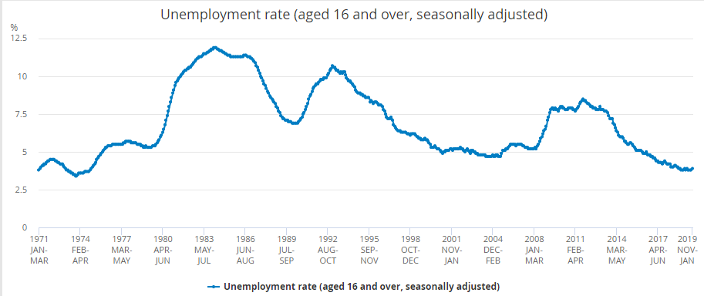
Figure 1: average rate of unemployment in UK
(Source: Ons.gov.uk, 2020)
The per capita income of the UK is around 40319 dollars, which represents that society is earning profoundly. It will help the company to attract customers in order to enhance its probability. However, the occurrence of Coronavirus will make a huge negative impact on the revenue of the organization.
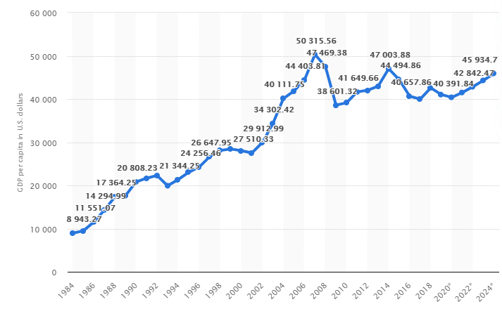
Figure 2: Per Capita Income of UK
(Source: Statista.com, 2020)
The marketing mix is referred to as the set of tactics and actions that helps the firm to promote its brand in the market (Leigh and Li,2015). It can be concluded from the entire essay that businesses focus on implementing effective strategies to maintain their foothold in the competitive market. Nike is one of the profound brand names on the global platform by effectively targeting customers who have effective attraction and love for fashion. The key peoples who effectively facilitate the company to make a strong foothold in the consumer market are the employees, management, customer service, and partners. It effectively facilitates the organization to make profound public relations. The process of the company involves the supply, manufacturing, selling, and production of the products and the services. Moreover, the physical environment of the organization involves offline and online stores.

The role of marketing in creating value for customers
The direct marketing of Nike Inc. assists the company to establish a stronger relationship with the customers as well as influence them to purchase the products and services of the organization. The direct market helps the company to introduce its products to the customers; for heavy advertisements and increase brand awareness among the customers (Baineset al., 2014). The high-quality manufacturing, the supply of the equipment as well as the gear for various collegiate athletic teams and professionals facilitate the organization to earn a huge amount of productivity and profitability. Moreover, the excellent knowledge about marketing helps the organization to make a remarkable foothold at the global platform (Jobber, 2016).
The stages of marketing concept involve four phases, namely the product orientation, market orientation, production orientation, and sales orientation. Several companies are there that always looks forward to concentrate on increasing the overall production. The control of financial resources and reducing the production cost facilitates the company to gain a high-profit margin. In addition, the organization makes huge profits every year by increasing its sales volume in the market. With respect to the product orientation, it is always being considered that the products, which have good quality used to sell themselves in the market. The focus of the corporation on enhancing the quality of the product helps the organization with greater sales. Due to the juxtaposition of rich and poor customers all over the world, the approach doesn’t satisfy the needs of poor customers; moreover, they don’t hold the capability to afford it.
This approach concentrates more on those customers who have an effective income to support it. The sales orientation of companies facilitates the organization to concentrate upon emphasizing the stock clearance. It helps the company to reduce its inventory cost. In addition, the aggressive promotional and sales approach facilitates the company to gain a competitive edge over rival firms. On the other hand, the marketing orientation facilitates the organization to plan and make decisions to satisfy the needs and requirements of the customers (Housden, 2010). The organization focuses on involving various functions and actions in order to motivate the employees to contribute effectively towards the organizational work.
The organizations offer their products at competitive pricing. In addition, the premium editions of Nike involve premium pricing. The vertical integration pricing helps the firm to control its cost and influence product pricing. The shoes and other products of Nike are sold by multi-brand stores as well as the Nike exclusive stores in all over the world. The firm also vends its products through independent distributors, subsidiaries and licensees.
The major products of Nike are either sold by direct marketing through the retail outlets of the organizations, independent distributors, sales representatives, digital platforms, and licensees or are manufactured by independent contractors. Nike represented the net income of around 4 billion dollars in the year 2019. It was also observed that the net income of the organization grew by the rate of 108.4 percent in the financial year of 2019. It reportedly faced a decline of 54.4 percent in the year 2018 (Johnston, 2020).
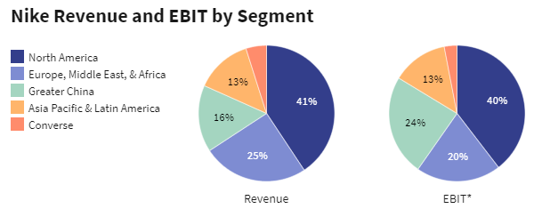
Figure 3: Nike Revenue and EBIT Segment
(Source: Johnston, 2020)
The organization faced a decline due to the consideration of the Job act as well as the Tax cuts in the year 2017. It soared the tax rate of the company from 13.2 percent in the year 2017 to 55.3 percent in the year 2018 (Macrotrends.net, 2020). The segment of organizations in Europe, the Middle East as well as in Africa helped the company to gain around 9.8 billion dollars of revenue in the year 2019, which accounts for around 25% of the overall revenue. The EBIT of Nike Inc. was around 2.0 billion dollars, and the EBIT, as well as the revue growth, were 25.7 percent and 6.2 percent, respectively.
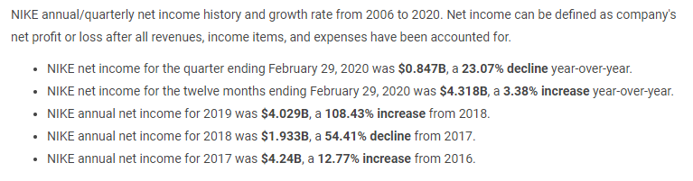
Figure 4: Net income growth rate from 2006 to 2020
(Source: Macrotrends.net, 2020)
Recently, the organization looked forward to close its half of the stores due to the threat of Coronavirus in China. It reduced the operating hours of the company and also anticipated lesser traffic in the opened stores. The occurrence of the coronavirus disease is hugely affecting the expected development of the organization in the greater china as well as in all over the world (Johnston, 2020).

Stakeholder engagement and their impact on the marketing activities of an organization
As Nike operates globally, the organization has various stakeholders who use to influence the sales of the firm in different forms (Brohiet al., 2016). In addition, the top prioritizations of the firm are the customers, communities, government, employees as well as the nearest groups. The CSR policy of Nike Inc. offers top priority to the customers as a group of stakeholders. In order to add to their interests, the company involves a significant investment in R&D so that they can provide high quality as well as advanced technology products. It effectively helps the company to satisfy the interest of the customers (Nike.com, 2020).
The community is also significant to Nike Inc.; it is always being considered by the organization that the customers intend towards buying the products when the product has a significant impact on society. For instance, in the year 2005, the organization looked forward to empower girls by initiating various programs of development hugely impact the mindset of the community (Nike.com, 2020). In addition, the company also allocates its 1.5 percent of the overall income so that they can support the initiatives of the company. On the other hand, the campaigns of the organization often make them suffer their entire profitability. In the year 2018, when the organization announced its alignment with the former American footballer Colin Kaepernick, after his controversial step of kneeling during the US national anthem costs the organizational profitability and goodwill in the market (Bbc.com, 2018).
The company also recognizes the significance of the employees within the firm. It influences Nike Inc. to offer fair salary, compensation, opportunities for career development, internal development of leadership, and other factors so that the company can maximize its ability to produce more advanced products. On the other hand, one of the reports in 2011, it was observed that the workers of Nike faced huge disrespect, verbal abuse, and physical violence while working in the factory (Dailymail.co.uk, 2011).
In addition, the CSR policy of the company also identifies government as its major stakeholder. The company makes an effective contribution to community development and tax revenues (Nike.com, 2020). The interest groups also influence Nike in various significant ways. The company uses to address the needs of the interest groups through the business sustainability, and initiatives of Nike’s foundations.
The organization aims towards suing the market information and research in order to bring innovation and inspiration to its products. It facilitates the company to remain competitive and identify the buying habits and needs of the end-users (Vasiliki, 2020). The company also focuses on analysing the competitors so that they can bring improvement in their product and maintain the unique selling proposition into the market (Zawawiand Razak, 2017).
The company had looked forward to position its brand as a profound market leader. Its high quality, as well as innovative use of technologies, had facilitated the company to convince its customers to become victories and ambitions. The slogan of the company to just do it through its promotional and endorsement activities helps the company to incorporate magnificent achievements of the prominent sportspersons (Vasiliki, 2020). The firm attracts its customers by providing a belief of accomplishing great achievements without any limitations. In the year 2018, the firm holds around 28 percent of the market share of being the largest supplier, as well as the manufacturer of athletic shoes, sports equipment, and apparel (O’Connell, 2019).

TASK 1 B
The overall study is done in a much profound manner. I have effectively looked forward to align my writing, learning, as well as the researching skills so that I can effectively outline the issues and factors in the context of Nike. I choose the organization for its effective brand image and market reach. It is considered as the largest manufacturer and producer of sportswear, apparel, sports equipment as well as sports shoes. In addition, it also holds a strong footmark on the global platform. I focused on researching the various areas of marketing and what is the factor that influences the organization to embrace its market share, profitability, economies of scale, and productivity. Effective documentaries were one of the most important communication tactics, which helped me to find the responses of marketing in the context of Nike. In addition, it also helped me to inculcate the ability to gather information related to the topic. Effectively looked ahead to review the information so that I can analyze, interpret, and critically evaluate the information in a profound manner.
The use of blog posts as a tactical tool helped me to effectively describe the overall tasks. I learned a lot about the concept of marketing and how the organizations use it in order to gain a competitive edge over rival firms. It effectively facilitated me to know about the management of the multinational organization. In addition, journals were one of the primary approaches as wellas communication tactics, which helped me to equip my thinking in a profound manner and helped me to outline the ideas into this paper. Writing the overall paper helped me to gain an overwhelming experience. The tactical communication tool effectively helped me to generate awareness and interests in my project. Usage of blog pots enhanced my initiation towards the academic researches. In the context of the theoretical approaches of ethnographic perspectives, it facilitates the student to take into account the social practices rather than focusing upon the skills (Street, 2015). The writing varies due to the differentiation of courses, contexts, countries as wellas the institutions. The ethnographic approach in writing always facilitates the students to find out the importance of managerial practices in a broader context.
In addition, I effectively looked forward to attempt the writing in the field of literacies as managerial practices. My entire study focuses on outlining what was done by Nike and its management. The essay was conducted in a systematic manner.

Conclusion
From the study, it is understood that Nike focuses on enhancing its brand awareness among the customers by executing profound promotional and endorsement activities with celebrity athletes. The approach to marketing is essential for businesses as it facilitates them to sell their services as well as the products in order to strengthen the bottom line. Nike effectively channelizes its goals and objectives in order to provide high-quality products to the customers. The socio-economic process helps the company to meet the requirements of the customers, along with maintaining effective relations with them.

Reference List
Baines, P., Fill C., and Page, K., 2014. Marketing, Oxford, 2nd edition
Bbc.com,2018. Nike sales defy Kaepernick backlash. Available at: https://www.bbc.com/news/business-45472399 (Accessed: 1 April 2020).
Blythe, J., 2014, Principles and Practice of Marketing, 3rd edition, Sage
Brohi, H., Prithiani, J., Abbas, Z., Bhutto, A. and Chawla, S., 2016. Strategic Marketing Plan of Nike. Pp.1-25
Dailymail.co.uk, 2011.Nike workers 'kicked, slapped and verbally abused' at factories making Converse Available at: https://www.dailymail.co.uk/news/article-2014325/Nike-workers-kicked-slapped-verbally-abused-factories-making-Converse-line-Indonesia.html (Accessed: 1 April 2020).
Davis, A. and Walsh, C., 2016. The Role of the State in the Financialisation of the UK Economy.Political Studies, 64(3), pp.666-682.
Gürel, E. and Tat, M., 2017. SWOT analysis: a theoretical review. Journal of International Social Research, 10(51).
Housden, M., 2010, Marketing Information and Research, Butterworth Heinemann
Jobber, D., 2016. Principles and Practice of Marketing, McGraw Hill 8th edition
Johnston, M., 2020. How Nike Makes Money: most revenue is generated by footwear sales. Available at: https://www.investopedia.com/articles/markets/080415/how-nike-nke-makes-its-money.asp (Accessed: 1 April 2020).
Leigh, M. and Li, X., 2015. Industrial ecology, industrial symbiosis and supply chain environmental sustainability: a case study of a large UK distributor. Journal of Cleaner Production, 106, pp.632-643.
Macrotrends.net, 2020. NIKE Revenue 2006-2020 | NKE Available at: https://www.macrotrends.net/stocks/charts/NKE/nike/revenue (Accessed: 1 April 2020).
McNair, B., 2017. An introduction to political communication.Taylor& Francis.
Mix, T. 2020. Marketing Mix Definition - 4Ps & 7Ps of the Marketing Mix, The Marketing Mix. Available at: https://marketingmix.co.uk/marketing-mix-7ps/ (Accessed: 1 April 2020).
Nike.com, 2020. Nike Foundation steps on to new field . Available at: https://news.nike.com/news/nike-foundation-steps-on-to-new-field (Accessed: 1 April 2020).
Nike.com, 2020. Nike Purpose: Stakeholder Engagement for FY16/17 Sustainable Business Report Available at: https://purpose.nike.com/stakeholder-engagement (Accessed: 1 April 2020).
O’Connell, L., 2019. Nike - Statistics & Facts. Available at: https://www.statista.com/topics/1243/nike/ (Accessed: 1 April 2020).
Ons.gov.uk, 2020.Unemployment rate (aged 16 and over, seasonally adjusted) - Office for National Statistics Available at: https://www.ons.gov.uk/employmentandlabourmarket/peoplenotinwork/unemployment/timeseries/mgsx/lms (Accessed: 2 April 2020).
Statista.com, 2020.United Kingdom - Gross domestic product (GDP) per capita 2024 | Statista. Available at: https://www.statista.com/statistics/263600/gross-domestic-product-gdp-per-capita-in-the-united-kingdom/ (Accessed: 2 April 2020).
Street, B., 2015. Academic Writing: Theory and Practice. Journal of Educational Issues, 1(2), p.110.
Vasiliki, P., 2020. SEGMENTATION, TARGETINGAND POSITIONING STRATEGYOF NIKE & BYING DECISIONANALYSIS. Marketing, [online] Available at: <http://academia.edu/37156778/SEGMENTATION_TARGETING_AND_POSITIONING_STRATEGY_OF_NIKE_and_BYING_DECISION_ANALYSIS> [Accessed 1 April 2020].
Zawawi, N.H.A. and Razak, WRA, 2017. Advertising Practices: The Case of Nike, Inc. pp.45-47

