HPEN7006 assignment 1

The book of A Parents’ and Teachers’ gives some answers to what the most important factors are in raising a bilingual child .The first one is to ‘make their language development a pleasure, a positive and enjoyable experience’(Colin Baker,2014,p.39). The greatest function of language for us is to help us communicate information and build relationships(Colin Baker,2014,p.39). If this is done in such a way that it is recognised, it will greatly enhance the pleasure and experience of using the language. In addition, it is important that children are exposed to both languages fully, consistently, constantly and richly(Colin Baker,2014,p.39). It is not realistic to try to develop bilingual children by exposing them to only one language, regardless of the distribution of the two languages in their lives (maybe one is 30%,the other is 70% or both of them are 50%,but the minimum percentage is 30%(Colin Baker,2014,p.39)). At the same time, surrounding language with language is not to be ignored(Colin Baker,2014,p.39). Parents should not over-prune, in other words they should not interfere too much with their child's language development. Being too concerned with the correctness of the child's language or doing mechanical repetition can have a negative impact on the child's language development(Colin Baker,2014,p.39). What parents need to do is to provide the ground for the child's language development, that is, to create a suitable and pleasant language environment for the child and to provide the appropriate stimulation to help the child's language development. Finally, developing the child's interest is also a very important aspect.Because children's attitudes towards language largely influence their language development(Colin Baker,2014,p.40).Besides, interest enhances motivation, which in turn helps internalisation and lasting progress in learning language. However, interest can only be the key to unlocking language learning and does not guarantee lasting learning, but motivation can, so interest is a key element before motivation is formed. But if there is not even an interest, it is very difficult for a child to learn a language in a sustainable and long-lasting way.

In my experience of raising children, I agree that it is ideal to allow children to develop language naturally and comfortably, but if this is not the case, parents can try to find ways to cultivate their interest and provide a conducive and secure environment for their child/children to learn language, without interfering too much when the child is using language and without transferring their anxiety to the child. It is also important to give positive feedback the child in a timely manner so that he or she feels loved and cared for(Kim, M., Woodhouse, S. S & Dai, C, 2018,p.1319).

If the parents are bilingual, congratulations, as long as the parents are able to communicate with each other in a normal and natural way, you have created a good environment for children and you just need to wait for the flowers to blossom and the child will pick it up on its own, although it is not necessary for the child to be equally competent in both languages(Colin Baker,2014,p.40;P43), as there are many factors that affect the degree of development of a language in a bilingual child. However, despite this advantage, there are still things that parents can do to better develop their child's acceptance of the language(Tina M. Hickey, Gwyn Lewis & Colin Baker,2014,p215).By contrast, parents who are monolingual should not be anxious of they have the disadvantage to raising a bilingual child. Parents could succeed to cultivate a bilingual child as long as use some tools and methods in a proper way(Colin Baker,2014,p.28).

I would like to give the following suggestions on how to cultivate bilingual children:

1. playful parenting - cultivate children's interest and protect their internal drive for language learning
Use games to help children learn two languages.This is a play-based approach to parenting and has the added benefit of being a bridge to a strong parent-child bond(Hromek, R & Roffey, S,2009,p.626). This approach can be used by both bilingual and monolingual parents.

Play is a major element of life and it is in the nature of children to play, and the vast majority of their learning behaviours are acquired through play as they grow up(Cohen, L., 2017,p.3). The energy and intimacy generated in play can relieve parents of stress and anxiety. Play helps children both to explore the world and to make sense of the information they receive on a daily basis, as well as to bounce back from life's frustrations(Cohen, L., 2017,p.4). In addition to this, it also helps children to develop relationships with others by building deep connections with them, especially with their parents, through play(Cohen, L., 2017,p.8), which is consistent with the learning process, especially in language learning where communication and relationship building is the main focus and where we can expose children to both languages naturally through the process of play.

We all know that a large part of a child's language development comes from interaction with their loved ones, and play gives a great opportunity to promote this. Interactive play with children not only provides an enjoyable experience, but also enhances the parent-child connection with language(Howard, J. and McInnes, K., 2012), allowing children to acquire language in a relatively natural way. Play may be perceived as a contrived situation, but nevertheless the joy, satisfaction and confidence that children get from playing is real(Canning, N., 2007;Hromek, R. and Roffey, S) and will undoubtedly increase their confidence in using language in real situations. All parents have to do at this point is to put their heads down and bring all your fancy and wisdom with them when they are with their child, then sit on the floor and tune in to the same channel as your child.

The type of games to be used to develop a child's bilingual skills should vary from person to person. As almost any normal child enjoys games, not every game is suitable for every child and parents need to take into account factors such as the child's personality and preferences when choosing games with their child. Therefore, I recommend that parents and children design the games and set the rules together(Ihmeideh, F., 2017).

But I also have some specific examples for parents to reference.

(1)Vocabulary connection -- what you see is what you get
In fact, during the language initiation stage, children do not express the subject matter of language that much. Just tell the child the vocabulary directly when they see something. And as the child masters some simple sentence structures, the game can be advanced, and each advance becomes a new game for the child to play for another week.
Table 1：Vocabulary connection games
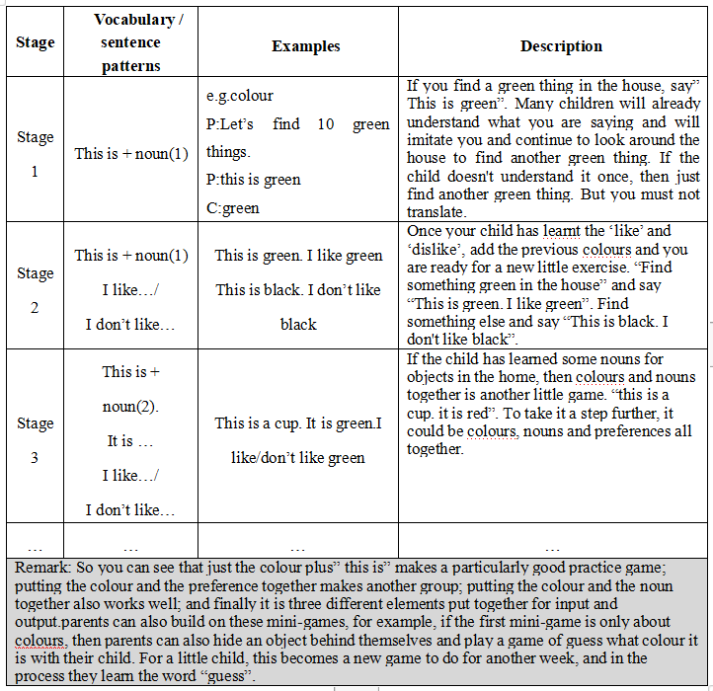
(2) Sentence extension -- Go out and have fun
It's an extension of the vocabulary strand and there are more opportunities to practise with your child every time you go out of the house, to the supermarket, to the market, to the park, to the playground, and it's always done in real-life situations, which is a very good natural and authentic environment for children to acquire language, which is very beneficial for their bilingual development(Krahnke, K. J., Krashen, S. D., & Terrell, T. D, 1985).

(3)role play——Hero experience journey
When the child has mastered enough vocabulary and sentence patterns, parents can play role-playing (Rahmatillah, K., 2019) games with the child to surpport the child to be the hero whoever she or he want in the imaginary world.

In fact, games can be played regardless of time and place. However, a short and frequent format is most in line with the rules of language learning. These small games, 10 or 20 minutes are enough, 3 times a week is good, 5 times a week is great. Talking, interacting and giving feedback to children from time to time is beneficial to their language growth.It is worth mentioning that regardless of your child's language level (Colin Baker,2014,p.39), a gentle heart with your child is what is most important. You are not the teacher, you are the mum and dad who can make your child willing to learn and use both languages, but it is important to remember that only one language can be used in the same game and try not to mix the two languages.

- Create a learning community with children - be a companion and supporter on your child's learning journey

If a monolingual parent is trying to raise a bilingual child, then this is an opportunity to learn together with the child and create a learning community between parent and child(García, O., Zakharia, Z. & Otcu-Grillman, B., 2013,p.52). A big reason why many monolingual families try to raise bilingual children but are unsuccessful is that there is no one to communicate with them, based on the fact that an important function of language is its communicative function and that if there is only a one-way flow of language and no two-way flow, the language function will deteriorate. As an example, just like even adults, if they live alone for a long time in an environment where they rarely have the opportunity to communicate with others, even their ability to express themselves in their mother tongue will deteriorate to some extent. So if monolingual parents want to raise bilingual children, they may want to learn and progress together with their children, enjoying the joy of growing up together and opening up another channel of communication with their children.

Parents may consider enrolling their child in a language course, hiring a language teacher or looking for online learning resources, but it is important to note that neither the course nor the teacher can replace the role of the parents in the learning process, they are only the transmitters of knowledge and are only responsible for the transfer of knowledge (Colin Baker,2014,p.154). More importantly, it is the parents' presence and communication that are needed to achieve better results. Parents' companionship, love and communication are the equivalent of creating a soil in which the seeds of language development can take root.

So although parents cannot give their children a good bilingual environment, they can raise bilingual children if they are willing to work hard and in the right way, learning and improving together with their children. On the other hand, one of the advantages of having monolingual parents is that they have a higher level of empathy than bilingual families. Although the strategies and strengths of language learning are different for adults and children, it is undeniable that they both have difficulties in learning and it is not the case that only one parent has difficulties and the other does not, so parents will not blame their children for having difficulties in language development or for not meeting their own requirements. Instead, they will be more patient and supportive, giving the child more understanding and making the child feel encouraged and cared for(García, O., Zakharia, Z. & Otcu-Grillman, B., 2013,p.105,p.154). In addition, as parents and children are not likely to have the same difficulties, they can, to a certain extent, learn from each other and complement each other's strengths and weaknesses.

However, due to the pressures of life or the fact that parents really don't have a talent for learning languages, not every parent may have the time and ability to work with their child, so it is important that we switch to being a supporter and support our child's language development in other ways that we can(García, O., Zakharia, Z. & Otcu-Grillman, B., 2013,p.373). For example, in addition to finding a variety of learning resources for your child, we can also use our community or peers to create a specific bilingual environment for your child. This simply means that if there are children of the same age, you can create as many opportunities as possible for them to play together and for other bilingual children to influence your child's language development (Colin Baker,2014,p.28;García, O., Zakharia, Z. & Otcu-Grillman, B., 2013,p.52,p.196
). Parents can even make use of current information technology to enable their child to connect with other bilinguals, and setting up a virtual language learning community online can be very effective(Colin Baker,2014,p.69).

- Feedback and motivation, love and respect

Children need to be recognised and are particularly sensitive to the reactions of their parents, so it is important that parents give them feedback. The purpose of feedback should first and foremost be motivational(D'Cruz, H. and Stagnitti, K., 2009,p.216), children should be recognised for their efforts, every little improvement should be seen, parents should try to find the bright spots in their child, pay attention to what the child says, respond to the child in a child-centred way, give sincere compliments and the child will shine in the feedback.

In the process of language acquisition, children will inevitably make mistakes. This is a time when parents should show the utmost understanding and tolerance. Excessive blame and anxiety at this time can greatly inhibit the child's desire to learn(Eysenck, M. & Calvo, M., 1992,p.409). As children are very concerned about their parents' attitudes, they may choose not to move forward in learning in order to avoid making them anxious and fearing negative feedback from them, as this seems a safe way of not moving forward and not making mistakes.Therefore, during the younger years of a child's language development, it is more important for parents to focus on the child's emotional needs, provide adequate emotional support and give love and respect to the child（D'Cruz, H. and Stagnitti, K., 2009.p.216 ）. This will create a sense of emotional security for the child. This will stimulate their spirit of adventure to explore new languages.

How to give children a sense of security? The easiest way is tolisten, and to give positive feedback in a timely manner(Duncan, L., Coatsworth, J. and Greenberg, M., 2009,p.255). It is important to note that positive feedback is not about giving your child credit for mistakes after they have made , but about telling your child in a positive way that he or she should not be afraid to make mistakes, that he or she will not be blamed for them, and that he or she will be able to correct them. In building a sense of security, parents must also place their trust in their children.Of course, it is fine to correct mistakes appropriately, but not to bring up every single one.
Table 2:A simple example of how to guide children
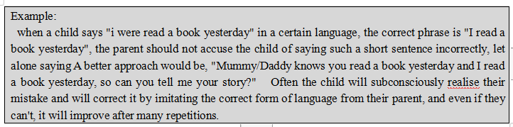
Parents should always remember that being recognised in their child's use of language is what they need most. All parents can do is to give plenty of encouragement, love and respect, and not set expectations in advance, but let the child develop naturally and enjoy the process.

Overall, there are many factors that influence the raising of a bilingual child, and both monolingual and bilingual parents have the opportunity to raise bilingual children with the right approach. A child's language development is based on love, respect and timely feedback, and putting yourself down to explore the world with your child in the same language is a valuable gift that parents can give their children. Language development is a long process and parenting requires an energy, a confidence, an affection, a creativity and, above all, patience. Parents are the soil and children are the seeds. If the seeds do not flower and bear fruit, perhaps the soil is bad and parents cannot put all the blame on their children. Don't have unrealistic hopes, and don't force the child.

References
Baker, C., n.d.A Parents' and Teachers' Guide to Bilingualism, 4th Edition. 2014. Beaverton: Ringgold Inc.

Cohen, L., 2017. You xi li. Tai bei shi: Yuan liu.

Kim, M., Woodhouse, S. and Dai, C., 2018. Learning to provide children with a secure base and a safe haven: The Circle of Security-Parenting (COS-P) group intervention. Journal of Clinical Psychology, 74(8), pp.1319-1332.

Hickey, T., Lewis, G. and Baker, C., 2013. How deep is your immersion? Policy and practice in Welsh-medium preschools with children from different language backgrounds. International Journal of Bilingual Education and Bilingualism, 17(2), pp.215-234.

Hromek, R. and Roffey, S., 2009. Promoting Social and Emotional Learning With Games. Simulation & Gaming, 40(5), pp.626-644.

Canning, N., 2007. Children's empowerment in play. European Early Childhood Education Research Journal, 15(2), pp.227-236.

Howard, J. and McInnes, K., 2012. The impact of children's perception of an activity as play rather than not play on emotional well-being. Child: Care, Health and Development, 39(5), pp.737-742.

Ihmeideh, F., 2017. Getting parents involved in children’s play: Qatari parents’ perceptions of and engagement with their children’s play. Education 3-13, 47(1), pp.47-63.

Krahnke, K. J., Krashen, S. D., & Terrell, T. D. (1985). The natural approach: Language acquisition in the classroom. TESOL Quarterly, 19(3), 591. doi:10.2307/3586280

Rahmatillah, K., 2019. Communicative Language Teaching (CLT) through Role Play and Task-Based Instruction. Script Journal: Journal of Linguistic and English Teaching, 4(2), p.161.

García, O., Zakharia, Z. and Otcu-Grillman, B., 2013. Bilingual community education and multilingualism. Bristol: Multilingual Matters.

D'Cruz, H. and Stagnitti, K., 2009. When parents love and don't love their children: some children's stories. Child & Family Social Work, 15(2), pp.216-225.

Eysenck, M. and Calvo, M., 1992. Anxiety and Performance: The Processing Efficiency Theory. Cognition & Emotion, 6(6), pp.409-434.

Duncan, L., Coatsworth, J. and Greenberg, M., 2009. A Model of Mindful Parenting: Implications for Parent–Child Relationships and Prevention Research. Clinical Child and Family Psychology Review, 12(3), pp.255-270.

Sandu, G., 2013. Games and Logic. Baltic International Yearbook of Cognition, Logic and Communication, 8(1).

