

Postgraduate/Distance Learning
Assignment coversheet & feedback form

THIS SHEET MUST BE THE FIRST PAGE OF THE ASSIGNMENT YOU ARE SUBMITTING (DO NOT SEND AS A SEPARATE FILE)

For completion by the student:
Student Name: Kimberly Corrall
Module code: HPCA7016  Module title: Researching Contemporary Cosmologies | Student ID number:  2024486 |  |  | Educational support needs: No
Module tutor: Jack Hunter

Assignment due date: 16 May 2022
If your module has multiple submissions please indicate which piece of work this is.

☐1st ☒ 2nd 3rd 4th 5th 6th
I confirm that this is my original work and that I have adhered to the University policy on plagiarism.
Signed (type your name in)……Kimberly Corrall……………………………………………
Email submission: if you are submitting this form via email, please tick this box ☒
(as a substitute for your signature) to confirm that you agree to the above declaration.
Assignment Mark

Final Mark
WILL BE GIVEN ON TURNITIN

NB. All marks are provisional until confirmed by the Final Examination Board.

PLEASE NOTE: ALL COMMENTS WILL BE POSTED ON TURNITIN

For completion by Marker 1 :
Comments:
Marker’s signature: |  |  | Date:
For completion by Marker 2/Moderator:

Comments:

Marker’s Signature: |  | Date:
AGREED INTERNAL MARK (where necessary):

Comment on process of arriving at agreed mark:

External Examiner’s comments (if relevant)

External Examiner’s Signature: |  | Date:

Extraordinary Experiences On The Trail
word count 5240

Introduction
The purpose of this research project was to explore a specific nature interaction – regular hiking and backpacking - to answer the question: Is there a correlation between interaction with nature through hiking/backpacking and the occurrence of extraordinary experiences? For the purposes of this study, extraordinary experiences included intelligence in nature, plant/animal communications, feelings of oneness with nature, encounters with supernatural beings and paranormal experiences.
In Jack Hunter’s study of permaculture, he expressed ‘an interesting correlation between interacting with the natural world (whether through observations of ecosystems, or the practical tending of gardens) and extraordinary experience (feelings of connectedness to nature, communication with plants and animals, and so on).’ In another study, Kathryn Williams and David Harvey found correlations between transcendent experience and forest environments, mostly in short or one-time exposures. This project used Hunter’s and Williams and Harvey’s findings as a basis to explore the types of extraordinary experiences that occur during medium-term exposure to nature through hiking and backpacking.
The research was conducted through surveys, responded to by 56 members of two online women’s hiking groups, and then through in-depth interviews with 4 of those respondents. Overall, the most common experience was a feeling of oneness with nature, but within the study group there were examples of all the types of extraordinary experiences listed above.

Literature Review/Academic Rationale
In his discussion of mystical experience, Hunter noted that W.T. Stace (1886-1967) named ‘nature mysticism as one of the main forms of mystical experiences’ and that these ‘extrovertive experiences’ are often ‘triggered by, and “transfigure,” the external physical landscape and environment, frequently inducing a sense of the underlying unity of the natural world.’ Williams and Harvey, in their 2001 study of forest experiences, confirmed that interaction with nature can prompt extraordinary or transcendent experience. They described the transcendent experience as ‘a moment of extreme happiness; a sense of harmony with the whole world; moments which are totally absorbing and which feel important’. Through surveys, Williams and Harvey instructed participants to relax and then describe a forest experience. They categorized the responses according to four characteristics: fascination, novelty, compatibility, and transcendence. Of the descriptions that had a high level of transcendence, two contrasting patterns stood out. Experiences with high fascination, high novelty and high transcendence were often associated with unusual or beautiful aspects of the landscape, while experiences with high compatibility and high transcendence correlated to feelings of effortless attention, relaxation, and feelings of belonging. As a result of their findings, Williams and Harvey concluded that there were ‘close relationships between transcendence and both aesthetic and restorative functions of nature’ and that the experiences were tied to the physical environment itself and not purely a function of either physical activity or relaxation.
While the Williams and Harvey study mostly dealt with one-time or short-term experiences in nature, there is also evidence that long-term, regular interaction can create extraordinary experience and connection. In their study of deep agroecology, Maria Botelho and her colleagues reviewed the experiences of coffee farmers in Brazil, as described through interviews over an extended period. They found farmers had developed a closer connection to the land after adopting agroforestry practices involving more detailed observation of and interaction with the land. In some cases the farmers could not describe how they had decided to reintroduce forgotten, older practices. One farmer said he was able to ‘spiritually reconnect with nature’ and ‘see new possibilities that the plants and animals and the natural environment teach him to explore,’ implying a perceived intelligence in the plants and animals he connected with. This type of expression also arose in Jack Hunter’s more recent study of extraordinary experience in permaculture (‘a design process for the regeneration of natural systems’ that relies heavily on observation and interaction). During his work in permaculture, Hunter had noticed ‘subtle hints of what we might call “non-ordinary communication” with plants, animals and other features of the natural environment’. In his study he surveyed the permaculture community online, asking about the participants’ experiences with the supernatural, intelligence in nature, plant/animal communication, the paranormal or other extraordinary interactions. The participants reinforced the idea of intelligence in nature, with many of them describing a sense of intuition or communication with nature, although they did not always perceive this as extraordinary.
This understanding of nature as inherently intelligent is an important element of many indigenous worldviews. Robin Wall Kimmerer expressed this in her recounting of her early challenges as an indigenous student of Western Biology. Drawn to study Biology to uncover the deeper questions of why nature operated as it did and how everything was connected, she found this line of enquiry firmly shut down by her teachers as being unscientific. As Kimmerer described her early quest, ‘It was an architecture of relationships, of connections that I yearned to understand. I wanted to know why we love the world, why the most ordinary scrap of meadow can rock us back on our heels in awe.’ It appears from the above studies on agroecology and permaculture that this perception of nature intelligence or sentience evolves organically from long-term, direct interaction with nature.
Situated between the short-term, transcendental forest experiences and the long-term farming relationships are the medium-term interactions with nature through regular hiking and backpacking. Thus arose the question of whether this type of activity was also correlated to extraordinary experiences and, if so, how these experiences affected the hikers. According to Hunter, ‘it is a commonly reported consequence of several different types of extraordinary experience that the experiencer comes away from their encounter with an enhanced sense of connection to the environment and the world around them’, which has been shown by the effects of nature-interactive farming methods on their practitioners. I wanted to explore if this phenomenon also applied to those who spend frequent periods out in nature, interspersed with periods of everyday life and work.

Methodology
This study used a mixed method approach of survey, followed by interviews of select respondents. Judith Bell noted that this approach is useful as questionnaire responses can be reviewed to determine ‘the types of issues it may be worth following up on in interviews.’ Hennink, Hutter and Bailey stated that ‘qualitative methods are… particularly useful for examining sensitive topics, as the process of rapport building provides a comfortable atmosphere for participant disclosure.’ As the topic of extraordinary experience involves personal beliefs, the methodology of including open-ended survey questions and following up with several in-depth interviews was chosen to capture the fullness of participant experiences. To narrow the pool of participants to regular hikers, two Facebook groups were identified for distribution: ‘Solo Female Hikers And Adventurers’ and ‘Women over 40 Who Hike’. The interview participants were chosen from among the survey respondents. As both groups have strict posting rules, the moderators were contacted to request permission to post the study well before it commenced.
For the survey, questions from Hunter’s permaculture study and the major themes of Williams and Harvey’s forest experience study were referenced. The opening section covered basic hiking habits, frequency, and duration, as well as the age range of participants. The second section focused on extraordinary experiences on the trail and consisted of yes/no/maybe responses to questions about intelligence in nature, plant/animal communication, extraordinary beings, paranormal experiences, and experiences of ‘transcendence’ or ‘oneness’. These yes/no/maybe questions were followed by a prompt to describe the experience in as much detail as possible. At the end of the survey, participants were offered the opportunity to participate in a Zoom interview. Once the questionnaire was created in Google Forms, a link was shared on the two Facebook groups’ pages. A word version of the survey is attached in Appendix A. As both groups number members over 10,000, responses were monitored closely to keep the amount of data within the scope of the study. In accordance with Bell’s suggestion of using the questionnaire to find useful interview topics, the survey was left open until there was a sufficient number of participants with diverse experiences who had agreed to be interviewed, resulting in a total of 56 respondents.
For the second phase of the study, four interviews were conducted. Hennink, Hutter and Bailey pointed out that, as the goal of qualitative research is a depth of understanding rather than a statistical sampling, few participants are needed when working with in-depth interviews. The interviews were about an hour each in length and the participants held a wide range of personal beliefs and had had varied experiences on the trail, thus providing rich data for study. The interviews were semi-structured: specific questions were asked based on the survey responses and the interview developed based on additional information that was shared. A sample copy of a prepared interview guide is included in Appendix B. Hennink, Hutter and Bailey described an overall arc of an interview as establishing rapport, going deeper and then returning to less emotional ground to close. Following this, the interviews began with questions about hiking habits and favorite hikes, moved into in-depth discussions of specific experiences and closed with questions about upcoming trips. Each interview was recorded and then transcribed verbatim, including non-verbal fillers to capture the tone of the interviewee, as suggested by Hennink, Hutter and Bailey.
Once all data had been collected, it was analyzed to look for the themes from the initial literature review, as well as new themes which arose organically from the data. As recommended by Bell, long-form questions and interview transcripts were ‘coded’ to provide ‘clusters’ of ‘key issues in (the) data and take steps towards “drawing conclusions”.’ A list of codes was created to describe these issues and excerpts from the surveys/interviews were color-coded to identify them. These excerpts were then examined and compared to draw meaning from the findings, examine the limitations of the study and reflect on potential topics for further research.

Reflexivity and Ethical Considerations
In this study, I am both insider and outsider. I have been hiking most of my adult life, am a member of both Facebook groups surveyed and consider myself a hiking insider. While I have regularly car camped, I have rarely overnighted on the trail and until recently, did most of my hiking with others. All my interviewees hike primarily solo, which gives them unique insights to solo experiences and positions me as an outsider. I have experienced oneness with nature on the trail and have perceived intelligence in plants and animals. I do not belong to an established church and mostly find my spiritual connection in nature. Though I have not had paranormal experiences on the trail, I know people who have and believe that they happen.
This research project was guided by University ethics guidelines and my project supervisor. Consent was obtained for all questionnaires and interviews. Interview participants also consented to interviews being recorded and were informed of the method and timeframe of data storage. As this study covered sensitive topics of belief and personal experience, I came into each interview with an open, listening mind to capture the experiences as purely as possible and ensure that each participant left feeling heard and respected.

Findings and Discussion

Quantitative Survey Results
Due to Facebook tending to older users and one of the two survey groups being made up of women over 40, over 85% of the 56 respondents were over 40. I had hoped to look at variations in responses between older and younger participants, but the lack of data on women under 40 precluded that. The intention to reach regular hikers, however, was successfully achieved: only 18% of the women hiked fewer than 7 times a year, 34% hiked every week and several women mentioned on the survey post that I should add an option for ‘every day’. Additionally, only 7% of respondents had been hiking for less than a year, while 48% had been hiking for more than 10. About half of the respondents overnight on the trail sometimes and about 84% hike solo. By far the most common extraordinary experience was that of ‘transcendence’ or ‘oneness with nature’, reported by almost 75% of respondents (Fig. 1).
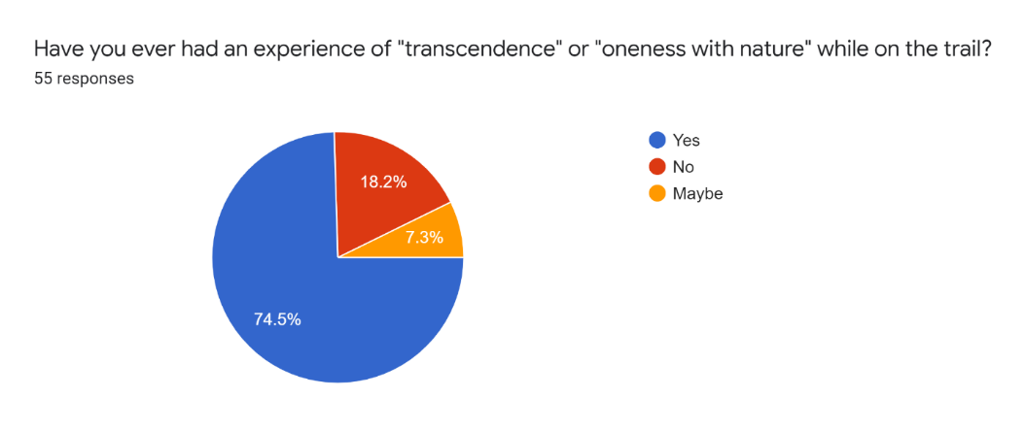
Fig. 1. Results: transcendence. 15 April 2022. Pie Chart: Kim Corrall via Google Forms
Experiences of intelligence in nature and plant/animal communication followed at 44% each, with encounters with extraordinary beings and paranormal experiences at 25% and 18% respectively. About 62% of extraordinary experiences occurred while the hiker was solo, which prompted some respondents to hike solo more often. More than half of the women indicated that their experiences had changed their feeling of connection to nature (Fig. 2). For the complete set of pie charts, see Appendix C.
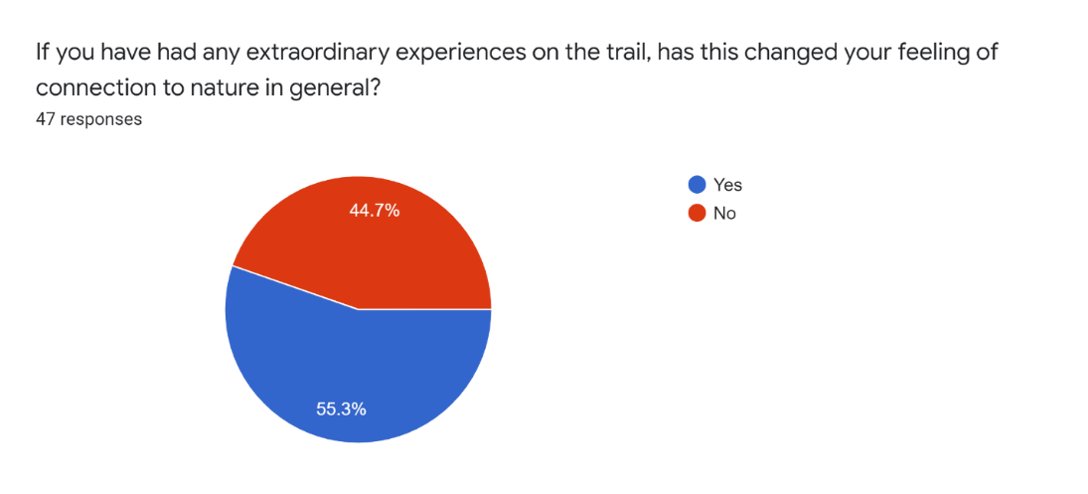
Fig. 2. Results: connection to nature. 15 April 2022. Pie Chart: Kim Corrall via Google Forms

Main Themes That Emerged From The Qualitative Data

Connection With Nature, Presence And Interconnectedness
The most common theme to emerge from the data was a feeling of connection with nature, which took on several different forms. For some it was simply a calming presence and a sense of peace, similar to the ‘high compatibility, high transcendence’ experiences described by Williams and Harvey. As one respondent wrote,
I am a different person out in nature. My mind feels peaceful and my thoughts are slow enough for me to understand them. It’s as if I can feel each plant, tree, rock, and all the dirt comforting me.
In contrast to the Williams and Harvey study, this sense of peace or calm was often tied not just to the physical landscape, but to a feeling of there being a palpable presence or energy. One woman, in response to the question on nature spirits or spirits of place, said,
There are just some places that give one a sense of peace that is more than just what you have in nature. Like a very calming influence.
Another respondent explained it by writing,
Many times I have been flooded with calming feelings when in certain settings in nature. It is as if the place exudes a certain energy and craves oneness.
This thread of nature having a presence ran through many of the questionnaire and interview responses. Beyond experiencing a sense of peace, some participants described it as a recognition of the interconnectedness of nature that they are also part of. As one interviewee described it,
I feel like being in those spaces makes me a more authentic version of myself, because my body and my brain and my everything is made up of cells, too, so when those, the nature cells and the nature symphony I guess is what I would call it, when I enter into the nature symphony, then the energy and the flow and the life vitality of that place reaches out to me and then all of my body that is living responds to it and we start to have that connection and that bond.
For one respondent this experience was ecstatic:
When I am alone in the forest, where all I can hear is silence roaring inside my head, and all I smell is the strong scent of pine, I feel like I am completely at peace. I have never done drugs, but I feel like this must be what being high feels like… I feel euphoric and relaxed at the same time. I feel a connection with everything around me as if I am part of the ecosystem.
For another, a wildlife biologist, it is scientific:
Yes, once again it’s called awe. Everything is connected because we all share the same molecules. Once I die my cells will be turned into other cells. I am hoping for something badass like a bird. I’ll probably be incorporated into a dung beetle knowing my luck.
All of these varied experiences, even the awe expressed by the biologist, share the hallmarks of mystical experience which, as Hunter noted, ‘give rise to a renewed vision of the Earth and an enhanced sense of connection to the natural world, both physically and spiritually.’ In keeping with this, several of the participants found nature to be a conduit to God and spiritual beings, while others who did not identify with established religion expressed that nature was their church.
As noted above, about 75% of all survey respondents affirmed having experienced ‘transcendence’ or ‘oneness with nature’ while on the trail. As this was the most common experience, there were many descriptions of it in the data, but the above quotes are representative of the three main manifestations of this phenomenon: a sense of peace and calm, a sense of a nature presence or energy and an experience of the interconnectedness of all things. For many of the participants, being in nature was described as a spiritual experience, regardless of their religious beliefs.

Feeling Supported By Nature Or Having It Carry Burdens
Out of this theme of connectedness with nature arose an offshoot that I had not encountered in previous studies, that of nature carrying the burden for participants through difficult life experiences or emotions. This thread first emerged in the survey responses in comments such as, ‘the trees take the weight of my sadness’. One respondent described how:
Hiking in tears during my mother’s hospice care. Looked up to see small owl face to face, staring at me, in daylight [place name]! Uncommon! I felt overwhelming flow or thought, ‘I am here, Mom’.
This theme was an integral part of two of the in-depth interviews. One interviewee described how she was training for a marathon on forest trails during a very difficult period and the trails offered a way to process her grief and worry, often with the help of angels that inhabited certain natural spaces. As she described it,
There were several spaces along the trail where the beauty that you could see with the eyes and the presence you could feel, that I could feel with my heart, would resonate with the…difficulty I was having and would do that process that I described, where it would bring it to the surface and then it would help me to break it down and then it would help to process it out and through, which really is, what else can you ask for? I’m so grateful that it existed. … There were some places where it was so consistent and so persistent that I came to depend on it … and I would just take myself to those places and just sort of offer it up to the Lord through the space because it was the most effective way to deal with it.
Another interviewee described her experience with a life-threatening illness and later medical errors that left her unable to walk or perform basic functions. Having spent most of her life outdoors and on the verge of suicide, she had her family take her to the woods, where she had an extraordinary experience:
It didn’t matter what I was, it didn’t matter how broken I was. … The forest was not afraid of me. It wasn’t afraid I was gonna die. It wasn’t depending on me to live in a life I didn’t wanna live then, you know? And I could just lay there and listen to a woodpecker, and this was for me. This was for me. I don’t mean like I was doing this for me, I’m saying THIS was doing this FOR ME and I felt, I didn’t have to be anything else. I was everything I needed to be. That was it. And I could just sit there and if this is all I ever became, that was ok. And that was the first time that I felt like this was gonna be okay. … No expectation. Nothing. It just accepted me, just the way I was… And I, I know it sounds crazy, but…I don’t even believe in God. I don’t know why I’m saying this… I felt like it was on purpose, like there was a…force, I don’t even know. I don’t know, it makes me embarrassed to say it, I don’t know, but it was for me. I know it was. Nothing will ever convince me otherwise. It was for me. It was doing it for me. It was taking care of me and holding me…
She continued to go to the forest, eventually was able to begin physical therapy, and has recovered enough to able to work outdoors again in a physical job that she loves. As she stated in her survey response, ‘the forest saved’ her.
These experiences are reflected in Kimmerer’s tale of her neighbor, who declared,
There ain’t hardly no hurt the woods don’t have medicine for. That witch hazel…it’s not just good for you outside, but inside too. Land sakes, flowers in November. The good Lord gave us witch hazel to remind us that there’s always somethin’ good even when it seems like there ain’t. It just lightens your heavy heart is what it does.
Although this theme is related to the mystical experiences described in the previous section and in Williams and Harvey’s study, it is unique in the emphasis on nature helping to heal emotional wounds and carry one through difficult life experiences. This type of experience goes beyond mystical or physical interconnectedness and allows nature to become an ally through life’s most difficult moments.

Plant And Animal Intelligence
The second most common experience that emerged was encounters with plant or animal intelligence. Many participants described observing intelligent behaviors in animals or being followed by animals, such as one who related how a butterfly had followed her husband back to their car and then landed on his fingers. One interviewee played a video of a bird that had accompanied her on the trail for quite a long time, despite showing no signs of foraging for food or defending a nest. In another case, an animal encounter was described as protective:
During one hike in a local area, I was walking alone on the trail when I came upon a pair of does. We were on opposite sides of the trail, but they didn’t seem bothered. As I slowly walked past, there was a loud commotion ahead around a curve in the trail. Rather than dart away, the does moved off the trail toward a smaller semi-hidden trial…and the larger of the two turned and looked back at me, as if asking me to follow. … I walked about 10 steps in, following them, just as a group of several young and clearly inebriated young men came down the larger trail I had just left. … That moment of hesitation and her questioning look likely saved me from a very unpleasant encounter.
Sometimes, participants were struck by the intelligence of creatures, such as crows who drop walnuts in front of cars, timing them so the cars will run over them and crack the shells. The interviewee then encountered this same behavior at another location:
…so, like more in the wild, but still trails do go near the roads where there’s pretty frequent traffic and I saw it there as well. So, I’m scratching my head, like, is this the same group of crows? I mean, they’re very social creatures and they absolutely think things through and so it was just interesting to see that they had figured out a tool, so to speak, to get what they wanted.
Another participant, who is a birder, marveled at how:
…birds are really, really attuned in terms of their ability to navigate, for example when they migrate. Umm, science does not even completely understand how they find their way. Just their ability to survive in environments where humans necessarily couldn’t.
Although descriptions of plant encounters appeared less frequently in the data, they were often described as intelligent, for example ‘in the way flowers bend towards the sun’ or the ‘branching pattern of trees’ or ‘the complexity in a blade of grass’.
As with the permaculturists in Hunter’s study, many of my study participants experienced plant and animal intelligence and communication and none of them found this particularly extraordinary. It was accepted that plants and animals have their own intelligence and are willing to interact and/or communicate when they do not detect a threat from a human.

Paranormal Encounters
About 18% of respondents indicated that they had had paranormal experiences on the trail. Sometimes these occurred at night, as in one case where the interviewee was awakened by ‘sonic booms’ and rock fall that she attributed to military exercises until she arose in the morning to find that none of her companions had heard anything and there was no rock fall in the area. In another nighttime encounter, an interviewee experienced a mist in the forest that she couldn’t explain away with her usual scientific rationale.
Daytime paranormal experiences ranged widely: a backpack being tugged multiple times in a place where there was no growth on the trail to snag it; seeing ghosts in the proximity of a ‘hanging tree’; buttocks being grabbed when hiking through an old cemetery and feeling the presence of a nature spirit.
Sometimes, the extraordinary experience was an instinctive knowing, as when an interviewee received guidance when she was out on an unfamiliar path near dusk and unsure how to get back:
…but then at a crossroads, a Y, it’s really getting on towards dark and, you know, which way do I go? Flip of a coin as to one’s gonna lead me nowhere, one’s gonna lead me to where I think I wanna go, right? Cuz it looked like they’re both going in the right direction and that’s when, I don’t even, I can’t say it’s a voice just like this, but my intuition said, you should go this way. And I took that one and like literally within, you know, 5 minutes, I was at the road…and then I later went and looked at maps and, if I’d gone the opposite direction at the Y, I would’ve been going for a couple of miles before it just dead-ended.
While these experiences were only reported by 18% of participants, many of them have elements of what Hunter termed ‘high strangeness’, which is ‘often employed in paranormal research to refer to experiences, events and phenomena that are so bizarre that they evade easy classification and explanation.’ Hunter argued that these experiences often get discounted as academically unacceptable. As one participant recounted, ‘I have had multiple experiences that were not drug induced. I don’t share these experiences because I don’t want to get locked up in a hospital.’ It is unfortunate that this respondent did not offer to be interviewed, because as Hunter pointed out, ‘it is precisely the most unusual…accounts of paranormal experiences that we should be investigating, because they raise the most questions and challenge our established worldviews most strongly.’

Limitations/Reflections
The study consisted of female participants, mostly over 40. Future studies could benefit from soliciting responses from a wider distribution of gender and age. The question on intelligence in nature drew responses that indicated it had been interpreted differently than I intended. Other questions, such as the one on flow, needed an open-ended prompt to gather useful data. One survey respondent expressed a strong response to my questions, classifying them as ‘woo-woo’. As none of these issues emerged from the pilot, it would be useful to widen future pilots to draw participants from a more diverse pool. One theme that appeared tangentially during interviews was that of caring for nature: the connection between extraordinary experiences in nature and positive environmental behaviors could be further explored in a future study.

Conclusion
This research project posed the question: Is there a correlation between interaction with nature through hiking/backpacking and the occurrence of extraordinary experiences? Using Hunter’s and Williams and Harvey’s findings as a starting point, the types of extraordinary experiences that occur during medium-term exposure to nature through regular hiking or backpacking were explored in surveys and in-depth interviews of female hikers.
While all the types of experiences queried in the survey were reported by participants, the most common was that of ‘oneness with nature’. Three manifestations of this experience emerged: a sense of peace and calm, a sense of a nature presence or energy and an experience of the interconnectedness of all things. While transcendent experiences had been reported in previous studies cited, the sense of a palpable nature presence had not. For many of the participants, being in nature was described as a spiritual experience, regardless of their individual spiritual beliefs.
Beyond the connection to nature described above, there was an additional phenomenon of nature assisting in emotional healing that was also not present in previous studies. This connection transcended mystical experience or physical interconnectedness and became an ally to participants, helping them to move through difficult life experiences and emotions.
About half of the respondents reported encountering plant or animal intelligence on the trail. In keeping with Hunter’s study, this was not perceived as extraordinary. It was accepted that plants and animals have their own intelligence and seem to be willing to interact and/or communicate with non-threatening humans.
Among the participants who had paranormal experiences, some reported physical sensations, while others had experiences of intuition or unexplained sightings. Some of these respondents did not wish to talk about their experiences for fear of censure. While these experiences were only reported by 18% of participants, many of them have elements of what Hunter termed ‘high strangeness’, which has been understudied due to academic bias.
Overall, the study found that there is a clear correlation between hiking and extraordinary experiences. While experiences of connection to nature can often be attributed to the peace and beauty of wild places, many participants reported feeling far more than simple connection. Nature was perceived as a presence, usually intelligent, and at times a source of comfort and emotional support.

References

Bell, Judith, Doing Your Research Project: A Guide For First-Time Researchers, 6th ed. (New York: McGraw Hill Education, 2014)

Botelho, Maria Izabel Vieira, Irene Maria Cardoso and Kei Otsuki, ‘”I Made A Pact With God, With Nature And With Myself”: Exploring Deep Agroecology’, Agroecology And Sustainable Food Systems, 40.2 (2016), 116-131 <DOI: 10.1080/21683565.2015.1115798>

Hennink, Monique, Inge Hutter and Ajay Bailey, Qualitative Research Methods (Los Angeles: Sage, 2020)

Hunter, Jack, ‘Greening The Paranormal: Re-Wilding And Re-Enchantment’ in Greening The Paranormal: Exploring The Ecology Of Extraordinary Experience, ed. by Jack Hunter (USA/UK: August Night Press, 2019), 1-42

Hunter, Jack, ‘Editorial: Religious Experience And Ecology’, Journal For The Study Of Religious Experience, 7:2 (2021), 3-16

Hunter, Jack, ‘Preliminary Report On Extraordinary Experiences in Permaculture: Collapsing The Natural/Supernatural Divide’, Journal of Exceptional Experiences and Psychology, 6:1 (2018), 13-22. < https://www.academia.edu/37600186/Preliminary_Report_on_Extraordinary_Experiences_in_Permaculture_Collapsing_the_Natural_Supernatural_Divide> [accessed 24 November 2021]

Kimmerer, Robin Wall, Braiding Sweetgrass (Minneapolis: Milkweed Editions, 2013)
Williams, Kathryn and David Harvey, ‘Transcendent Experience In Forest Environments’, Journal of Environmental Psychology, (2001) 249-260. DOI:10.1006/jevp.2001.0204

Appendix A – Questionnaire: Extraordinary Experience On The Trail

MA in Ecology and Spirituality, Faculty of Humanities and the Performing Arts, University of Wales Trinity Saint David, Ceredigion, Wales, SA48 7ED, UK


I hereby consent to my data being used for the purpose of this MA research project. I understand that all my information will be kept confidential and anonymous. I understand that I may choose not to answer certain questions or request that my data not be used at all, should I change my mind.
- I consent (required to continue)

Hiking Patterns and General Info

Age Range
- Twenties or below
- Thirties
- Forties
- Fifties
- Sixties
- Seventies
- Eighties or above
How long have you been hiking/backpacking?
- Less than a year
- 1-5 years
- 6-10 years
- More than 10 years
How often do you backpack?
- 1-6 times a year
- 7-12 times a year
- Several times a month
- Every week
How often do you overnight on the trail?
- Never
- About 1 in 4 hikes
- About 2 in 4 hikes
- About 3 in 4 hikes
- Always
How often do you hike/backpack solo?
- Never
- About 1 in 4 hikes
- About 2 in 4 hikes
- About 3 in 4 hikes
- Always
How often do you feel like you reach a ‘flow’ state while on the trail?
- Never
- About 1 in 4 hikes
- About 2 in 4 hikes
- About 3 in 4 hikes
- Always

Experiences on the Trail

Have you ever had an experience of what might be called ‘intelligence’ in nature while on the trail?
- Yes
- No
- Maybe
Please describe your experience in as much detail as you can.
Have you ever had an experience of connection or communication with plants/animals on the trail that went beyond everyday interactions?
- Yes
- No
- Maybe
Please describe your experience in as much detail as you can.
Have you ever had encounters or communication with what you would consider to be nature spirits, spirits of place or extraordinary beings while on the trail?
- Yes
- No
- Maybe
Please describe your experience in as much detail as you can.
Have you ever had an experience of ‘transcendence’ or ‘oneness with nature’ while on the trail?
- Yes
- No
- Maybe
Please describe your experience in as much detail as you can.

If you have had extraordinary experiences on the trail, were you solo or with others?
- Solo
- With others
- Both
If you have had extraordinary experiences on the trail, has this changed how you approach your hikes or your time in nature?
- Yes
- No
If yes, please describe how your approach has changed.
If you have had extraordinary experiences on the trail, has this changed your feeling of connection to nature in general?
- Yes
- No
If yes, please describe how your feeling of connection has changed.
Would you be willing to be contacted for an interview via Zoom (45min-1hr)?
- Yes
- No
If yes, what is your e-mail address, so I can reach out to arrange a time?

Appendix B – Example Interview Guide

Thanks so much for agreeing to be interviewed. As you’ve probably seen, I’m Kim and I’m doing this research project for my Master’s in Ecology and Spirituality at the University of Wales. So, I’ll be using the data from this study to write a paper. Just to review – all your answers are confidential and will be used anonymously. I’ll be recording this session so I can transcribe your words exactly and then deleting it once the MA is complete. Is that ok?
Great. So, let’s start by talking about your hiking. I see you’ve been hiking for a long time and go out pretty regularly. What got you started hiking?
Do you tend to hike locally, or do you also go on longer trips? Whereabouts? Is there a trip that really stood out? Why?
Do you have favorite spots to hike?
Do you encounter much wildlife? Do you tend to see the same species in your regular spots? Do you feel like you’ve gotten to learn more about them by seeing them more often? Does the regular interaction make you feel connected with them in any way?
On your overnights, do you do primitive hiking or camp at campsites?
I loved how you talked about crows dropping walnuts in front of cars. Have you seen other intelligent behaviors in animals? Do you believe they are sentient/have a purpose to their intelligence?
Do you also encounter animals where you live? Has having interactions on the trail made you more attentive to them at home?
Have you noticed intelligent behaviors with plants?
When you talk with wildlife and hug trees, do you ever feel a response on some level?
You talked about a time when you heard a voice telling you which way to go. Can you tell me more about that? What impact did that experience have on you?
You said about 75% of the time, you go into “flow”. What does that feel like for you? Is that different from the feeling of oneness you experience when alone?
Does that feeling or your other experiences on the trail carry over into your day-to-day?
Has your time on the trail made you feel more connected to nature? To the planet? To other humans?
Has your time on the trail had any longer-term impacts on you? On your mental, spiritual or physical well-being?
What is your favorite part about hiking?
Do you have any longer trips coming up? Or something you’re excited about seeing again?

Appendix C – Questionnaire Results: Pie Charts
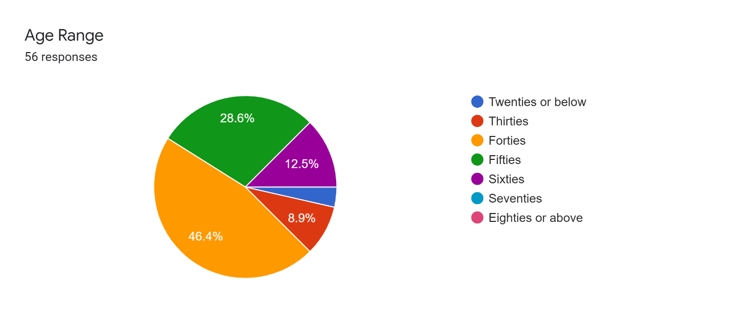
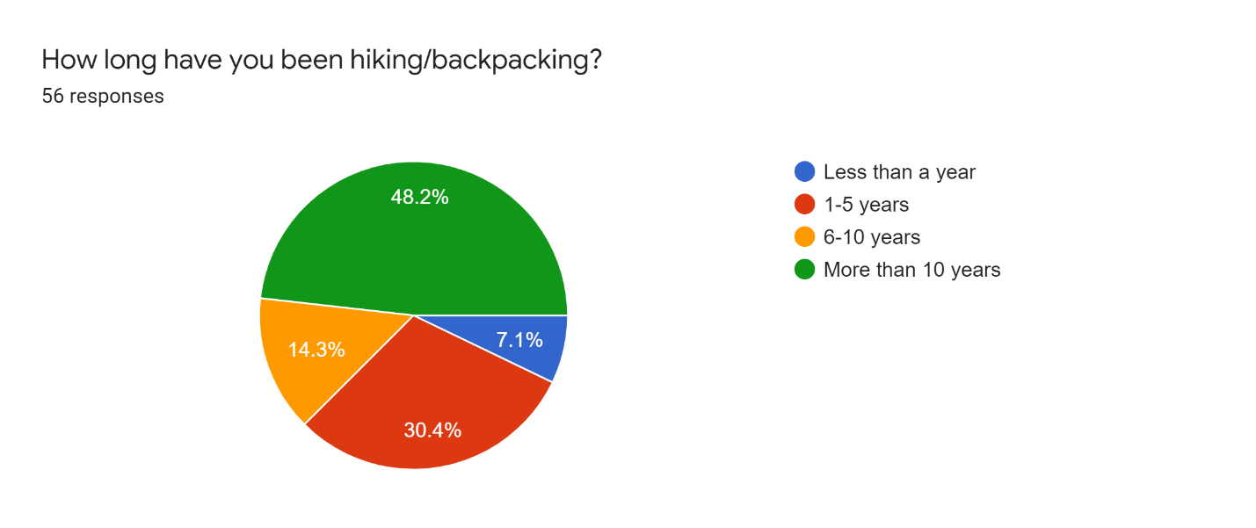
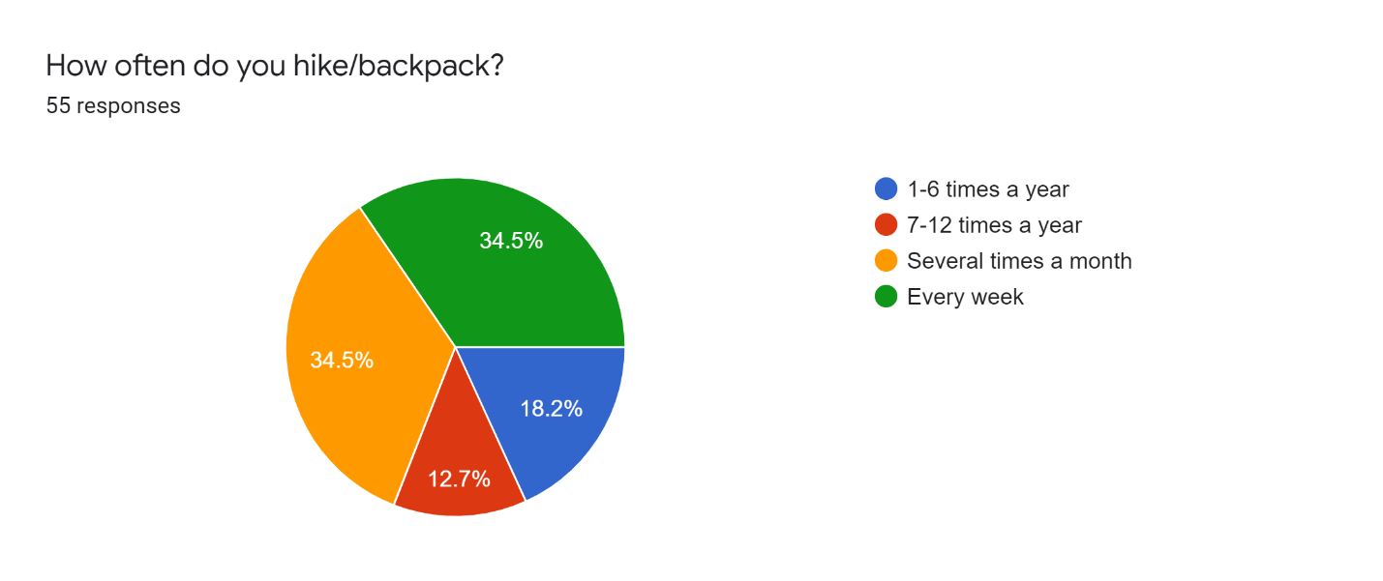
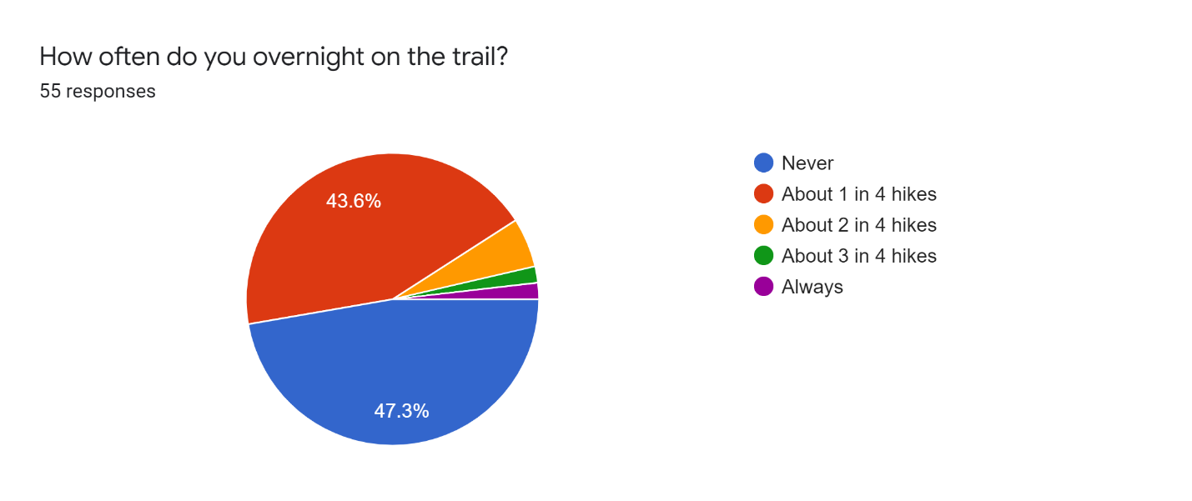
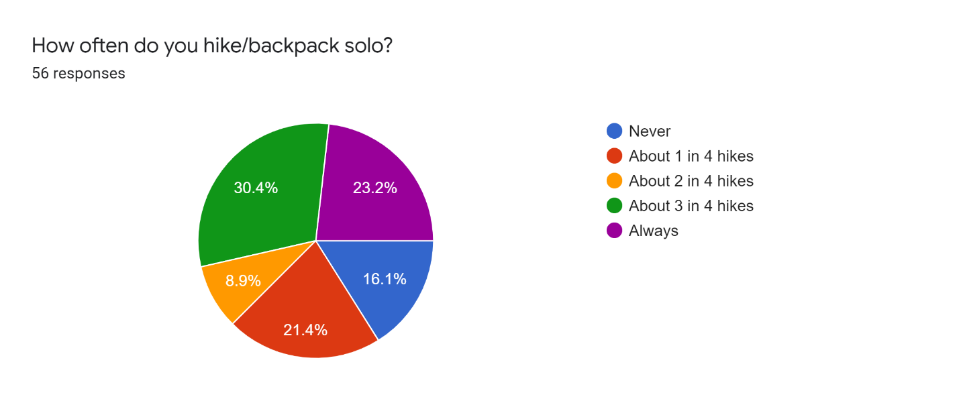
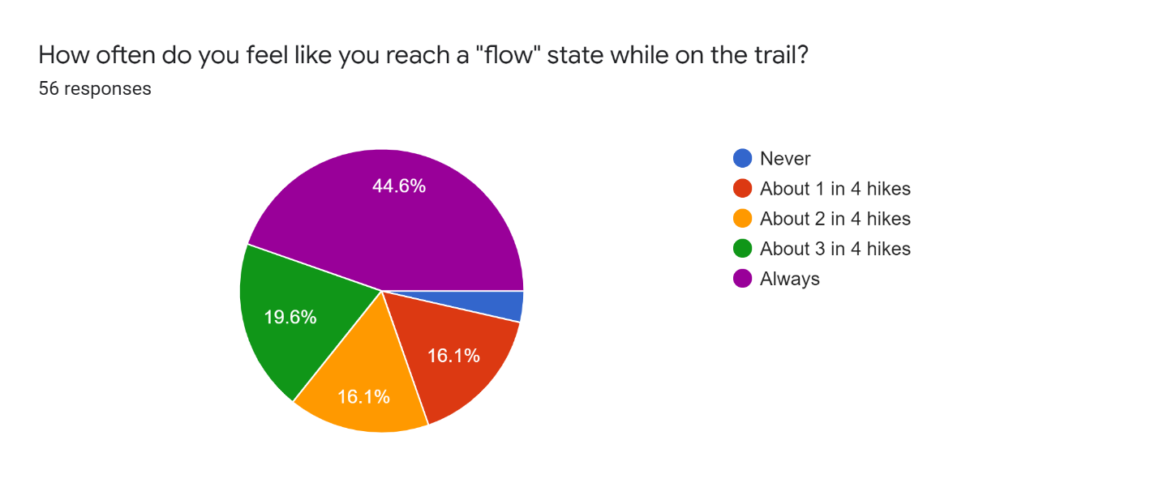
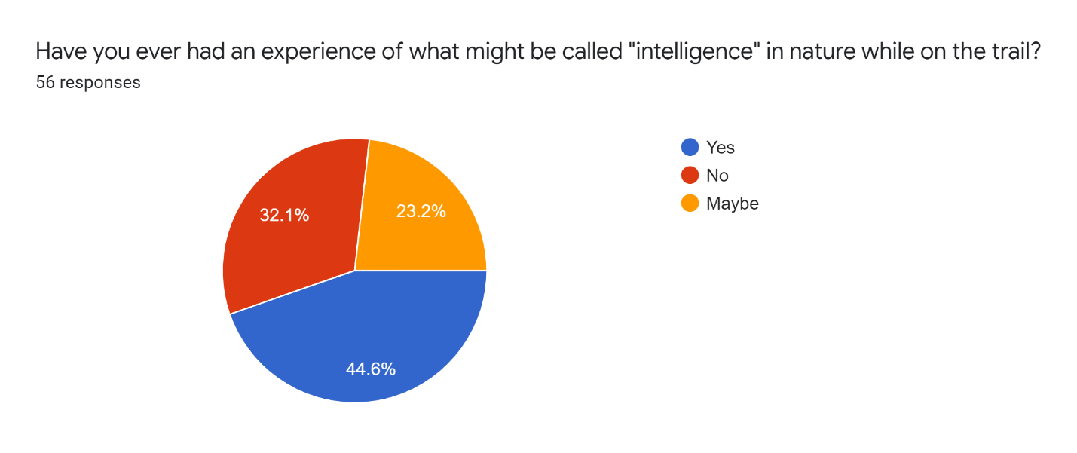
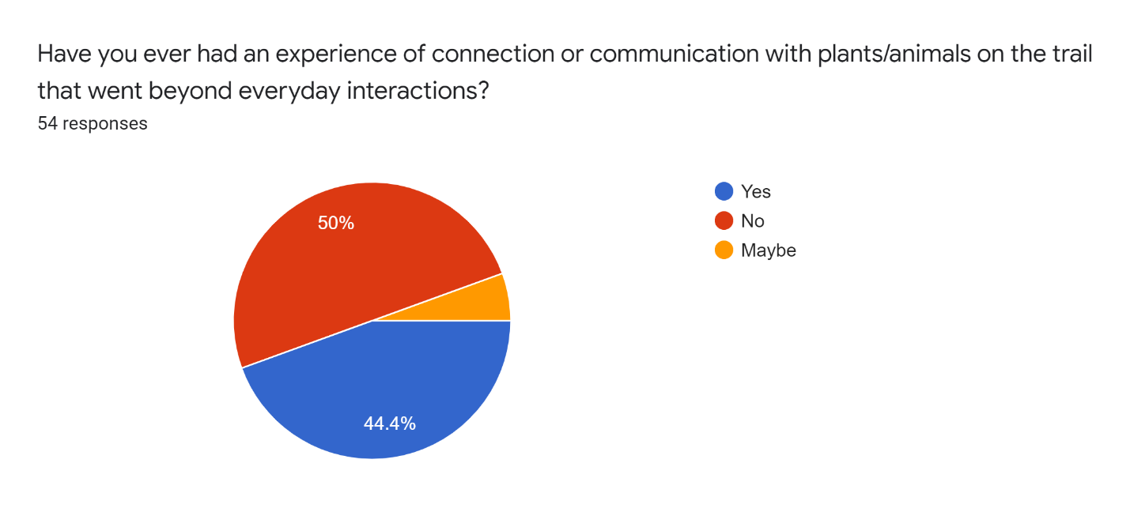
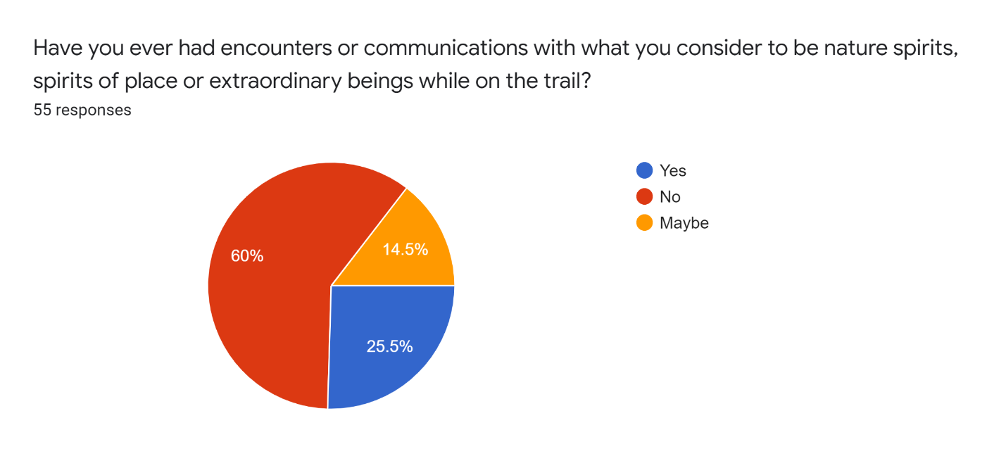
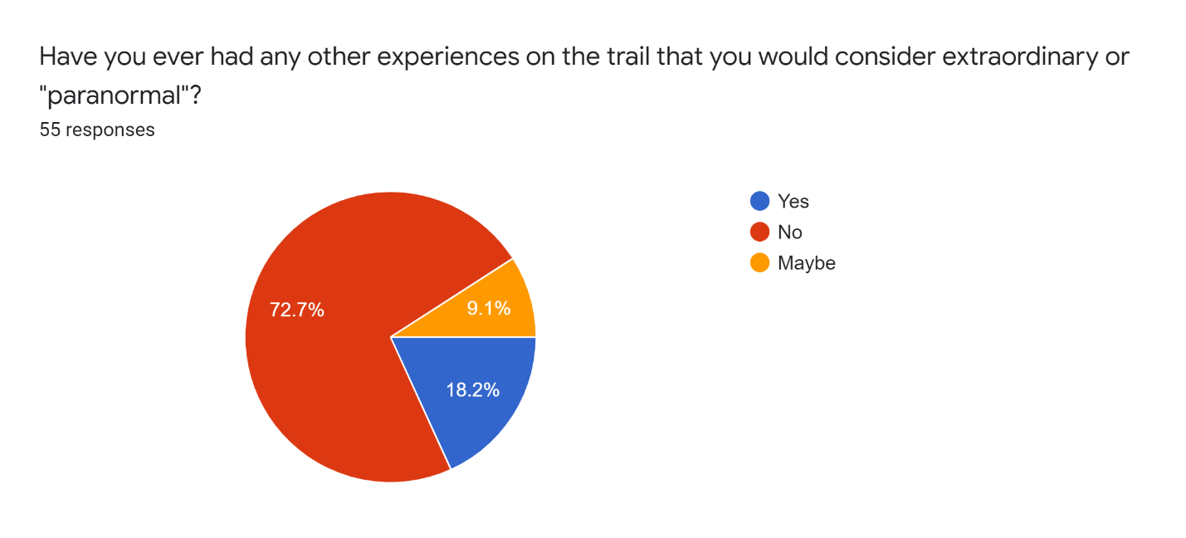
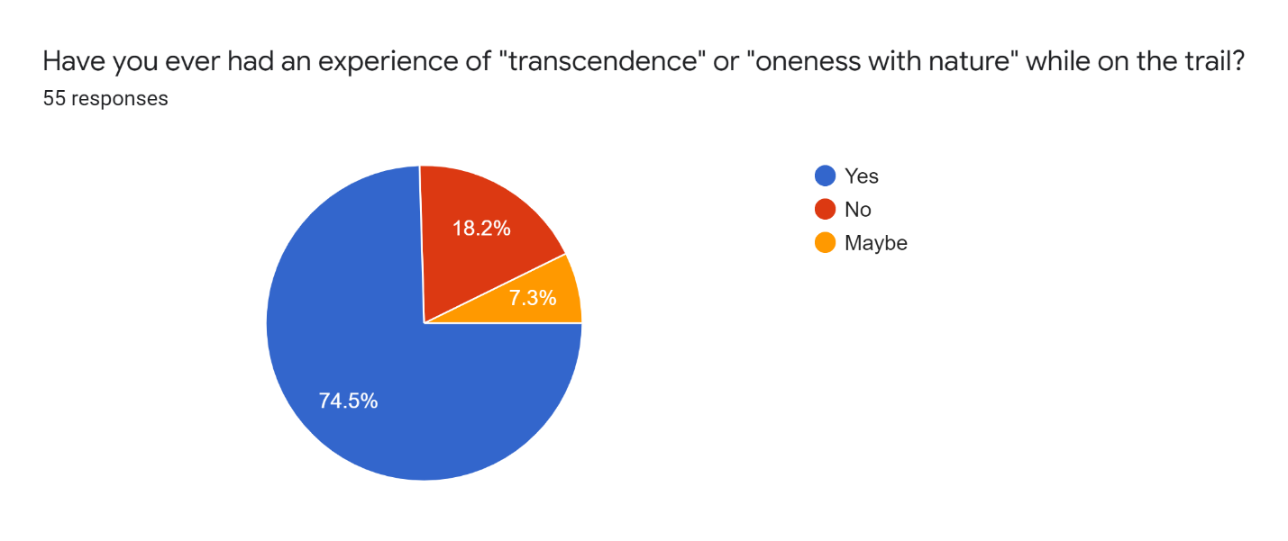
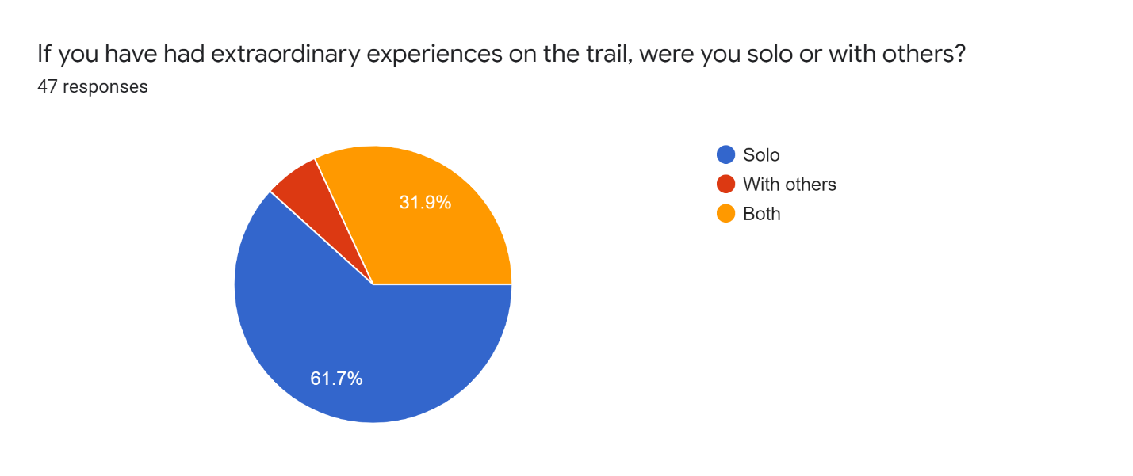
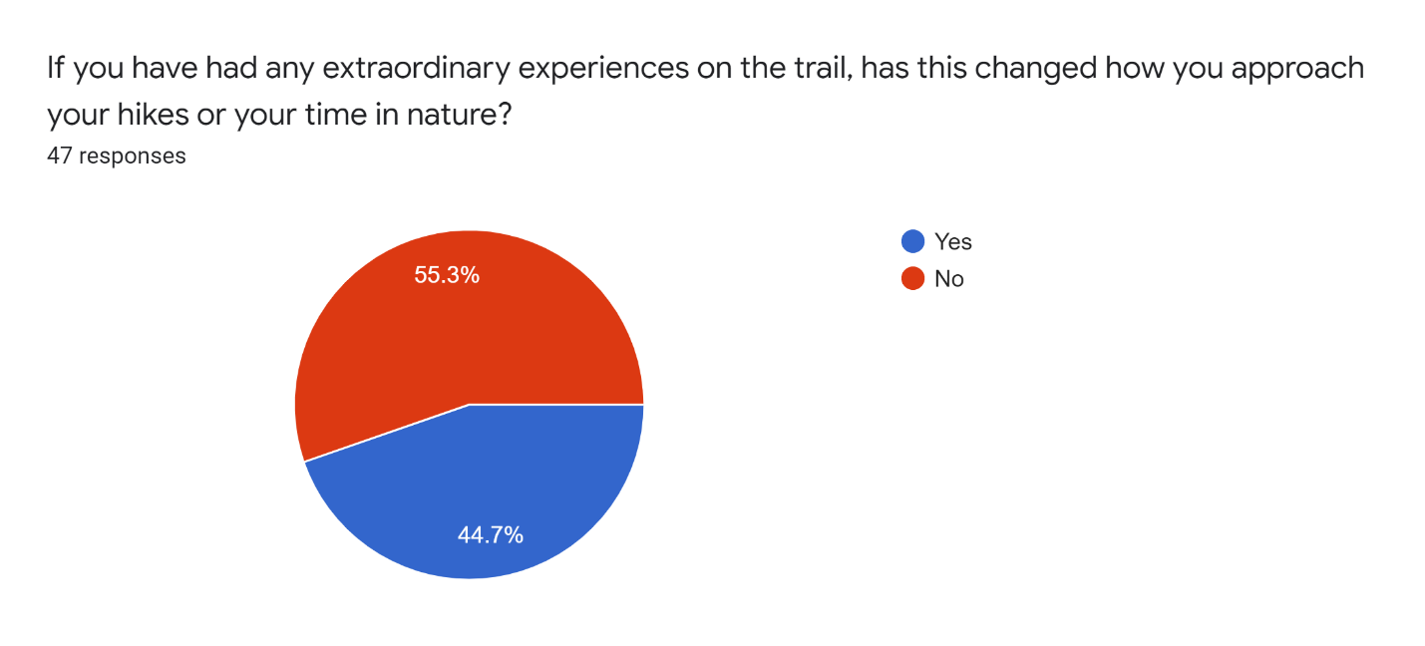
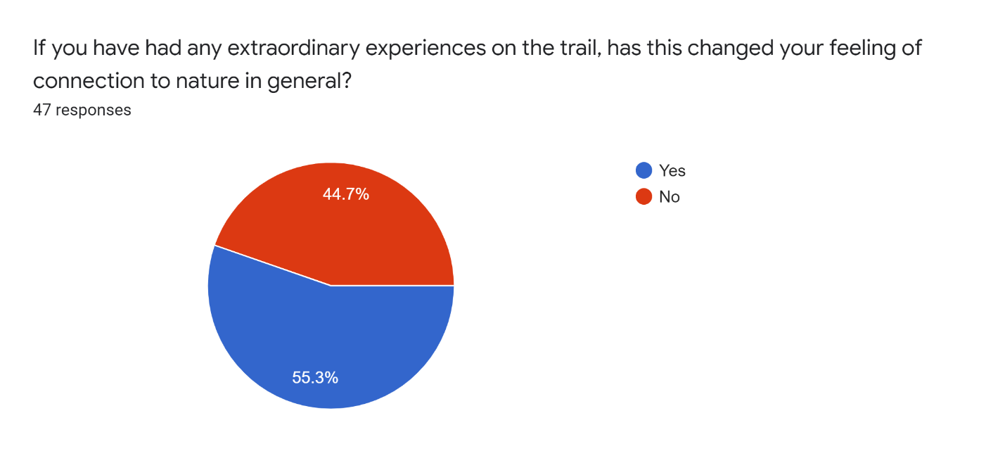
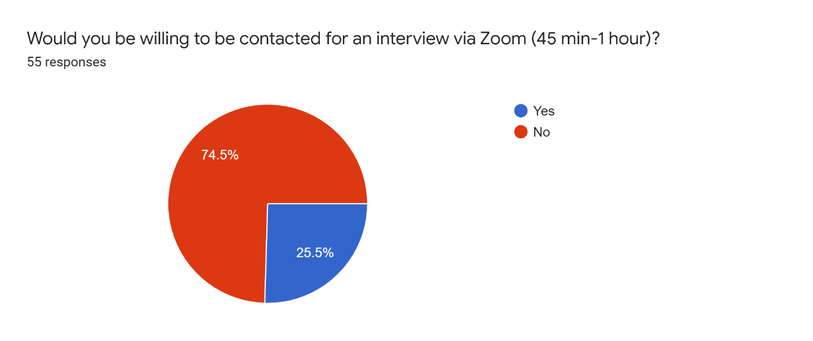

Jack Hunter, ‘Preliminary Report On Extraordinary Experiences in Permaculture: Collapsing The Natural/Supernatural Divide’, Journal of Exceptional Experiences and Psychology, 6:1 (2018), 20. < https://www.academia.edu/37600186/Preliminary_Report_on_Extraordinary_Experiences_in_Permaculture_Collapsing_the_Natural_Supernatural_Divide> [accessed 24 November 2021].
Kathryn Williams and David Harvey, ‘Transcendent Experience In Forest Environments’, Journal of Environmental Psychology, (2001) 249-260. DOI:10.1006/jevp.2001.0204.
Jack Hunter, ‘Editorial: Religious Experience And Ecology’, Journal For The Study Of Religious Experience, 7:2 (2021), p. 4.
Williams, ‘Transcendent Experience’, p. 249.
Williams, ‘Transcendent Experience’, pp. 251-256.
Williams, ‘Transcendent Experience’, p. 256.
Maria Izabel Vieira Botelho, Irene Maria Cardoso and Kei Otsuki, ‘”I Made A Pact With God, With Nature And With Myself”: Exploring Deep Agroecology’, Agroecology And Sustainable Food Systems, 40.2 (2016), 116-131<DOI: 10.1080/21683565.2015.1115798>.
Botelho, ‘I Made A Pact’, p. 124.
Botelho, ‘I Made A Pact’, p. 124.
Hunter, ‘Extraordinary Experience’, p. 13.
Hunter, ‘Extraordinary Experience’, p. 15.
Hunter, ‘Extraordinary Experience’, pp. 16-18.
Robin Wall Kimmerer, Braiding Sweetgrass (Minneapolis: Milkweed Editions, 2013), pp. 39-47.
Kimmerer, Braiding Sweetgrass, p. 46.
Jack Hunter, ‘Greening The Paranormal: Re-Wilding And Re-Enchantment’ in Greening The Paranormal: Exploring The Ecology Of Extraordinary Experience, ed. by Jack Hunter (USA/UK: August Night Press, 2019), p. 21.
Judith Bell, Doing Your Research Project: A Guide For First-Time Researchers, 6th ed. (New York: McGraw Hill Education, 2014), p. 250.
Monique Hennink, Inge Hutter and Ajay Bailey, Qualitative Research Methods (Los Angeles: Sage, 2020), p. 11.
Hunter, ‘Extraordinary Experience’, p. 15.
Williams, ‘Transcendent Experience’, pp. 250-251.
Hennink, Qualitative Research Methods, p. 17.
Hennink, Qualitative Research Methods, pp.119-120.
Hennink, Qualitative Research Methods, pp. 213-214.
Bell, Doing Your Research Project, p.239.
Williams, ‘Transcendent Experiences’, p. 255.
Hunter, ‘Greening The Paranormal’, p. 11.
Kimmerer, Braiding Sweetgrass, p.78.
Hunter, ‘Extraordinary Experience’, pp. 16-19.
Hunter, ‘Greening The Paranormal’, p.14.

