Kinetic Energy Recovery
Alternative Propulsion Systems
Mark Sandford

University of Wales Trinity Saint David
Motorsport Engineering (BEng)
Ellis Phillips – 2404558

Introduction
Kinetic Energy Recovery Systems (KERS) function by capturing energy, usually lost as heat during braking, so it can be stored and redeployed to help accelerate the vehicle at a later point. The impact of KERS can be analysed using a Worldwide Harmonized Light Vehicles Test Procedure (WLTP) cycle, this measures a vehicles fuel consumption under simulated real-world driving conditions and assists in providing an understanding of a vehicles efficiency and hence its environmental impact. Integrating KERS into road vehicles can increase performance while also decreasing harmful emissions. To analyse these effects I have chosen to propose the integration of a KER system into a 2024 Alfa Romeo Giulia, this vehicle can be used as a daily commuting vehicle or for spirited driving so will be able to showcase all the positive feedback a KER system has to offer.

(Champion Alfa Romeo,2023)
Vehicle Data –
Test mass = 1638+37+167 = 1842
Frontal area = 1.44 x 1.87 = 2.6928m^2
Rolling resistance coefficient = 0.012
Coefficient of aerodynamic drag = 0.28

Deciding on a WLTP
The calculated Power to Mass Ratio (PMR) is used to find the appropriate WLTP for the vehicle. The Alfa Romeo Giulia, with a Test mass of 1842kg and 280hp, has a PMR of 152hp/ton which equates to 113.3W/kg. Since a Class 3 WLTP is used for any vehicle with a PMR above 34, Class 3 is appropriate for this vehicle.
Energy Produced over WLTP
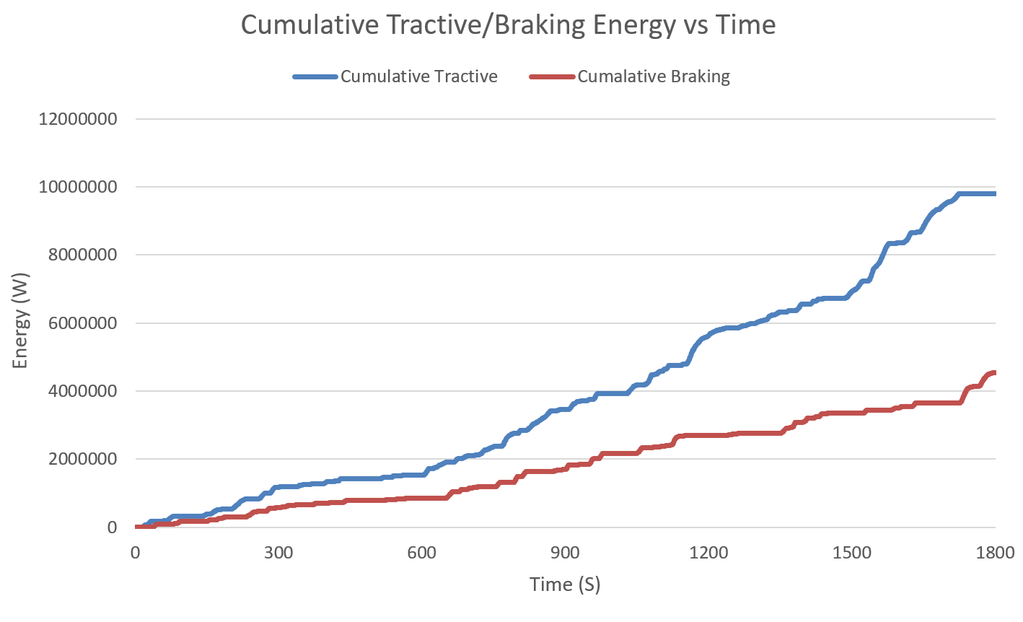
The differences between these two pieces of data represents the energy losses that occur during the WLTP cycle due to aerodynamic drag, the rolling resistance at the wheels and the vehicles acceleration resistance caused by the vehicles mass and drivetrain forces. The total energy lost is 5.267MW, this can be reduced using a KER system.

Possible KERS input
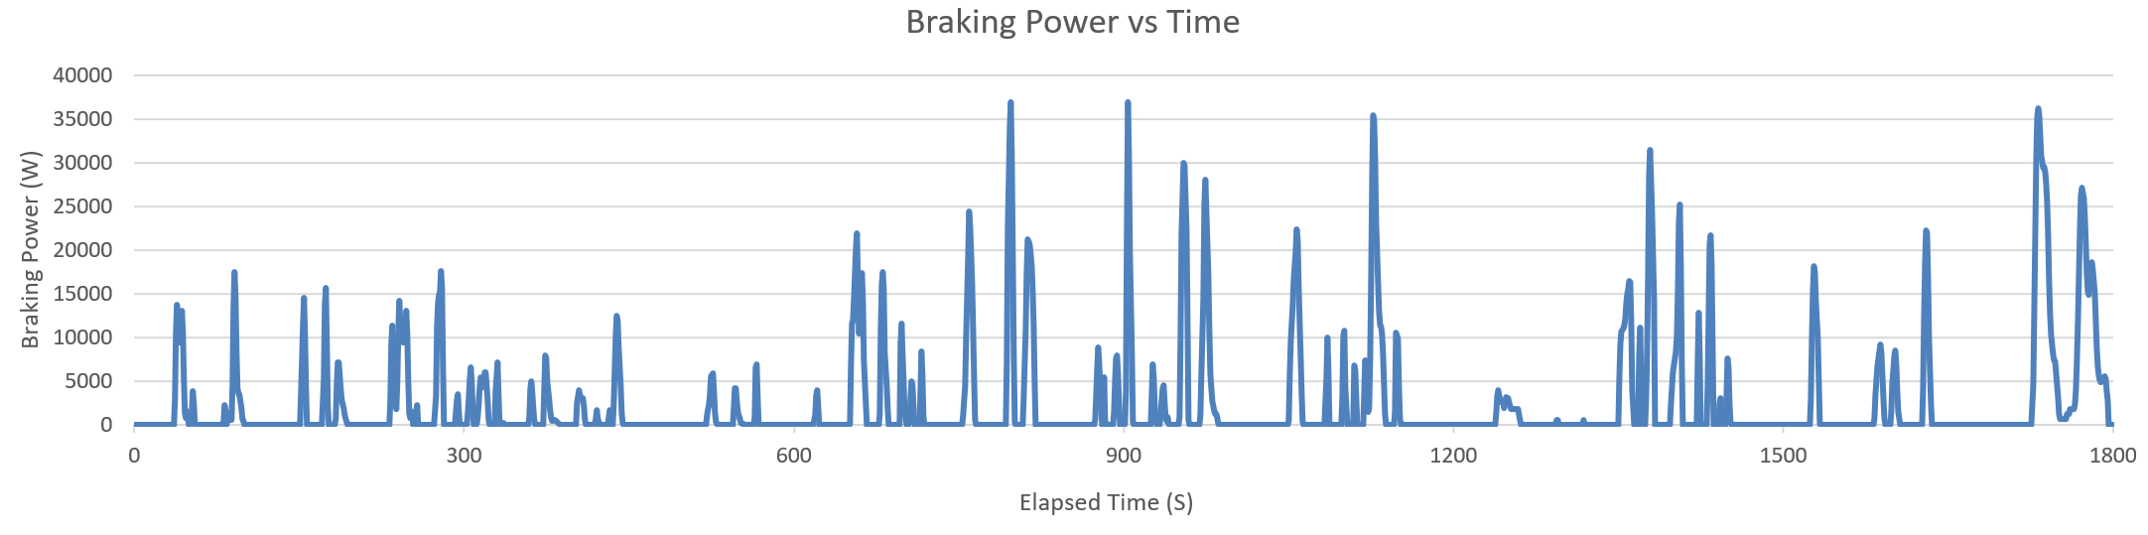
The graph above displays the negative braking power produced when decelerating during the cycle. The maximum possible KERS input is equal to the maximum braking power produced which is 36958.2W. Due to the efficiency of the KER system used, the maximum energy will not be recovered but the negative braking power can be drastically reduced.
KER Systems
There are multiple methods of recovering kinetic energy from a vehicle which are utilised by a range of different types of KER Systems :
Mechanical –
Mechanical KER systems operate by transferring the energy produced while braking to a flywheel, which causes it to spin at high RPM and store it as kinetic energy to later be used. When the vehicle accelerates, the flywheel drives a generator which supplies additional power using the kinetic energy recovered while braking. Mechanical systems are regarded as highly efficient with a typical efficiency of between 70% and 90% although can be difficult to implement into the design and layout of road vehicles. The power rating of flywheel KER systems is around 60kW in road cars as demonstrated by Volvo’s KER flywheel prototype in 2013 which with a full tank of fuel demonstrated and increase of 80bhp (59.7kW)(Volvo, 2013).
Electrical –
Usually used in hybrids, an electrical motor is used as a generator to convert mechanical energy to electrical energy and stored in an additional battery which can then transfer the energy back to the motor during acceleration to limit fuel use. This method can be limited by the charging efficiency of the battery and the frictional losses in the motor. Electrical systems have similar efficiency values to mechanical KER systems.
Supercapacitor –
As the vehicle brakes, a motor is used to collect the energy produced and is stored in supercapacitors which can then rapidly discharge to release a large amount of accelerating force to the wheels. Although typically used in hybrid vehicles, their potential for greater than 98% efficiency (Eaton, 2025) and their robustness make them an appealing choice for use on the Alfa Romeo. A supercapacitor KER system made by Adgero has a potential power output of 200kW (Kamdar, 2017), this would be more than enough to cover the energy losses which occur during the cycle and would be used predominantly in areas of quick acceleration like motorway merging, overtaking at high speeds, etc. This method seems the most suitable to recover kinetic energy on the Alfa Romeo Giulia and will most easily integrate into the vehicles design compared to the other options.

References
- Champion Alfa Romeo, 2023, Alfa Romeo Announces New Giulia and Stelvio Quadrifoglio 100th Anniversary Models, https://www.championalfaromeo.com/2023/05/18/alfa-romeo-announces-new-giulia-and-stelvio-quadrifoglio-100th-anniversary-models/
- Volvo, 2013, Volvo Cars tests of flywheel technology confirm fuel savings of up to 25 per cent, https://www.volvocars.com/uk/media/press-releases/65C25AB712386DFE/
- Eaton, 2025, Supercapacitor modules frequently asked questions, https://www.eaton.com/us/en-us/products/electronic-components/faq/supercapacitor-modules-frequently-asked-questions.html#:~:text=The%20typical%20round%2Dtrip%20efficiency%20is%20greater%20than%2098%25.
- A Kamdar, 2017, ULTRACAPACITOR KINETIC ENERGY RECOVERY SYSTEMS IN ROAD TRANSPORT VEHICLES. IS IT A VIABLE RETROFIT OPTION FOR REDUCING FUEL CONSUMPTION AND CO2 EMISSIONS?, https://repository.up.ac.za/server/api/core/bitstreams/8959601e-2883-4e6a-9602-f32af8e46c70/content

