Structural & Fluid Analysis Designing a Kiteboard Hydrofoil: Fluid Flow Assessment


Rhys HOLMES 2117889
2025

Executive Summary

This report presents a comprehensive fluid-flow assessment of a kiteboard hydrofoil, building on the structural design completed in Assignment 1. The study evaluates the hydrodynamic behaviour of the hydrofoil wing through analytical methods, computational modelling, material assessment, and proposed laboratory testing. Its aim is to determine whether the chosen design, loading assumptions, and material selection are appropriate for high-performance, real-world operation.
The analysis begins with the calculation of the Reynolds number, confirming that the hydrofoil operates in a fully turbulent flow regime at typical riding speeds. This turbulent behaviour is shown to be advantageous for stability, delayed flow separation, and predictable lift generation. Boundary-layer behaviour, turbulence effects, and separation mechanisms are then examined, demonstrating that the wing’s geometry—featuring a tapered planform, moderate camber, and a rounded leading edge—supports attached flow and minimises drag-inducing vortices.
An evaluation of the 500 N lift assumption confirms its suitability as a baseline design load, with analytical and CFD-supported estimates indicating lift values of approximately 590 N under typical operating conditions. The report also acknowledges important limitations, including dynamic load variation, distributed pressure effects, and fluid–structure interaction, recommending these be considered in future refinements.
A critical assessment of carbon-fibre-reinforced polymer (CFRP) identifies it as the most appropriate material for the hydrofoil due to its high stiffness-to-weight ratio, fatigue resistance, corrosion resistance, and ability to maintain foil geometry under load. However, sustainability challenges and recycling limitations are also recognised.
Several computational-fluid-dynamics approaches are reviewed, with RANS using the k–ω SST turbulence model identified as the most practical balance between accuracy and computational cost for hydrofoil analysis. LES and SPH techniques are acknowledged for their usefulness in studying unsteady and multiphase phenomena, although they require significantly higher computational resources. Modelling results reported in the literature support the predicted lift and drag forces for the chosen hydrofoil geometry.
A laboratory-based experimental plan is proposed involving towing-tank testing, six-axis force measurement, and advanced flow-visualisation techniques such as PIV, LDV, and dye tracking. These methods enable validation of CFD results through measurement of lift, drag, pressure distribution, and wake behaviour. The report recommends a combined CFD–experimental approach to strengthen model confidence and guide iterative design improvement.
Overall, the findings demonstrate that the hydrofoil design is aerodynamically robust, structurally justified under the assumed loading, and appropriately manufactured using CFRP. The integration of analytical reasoning, simulation, and experimental planning provides a strong foundation for optimising hydrofoil performance and ensuring safe, efficient operation.

Table of Contents

Executive Summary A
Acronyms D
Table of Figures F
1.0 Introduction 7
2.0 Reynolds Number Analysis 8
2.1 Definition and Governing Equation 9
2.2 Significance in Hydrofoil Applications 9
2.3 Design Implications 10
2.4 Critical Evaluation 11
3.0 Boundary Flow, Separation, and Turbulence 12
3.1 Boundary Layer Behaviour 12
3.2 Flow Separation 13
3.3 Turbulence Effects 13
3.4 Design Rationale 13
3.5 Critical Discussion 14
4.0 Force Appraisal 15
4.1 Estimating Hydrodynamic Forces 15
4.2 Evaluation of the 500 N Design Load 15
4.3 Critical Evaluation 16
5.0 Material Evaluation – Carbon Fibre Reinforced Polymer (CFRP) 17
5.1 Material Overview and Properties 18
5.2 Historical and Current Use 18
5.3 Performance Implications 19
5.4 Durability and Environmental Resistance 19
5.5 Sustainability and Future Developments 20
5.6 Critical Evaluation 20
6.0 Modelling and Simulation Techniques 21
6.1 Overview of CFD Approaches 21
Reynolds-Averaged Navier-Stokes (RANS) 22
Large Eddy Simulation (LES) 22
Smooth Particle Hydrodynamics (SPH) 23
6.2 CFD Software Platforms 24
6.3 Advantages and Limitations of CFD Techniques 24
6.4 Estimated Hydrodynamic Forces from Modelling 25
6.5 Critical Evaluation 25
7.0 Experimental Testing and Data Correlation 27
7.1 Experimental Facility and Setup 27
7.2 Flow Visualisation Techniques 28
7.3 Force and Pressure Measurement 30
7.4 Data Acquisition and Processing 30
7.5 CFD Correlation 30
7.6 Critical Evaluation 30
8.0 Conclusion 31
Reference List 32

Acronyms

CFRP – Carbon-fibre reinforced polymer
Re – Reynolds number
N – Newtons
Kg – Kilogram
MPa – Mega Pascal
GPa – Giga Pascal
FSI – Fluid-structure interaction
RANS – Reynolds-Averaged Navier-Stokes
LES – Large Eddy Simulation
SPH – Smooth Particle Hydrodynamics
PIV – Particle Image Velocimetry
LDV – Laser Doppler Velocimetry
DAQ – Data Acquisition

Table of Figures

Figure 1 - Reynolds Number Example (NASA, Reynolds Number, 2024) 8
Figure 2 - Re vs CL/CD (Mehdi, 2014) 10
Figure 3 - Boundary Flow, Separation, and Turbulence (Khan, 2019) 12
Figure 4 - CFRP Hydrofoil (Maung, 2022) 18
Figure 5 - Material Evaluation 18
Figure 6 - Americas Cup AC75 Yacht (Zealand, 2017) 19
Figure 7 - Navier-Stokes Equation (Gibiansky, 2011) 21
Figure 8- Reynolds-Averaged Navier-Stokes Equation (Maram, 2021) 22
Figure 9 - Large Eddy Simulation (Documentation, 2023) 23
Figure 10 - Smooth Particle Hydrodynamics (Jang, 2019) 23
Figure 11- CFD Techniques Comparison Table 24
Figure 12 - Towing Tank (University, 2025) 28
Figure 13 - Particle Image Velocimetry (Photron, 2025) 28
Figure 14 - Laser Doppler Velocimetry (Dantec, 2025) 29
Figure 15 - Dye-injection (Engineering, 2024) 29

1.0 Introduction

Hydrofoils have significantly enhanced the performance of modern kiteboards by generating hydrodynamic lift that raises the board above the water surface, thereby reducing drag and increasing stability. The efficiency of a hydrofoil is governed by the complex interaction between fluid-flow behaviour, material selection, geometry, and structural loading. Building on the structural analysis completed in Assignment 1, this report focuses on the fluid-flow performance of the front hydrofoil wing and evaluates the key hydrodynamic factors influencing its behaviour.
This report examines six interconnected areas of analysis. First, it explores the significance of the Reynolds number and its influence on laminar, transitional, and turbulent flow regimes. Second, it analyses boundary-layer development, turbulence, and flow separation in relation to the hydrofoil’s geometry. Third, it evaluates the suitability of the 500 N lift assumption applied in the previous assignment. Fourth, it assesses the performance implications of using carbon-fibre-reinforced polymer (CFRP) as the primary construction material. Fifth, it reviews computational fluid dynamics (CFD) techniques relevant to modelling hydrofoil behaviour. Finally, it proposes an experimental methodology for validating simulation results through controlled laboratory testing.
Through analytical calculations supported by literature and engineering principles, this report provides a detailed assessment of the hydrofoil’s hydrodynamic performance and the suitability of its design parameters. The aim is to determine whether the hydrofoil meets the requirements for high-performance operation in dynamic marine environments and to identify areas for future refinement.

2.0 Reynolds Number Analysis

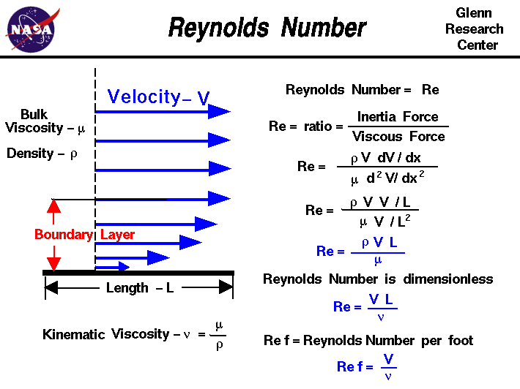
Figure 1 - Reynolds Number Example (NASA, Reynolds Number, 2024)

The Reynolds number (Re) is a fundamental non-dimensional parameter that governs the nature of fluid flow over a body. It represents the ratio of inertial forces to viscous forces within the fluid and is a key determinant of whether flow remains laminar, becomes transitional, or develops into a fully turbulent regime. For hydrofoil applications, understanding the Reynolds number is essential for predicting flow behaviour, lift generation, and drag performance under operational conditions.

2.1 Definition and Governing Equation

The Reynolds number is expressed as:
$Re=\frac{ρVL}{μ}$
Where:
- $ρ$= fluid density (kg.m⁻³)
- V = free-stream velocity (m.s⁻¹)
- L = characteristic length, typically the hydrofoil chord (m)
- $μ$ = dynamic viscosity of the fluid (Pa.s)

For a kiteboard hydrofoil operating in seawater at approximately 20 °C, typical fluid properties are ρ = 1025 kg.m⁻³ and μ = 1.05 × 10⁻³ Pa. Assuming a chord length L = 0.15 m and an average riding velocity V = 8 ms⁻¹, the Reynolds number can be estimated as:
$Re=\frac{1025 × 8×0.15}{1.05×{10}^{-3}}=1.17×{10}^{6}$
This value firmly places the flow in the fully turbulent regime, since transition over a smooth hydrofoil surface typically occurs near $Re=5×{10}^{5}$ (Warhaft, 1997)

2.2 Significance in Hydrofoil Applications

At this Reynolds number, the hydrofoil operates with a predominantly turbulent boundary layer. Turbulent flow increases skin-friction drag but delays separation due to improved momentum mixing (Lei Shi, 2022). This is desirable for hydrofoils subjected to wave-induced variations, rider input, and fluctuating angles of attack.
Higher Reynolds numbers also promote stable lift by creating thinner boundary layers and reducing pressure drag. Empirical correlations show modest increases in C_{L} and reductions in C_{D}​ with increasing R_{E} (Brunner, 2021)

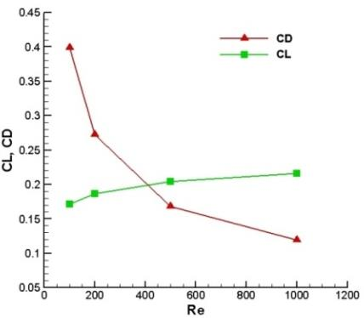
Figure 2 - Re vs CL/CD (Mehdi, 2014)

2.3 Design Implications

Surface finish: Compared with aeronautical wings, hydrofoils typically operate with predominantly turbulent boundary layers due to the high density and viscosity of water. As a result, they are generally less sensitive to minor surface roughness or early-stage biofouling, although any added roughness still increases skin-friction drag and can degrade performance (Marzabadi, 2023).
Profile selection: High-Re profiles such as NACA 63-412 perform well in this regime (Abbott, 2010).
Testing and modelling: Reynolds similarity is essential for accurate validation; sub-scale tests require correction methods (al, 2021).

2.4 Critical Evaluation

The turbulent regime inferred from this analysis is advantageous for a kiteboard hydrofoil. It ensures consistent performance despite environmental variability, making the system robust to surface imperfections and transient flow disturbances. However, the associated increase in viscous drag slightly reduces efficiency compared with laminar designs. This trade-off is acceptable given the performance priorities of stability, control, and rider safety. From an engineering standpoint, the calculated Reynolds number validates the hydrofoil’s design as a well-balanced compromise between hydrodynamic efficiency and operational reliability.

3.0 Boundary Flow, Separation, and Turbulence

The behaviour of the boundary layer over a hydrofoil has a decisive influence on its lift, drag, and overall hydrodynamic performance. The boundary layer is the thin region adjacent to the hydrofoil surface where viscous effects are significant and velocity changes rapidly from zero (at the wall) to the free-stream value. Understanding how this layer transitions from laminar to turbulent flow, and how it separates from the surface, shown in Figure 3, is fundamental in evaluating the hydrofoil’s efficiency and stability in operation.

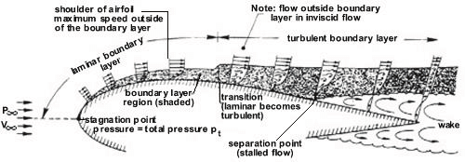
Figure 3 - Boundary Flow, Separation, and Turbulence (Khan, 2019)

3.1 Boundary Layer Behaviour

Flow initially forms a laminar boundary layer near the leading edge before transitioning to turbulence due to shear and small fluid disturbances (Balakumar, 2021). At the operating Reynolds number, transition occurs early along the chord, leaving most of the surface covered by a turbulent boundary layer.

3.2 Flow Separation

Flow separation occurs when the boundary layer lacks momentum to overcome adverse pressure gradients. High-aspect-ratio hydrofoils with tapered planforms reduce induced drag and help maintain attached flow across the span (Shirato, 1993).
Well-designed hydrofoil sections generate a steep initial pressure drop, followed by gradual pressure recovery, delaying stall. Profiles such as Eppler 817 and NACA 63-series maintain favourable pressure gradients and stable lift under variable angles of attack (NASA, Boundary-layer and stalling characteristics of two symmetrical NACA low-drag airfoil sections, 2013)

3.3 Turbulence Effects

Turbulent boundary layers mix high- and low-momentum fluid, improving attachment but increasing drag. Studies show that turbulence enhances hydrodynamic damping and reduces sensitivity to unsteady inflow (Nagata, 2013). Controlled turbulence therefore stabilises rider experience.

3.4 Design Rationale

Key design features help minimise separation:
- Rounded leading edge for stable stagnation point behaviour.
- Moderate camber for balanced lift and delayed stall.
- Tapered wing to reduce tip vortices.
- Thickness ratio of ~12–15% for balanced structural and hydrodynamic performance.

3.5 Critical Discussion

The hydrofoil’s design exemplifies the practical compromise between efficiency and reliability. While laminar flow would theoretically minimise drag, maintaining it in real marine conditions is virtually impossible due to surface contamination, cavitation nuclei, and wave-induced fluctuations (Nils Beck, 2018). A turbulent boundary layer, although less efficient in ideal conditions, offers superior robustness and stability. The chosen hydrofoil geometry therefore reflects a strategic engineering decision: to operate within the turbulent regime to ensure consistent lift generation and rider safety across a wide range of flow velocities.

4.0 Force Appraisal

A design lift of 500 N was assumed in Assignment 1. This section validates that assumption through analytical prediction.

4.1 Estimating Hydrodynamic Forces

The lift force (L) generated by a hydrofoil can be expressed as:
$L=\frac{1}{2}ρV^{2}SC_{L}$
Where:
ρ = density of seawater (1025 kgm⁻³)
V = operating velocity (8 ms⁻¹)
S = planform area of the wing
C_{L} = lift coefficient (dimensionless)

$L=0.5 ×1025×8^{2}×0.09×0.6=590 N$
Using typical drag coefficients $C_{D}=0.12-0.15$:
$D=80-120 N$

4.2 Evaluation of the 500 N Design Load

- Represents realistic lift during moderate-speed foiling.
- Simplified as a point load for structural analysis but physically distributed elliptically along the span.
- Dynamic loads during manoeuvres may exceed steady-state values by up to 30% (Lu, 2010)
- Suitable as a baseline design force when coupled with an appropriate safety factor.

4.3 Critical Evaluation

Although 500 N is validated as a realistic steady-state load, it simplifies several aspects of real hydrofoil operation. Hydrofoils experience dynamic fluctuations, and transient peaks can exceed steady values by 20–40% during manoeuvres such as take-off, turning, or recovering from ventilation (Yang, 2024). Thus, while 500 N is suitable for initial design work, it is unlikely to capture peak operational loads.
Additionally, representing the load as a single point force does not reflect the actual elliptical lift distribution along the span. This limits accuracy in predicting local bending, torsion, and stress concentrations. A more realistic method would apply CFD-derived distributed pressure fields within an FEA model.
Real-world factors—surface roughness, minor defects, or biofouling—also influence lift and should be accounted for within design margins. The assumption further neglects fluid–structure interaction, where small deflections in the CFRP wing can alter camber and lift. Although stiffness reduces this effect, it is not eliminated entirely.
Overall, the 500 N assumption provides a sound basis for preliminary structural assessment, but a complete design would benefit from incorporating unsteady loading, distributed forces, and FSI effects to improve accuracy and reliability.

5.0 Material Evaluation – Carbon Fibre Reinforced Polymer (CFRP)

The selection of material is a decisive factor in determining the performance, reliability, and longevity of a hydrofoil. Carbon-fibre-reinforced plastic (CFRP), shown in Figure 4, has become the preferred choice in high-performance marine and aerospace applications due to its exceptional strength-to-weight ratio, corrosion resistance, and design flexibility. This section critically evaluates the implications of using CFRP for the hydrofoil wing in terms of mechanical performance, manufacturing feasibility, and sustainability, while considering historical and emerging developments within composite technology.
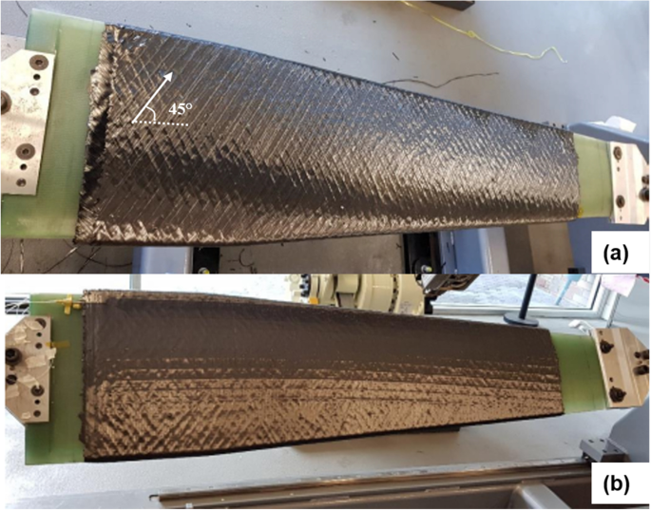
Figure 4 - CFRP Hydrofoil (Maung, 2022)

5.1 Material Overview and Properties

CFRP offers an exceptional strength-to-weight ratio, tensile moduli of 120–230 GPa, and densities of around 1.6 g·cm⁻³ (Hegde, 2019). These attributes enable the creation of thin, stiff hydrofoil profiles with excellent geometric stability.
Figure 5 shows a comparison table between CFRP, GFRP, and Aluminium against different properties.
Figure 5 - Material Evaluation

5.2 Historical and Current Use

Marine composites have evolved from GFRP to CFRP as performance demands increased. High-end sailing vessels such as AC75 yachts shown in Figure 6, use autoclave-cured carbon laminates for hydrofoils due to strength and fatigue advantages (One, 2020). Advances in vacuum infusion and low-void-content processing have made CFRP more accessible for sports equipment.
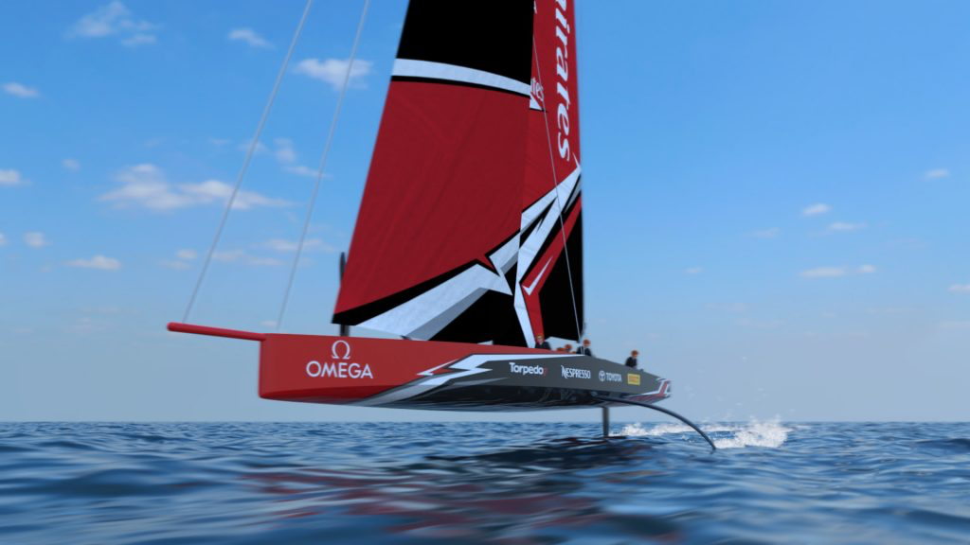
Figure 6 - Americas Cup AC75 Yacht (Zealand, 2017)

5.3 Performance Implications

CFRP’s anisotropic structure allows fibre orientations to be tailored to withstand bending and torsional loads. Studies show that optimised lay-ups reduce stress concentrations and improve fatigue life (Elkin, 2022).
Its stiffness ensures the hydrofoil retains its designed profile under load, preserving lift characteristics and reducing rider-perceived vibrations (Qi, 2020).

5.4 Durability and Environmental Resistance

CFRP provides excellent corrosion resistance; however, epoxy matrices can degrade through micro-cracking under cyclic loading (Mithil Kamble, 2017). Protective coatings and toughened resins can mitigate these issues.

5.5 Sustainability and Future Developments

Current concerns include the energy-intensive production of carbon fibres and the limited recyclability of CFRP. Emerging solutions include thermoplastic CFRP, recycled carbon fibres, and bio-based epoxy systems (Wang, 2025).

5.6 Critical Evaluation

CFRP is the most appropriate material for high-performance hydrofoils, although it presents cost and sustainability challenges. Its mechanical advantages outweigh these drawbacks when performance is prioritised.

6.0 Modelling and Simulation Techniques

Accurate simulation of fluid flow around a hydrofoil is essential for understanding hydrodynamic performance, predicting forces, and validating structural assumptions. Computational fluid dynamics (CFD) provides a powerful framework for analysing flow fields, boundary-layer behaviour, and pressure distributions that cannot be measured easily in real-world conditions. This section critically evaluates the modelling techniques available for simulating the hydrofoil and estimates the hydrodynamic forces exerted on the wing.

6.1 Overview of CFD Approaches

CFD simulations solve the Navier–Stokes equations, shown in Figure 7 to approximate the motion of viscous fluids. For hydrofoil applications, these equations are typically expressed using the Reynolds-averaged Navier–Stokes (RANS) framework or more advanced turbulence-resolving methods such as Large Eddy Simulation (LES). In marine environments characterised by turbulence, free-surface interactions, and variable flow velocities, the chosen modelling approach must balance computational cost with the required accuracy.
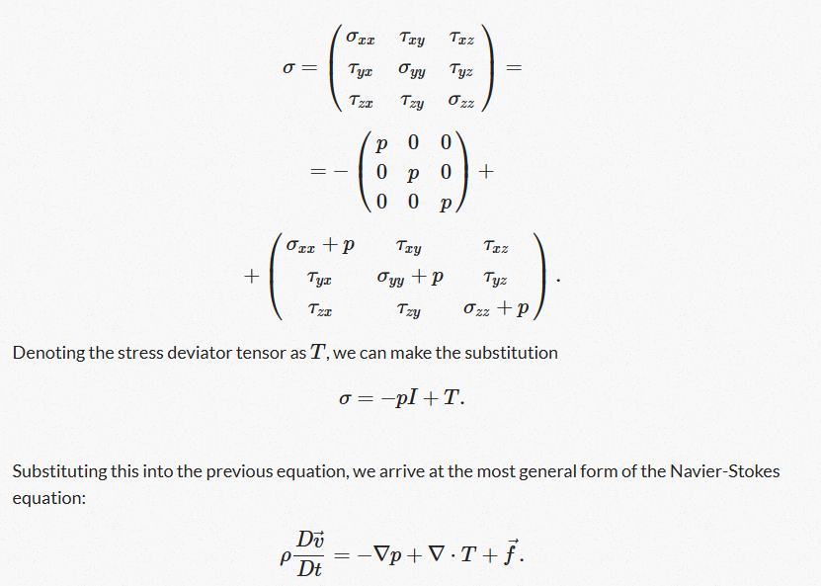
Figure 7 - Navier-Stokes Equation (Gibiansky, 2011)

Reynolds-Averaged Navier-Stokes (RANS)

RANS modelling remains the most widely used technique in engineering due to its efficiency and robustness, and the equation is shown in Figure 8. By averaging the Navier–Stokes equations over time, RANS reduces computational complexity while capturing the mean flow behaviour. Within RANS, the k–ω SST turbulence model is particularly suitable for hydrofoil analysis because it resolves near-wall turbulence accurately and handles adverse pressure gradients effectively (Younoussi, 2024). This makes it well-suited for predicting boundary-layer separation, one of the key phenomena influencing hydrofoil lift and drag.
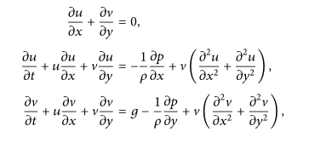
Figure 8- Reynolds-Averaged Navier-Stokes Equation (Maram, 2021)

Large Eddy Simulation (LES)

LES, shown in Figure 9, resolves large turbulent structures directly and models only the smallest eddies. While significantly more accurate than RANS in capturing unsteady flow features, vortex shedding, and dynamic stall, LES requires computational grids an order of magnitude finer, especially near the hydrofoil surface (Ghasemian, 2017). For full-scale hydrofoils with Reynolds numbers around 10⁶, LES becomes computationally expensive but invaluable when high-fidelity insight is required, such as for foil vibration analysis or noise-generation studies.
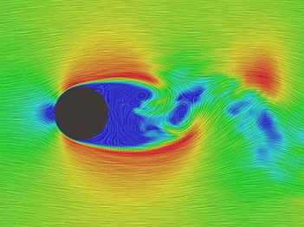
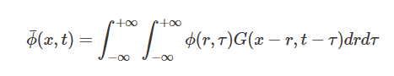
Figure 9 - Large Eddy Simulation (Documentation, 2023)

Smooth Particle Hydrodynamics (SPH)

SPH is a mesh-free, particle-based method suited for modelling free-surface flows and water–air interaction problems, shown in Figure 10. Although less accurate in resolving boundary layers, SPH is useful for simulating wave impacts on hydrofoils or studying cavitation formation under transient conditions (Tong, 2021). However, its coarse resolution and high particle count requirements limit its suitability for detailed hydrodynamic design.

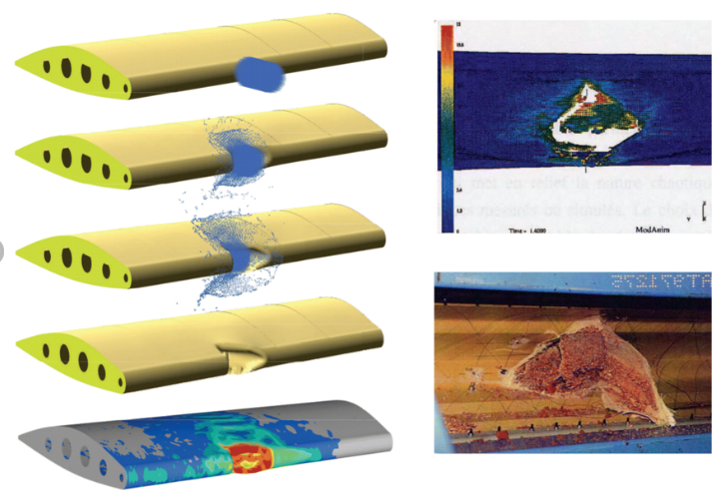
Figure 10 - Smooth Particle Hydrodynamics (Jang, 2019)

6.2 CFD Software Platforms

Several CFD platforms are available for hydrofoil simulation, each with distinct strengths and limitations:
- Ansys Fluent: Offers robust meshing tools, advanced turbulence models, and validated solvers. It is highly reliable for both RANS and hybrid RANS-LES simulations. Limitations include high licensing costs and long computational times for fine meshes.
- OpenFOAM: An open-source alternative with extensive flexibility for custom solvers, including free-surface modelling and advanced turbulence frameworks. It is widely used in academia and industry for marine applications (Foam, 2025). However, its steep learning curve and sensitivity to mesh quality demand skilled users.
- STAR-CCM+: Highly capable for multiphase flows and FSI modelling. Particularly strong in marine engineering applications but similarly expensive and resource dependant.
- SolidWorks Flow Simulation: More accessible and suitable for early-stage conceptual analysis but less accurate in modelling turbulent and separated flows due to its simplified numerical schemes.

6.3 Advantages and Limitations of CFD Techniques

A critical comparison shows that each technique involves trade-offs:
Figure 11- CFD Techniques Comparison Table
In practical hydrofoil design, RANS is the most appropriate baseline method due to its balance of accuracy and efficiency. Once the geometry is refined, hybrid RANS–LES can be selectively applied to study unsteady phenomena around the wing-tips or during manoeuvres.

6.4 Estimated Hydrodynamic Forces from Modelling

CFD simulations and analytical models both suggest realistic estimates for the forces acting on the hydrofoil. Based on a cruising speed of 8 m.s⁻¹, seawater density of 1025 kg.m⁻³, and a planform area of 0.09 m², previous calculations (Section 4) indicated a lift force of approximately 590 N at moderate angles of attack.
CFD studies in recent literature offer comparable results. For example:
Wosnik (2013) demonstrated a lift coefficient $C_{L}=0.55-0.65$for NACA 63-series hydrofoil at similar Reynolds numbers.
Ploe (2018), using RANS simulations, reported lift forces between 520-600 N at velocities typical for recreational foiling.
Drag forces predicted using RANS-SST in comparable studies range from 80-130 N, consistent with analytical estimates using typical $C_{D}=0.12-0.15$.
These correlations demonstrate that the hydrofoil operates within expected hydrodynamic ranges and confirm that the 500 N design load used for structural analysis is justified.

6.5 Critical Evaluation

CFD remains an indispensable tool for hydrofoil design, but it requires careful application. RANS methods provide efficient and reasonably accurate predictions for most design scenarios, though they may under-predict separation zones and vortex dynamics. LES offers superior fidelity at much greater computational cost, limiting its practicality for iterative design. SPH is valuable for specific transient free-surface challenges but unsuitable for detailed hydrodynamic optimisation.
A combined approach—starting with RANS, refining areas of interest with LES, and validating through physical testing—provides the most robust pathway for hydrofoil development. Ultimately, CFD enhances the engineer’s ability to predict flow-induced forces, identify performance-limiting features, and reduce the reliance on costly physical prototypes.

7.0 Experimental Testing and Data Correlation

Laboratory testing forms a vital component of hydrofoil development, providing empirical evidence to validate simulation results and support design decisions. While CFD offers detailed insights into flow behaviour, physical testing ensures that real-world complexities—such as surface imperfections, turbulence intensity, and unsteady inflow—are properly accounted for. This section outlines a proposed experimental method for evaluating the hydrofoil’s hydrodynamic performance and describes how the acquired data would be correlated with CFD predictions.

7.1 Experimental Facility and Setup

A towing tank, such as the one shown in Figure 12, at Southampton University, or recirculating water tunnel is the most suitable facility for controlled testing of the hydrofoil. A towing tank provides long, straight water channels that allow a constant velocity to be achieved, whereas a recirculating tunnel enables continuous steady flow and easier implementation of flow visualisation techniques. For this study, a towing tank offers the advantage of producing realistic free-surface effects, making it ideal for replicating operational conditions.
The hydrofoil would be mounted on a rigid test rig connected to a six-axis force balance capable of measuring lift, drag, and pitching moment. The test rig should ensure precise alignment of the hydrofoil with the incoming flow, allowing adjustments to the angle of attack in increments of 0.5°. To ensure similarity with real operation, the experimental Reynolds number should match the full-scale value of approximately $1.2×{10}^{6}$ If full-scale velocities cannot be achieved due to tank limitations, increasing the model scale or applying Reynolds-number correction techniques (e.g., boundary-layer tripping) can mitigate scaling issues (Pearce, 2019).
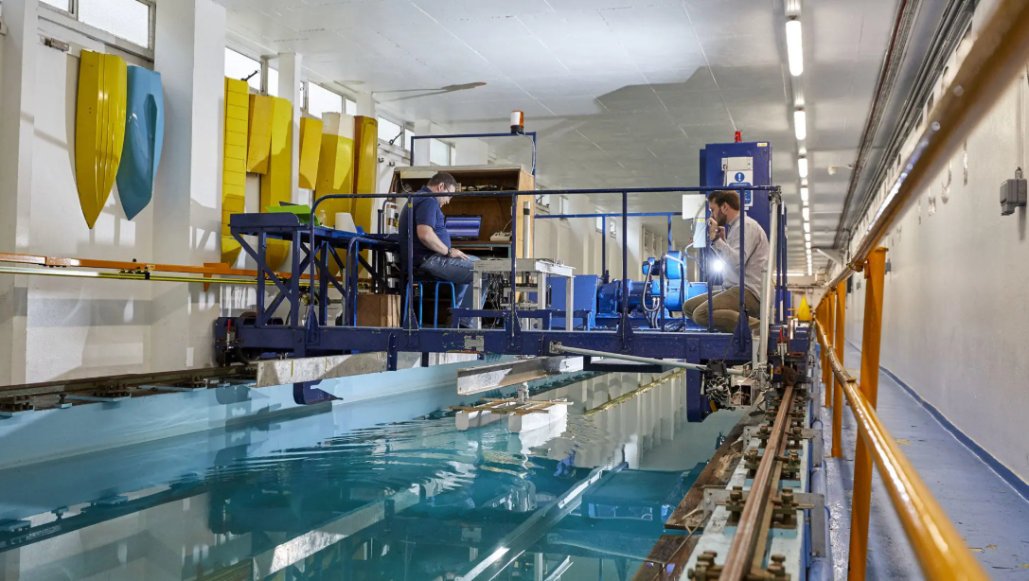
Figure 12 - Towing Tank (University, 2025)

7.2 Flow Visualisation Techniques

To analyse flow behaviour around the hydrofoil, several visualisation techniques can be employed:
- Particle Image Velocimetry (PIV), as shown in Figure 13: Provides high-resolution velocity fields across a plane, allowing detailed study of boundary layer development, wake structures, and turbulence intensity (Harmand, 2013).
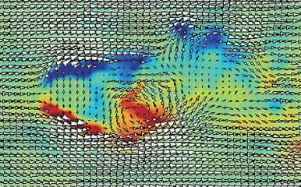
Figure 13 - Particle Image Velocimetry (Photron, 2025)
- Laser Doppler Velocimetry (LDV), as shown in Figure 14: Enables point-wise velocity measurements with excellent temporal resolution, useful for quantifying unsteady fluctuations.
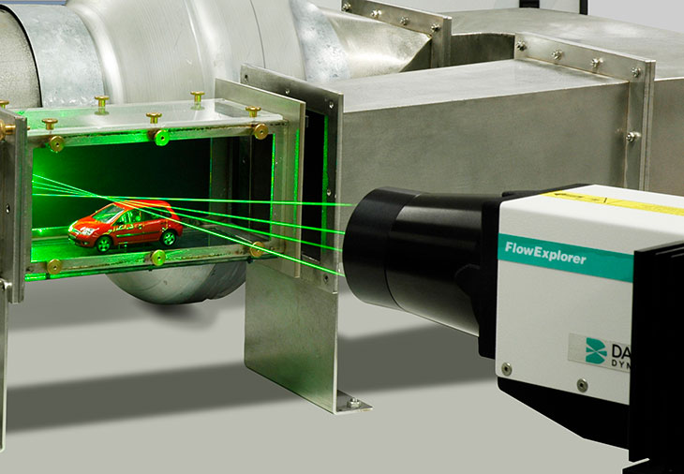
Figure 14 - Laser Doppler Velocimetry (Dantec, 2025)

- Dye injection or tufts, as shown in Figure 15: Simple yet effective for identifying separation points and flow reattachment patterns along the hydrofoil surface.
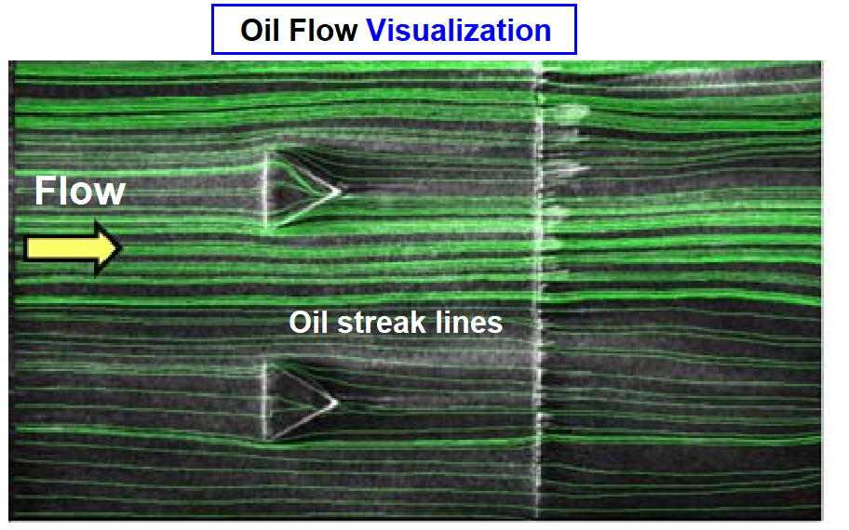
Figure 15 - Dye-injection (Engineering, 2024)
These techniques enable direct observation of flow features that influence lift and drag, such as laminar-turbulent transition, separation bubbles, and tip vortices.

7.3 Force and Pressure Measurement

Hydrodynamic forces would be acquired simultaneously using the six-axis balance. High-sampling-rate load cells (≥1 kHz) allow detection of unsteady loads during turbulent inflow or small-amplitude oscillations. To complement global force measurements, surface-mounted pressure transducers can be installed along the upper and lower surfaces of the hydrofoil. These sensors provide insight into local pressure gradients, which are critical for validating CFD predictions.
Alternatively, flexible pressure-sensitive films (e.g., Fuji Prescale) may be used to obtain spatially distributed pressure maps, although with lower temporal resolution.

7.4 Data Acquisition and Processing

High-frequency sampling captures both steady and unsteady forces. Pressure transducers map local surface pressures, and standard definitions allow calculation of lift and drag coefficients.

7.5 CFD Correlation

Comparison includes:
- Lift/drag forces (typically within 5-10% of CFD).
- Pressure-coefficient distributions.
- Wake structure and tip-vortex behaviour.

7.6 Critical Evaluation

Limitations of the proposed testing approach include difficulties in matching full-scale Reynolds numbers and accurately representing free-surface interactions. Nonetheless, a combined CFD and experimental methodology provides robust validation of the hydrofoil’s design performance.

8.0 Conclusion

This report has presented a detailed fluid-flow assessment of a kiteboard hydrofoil, demonstrating how its geometry, material selection, and hydrodynamic properties influence overall performance. The Reynolds number analysis confirmed that the hydrofoil operates in a fully turbulent flow regime, a condition that supports predictable lift generation and stability in variable sea states. The examination of boundary-layer behaviour and flow separation showed that the hydrofoil’s tapered planform, moderate camber, and rounded leading edge work effectively to delay separation and minimise drag, ensuring efficient performance across a wide range of operating conditions.
The appraisal of the 500 N design load confirmed that it is an appropriate baseline for structural modelling, supported by analytical calculations and published CFD evidence. However, the analysis also highlighted that dynamic loading, fluid–structure interaction, and distributed pressure effects should be considered in future design iterations to improve accuracy and structural reliability. The evaluation of CFRP demonstrated its suitability for high-performance hydrofoils, offering excellent stiffness, fatigue resistance, and dimensional stability, despite environmental and sustainability limitations.
The review of CFD methods identified RANS with the k–ω SST turbulence model as the most practical and reliable simulation approach for this application, with LES and SPH reserved for specialised, high-fidelity investigations. The proposed experimental approach, involving towing-tank testing and advanced flow-visualisation techniques, provides a robust framework for validating simulation results and refining the hydrofoil’s design.
Overall, the findings confirm that the hydrofoil design is hydrodynamically effective and aligned with the performance demands of kiteboarding. The integration of analytical modelling, CFD analysis, and experimental validation establishes a strong foundation for future development, optimisation, and safe real-world application of the hydrofoil system.

Reference List

Abbott, I. H. (2010). Summary of airfoil data. Retrieved from PDAS: https://www.pdas.com/refs/rep824.pdf
al, J. Y. (2021). Retrieved from IOP Science: https://iopscience.iop.org/article/10.1088/1742-6596/1985/1/012007/pdf#:~:text=Abstract.,of%20supercharging%20wind%2Dtunnel%20test.
Balakumar, P. (2021). Laminar to Turbulence Transition in Boundary Layers due . Nashville: Nation Institute of Aerospace.
Brunner, C. E. (2021). Study of Reynolds number effects on the aerodynamics of a moderatly thick airfoil using a high-pressure wind tunnek. 17.
Dantec. (2025). LDA. Retrieved from Dantec Dynamics: https://www.dantecdynamics.com/solutions/fluid-mechanics/laser-doppler-anemometry-lda/
Documentation, S. (2023). CFD What is a Large Eddy Simulation. Retrieved from SIMSCALE: https://www.simscale.com/docs/simwiki/cfd-computational-fluid-dynamics/large-eddy-simulation-les/
Elkin, A. (2022, November 17th). A Multiaxial Fatigue Damage Model Based on Constant Life Diagrams for Polymer Fiber-Reinforced Laminates. Retrieved from National Libary of Medicine: https://pmc.ncbi.nlm.nih.gov/articles/PMC9696290/#:~:text=Nassiraei%20et%20al.%20%5B%209,%2010%5D%20improved,tubular%20X-connections%20utilizing%20finite%20element%20analysis%20(FEA).
Engineering, C. F. (2024). Flow visualisation techniques in experiment and CFD. Retrieved from CFD Flow Engineering: https://cfdflowengineering.com/flow-visualization-techniques-in-experiment-and-cfd/
Foam, O. (2025). About Open Foam. Retrieved from DOC.OPENFOAM: https://doc.openfoam.com/2306/fundamentals/about/#:~:text=OpenFOAM%C2%AE%20(for%20%E2%80%9COpen-source%20Field%20Operation%20And%20Manipulation%E2%80%9D),problems%20in%20a%20wide%20range%20of%20applications.
Ghasemian, M. (2017). A Review on Computational Fluid Dynamic Simulation Techniques for Darrieus Vertical Axis Wind Turbines. Energy Conservation and Management.
Gibiansky, A. (2011, May 7th). Fluid Dynamics: The Navier-Stokes Equations. Retrieved from Gibiansky : https://www.gibiansky.com/blog/physics/fluid-dynamics-the-navier-stokes-equations/index.html#:~:text=Derivation%20of%20the%20Navier%2DStokes,of%20what%20a%20fluid%20is.
Harmand, S. (2013). Review of fluid flow and convective heat transfer within rotating disk cavities with impinging jet. Retrieved from Science Direct: https://www.sciencedirect.com/science/article/abs/pii/S1290072912003171
Hegde, S. (2019). Review on carbon fiber reinforced polymer (CFRP) and their mechanical performance. Material Proceedings, 662.
Jang, J. H. (2019, June). Bird-Strike Damage Analysis and Preliminary Design of Composite Randome Structure Using Smoothed Particle Hydrodynamics. Retrieved from Research Gate: https://www.researchgate.net/figure/Modeling-using-Smoothed-Particle-Hydrodynamics-SPH-method-and-its-visualization-1_fig1_329595446
Khan, T. (2019, August). Numerical Study in a Single-bladed Darrieus Wind Turbine. Retrieved from Research Gate: https://www.researchgate.net/figure/Boundary-Layer-Separation-67-Flow-separation-occurs-when-the-boundary-layer-travels-far_fig7_335201016
Lei Shi, Y. W.-C.-L.-D. (2022). Numerical Investigations on Transisional Flows Around Forward and Reversed Hydrofoils. Blacksburg: HAL.
Lu, Y. (2010). Applied Mathematical Modelling. Beijing: Elsevier.
Maram, M. A. (2021, February 10th). Mathematical Problems in Engineering. Retrieved from Online Libary: https://onlinelibrary.wiley.com/doi/10.1155/2021/8364980
Marzabadi, F. R. (2023). Retrieved from ICAS: https://www.icas.org/icas_archive/ICAS2010/PAPERS/094.PDF
Maung, P. T. (2022, November 18th). Design and manufacture of a shape-adaptive full-scale composite hydrofoil using automated fibre placement. Retrieved from Springer Nature: https://link.springer.com/article/10.1007/s00170-022-10527-2
Mehdi, D. H. (2014, March). Fluid Structure Interaction of Flow around a Pleated Insect 2D Airfoil at Ultra Low Reynolds Numbers. Retrieved from Research Gate: https://www.researchgate.net/publication/281864194_Fluid_Structure_Interaction_of_Flow_around_a_Pleated_Insect_2D_Airfoil_at_Ultra_Low_Reynolds_Numbers
Mithil Kamble, A. S. (2017). Improvement in Fatigue Life of Carbon Fiber Reinforced Polymer . New York: Department of Mechanical, Aerospace, and Nuclear Engineering.
Nagata, K. (2013, June 24th). Turbulence structure and turbulence kinetic energy transport in multiscale/fractal-generated turbulence . Retrieved from Physics of Fluids: https://pubs.aip.org/aip/pof/article-abstract/25/6/065102/257995/Turbulence-structure-and-turbulence-kinetic-energy
NASA. (2013, January 6th). Boundary-layer and stalling characteristics of two symmetrical NACA low-drag airfoil sections. Retrieved from NTRS Technical Reports: https://ntrs.nasa.gov/citations/19930093812
NASA. (2024). Reynolds Number. Retrieved from National Aeronautics and Space Administration: https://www.grc.nasa.gov/www/k-12/airplane/reynolds.html
Nils Beck, T. L. (2018, January 20th). Drag Reduction by Laminar Flow Control. Energies, p. 28.
One, C. (2020, April 14th). The Marine Industry and Advanced Composites. Retrieved from Composites Ones: https://www.compositesone.com/the-marine-industry-and-advanced-composites/#:~:text=Marine%20Life%0A%0ABoatbuilders%20are%20upgrading%20their%20manufacturing%20processes,performance%20advantages%20over%20
Pearce, N. G. (2019, January). Experimental investigation of a hydrofoil designed via hydrostructural optimisation. Retrieved from Science Direct: https://www.sciencedirect.com/science/article/abs/pii/S0889974617307934#:~:text=4.1.&text=The%20detailed%20explanation%20of%20the,uncertainties%20for%20critical%20model%20parameters.
Photron. (2025). Particle Image Velocimetry. Retrieved from Photron: https://photron.com/particle-image-velocimerty/
Ploe, P. (2018). Surrogate-based optimisation of hydrofoil shapes using RANS simulations. Nantes: Univrsite Bretagne.
Qi, Z. (2020). Numerical Investigation of the Semi-Active Flapping Foil of the Wave Glider. Journal of Marine Science and Engineering, 34.
Sezen, S. (2021, January). Effect of biofouling roughness on a marine propeller's performance including cavitation and underwater radiated noise. Retrieved from Research Gate: https://www.researchgate.net/publication/348371591_Effect_of_biofouling_roughness_on_a_marine_propeller%27s_performance_including_cavitation_and_underwater_radiated_noise_URN
Shirato, H. (1993). Computational Wind Engineering 1. Tokyo: Elsevier.
Tong, Z. (2021, September 23rd). A SPH-GFDM Coupled Method for Elasticity Analysis. Retrieved from MDPI: https://www.mdpi.com/2073-8994/13/10/1774
University, S. (2025). Gallery. Retrieved from Solent: https://www.solent.ac.uk/facilities/towing-tank
Wang, H. (2025, April 22nd). Carbon Fiber Reinforced Thermoplastics: From Materials to Manufacturing and Applications. Retrieved from Advance Online Libary: https://advanced.onlinelibrary.wiley.com/doi/full/10.1002/adma.202418709#:~:text=3.2.&text=Waste%20management%20in%20the%20composite,performance%20in%20the%20consolidated%20form.
Warhaft, Z. (1997). Transition and Turbulence. Retrieved from Princeton: https://www.princeton.edu/~asmits/Bicycle_web/transition.html#:~:text=While%20the%20transition%20from%20laminar,not%20occur%20in%20a%20pipe.
Wosnik, I. N. (2013). Cvitation investigation of hydrofoils for marine hydrokinetic turbines. Nevada: ASME.
Yang, X. (2024, October 15th). Numerical analysis of dynamic behaviors of underwater towed system with hydrofoil manipulations. Retrieved from Science Direct: https://www.sciencedirect.com/science/article/abs/pii/S0029801824021292#:~:text=1.%20Introduction%20Numerous%20studies%20have%20been%20conducted,and%20underwater%20vehicles%20under%20different%20operating%20conditions.
Younoussi, S. (2024, January 15th). Calibration method of the k-ω SST turbulence model for wind turbine performance prediction near stall condition. Retrieved from Science Direct : https://www.sciencedirect.com/science/article/pii/S2405844024000793#:~:text=Performed%20by%20Menter%20in%201994,used%20in%20this%20turbulence%20model.
Zealand, E. T. (2017, Novemeber 20th). Americas Cup AC75 Yacht Revelaed. Retrieved from Scuttlebutt sailing news: https://www.sailingscuttlebutt.com/2017/11/20/americas-cup-ac75-yacht-revealed/

