

Daily Tools Identification for Home Service Robot
by
Xinzhe Lyu

Supervisor: Dr Mike Dacey

Project submitted as part of the requirements for the award of
MSC-SEAI Software Engineering and Artificial Intelligence

September 2023
DECLARATION
I, Xinxhe Lyu declare that I am the sole author of this Project; that all references cited have been consulted; that I have conducted all work of which this is a record, and that the finished work lies within the prescribed word limits.

This work has not previously been accepted as part of any other degree submission.

Signed : .............. Xinxhe Lyu...............................

Date : .................9/12/2023............................

FORM OF CONSENT

I, Xinxhe Lyu hereby consent that my Project, submitted in candidature for the MSC-SEAI Software Engineering and Artificial Intelligence, if successful, may be made avaiLabel for inter-library loan or photocopying (subject to the law of copyright), and that the title and abstract may be made avaiLabel to outside organisations.

Signed ___________ Xinxhe Lyu _______________

Date _____________9/12/2023._______________

Abstract
With the progress of science and technology, the vigorous development of economy and artificial intelligence involved in various fields, home service robot is the product of this era, but how to make the robot cognition of the environment have better effect, so as to further improve the intelligent level of robot.
In this paper, from the perspective of tool recognition, we use the existing deep learning algorithm and a Qizhi ROS home service robot to design a home service robot environment cognition research platform. The model written in Python, uses deep learning MobileNetV3 algorithm, uses the pre training model for migration learning, establishes the recognition model of the tool, transplants it to the home service robot platform, carries on the accurate recognition of the tool, and completes the recognition in the form of voice broadcast. Firstly, the existing methods of object recognition and detection based on deep learning are studied and summarized. On this basis, MobileNetV2 is upgraded to V3, and the verification experiment is done on UMD part force dataset. Finally, the model is loaded to the platform for entity debugging. The results show that this topic effectively solves the problem of tool recognition, makes the robot have more functions, so as to improve the intelligence of home service robot.

Keywords: Home service robot; Environment cognitive; Tool recognition; Deep learning; MobileNetV3; Qizhi ROS robot

CONTENTS PAGE

CHAPTER 1: INTRODUCTION
1.1 Background of Topic Selection
As not only a new discipline, but also a cutting-edge technology, artificial intelligence is gradually changing people's lifestyles and subverting people's production methods. The need to learn emerging technologies such as artificial intelligence is increasingly important not only for technical people but also for non-technical people.[1] As a carrier of artificial intelligence technology, service robots have been involved in the medical industry, catering industry, logistics, manufacturing and other industries. The global market for service robots reached $9.46 billion in 2019, after an average annual growth rate of 21.9%. China's service robot market has reached $2.2 billion, with the home sector accounting for 45% of the total market, according to the China Institute of Electronics, followed by 27% for medical services and 28% for public services. Service robots can be seen everywhere in our society nowadays, ranging from robotic arm robots for factory sorting, robots for handling express packages in logistics warehouses, to shopping mall navigation interactive robots, restaurant service robots, and even home cleaning robots, learning to speak voice interactive service robots for younger children. Visible service robots have been fully integrated into our living environment and serve human beings. However, the family service robot is still in its initial stage of development, and people have a good vision for its functions. At this stage, the market can only see a single function or a few functions integrated together, and has not achieved a relatively complete and achievable robot.
1.2 Project Aim and Objectives
At present, there is no robot on the market that can help humans complete a variety of daily activities at home. The research aim of this paper is to achieve basic functions, such as movement, obstacle avoidance, map construction, positioning, navigation, picture acquisition, and voice broadcast. With this information, we can create an informational map of the home-based environment for the realization of robot assistance of humans in their daily activities at home, especially for disabled people.[2] Based on the basic function to complete the development of the home service robot environment cognitive platform, the main function is a recognition of daily life tools, through the recognition results to voice broadcast.
1.3 Report Structure
As for the structure of this paper, the first chapter introduces the background of the topic of this paper, the purpose of the research and the results achieved. The second chapter mainly introduces the related technologies of home robots and the basic situation of the research level from two parts: the status quo of technology development and the status quo of research. In the third chapter, the hardware conditions required for this project are related to the technology of robot operation, and the software part is the data set, algorithm and related technology required for training the recognition model. The fourth chapter implements the code based on the technology proposed in the third chapter, explains the functions of part of the code, trains the model based on the data set, and shows the training process. Chapter five mainly transfers the robot's comprehensive ability and trained model realized in chapter four to the robot, and carries out an autonomous tool recognition. The sixth chapter summarizes and analyzes the process of this topic and gives some suggestions, and puts forward ideas for subsequent improvement. The seventh chapter is to reflect on the problems encountered in this topic, as well as the bad places, sum up experience. The eighth part is the reference part of this paper, which lists the excellent articles cited in this paper, and they provide good suggestions and solutions or ideas for this topic.
CHAPTER 2: LITERATURE REVIEW
2.1 Status of Development
Home service robot based on degree and uses are divided into primary household appliances robot, early childhood education and man-machine interactive entertainment robot family service robot. Home appliances cleaning, security robots can realize intelligent dust removal function, Siasun security robot, irobi, etc. The security robot can detect whether the gas and tap in the home are turned off, and send the test results to the owner in the form of email, effectively realizing the function of "guarding the home". Educational robots such as Lle Yong Intelligence and Xiao Du can replace busy parents to tutor children in learning. Entertainment robots can relieve adults' fatigue when they return home from work and become their soul mates in human life. The technical threshold of service robots is high, and service robot enterprises must master artificial intelligence, speech recognition and synthesis technology, voice interaction technology, navigation and positioning technology, robot following technology, robot multi-machine scheduling, robot chassis technology, etc. With the development of artificial intelligence, 5G, Internet of things, big data and other technologies, the mode of service robots can be more diversified and diversified. At present, China has carried out extensive research in the application of robots in medical care, catering, logistics and other fields. With the further improvement of robot technology, the market demand for service robots will increase rapidly and the application scenarios will continue to expand. It is expected that the market size of service robots in China is expected to approach $10 billion in 2024.
2.2 Research Status
After consulting papers and academic reports, the research on home service robots at the present stage involves theoretical research. For example, Wu Peiliang[3][5] studied a detection algorithm of functional parts of daily household tools based on joint learning, a classification of daily household tools based on functional semantic combination of components, and a classification of daily household tools based on functional semantic combination of components. Classification of household service daily tools based on spatial pyramid pooling features; Chen Weizhao[4] studied the detection and recognition system of daily tools for home services based on home service robots. The aims of these researches is to classify the daily tools of home service on the network for the home service robot, and does not rise to the level of practical application. Inspired by Chen Weizhao's paper, this paper will use MobileNetV3 network to train the model of the identification of daily tools of home service, load the model into the home service robot, and complete the development of the environment cognitive platform of the home service robot, so as to realize the autonomous identification of the robot and return the name of the tool report, making it rise from theoretical research to practical application level.
2.3 Summary
在本章末尾写一段总结，简要总结最重要的要点。
CHAPTER 3: DEVELOPMENT METHODOLOGY
3.1 Hardware Platform
The structure of it will be first introduced, as shown in Figure 3.1:
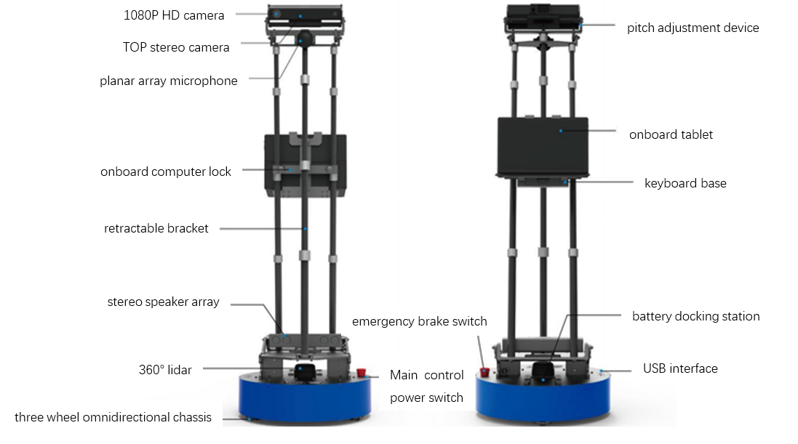
Fig 3.1 Home service robot structure
The chassis of the home service robot is a three-wheeled omnidirectional structure, and the main electrical control systems are also integrated in the chassis. On both sides of the chassis panel are the relevant interfaces and switch buttons of the robot, as shown in Figure 3.2:
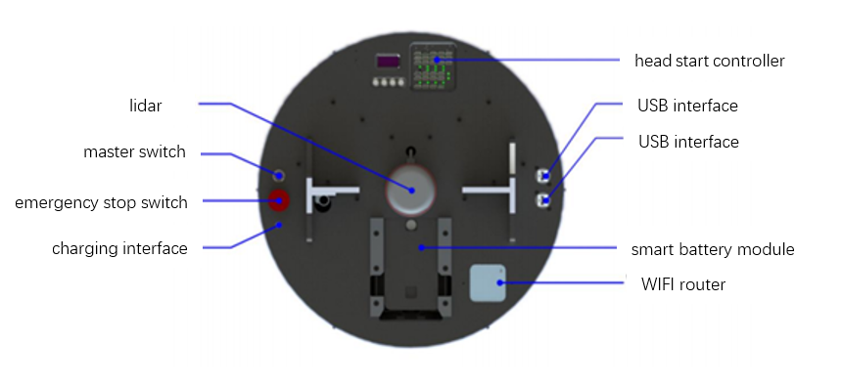
Fig 3.2 Functions of the chassis panel
3.1.1 Motion control
The omnidirectional mobile robots can move in an arbitrary direction without changing the direction of the wheels.[6] The omnidirectional moving mechanism includes omnidirectional wheel, motor, driving shaft system and motion controller. The omnidirectional wheel is the core of the whole movement mechanism. There are many small rollers distributed in the oblique direction of its wheel edge, so the wheel can slip laterally. Depending on the load, the size, area and other factors of the omnidirectional wheel should be considered. Three or four omnidirectional wheels can form the wheel train, driven by the sub-motor, it can complete the motion in any direction of 360° in the plane. Omnidirectional mobile mechanism is common in robot projects that need high flexibility, such as automatic guided vehicle and soccer robot competition.
The movement principle of omnidirectional three-wheeled chassis
In this study, the three-wheeled omnidirectional moving mechanism is used, and the driving wheel of the three-wheeled omnidirectional chassis is generally composed of three completely identical omnidirectional wheels and driven by motors with the same performance. Each wheel is installed in a mirror image with an Angle of 120°, as detailed in Figure 3.3.
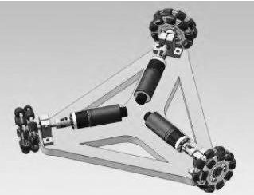
Fig 3.3 three-wheeled omnidirectional chassis
Establish the world coordinate system X 'O' Y ', and then establish the robot's own coordinate system XOY. Let the distance between the centre of the robot and the omnidirectional wheel be a constant L, the angular velocity of the robot itself be, the clockwise is defined as the positive direction of angular velocity, and the velocity of each omnidirectional wheel is Va, Vb, Vc, respectively. The fractional velocity of the robot in its own frame is Vx, Vy. Angle $θ_{1}=\frac{π}{3}$，$θ_{2}=\frac{π}{6}. a$ is the Angle between the two coordinate systems, as shown in Figure 3.4:
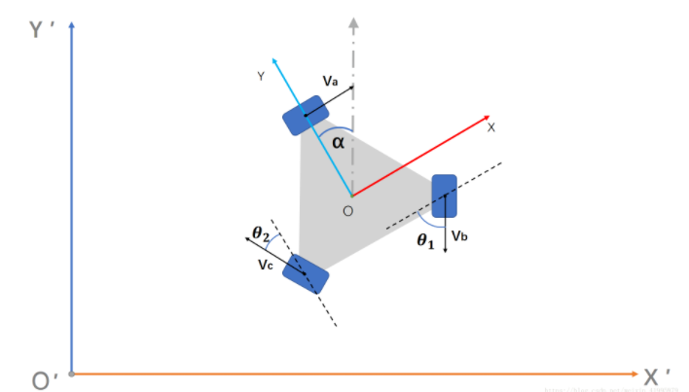
Fig 3.4 World coordinate system and self coordinate system
The following is the calculation of the inverse solution. The so-called inverse solution is that given a velocity vector in the world coordinate system, it is necessary to find out how much speed the three wheels need to give to make the robot reach the velocity vector in the world coordinate system. With simple velocity vector operations we can formulate the following linear system of equations:
$V_{a}=V_{x}+ωL$ （3-1）
$V_{b}=-V_{x}\cos{θ_{1}}-V_{y}\sin{θ_{1}}+ωL$ （3-2）
$V_{c}=-V_{x}\sin{θ_{2}}+V_{y}\cos{θ_{2}}+ωL$ （3-3）
The deformation matrix of this linear equation system is:
$\left[\begin{aligned}V_{a} \\ V_{b} \\ V_{c}\end{aligned}\right]=\left[\begin{matrix} 1 0 & L \\ -\cos{θ_{1}} -\sin{θ_{1}} & L \\ -\sin{θ_{2 }\cos{θ_{2}}} & L\end{matrix}\right]\left[\begin{aligned}V_{x} \\ V_{y} \\ ω\end{aligned}\right]$ （3-4）
Then the rotation matrix from XOY to X 'O' Y 'is the inverse of R($a$) :
${\left[\begin{matrix}\cos{α} & -\sin{a} & 0 \\ \sin{α} & \cos{a} & 0 \\ 0 & 0 & 1\end{matrix}\right]}^{-1}=\left[\begin{matrix}\cos{α} & \sin{α} & 0 \\ -\sin{α} & \cos{a} & 0 \\ 0 & 0 & 1\end{matrix}\right]$ （3-5）
$R^{-1}\left(a\right)=\left[\begin{matrix}\cos{α} & \sin{α} & 0 \\ -\sin{α} & \cos{α} & 0 \\ 0 & 0 & 1\end{matrix}\right]$ （3-6）
So we have:
$\left[\begin{aligned}V_{x} \\ V_{y} \\ ω\end{aligned}\right]=\left[\begin{matrix}\cos{α} & \sin{α} & 0 \\ -\sin{α} & \cos{a} & 0 \\ 0 & 0 & 1\end{matrix}\right]\left[\begin{aligned}V_{x}^{'} \\ V_{y}^{'} \\ ω\end{aligned}\right]$ （3-7）
Substituting Equation (3-7) into Equation (3-4), we obtain:
$\left[\begin{aligned}V_{a} \\ V_{b} \\ V_{c}\end{aligned}\right]=\left[\begin{matrix} 1 0 & L \\ -\cos{θ_{1}} -\sin{θ_{1}} & L \\ -\sin{θ_{2 }\cos{θ_{2}}} & L\end{matrix}\right]\left[\begin{matrix}\cos{α} & \sin{α} & 0 \\ -\sin{α} & \cos{a} & 0 \\ 0 & 0 & 1\end{matrix}\right]\left[\begin{aligned}V_{x}^{'} \\ V_{y}^{'} \\ ω\end{aligned}\right]$ （3-8）
This simplifies to:
$\left[\begin{aligned}V_{a} \\ V_{b} \\ V_{c}\end{aligned}\right]=\left[\begin{matrix}\cos{α} & \sin{α} & L \\ -\cos{θ_{1}\cos{α}}+\sin{θ_{1}\sin{α}} & -\cos{θ_{1}\sin{α}}-\sin{θ_{1}\cos{α}} & L \\ -\sin{θ_{2}\cos{α}}-\cos{θ_{2}\sin{α}} & -\sin{θ_{2}\sin{α}}+\cos{θ_{2}\cos{α}} & L\end{matrix}\right]\left[\begin{aligned}V_{x}^{'} \\ V_{y}^{'} \\ ω\end{aligned}\right]$ （3-9）
3.1.2 Lidar obstacle avoidance
Lidar is a commonly used sensor for ground mobile robots, and its working principle is to use a high-speed rotating laser ranging probe to measure the surrounding 360° distribution of obstacles, as shown in Figure 3.5.
Rotating part
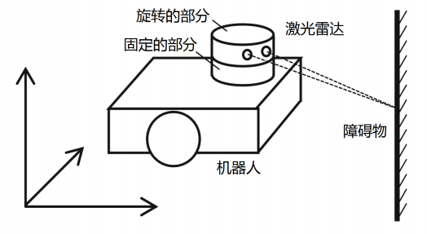
Fixed part
Laser radar
Obstacles
Robot
Fig 3.5 Schematic diagram of the lidar structure
The rotating part of the lidar is equipped with a laser ranging probe, which measures the distance at every certain Angle during the rotation. When it rotates one circle, it can just get a top-down two-dimensional dot map of the contour of the surrounding obstacles, and this dot map is the output value of the lidar, as shown in Figure 3.6.
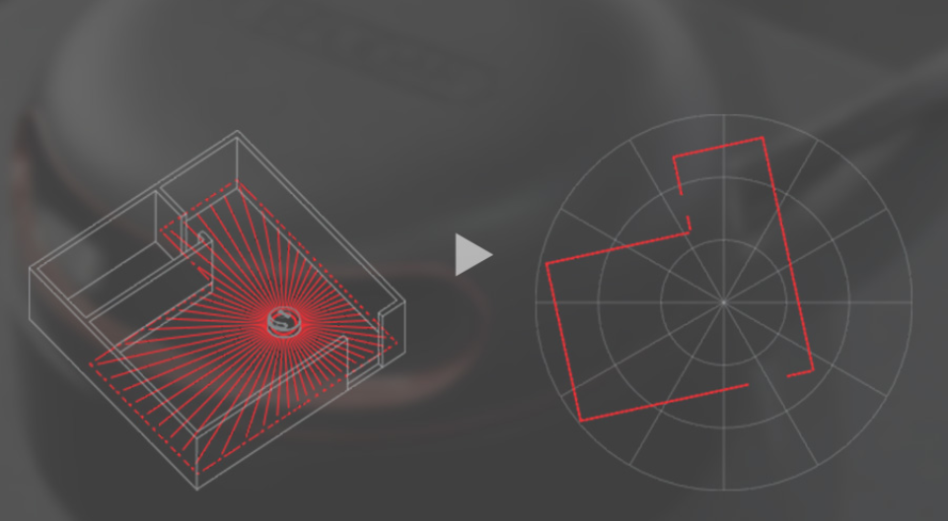
Figure 3.6 generates a contour map from a 360° scan
The home service robot carries the RPLIDAR A2 lidar, which is mounted above the robot's rounded chassis and protected from damage by a carrier bracket. The rotation frequency of the RPLidar A2 lidar is 10 Hz, which is 10 revolutions per second. The scanning Angle is 0° to 360°, and the scanning resolution is 1°, that is, a distance value is measured every 1°, and 360 distance values can be obtained by rotating one week.
3.1.3 SLAM Mapping
The full name of SLAM is "Simultaneous Localization And Mapping", which translates to "real-time positioning and map construction". SLAM was first proposed by Smith, Self and Cheeseman in 1988. Because of its important theoretical and application value, it is considered by many scholars to be the key to realize truly autonomous mobile robots. As a powerful localization system, SLAM is considered to play a key role in making mobile robots truly autonomous.[7] To understand SLAM, it is necessary to understand the characteristics of lidar data. The scanning data of lidar can be understood as a section diagram of the obstacle distribution, which reflects the edge shape and distribution position of the obstacle facing the radar at a specific height. The principle is shown in Figure 3.7.
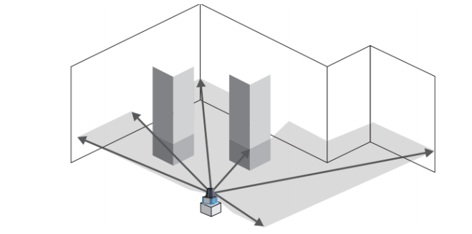
Fig 3.7 Schematic diagram of SLAM mapping
Therefore, when the robot carrying lidar moves in the environment, it can only get the partial contour of the obstacles in a limited range and their relative positions in the robot body coordinate system at a certain time. For example, the following figure reflects the contour of obstacles scanned by lidar of A robot at three adjacent positions A, B and C, as shown in Figure 3.8.
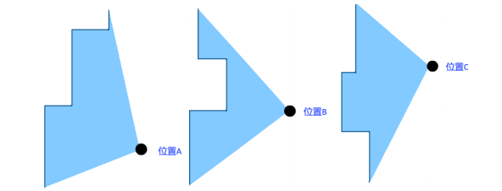
Fig3.8 Obstacle contours scanned by lidar at three positions A, B, and C
Although the relationship between positions A, B and C is not known at this time, as shown in Figure 3.8, it can be found that some parts of the obstacle contours scanned at the three positions A, B and C can be matched and overlapped by careful observation. Since these three positions are relatively close, it is assumed that the similar part of the scanned obstacle contour is the same obstacle, so that the obstacle contour of the similar part can be superimposed and overlapped to obtain a larger obstacle contour pattern. For example, the obstacle contours at positions A and B are superimposed as shown in Figure 3.9:
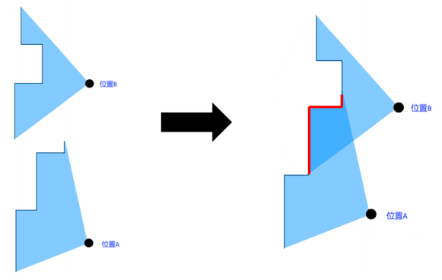
Fig 3.9 overlays Figure A and Figure B
For another example, the obstacle contours at positions B and C are superimposed as shown in Figure 3.10:
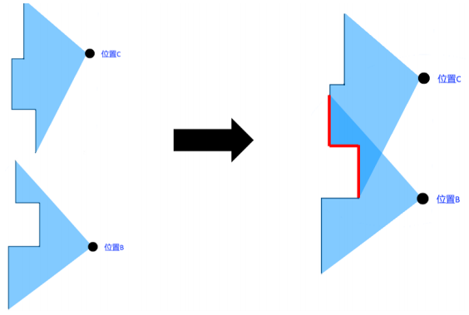
Fig 3.10 overlays the B and C diagrams
According to the above method, a relatively complete planar map can be formed by stitched together the obstacle contours of consecutive multiple positions of lidar scans. This map is a two-dimensional map, which reflects the outline and distribution of obstacles in the whole environment on the scanning surface of the lidar. In the process of building the map, the relationship between the positions that the robot has walked and the position of the robot in the map can also be deduced according to the coincidence relationship of the contour of the obstacles, which completes the two functions of map construction and real-time positioning of the robot. This is where the full name "SLAM" comes from, "Simultaneous Localization And Mapping". Similarly, taking the three locations A, B, and C as an example, by stitching the lidar scan contours of the three locations together, A relatively complete planar map can be obtained, and the position of the three locations in this map can also be obtained, as shown in Figure 3.11:
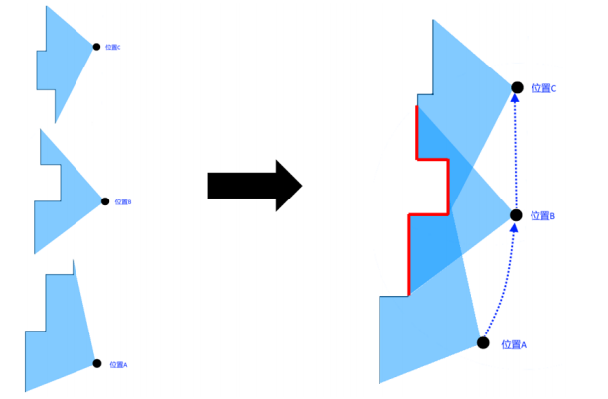
Fig 3.11 Results after stacking the three positions
ROS supports a variety of SLAM algorithms, the mainstream of which are Hector SLAM and Gmapping. Hector SLAM can work only by relying on lidar, and its principle is similar to the method described previously. On the basis of the above methods, Gmapping also incorporates information such as motor code plate odometry, and its mapping stability is higher than that of Hector SLAM. Therefore, we use Gmapping method for mapping in the subsequent research.
3.1.4 Autonomous navigation
The map established by lidar SLAM in this study is a grid map, which is a common map format for indoor mobile robots to navigate. The self-organizing map describes a mapping from a higher dimensional input space to a lower dimensional mapspace.[8] The grid map divides the whole environment into a small grid space arranged horizontally and vertically in a section, and each small space is marked with a different colour to mark the situation of this space. As shown in Figure 4-6, the left figure shows the two-dimensional planar map established by the SLAM algorithm of ROS in Rviz. If you zoom in, the details of the two-dimensional map are as shown in the right figure, which is composed of square grids. White indicates that there are no obstacles in the grid space and the robot can pass through it. Black indicates that there is an obstacle in the grid space and the robot cannot pass through it. Gray indicates that the raster space has not been explored and the passable condition is unknown, as shown in Figure 3.12.
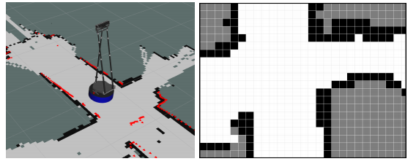
Fig 3.12 Two-dimensional map
With the grid map, the map navigation problem of robot becomes to find the space area that the robot can pass in the grid map and drive the robot to move from the starting point to the end point, which contains two parts of the task: robot localization. The robot needs to know its own location in order to add new information to the map, but the robot may also need a map to determine its own location.[5] In the process of moving, the robot also needs to determine whether its position fits the planned path. Path planning and navigation. The path planning algorithm looks for a passable path in the grid map, that is, a continuous passable grid, extending from the current position of the robot to the destination of the navigation.
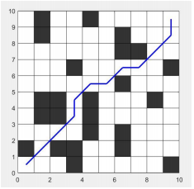
Fig 3.13 Schematic diagram of path planning
In the actual robot path planning, in addition to considering the connectivity of the white traversable grid, it is also necessary to consider the space occupied by the volume of the robot itself. Only when the white traversable grid space is larger than the diameter of the robot chassis, the robot can safely pass. Therefore, a collision safety boundary is usually expanded in the black obstacle domain, and the width of this boundary is the radius length of the robot chassis. Its meaning is: the robot will collide with the obstacle when it is located in this safety boundary. The first notion we consider is static safety, which requires that the robot does not collide with any stationary obstacle.[10] Finally, the traversable path of the robot will avoid this safety boundary and plan in the remaining traversable area. In ROS, when the Navigation system is activated, Rviz shows a light blue safety perimeter around the obstacle grid. The path planning of the robot will avoid the black obstacle grid and the light blue safety boundary, and find a shortest path in the remaining white passable area. The purple curve in Figure 3.14 is the Navigation path planned by the navigation system.
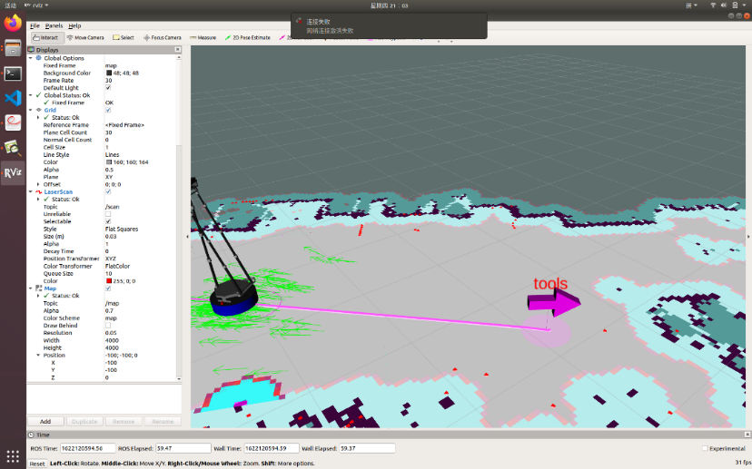
Fig 3.14 Path planning of the laboratory
The Navigation system of ROS is divided into two main parts according to the above functions: AMCL: English stands for "Adaptive Monte Carlo Localization". This is a method of estimating the self-determined position of the robot in a known map using probability theory. This method will assume multiple locations around the possible locations of the robot, and then filter these hypothetical locations according to the information such as lidar and motor code plate odometry during the robot's progress, and gradually eliminate the obvious untrustworthy hypothetical locations, leaving the positioning position with high credibility. For example, the scattered green arrows on the ground in Figure 2.20 are the assumed positions of the robot. At the beginning, there are many green arrows and they are scattered. After several iterations, most particles tend to converge to the real position of the robot and estimate the fine pose of robot.[9] During the movement of the robot, these arrows will gradually converge and eventually converge into one arrow, which is the most credible positioning position of the robot. Move_Base: This is the ROS package that acts as the central hub of the Navigation system. It connects the map, coordinates, path and behavior planner for robot navigation. It also provides an interface for setting navigation parameters. As shown in the figure above, the general workflow of Move_Base is:
1.map_server provides the global map information in the theme "/map", global_costmap obtains the global map information from this theme, and obtains lidar and point cloud information from sensor sources to fuse into a global raster costmap.
2.the global grid cost map is sent to the global_planner for global path planning, and combined with the movement endpoint sent by external nodes to the theme "/move_base_simple/goal" to obtain the purple global movement path.
3.local_costmap intercepts the map within a certain distance around the robot from the global_costmap, and combines the sensor information to generate a local costmap. We use depth data from Kinect sensor and bumper sensor to build a local costmap of the area that the robot is facing.[11]
4.local_planner gets the global path from global_planner, combines the local costmap obtained from local_costmap and the robot position information provided by amcl, calculates the current speed of the robot, and sends it to the topic "/cmd_vel". The robot is driven to move along a global path. As you can see from the above description, ROS Navigation system already contains most of the functions needed for navigation, we only need to provide two pieces of information: the global map needed for navigation, which was generated in the SLAM mapping in the previous section. The moving end point of the navigation, which will be set during the run.
3.1.5 Kinect2.0 RGB-D camera
The head of the home service robot is equipped with a Kinect2 vision sensor, which is a typical RGB-D camera. The full name of RGB-D is "RGB-depth", where "RGB" means "red, green, and blue" and represents a colour image; "Depth" means depth and represents the depth (distance) image. Therefore, RGB-D camera is a composite sensor that can perceive the colour of the object and detect the distance of the object. In the form of the acquired data, it is a colour image, and a dot matrix containing distance information is a 3D point cloud. In this section, we will have a general understanding of the composition of the camera and the shape of the data collected.
Looking at the composition of Kinect2 first, you can see that the body of Kinect2 is a cuboid shape. The front panel of the main body is arranged with several main sensors, from left to right, colour camera, infrared camera, infrared emitter, and point cloud indicator light. Below the main body, there is a long strip of sensors, which is a microphone array containing four uniformly arranged microphones, as shown in Figure 3.15.
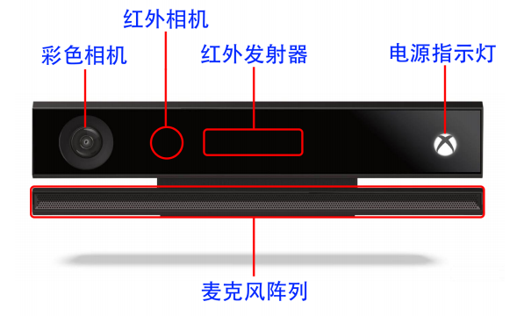
Fig 3.15 External structure of Kinect2
Because the front panel of the Kinect2 is a piece of black plexiglas, it's impossible to see where most of the sensors are when they're not working. After removing the panel, as shown in Figure 3.16, the components can be seen more clearly:
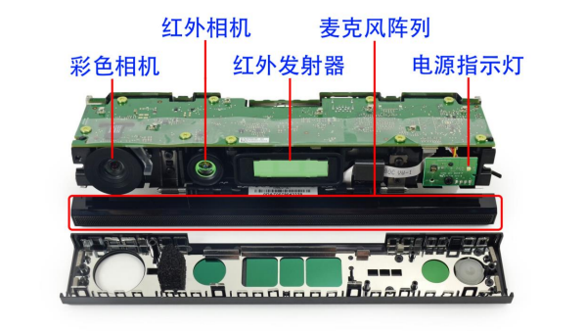
Fig 3.16 Internal structure of Kinect2
Next, the colour camera, infrared camera and infrared emitter combination are mainly introduced.
Colour Camera The colour camera of Kinect2 is an ordinary RGB camera, and the collected data is an ordinary colour image, as shown in Figure 3.17.
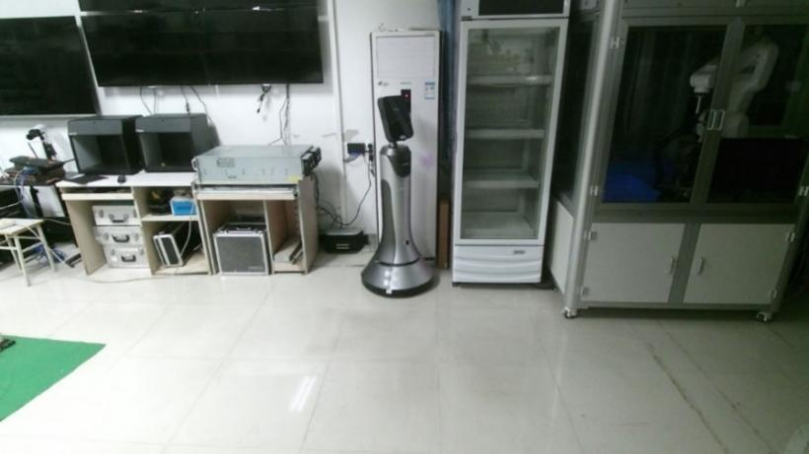
Fig 3.17 Obtaining a picture of the laboratory
Infrared camera and Infrared emitter Kinect2's infrared camera is used with an infrared emitter. The infrared emitter emits an infrared laser, which is reflected by obstacles and received by the infrared camera. By calculating the Time difference between emission and reception, the distance Of infrared laser Flight, that is, the distance between this obstacle point and Kinect2, can be calculated. This imaging method is also called TOF (Time Of Flight), as shown in Figure 3.18. Kinect2's infrared emitters are three array emitters, which can fire many infrared laser beams at the same time, so the final data is a matrix containing the distance of many obstacles.
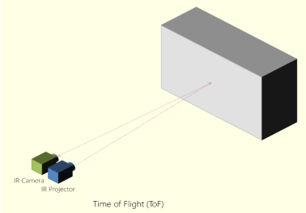
Fig 3.18 Principle of TOF camera
Usually, this matrix is converted into a picture for easy observation, and the colour is used to indicate the distance of each obstacle point, resulting in a complete "depth map", as shown in Figure 3.19.
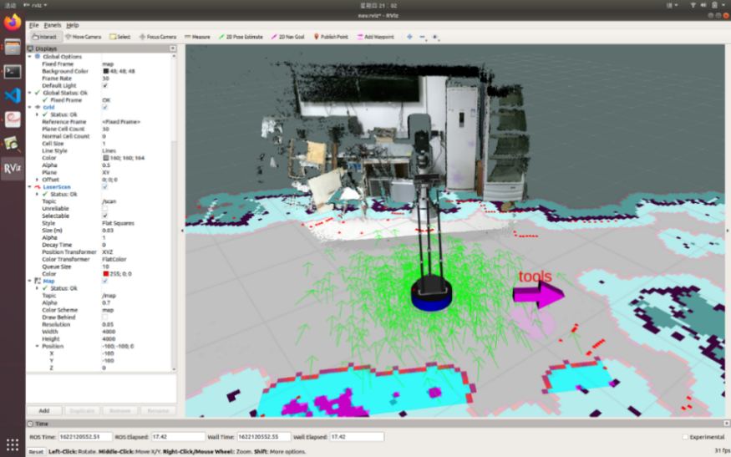
Fig 3.19 Obtaining the depth map of the laboratory
By combining the colour image and the depth map, the obstacle points in the depth map are restored to the three-dimensional space, and then the obstacle points are coloured according to the corresponding pixels in the colour image. A colour point cloud containing both spatial information and colour information can be obtained.
The higher the resolution of the point cloud, the finer the model is displayed, and accordingly, the larger the amount of computation to be processed. In practice, we need to choose the appropriate resolution according to the characteristics of the application. In general, for applications that only need to deal with point clouds (e.g., object detection), use the lowest resolution; If you're working with RGB colour images (e.g., face detection), you'll want to use the highest resolution. Resolution selection is usually done by subscribing to the data topic for that resolution, as shown in Table 3-1.
Table 3.1.Resolution selection table
Topic | Point cloud resolution
Kinect/sd/points | 521×424
Kinect/qhd/points | 960×540
Kinect/hd/points | 1920×1080
3.2 software Methodology
3.2.1 Pre-training dataset
The CIFAR-100 dataset is selected as the pre-training data set in this paper, which has 100 classes and each class contains 600 images. There are 500 training images and 100 test images for each class. The 100 Classes in CIFAR-100 are divided into 20 Superclasses. Each image comes with a class label and a superclass label, such that two labels.
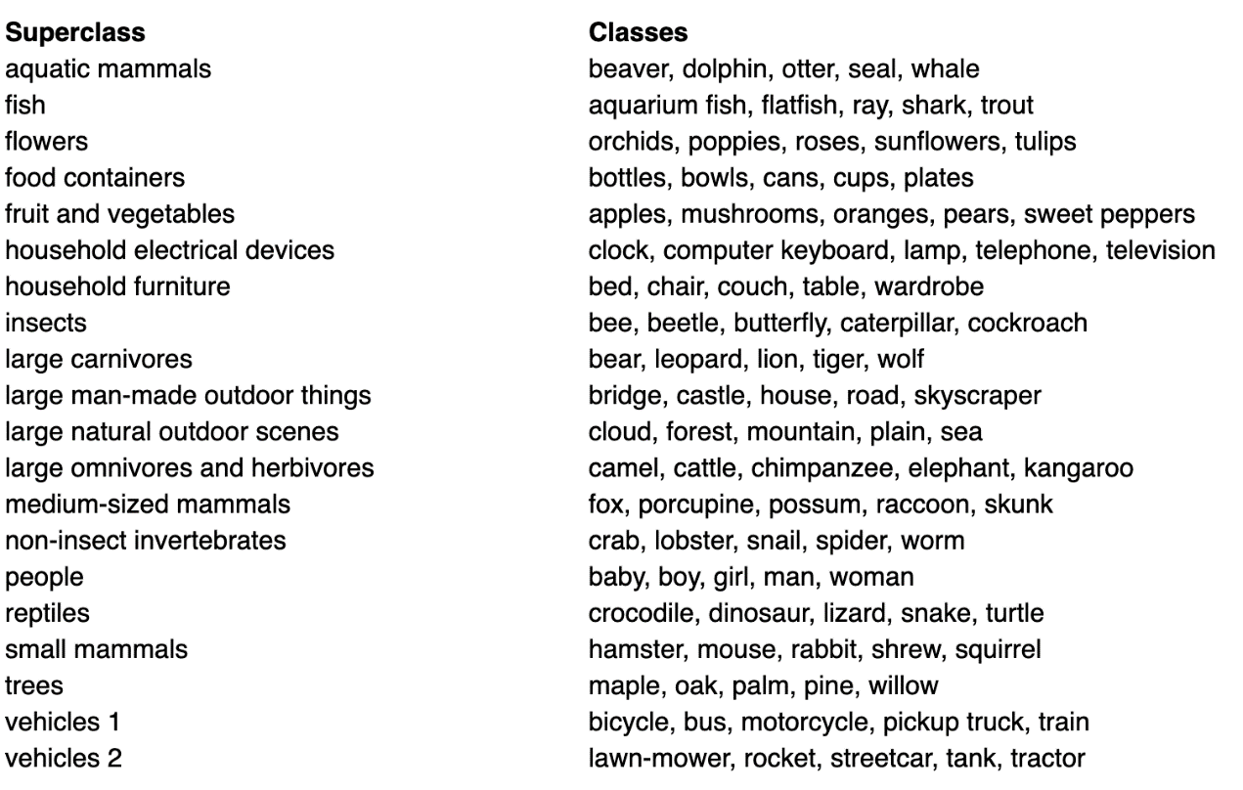
3.2.2 Training dataset
In this study, the UMD Part Affordance dataset produced by the University of Maryland is selected. This dataset contains colour depth data and functional semantic labels of tools and their parts, and collects 17 kinds of household daily tools. The RGB-D information for turner, trowel, tenderizer, spoon, shovel, knife, shear, scoop, scissors, saw, pot, mug, mallet, ladle, hammer, cup, bowl, It is a relatively complete general data set at present. In this study, 17 household daily tools were divided into 17 categories, roughly 7:2: The ratio of 1 is divided into training set, prediction set and validation set, as shown in Table 3-2. In the actual application scenario, colour images are obtained through the RGB-D camera of KinectV2 mounted on the home service robot platform to identify the tools and complete the verification of the model.
Table 3-2 Dataset classification
Label | Training set | Predict set | Validation set | Label | Training set | Predict set | Validation set
Bowl | 1847 | 527 | 265 | Scissors | 1464 | 421 | 209
Cup | 1084 | 314 | 157 | Scoop | 416 | 119 | 60
Hammer | 781 | 224 | 111 | Shears | 428 | 124 | 61
Knife | 2580 | 578 | 290 | Shovel | 298 | 86 | 44
Ladle | 1045 | 302 | 149 | Spoon | 2005 | 574 | 290
Mallet | 799 | 229 | 113 | Trowel | 446 | 128 | 64
Mug | 3813 | 959 | 478 | Turner | 881 | 255 | 128
Pot | 339 | 96 | 50 | Tenderizer | 1619 | 465 | 233
Saw | 624 | 180 | 91 | Total | 20469 | 5581 | 2793
3.2.2 MobileV3(Large)
Network structure
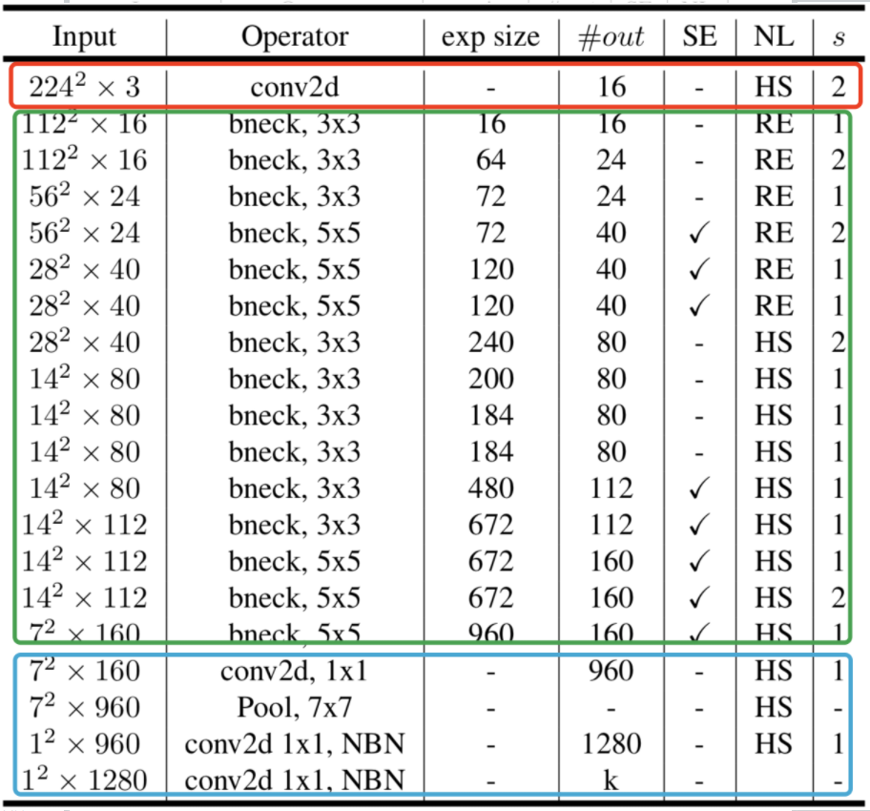
Fig 3.20 MobileNetV3-Large Network structure
As shown in Figure 3.20, the network structure of MobileNetV3 is divided into three stages: the first stage (red square part) : a single convolution layer, which extracts features through 3×3 convolution; The second stage (green box part) : multiple convolutional layers, bneck bottleneck layer plus ReLU and h-swish activation functions to refine features; Final stage (blue box) : We pass two 1×1 convolutional layers instead of fully connected ones to output the classes. The model applied special processing in the second stage. Firstly, the 1×1 convolution was converted from the input channel to the dilation channel. Next, 3×3 or 5×5, inflate the channel, using stride; Finally, the 1×1 convolution, the dilation channel, is converted to the output channel.
Version optimization
In essence, MobileNetV3 is a manual improvement of MnasNet. The main changes are:
1.Redesign the time-consuming layer;
2.Use h-wish instead of ReLU6.
3.Different number of filters used in the extension layer (NetAdapt algorithm is used to obtain the best number)
4.The number of channels output by the bottleneck layer is different (NetAdapt algorithm is used to obtain the best number)
5.Squeeze-and-excitation module (SE) reduces the number of channels by a factor of only 3 or 4
6.For the SE module, instead of using sigmoid, ReLU6(x + 3) / 6 is adopted as the approximation
7.Modify the tail structure to advance avg pooling
For point 1, both MobileNetV1 and V2 start with a regular 3×3 convolutional layer with 32 filters, however experiments show that this is a relatively time-consuming layer and only 16 filters are enough to complete the filtering of 224 x 224 feature maps. This doesn't save many parameters, but it does improve speed. For the second point, before V1 and V2 both used ReLU6 as the activation layer, but in V3, the authors used hard swish(h-swish) as shown in Equation (3-10) :
$h-swish(x)=\frac{x×\operatorname{Re}{LU6\left(x+3\right)}}{6}$ (3-10)
Regular swish uses $x×sigmoid\left(x\right)$ which can significantly improve the accuracy of the neural network, but the calculation of sigmoid is too time-consuming, so here the authors use ReLU6 as an alternative. The authors believe that the optimized implementation of ReLU6 can be used on almost all software and hardware frameworks. Second, it eliminates the potential loss of numerical accuracy due to different implementations of the approximate sigmoid in a particular mode.
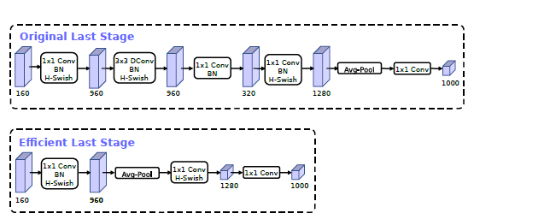
Fig 3.21 Improved methods for the last layer
For the seventh point, in mobilenetv2, before avg pooling, there is a 1x1 convolutional layer, in order to improve the dimension of the feature map, which is more conducive to the prediction of the structure, but this actually brings a certain amount of calculation, so the author modified it here, and put it after avg pooling. First, avg pooling is used to reduce the size of the feature map from 7x7 to 1x1, and then 1x1 is used to increase the dimension, thus reducing the amount of calculation by 7x7=49 times. In addition, in order to further reduce the amount of calculation, the author directly removed the 3x3 and 1x1 convolution of the spindle convolution, which further reduced the amount of calculation and became the structure shown in the second line of Figure 3.21. The model author removed the 3x3 and 1x1 of the convolution, and the accuracy was not lost. Here the slowdown is about 15ms.
Depthwise separable convolutions
Depthwise separable convolution is divided into depthwise convolution and pointwise convolution.
Deep convolution, in the deep operation, the convolution is applied to a single channel at a time instead of all M channels as in a standard CNN. Therefore, the size of the convolution kernel here is D k × D k × 1. Assuming that there are M channels in the input data, M such filters are needed. The size of the output is D p × D p × M. The calculation process is shown in Figure 3.22.
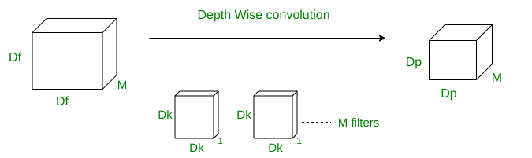
Fig 3.22 Deep convolution calculation process
The convolution kernel slides D p × D p times over all M channels, and the computation of a single convolution operation is D k × D k.
Since the convolution kernel slides D p × D p times over all M channels, the total number of multiplications is equal to M × D p × D p × D k × D k. Therefore, the total number of multiplications for the deep convolution is =M × Dk^2 × D p^2.
Pointwise convolution, in the pointwise convolution operation, a 1×1 convolution operation is applied on M channels. Therefore, the convolution kernel size for this operation will be 1 × 1 × M. Assuming that N such convolution kernels are used, the output size is D p × D p × N, as shown in Figure 3.23.
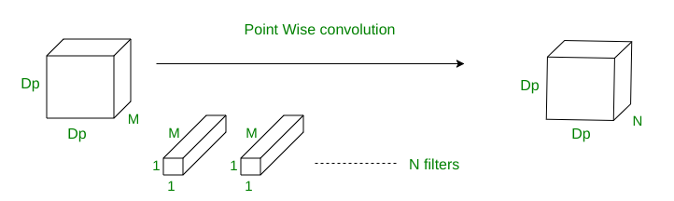
Fig 3.23 Pointwise convolution calculation process
A single convolution operation requires 1 × M multiplications. Since the kernel slides D p × D p times, the total number of multiplications is equal to M × D p × D p × (the number of kernels). Therefore, the total number of multiplications for the pointwise convolution operation = M × D p^2 × N.
Total computation of depthwise separable convolution =M×Dk^2×Dp^2+M×Dp^2×N.
By comparing Figure 3.24 and Figure 3.25, the calculation method and advantages of depth-wise separable convolution and ordinary convolution can be obtained.
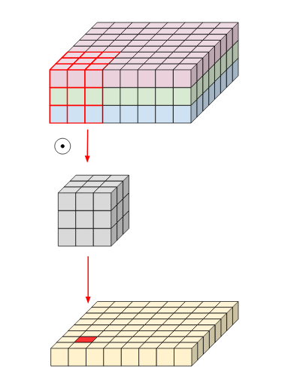 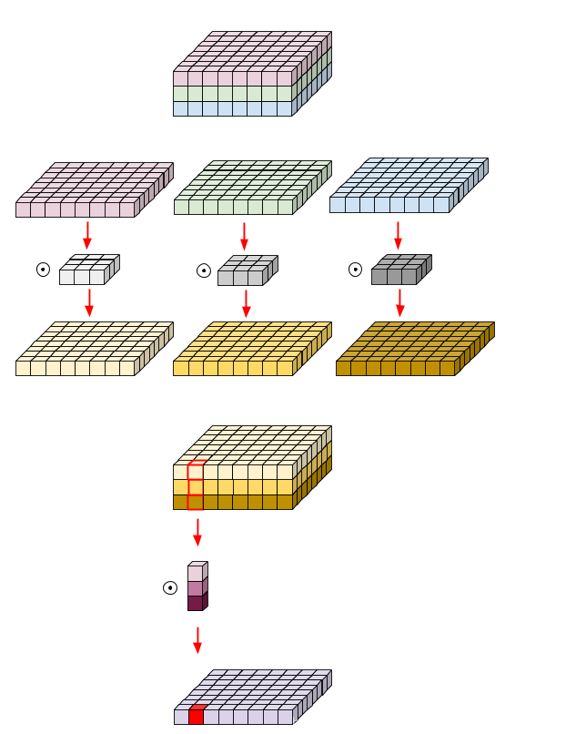Fig 3.24 Ordinary convolution calculation Fig 3.25 Depth separable convolution calculation
CHAPTER 4: DESIGN AND IMPLEMENTATION
4.1 Motion Control
The speed of the robot is controlled by sending a speed message to the robot's core node. This message type is defined in ROS as geometry_msgs::Twist. This message type contains two velocity parts. The first part is linear, which contains x, y, and z values, and represents the robot's speed in meters per second when it is moving forward, backward, left, right, and up and down. The second part is angular, which also contains three values of x, y and z, representing the rotation speed values of the robot in the horizontal front and back axis, the horizontal left and right axis, and the vertical up and down axis. The definition of the rotation direction follows the right-hand rule, and the numerical unit is "radians/second", as shown in Figure 4.1.
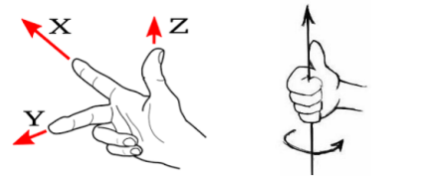
Fig 4.1 Right-handed coordinate system and right-hand rule
The simple motion control code is as follows:
#include <ros/ros.h>
#include <geometry_msgs/Twist.h>
int main(int argc, char×× argv)
{
ros::init(argc, argv, "vel_ctrl");
ros::NodeHandle n;
ros::Publisher vel_pub = n.advertise<geometry_msgs::Twist>("/cmd_vel", 10);
while(ros::ok())
{
geometry_msgs::Twist vel_cmd;
vel_cmd.linear.x = 0.1;
vel_cmd.linear.y = 0;
vel_cmd.linear.z = 0;
vel_cmd.angular.x = 0;
vel_cmd.angular.y = 0;
vel_cmd.angular.z = 0;
vel_pub.publish(vel_cmd);
ros::spinOnce();
}
return 0;
}
1.At the beginning of the code, we include two header files, one for the ros system header and the definition file for the motion speed struct type geometry_msgs::Twist.
2.The body function of a ROS node is int main(int argc, char×× argv), whose parameters are defined as in other C++ programs;
3.In the main function, first call ros::init(argc, argv, "vel_ctrl"). To initialize the node, the third argument is the name of the node.
4.Next, declare a ros::NodeHandle object n and use it to generate a broadcast object vel_pub. The call argument specifies that vel_pub will broadcast geometry_msgs::Twist data in the topic "/cmd_vel". Our control of the robot is achieved through this broadcast form.
5.For continuous sending speed, use a while(ros::ok()) loop with the ros::ok() return value as the loop end condition to allow the loop to exit normally when the program closes.
6.To send the speed value, declare a geometry_msgs::Twist object called vel_cmd and assign the speed value to it. Where: vel_cmd.linear.x is the robot forward and backward translational motion speed, positive value forward, negative value backward, unit is "meters/second"; vel_cmd.linear.y is the robot's left and right translational motion speed, positive values to the left, negative values to the right, the unit is "meters per second"; vel_cmd.angular.z (note that angular) is the robot's rotation speed, positive left turn, negative right turn, in radians per second; The other values do not make sense to the heuristic robot, so they are all assigned zero. Once vel_cmd has been assigned, it is published to the topic "/cmd_vel" using the broadcast object vel_pub. The core node of the robot receives the velocity value from this subject and forwards it to the hardware chassis for execution.
4.2 Realization of radar obstacle avoidance
Motion control and the use of radar to obtain ranging information have been studied in the early stage. The two can be combined to achieve an obstacle avoidance movement based on lidar ranging information. The program logic designed is shown in Figure 4.2:
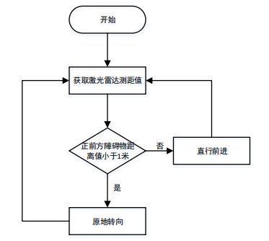
Fig 4.2 Logic diagram of radar obstacle avoidance
According to this idea, after obtaining the lidar ranging information, the distance value of the obstacle in front of the robot becomes the judgment basis for the robot to move. If the distance value of the obstacle directly in front of the robot is less than 1 meter, the robot will turn in place to try to avoid the obstacle until the distance value of the obstacle directly in front of the robot is greater than 1 meter, the robot stops rotating and moves forward in a straight line. The distance value of the obstacle directly in front of the robot, and the ranging Angle of the RPLidar lidar carried by the home service robot are shown in Figure 4.3:
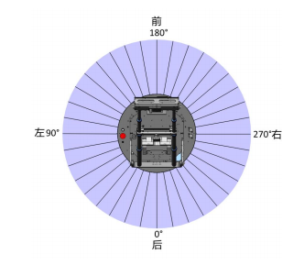
Fig 4.3 Schematic diagram of the radar operation
The scanning Angle range of a lidar rotation is 0° to 360°, and the laser ray Angle directly in front of the robot is the middle value of the scanning Angle range, that is, half of 360° is 180°. When the program is implemented, it is only necessary to use the lidar ranging value in the 180° direction as the judgment basis to control the robot to rotate and go straight.
The code is as follows:
#include <ros/ros.h>
#include <std_msgs/String.h>
#include <sensor_msgs/LaserScan.h>
#include <geometry_msgs/Twist.h>
ros::Publisher vel_pub;
void lidarCallback(const sensor_msgs::LaserScan::ConstPtr& scan)
{
int nNum = scan->ranges.size();

int nMid = nNum/2;
float fMidDist = scan->ranges[nMid];
ROS_INFO("Point[%d] = %f", nMid, fMidDist);
geometry_msgs::Twist vel_cmd;
if(fMidDist > 1.0f)
{
vel_cmd.linear.x = 0.05;
}
else
{
vel_cmd.angular.z = 0.1;
}
vel_pub.publish(vel_cmd);
}
int main(int argc, char×× argv)
{
ros::init(argc,argv,"behavior_node");

ROS_INFO("behavior_node start!");
ros::NodeHandle nh;
ros::Subscriber lidar_sub = nh.subscribe("/scan", 10, &lidarCallback);
vel_pub = nh.advertise<geometry_msgs::Twist>("/cmd_vel",10);
ros::spin();
}
1.The beginning of the code includes four headers: ros.h is the ros system header; String.h is a character-based custom file for text output. LaserScan.h is the lidar data format definition file used to load the radar data. h is the format definition file of the machine motion speed message packet, and the corresponding Twist message packet format is as follows: where linear is the linear component of the motion control, that is, the component of the robot moving in a straight line, and angular is the component of the robot rotating motion. Both components are Vector3, whose structure is defined as follows: The Vector3 type contains three floating-point numbers: x, y, and z. For linear, x, y, and z correspond to the velocity components along the X -, Y -, and z-axes in meters per second. For angular, x, y, and z correspond to the rotation velocity components with the X, Y, and Z axes as the rotation axes, and the component values are in radians per second.
2.The program then defines a publishing object vel_pub that will be used to send velocity control message packets to the robot core node.
3.Define a callback function called void lidarCallback() to process the lidar data. The callback function is automatically invoked once every frame of lidar data is received by ROS. The radar range is passed as an argument to this callback function.
4.In the void lidarCallback() callback function, the scan argument is a packet of sensor_msgs::LaserScan data in the following format: The float32[] ranges array contains the lidar range values. The home service robot is using the RPLidar A2 lidar, which measures 360 range values in one rotation, so in our code, ranges is a 360-member range array. According to the program logic, what we need is the ranging value directly in front of the robot. According to the installation position of the lidar on the robot, the scanning Angle of the lidar is shown in the following figure: From the figure, we can see that the laser ray Angle directly in front of the robot is the middle value of the scanning Angle range, and we define a variable nNum to get the number of members in the ranges array. Define another variable nMid, the value is half of nNum, the lidar scan line sequence corresponding to nMid is the scan line in front of the robot, and the value taken from the ranges array with nMid as the index is the radar range value in front of the robot. We store this ranging value in the variable fMidDist. The number in fMidDist is a decimal number in meters. We use ROS_INFO() to display the radar range value fMidDist directly in front of the robot into the terminal program for easy observation and debugging. We define a geometry_msgs::Twist message packet vel_cmd to hold the robot motion controls we want to send, and then assign different values to vel_cmd depending on the value of fMidDist. When fMidDist is greater than 1.0, that is, when the distance between the obstacles directly in front of the robot is greater than 1 meter, we assign a value of 0.05 to x for vel_cmd and control the robot to move slowly forward at a speed of 0.05 m/s. When fMidDist is not greater than 1.0, that is, when the distance of the obstacle directly in front of the robot is less than or equal to 1 meter, we assign a value of 0.1 to z of vel_cmd and control the robot to rotate in place to the left at a speed of 0.1 radians/s. After assigning the value of vel_cmd, it publishes its publish to the relevant topic through vel_pub. The core node of the home service robot will get this data packet from the topic and carry out motion control to the robot chassis according to the speed we assigned.
5.In the main() function, call ros::init() to initialize the node.
6.Call ROS_INFO() to output string information to the terminal program indicating that the node started normally.
7.Define a ros::NodeHandle node handle nh and use this handle to subscribe to the ROS core node for the "/scan" topic. The callback function is set to the previously defined lidarCallback().
8.Use the node handle nh to initialize vel_pub to post speed control messages on the topic "/cmd_vel". The core node of Headstart ROS will get the message posted by vel_pub from this topic and control the robot's base to execute the speed value in the message packet.
9.Call ros::spin() to block the main() function so that the program doesn't finish exiting this node.
4.3 Using SLAM to achieve mapping
1. Connect the USB Type-C of the home service robot to the onboard tablet.
2. open the USB power switch on the robot chassis (press down, the blue light is on).
3. Connect the remote control handle to the USB interface of the robot.
4. Open the red emergency stop switch of the robot (rotate along the direction of the arrow on the button and let it bounce off). The chassis motor will be in the state of power-up lock, and the robot will feel resistance when forced to push.
5. On the airborne tablet, launch the Terminal application by clicking the "Terminal" icon from the launch bar on the left side of the Ubuntu desktop (you can also launch it by pressing the keyboard key combination "Ctrl + Alt + T" at the same time).
Enter the following command: roslaunch wpb_home_tutorials gmapping.launch
Rviz will be started after the enter is confirmed. You can see in Rviz that the ground reference around the robot turns dark gray, while a white scanning area appears under the robot's feet.
6. Operate the handle, remotely control the robot to move in the scene and observe the change of colour area in Rviz, as shown in Figure 4.4.
(1) The left rocker of the handle controls the translation vector of the robot motion. The upper and lower control the forward and backward movement respectively, and the left and right control the lateral translation respectively;
(2) The rocker on the right side of the handle controls the rotation vector of the robot motion. Turning to the left is turning left, and turning to the right is turning right. The white area is increasing, and it is getting closer and closer to the contour of the static obstacles such as the surrounding walls and tables.
7. The remote-controlled robot can save the map after it has moved around the field for one circle, which will be used in the future for autonomous navigation. When you save a map, you need to keep the Gmapping program running and not close the Rviz interface where the plot is being built. Launch the Terminal application by clicking the "Terminal" icon from the launch bar on the left side of the Ubuntu desktop (this can also be done by pressing the "Ctrl + Alt + T" keyboard combination simultaneously). Enter the following: rosrun map_server map_saver -f map Press Enter to confirm the save. After saving, you will find two new files in the "main file directory" of Ubuntu, one named "map.pgm" and the other named "map.yaml". Where "map.pgm" is the image format, double-click to view the file content, you can see the built map, as shown in Figure 4.5.
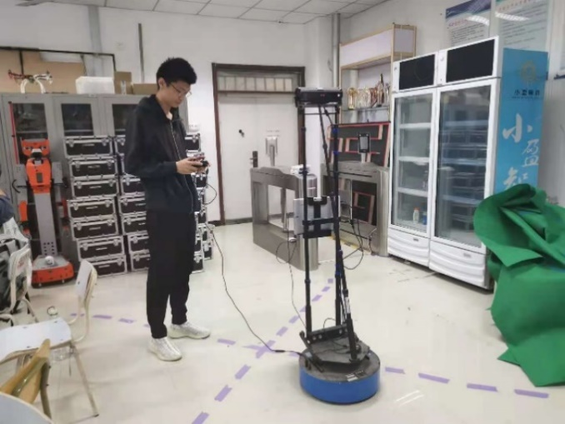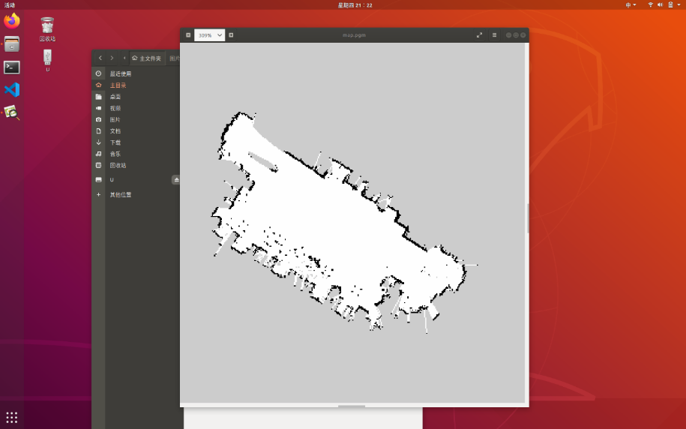
Fig 4.4 Mapping process Fig 4.5 map.pgm file
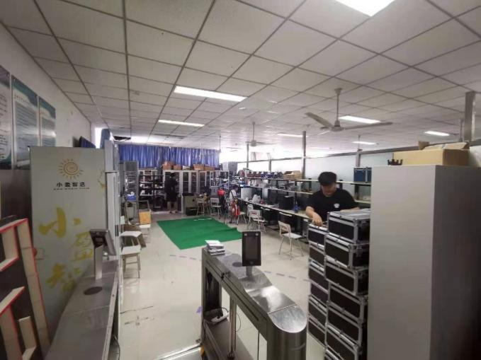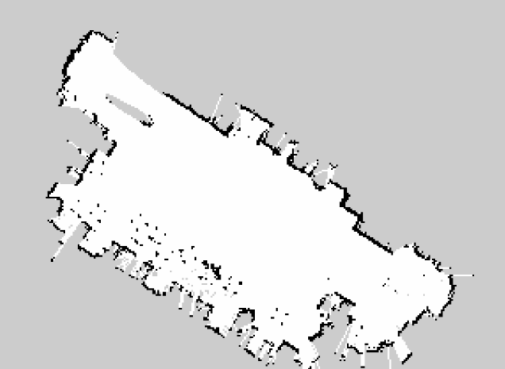
Fig 4.6 Lab real photo (left) and generated map (right)
It is easy to see from the figure that the generated map is very similar to the actual effect. Tables, chairs and refrigerators are all represented by black dots or black lines. The outline of the room is also roughly similar to that generated by the map.
4.4 Implementation of Navigation.
1. Connect the USB Type-C of the home service robot to the onboard tablet.
2. open the USB power switch on the robot chassis (press down, the blue light is on).
3. Open the red emergency stop switch of the robot (rotate along the direction of the arrow on the button to let it spring up), and the chassis wheel is locked.
4. Open File Manager by clicking the "File Manager" icon from the launch bar on the left side of the Ubuntu desktop. Copy both "map.pgm" and "map.yaml" files from the "main file directory" to the working directory "catkin_ws/src/wpb_home/wpb_home_tutorials/maps".
5. Click the "Terminal" icon from the launch bar on the left side of the Ubuntu desktop to launch the terminal program (you can also press the keyboard key combination "Ctrl + Alt + T" at the same time to launch). Enter the following command: roslaunch wpb_home_tutorials nav.launch Press Enter, and Rviz will be launched. You can see the model of the robot in the map we created earlier. You can see that around the original black pattern (the outline of the static obstacle), a blue ribbon appears, which represents the safety boundary, and the width of the ribbon is roughly equal to the radius of the robot. This means that if the robot enters this ribbon, it is likely to collide with static obstacles (walls or legs of chairs and tables), and this safety boundary will be used when the robot plans its path.
6. When Rviz is first started, the default position of the robot is the starting point of the map, which is the place where the robot starts when building the map. At the beginning of the navigation, there is a high probability that the robot in the real world will not be at the position from which the robot started in the previous mapping. This can also be judged by observing whether the red lidar data points and static obstacle contours in Rviz fit. If there is a discrepancy between the real world robot position and the one shown in Rviz, you need to correct this before navigating: click the "2D Pos Estimate" button in the toolbar at the top of the Rviz screen, and then click the real robot position in the Rviz map. At this point, a big green arrow will appear, representing the orientation of the robot in its initial position. You can control the direction of the green arrow by holding down the mouse button and dragging the circle across the screen. Drag the green arrow in Rviz, select the orientation, release the button, and the robot model will be positioned at the location of our choice. The initial position of the virtual robot is adjusted continuously until the red lidar data point and the contour of the static obstacle roughly fit.
7. After setting the initial position of the robot, you can start to specify the target place for the robot to navigate. Click the "2D Nav Goal" button in the bar at the top of the Rviz screen, then click the navigation goal point on the map in Rviz (usually selecting a location in the white area). The green arrow will appear again, and as before, you can set the orientation of the robot as it moves to the end point by holding down or dragging the circle. After selecting the target orientation, release the click, and the global planner will automatically plan a purple path that starts from the current point of the robot, bypassing the blue safety boundary, and ends at the moving target point. After the path is planned, the robot in the real world will start moving along this path until it reaches the end point.
4.5 Speech output
In ROS, we provide a package called sound_play, which is based on the Festival project at Carnegie Mellon University, and is used to make the robot speak by synthesising string messages into speech. Download it to your workspace and create a new "speak_node.cpp".This section will use a demo to illustrate the use of speech output. The code is as follows:
#include <ros/ros.h>
#include <sound_play/SoundRequest.h>
int main(int argc, char×× argv)
{
ros::init(argc, argv, "speak_node");
ros::NodeHandle n;
ros::Publisher tts_pub= n.advertise<sound_play::SoundRequest>("/robotsound", 20);
ros::Rate r(0.2);
while(n.ok())
{
sound_play::SoundRequest sp;
sp.sound = sound_play::SoundRequest::SAY;
sp.command = sound_play::SoundRequest::PLAY_ONCE;
sp.volume = 1.0;
sp.arg = "hello world";
tts_pub.publish(sp);
r.sleep();
}
return 0;
}
The beginning of the code includes two headers: ros.h is the ros system header and SoundRequest.h is the speech
The format definition file for the synthesized message packet.
At the beginning of the program, two objects are defined: spk_pub is the publisher of the spoken output message, and strSpeak is a string-format object that serves as the data structure carrier for the spoken output.
In the main() function, call ros::init() to initialize the node.
Define a ros::NodeHandle node handle n and use it to generate a publishing object called tts_pub that will send a message to the topic "/robotsound" in the form of sound_play::SoundRequest. The sound_play speech synthesis package takes messages from this topic and converts the strings into speech data to drive the bot to speak. So the program we wrote only needs to send message packets to this topic to achieve the function of letting the robot talk.
5.Use a while(ros::ok()) loop to make the robot keep talking at a frequency determined by the constructor parameter of the ros::Rate object r. Here we give a frequency parameter of 0.2, which means the robot is talking at 0.2Hz. Say 0.2 times per second, which is one speech per 5 seconds. The while loop ending with the ros::ok() return value allows the loop to exit normally when the program closes.
6.Declare a message object sp of type sound_play::SoundRequest and assign both the spoken message and the playback Settings to it. Where: sp.sound is the type of spoken content provided and is set to sound_play::SoundRequest::SAY to say that the utterance is converted from a string to speech. Command is to set the mode of voice playback, set to sound_play::SoundRequest::PLAY_ONCE
This means that only one speech is played at a time. sp.volume is the volume at which the speech is played, and the range from 0 to 1 indicates that the volume is from minimum to maximum. sp.arg is the content of the voice playback, which is set to "hello world" here, but can also be set to other content. Note that sound_play only supports English, so the speech must be in English.
7.Once the sp is assigned, use the broadcast object tts_pub to publish it to the topic "/robotsound" to drive the robot to vocalize.
8.Call r.loop () to pause the while loop for a period of time.Set the loop to run at 0.2Hz, or every five seconds.
4.6 model build
According to the previous investigation, in the selection of model, it is necessary to avoid using a network with a large network depth for direct training, which will lead to a long training cycle, the parameters cannot be modified in time during training, and the large model file will lead to a timely prediction when the model is transplanted to the home service robot platform. In competitions or daily services, a fast response is needed. Therefore, it is necessary to consider the accuracy of recognition, but also have good robustness, portability, and be able to adapt to object recognition in various environments. In terms of data sets, training models with good practicability require a large amount of data to train, but this time we use a small training set, 17 categories, a total of about 30,000 images, so we use pre-trained model parameters. After consulting information and combining with my own experience and the advice of my tutor, I finally used the lightweight neural network MobileNetV3 for model training. Because the data set for training is small, the MobilenetV3-CIFAR100-large model was used as the pre-training model, and the transfer learning was used. The weights of the trained model are loaded into the 17 classification models in this study. In the training process, a breakpoint method is used to modify the optimizer that is more suitable for the present stage, so as to avoid the training results falling into local optimal solutions or over-fitting. Finally, an object recognition model with good generalization ability is obtained based on deep learning, computing power and storage capacity of home service robot platform.
The MobileNetV3-Large network model was used to load the MobileNetV3-Large weight parameters of pre-trained cifar100, and the hyperparameters were set as follows: Batch data of 256 images each time, 200 total training times, the initial value of the learning rate is 0.001, and the learning rate adjustment method of index adjustment and multi-stage decay is used. The breakpoint appears in 28 training times and 62 training times, and the first breakpoint is as follows: The optimizer parameters were adjusted, the Adam optimizer was switched to the SGD optimizer, and the training model was loaded 28 times for subsequent training. The second breakpoint does the following: tuning the optimizer parameters. The SGD optimizer is switched to the RMSprop optimizer, and the trained model is loaded for 62 times, and the subsequent training is carried out until the end.
Analysis of model results
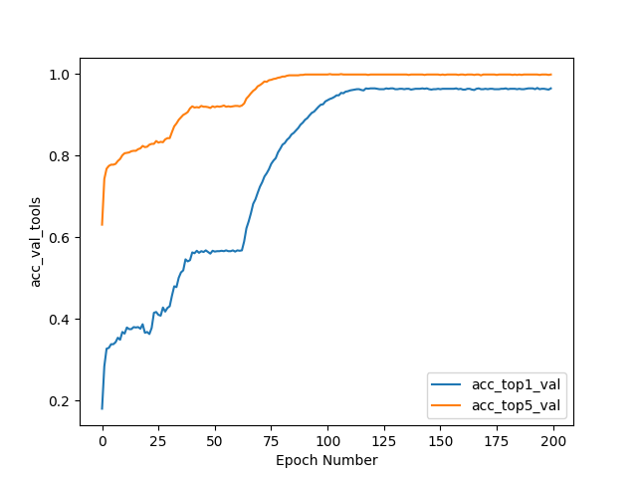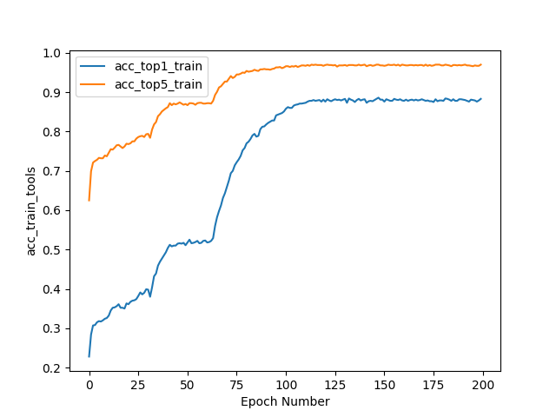
Fig 4.7 Train set accuracy Fig 4.8 Validation set data
It can be seen from Figure 4.7 that the accuracy of the training group is obviously ladder-shaped through breakpoint debugging. The first step is from 0 to 28. The Adam optimizer is used, and the accuracy increases from 0 to about 0.4 and stays near 0.4. The second step is from 28 to 62, the accuracy rises from 0.4 to about 0.5 and remains near 0.5. Although it passes the local minimum value of the first part, it falls into the local minimum value again around 0.5 after 35 training times, and the effect is not very good, so the second breakpoint debugging is performed. Adjusting the optimizer to RMSprop optimizer, the effect has been significantly improved. The third step is from 62 to the end of training, the accuracy has increased from 0.5 to 0.9, and the final training results begin to converge after 125 iterations.
It can be seen from Figure 4.8 that the accuracy of the validation group is obviously ladder-shaped through breakpoint debugging. The first step is from 0 to 28. The Adam optimizer is used, and the accuracy increases from 0 to about 0.4 and stays near 0.4. The second step is from 28 to 62, and the accuracy rises from 0.4 to 0.6 and stays near 0.6. Although it passes the local minimum value of the first part, it falls into the local minimum value again around 0.5 after 35 training times, and the effect is not very good. The optimizer is adjusted to the RMSprop optimizer, and the effect has been significantly improved. The third step is from 62 to the end of training, and the accuracy is increased from 0.6 to about 0.95.
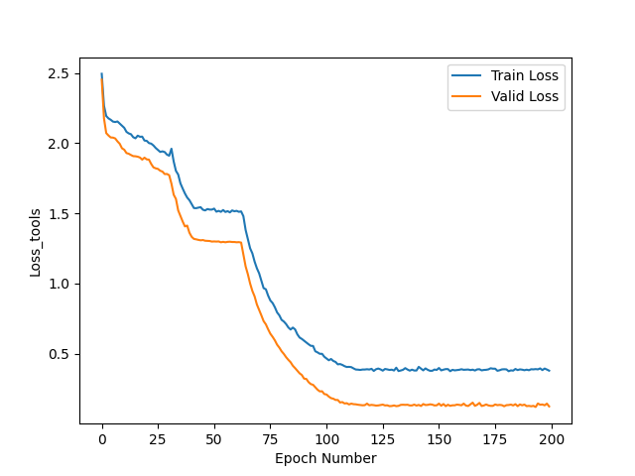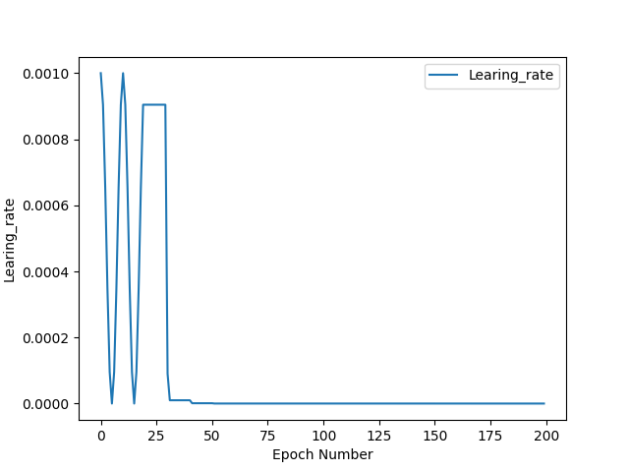
Fig4.9 Loss value Fig4.10 Learning rate
It can be seen from Figure 4.9 that through breakpoints debugging, the loss values of the training group and the validation group obviously form a staircase. The first step is from 0 to 28. With Adam optimizer, the loss value of the training group drops from 2.5 to about 2.0 and stays near 2.0. The loss value of the validation group decreased from 2.5 to about 1.75 and remained near 1.75. The first breakpoint debugging was started, and the optimizer was adjusted to the SGD optimizer. The second step was from 28 to 62, and the loss value of the training group decreased from 2.0 to about 1.5 and remained near 1.5. In the validation group, the loss value dropped from 1.75 to 1.25 and remained around 1.25. Although it crossed the local minimum value of the first part, it fell into the local minimum again after 35 training times, and the effect was not very good. The effect has been significantly improved. The third step is from 62 to the end of the training stage, the loss value of the training group decreases from 1.5 to about 0.4, and the loss value of the validation group decreases from 1.25 to about 0.2, and the final training results begin to converge after 125 times.
It can be concluded from Figure 4.10 that there are many adjustments to be made in the early training, which leads to the oscillation of the value of the learning rate. With the improvement of the accuracy and the decline of the loss value, the value gradually flattens out, and finally the number of training per time is 0.99 times that of the last time.
Through the breakpoint training, the parameters can be modified in time to avoid falling into the local optimal solution in the training process. The overall training process is good, the accuracy of TOP1 in the training group is about 90%, the accuracy of TOP5 is 97%, the accuracy of TOP1 in the validation group is about 96%, and the accuracy of TOP5 is close to 100%. The loss value of the training group is controlled below 0.5, and the validation group is lower than 0.2. It starts to converge in 125 out of 200 iterations, and the overall effect is very impressive.
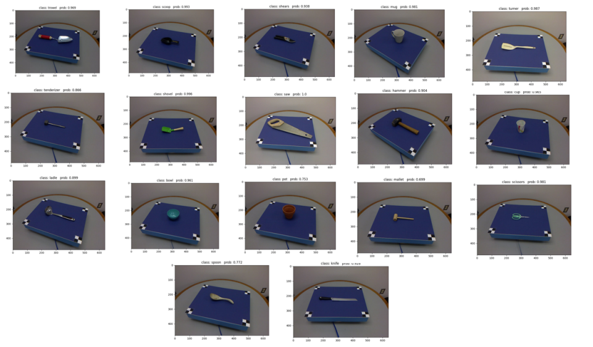
Fig 4.11 Typical test results
Tab 4-1 Typical test results
category | Predicted value | category | Predicted value | category | Predicted value
Trowel | 0.969 | Tenderizer | 0.866 | Ladle | 0.899
Scoop | 0.993 | Shovel | 0.996 | Bowl | 0.961
Shears | 0.938 | Saw | 1.000 | Pot | 0.753
Mug | 0.981 | Hammer | 0.904 | Mallet | 0.699
Turner | 0.987 | Cup | 0.965 | Scissors | 0.981
Spoon | 0.772 | Knife | 0.928
CHAPTER 5: RESULTS AND DISCUSSION / EVALUATION
5.1
The home service robot platform is equipped with Ubuntu16.04, but it does not have the python model framework itself. To port the model to this platform, we need to load the Python part of the environment trained on the Window platform to the Ubuntu system.
Step 1: Create an anaconda3 folder inside your main folder to store our subsequent downloads and configuration environment.
Step 2: Download the.sh file of Anaconda3 through the Tsinghua image source. By default, it is downloaded to the donloads file directory, and the file with the suffix.sh is copied into the anaconda3 folder, as shown in Figure 5.1.
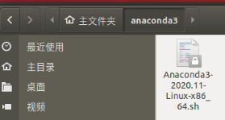
Fig 5.1Download the.sh file to the anaconda3 folder
Step 3: Launch the Terminal application by clicking the "Terminal" icon from the launch bar on the left side of the Ubuntu desktop (this can also be done by pressing the keyboard key combination "Ctrl + Alt + T"). Type the following command: cd /anconda3 and enter bash anaconda3-4.2.0-linux-x86_64.sh. Follow the prompts to install Anaconda3 and add environment variables, as shown in Figure 5.2.
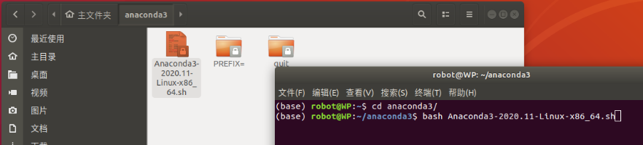
Fig 5.2 Input instruction
Step 4: create an environment to run the models identified by the tool, open a terminal and enter the following command: conda create-n tools python=3.6. Create an environment called: tools, as shown in Figures 5.3 and 5.4.
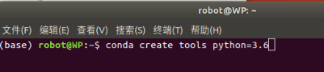
Fig 5.3 Creating the environment
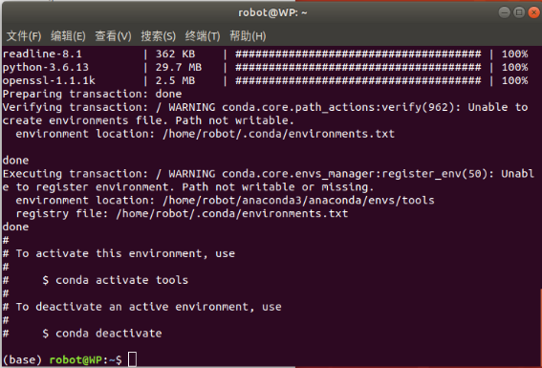
Fig 5.4 Creation completed
Step 5: Create a tools folder under the main folder and copy the trained model, the prediction code, and the json file of the class names read into it as shown in Figure 5.5.
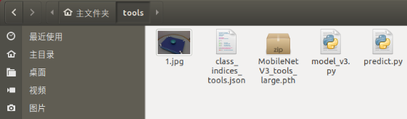
Fig 5.5 Put the prediction file in the tools folder
Step 6: Run the prediction code in the created environment, and find the missing library files. install the library files into the tools environment via pip install method, as shown in Figure 5.6.
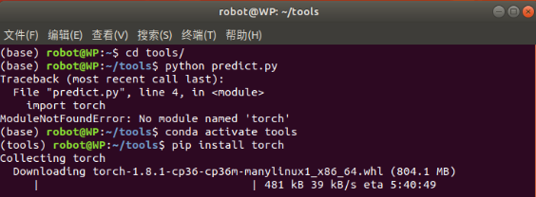
Fig 5.6 pip install installs the libraries
Step 7: Successfully run the prediction file and the output is very accurate, indicating that the model trained on the Windows system is successfully transplanted to the home service robot and runs correctly, as shown in Figure 5.7.
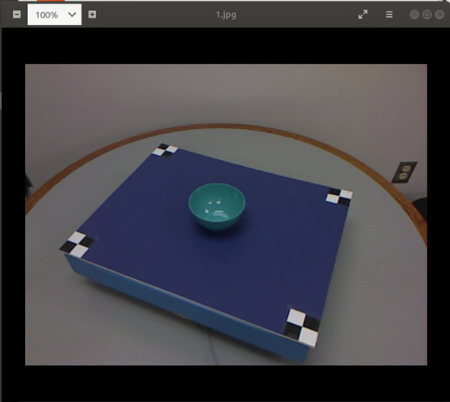
Fig5.7 Test images and porting results
5.2 Final result
Since the final results cannot be presented in the form of video in the paper, the following will be described in the form of text and pictures, the operation process of tool recognition for the environment cognition research platform of home service robot.
Step 1: Establish the map of the laboratory environment by the method of Gmapping, as shown in Figure 5.8.
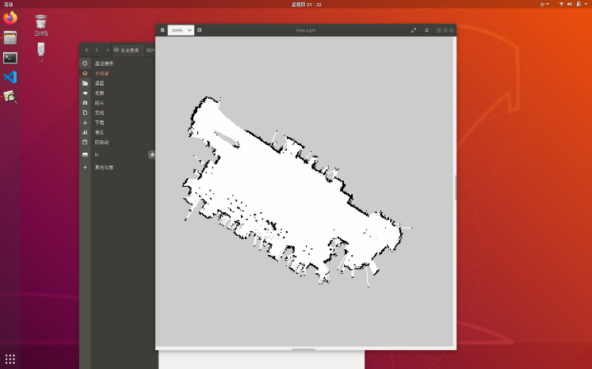
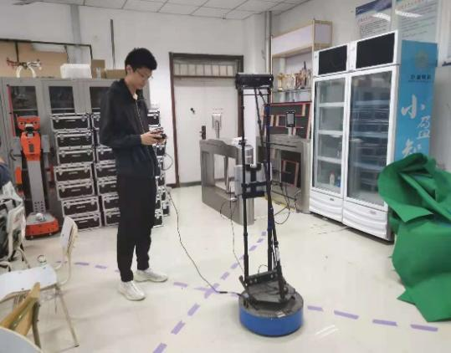

Fig 5.8 Mapping with Gmapping
Step 2: Set up the navigation point. Set up the navigation point to identify the location :tools and the master's navigation point: maste in the determined place, as shown in Figure 5.9.
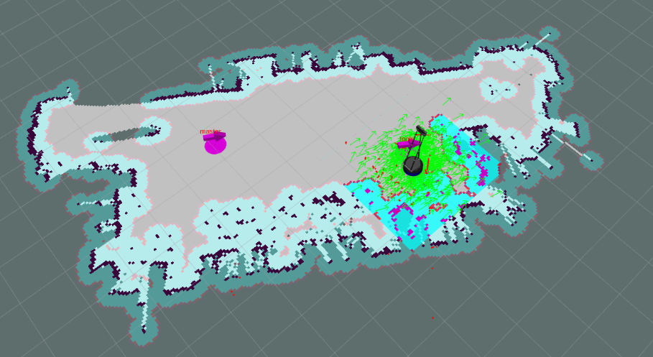
Fig5.9 The pink logo on the left is master, and the right is tools
Step 3: Place the object to be recognized at the recognition position, as shown in Figure 5.10.
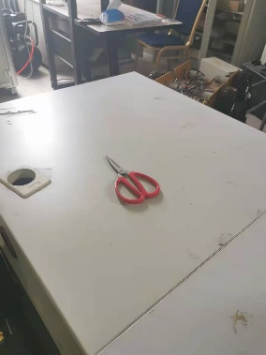
Fig 5.10 Place the object to be recognized
Step 4: Open the recognition program and reposition the robot in the Rviz program. Click 2D Pose Estimate to select the reset point and the machine orientation direction, as shown in Figure 5.11 and Figure 5.12.
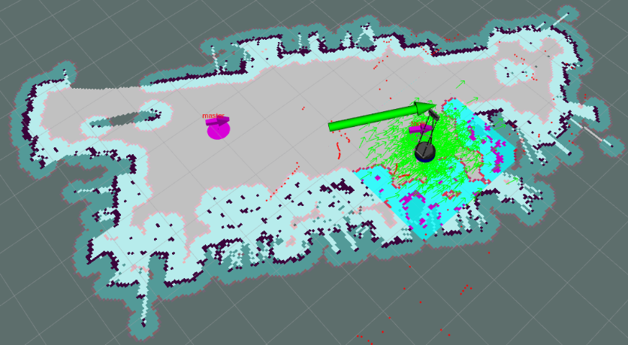
Fig 5.11 Select the reset point and the machine orientation
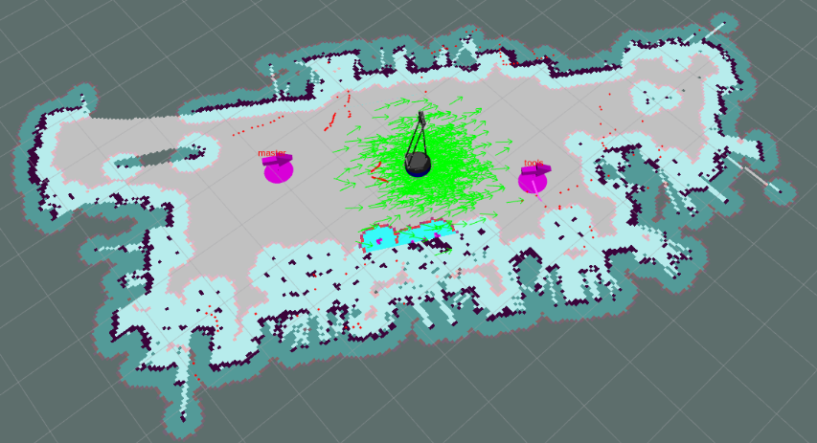
Fig 5.12 Reset successfully
Step 5: Turn on the red emergency stop switch of the robot, so that the robot is powered on and starts to execute the recognition program.
Step 6: The robot naviifies autonomously to the tools point, as shown in Figure 5.13.
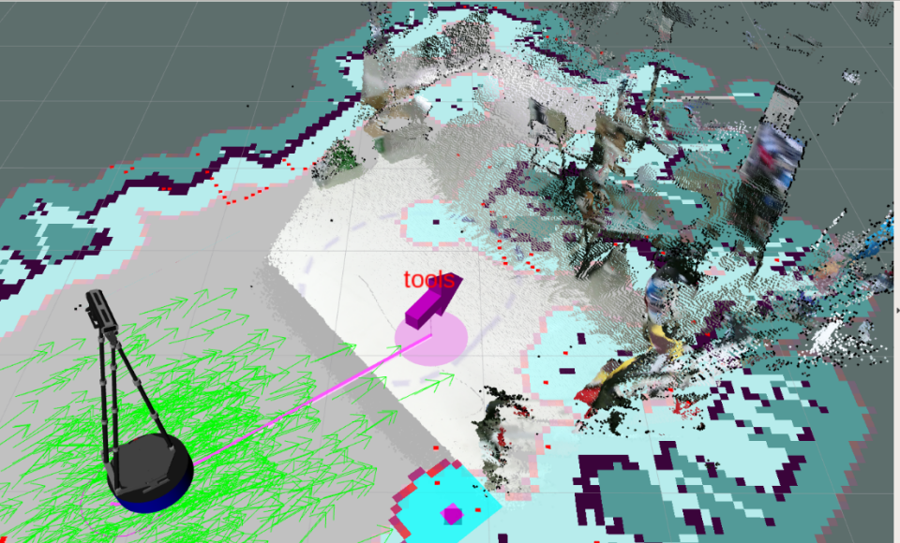
Fig 5.13 The robot goes to the tools navigation point
Step 7: Get the picture, voice broadcast: "Start object recognition", tool recognition.
Step 8: Start returning to the master point, as shown in Figure 5.14.
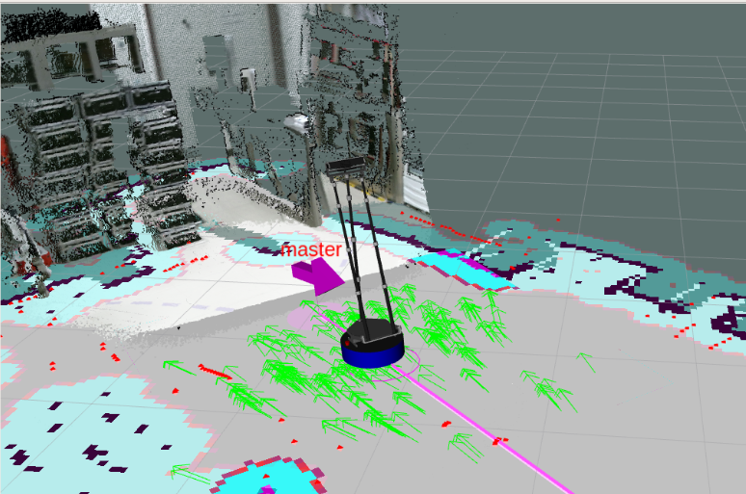
Fig 5.14 The robot goes to the master waypoint
Step 9: Broadcast the speech result: "The object is scissors", and the recognition is completed. Figure 5.15 below the image acquired by the robot, the result of manual recognition.
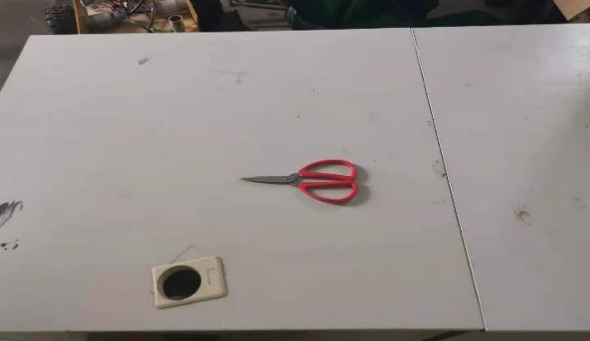
Fig 5.15 Identify the image with the corresponding result
CHAPTER 6: CONCLUSIONS AND RECOMMENDATIONS
This research on the development of the home service robot environment cognition research platform, through the writing and calling of the hardware platform action, the training of the tool recognition model, and finally the model is transplanted to the platform to complete the accurate recognition of the tool, and the recognition result is a voice broadcast, and all the basic requirements are completed. However, there are some shortcomings, such as the call between different languages takes a simple way to call the system function to solve this problem, the problem that the robot has no mechanical arm can not achieve the acquisition, can only complete the voice broadcast to replace the grasp of the mechanical arm.
CHAPTER 7: REFLECTION
The development and research of this platform has only completed the realization of basic actions, and there is still a large space for improvement. The parts that need to be improved and promoted are as follows:
1. At the present stage, only one model is used for recognition. It can be extended to scene recognition, item classification, garbage classification and so on.
2. The model involves the call of different languages, which can choose the fixed mode of input and output or the reading and writing of temporary files or better ways to complete the acquisition of recognition results.
3. One or more robotic arms are equipped to complete the corresponding acquisition action after the later recognition is successful, so that the common energy of the platform is more perfect.
REFERENCES
[1] K. Seya, N. Kobayashi, and S. Shirasaka, “Features of a good story for non-technical adults to learn emerging technologies,” International Journal of Emerging Technologies in Learning (iJET), vol. 15, no. 03, p. 15, 2020. doi:10.3991/ijet.v15i03.11645
[2] N. N. Mohd and M. Mizukawa, “Robotic Services at home: An initialization system based on robots’ information and user preferences in unknown environments,” International Journal of Advanced Robotic Systems, vol. 11, no. 7, p. 112, 2014. doi:10.5772/58682
[3] Wu Peiliang, Fu Weixing, and Kong Lingfu, “A fast algorithm for affordance detection of household tool parts based on structured random forest,” Acta Optica Sinica, vol. 37, no. 2, p. 0215001, 2017. doi:10.3788/aos201737.0215001
[4] W. Chen et al., “Research on classification and detection system of common household tools for Home Service Robot,” 2020 International Conference on System Science and Engineering (ICSSE), 2020. doi:10.1109/icsse50014.2020.9219314
[5] S. Wu et al., “Design of an ergonomic app for entire rapid body assessment based on Mask RCNN,” Journal of Physics: Conference Series, vol. 1633, no. 1, p. 012150, 2020. doi:10.1088/1742-6596/1633/1/012150
[6] J.-T. Zou, “The development of the Omnidirectional Mobile Home Care Robot,” Mobile Robots - Current Trends, 2011. doi:10.5772/26767
[7] G. Trehard, Z. Alsayed, E. Pollard, B. Bradai, and F. Nashashibi, “Credibilist simultaneous localization and mapping with a Lidar,” 2014 IEEE/RSJ International Conference on Intelligent Robots and Systems, 2014. doi:10.1109/iros.2014.6942931
[8] S. B. Wankhede, “Analytical study of neural network techniques: Som, MLP and classifier-A survey,” IOSR Journal of Computer Engineering, vol. 16, no. 3, pp. 86–92, 2014. doi:10.9790/0661-16378692
[9] S. Xu, W. Chou, and H. Dong, “A robust indoor localization system integrating visual localization aided by CNN-based image retrieval with Monte Carlo localization,” Sensors, vol. 19, no. 2, p. 249, 2019. doi:10.3390/s19020249
[10] S. Mitsch, K. Ghorbal, D. Vogelbacher, and A. Platzer, “Formal verification of obstacle avoidance and navigation of Ground Robots,” The International Journal of Robotics Research, vol. 36, no. 12, pp. 1312–1340, 2017. doi:10.1177/0278364917733549
[11] R. Du, V. Jagtap, Y. Long, O. Onwuka, and T. Padir, “Robotics enabled in-home environment screening for fall risks,” Proceedings of the 2014 workshop on Mobile augmented reality and robotic technology-based systems, 2014. doi:10.1145/2609829.2609836

