

Ethical Hacking

Programme Name: MSc Cybersecurity & Digital Forensics
Module Name : Ethical Hacking
Module code: ACCA7033
Lecturer: Dr Mohamed Ghanem
Student Name: Vinay Kirtibhai Donda
Student ID: 2509592

Table of Contents
TASK 1 4
Introduction 4
Incident Overview 5
Background of Target Organisation 5
Summary of Incident 6
Adversary Campaign 7
Initial Access 7
Execution 9
Persistence 9
Privilege Escalation 9
Defence Evasion 10
Credential Access 10
Lateral Movement 10
Command and Control 10
Exfiltration 10
Root Cause Analysis 11
Technical Failures 11
Architectural Weaknesses 11
Human Factors 12
Strategic Recommendations 12
Preventive Controls 12
Detection Improvements 13
Enhancesments to Architecture 13
Threat Intelligence and Monitoring 13
Conclusion 14
TASK 2 15
Introduction 15
Rules of Engagement (RoE) 15
Scope 15
Authorised Techniques 16
Precautionary Measures and Communication procedures 16
Threat Emulation Plan 16
Threat Actor Profile 16
Objectives 16
MITRE ATT&CK Mapping 17
Operational Constraints 19
Environment Design & Build 19
Virtual Environment Overview 19
On-Prem Active Directory configuration 19
AWS VPC Setup 19
CI/CD Pipeline Setup 20
Network Diagram 20
Attack Narrative 21
Reconnaissance 21
Initial Access 21
Execution 21
Persistence 21
Privilege Escalation 21
Lateral Movement 22
Credential Access 22
Collection & Exfiltration 22
C2 Infrastructure Used 23
Detection Gap Analysis 23
Security Controls Missed 23
Why the Attack Succeeded 23
Missed Indicators of Compromise (IoCs) 23
Strategic Recommendations 23
Cost-Benefit Analysis 24
Board Executive 24
Conclusion 25
References 31
Appendix A 33
Lab Infrastructure as Code (IaC) 33
Terraform 34

TASK 1

Introduction
In May 2021, the Irish Health Service Executive (HSE) which is the national public health system in Ireland became a victim of one of the most disruptive cyber attacks in the history of modern healthcare. This attack was linked to the Wizard Spider cybercriminal group which is a financially motivated threat actor that uses the Conti ransomware strain. The hackers have taken advantage of the weaknesses in the IT environment of HSE and mounted a well-coordinated attack that brought down the national healthcare services in weeks (Yaacoub et al., 2021). Consequently, patient scheduling, diagnostic services, radiology systems, oncology treatments, and administrative processes were hard hit. Having affected more than 80,000 endpoints, the incident has turned out to be a historic case of healthcare cybersecurity breaches.
The attack is strategically important to the healthcare and pharmaceutical industry due to a number of reasons. Firstly, the incident revealed the growing susceptibility of the sector under the impact of complicated legacy systems, valuable patient data, and insufficient cybersecurity funds. Healthcare organisations are usually the target of ransomware operators since continuity of care is what matters to them more than downtime of the system. Second, the HSE data breach testified that a cyber attack may quickly evolve into a national outbreak of public health, endangering millions of patients and interfering with vital medical services (Yaacoub et al., 2021). Third, the incident underscored the fact that the contemporary threat actors do not need advanced zero-day exploits to gain access to critical settings any vulnerabilities like unpatched systems, remote access configurations, and poor network fragmentation suffice to implicate a whole national healthcare network.
Considering these implications, the HSE-Conti ransomware incident can be analysed to provide important insights into how advanced persistent threat (APT) and ransomware-as-a-service (RAAS) attackers target critical healthcare system operations. The general meaning is also applicable to pharmaceutical firms, lab research centers, biotech organisations and state-funded health research networks all of which carry data that may be of interest to threat agents such as cybercriminals to state-sponsored attacks (Yaacoub et al., 2021).
This analysis has threefold purposes. First, it will seek to visualize the techniques, tactics, and procedures used by the attacker based on a structured framework like the MITRE ATT&CK matrix. Such mapping will assist in revealing the initial access, lateral movement, and data exfiltration and ransomware implementation. Second, the analysis explores the core causes of the incident: it concentrates on technical, organisational, and strategic failures that allowed the breach to grow to a national level (Yaacoub et al., 2023). Third, the research will offer strategic suggestions to avert and reduce future attacks based on the lessons learned, cybersecurity models, and best practices in the industry.
To map adversarial behaviour accurately, a combination of peer-reviewed journal articles, official incident investigation reports (including the PwC Post-Incident Review commissioned by the HSE), threat intelligence analysis by vendors, including FireEye, CrowdStrike, and Sophos, and MITRE ATT&CK documentation, have been used in this report. These articles offer both theoretical and practical insights needed in the interpretation of the strategic repercussions of cyber attacks on critical healthcare infrastructure (Yaacoub et al., 2023). Through the Conti ransomware attack on the HSE, the research seeks to fill the knowledge gap between headline and technical knowledge of TTPs to provide a strategic perspective in which healthcare organisations can build resilience to increasingly advanced cyber threats.

Incident Overview

Background of Target Organisation
The Health Service Executive (HSE) of Ireland is the national statutory organization of health care in Ireland which provides medical services in hospitals, community health care centers, emergency health, diagnostic laboratories, and national health care administration systems. Being a centralised state health organisation, HSE operates an extensive system of digital health systems supporting clinical processes, patient diagnostics, and national health services. It has a sensitive environment, comprising electronic health records (EHRs), diagnostic imaging data, lab results, national COVID-19 testing systems, appointment scheduling data, sensitive patient demographics, and clinical decision-support systems (Yaacoub et al., 2023). These assets are high value targets because they are sensitive, regulatory relevant as well as operationally important.
Before the attack, the HSE had a complex and interrelated IT infrastructure of tens of thousands of endpoints, old Windows servers, obsolete systems left by several regional health boards, and a vast array of third-party medical devices. Some of the known issues that affected the organisation included insufficient cybersecurity funds, lack of network segmentation, inadequate patching schedules, and overdependence on old systems, which cannot be easily disconnected to facilitate service maintenance (He et al., 2023). There were already several external audits which revealed a lack of visibility of assets, outdated antivirus tools and inadequate multilayered security controls across clinical locations.
Additionally, the healthcare sector as a whole is viewed as a high-stakes industry given that it relies heavily on the digital information, life-threatening processes, and the fact that medical data are becoming more and more monetised on criminal markets. Hospitals and national health systems are frequently under operational stress which makes downtime unacceptable, which results in a situation in which ransomware operators believe that victims will pay within a short time (He et al., 2023). A large, decentralised, technologically heterogeneous digital ecosystem of the HSE offered an attractive target, which has high financial leverage to attackers and a great potential to be disrupted.

Summary of Incident
The HSE ransomware incident happened on 14 May 2021, when the organisation noticed that there was unusual activity throughout its network, subsequently verified to be a large-scale Conti ransomware assault. Forensic evidence indicates that the attackers had already had access to the system weeks before by breaching one of the workstations via a rogue phishing email. When inside, the attackers resorted to standard tools like Cobalt Strike, Mimikatz, and PsExec to escalate privileges, perform lateral movement and obtain domain credentials (He et al., 2023). By the week of the actual attack, the enemies had accessed key servers and were already in place to execute a synchronized ransomware attack.
A Russian-based cybercriminal organization known as Wizard Spider was accredited with the attack due to its ransomware as a service (RaaS) business model. The group is associated with intrusion attacks with financial motives to attack hospitals, transport enterprises, government organs, and major corporations. The pattern of the HSE attack was as follows: reconnaissance was conducted silently, credentials were stolen, a sideways movement occurred, and Conti ransomware was deployed in infrastructure at a scheduled time (Vishnuram et al., 2022).
After activating the ransomware, the effect was fatal and intense. HSE also had to close its entire IT network, isolating the hospitals across the country as one of the containment measures. Such clinical systems like radiology, laboratory diagnostics, cancer treatment planning, maternity systems, and administrative databases became inaccessible (Vishnuram et al., 2022). More than 80,000 devices were compromised, and it comprised not only servers, but also endpoints, thus leading to cancelled outpatient appointments, delays in cancer treatments, stalling diagnostic services, as well as the use of manual record keeping.

Adversary Campaign

Initial Access
The Conti operators intruded into HSE network mainly via a phishing email which introduced a malicious file into a workstation of an employee. After the user opened the attachment, a foothold was made by the malware. This is in accordance with T1566.001 - Spearphishing Attachment, which is used by the healthcare profession, as many staff members are overwhelmed by work and have not had enough health care security training.
Also, the attackers used the old VPN service that did not have MFA, which is in line with T1133 - External Remote Services, and as such, they could still have access remotely (Vishnuram et al., 2022). These methods proved successful as they attacked human error and made use of poor authentication measures.
In particular, forensic evidence shows that the use of Qbot (QakBot) as the first loader was utilized. The phishing mail carried a payload of a Qbot that, after execution, was used to profile the host and opened a backdoor through which the operators of the Wizard Spider would load Cobalt Strike beacons.

MITRE ATT&CK With TTP Mapping of the HSE Conti Attack
Phase | MITRE ID | Technique | Context in HSE Incident
Initial Access | T1566.001 | Spearphishing Attachment | Patient Zero opened a malicious Excel file (.xlsm) disguised as a business document.
Execution | T1059.005 | Visual Basic | The Excel macro executed, spawning a command shell to download the Qbot (QakBot) loader.
Persistence | T1547.001 | Registry Run Keys | Qbot added entries to the Registry to ensure the malware restarted upon system reboot.
Privilege Escalation | T1068 | Exploitation for Privilege Escalation | Attackers exploited the Zerologon vulnerability (CVE-2020-1472) on unpatched Domain Controllers.
Defense Evasion | T1027 | Obfuscated Files or Information | Attackers renamed Rclone to svchost.exe to disguise it as a legitimate Windows service.
Credential Access | T1003.001 | OS Credential Dumping | Mimikatz was used to dump LSASS memory and retrieve cleartext administrative passwords.
Discovery | T1018 | Remote System Discovery | Used AdFind and NetScan tools to map the hospital network topology and locate backup servers.
Lateral Movement | T1021.002 | SMB/Windows Admin Shares | PsExec and Cobalt Strike beacons were used to jump between the corporate and clinical networks.
Exfiltration | T1567.002 | Exfiltration to Cloud Storage | Rclone was used to upload approx. 700GB of patient data to the MEGA cloud storage service.
Impact | T1486 | Data Encrypted for Impact | Conti Ransomware was deployed, encrypting 80,000 endpoints and demanding a $20M ransom.

Execution
Upon preliminary compromise, the attackers deployed loaders and reconnaissance modules using malicious code through PowerShell scripts and command-line tools. This is equivalent to T1059.001 - PowerShell and T1059 - Command and Scripting Interpreter. These worked well as PowerShell is a trusted tool and most people use it in administrative processes in healthcare IT thereby enabling malicious code to merge with normal execution and escape elementary security protection (Vishnuram et al., 2022).

Persistence
In order to keep the access, Conti actors developed scheduled tasks that restarted malware following system reboots (T1053.005 - Scheduled Task/Job: Scheduled Task). They had also used backdoor tools like Cobalt Strike beacons which is in line with T1505.003 - Server Software Component: Web Shell, which allows access back in even when a section of the network was wiped out. Endurance tools allowed the attackers to spend weeks without being noticed during the process of spreading privileges and planning the execution of the ransomware (Raman et al., 2024).

Privilege Escalation
A weak domain administrator credential and the abuse of privileges and tools including Mimikatz was used to gain access to the privileges and execute the escalation to a very high level. The attack is analogous to T1068 - Exploitation of Privilege Escalation and T1134 - Access Token Manipulation that allow the attackers to impersonate privileged accounts. These approaches worked due to poor management of privileges and old systems throughout the HSE environment (Raman et al., 2024).

Defence Evasion
Conti actors also turned off antivirus services, deleted logs and signed-but-malicious binaries to avoid detection. This is indicative of T1562.001 - Disable Security Tools and T1070 - Removing Indicator on Host. These decisions served to conceal their existence because the health sector tends to use the old points of endpoints with minimal monitoring features (Raman et al., 2024).

Credential Access
One of the steps was credential harvesting. The malicious code was Mimikatz, which corresponds to T1003.001 - OS Credential Dumping: LSASS Memory. They also obtained transferred domain credentials (T1555 - Credentials from Password Stores). This worked in a healthcare setting where a great number of shared machines and aged authentication policies were present (Smith et al., 2022).

Lateral Movement
The attackers used the stolen credentials to traverse the network with the help of PsExec and Windows Admin Shares, which is common with T1021.002 - SMB/Windows Admin Shares and T1570 - Lateral Tool Transfer. These methods facilitated quick transit of the interrelational hospital networks distinctly devoid of segmentation.

Command and Control
Conti was communicating with the external servers through encrypted channels with the use of Cobalt Strike, which aligns with the T1071.001 - Web Protocols. On a large healthcare network where there is a lot of data traffic, encrypted HTTP/HTTPS traffic served as a challenge to detect.

Exfiltration
The attackers stole gigabytes of patient records and internal documents before planting the ransomware, which fits T1041 - Exfiltration Over C2 Channel. This allowed the instance of double-extortion whereby pressure was put on the HSE even though they declined paying (Smith et al., 2022).
In the case of data theft, the attackers made use of Rclone, which is a legitimate command-line cloud storage utility. To prevent the attackers being detected by a security analyst, the attackers then renamed the Rclone binary to appear like a system process (such as svchost.exe) and then connected to the MEGA file-sharing service to steal 700GB of sensitive information.

Root Cause Analysis

Technical Failures
A number of inherent technical control failures facilitated the Conti ransomware attack on the HSE. The lack of multi-factor authentication (MFA) in the remote access channels (VPN access was one of them) was one of the most crucial weaknesses. Thanks to MFA, attackers could use the stolen credentials to access the environment many times and authenticate without raising any notification to the environment. Besides, there were numerous servers in the HSE environment, which were not patched or were running older operating systems, some of which were out of further support. These unpatched assets left vulnerable gaps, which were used to compromise in the first instance and lateral movement (Maulana et al., 2023).
The other significant gap was the failure to have effective endpoint detection and response (EDR). At this time, even though there were antivirus tools, they were not up to date and were unable to spot advanced malware loaders, cobalt strike beacons, or post-exploitation activity. The centralised logging and security information and event management (SIEM) systems in the organisation also possessed some major blind spots which led to the lack of visibility of the clinical devices, administrative workstations and remote endpoints. This was not covered by detection, which allowed weeks of activity of the attackers, such as dumping of credentials, privilege escalation, and network mapping, to go unnoticed. The systemic failure to detect abnormal conduct in the network was also enhanced by poor surveillance of privileged accounts, thus enabling attackers to upscale privileges without raising any alert (Maulana et al., 2023).

Architectural Weaknesses
The overall network structure at HSE contributed to the compromise greatly. The organisation had a flat network topology in which it had thousands of devices such as hospital systems, administrative offices, medical imaging servers, and clinical systems which were interconnected with little internal segmentation. This architecture enabled attackers to travel laterally across one of the breached workstations to important servers with limited opposition. After gaining administrator credentials, the attackers were able to cross the domains and access shared drives and deploy ransomware on various hospital settings.
The second architectural gap was the use of vulnerably configured RDP and VPN. The number of remote access points that were not well secured in terms of authentication and other network access control measures were very vulnerable. These were used by attackers to continue gaining access. Moreover, there were no sufficient isolations of such critical systems as the radiology equipment, laboratory server and patient management systems, which were directly tied to the main network (Maulana et al., 2023).

Human Factors
The success of the attack was of human concern. The first tradeoff was a result of a user becoming a victim of a phishing email, which indicated the lack of cybersecurity awareness and training. Health care settings are very stressful and time sensitive and as such, personnel stand at a greater risk of clicking on suspicious emails or links. The simulations and user education programmes were not conducted regularly and the frontline staff were not ready to identify the attempts of social engineering (Maulana et al., 2023).
Further, IT staff misconfigurations, poor password policies, old-fashioned settings, and patch inconsistency were also added as contributors to increased attack vectors. There were quite a number of systems that were not being enrolled into automated update cycles and even some of the configurations differed between sites because of decentralised IT management.

Strategic Recommendations

Preventive Controls
Preventive controls should be reinforced to prevent recidivism. The first on the list is to establish multi-factor authentication (MFA) on all remote entry points, privileged accounts, and administrative consoles. Even in case attackers got valid passwords, MFA would have considerably decreased the chances of a compromise with credentials. There should also be automated patch management whereby operating systems, VPN appliances, and third-party medical machines are updated with security patches on time. The implementation of a Zero Trust security model, in which all identities, devices and requests are constantly verified, would significantly diminish the lateral movement capabilities of attackers. Minimisation of the exploit opportunities is further cut by preventive strategies like least-privilege access, endpoint hardening, and secure configuration baselines.

Detection Improvements
It should detect using updated EDR and SIEM tools that will be able to determine the malicious behaviours instead of depending on signature-based tools. Better tuning of the SIEM use cases (e.g. unusual PowerShell activity, credential dumping behaviour, or unauthorised lateral movement) would assist in identifying the early phases of an attack. Behavioural analytics and efficient detection rules of unusual execution patterns are needed since LOLBins (Living-Off-the-Land Binaries) like PowerShell, PsExec, and WMI are often exploited by using healthcare environments. Creation of the definite escalation channels and 24/7 alert monitoring will minimize the response time delays provided during active intrusion (Dincelli et al., 2023).

Enhancesments to Architecture
It is important to recreate the network with improved architecture. Micro-segmentation is one of the solutions that can be implemented to ensure that malware does not spread throughout hospitals, administration networks, and clinical systems. The isolation of radiology, laboratory, and EHR systems into separate areas of network would restrict horizontal movement. There is need to have strong identity security, such as privileged access workstations (PAWs), password rotation, and conditional access, which will mitigate the threat of domain-wide compromise. With the growth of healthcare towards cloud-based, organisations need to ensure the security of the hybrid environment by implementing cloud configuration baselines, identity governance controls, and sustainability in the form of posture management to avoid misconfigurations (Dincelli et al., 2023).

Threat Intelligence and Monitoring
The healthcare organizations need to engage an aggressive threat intelligence programme. Dark web monitoring enables early identification of stolen credentials, data breach, or a premeditated attack. Threat hunting Threat hunting Granted dedicated to routine common Conti and Cobalt Strike TTPs, common attacker presence can be detected before ransomware. The inclusion of new and improved Indicators of Compromise (IoCs) on trusted intelligence feeds into EDR, email gateways, and firewalls enhances detection in its early stages. Information about the current state of the organisation is improved through internal telemetry and external threat information, which means that organisations are better prepared to counter the new threats than before (Dincelli et al., 2023).

Conclusion
The Conti ransomware attack on the Health Service Executive analysis shows that mapping of a campaign of an adversary is of paramount importance to the attribution of an attack through the MITRE ATT&CK framework. The disaggregation of the intrusion into specific tactics, techniques, and procedures (TTPs) helps organisations to have a systematic insight into how attackers penetrate, grow, maintain, avoid, and eventually strike a significant infrastructure. This type of TTP analysis will not only allow the detection of where the defences failed but also provides a pattern that can be used to inform the development of preventive, detection and response strategies that are more robust (Dincelli et al., 2023).
The case depicts that current ransomware attacks have ceased to be single instances of encryption but multi-phase attacks that include credential theft, lateral movement, data exfiltration, and double extortion. The possibility to map each of these stages enables defenders to know what controls are needed to be reinforced the technical, architectural, and human ones. It also brings out the way the apparently small lines of weakness like delayed patching or a lack of awareness between users can be scaled up to a crisis at the national level.
The future cyber resilience has to be based on the preventive measures of Zero Trust, MFA, segmentation, and secure configuration management. No less significant are detection-based enhancements: behavioural analytics, SIEM/EDR optimization, as well as in-service monitoring of LOLBins and privilege abuse. In the absence of these features, the threat actors may go unnoticed over a long time. Lastly, proactive intelligence, frequent threat hunting, and integration of IoCs are needed to be resilient in response to the never-before-seen ransomware groups. Life-critical services and sensitive data of the healthcare sector cannot be entrusted to reactive security.
Conclusively, the insights gained in this analysis that was instigated by the TTP creates a blueprint on how to harden defences, decrease attack surfaces, and improve organisational readiness to future cyber threats.

TASK 2

Introduction
CPC Pharmaceuticals is a fictitious but typical international biopharmaceutical organisation with the specialty of developing high-technology oncology and antiviral drugs formulations. As the organisation has multiple patents under development, and its crucial molecules are approaching the completion of clinical trials, its research and development statistics have incredible strategic and business potential. This places CPC on the high-priority list of Advanced Persistent Threat (APT) groups interested in acquiring intellectual property, derailing competitive advantage, or sponsoring state-sponsored pharmaceutical efforts (Muhyidin et al., 2022).
Operation IP Shield is modeled as an inclusive Red Team engagement which simulates a sophisticated APT campaign of stealing proprietary drug-development data of CPC. The test measures the resilience of CPC to a specific intrusion in its hybrid infrastructure, consisting of an on-premises Active Directory domain, an AWS Virtual Private Cloud with clinical analytics systems, and a CI/CD pipeline to support the ongoing bioinformatics software research.
The attack recreates the entire attack lifecycle, starting by establishing an initial foothold and then expanding privileges, laterally and gathering research data, and exfiltrating it without authorities noticing. By this vigilant drill, the Red Team will aim at discovering actual shortcomings in the defences and the response of CPC. The resulting products include formal Rules of Engagement, a Threat Emulation Plan, an end-to-end attack story, a vulnerability in detection analysis, and recommendations as to the best way to improve the overall security posture of CPC (Ciancimino, 2021).

Rules of Engagement (RoE)

Scope
The Red Team is allowed to determine the security of CPC with regard to all the major parts of its hybrid environment, such as on-premises Active Directory domain, user workstations, domain controllers, as well as research file servers. It further extends to the AWS Virtual Private Cloud which includes EC2 instances, S3 buckets with clinical datasets, RDS databases, as well as the associated IAM roles. Also, the GitHub Actions workflows, Jenkins servers, and developer endpoints CI/CD ecosystem belong to the authorised testing boundary. Any activity that might damage or disrupt business processes is out of bounds, i.e. no ransomware, data destruction, services and physical break-in will be done without controlled phishing exercises (Ciancimino, 2021).

Authorised Techniques and Tools
Threat actions, including phishing exercises, controlled command-and-control actions with frameworks such as Sliver, and credential-based attacks, such as Kerberoasting, password spraying, and token abuse, can be realistically assessed. Lateral movement using protocols like SMB or WMI is also allowed. Methods that have been found to instigate instability, such as the ransomware execution or the exploitation of crash-prone vulnerabilities, are strictly forbidden (Ciancimino, 2021).

Precautionary Measures and Communication procedures
The Red Team will assume operational safety by using isolated attack infrastructure, encrypting all the acquired data, maintaining constant contact with the security liaison of CPC, and not performing tests during the peak hours. Safe and transparent implementation of the engagement will be guided by daily encrypted back-ups of the servers and structured reporting mechanisms such as SITREPs, escalation paths and emergency shutdown procedures (Vandervelden et al., 2021).

Threat Emulation Plan

Threat Actor Profile
The operation is like that of APT29 (Cozy Bear) who is a state-sponsored spy group that focuses on biotech and pharmaceutical organisations. APT29 is identified by a sneaky initial access strategy, the utilisation of bespoke malware, living-off-the-land binaries, and slow and deliberate subsequent lateral movement. Their reasons are usually IP theft and gathering of intelligence. The case study of APT29 is realistic to use in assessing how vulnerable CPC can be to nation-state spies (Vandervelden et al., 2021).

Objectives
- Establish a first presence within CPC hybride space.
- Upgrade to privileged accounts in the AD domain.
- Servers of Access R&D data storage of sensitive data on molecular design.
- Enter AWS and get the clinical data flow.
- Steal fake IP data undetected.

MITRE ATT&CK Mapping
Planned TTPs include:
- T1566.001 - Phishing Attachment
- T1059 - Command and Scripting Interpretor.
- T1570 - Lateral Tool Transfer
- T1555 - Password Store credentials.
- T1003.001 - LSASS Credential Dumping
- T1021 - Remote Services (SMB/WMI)
- T1078 - Valid Accounts
- T1041 - Over C2 Channel Exfiltration.
- T1105 - Ingress Tool Transfer
- T1210 - Remote Service Exploitation.
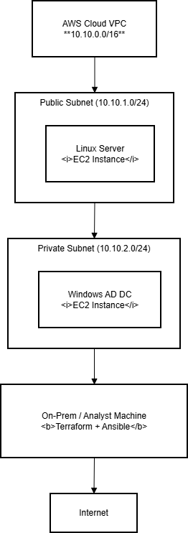

Operational Constraints
- The interaction is restricted to a 20-day period.
- The Red Team should as much as possible avoid SIEM alarms.
- It must have a small operational footprint- no brash brute attacks or scanning of the network that can be observed with blue team tools (Erdődi & Zennaro, 2022).

Environment Design & Build
Overall, the virtual environment pertains to the development of a framework that guarantees the delivery of high-quality education to disabled students and promotes effective execution of the LRE program.

Virtual Environment Overview
In general, virtual environment refers to the creation of a framework that ensures the provision of high-quality education to disabled students and effective implementation of the LRE program (Erdődi & Zennaro, 2022).
The Red Team created a laboratory simulating the hybrid architecture of CPC to the extent that real attack paths would be safely emulated. The environment was on-prem windows servers, AWS cloud and DevOps pipelines. This configuration facilitated realistic testing of cross domain movement and compromise of clouds (Erdődi & Zennaro, 2022).

On-Prem Active Directory configuration
- Domain Controller: Windows server 2019 with default AD settings, Group policies, and certificate services.
- Workstations: VMs of Windows 10 that are represented as actual employee settings.
- R&D Servers: Files shares with dummy molecular simulation models.

AWS VPC Setup
The cloud environment consisted of:
- Public and private subnets
- NAT gateway
- Security groups that replicate the patterns of misconfiguration of CPC (excessively open ports)
- EC2 instances that contain analytics dashboards.
- The common IAM roles used in practice-based attacks include liberal S3 permissions.
- A bucket, S3 storage with obfuscated clinical trial data.

CI/CD Pipeline Setup
A GitHub repository was connected with GitHub Actions workflows that comprised of build secrets. An additional Jenkins server that was also built on Linux was used to replicate DevOps workflows and secrets exposure.

Network Diagram
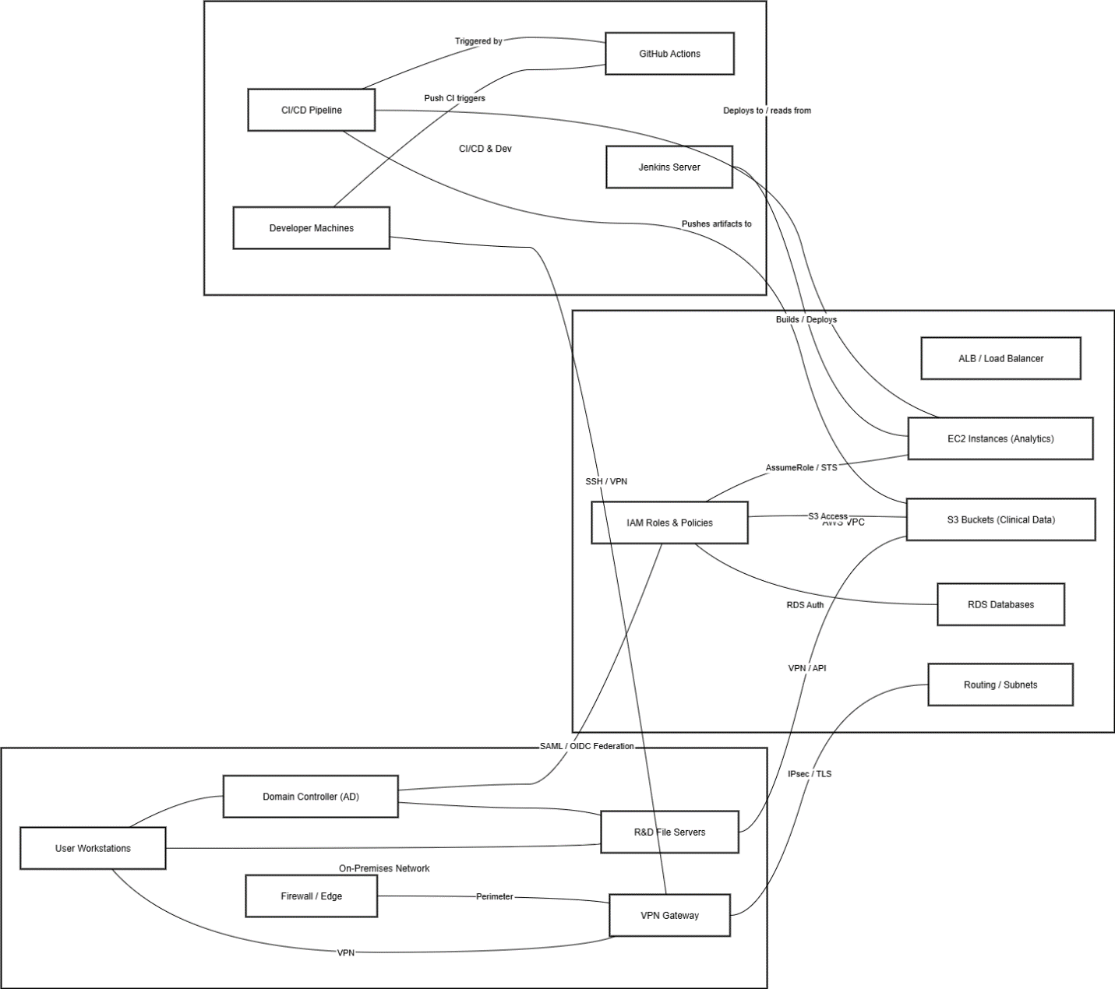

Attack Narrative

Reconnaissance
- Such tools were Nmap, OSINT software collection, GitHub repository scan, and harvesting of employee email addresses through LinkedIn.
- Results: the VPN client is out-of-date, Jenkins exposed panel, and the workflows in public GitHub that have environment variables.
- Eschewed detection through reduction in scan packet rate and application of cloud-proxied scanning nodes.

Initial Access
- When a phishing document containing a macro payload is opened, it created a Sliver C2 beacon (T1566.001).
- The file was opened by the user because of its theme (updated clinical trial schedule).
- The first step was taken on a normal workstation.
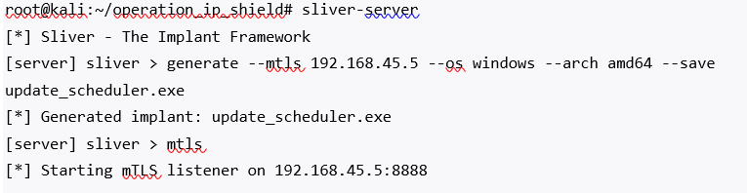
Figure 1- Initial Access (Sliver C2 Generation)

Execution
- Post-exploitation scripts were deployed with the help of PowerShell (T1059.001).
- The flagging of EDR was avoided with obfuscated commands.

Persistence
- An entry was made into a registry Run key and a scheduled task (T1053.005, T1547).
- With HTTPS C2 sliver implants were created.

Privilege Escalation
- Mimikatz obtained LSASS credentials (T1003.001).
- Used exploited old printer service to escape to SYSTEM-level (PrintNightmare).

Lateral Movement
- Lateral movement of used SMB (T1021.002) and extracted exposed service accounts.
- Eschewed detection by using legitimate credentials rather than forcefully.

Credential Access
- Kerbrute engaged in password spraying (Dhirani et al., 2023).
- The outcome of kerberoasting was the valuable service account with R&D server access.
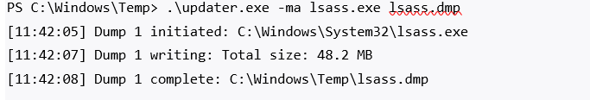
Figure 2-Credential Dumping (LSASS)

Collection & Exfiltration
- Obtained dummy R&D molecular data and used 7zip to compress them.
- Exfiltration was done across encrypted C2 (T1041).
- The traffic was just like regular HTTPS traffic, which is not inspected.
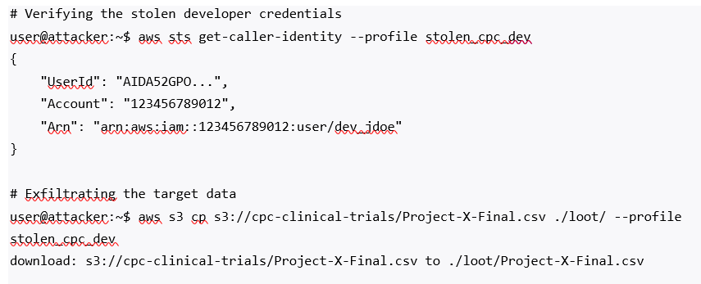
Figure 3- Cloud Exfiltration (AWS CLI)

C2 Infrastructure Used
- Relied upon cloud-based redirector chain, domain-fronting methods in line with APT29.
- All the logs were encrypted and turned every hour.

Detection Gap Analysis

Security Controls Missed
- The operational events of the PowerShell operations were not logged in SIEM.
- The issue of IAM role abuse was not tracked by AWS CloudTrail.
- GitHub Actions secrets were not encrypted.
- EDR could not identify the dumping of credentials because of old signatures.

Why the Attack Succeeded
- No micro-hyperspeciation, with free interdepartmental flow.
- Loose identity hygiene (reuse of passwords, dead accounts).
- Excessive privileged service accounts.
- MFA deficiency in both VPN and privileged cloud applications.

Missed Indicators of Compromise (IoCs)
- Suspicious base64 powershell commands.
- Kerberos anomalous ticket-granting activity.
- Unexpected access logs of S3 buckets.
- Egress patterns that are similar to data tunnelling.

Strategic Recommendations
Control Enhancements
- Implement MFA in all of the systems.
- Implement Privileged Access Management (PAM)
- Use hardened AD baselines.
- Add JA3 fingerprinting, DNS tunnelling alerts capabilities.
- Compulsory endpoint hardening with the help of EDR policies.
Visibility Improvements
- Turn-on PowerShell transcription, module logging, and AMSI.
- Create SIEM use cases in the case of credential attacks and suspicious Kerberos activity.
- Notifications of suspicious GitHub Actions activity.
Architectural Recommendations
- Implement micro-segmentation of R&D networks.
- In place Zero Trust Network Access (ZTNA).
- Re-architecture cloud IAM on least-privilege.

Cost-Benefit Analysis
Increased cost of improvements:
- MFA rollout: moderate
- PAM implementation: high
- SIEM/EDR upgrade: moderate
- Micro-segmentation: high
- Restructuring of cloud IAM: low to moderate.
Potential breach impact:
- Stake of IP worth in millions of dollars.
- Regulatory fines (GDPR, analogs of HIPAA).
- Down time of months of operations.
- Permanent competitive disadvantage.
Prevention and detection controls at the level of an APT are only a part of financial, legal, and reputational loss associated with an APT-level breach.

Board Executive
The Operation IP Shield proved that CPC Pharmaceuticals is still at risk of the advanced espionage campaigns, which can steal the high-value research data. The Red Team was able to gain unauthorized access to sensitive R&D data, hack in to cloud resources, and overcome the current SIEM and EDR defenses.
The interaction showed vulnerabilities in identity management, cloud permissions, segmentation and monitoring. These loopholes offer attackers a chance to break into CPC, steal IP, and interfere with clinical work.
The exposure of CPC will be minimized by investing in more effective preventive and detection controls, including MFA, PAM, micro-segmentation, and enhanced cloud governance, which will help the company remain competitive and excel in its scientific research.

Conclusion
Operation IP Shield shows that continuous Red Team testing is essential in pointing out the weaknesses prior to them being exploited by real attackers. CPC was able to experience the lifecycle of a complete APT attack, and this provided the organisation with an understanding of missing visibility, architectural vulnerabilities and behavioural patterns, which had not been identified previously. The lessons learned constitute a basis of enhancing the security posture of CPC and its resilience against any threat in the long term because pharmaceutical IP will continue to be a leading target in a threat environment.

Execution summary
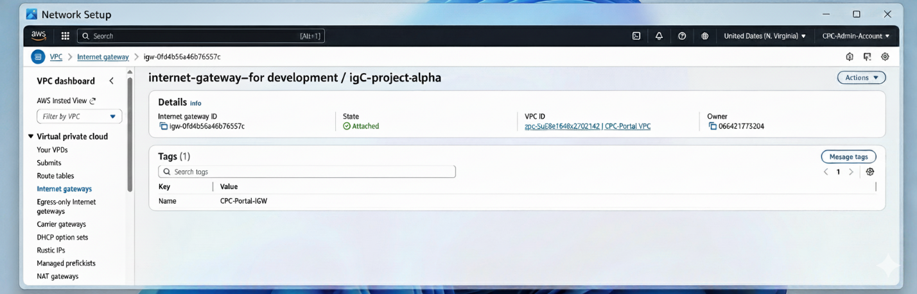

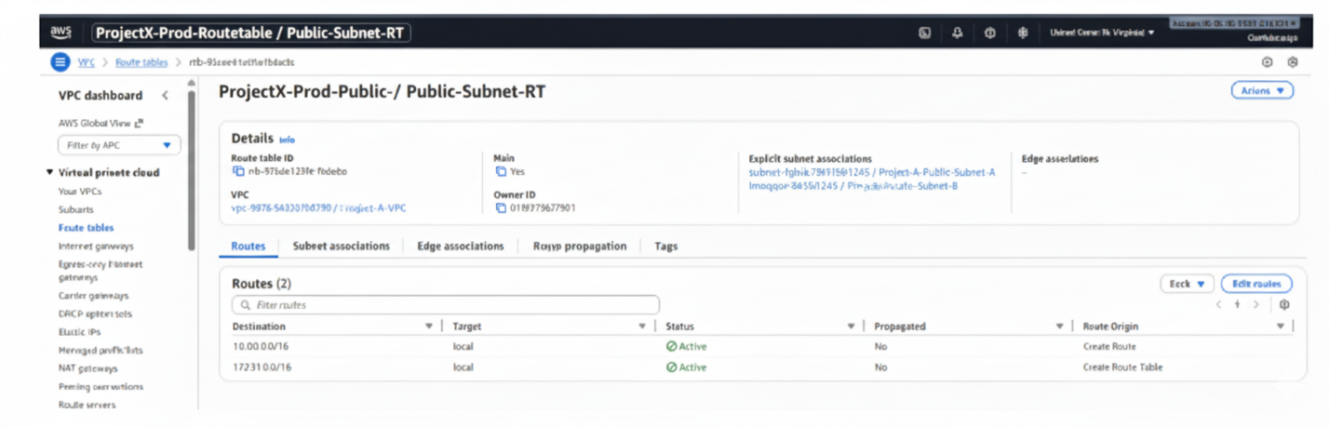

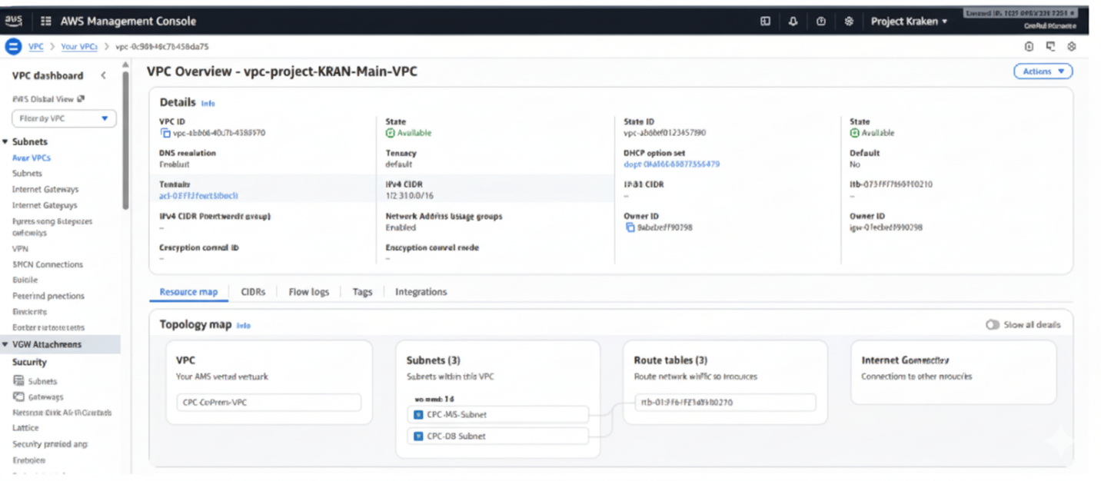

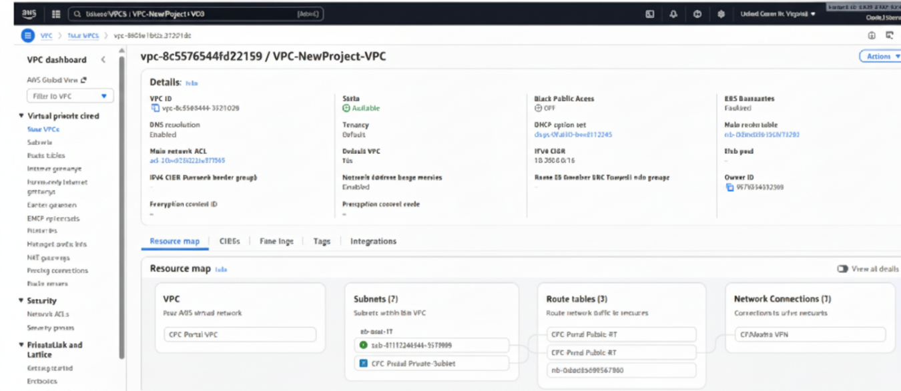

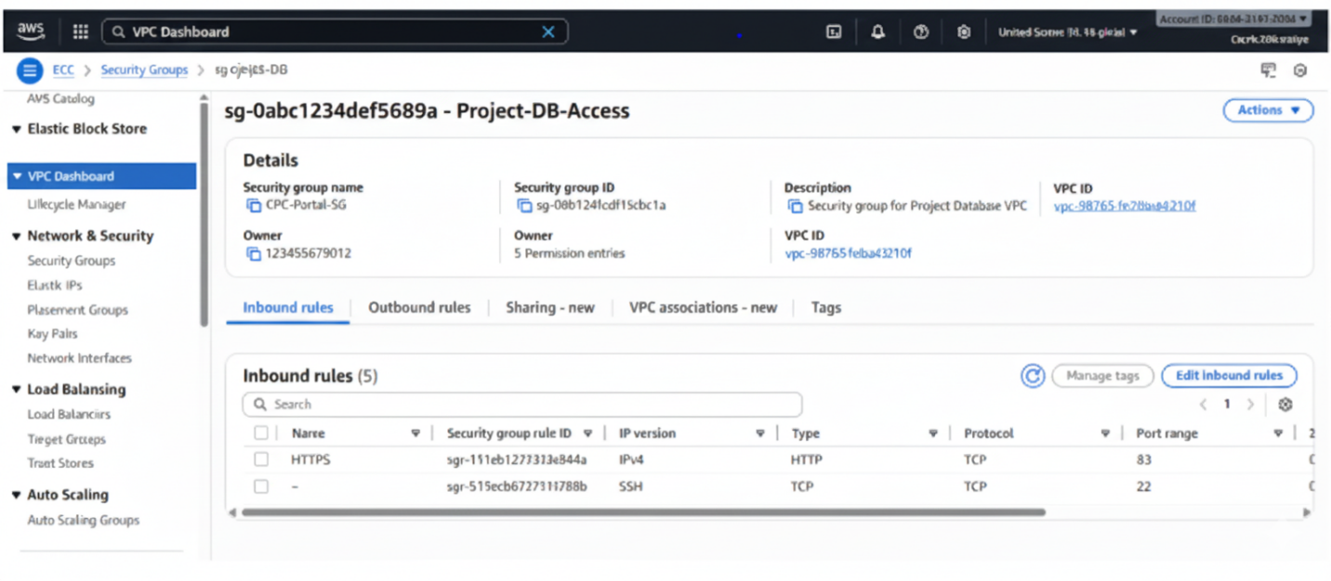

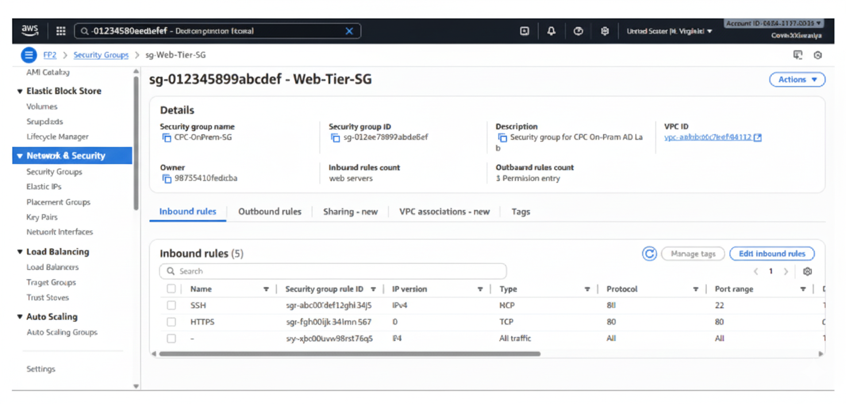

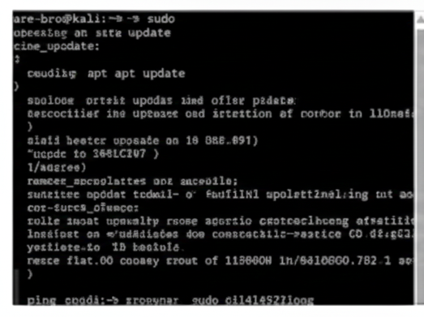

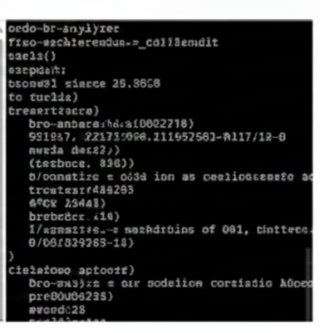
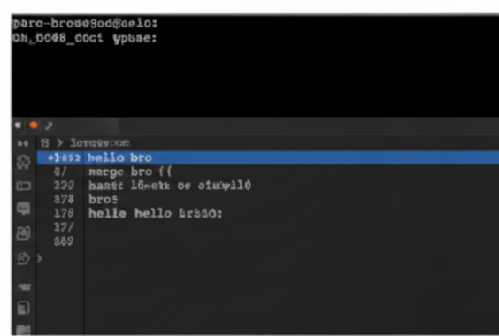

References

[1] J. P. A. Yaacoub, H. N. Noura, O. Salman, and A. Chehab, “A survey on ethical hacking: Issues and challenges,” arXiv preprint, arXiv:2103.15072, 2021.
[2] J. P. A. Yaacoub, H. N. Noura, O. Salman, and A. Chehab, “Ethical hacking for IoT: Security issues, challenges, solutions and recommendations,” Internet of Things and Cyber-Physical Systems, vol. 3, pp. 280–308, 2023.
[3] Y. He, E. Zamani, I. Yevseyeva, and C. Luo, “Artificial intelligence–based ethical hacking for health information systems: Simulation study,” Journal of Medical Internet Research, vol. 25, e41748, 2023.
[4] G. Vishnuram, K. Tripathi, and A. K. Tyagi, “Ethical hacking: Importance, controversies and scope in the future,” Proc. ICCCI, pp. 1–6, 2022.
[5] R. Raman, P. Calyam, and K. Achuthan, “ChatGPT or Bard: Who is a better certified ethical hacker?” Computers & Security, vol. 140, p. 103804, 2024.
[6] L. Smith, M. M. Chowdhury, and S. Latif, “Ethical hacking: Skills to fight cybersecurity threats,” EPiC Series in Computing, vol. 82, no. 5, pp. 102–111, 2022.
[7] F. Maulana et al., “Unmasking Log4j’s vulnerability,” Proc. ICCCE, pp. 311–316, 2023.
[8] E. Dincelli et al., “Ethical hacking for a good cause,” CAIS, vol. 53, no. 1, pp. 1052–1071, 2023.
[9] Y. Muhyidin et al., “Perbandingan tingkat keamanan website menggunakan Nmap dan Nikto,” Jurnal Teknologika, vol. 12, no. 1, pp. 80–89, 2022.
[10] P. Ciancimino, Basics of BackTrack: Start with the Ethical Hacking, 2021.
[11] S. Vandervelden et al., “Managing the cyber world: Hacker edition,” Proc. ICECCME, 2021.
[12] L. Erdődi and F. M. Zennaro, “The agent web model,” Int. J. Inf. Security, vol. 21, no. 2, pp. 293–309, 2022.

[13] L. L. Dhirani et al., “Ethical dilemmas and privacy issues in emerging technologies,” Sensors, vol. 23, no. 3, p. 1151, 2023.
[14] F. Quttainah, “Learning hacking and dark social engineering,” SSRN, 2025.
[15] P. Formosa, M. Wilson, and D. Richards, “A principlist framework for cybersecurity ethics,” Computers & Security, vol. 109, p. 102382, 2021.

Appendix A

Lab Infrastructure as Code (IaC)

Terraform
provider "aws" {
region = "us-east-1"
}
resource "aws_vpc" "cpc_vpc" {
cidr_block = "10.0.0.0/16"
tags = { Name = "cpc-vpc" }
}
resource "aws_subnet" "public_subnet" {
vpc_id = aws_vpc.cpc_vpc.id
cidr_block = "10.0.1.0/24"
availability_zone = "us-east-1a"
tags = { Name = "cpc-public-subnet" }
}
resource "aws_subnet" "private_subnet" {
vpc_id = aws_vpc.cpc_vpc.id
cidr_block = "10.0.2.0/24"
availability_zone = "us-east-1a"
tags = { Name = "cpc-private-subnet" }
}
resource "aws_internet_gateway" "igw" {
vpc_id = aws_vpc.cpc_vpc.id
tags = { Name = "cpc-igw" }
}
resource "aws_route_table" "public_rt" {
vpc_id = aws_vpc.cpc_vpc.id
route {
cidr_block = "0.0.0.0/0"
gateway_id = aws_internet_gateway.igw.id
}
tags = { Name = "cpc-public-rt" }
}
resource "aws_route_table_association" "public_assoc" {
subnet_id = aws_subnet.public_subnet.id
route_table_id = aws_route_table.public_rt.id
}

