Research Methodology

Chapter 3

3.1 Introduction
3.2 Research Onion
3.2.1 Philosophy
3.2.2 Approach
3.2.3 Strategy
3.2.4 Choice
3.2.5 Time Horizon
3.2.6 Data Collection - Techniques: Data collection and Analysis
3.3 Survey Design
3.4 Limitations and Potential Problems
3.5 Conclusion

3.1 Introduction

The purpose of this paper is to determine whether police officer should all carry taser. The literature review demonstrates that many aspects of taser have been examined and documented however studies clearly lack the opinion and point of view of the police officers themselves.
This section of the paper will detail the research methods chosen for obtaining the required data using the research onion (Saunders, et al., 2009) The techniques chosen will be explained and any potential problems or limitations highlighted.

3.2 Research Onion

When conducting research, The Research Onion will be utilised, this is a research method developed by Saunders et al in 2007 (Saunders, et al., 2007). The research onion is suitable for the majority of research methods and provides a structure to progress through the research by isolating each stage in to layers (Bryman, 2012)

Figure 1.1 The research onion
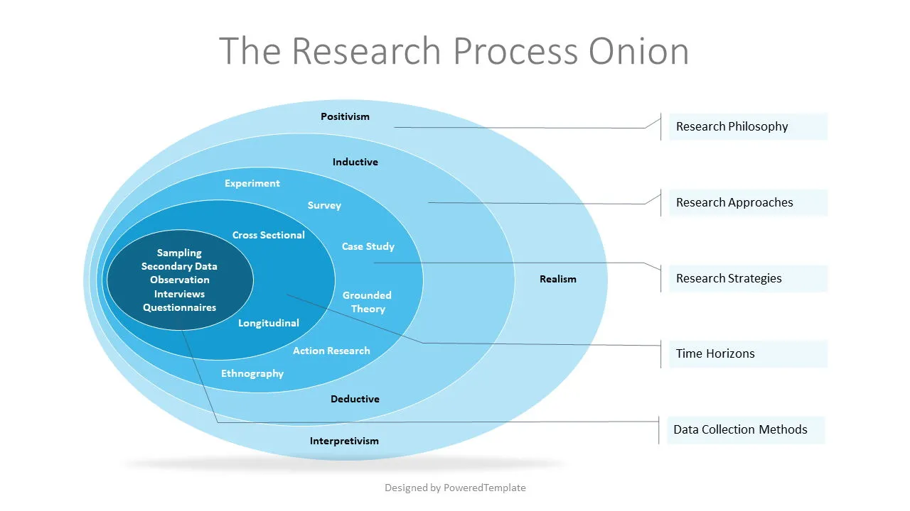

3.2.1 Philosophy

The research method chosen is considered to be a Positivist Research Approach as this relies on quantitative methods such as surveys and statistics to determine the outcome rather than opinions that may be associated with a Constructivist Research Approach (UKEssays, 2018)

3.2.2 Approach

The research will be conducted using an inductive approach. This is essentially where data is collected from singular identities around a specific area and then reviewed as a whole to identify patterns (Survey Sparrow, 2024)

3.2.3 Strategy

Surveys will be created using Microsoft forms, a link to these surveys will be posted on internal police systems to ensure that they are only available to police officers. The questionnaires will be titled Taser officers and non-Taser officers to ensure that the officers complete the correct survey for their skill set. The surveys will remain anonymous to allow for freedom of speech and will remain available for a period of ten days.

3.2.4 Choice

A mixed method approach will be utilised that incorporates quantitative and qualitative data. This allows for stronger evidence, increased confidence and balances the limitations however can be more complex and time consuming (Gov.uk, 2020)
Although primarily, quantitative research will be used which focuses on numbers and data collected to answer the question. During the survey stage, qualitative research will be used through a selection of open questions will also be used to capture participants feelings regarding the use of taser (Sheilds & Twycross, 2003)

3.2.5 Time Horizon

The primary research will be conducted using a survey which will be available for a period of ten days. This time scale has been chosen as the majority of police officers work a six on and 4 off pattern, ten days ensures all who wish to complete the survey will have the opportunity. This has been limited to ten days as the posting will drop out of view on internal police systems after a period of ten days, therefore there will be limited completions after this period.

The secondary research will be conducted using a cross-section study where data held by the Home Office will be analysed between 2017 when records began to 2024 (Home Office, 2023).

3.2.6 Data Collection - Techniques: Data collection and Analysis

Initially, data will be collected regarding taser use from the public domain. Since 2017, all police forces in the United Kingdom have been required to record data on police use of force (Home Office, 2023).
This would be considered to be secondary research which Professor Imed Bouchrika, Phd, describes as “A summary or synthesis of data and literature that has been organized and published by others” (Bouchrika, 2025)

These statistics are published by the Home Office each year and include force such as,

Restraint tactics – these include handcuffing and the use of limb restraints.
Unarmed skills – these include using force to escort prisoners and using pressure points to gain compliance.
Use of other equipment – these include use of batons and irritant spray.
Less lethal weapons – this section includes taser and will be the focus of the data collected.
Firearms – this includes firearms being drawn, aimed and fired.
Other – these include where a police dog is deployed regardless of whether they come in to a contact with a person or not (Home Office, 2023).

Data will also be collected in the form of a survey directed at police officers in order to gain an understanding of how an active police force as a collective feel about carrying a taser. This is considered to be primary research which Ian Jones states “involves collection of original data specific to a particular research project” (Jones & Gratton, 2015)
A survey is considered to be one of the most common forms of data collection where individuals are asked questions around a particular research subject in an attempt to capture their emotions, feelings, beliefs and opinions amongst other attributes (Bouchrika, 2025).

3.3 Survey Design

There will be two surveys made available to police officers, one directed to officers currently equipped with taser and one directed to officers not equipped with taser. The surveys will include open and closed questions, this will allow accurate data to be collected and presented as well as capturing individual officers’ thoughts and feelings openly.

Taser officer – This survey will look to determine if these officers believe all officers should carry taser as well as determine how much service they had when they received taser. The survey will also ask questions regarding their personal use of taser and how this made them feel.

Non-Taser officers - This survey will look to determine if these officers wish to carry taser, if they have applied and if they feel safer attending calls with a taser officer present. The survey will also look to determine if these officers have witnessed a taser discharge while attending a call.

3.4 Limitations and Potential Problems

As the study is based on a mixed methodology there are several potential limitations and problems that could occur. The study will look to collect data regarding taser use from local police forces and government statistics held on public databases. The data collected may be incomplete or outdated preventing a clear and accurate picture. Likewise, some data may be of a sensitive nature and not available to the public.
In regard to questionnaires as a means of collecting data, this is very much dependant on participants taking part. If responses to the questionnaires are low, it will be difficult to determine a true percentage from the data obtained.

3.5 Conclusion

In conclusion, in order to answer the question, should all police officers carry taser? Research will be conducted using primary research in the form of two surveys directed at police officers currently equipped with taser and those not equipped. Secondary research will also be utilised in form of statistics compiled by the home office to allow a comparison between the demand for taser and the reality.

Bibliography
Bouchrika, I., 2025. Primary Research vs Secondary Research in 2025: Definitions, Differences, and Examples. [Online]
Available at: https://research.com/research/primary-research-vs-secondary-research#secondary
[Accessed 24 01 2024].
Bryman, A., 2012. Social research methods. 5th Edition ed. Oxford: Oxford University Press.
Gov.uk, 2020. Mixed methods study. [Online]
Available at: https://www.gov.uk/guidance/mixed-methods-study#:~:text=A%20mixed%20methods%20study%20combines,with%20more%20in%2Ddepth%20findings.
[Accessed 24 01 2025].
Home Office, 2023. Police use of force statistics, England and Wales: April 2022 to March 2023. [Online]
Available at: https://www.gov.uk/government/statistics/police-use-of-force-statistics-april-2022-to-march-2023/police-use-of-force-statistics-england-and-wales-april-2022-to-march-2023
[Accessed 24 01 2025].
Jones, I. & Gratton, C., 2015. Research Methods for sport studies. 3rd Edition ed. Oxon: Routledge.
Saunders, M., Lewis, P. & Thornhill, A., 2007. Research Methods for Business Students. 6th Edition ed. London: Pearson.
Saunders, M., Lewis, P. & Thornhill, A., 2009. Research methods for business students. England: Pearson education limited.
Sheilds, L. & Twycross, A., 2003. The difference between quantitative and qualitative research: this paper is one of a series of short papers on aspects of research by Linda Shields and Alison Twycross. Paediatric Nursing, 5(9).
Survey Sparrow, 2024. What’s Inductive Research? A Simple Guide. [Online]
Available at: https://surveysparrow.com/blog/inductive-research/
[Accessed 24 01 2025].
UKEssays, 2018. Research Onion - Explanation of the Concept. [online]. [Online]
Available at: https://www.ukessays.com/essays/psychology/explanation-of-the-concept-of-research-onion-psychology-essay.php
[Accessed 24 01 2025].

