Mohammed Ismail (2539445)
2539445@student.uwtsd.ac.uk
Software Solutions for Business
Module Code: ACCA4026
University: University of Wales Trinity Saint David
Lecturer: Mohd Syafiq Bin Zolkeply
Programme: CertHE Computing Skills for Workplace
Submission Deadline: July 20, 2026, 2:00PM

Table of Contents
Task 1: Contemporary E-Commerce Website Builders 2
Task 2(a): Mind Mapping and Its Benefits in Business Operations 3
Task 2(b): Mind-map of contemporary software applications 4
Task 3(a): Office Software Solutions for Business Operations 5
14
Task 4(a): Communication and Collaboration Applications 14
Task 4(b): Practical Use of Communication and Collaboration Applications 17

Task 1: Contemporary E-Commerce Website Builders
E-commerce website builders are software platforms that enable businesses to create and manage online stores without requiring advanced programming knowledge. These platforms provide a range of tools that allow organisations to design websites, manage products, process secure payments, and communicate with customers through a single system. As online shopping has become increasingly popular, businesses of all sizes have adopted e-commerce platforms to improve their online presence, reach wider markets, and operate more efficiently [1]. Two of the most widely used e-commerce website builders are Shopify and Wix, both of which provide businesses with practical solutions for selling products online while offering distinctive features and levels of functionality.
Shopify is a cloud-based e-commerce platform that was launched in 2006 and is designed specifically for businesses that focus on online retail [2]. It enables users to create a professional online store using customisable themes without requiring coding experience [2]. Shopify includes built-in tools for managing products, tracking inventory, processing secure payments, and monitoring customer orders through a single dashboard [2]. The platform also supports multiple payment methods, including Shopify Payments and PayPal, making it easier for businesses to sell products to customers in different countries [2]. Another important feature is the Shopify App Store, which provides thousands of third-party applications that allow businesses to add functions such as email marketing, accounting software, customer support, and stock management [2]. In addition, Shopify offers reporting and analytics tools that help businesses monitor sales performance and customer behaviour, allowing managers to make informed decisions based on business data [2]. Although Shopify provides a comprehensive range of e-commerce features, some advanced functions require paid applications or higher subscription plans, which may increase the overall cost for smaller businesses [2].
Wix is another popular website builder that enables users to create websites using a drag-and-drop editor without requiring technical knowledge [3]. Although Wix supports many diverse types of websites, it also includes a comprehensive e-commerce solution that allows businesses to sell products online through secure payment systems and integrated shopping features [3]. The platform provides professionally designed templates, secure hosting, mobile optimisation, and search engine optimisation (SEO) tools that help businesses create attractive and accessible online stores [3]. Wix also includes marketing features such as email campaigns, discount codes, and social media integration, enabling businesses to promote products and improve customer engagement [3]. Its simple interface makes it particularly suitable for small businesses, freelancers and start-up companies that have limited technical experience [3]. However, compared with Shopify, Wix offers fewer advanced e-commerce management features for businesses that expect significant growth or manage large product catalogues [1].
Overall, Shopify and Wix are both effective e-commerce website builders that help organisations establish a professional online presence. Shopify is better suited to businesses whose primary focus is online retail because it offers advanced selling tools, greater scalability, and a large marketplace of third-party applications [2]. In comparison, Wix is more appropriate for individuals and small businesses that require an easy-to-use platform with integrated online selling capabilities [3]. The choice between the two platforms depends on the size of the business, available budget, and future objectives, as both platforms provide reliable solutions for developing successful e-commerce websites [1].

Task 2(a): Mind Mapping and Its Benefits in Business Operations
Mind mapping is a visual technique used to organise information by placing a central idea at the centre of a diagram and connecting related ideas through branches. These branches can include keywords, images, colours, and symbols to show the relationships between different ideas in a logical and structured format. Unlike traditional notetaking, mind maps present information visually, making it easier to understand complex topics, identify connections and organise ideas effectively [4]. Mind maps are widely used in education, business, and project management because they encourage creative thinking, improve knowledge sharing and support problem-solving by displaying information in a clear and accessible way [4]. The technique was popularised by Tony Buzan and has become an established method for brainstorming, planning, and organising information [5].
One of the main benefits of mind mapping in business operations is improved planning and organisation. Businesses often manage multiple projects, deadlines, and objectives simultaneously. Mind maps enable managers to break large projects into smaller tasks, assign responsibilities, and identify the relationships between different activities. This structured approach makes it easier to monitor progress, identify priorities and ensure that all team members understand the overall project objectives [5].
Mind mapping is also an effective tool for brainstorming and generating ideas. During meetings or project discussions, employees can contribute ideas that are added to the mind map as new branches without disrupting the overall structure. This visual representation helps teams identify patterns, explore alternative solutions, and encourage creative thinking. Research has shown that mind maps can improve attention, understanding and knowledge sharing by presenting information in a format that highlights the relationships between concepts [4].
Another important advantage is improved communication and decision-making. Business managers often need to evaluate several options before making strategic decisions. A mind map enables information such as risks, costs, opportunities, and outcomes to be displayed within a single diagram, making comparisons easier and reducing the likelihood of overlooking essential information. Because all relevant information is presented visually, employees and managers can communicate ideas more clearly and collaborate more effectively when solving business problems [4].
Mind mapping also supports productivity by helping individuals organise their thoughts and manage information more efficiently. Employees can use mind maps to prepare presentations, record meeting notes, plan business strategies and organise workflows. Digital mind-mapping software allows teams to edit, update and share diagrams in real time, improving collaboration across departments and supporting remote working environments [6].
Overall, mind mapping is a valuable business tool because it combines organisation, creativity, and communication within a single visual framework. It enables businesses to plan projects, generate ideas, improve teamwork, and make informed decisions by presenting information in a structured and easy-to-understand format. As organisations continue to manage increasing amounts of information, mind mapping remains an effective technique for improving efficiency and supporting successful business operations [4][5]

Task 2(b): Mind-map of contemporary software applications
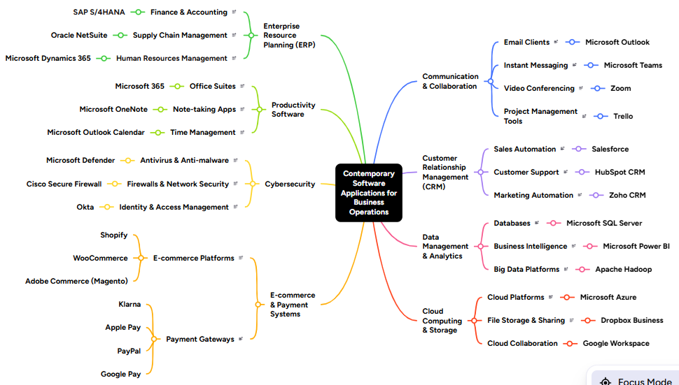
Link for mind map: https://mm.tt/map/4052255053?t=CJgQadO5k2

Task 3(a): Office Software Solutions for Business Operations

Introduction
Office software applications are essential tools that enable businesses to create, manage, analyse, and present information efficiently. They support a wide range of day-to-day business activities, including producing professional documents, analysing business data, delivering presentations, and managing organisational information. These applications help improve communication, increase employee productivity, and support informed decision-making across different departments. Microsoft Office remains one of the world's most widely used productivity suites because its integrated applications allow organisations to streamline workflows and improve operational efficiency [7]. Four of the most widely used Microsoft Office applications in business operations are Microsoft Word, Microsoft Excel, Microsoft PowerPoint, and Microsoft Access.

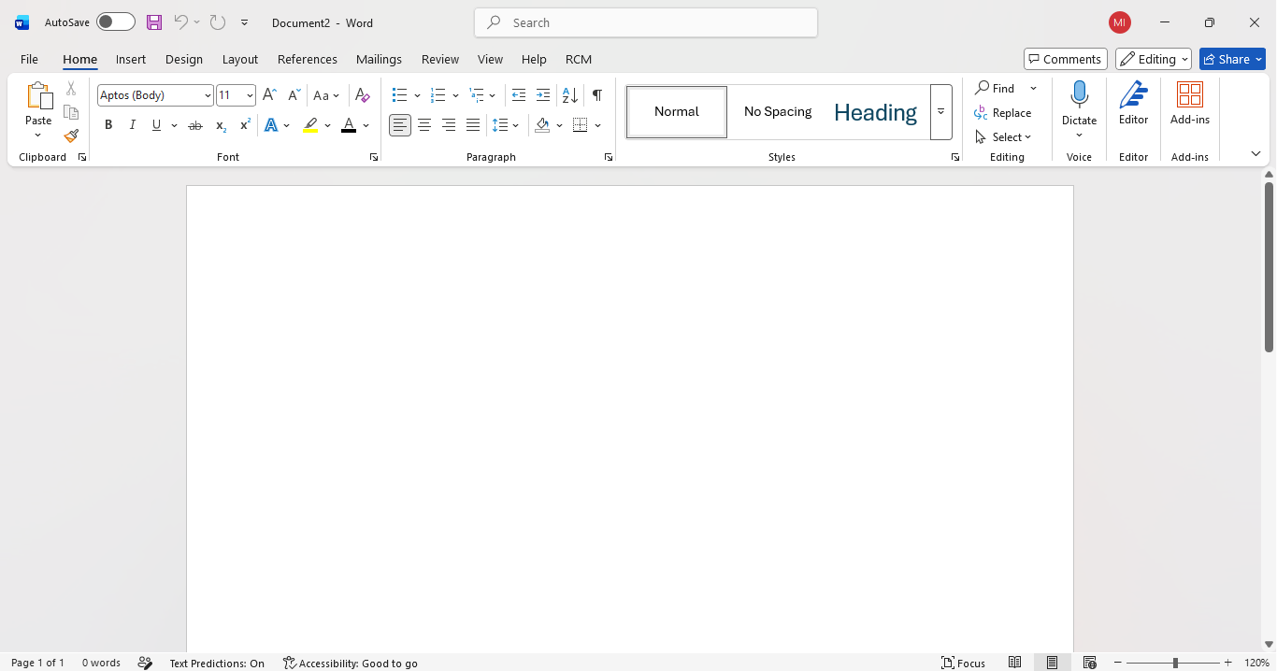
Microsoft Word

What is Microsoft Word?
Microsoft Word is a word processing application used to create, edit, format, and share professional documents [8]. Businesses use Word to produce reports, business letters, contracts, policies, meeting agendas, and other formal documentation. Its intuitive interface and comprehensive formatting tools make it suitable for organisations of all sizes.
Major Features
Microsoft Word provides a wide range of features that enhance document creation and management. Users can customise fonts, headings, page layouts, tables, and images to produce clear, consistent, and professional documents [8]. The built-in spelling and grammar checker helps minimise errors and improve the quality of written communication.
Word also includes Track Changes and Comments, enabling multiple users to review, edit and provide feedback on documents collaboratively. Another valuable feature is Mail Merge, which allows organisations to automatically generate personalised letters, invoices, and certificates by linking a document to a database of recipients. This significantly reduces the time required to produce high volumes of personalised documents [8].
Benefits
Microsoft Word improves organisational productivity by enabling employees to create professional documents quickly and consistently. Its collaboration features within Microsoft 365 allow multiple users to work on the same document simultaneously, making teamwork more effective in both office-based and remote working environments [7]. Mail Merge further improves efficiency by automating repetitive administrative tasks. For example, a Human Resources department can generate employment contracts for multiple new employees from a single template.
Limitations
Although Microsoft Word is highly effective for document creation, it is not designed for advanced numerical analysis or large-scale database management. Some advanced collaboration and cloud storage features also require a Microsoft 365 subscription, which may increase software costs for organisations [8].

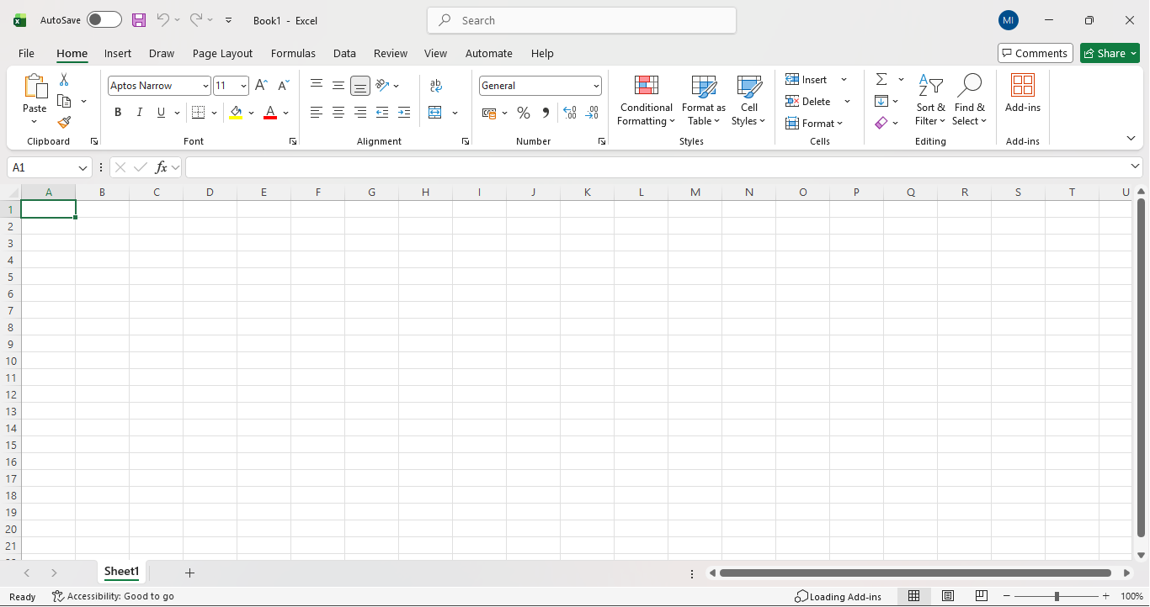
Microsoft Excel
What is Microsoft Excel?
Microsoft Excel is a spreadsheet application used to organise, calculate, analyse, and present business data [9]. It is widely used for budgeting, financial analysis, forecasting, inventory management, and performance reporting. Information is stored in rows and columns, allowing organisations to manage large volumes of numerical and textual data efficiently.
Major Features
Excel contains a wide range of analytical tools that support business decision-making. Built-in formulas and functions automate calculations, improving both speed and accuracy. Common functions include SUM, AVERAGE, IF, VLOOKUP and Goal Seek, all of which help organisations analyse business scenarios and perform complex calculations [9].
Another key feature is PivotTables, which summarise large datasets into meaningful reports. Excel also includes charts and graphs for visualising data and Conditional Formatting, which automatically highlights trends, exceptions, and patterns, making business information easier to interpret.
Benefits
Microsoft Excel enables organisations to process and analyse large volumes of business data efficiently. Managers can monitor budgets, evaluate financial performance, forecast future sales, and generate reports that support strategic decision-making [7]. Retail organisations, for example, frequently use PivotTables to identify their best-selling products and analyse monthly sales performance. By automating calculations, Excel also reduces manual effort and improves the accuracy of business reporting.
Limitations
Despite its versatility, Excel is vulnerable to human error if incorrect formulas or inaccurate data are entered. As spreadsheets become larger and more complex, they can become difficult to maintain and audit. Furthermore, Excel is not intended to replace dedicated database management systems when organisations need to manage extremely large datasets or support many simultaneous users [9].

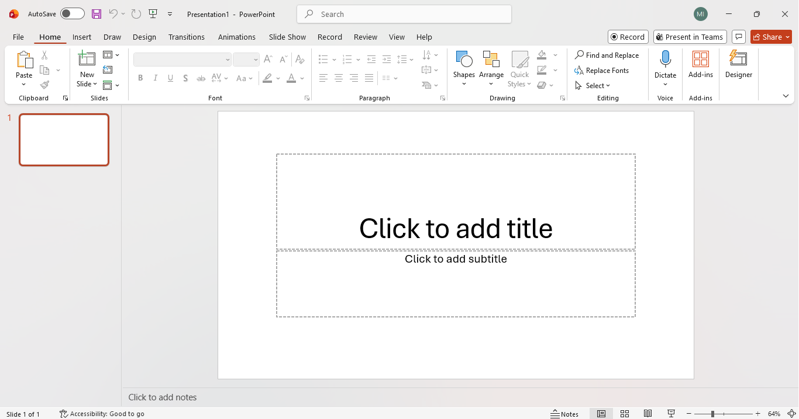
Microsoft PowerPoint
What is Microsoft PowerPoint?
Microsoft PowerPoint is presentation software used to create and deliver professional visual presentations [10]. Businesses use PowerPoint for staff training, project updates, client meetings, sales presentations, and business proposals. The software enables users to combine text, images, charts, SmartArt, videos, and animations to communicate information clearly and effectively.
Major Features
PowerPoint offers professionally designed templates, themes and slide layouts that help users create visually appealing presentations. Additional features include animations, slide transitions, embedded multimedia, and Presenter View, which allows speakers to view notes while the audience sees only the presentation [10]. Integration with Microsoft Word and Excel also enables users to import text, charts, and tables directly into presentations.
Benefits
PowerPoint improves business communication by presenting complex information in a structured and engaging format. Marketing teams use PowerPoint to deliver persuasive product demonstrations, while managers use it to communicate organisational performance and strategic objectives. Well-designed presentations improve audience understanding, encourage engagement and support more effective communication [7].
Limitations
The effectiveness of PowerPoint depends on both the quality of the presentation and the presenter's communication skills. Slides containing excessive text, unnecessary animations or poor design can reduce audience engagement and distract from key messages. Therefore, presentations should follow recognised design principles to maximise their effectiveness [10].
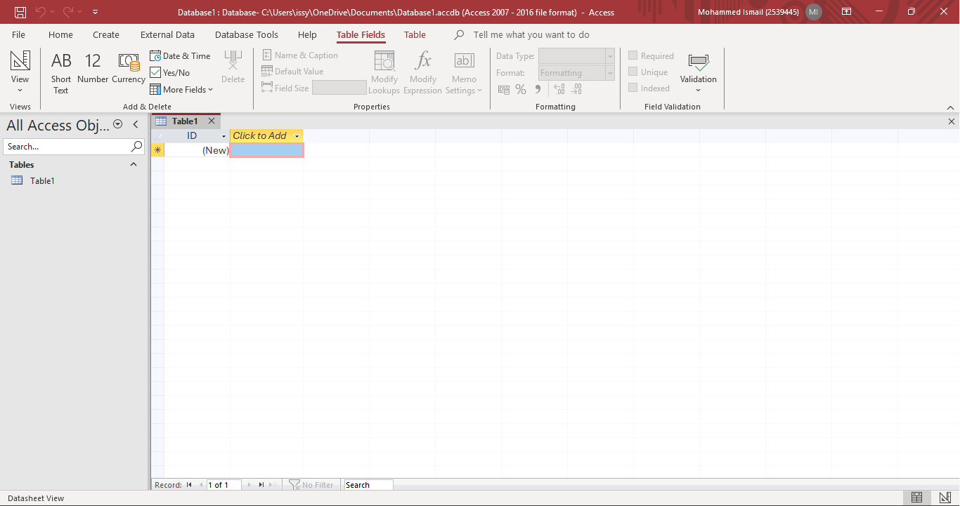
Microsoft Access

What is Microsoft Access?
Microsoft Access is a relational database management system (RDBMS) used to store, organise, and manage structured business information [11]. It is commonly used to manage customer records, inventory, employee information, supplier details, and sales data. Unlike spreadsheets, Access stores related information within linked tables, reducing duplication and improving data accuracy.
Major Features
Microsoft Access includes several important database components, including tables, queries, forms, and reports. Tables store data, queries retrieve specific information, forms simplify data entry and reports present information in a professional format [11]. Relationships between tables help maintain data integrity by ensuring that related records remain consistent across the database.
Benefits
Microsoft Access enables organisations to organise business information more efficiently than traditional spreadsheets. Small and medium-sized businesses can create customised databases without requiring advanced programming knowledge. For example, a retail business can use Access to manage customer records, stock levels, and supplier information within a single integrated system, improving operational efficiency and reducing duplicate records [7].

Limitations
Although Microsoft Access is suitable for many small and medium-sized organisations, it is less appropriate for enterprise-level systems with exceptionally large databases and hundreds of concurrent users. Larger organisations often use more scalable database management systems, such as Microsoft SQL Server, to provide greater performance, security, and multi-user capability [11].

Conclusion
Microsoft Word, Excel, PowerPoint, and Access each perform distinct but complementary roles within modern business operations. Word supports professional document creation, Excel provides powerful tools for analysing business data, PowerPoint enhances communication through engaging presentations, and Access enables efficient management of structured organisational information. When used together, these applications improve productivity, strengthen collaboration, support informed decision-making, and increase operational efficiency. As a result, Microsoft Office continues to be one of the most valuable productivity software suites used by organisations across a wide range of industries [7].

Task 3(b): Practical Demonstration of Microsoft Excel Features
Microsoft Excel provides a wide range of tools that enable organisations to manage, analyse, and interpret business data efficiently. Among its many features, PivotTables and Goal Seek are particularly valuable because they support data analysis and financial decision-making. PivotTables allow users to summarise and organise large datasets into meaningful reports, while Goal Seek enables users to determine the input required to achieve a desired result. This practical demonstration illustrates how both features can be applied using Microsoft Excel and highlights their importance within a business environment.

Feature 1: PivotTable

Step 1 – Creating the Dataset
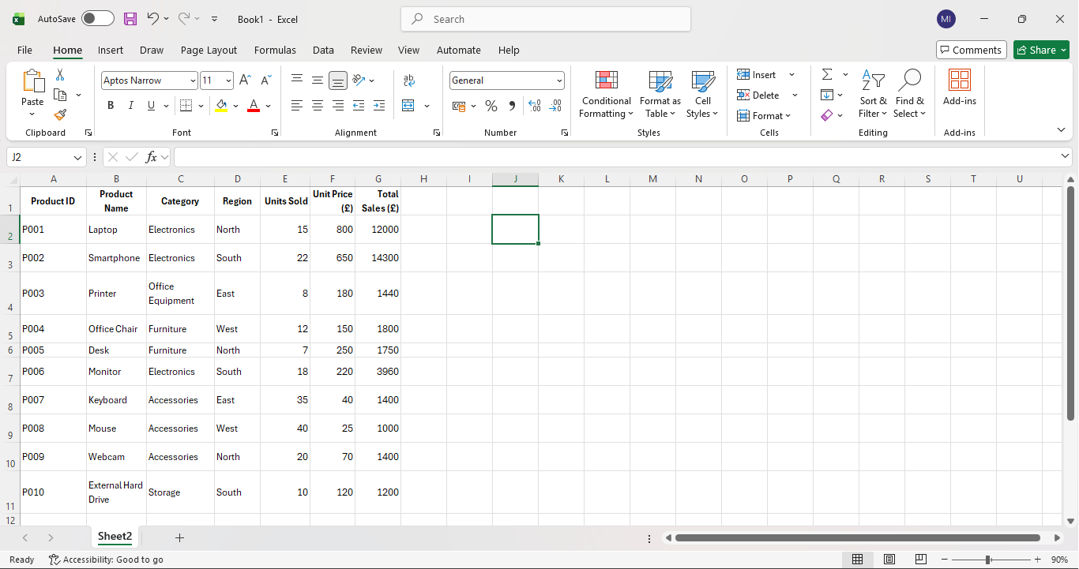
To begin the practical demonstration, Microsoft Excel was opened and a new workbook was created. A structured dataset was then entered consisting of product information, categories, sales regions, units sold, unit prices and total sales values. The data was organised into separate columns using clear headings, making it suitable for analysis. Organising data correctly is an important first step because PivotTables require consistent column headings and accurately structured information to produce meaningful summaries.

Step 2 – Selecting the Data
Once the dataset had been entered, the entire table was selected by clicking within the data and highlighting every row and column. Selecting the complete dataset ensures that all records are included in the PivotTable. If any rows or columns are omitted, the final report may be incomplete or inaccurate. Accurate data selection is therefore essential for producing reliable business reports.

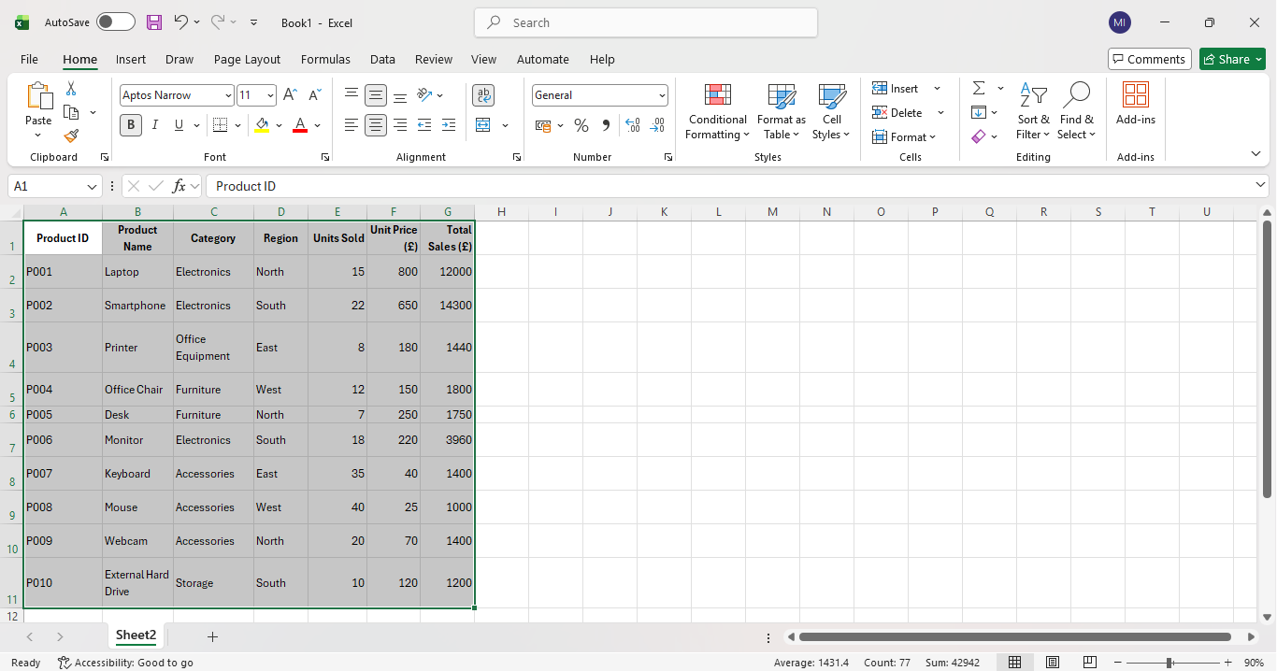

Step 3 – Creating the PivotTable
After selecting the dataset, the Insert tab was chosen from the Ribbon, and the PivotTable option was selected. Excel automatically recognised the data range and displayed the Create PivotTable dialogue box. The default option of New Worksheet was selected before clicking OK. Creating the PivotTable in a separate worksheet helps preserve the original dataset while providing a dedicated space for analysing information.
- Click Insert.
- Select PivotTable.
- Leave the table range unchanged.
- Select New Worksheet.
- Click OK.
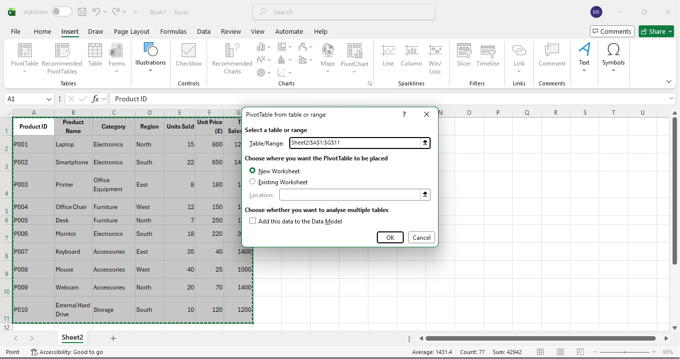

Step 4 – Configuring the PivotTable
Once the PivotTable had been created, the PivotTable Fields panel appeared on the right-hand side of the screen. The Category field was dragged into the Rows area, while Total Sales (£) was placed into the Values area. Excel automatically calculated the sum of sales for each category, producing a summary table. This process demonstrates how PivotTables can analyse substantial amounts of information within seconds without requiring complex formulas.

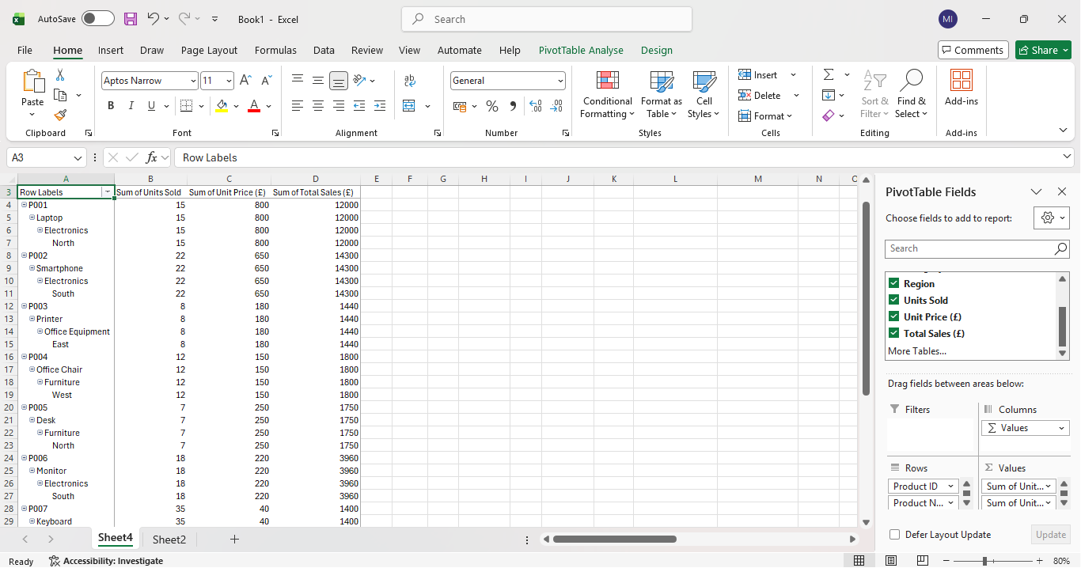

Step 5 – Analysing the Results
As shown below, the PivotTable Fields pane displays all the available fields from the original dataset. Users can customise the report by selecting or deselecting the tick boxes and by dragging fields between the Rows, Columns, Values, and Filters areas. This makes PivotTables highly flexible, as the same dataset can be analysed in separate ways without changing the original information. For example, the report could be changed to display sales by Region, Product Name, or Product ID simply by moving those fields into the Rows section.
The completed PivotTable shows that Electronics generated the highest Total Sales (£30,260), followed by Accessories (£3,800), Furniture (£3,550), Office Equipment (£1,440), and Storage (£1,200). It also summarises the total Units Sold and Unit Price (£) for each category, providing a broader overview of business performance. The Grand Total of £40,250 gives managers an immediate understanding of the company's overall sales. Presenting information in this format enables businesses to identify trends, compare product categories and make informed decisions quickly and accurately.
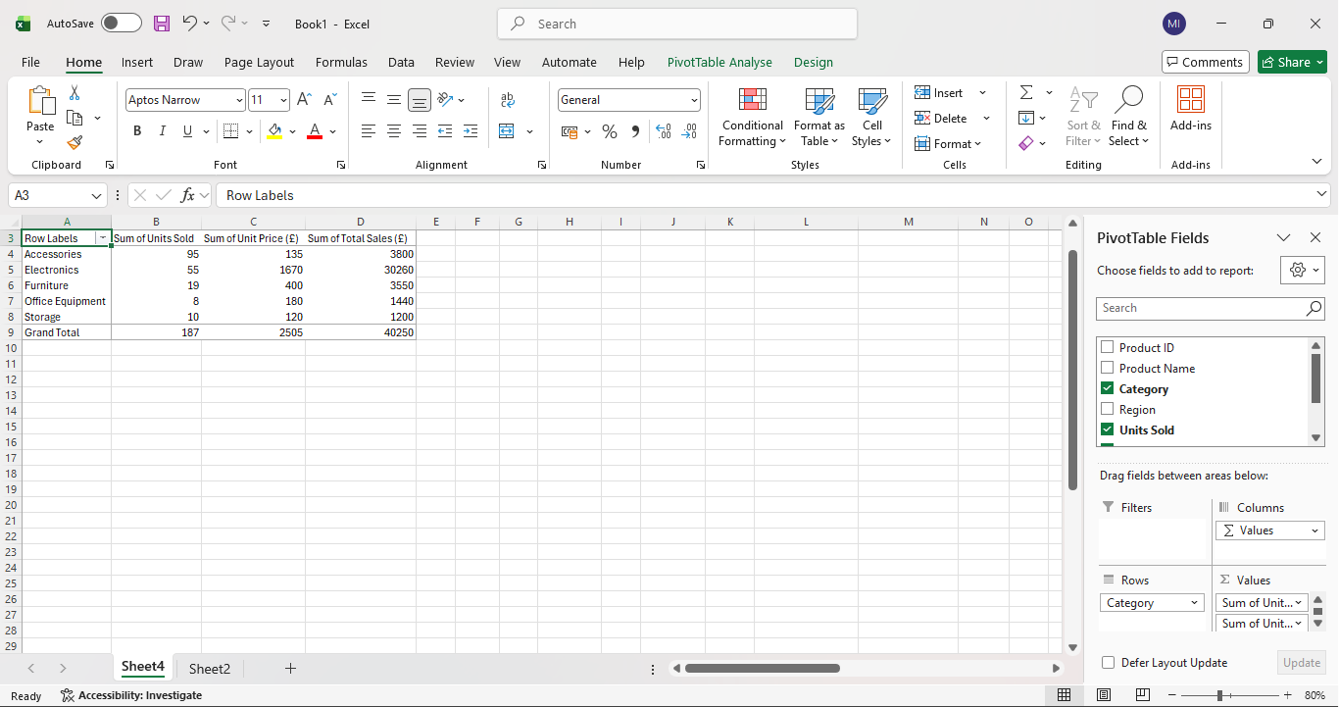

Task 4(a): Communication and Collaboration Applications
Introduction
Communication and collaboration applications have become an important part of modern businesses because they allow employees to work together more efficiently, regardless of where they are located. As many organisations now use remote or hybrid working, these applications help teams stay connected through messaging, video meetings, file sharing, and real-time collaboration. They also improve productivity by reducing the need for lengthy email conversations and making it easier to access shared documents. This report analyses Microsoft Teams as a communication application and Google Docs as an online collaboration application. It discusses their key features, advantages, and limitations; while explaining why they are widely used in today's business environment[12]
Microsoft Teams (Communication Application)
Microsoft Teams is a cloud-based communication platform developed by Microsoft as part of the Microsoft 365 suite. It is widely used by organisations of all sizes because it combines instant messaging, voice calls, video conferencing, and file sharing into a single application. Instead of relying on emails for every conversation, employees can communicate instantly through private chats or team channels, helping projects move forward more efficiently. According to Microsoft, Teams has been designed to improve workplace communication by allowing employees to collaborate from anywhere while keeping conversations and documents organised in one place [13].
One of the platform's strongest features is its video conferencing capability. Users can schedule virtual meetings, share their screens during presentations and record meetings so that colleagues who are unable to attend can watch them later. This has become especially valuable for organisations that support hybrid or remote working because it allows staff to communicate effectively without needing to be in the same office. Microsoft Teams also integrates with other Microsoft 365 applications such as Word, Excel, PowerPoint, and Outlook, allowing users to access, edit and share files directly within the application. This integration reduces the need to switch between multiple programs, helping employees work more efficiently and improving overall productivity [13].
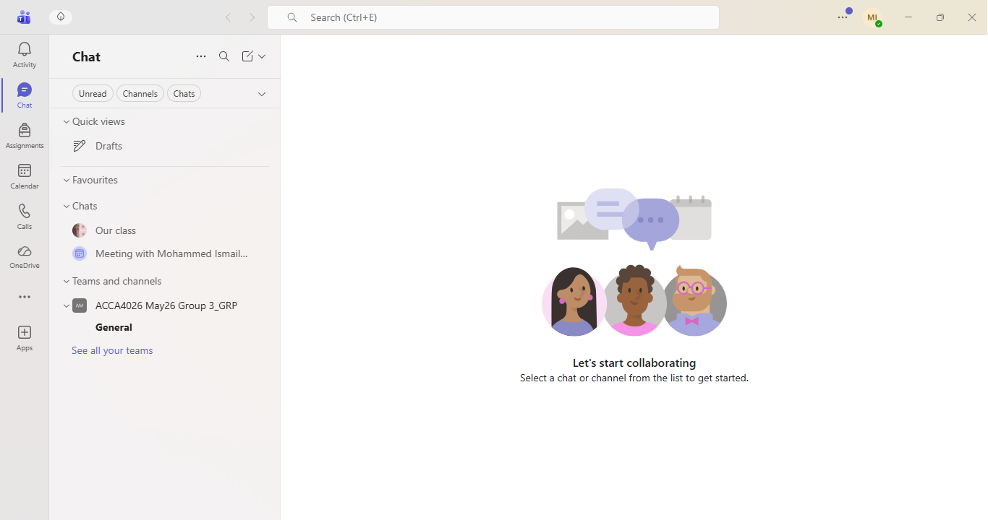
Google Docs (Online Collaboration Application)
Google Docs is a cloud-based word processing application that forms part of Google Workspace. Unlike traditional word processors, Google Docs allows multiple users to edit the same document at the same time, making it an effective tool for collaboration. Every change is automatically saved to Google Drive, reducing the risk of losing work if a computer unexpectedly shuts down or an internet connection is interrupted. This automatic saving feature also removes the need for users to manually save their work, making the application simple and dependable to use [14].
A key feature of Google Docs is real-time collaboration, which enables several people to work on the same document simultaneously while viewing each other's changes instantly. Users can also leave comments, reply to feedback and suggest edits without permanently changing the original document. This makes reviewing reports, assignments, and business documents much more efficient because team members can discuss changes directly within the document. Another useful feature is Version History, which records every change made to a document and allows users to restore previous versions if mistakes occur. Although Google Docs does not provide as many advanced formatting tools as Microsoft Word, its ease of use, accessibility and cloud-based storage make it one of the most popular collaboration tools used by businesses and educational institutions worldwide [14].
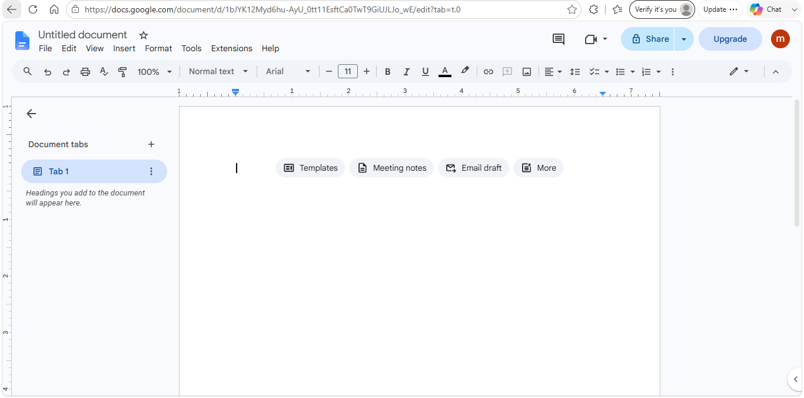

Comparison
Although Microsoft Teams and Google Docs serve different purposes, they complement each other in the modern workplace. Microsoft Teams focuses on communication by providing messaging, video meetings, and file sharing, whereas Google Docs is designed for collaborative document creation and editing. When used together, these applications improve teamwork, increase productivity, and support flexible working by allowing employees to communicate and collaborate securely from almost any location. Their cloud-based design also ensures that information is easily accessible while reducing the need for multiple copies of the same document [12].

Task 4(b): Practical Use of Communication and Collaboration Applications

Microsoft Teams – Testing the Chat Feature
To demonstrate the practical use of a communication application, the chat feature in Microsoft Teams was assessed. This feature allows users to send instant messages to individuals or groups, making it one of the most used communication tools in businesses. Compared with email, Teams chat provides faster communication, making it easier to ask questions, share updates and collaborate on tasks in real time [13].
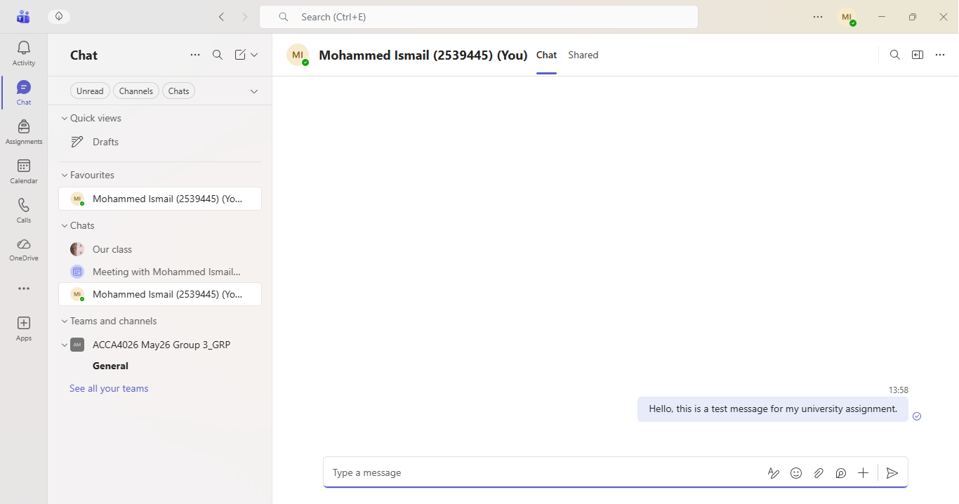

After completing the test, it was clear that Microsoft Teams provides fast and reliable communication. The message appeared instantly within the conversation, demonstrating how employees can communicate efficiently without relying on traditional email. This feature is particularly useful when quick responses are needed or when teams are working remotely. The ability to share files, images and links within the chat also makes Microsoft Teams a practical communication solution for businesses [13].

Google Docs – Testing the Comment Feature
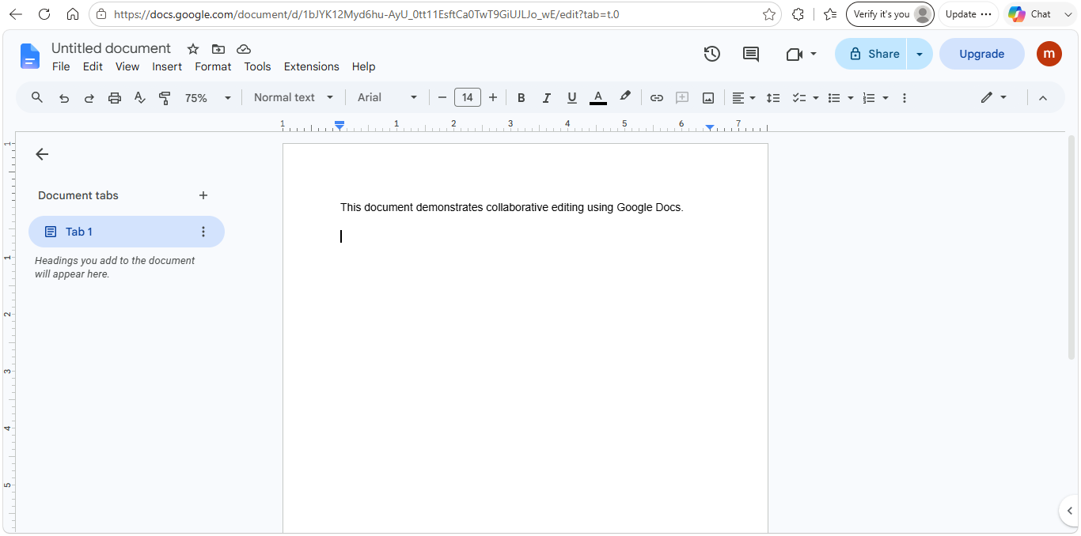
To demonstrate the practical use of an online collaboration application, the Comment feature in Google Docs was assessed. This feature allows users to leave feedback, ask questions and suggest improvements without changing the original content of a document. It is commonly used in businesses, schools, and universities because it enables teams to review documents together and communicate directly within the file, reducing the need for separate emails or meetings [14].

The document is automatically saved to Google Drive as you type, meaning there is no need to manually save your work. This helps prevent data loss and ensures that the latest version of the document is always available [14]

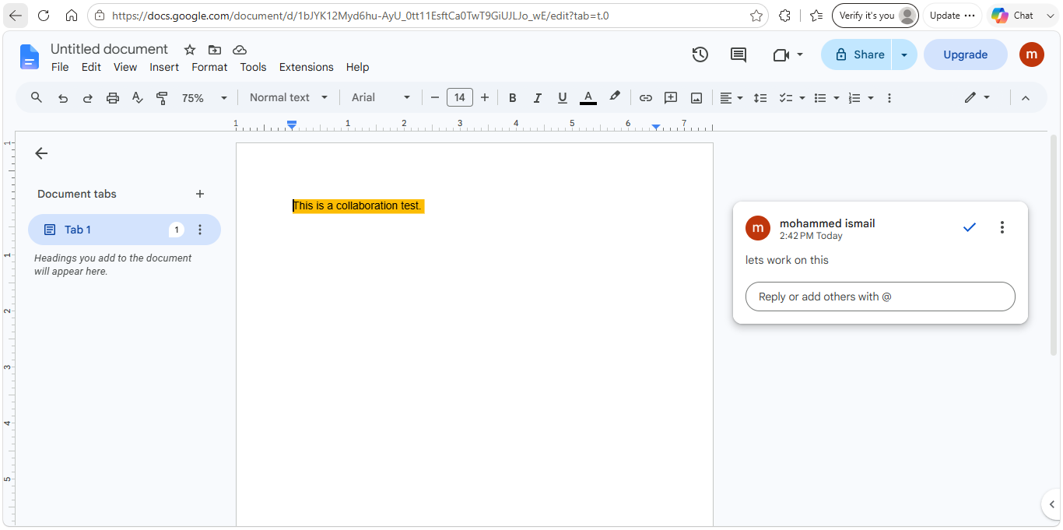
Assessing this feature showed how useful Google Docs can be when several people are working on the same document. Instead of making changes directly to someone else's work, users can leave comments to ask questions, suggest improvements, or point out areas that may need more attention. During the practical test, the comment appeared immediately next to the highlighted text, making it clear which part of the document the feedback related to. This makes it much easier for team members to discuss changes without causing confusion or accidentally editing the wrong section. Another benefit is that users can reply to comments and mark them as resolved once the issue has been addressed, helping everyone keep track of what has been completed. The automatic saving feature also meant that every change was saved instantly without needing to click the save button, which reduces the risk of losing work. Overall, the practical test showed that Google Docs is a simple but effective collaboration tool that helps teams communicate more clearly, stay organised, and work together more efficiently. The Version History feature provides an extra level of security by allowing previous versions of the document to be restored if any mistakes are made, making it a reliable choice for both businesses and educational environments [14].
Conclusion
The practical tests successfully demonstrated the core features of both Microsoft Teams and Google Docs and highlighted why they are widely used in modern organisations. Microsoft Teams proved to be an effective communication platform by allowing instant messaging, quick information sharing and easy access to conversations within one application. Google Docs demonstrated how multiple users can collaborate efficiently through shared documents, comments, and automatic cloud saving. Both applications are designed to improve teamwork, increase productivity, and support flexible working arrangements, making them valuable tools for businesses of all sizes. The practical exercises confirmed that these applications are easy to use, dependable and capable of supporting day-to-day business activities. As organisations continue to adopt digital technologies and hybrid working practices, communication and collaboration tools such as Microsoft Teams and Google Docs will remain essential for improving efficiency, supporting decision-making and enabling employees to work together successfully regardless of their physical location.

References
[1] D. Chaffey, Digital Business and E-Commerce Management, 8th Ed. Harlow, UK: Pearson, 2022.
[2] Shopify. "What is Shopify and How Does It Work?" shopify. Accessed: 17 July 2026. [Online]. Available: https://www.shopify.com/uk
[3] Wix. "Wix eCommerce Features." Wix. Accessed: 17 July 2026. [Online]. Available: https://www.wix.com/ecommerce
[4] M. J. Eppler, "A Comparison between Concept Maps, Mind Maps, Conceptual Diagrams and Visual Metaphors as Complementary Tools for Knowledge Construction and Sharing," no. 3, pp.202–210, 2006,
[5] T. Buzan and B. Buzan,The Mind Map Book, Revised Ed. London, UK: BBC Active, 2006.
[6] MindMeister. "What is Mind Mapping?" MindMeister. Accessed: 17 July 2026. [Online]. Available: https://www.mindmeister.com/content/mind-mapping
[7] J. M. Shelly, S. M. Vermaat and M. E. Freund,Microsoft 365 & Office 2021 Introductory, Boston, MA: Cengage Learning, 2022.
[8] Microsoft. "Microsoft Word Help & Learning." Microsoft Support. Accessed: 17 July 2026. [Online]. Available: https://support.microsoft.com/en-us/word/
[9] Microsoft. "Microsoft Excel Help & Learning." Microsoft Support. Accessed: 17 July 2026. [Online]. Available: https://support.microsoft.com/en-us/excel/
[10] Microsoft. "Microsoft PowerPoint Help & Learning." Microsoft Support. Accessed: 17 July 2026. [Online]. Available: https://support.microsoft.com/en-us/powerpoint/
[11] Microsoft. "Microsoft Access Help & Learning." Microsoft Support. Accessed: 17 July 2026. [Online]. Available: https://support.microsoft.com/en-us/access/
[12] P. A. Grudin, "computer-supported Cooperative Work: History and Focus," vol. 27, no. 5, pp.19–26, May 1994,
[13] Microsoft. "Microsoft Teams documentation." Microsoft learn. Accessed: 17 July 2026. [Online]. Available: https://learn.microsoft.com/en-us/microsoftteams
[14] Google. "Google Docs- Google Workspace." Google Workspace. Accessed: 17 July 2026. [Online]. Available: https://workspace.google.com/intl/en_uk/products/docs/

