Module Name: Enterprise & Entrepreneurship

Module Code: LCLM4006

Student Name: Cristian Chiuariu

Student Number: 2511685

Lecturer: Richard Ashaye

Assignment 1: Individual Written Business Plan

Business Name: Dacorum Construction Ltd

Owner: Cristian Chiuariu

Address: 23 Newbury Close, Luton LU49QJ

Phone Number: 07311770341

Dacorum Construction Ltd – Business Plan

Table of Contents
- Executive Summary
- Business Overview
- Services Provided
- Sustainability and Community Support
- Management Structure
- Legal Format
- PESTEL Analysis
- Competitor Analysis
- Marketing Strategies
- Funding Requirements and Sources
- Startup Expenses
- Fixed Costs
- Variable Costs (First Month)
- Breakeven Analysis
- Cashflow Management
- Conclusion

1. Executive Summary
Dacorum Construction Ltd is a newly established construction company based in London, aiming to deliver high-quality residential and commercial building services. The company will focus on reliability, safety, and modern construction practices while integrating sustainability and community engagement into its operations. With London’s continuous demand for housing, refurbishment, and commercial development, Dacorum Construction Ltd is positioned to become a trusted contractor for private clients, property developers, and small businesses.
The business will operate with a lean management structure—an Owner/Director, Procurement Manager, and Administrative Officer—supported by subcontracted tradespeople. The company seeks initial funding to cover startup costs, equipment, insurance, marketing, and working capital. Dacorum Construction Ltd aims to achieve profitability within the first 18 months by securing recurring contracts and building a strong reputation for quality workmanship.

2. Business Overview
Dacorum Construction Ltd will operate as a London-based construction contractor offering general building, refurbishment, maintenance, and small-scale development services. The company’s mission is to provide dependable, efficient, and safe construction solutions while maintaining transparent communication with clients.
London’s construction sector remains one of the most active in the UK, driven by population growth, infrastructure investment, and ongoing regeneration projects. Dacorum Construction Ltd will target residential homeowners, landlords, estate agents, property developers, and small commercial clients seeking reliable contractors for renovations, extensions, repairs, and new builds.
The company will differentiate itself through strong project management, competitive pricing, and a commitment to sustainable building practices.

3. Services Provided
Dacorum Construction Ltd will offer a comprehensive range of construction services, including:
- Residential Construction
  - Home extensions
  - Loft conversions
  - Kitchen and bathroom renovations
  - Structural alterations
  - Full property refurbishments
- Commercial Construction
  - Office fit-outs
  - Retail space refurbishment
  - Small-scale commercial builds
  - Maintenance contracts
- General Building & Repairs
  - Brickwork and carpentry
  - Roofing and plastering
  - Electrical and plumbing (via certified subcontractors)
  - Painting and decorating
- Project Management
  - Site supervision
  - Procurement of materials
  - Contractor coordination
  - Health and safety compliance
This service portfolio allows the company to meet diverse client needs while maintaining flexibility in project size and scope.

4. Sustainability and Community Support
Dacorum Construction Ltd will integrate sustainability into its operations by:
- Using eco-friendly materials where possible
- Minimising waste through recycling and responsible disposal
- Encouraging energy-efficient building designs
- Partnering with suppliers who prioritise sustainable sourcing
Community support initiatives will include:
- Hiring local tradespeople
- Offering discounted services for community centres or charitable projects
- Providing apprenticeship opportunities for young people interested in construction
This approach strengthens the company’s social impact and enhances its reputation within the local community.

5. Management Structure

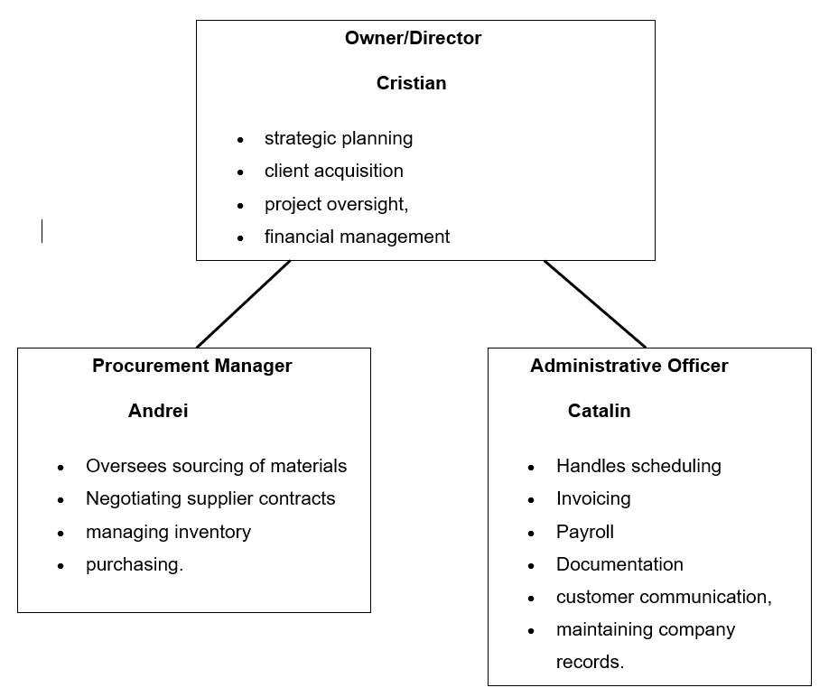
The company will operate with a streamlined management team:
- Owner / Director Responsible for strategic planning, client acquisition, project oversight, financial management, and ensuring compliance with industry regulations.
- Procurement Manager Oversees sourcing of materials, negotiating supplier contracts, managing inventory, and ensuring cost-effective purchasing.
- Administrative Officer Handles scheduling, invoicing, payroll, documentation, customer communication, and maintaining company records.
Skilled tradespeople will be hired on a subcontract basis, allowing flexibility and cost control during the early stages of business growth.

6. Legal Format
Dacorum Construction Ltd will be registered as a Private Limited Company (Ltd) in the UK. This structure provides:
- Limited liability protection
- Professional credibility
- Clear separation between personal and business finances
- Eligibility for business banking, insurance, and contracts
The company will comply with UK construction regulations, including:
- Health and Safety at Work Act
- CDM Regulations
- Building Regulations
- CIS (Construction Industry Scheme) requirements

7. PESTEL Analysis

Political
- UK government investment in housing and infrastructure supports construction demand.
- Planning regulations may delay project approvals.

Economic
- London’s strong property market drives continuous renovation and development.
- Inflation and rising material costs may affect profit margins.

Social
- Growing demand for modern, energy-efficient homes.
- Increased preference for open-plan living and home improvements.

Technological
- Advancements in construction software improve project management.
- Modern materials and sustainable technologies enhance efficiency.

Environmental
- Pressure to reduce carbon emissions in construction.
- Strict waste disposal regulations.

Legal
- Compliance with building regulations and health and safety laws is mandatory.
- Employment and subcontracting laws affect labour management.

8. Competitor Analysis
London’s construction market is competitive, with numerous small and medium-sized contractors. Key competitor categories include:
- Local independent builders offering low-cost services.
- Medium-sized construction firms with established client bases.
- Specialist contractors focusing on loft conversions, extensions, or commercial fit-outs.
Competitive Advantages for Dacorum Construction Ltd:
- Personalised service and strong client communication
- Competitive pricing due to lean structure
- Commitment to sustainability
- Flexible project size acceptance
- Strong project management and reliability

9. Marketing Strategies
Dacorum Construction Ltd will use a multi-channel marketing approach:
- Digital Marketing
  - Professional website showcasing services, portfolio, and testimonials
  - SEO targeting “London builders”, “home renovation London”, etc.
  - Google Business Profile for local visibility
  - Social media presence on Facebook, Instagram, and LinkedIn
- Partnerships
  - Collaboration with estate agents, property developers, and landlords
  - Networking with architects and interior designers
- Offline Marketing
  - Flyers and brochures distributed in local communities
  - Branded vehicle signage
  - Attendance at local business events
- Reputation Building
  - Encouraging client reviews
  - Offering referral discounts
  - Maintaining high-quality workmanship

10. Funding Requirements and Sources
Estimated funding required: £65,000, covering:
- Equipment and tools
- Vehicle purchase or lease
- Insurance and certifications
- Marketing and branding
- Initial labour costs
- Working capital for first 3–6 months
Potential Funding Sources:
- Owner investment
- Bank loan or business overdraft
- Government startup grants
- Asset finance for vehicles and equipment
- Startup Expenses
Estimated initial expenses:
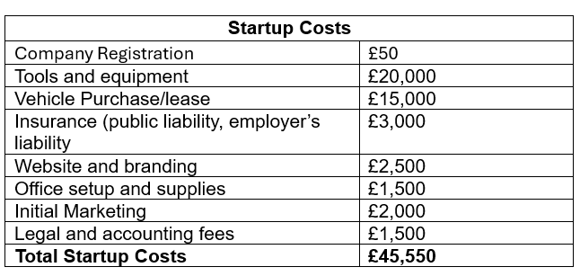

b) Fixed Costs
Monthly fixed costs include:
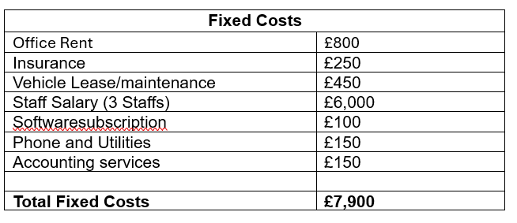

- Variable Costs (First Month)

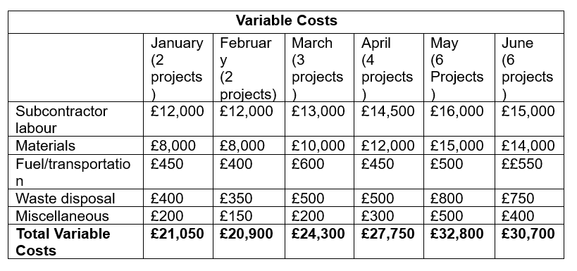
Variable costs depend on project volume. Estimated first-month variable costs:

14. Breakeven Analysis
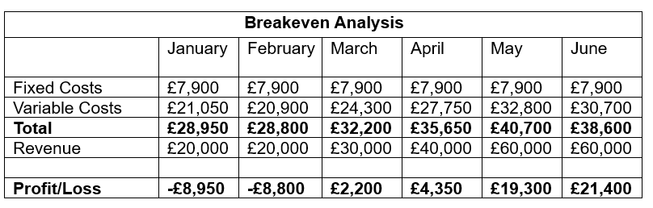
Investment Capital Needed: £45,550 (Startup) + £17,750 (£8,950 loss for January + £8,800 loss for February) = £63,300 (round-up to £65,000)
If average project value is £10,000, the company must secure 4 projects per month to break even.

15. Cashflow Management
Effective cashflow management will include:
- Clear payment schedules with deposits, mid-stage payments, and final payments
- Use of accounting software for invoicing and tracking
- Maintaining a cash reserve for unexpected expenses
- Negotiating favourable payment terms with suppliers
- Monitoring project profitability monthly
- Avoiding overextension by accepting manageable project volumes
Strong cashflow practices ensure financial stability and support sustainable growth.

16. Conclusion
Dacorum Construction Ltd is positioned to enter London’s thriving construction market with a strong value proposition, lean management structure, and commitment to quality and sustainability. With strategic marketing, efficient operations, and careful financial planning, the company aims to build a solid reputation and achieve profitability within its first 18 months. This business plan provides a clear roadmap for launching and growing Dacorum Construction Ltd into a trusted and successful construction contractor in London.

