
APPENDIX GA36a

LEVEL 4 ASSESSMENT SPECIFICATION

Student name: |  | Student ID number:
Programme: | HNC / HND / BSc Environment, Sustainability & Climate Change
Module: | Physical Landscape and the Geosphere
Module code: | ACNA4007 | Contribution to Overall Module Assessment (%): | 50%
Lecturer: | Alissa Flatley | Internal Verifier: | Elanor Alun
Assignment Title: | River Survey | Word count (or equivalent): | 2500 +/- 10%
Submission deadline: | TBC | Return date of provisional marks & written feedback: | TBC
Submission method: | All written assessments, where practical and possible, must be submitted via Turnitin unless otherwise instructed by the Lecturer. (Please DO NOT put this assessment specification into Turnitin or it will match many similarities with other students’ submissions.)  Alternative submission method (if applicable):  Late submission of the assessment will result in a late penalty mark. Penalties for late submission: Up to one week late, maximum mark of 40%. Over one week late, 0%. Only the Extenuating Circumstances Panel may approve a change to submission dates.
Academic honesty / referencing: | Academic honesty is required. In the main body of your submission you must give credit to authors on whose research and ideas your work is based. Append to your submission a reference list that indicates the books, articles, etc. that you have used, cited or quoted in order to complete this assessment.

Module Learning Outcomes
(from module syllabus)
- Express an understanding of Earth systems and their influence on the environment.
- Establish an understanding of the physical processes that influence the environment
- Complete practical fieldwork on a selected physical landscape.

TASK DESCRIPTION

2,500-word scientific field report. Use figures and tables where necessary.

The report should include:
- Title
- Introduction
  - Background
  - Rationale (Inc. Hypotheses and primary theoretical literature)
  - Location
- Methodology
- Results and analysis (Should include figures, tables and photos)
- Conclusion
  - Conclusion to hypotheses
  - Research limitations
  - Reflection on how to improve the research
- Reference list (NOT included in word count)
- Appendices (if required, NOT included in word count)

N.B. figures, tables, references and appendices are not part of the word count

Refer to http://unilearning.uow.edu.au/report/2b.html to help with the structure

READ BEFORE TRIP. ANY Q's

Always observe, then describe, and finally then and only then interpret.

Introduction
This exercise is designed to assess the changing characteristics of the river Ilston from near its source by Swansea airport to its estuary on the Gower Peninsula. Observations and field notebook information will be used for assessing the ecological characteristics of macro invertebrates and flora with particular emphasis on how these characteristics change in relation to the physical properties of the river. The data collected will be drawn together from each group and used for the physical landscape assignment OR data will be provided. Refer to Huggett, R. (2002) Topography and the Environment and Huggett, R. (2013) Fundamentals of geomorphology etc. Note module reading list.

Depending on circumstances (e.g. weather on the day, etc) it’s possible not all tests described below will be carried out, or that only one section of the river will be surveyed. If so, you will be provided with additional data.

WEAR APPROPRIATE FOOTWEAR AND CLOTHING. Be prepared for all weather and act responsibly at all times. Stay within your group. Be careful of potholes in river bed. Think of hygiene if eating/drinking. Tell tutor if you have any concerns, including health issues. Use equipment appropriately. Beware of polluted water. Do not continue experiment if you suspect polluted water. Beware of water depth (use a stick), wipes, food, Weils disease (Refer to later section).
PART 1 Hydrological Study

Aim
To examine the changing characteristics of the river

Hypotheses
- The river becomes wider and deeper downstream
- The cross-sectional area of the river increases downstream
- The river velocity increases on the outside of a meander
- The highest velocity is to be found in the centre of the river
- The river velocity decreases downstream
- The size of the bed load gets smaller downstream
- The shape of the bed load becomes more rounded downstream
- The discharge of water in the river increases downstream

Ecological objectives
Within the field notebook, you should demonstrate the relationship of ecological form and behaviour to the physical setting.

Apparatus
- 1:25000 Map (Photocopy/mobile phone app) showing the location of group work
- Datasheets
- 25m tape measure
- Metre rule
- Clipboard
- Stopwatch
- 2 surveying poles
- Oranges
- Current flow meter
- Waders
- Powers Scale of roundness chart

Methodologies

Hypothesis 1 & 2
Measure across the stream (from water's edge to water's edge) at 5 points on your section of river (keep taut). At each point, measure (metre rule) the depth of the river at 25-cm intervals:
Note data on the following logging sheet:

Date | River Name:  Group: | Grid Ref. | Weather
Point e.g. 1 | Width 2m | Point | Width
Depth in M. | Horizontal Dist. from right bank (pointing downstream) | Depth in M. | Horizontal Dist. from right bank (pointing downstream)
1.3 | 0.25
2.2 | 0.50 etc.

Using the results, work out your average depth and cross-sectional area of each point: e.g.

2M

Readings 1 - 7
1 - 0.20m
2 - 0.25m
3 - 0.50m
4 - 0.60m
5 - 0.45m
6 - 0.20m
7 - 0.10m
Total 2.3m

Average depth (n+1)
2.3 | = 0.288
8

Cross Sectional area 2 (width) * 0.288 = 0.576 m2

Plot the cross section for each point on graph paper.

Hypotheses 3, 4, 5.
3 & 4 will be examined using the current meter. The apparatus and technique will be demonstrated in the field.

All groups will do hypothesis 4, but only the groups with a meander on their section of the river will do 3

Take meter readings at the following locations on a straight section of the river. Note readings in the box provided:

1
2
3
4
5

Location IN river  Data collection point (on map) | 1 | 2 | 3 | 4 | 5 | Orange

Hypothesis 5
Using the tape measure a straight section of river 5m or 10m (If possible)
Mark the distance using the surveying poles
Drop the orange provided into the middle of the river at survey pole 1 (upstream). Time the number of seconds it takes the orange to travel between the 2 poles. Use waders to do this exercise at least 5 times, rotating tasks amongst the group. If the orange gets stuck on route, repeat the measurement
Log data on the following sheet

Date | River | Group | Grid Ref. | Weather
Reading number |  |  | Time in seconds

Measurement of Velocity
Length of reach ..............m
Average time of oranges ..............Secs.
Multiply average time by 0.85 (converts surface velocity to stream velocity)

Average velocity =

Distance (m) | = m / sec. |  | =
Time (Seconds)

Hypotheses 6 & 7
Take 5 representative samples of sediment from each of the 5 points used in the cross-sectional part of the survey. Measure the long axis of each and assess their roundness using the following table:

 | Point | 1 | 2 | 3 | 4 | 5
Sample 1 | Long Axis
 | Roundness
Sample 2 | Long Axis
 | Roundness
Sample 3 | Long Axis
 | Roundness
Sample 4 | Long Axis
 | Roundness
Sample 5 | Long Axis
 | Roundness

Roundness
Roundness "The degree of abrasion of a clastic particle as shown by the sharpness of its edges and corners, expressed by Wadell (1932) as the ratio of the average radius of curvature of the several edges or corners of the particle to the radius of curvature of the maximum inscribed sphere (or to one-half the nominal diameter of the particle.)" Bates and Jackson (1987: 546).
For descriptive purposes we can take the entire spectrum of roundness and break it up in to a small number of divisions each referred to as a Roundness Class ["An arbitrarily defined range of roundness values for the classification of sedimentary particles." Bates and Jackson (1987: 547). Below are verbal descriptions of the usual roundness classes as commonly applied.
Well-rounded: original faces, edges, and corners have been destroyed by abrasion and whose entire surface consists of broad curves without any flat areas. Roundness value between 0.60 and 1.00. (See Pettijohn, 1957, p. 59 for further details if you are so inclined)
Rounded: Round or curving in shape; original edges and corners have been smoothed of to rather broad curves and whose original faces are almost completely removed by abrasion. Some flat areas may remain. Roundness value between 0.40 and 0.60.
Subrounded: Partially rounded, showing considerable but not complete abrasion, original form still evident but the edges and corners are rounded to smooth curves. Reduced area of original faces. Roundness value between 0.25 and 0.40.
Subangular: Somewhat angular, free from sharp edges but not smoothly rounded, showing signs of slight abrasion but retaining original form. Faces untouched while edges and corners are rounded off to some extent. Roundness value between 0.15 and 0.25.
Angular: Sharp edges and corners, little or no evidence of abrasion. Roundness value between 0.0 and 0.15.
Very Angular: Powers (1953) used this as a class similar to that of Angular of Pettijohn (1957) and with a roundness value of 0.10 to 0.17. I would suggest to reserve this term for those few particles whose edges and corners are so sharp that they could cut you.
Subangual-subrounded: A term sometimes used when one cannot decide which to choose as is generally the case when you are working with granular or smaller sized particles.
Some text and reference books use cartoon illustrations of these various classes (see below) and some geologists will actually carry a reference card with them with these same illustrations. This, I think, is a little silly. Similarly it is a bit silly to spend the day measuring circles and what not to get a numerical value for roundness. It is best to train your eye to recognize the various roundness classes.
(University of North Carolina, 2015)

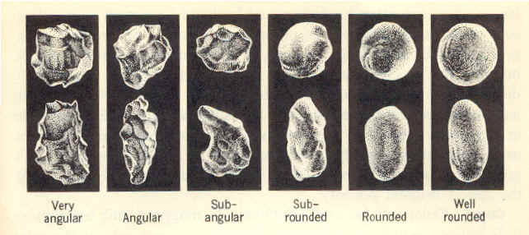
Modified after Powers, M . C., 1953, Journal of Sedimentary Petrology, v. 23, p. 118.

Hypothesis 8
Discharge = velocity * cross - sectional area
= m3/sec.

Results

Each group should tabulate (using excel) all these results and input within 2 weeks of trip.

Other issues to consider
- What are the anthropogenic influences on the natural processes of the river?
- How would the airport influence natural processes?
- Does the cost of land influence river?
- Is there any evidence of cost-benefit analysis in the location of river defences?
- Do flood defences affect erosion/deposition and transportation in the river?
- Is forest management critical? Why?
- Where does the river flood now?
- Where did it flood in the past?
- What is the geology? Is it essential in a hydrological study?

Additional points you may want to consider
- Drainage basin size 30 sq. km
- Major floods in the years 1942-1945
- Lag time catchment type, NRA and previous Environment Agency/ (NRW) Hydrographs
- River order, Interception, Depression storage, Through flow, groundwater, saturated overland flow, evaporation, precipitation, Bank full-width channel width, hydraulic radius, wetted perimeter, x sectional area, field sketches, evidence for meanders cut through/time.
- CEH Centre for Ecology and Hydrology
- River levels U.K.
- Environment Agency (England) Natural Resources Wales
- Met Office (Good data over time)
- Evaluate how your findings compare to the models of 1.Bradshaw, 2. Schumn and 3. Hjulstrom.
- Develop your diagrammatic model for the river Ilston
- Note positive/negative correlation in your data.
- To help you highlight the statistical significance of your findings, calculate a Spearman's Rank Correlation Coefficient to test distance from the source, Velocity etc.

During your considerations, also ask yourself:
- How appropriate was your sample site and sampling strategy?
- Was it a good location to assess hydrological theory?
- Were there any limitations to your method which reduced the accuracy of the data e.g. how accurate is the float method?
- How reliable are your results? For example, what are the limitations of using subjective data such as the Power's Index?
- How robust was your statistical test? Did you have enough data? Are there any limitations inherent to the test?
- How robust are your conclusions? You are likely to be limited by only being able to sample at one time of year (perhaps only one day), so you will not have in-depth data on seasonal variation. Your secondary data on river levels may indeed indicate that there is seasonal variation in depth.
- What other data would have been helpful to obtain? (FSC, 2015)

Some sources specific to Gower
Lawler, D.M. & Bull, P.A. (1978) Erosion in the Valley of the Pennard Pill: Some preliminary observations Gower Journal Vol. 28 pp. 46-54

Lawler, D.M. (1986) River bank erosion and the influence of frost: a statistical examination Transactions IBG Vol. 11 No. 2 pp. 227-242

Owen, T.R. (1972) The carboniferous Limestone of the Gower. Gower Journal Vol. 23, pp. 10-14

http://www.geolsoc.org.uk/gsl/site/GSL/lang/en/page2544.html (Gower by Ted Neald)

http://www.explore-gower.co.uk/index.php

Also:
Glamorgan and Gwent Archaeological Trust
Environment Agency/NRW
Met Office, 2019

Etc.
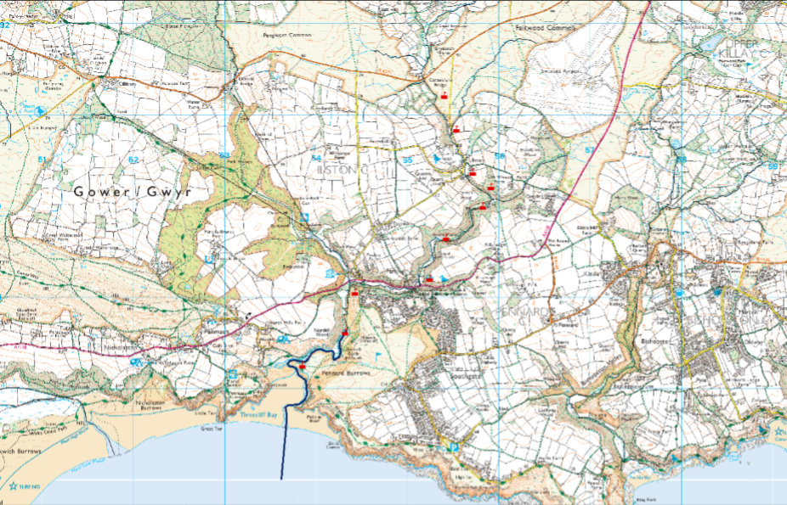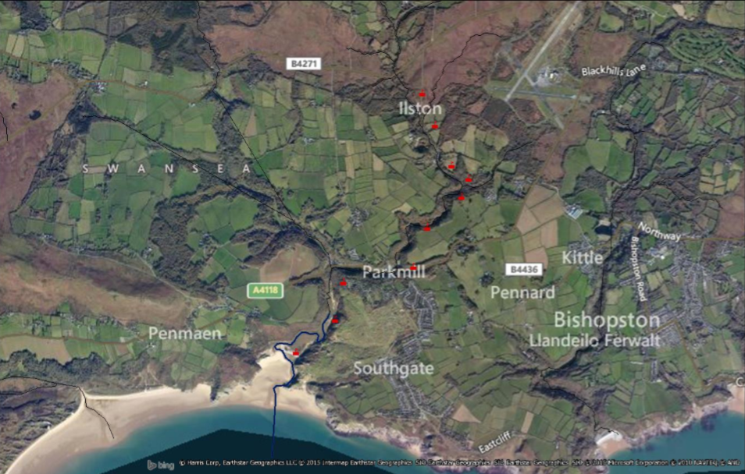
Data collection points
GUIDANCE FOR Students IN THE COMPLETION OF TASKS

NOTE: The guidance offered below is linked to the five generic assessment criteria overleaf.

- Engagement with Literature Skills
Your work must be informed and supported by scholarly material that is relevant to and focused on the task(s) set. You should provide evidence that you have accessed an appropriate range of sources, which may be academic, governmental and industrial; these sources may include academic journal articles, textbooks, current news articles, organisational documents, and websites. You should consider the credibility of your sources; academic journals are normally highly credible sources while websites require careful consideration/selection and should be used sparingly. Any sources you use should be current and up-to-date, mostly published within the last five years or so, though seminal/important works in the field may be older. You must provide evidence of your research/own reading throughout your work, using a suitable referencing system, including in-text citations in the main body of your work and a reference list at the end of your work.

Guidance specific to this assessment: You have been provided with some sources here, but you should read beyond this. All literature should be credible and referenced to Harvard standards.

- Knowledge and Understanding Skills
At level 4, you should be able to demonstrate knowledge of the underlying concepts and principles associated with your area(s) of study. Knowledge relates to the facts, information and skills you have acquired through your learning. You demonstrate your understanding by interpreting the meaning of the facts and information (knowledge). This means that you need to select and include in your work the concepts, techniques, models, theories, etc. appropriate to the task(s) set. You should be able to explain the theories, concepts, etc. to show your understanding. Your mark/grade will also depend upon the extent to which you demonstrate your knowledge and understanding.

Guidance specific to this assessment: Your paper should make it clear that you understand the physical processes behind river dynamics – why do they get wider? Why and how does the sediment change? Etc

- Cognitive and Intellectual Skills
You should be able to present, evaluate and interpret qualitative and quantitative data, in order to develop lines of argument and make sound judgements in accordance with basic theories and concepts of your subject(s) of study. You should be able to evaluate the appropriateness of different approaches to solving problems related to your area(s) of study and/or work. Your work must contain evidence of logical, analytical thinking. For example, to examine and break information down into parts, make inferences, compile, compare and contrast information. This means not just describing what! But also justifying: Why? How? When? Who? Where? At what cost? You should provide justification for your arguments and judgements using evidence that you have reflected upon the ideas of others within the subject area and that you are able to make sound judgements and arguments using data and concepts. Where relevant, alternative solutions and recommendations may be proposed.

Guidance specific to this assessment: Once you have your results, the most important part is to interpret them. What kick sampling results did you get? Are they different from what you’d expect? Why? Are there clues in the landscape around you to explain any anomalies?

- Practical Skills
At level 4, you should be able to apply the basic underlying concepts and principles to evaluate and interpret these within the context of your area of study. You should be able to demonstrate how the subject-related concepts and ideas relate to real world situations and/or a particular context. How do they work in practice? You will deploy models, methods, techniques, and/or theories, in that context, to assess current situations, perhaps to formulate plans or solutions to solve problems, or to create artefacts. This is likely to involve, for instance, the use of real world artefacts, examples and cases, the application of a model within an organisation and/or benchmarking one theory or organisation against others based on stated criteria.

Guidance specific to this assessment: Practical skills here include kick sampling, velocity measurements, cross-sectional analysis, etc.

- Transferable Skills for Life and Professional Practice
Your work must provide evidence of the qualities and transferable skills necessary for employment requiring the exercise of some personal responsibility. This includes demonstrating: that you can communicate the results of your study/work accurately and reliably, and with structured and coherent arguments; that you can initiate and complete tasks and procedures, whether individually and/or collaboratively; fluency of expression; clarity and effectiveness in presentation and organisation. Work should be coherent and well-structured in presentation and organisation.

Guidance specific to this assessment: Your report should be coherent and professionally presented in a scientific format.

Student FEEDBACK FORM

This section details the extent to which the assessment criteria are demonstrated by you, which in turn determines your mark. The marks available for each category of skill are shown. Lecturers will use the space provided to comment on the achievement of the task(s), including those areas in which you have performed well and areas that would benefit from development/improvement.

Generic Assessment Criteria | Marks available | Marks  awarded
1. Engagement with Literature Skills
.
 | 10
2. Knowledge and Understanding Skills

 | 30
3. Cognitive and Intellectual Skills

 | 40
4. Practical Application Skills

 | 10
5. Transferable Skills for Life and Professional Practice

 | 10

Assessment Mark (Assessment marks are subject to ratification at the Exam Board. These comments and marks are to give feedback on module work and are for guidance only until they are confirmed. ) | Late Submission Penalties (tick if appropriate) |  | %
 | Up to 1 week late (40% Max) |  | %
 | Over 1 week late (0%) |  | %

GENERIC ASSESSMENT CRITERIA

Level 4
In accordance with the Framework for Higher Education Qualifications, at the end of Level 4 students will be expected to have demonstrated knowledge of the basic underlying concepts and principles of a subject, and an ability to evaluate and interpret these within the context of that area of study. They should be able to present, evaluate and interpret qualitative and quantitative data in order to develop lines of argument and make sound judgements in accordance with basic theories and concepts of their subject(s) of study. They will have learned how to evaluate different approaches to solving problems, and will be able to communicate the results of their study/work accurately and reliably, and with structured and coherent arguments. They will be able to undertake further training and develop new skills within a structured and managed environment and will have the qualities and transferable skills necessary for employment requiring the exercise of some personal responsibility.

Level 4 | FAIL | MARGINAL FAIL | SATISFACTORY  (3rd / Pass) | GOOD  (2.2 / Pass) | VERY GOOD  (2.1 / Merit) | EXCELLENT  (1st / Distinction) | EXCEPTIONAL  (1st / Distinction)
Category | 0-29% | 30-39% | 40-49% | 50-59% | 60-69% | 70-84% | 85-100%
Engagement with literature (including reading, referencing,  academic conventions and  academic honesty) | Little or no evidence of reading and/or reliance on inappropriate sources.  Views and findings mostly unsupported and non-authoritative.  Referencing conventions used incoherently or largely absent. | Poor engagement with essential reading. No evidence of wider reading. Reliance on inappropriate sources, and/or indiscriminate use of sources. Heavily reliant on information gained through class contact. Inconsistent and weak use of referencing. | Engagement with a limited range of mostly relevant and credible sources but with some reliance on information gained through class contact. Some omissions and minor errors.  Referencing conventions evident though not always applied accurately or consistently. | Engagement with an appropriate range of literature, including sources retrieved independently. Some over-reliance on texts rather than other sources. Referencing may show minor inaccuracies or inconsistencies. | Engagement with a wide range of literature, including sources retrieved independently.  Selection of relevant and credible sources. Generally sound referencing, with no/very few inaccuracies or inconsistencies. | Engagement with an extensive range of relevant and credible literature. Consistently accurate application of referencing. | Exceptional engagement with an extensive range of relevant and credible literature. High-level referencing skills consistently applied.
Knowledge and understanding (Knowledge of the basic underlying concepts and principles of a subject.) | Major gaps in knowledge and understanding of the basic underlying concepts and principles of the subject matter. Inclusion of irrelevant material. Substantial inaccuracies. | Gaps in knowledge of the basic underlying concepts and principles, with flawed or superficial understanding. Some significant inaccuracies and/or irrelevant material. | Limited knowledge and understanding of the basic underlying concepts and principles within the subject area. Some elements may be missing. | Knowledge of the basic underlying concepts and principles is accurate with a good understanding of the field of study but lacks depth and/or breadth. | Competent knowledge of the basic underlying concepts and principles. Exhibits very good understanding. | Excellent knowledge and understanding of the basic underlying concepts and principles of the subject. | Exceptional, detailed knowledge and understanding of the basic underlying concepts and principles
Cognitive and intellectual skills  (Evaluate underlying concepts and principles of a subject and interpret qualitative and quantitative data in order to develop lines of argument and make sound judgements.) | Wholly or almost wholly descriptive work. Little or no evaluation of the underlying concepts and principles.  Failure to develop arguments, leading to illogical or invalid judgements. Minimal or no use of  evidence to back up views. | Largely descriptive work, with superficial evaluation of the underlying concepts and principles. Weak interpretation of data, flawed development of arguments and judgements. Information accepted uncritically, uses generalised statements made with scant evidence and unsubstantiated opinions. Ideas sometimes illogical and contradictory. | Limited attempt at evaluation of the underlying concepts and principles, tending towards description.  Can interpret qualitative and quantitative data but with some errors. Some evidence to support emerging arguments and judgements but these may be underdeveloped or with a little inconsistency / mis-interpretation. | Good evaluation of the underlying concepts and principles. Can interpret qualitative and quantitative data, with minor errors.  An emerging ability to use evidence to support the argument.  Mostly valid arguments and logical judgements. | Sound evaluation of the underlying concepts and principles. Can interpret qualitative and quantitative data accurately. Ability to devise arguments using evidence to make mostly appropriate and valid judgements. | Excellent evaluation of the underlying concepts and principles. Can interpret qualitative and quantitative data accurately and with some insight. Excellent ability to devise arguments using evidence and make appropriate and valid judgements. | Exceptional evaluation of the underlying concepts and principles based evidence. Outstanding interpretation of qualitative and quantitative data.  Exceptional ability to devise arguments using evidence and make wholly appropriate and valid judgements.
Practical skills  (Different approaches to solving problems in particular contexts.) | Limited or no use of taught, basic methods, materials, tools and/or techniques.  Little or no appreciation of the context of the application.  Very weak evidence of different approaches to problem-solving in particular contexts. | Rudimentary application of taught, basic methods, materials, tools and/or techniques but without consideration and competence. Flawed appreciation of the context of the application.  Weak evidence of different approaches to problem-solving in particular contexts. | An adequate awareness and mostly appropriate application of basic methods, materials, tools and/or techniques.  Basic appreciation of the context of the application.  Can identify problems in particular contexts and propose basic alternative approaches or solutions though there may be errors. | A good and appropriate application of basic methods, materials, tools and/or techniques.  Clear appreciation of the context of the application.  Good evidence of different approaches to problem-solving in particular contexts and proposes mostly appropriate solutions. | A very good application of a range of basic methods, materials, tools and/or techniques.  Very good consideration of the context of the application. Very good evidence of different approaches to problem-solving in particular contexts and proposes appropriate solutions. | An advanced application of a range of taught, basic methods, materials, tools and/or techniques.  The context of the application is well considered, and insightful.  Excellent evidence of different approaches to problem-solving in particular contexts and proposes appropriate solutions. | Exceptional levels of application and deployment skills in particular practical contexts. Outstanding identification of problems in particular contexts and formulation of wholly appropriate, thoughtful solutions / different approaches.
Transferable skills for life and professional practice  (Communicate the results of their study/work accurately and reliably, and with structured and coherent arguments; the qualities needed for employment requiring the exercise of some personal responsibility within a structured and managed environment.) | Work is poorly structured, disorganised, inaccurate and/or confusingly expressed. Very weak use of language and/or very inappropriate style. Failure to work effectively individual or as part of a group. Little or no evidence of the skills for employment requiring the exercise of some personal responsibility. | Work is poorly presented in a disjointed manner. It is loosely, and at times incoherently, structured, with information and ideas often poorly expressed. Weak use of language and/or inappropriate style. Flawed approach to individual or group work, meeting only partial obligations to others. Limited evidence of the skills for employment requiring the exercise of some personal responsibility. | Mostly ordered presentation and structure in which relevant ideas / concepts are reasonably expressed. Work may lack coherence and/or accuracy in places. Can work as part of a group, meeting most obligations to others but perhaps with limited involvement in group activities.  Demonstrates the basic skills for employment requiring the exercise of some personal responsibility, with some areas of minor weakness. | Mostly coherent, organised and accurate work, in a suitable structure and is for the most part clearly expressed. Can work effectively independently and/or as part of a team, with clear contribution to group activities.  Demonstrates the skills for employment requiring the exercise of some personal responsibility, with some areas of strength and some of minor weakness. | Work is accurate, coherent, fluent, well-structured and organised.  Can work effectively independently and/or as part of a team, with very good contribution to group activities. Demonstrates very good skills for employment requiring the exercise of some personal responsibility, with just occasional minor weakness. | Work is coherent, very fluent and is presented professionally. Can work effectively independently and/or as part of a team, with an excellent contribution to group activities. Demonstrates excellent skills for employment requiring the exercise of some personal responsibility with an appetite for further development. | Work is accurate, exceptionally coherent, very fluent and presented well. Can work effectively independently and/or as part of a team, with an exceptional contribution to group activities. Demonstrates exceptional skills for employment requiring the exercise of some personal responsibility with an appetite for further development.

THIS DOCUMENT IS ALSO AVAILABLE IN WELSH

