Motorcycle Dynamics Assignment
Motorcycle Technology (ACHA4003)
2020 - 2021

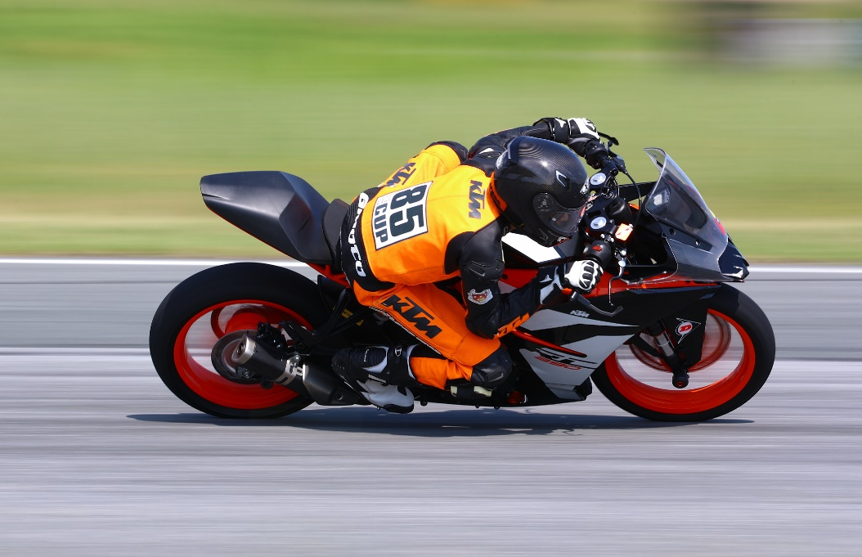

Figure 1: Motorcycle rider (Iatrakis, 2019)

Ilias Gideon Iatrakis (2011922)
Lecturer: Andrew Harrison

Contents
Contents 2
Introduction 3
1 Methodology 4
2 Analysis 5
2.1 Centre of gravity 5
2.2 Rake and Trail 6
2.3 Honda VFR400 7
2.4 Honda CRF450 8
2.5 KTM RC390 10
2.6 Speed, Power Calcs. 12
2.7 Husqvarna FS450 13
2.8 VFR400 alternations 13
Conclusion 14
References. 15
Appendices 16

Introduction
The following assignment is an investigation formulated to show the understanding of:

Motorcycle geometry and dynamic handling characteristics, including:

- The measurement and presentation of geometric data such as trail, rake, Wheelbase and center of gravity.
- Gear ratios and maximum speed calculation.
- Explain how the motorcycles have been tailored to perform best to their application by analyzing the acquired data.
- Compare the acquired data to 2 other motorcycles explaining the differences in handling of each model and how they are suited to their purpose.

Methodology
To complete this investigation, 4 motorcycles were chosen to measure or acquire data from and represent a variety of measurements and aspects.

- Honda VFR400 1998, race setup for a 400cc sprint class.
- KTM RC390 2017, Stock except from the seat cowl and exhaust.
- Honda CRF450R 2009 Stock Motocross bike.
- Husqvarna FS450 2020, stock factory built Supermoto.

We’ve measured and calculated data From the VFR400 and CRF450. These data we are going to compare to newer, but similar style motorcycles to see the evolution and changes over the years of development.

First we measured the data to calculate COG with the practical method (see Figure 2 and 3). Both COG with and without rider were calculated.
Rake and Trail of the VFR and CRF were also measured.

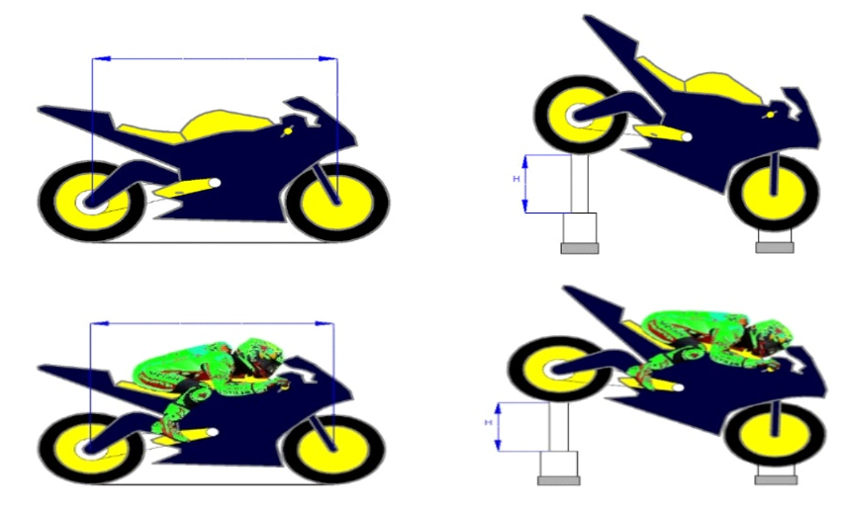
These data of the other 2 bikes were acquired through the user manuals. With researched data we have calculated the top speed and required power of The VFR and CRF using Microsoft Excel. After the geometry calculations, we have explained how these design elements were tailored to the motorcycle’s application.
Figure 2: Weighing method COG (NT Project, 2005)

Excel was used to calculate and formulate the information.
Affinity Photo was used to make the bike schematic diagram.

Data acquisition and formulae used in each section of the process of this investigation are included in Appendices.

Sources including Internet, library and lectures were used.

Analysis

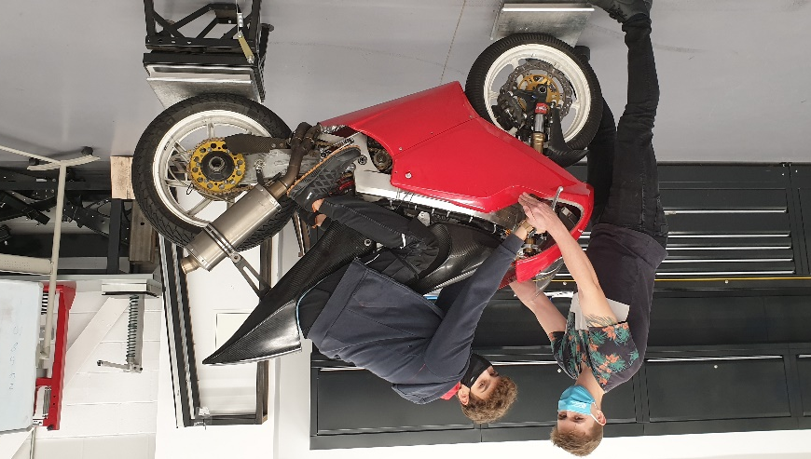
Centre of gravity
Figure 3: COG measurements (Iatrakis, 2020)

The centre of gravity is arguably the biggest variable in how the Motorcycle feels and handles.

Weight distribution (in all three dimensions) is determined by where we choose to locate parts, particularly the very heavy ones such as thee engine, fuel tank, forks, wheels and rider. The overall result is defined by the location of something called the centre of gravity. (Bradley, 1996)

The center of gravity, is the point where forces like load transfer, acceleration, braking, and cornering can be considered to act.

The COG can be altered by different variables such as wheelbase, ride height etc. but the most important influence on the centre of gravity is the rider.
The riders’ weight, seating position, footrest and handlebar position will all alter the CoG position.
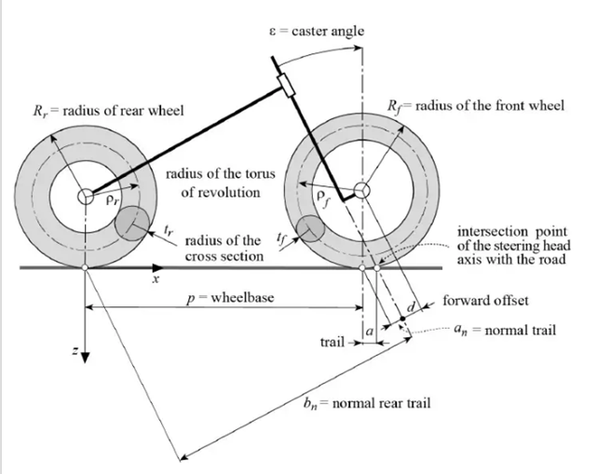
Figure 4 (Cossalter 2006)
As we will see a bit further on, the Centre of gravity on each bike is on a different place, this is dependent on the type and purpose of the bike.

Rake and Trail

Rake and Trail (see Figure 4 and 5) are 2 of the vital factors in geometry and handling of the motorcycle.

Rake: Rake is the angle measured between the line projected through the steering stem, and the vertical line projected through the front axle.

The rake angle is different on motorcycles with different purposes.

Changing the rake mainly alters the trail.

Trail: The primary function of trail is to build a certain amount of steering stability, and it also is of great importance to the lean-in phase when cornering. (Bradley, 1996)

Trail gives a self centering effect due to the front wheel being behind the steering axis (trailing)

-Too little trail: Self centering is decreased, bike becomes unstable.
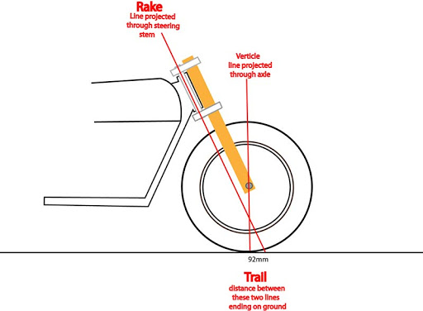
-Too much trail: Steering becomes heavy.
Figure 5: Rake and Trail (TagTeamRacing, 2011)

Honda VFR400

This motorcycle has been modified from a street bike to suit a certain purpose, In this case sprint racing. Which means that this motorcycle has been modified to make it faster. Modifications regarding to power output, weight, aerodynamics, height, length and brakes were made. To compare this motorcycle we will compare this to a newer, Similar lightweight 400cc, an 2017 KTM RC390.

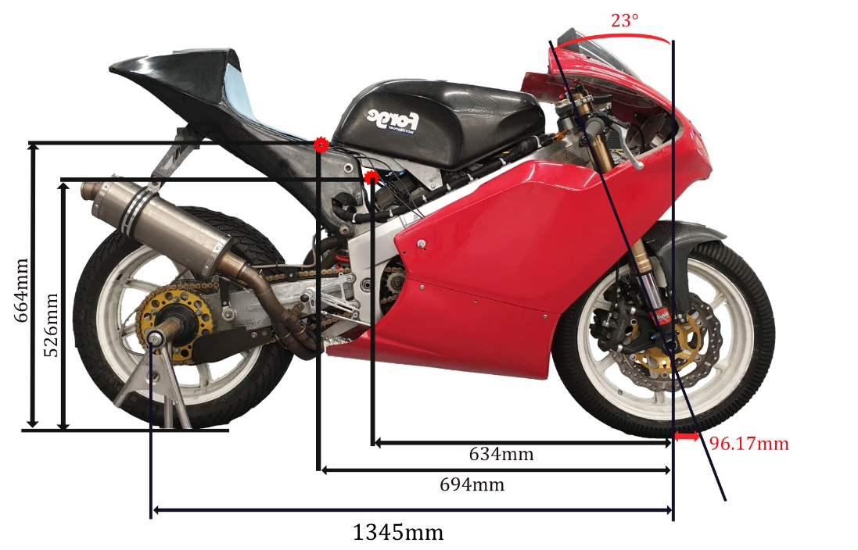
Figure 6: VFR400 Diagram. (Iatrakis, 2020)
Geometry data visible in figure 6.
COG calculations are mentioned below, Used data visible in Table 1.
Table 1: VFR400 COG calcs. (Iatrakis, 2020)

Honda CRF450

The Honda CRF450 is a competition motocross bike, its built to go fast on off-road tracks and be able to jump etc. It needs to be stable for the rough terrain but also turn fast in small corners. The bike we measured is completely stock.

Due to the long wheelbase and large rake angle/ trail the bike handles stable on rough terrain. This high amount of stability is compensated by the fairly low COG which sits pretty close to the crankshaft. The lower COG causes the bike to turn faster. The bike is also pretty high to have enough suspension travel and ground clearance, thanks to this it turns faster and easier too.
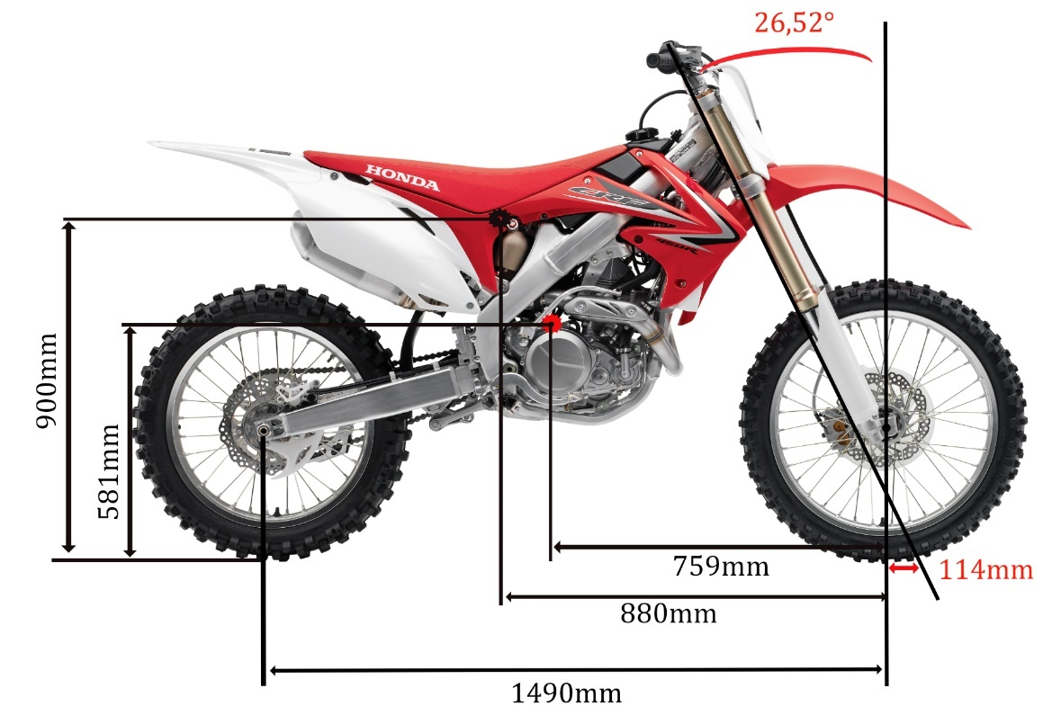
In figure 7 you see the schematic diagram of geometry data. On Table 2 the excel spreadsheet with used data.
Table 2: CRF450 COG Calcs. (Iatrakis, 2020)
Figure 7: CRF450 Diagram (Iatrakis, 2020)

COG calculations and measurement:

The COG measurements and calculations of the VFR400, CRF400 and FS450 where done by me, the VFR and CRF where both measured at the university workshop (see figure 6 and 8). The RC390 data were provided by Zero chassis. (See appendices for pictures and Excel spreadsheet)
- Wheelbase: by measuring front axle to rear axle on both sides with the front wheel straight, average of both readings to give an accurate result.
- Front and rear axle height by measurement with motorcycle vertical.
- Front and rear load under level conditions: using scales, weighed the front and rear then repeated with rider on board.
- Centre of Gravity horizontal position. Using equilibrium/moments theory: Clockwise forces are equal to anticlockwise forces on the front axle.
$$Weight on rear axle ×Wheelbase=total weight ×CoG distance$$
Transposing gives:

$$CoG Distance=\frac{Weight on rear axle ×Wheelbase}{Total Weight}$$

- Centre of Gravity height: by using the wheelbase ,front axle height, and front /rear loads as set out above then repeating with the rear raised by 0.345m.
$$COG Ht=Fr axle Ht+( \frac{Fr weight Diff ×WB^{1}×WB^{2}}{Total weight ×Height raised} )$$
Where: WB₁ = Original wheelbase.
WB₂ = Horizontal wheelbase when lifted.

- Horizontal wheelbase when the rear is raised was found using the Pythagoras Theorem
$Horizontal wheelbase= \sqrt{(Original}wheelbase²-height raised² )$

This process gets repeated with and without the rider on board.

KTM RC390
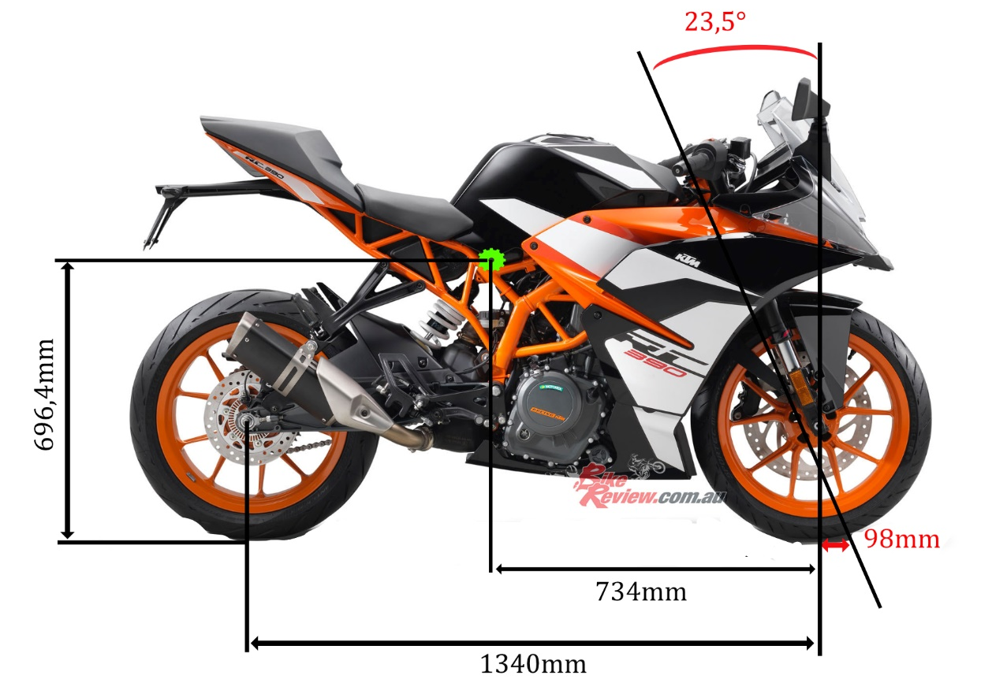
Figure 8: KTM RC390 with dimensions (Iatrakis, 2020)

The RC390 (Figure 8) has been designed to be a street bike ready for the racetrack, which means it has been designed to be stable and agile. As we can see the geometry of this newer bike similar to the VFR400 hasn’t changed a lot.

We can see that the rake angle is 0,5° larger than the VFR making it a bit more stable due to more trail. The wheelbase is a bit shorter to keep the bike from being too stable and turning slowly.

As I personally ride this Bike I’ve chosen to do the speed calculations on the RC390, the gear ratios were taken out of the workshop manual. Power data were taken of a dyno test of my personal bike (see appendices). On Table 11, 12 and Figure 9 we can see the speed and power results. The Bike makes enough driving force to overcome the aerodynamic resistance forces and reach it’s top speed of 168km/h.

Table 3: Speed, Power results (Iatrakis, 2020)
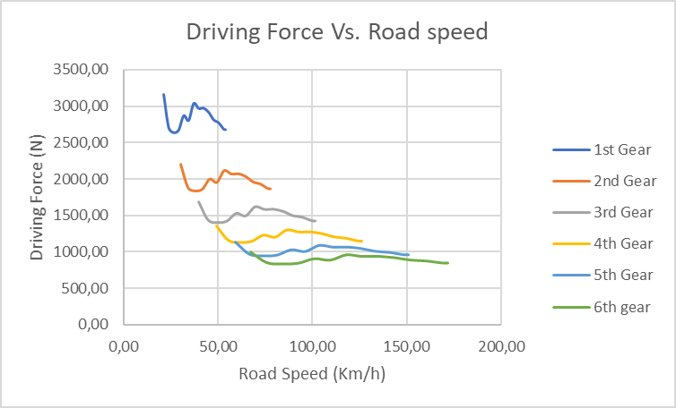
Figure 9: Speed Vs. Power for each gear (Iatrakis, 2020)
Table 4: Gear ratios and speed Calc. (Iatrakis, 2020)

Speed, Power Calcs.

Overall gear ratio; Top gear.
$Overall ratio=primary ×gear ×final$ drive ratio

    - Maximum Velocity using basic force.

- Driving Force. From, $Power=Force ×Velocity$
Transposing gives;
$$Force=\frac{Power}{Velocity}$$
- Opposing force.
= $Friction+(0.5 ×Air Density ×Drag Cd ×frontal area ×(velocity^{2})$

    - Maximum Velocity by Formula.

From;
$$Power at\max{v=0.5×air density×Cd ×Front area×Vmax³}$$
Transposing gives;
$$Vmax=\sqrt[3]{(\frac{\left(Max power\right)}{0.5×air density×Cd ×Front area}) }$$

    - Maximum Velocity with all forces represented.

- Coefficient of friction; General CdA Value taken of superbike from Vittore Cossalter.

- By multiplying primary, gear and final ratios to get overall gear ratio;
$$Overall ratio=primary ×gear ×final$$
- Theoretical maximum velocity;
$$Max Vel=\frac{tyre circumference ×revs per second}{overall gear ratio}$$
- Resistive force due to gradient;

$$Mass ×Gravity ×Gradient ratio$$

- Tractive effort. Being the force available to drive the vehicle forward at given velocity in given gear;
$$Tractive Force=\frac{\left(Torque ×Overall gear ratio ×1000\right)}{Revs per Second}$$
- Torque;
Torque = ((5252 ×Revs per Minute))/Horsepower

Husqvarna FS450

The Husqvarna FS450 is a Supermoto ready built from the factory.
As we see it is similar built to a motocross bike, we see that the wheelbase is shorter and there is more trail than the CRF450.

The trail keeps the bike stable at higher speeds while the shorter wheelbase and very low COG (figure 10 and excel file) keep it very easy to handle and able to turn fast. This makes the supermoto a perfect bike for it’s purpose, being fast on small karting tracks.
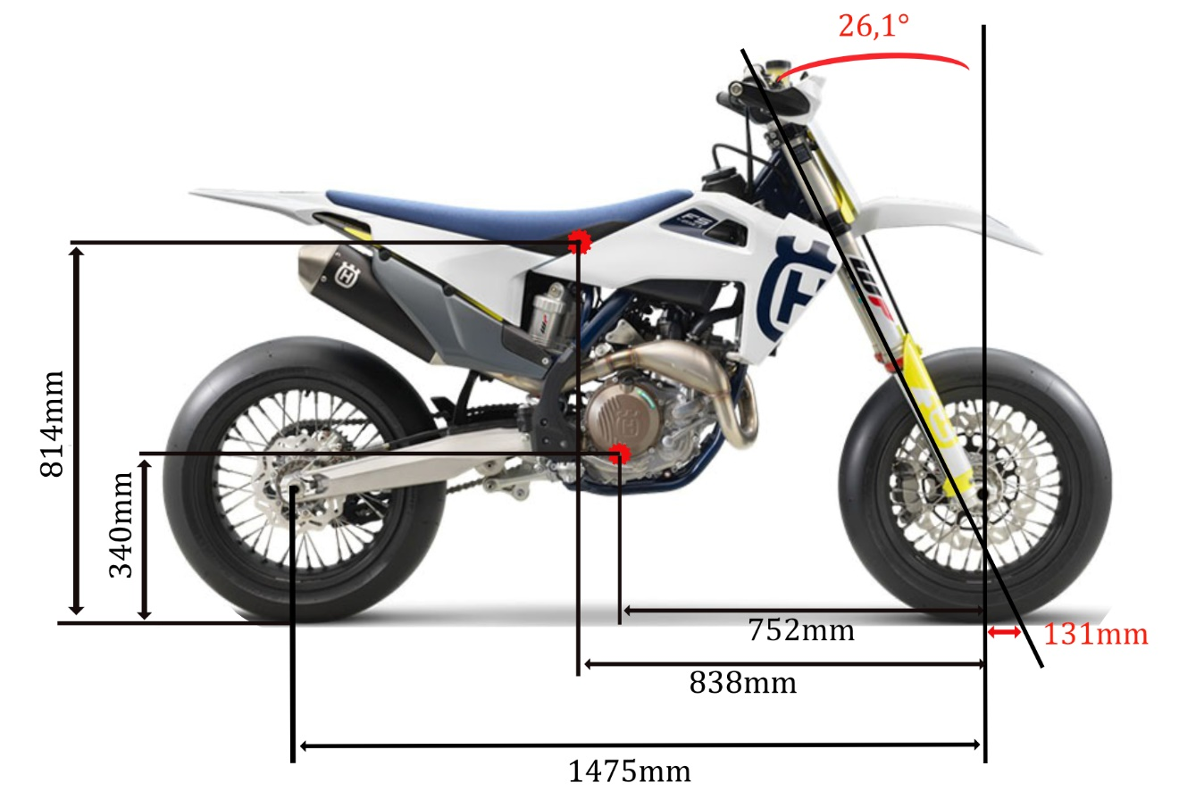
Figure 10: FS450 (Iatrakis, 2020)

VFR400 alternations

When I rode the VRF400 I noticed the steering in small corners was very heavy and hard to change directions fast. I can try and shorten the wheelbase, or insert new headstock inserts to shorten the trail and make the bike turn faster. Also with the current seat the COG with rider is very high. Changing the seat or handlebar height will hopefully lower the COG and make the bike turn faster.

Conclusion
We’ve found that the Geometry of all 4 bikes were different to each other to suit each bike’s individual purpose as good as possible.

References.

- Researchgate, 2014 (Online)
https://www.researchgate.net/figure/Drag-coefficients-for-dirt-bike-without-wind-turbine_fig2_270566521

- Vittore Cossalter, Motorcycle dynamics 2nd edition, 2006. (book)

- Cycleworld, 2020 (Online)
https://www.cycleworld.com/story/bikes/motorcycle-center-of-gravity-motorhead-myths/

- Cycleworld, 2016. (Online)
https://www.cycleworld.com/sport-rider/all-about-geometry/

- Bykez.com, 2020. (Online)
https://bikez.com/motorcycles/husqvarna_fs_450_2020.php

Appendices
Rake and Trail.
(app.1)
- Conversion from radians to degrees for calculating result purposes ;
$$Radians=Angle in Degrees×(\frac{180}{Pi})$$
$$Angle in Degrees=Radians×(\frac{Pi}{180})$$

- Yoke offset is measured from headstock centerline to fork leg centerline
- Rake angle information from relevant service manuals
- Trail calculation formula;

$Trail=\left[\frac{Fr wheel radius ×\sin\left(Rake\right)- Fork offset}{\cos\left(Rake\right)}\right] ×1000$

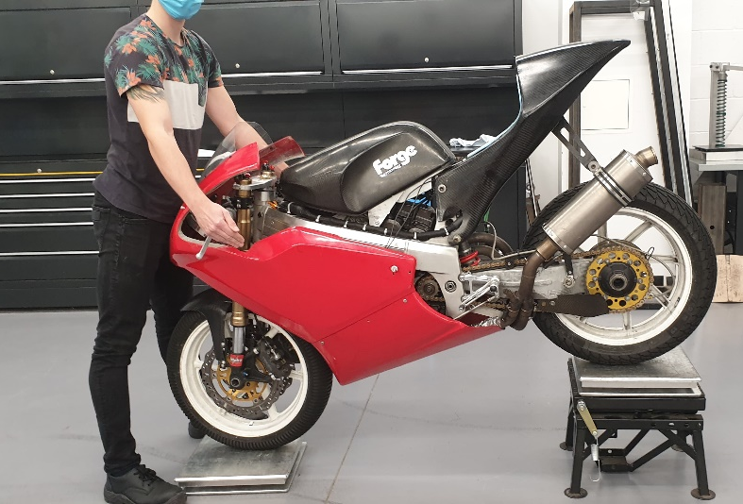
Table 5: FS45O COG Calc. (Iatrakis, 2020)
Figure 11: COG measurement (Iatrakis, 2020)
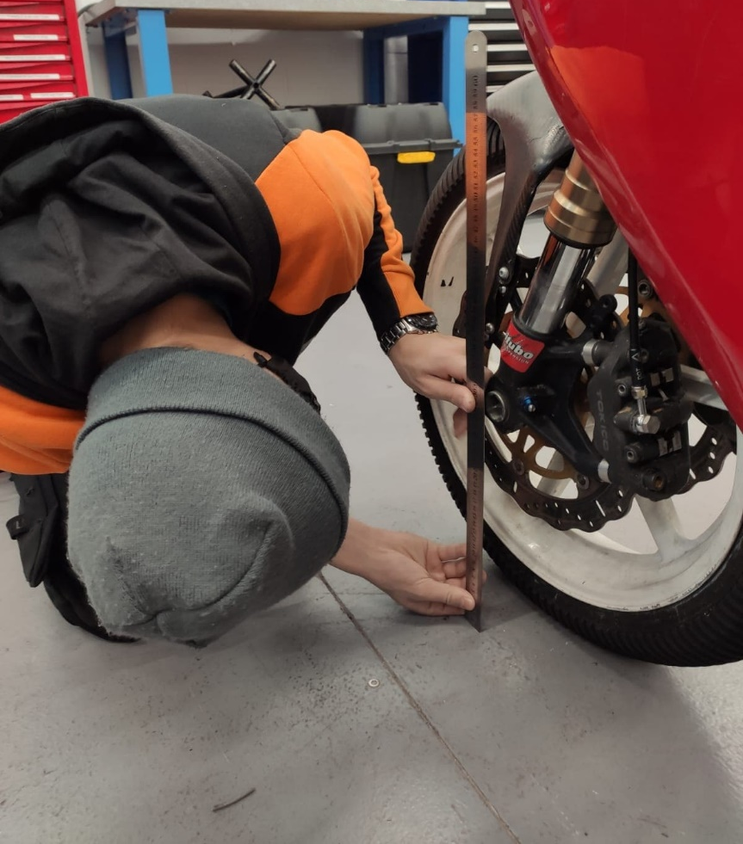
Figure 12: Wheel radius measurement (Wienclaw, 2020)

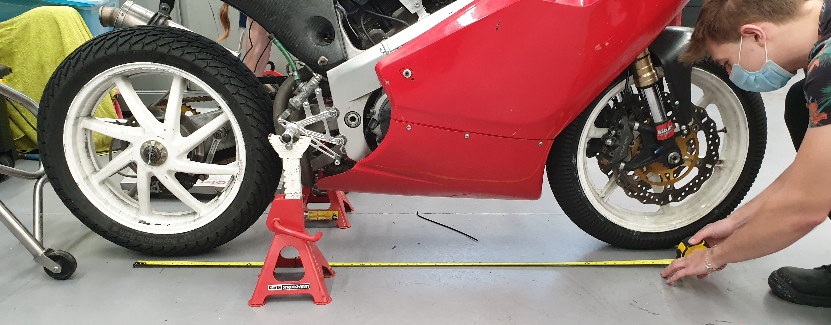

Figure 13: Wheelbase measurement (Iatrakis, 2020)

