Engineering Problem

Kiera Ryman
2404390

University of Wales Trinity Saint David
Engineering Academic Discipline
Beng Motorsport Engineering

ACHA4001
Engineering Design

03/04/2025

Word Count: 1959

Contents
1 Interpretation of the Client Brief 3
2 Key Legislation Considerations 4
3 Specification 5
4 Gantt Chart 7
5 Research with Mind mapping 8
6 Design Concepts 10
6.1 Design 1 10
6.2 Design 2 11
6.3 Design 3 12
7 Decision Matix 14
8 CAD Modelling 15
9 Technical Drawings 17
10 Manufacturing Processes 23
11 Justification 24
12 Further Work 25
13 Conclusion 26
14 References 27

Interpretation of the Client Brief
The aim of this project is to redesign a removable cover for a tank used in an adonisation process. The current cover requires a 2-person lift and staff have complained that it is challenging to place correctly on the tanks. This difficulty is causing a health & safety hazard due to there being many tanks at the facility, and the risk of the cover being fitted incorrectly is high.
There are also many objectives and constraints which must adhered to:
- The removal of the cover must be done by one person.
- The entire operation must be safe.
- The tank dimensions and material must remain the same (modifications can be made).
- There must be clearance from above, allowing space for the aluminium parts to be lowered.

Key Legislation Considerations
Before any of the redesign process can begin, it is important to ensure that the project adheres to legal, environmental, safety and ethical standards. This means the key areas of legislation that must be researched.
When redesigning the cover, it is important to consider how easy the load being lifted by a singular person will be to grasp. Loads that need to be lifted without handholds or handles can be difficult to grasp (Health and Safety Executive, 1992). Therefore, during the design process it is important to think about implementing a feature such as a handle or handhold.
Looking at guidance about lifting loads, it is said that lifting a load can be made easier by adjusting the initial handling technique used. This could include pulling or sliding the weight before beginning the lift, ultimately meaning that the load is closer to the body, making it easier to lift (Health and Safety Executive, 1992).
Guidelines state that there are no specific requirements regarding weight limits. However, when manual handling is required, the relevant risks should be determined and assessed (Health and Safety Executive, 1992).
Guidelines also state that systems involving chemicals should be totally enclosed (Control of Substances Hazardous to Health Regulations 2002). This means that the redesigned lid should allow the top of the tank to be completely covered when refitted.

Specification
Product specification provides details on specific areas of the entire project. This allows all areas that must be taken into consideration to be accounted for, ultimately reducing confusion and mistakes at later stages in the project.
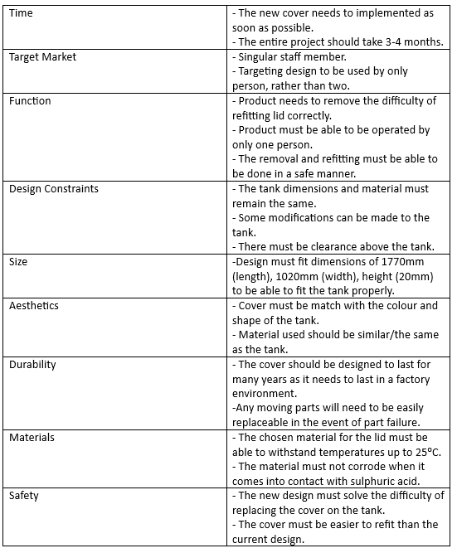
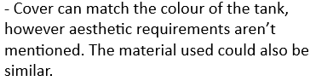
Table 1 - Product Design Specification
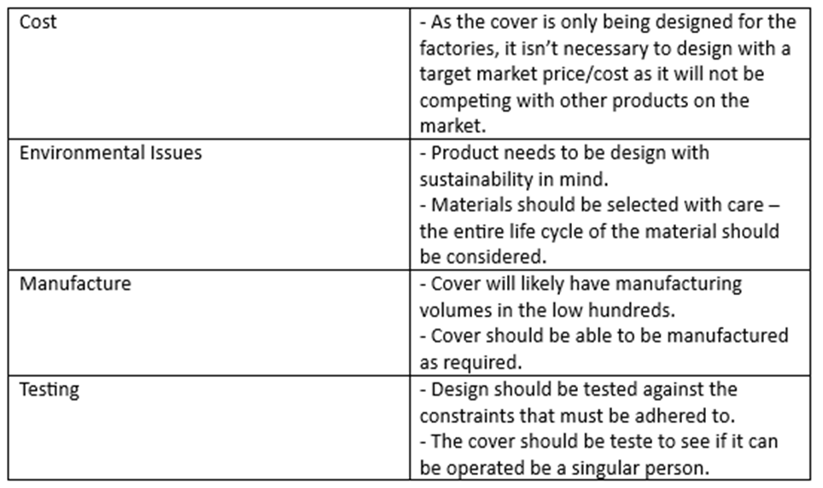
Creating a design specification table means that the design process can now be carried out knowing which areas are more important to take into consideration. For example, it is clear that functionality is very important to achieve the best possible redesign of the cover. In contrast to this, aesthetic requirements are not mentioned in the client brief, meaning that this is an area that does not require as much consideration.

Gantt Chart
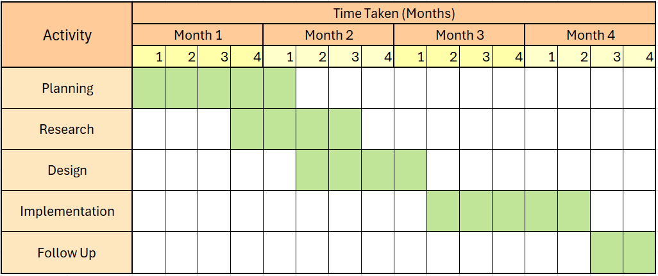
A Gantt chart helps assess how long a project should take and displays this information in a visual manner that is easy to read. Organising the stages of a project in this way ensures that a project stays on schedule and that key tasks are completed in the correct order. Ultimately, it provides a time-focused plan that maximises the work that can be done over a time period (Geraldi and Lechter, 2012).
Figure 1 - Cover Redesign Gantt Chart
Each activity that must be completed within the project is assigned a time frame to be completed within. Each of these are essential for the completion of the tank lid redesign and cover different areas of the project:
Planning: It is important to spend sufficient time interpreting the client brief and looking at key legislation, as well as completing a product specification to provide detail across the whole project.
Research: Before any designing can begin, it’s important to conduct relevant research to generate design ideas. This includes looking at current products which are on the market to determine how to best solve the design problem.
Design: Towards the end of conducting research, the design stage can begin. This includes generating ideas using various techniques such as mind mapping or SCAMPER; a process that can be used to generate design ideas.
Implementation: After finalising a design, the product can be prototyped and eventually integrated into the system at the factory. This requires manufacturing the new cover after ensuring that the design solves all the issues raised in the client brief.
Follow Up: It is important to follow-up after the completion of a project to ensure that the product development cycle continued. Any experiences and feedback can be shared to improve future projects.

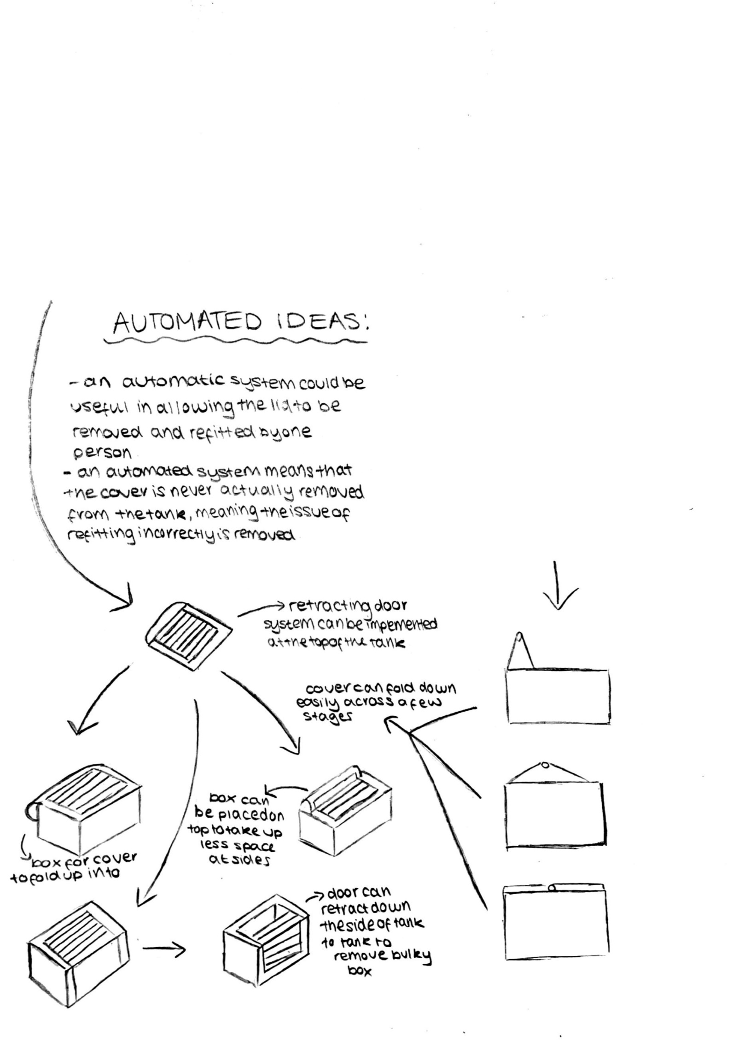
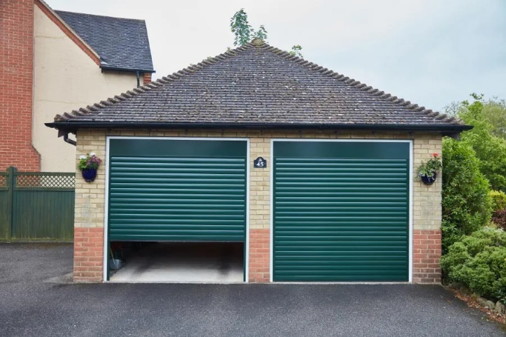
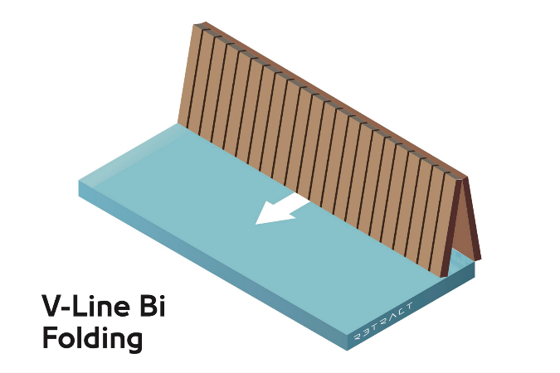
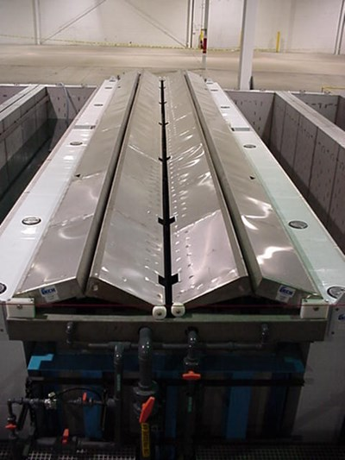
Research with Mind mapping
(Anglican Home, 2025)
(Pool Cover Marketing, 2023) 2025)
(Products Finishing, 2011)
Figure 2 - Automated Ideas Mind Mapping Design Process

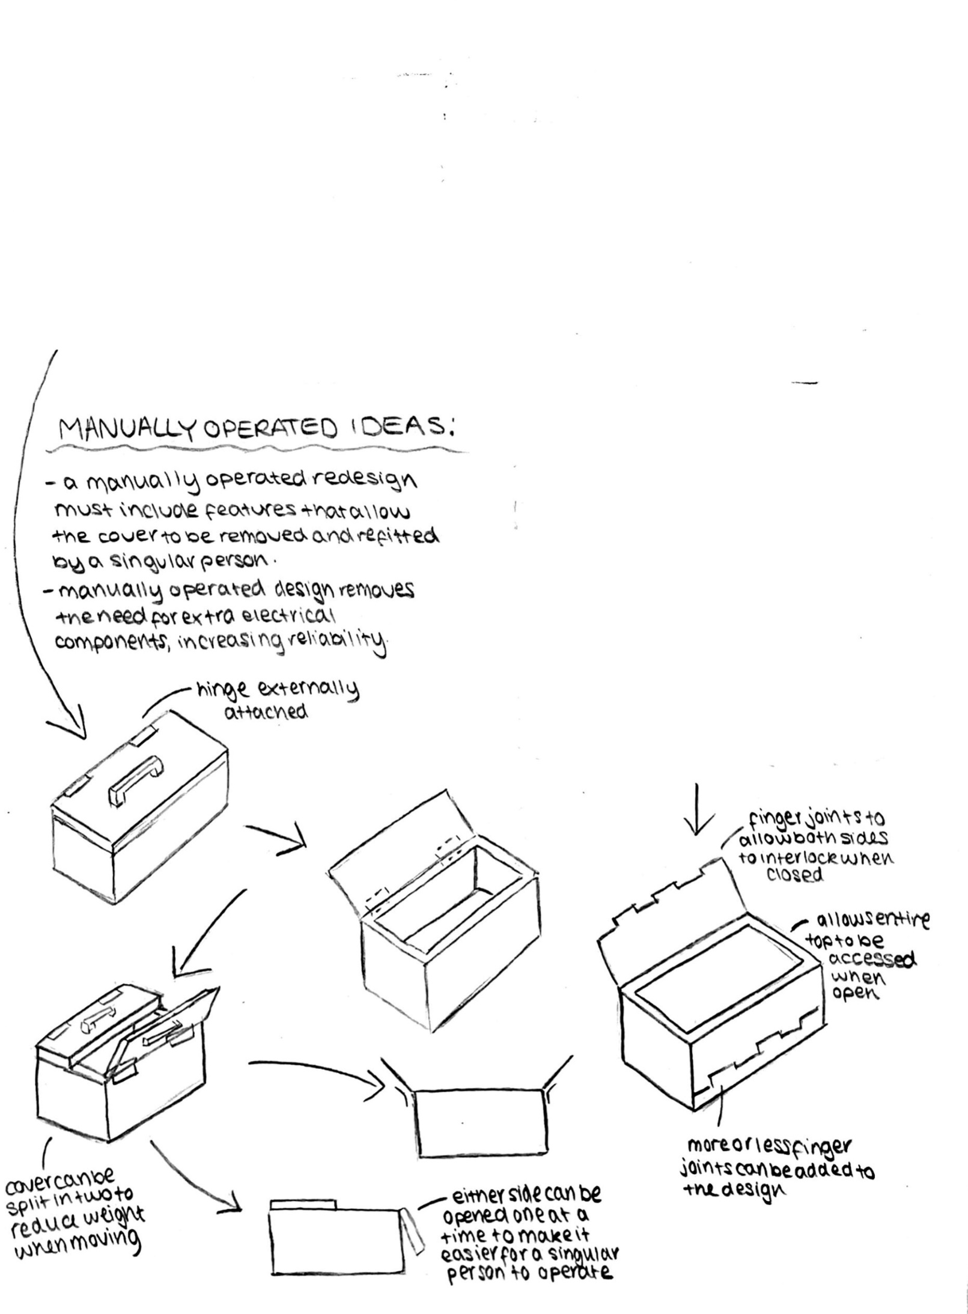
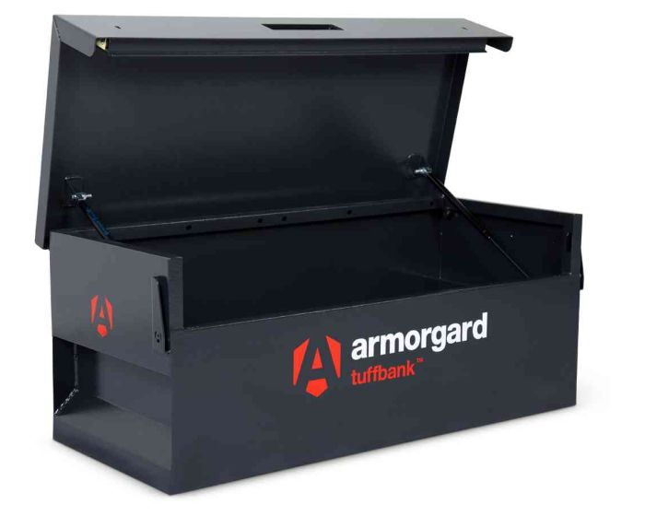
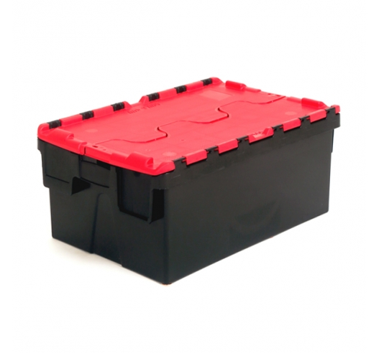
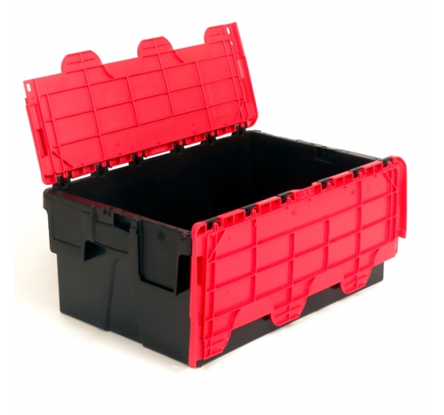
(Safe Options, 2025)
(Plastor, 2025a)
(Plastor, 2025b)
Figure 3 - Manually Operated Ideas Mind Mapping Design Process

Design Concepts

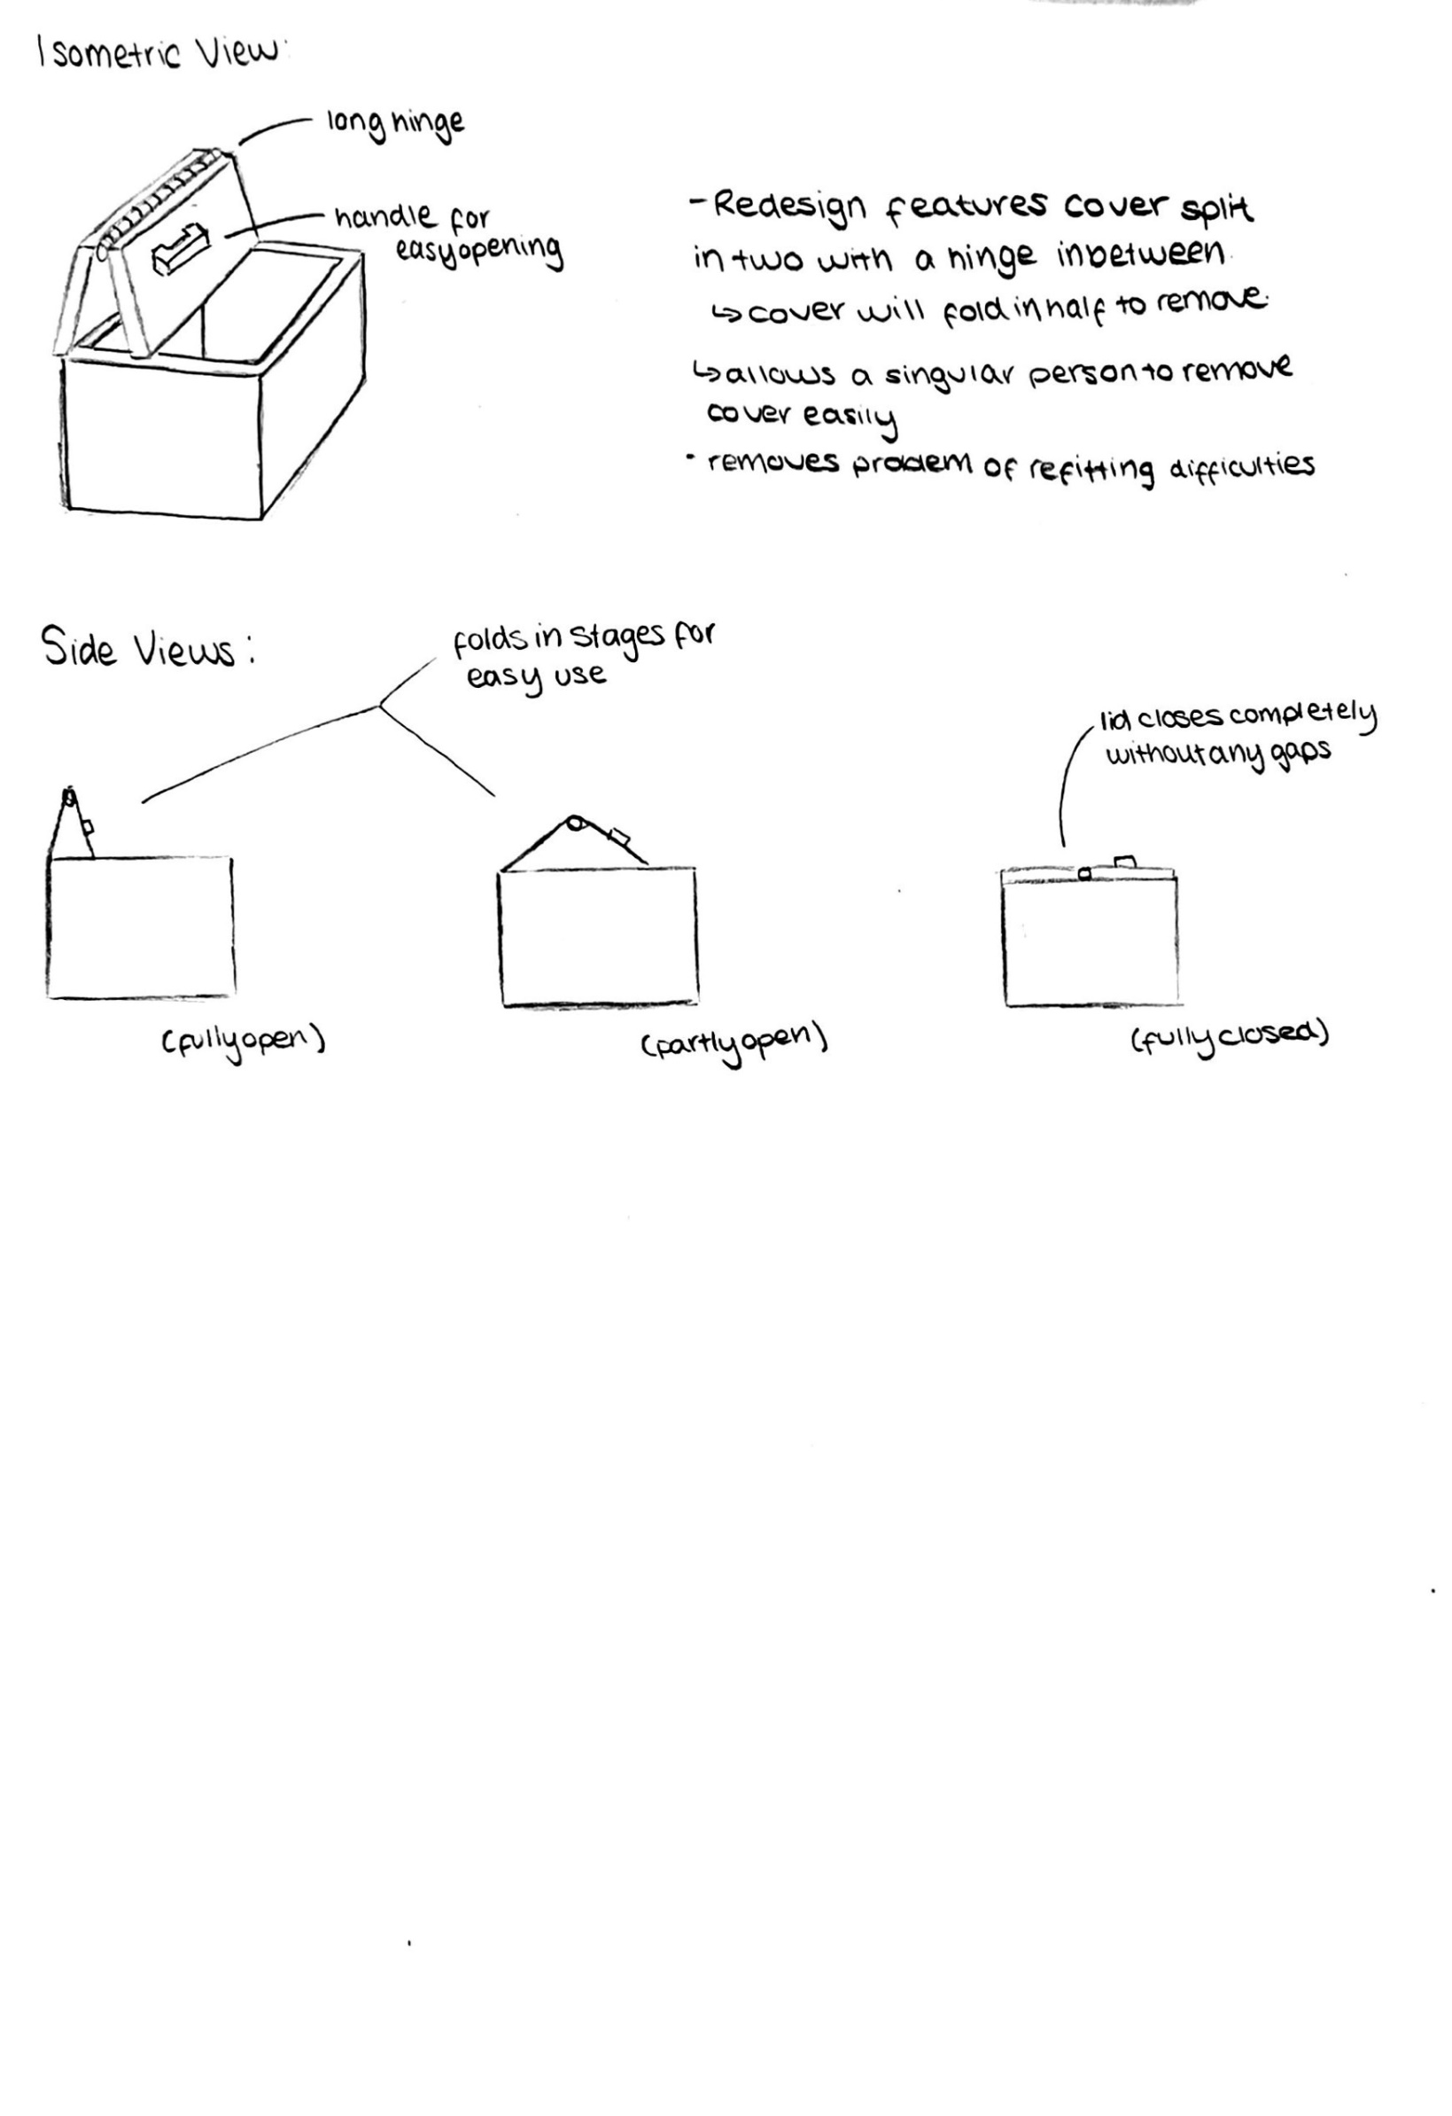
Design 1
Figure 4 - Design 1 Concepts

Design 1 features a folding cover design made of stainless steel. The pushing/pulling motion required allows the load of the cover to be easier to move, as per the Manual Handling Operations Regulations 1992 (Health and Safety Executive, 1992).

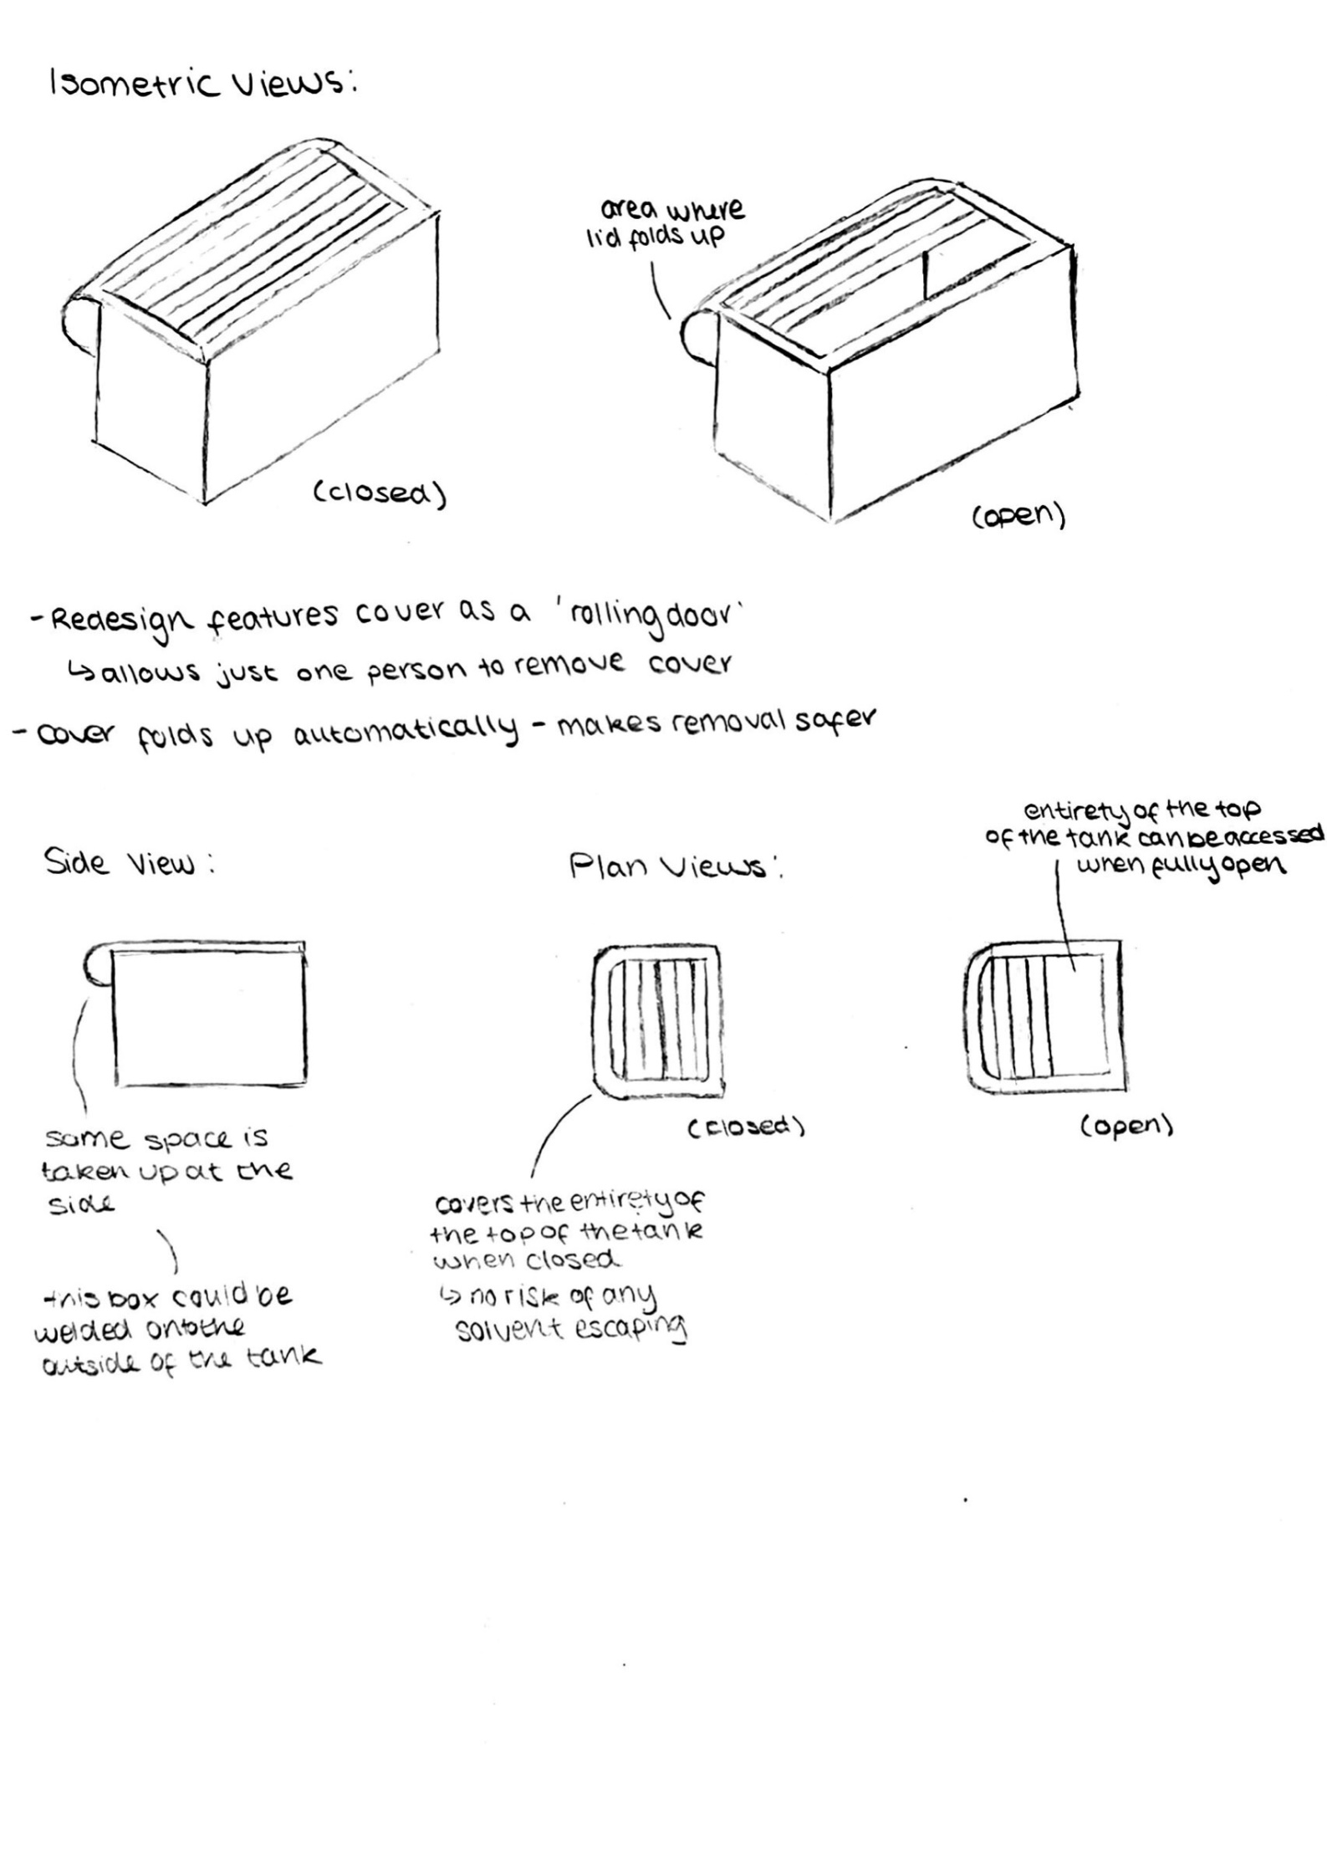
Design 2
Figure 5 - Design 2 Concepts
This design features a ‘rolling door’ as a cover made of sheet steel. The automated design means that no manual handling is required, improving the design regarding health and safety.
The design also tackles the issues of refitting the cover. The process is easier as the cover is never actually ‘removed’ from the tank.

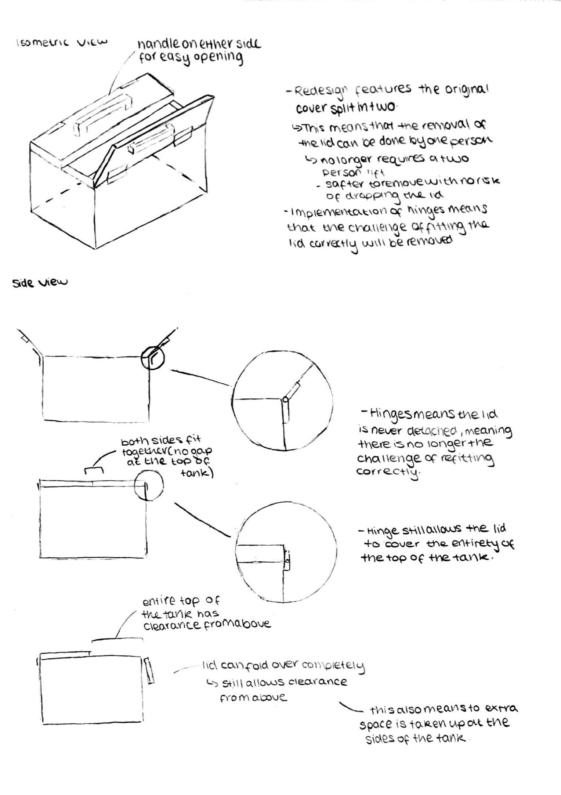
Design 3
Figure 6 - Design 3 Concepts
Design 3 features the original cover spilt in two, meaning that the material used in the design in stainless steel.
The initial weight of the cover is reduced as each side is lifted individually and are smaller than the original cover. This complies with the Manual Handling Operations Regulations 1992 as it is suggested to reduce loads where possible when manual handling is required (Health and Safety Executive, 1992).

Decision Matix
A decision matrix allows two or more variables to be analysed against different dimensions. This process reduces the number of possibilities that can be brought forward in a project (Popescu and Gîrboveanu, 2017).
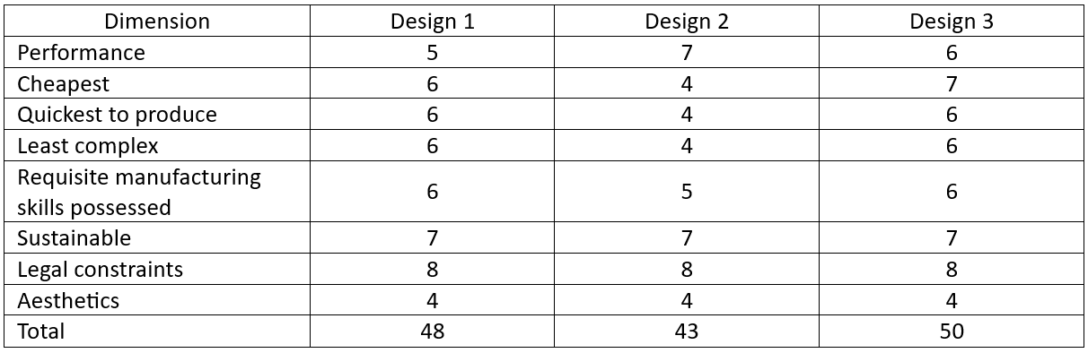
Table 2 - Decision Matrix
From the design matrix, it can be determined that third design, figure 6, would be the preferred solution to the problem because it has the highest total score.
When evaluating performance, the second design was superior as the solution easily allows the cover to be removed and refitted by one person, as well as allowing the process to be automated. However, this means that the design incorporates more electrical components, increasing the number of components that could fail and reduces the reliability of the design.
The second design requires more manufacturing skills than the other two solutions. There are more components and moving parts that need to be manufactured specifically for the design. Designs 1 and 3 are superior in this section as they include more parts that can be bought.
Aesthetic requirements aren’t covered in the assignment brief, however, as the materials used across the designs are similar, all the solutions have scored the same.
Both the first and third design would be much quicker to produce due to being able to repurpose most of the existing cover design. This differs to the second design which would need to be manufactured completely from scratch, making it inferior to the other designs.
Overall, the ideal solution to propose is the third design. Although the process to remove the cover won’t be automated, there can be an attempt to reuse the existing cover, and it can be operated by a single person due to the amount of weight being lifted being significantly reduced.

CAD Modelling
With the chosen design solution, a CAD model can be created. This allows for assembly modelling, detailed 3D models and ensures functionality of the product (Sun, Luh, Zhao and Wei, 2024).

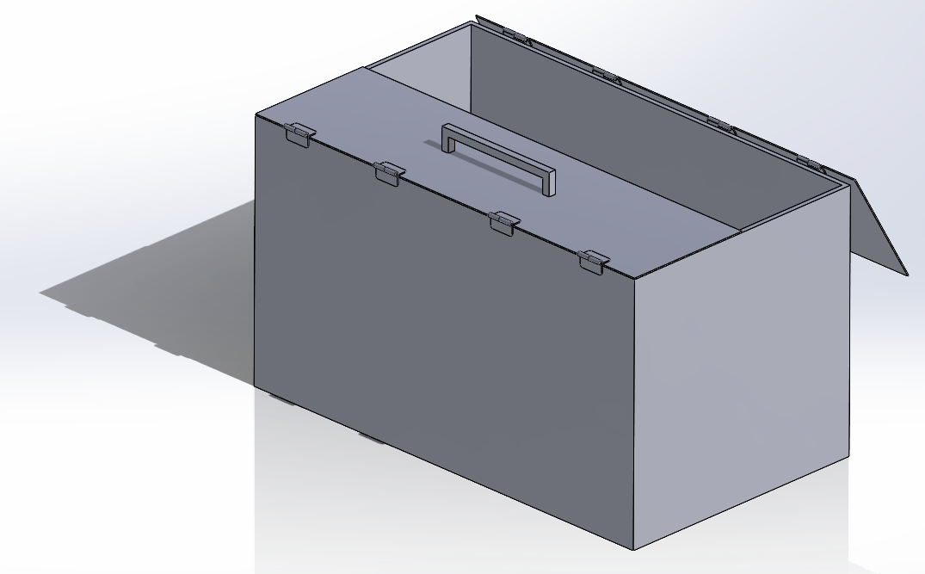
Figure 7 - CAD Assembly - Half Open, Half Closed

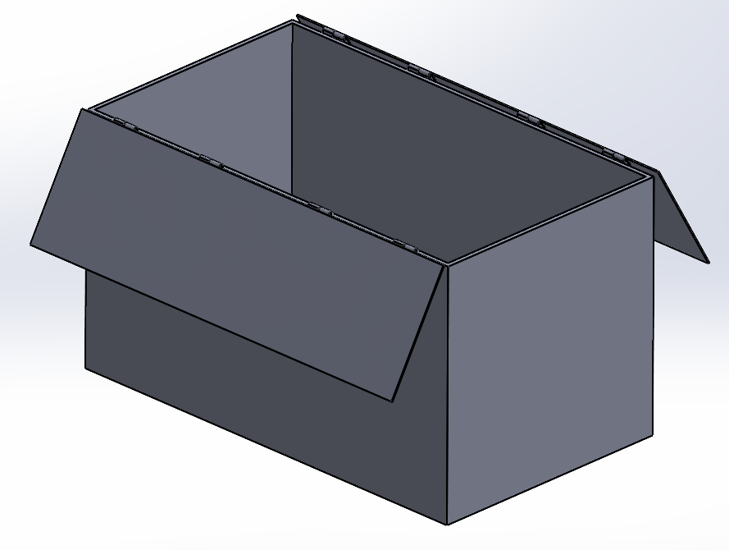
Figure 8 - CAD Assembly, Fully Open

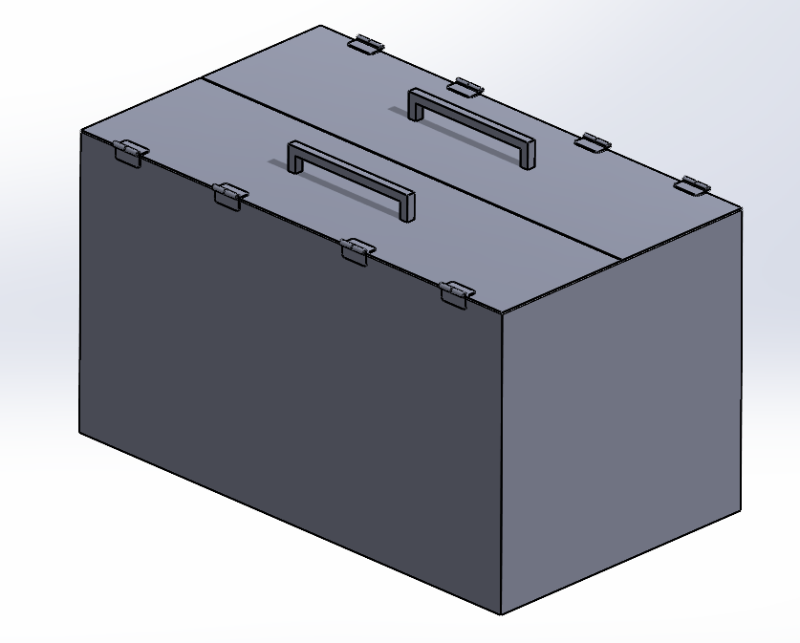
Figure 9 - CAD Assembly - Fully Closed

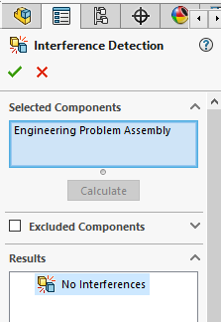
Figure 10 - Interference Detection within CAD Assembly

When producing the CAD model, it is important to ensure that any sketches used to make parts are fully defined and that the final assembly doesn’t contain any interferences, figure 10. Doing this ensures that all parts are modelled correctly, and that the product will function correctly, ultimately ensuring that the redesign of the cover will be successful.

Technical Drawings
The technical drawings include all the parts needed to make up the assembly, but only the parts that have been redesigned as per the client brief. The drawings include the cover, hinge, handle and hinge pin.
The drawings include key information which is essential when manufacturing each of the parts. Figure 11 includes a BOM (bill of materials) which shows each of the individual parts, along with how many are required. Each drawing also includes the material, scale, tolerance standard and dimensions.
The tolerances are included to BS8888 standard, which states that ISO 2768 should be used for general tolerances (British Standards Institution, 2011). The tables stating the permissible deviations has been used to create the tolerances seen in the drawings.
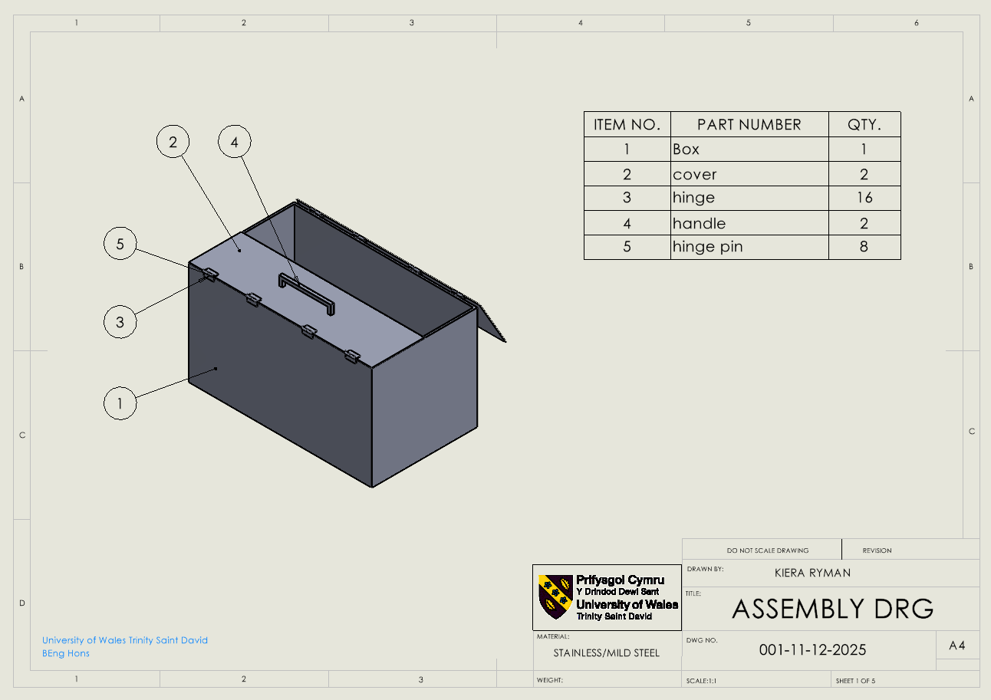
Figure 11 - Assembly Drawing
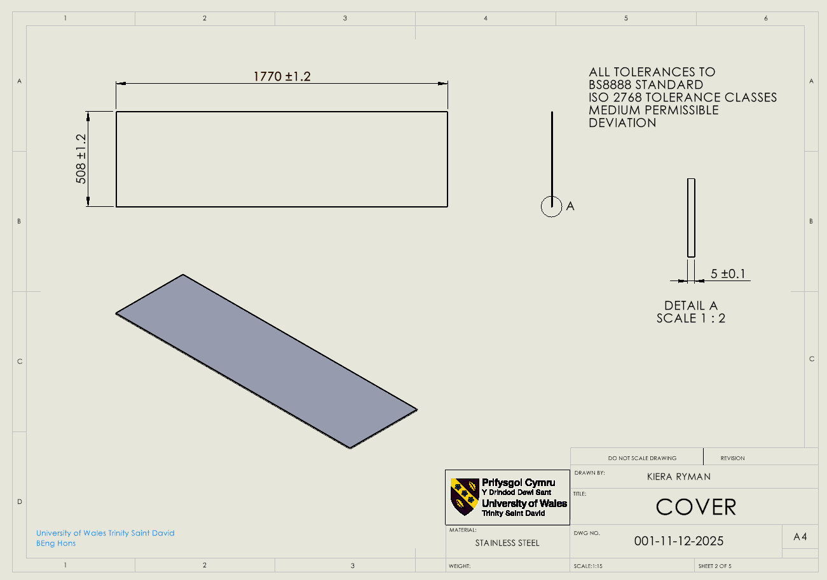
Figure 12 - Cover Drawing
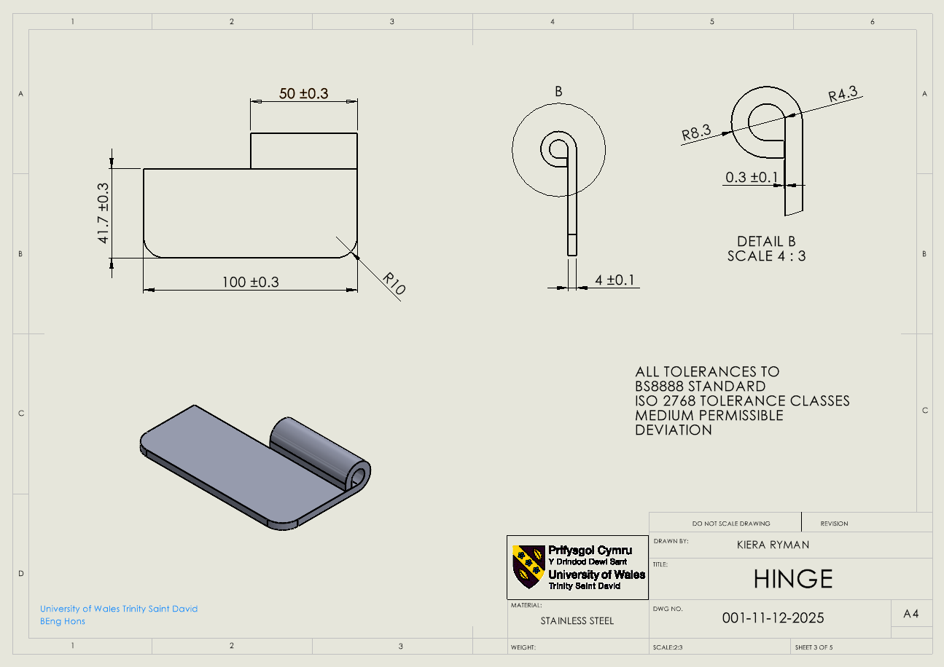
Figure 13 - Hinge Drawing
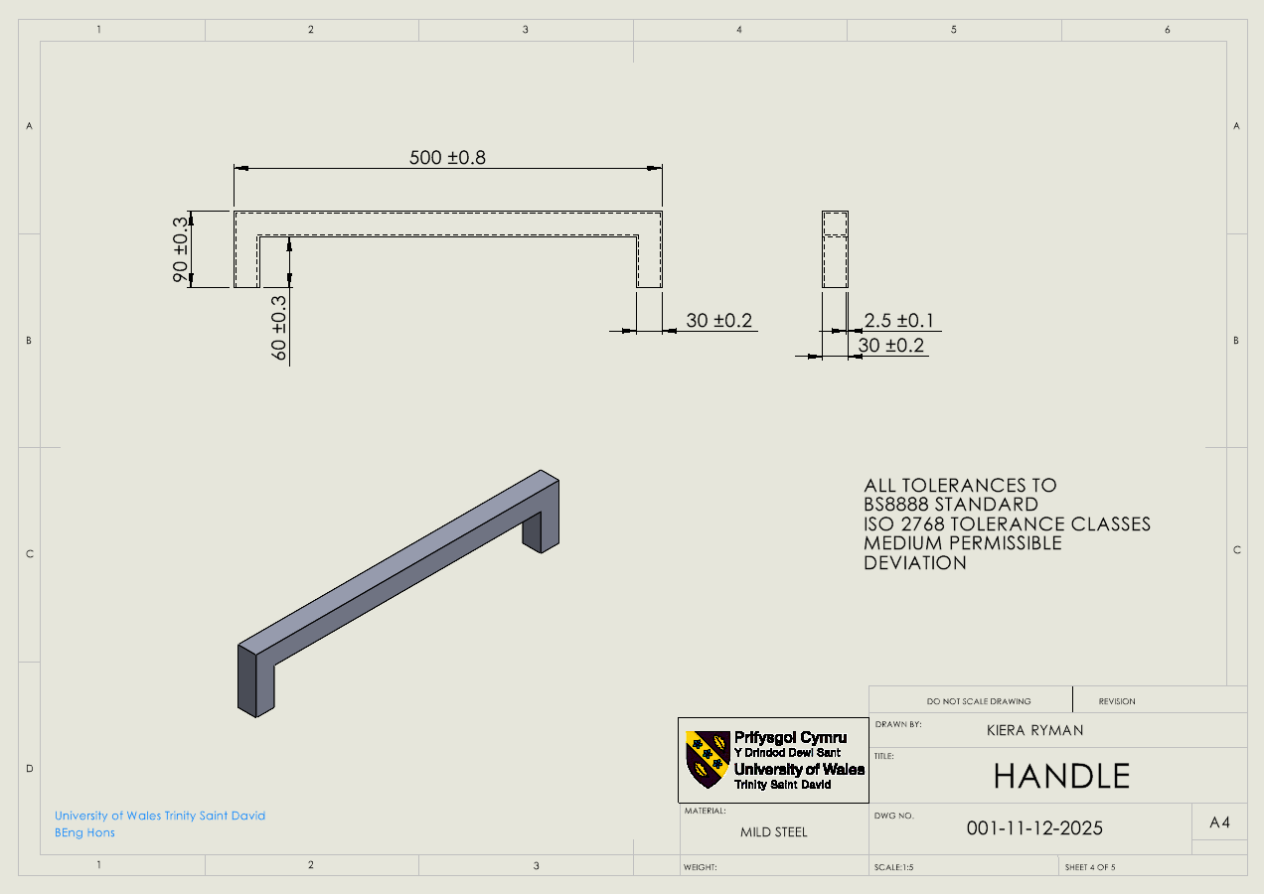
Figure 14 - Handle Drawing
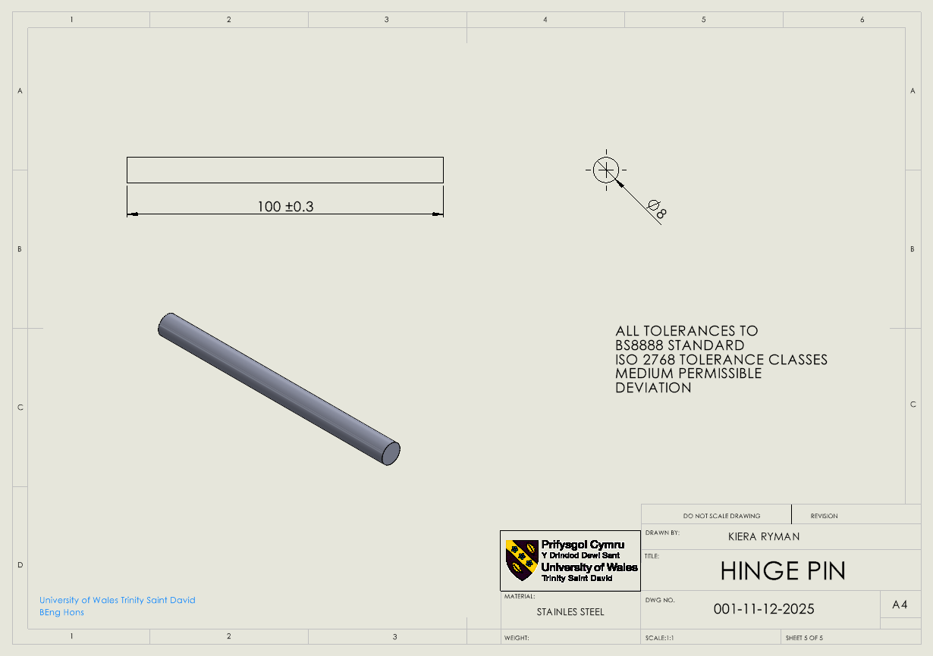
Figure 15 - Hinge Pin Drawing

Manufacturing Processes
After producing technical drawings, each of the components can be manufactured. To do this, various manufacturing processes are required.
The cover can be repurposed and cut to fit the new design. This can be done in several ways. For example, using an angle grinder, a plasma cutter or a rotary tool. However, to produce the covers in higher volumes, as stated in the client brief, a waterjet cutter would be more suitable; a tool used in a manufacturing process that uses high-pressure water to cut stainless steel (Industrial Metal Service, 2025).
The hinge and hinge pin designs are a resized version of a hinge that can be bought in (3D Content Central, 2025). Therefore, the hinges would not have to be manufactured in-house. Instead, it would be possible to talk to the manufacturing company and arrange a resizing of the parts.
The handle can be manufactured from 300mmX30mmX2.5mm Mild Steel (metals4U, 2025). This means that the part can be bought in and cut to size. The pieces can then be welded together to create the handle shape.
The hinges can be welded to the cover and tank to secure them to each other firmly. This allows for minimal modifications to be made to the tank, while still allowing for an easy way for everything to be attached and connected.

Justification
Ultimately, the design chosen can be justified by looking at the process that led to it being selected.
The design process began with mind-mapping, looking at many different design concepts and adaptations, eliminating the possibility of the ideas being brought forward being design persistent.
After researching and mind-mapping, design concepts could be brought forward. Each of these were contrasting, indicating that a wide range of possibilities had been taken into consideration. These concepts were then placed into a decision matrix, which compares the qualities of each design.
Placing the concepts in the decision matrix meant that the design was selected fairly and without bias. Multiple dimensions were compared, ultimately highlighting the preferred solution to be brought forward.
The design also met and took into consideration points mentioned when looking at key legislation. This means that the design complies with guidance given by the health and safety executive. Therefore, the design is justified regarding health and safety.
Overall, looking at the process leading to the CAD modelling, technical drawings and manufacturing process, the solution was chosen without being design persistent and without bias. This means that the solution proposed is the best possible redesign from the concepts that meets the requirements of the client brief.

Further Work
If future work was to be conducted, there are a few things which could be altered to improve the design further.
The design could be altered to include a lighter material, this would make the cover easier to lift and would guarantee that it could be operated by a singular person. However, the material chosen would have to withstand the sulphuric acid within the tank and not degrade due to this.
The possibility of making the entire process automated could also be explored. This would decrease the number of health and safety hazards as this would mean that a load is no longer being lifted by a person.

Conclusion
In conclusion, throughout a design project there are many processes involved which must be carried out to a professional standard. These include looking at legislation and carrying out the correct research, producing mind maps and design concepts, as well as producing CAD models.
Carrying out all the processes correctly has allowed for a full redesign of the cover for the anodization tank. The requirements stated in the client brief have been met and the design has been justified.

References
3D Content Online (2025) 283002-1. Available At: https://www.3dcontentcentral.com/download-model.aspx?catalogid=174&id=115883 (Accessed: 02 April 2025)
Anglican Home (2025) Fir Green Garage Doors in Aluminium Roller Style. Available At: https://www.anglianhome.co.uk/garage-doors/aluminium-roller (Accessed: 26 March 2025).
British Standards Institution (2011) BS8888:2011: Technical product documentation and specification. BSI Standard Publication. Available At: https://www.model-r.ru/images/perevod_chertegei/BS8888-2011-Engineering%20drawing.pdf (Accessed: 03 April 2025).
Control of Substances Hazardous to Health Regulations 2022 (SI 2677/Section 7). Available At: https://www.legislation.gov.uk/uksi/2002/2677/regulation/7 (Accessed: 02 April 2025).
Geraldi, J. and Lechter, T. (2012) ‘Gantt charts revisited’, International Journal of Managing Projects in Business, 5(4), pp. 578-594. Available At: https://www.proquest.com/scholarly-journals/gantt-charts-revisited/docview/1112229712/se-2?accountid=130472
Health and Safety Executive (1992) Manual handling. Manual Handling Operations Regulations 1992. Available At: https://www.hse.gov.uk/pubns/priced/l23.pdf (Accessed 02 March 2025).
Industrial Metal Service (2025) Precision in Action: How to Cut Stainless Steel the Right Way. Available At: https://industrialmetalservice.com/metal-sawing-precision-cutting/how-to-cut-stainless-steel/?srsltid=AfmBOortreAJ4JCRyzSJDVoTVWRZOpN9Jw_FJHSjF2nc2b4Dc_b1nEXx (Accessed: 02 April 2025).
metals4U (2025) 30mm x 30mm x 2.5mm Mild Steel Box Section. Available At: https://www.metals4u.co.uk/materials/mild-steel/mild-steel-box-section/2298-p (Accessed: 02 April 2025).
Plastor (2025a) Red and black totes with 40 litre capacity. Available At: https://www.plastor.co.uk/archived-products/archived-plastic-crates/ref-plas40-euro-attached-lid-container-40-litres-600-x-400-x-250mm-black-and-red-recycled/ (Accessed: 26 March 2025).
Plastor (2025b) Storage crates with black body and red lids. Available At: https://www.plastor.co.uk/archived-products/archived-plastic-crates/ref-plas40-euro-attached-lid-container-40-litres-600-x-400-x-250mm-black-and-red-recycled/ (Accessed: 26 March 2025).
Pool Cover Marketing (2023) V-Line Bi Folding. Available At: https://blog.r3tract.com/what-are-bifolding-pool-decks (Accessed: 26 March 2025).
Popescu, D. and Gîrboveanu, S. (2017) ‘THE MANAGEMENT TOOLS USED IN THE DECISION-MAKING PROCESS’, Management & marketing (Craiova, Romania), XV(1), pp. 153–164. Available At: https://www.mnmk.ro/documents/2017_01/10-14-1-17.pdf
Products Finishing (2011) Putting a Lid on Tanks. Available At: https://www.pfonline.com/articles/putting-a-lid-on-tanks (Accessed: 26 March 2025).
Safe Options (2025) Armorgard Tuffbank TB6 Security Tested Truck Tool Storage Box – open. Available At: https://www.safeoptions.co.uk/armorgard-tuffbank-truck-box-tb12 (Accessed: 26 March 2025).
Sun, Y. and Luh, D. and Zhao, Y. and Wei, H. (2024) ‘Research on the Design Process of Auxiliaries using Computer Aided Technology’, Journal of Electrical Systems, 20(10s), pp. 410–413. Available At: https://www.proquest.com/docview/3092061601/fulltextPDF/952135831A294726PQ/1?accountid=130472&sourcetype=Scholarly%20Journals

