
APPENDIX GA36a

LEVEL 4 ASSESSMENT SPECIFICATION

Student name: | Adam David Moore | Student ID number: | 1004334
Programme: | BSc/HND Computing Portfolio (PT and Computer Networks and Cybersecurity), BEng/HND Electronics Portfolio
Module: | Software Development
Module code: | ACCA4017 | Contribution to Overall Module Assessment (%): | 70%
Lecturer: | Gaynor Thomas | Internal Verifier: | Michael Dacey
Assignment Title: | Programs in C and documentation | Word count (or equivalent): | 1,586

Contents
PART A 3
Question 1: What is a variable and why are they important in writing programs? 3
Question 2: Explain why the for-loop can also be referred to as a counting-loop and give an example of when you would use it. 3
Question 3: Explain what an array is, what their features are, and give an example of when you would use one. 4
PART B 5
Question 1: Storing three variables 5
1.1 Solution breakdown 5
1.2 Annotated Code 5
1.3 Testing 5
Question 2: Calculating shaded area 6
2.1 Solution breakdown 6
2.2 Annotated Code 6
2.3 Testing 8
Question 3: Five products in an Array 10
3.1 Solution breakdown 10
3.2 Annotated Code 10
3.3 Testing 11
Question 4: Slot Machine (Non-Cumulative Scoring) 13
4.1 Solution Breakdown 13
4.2 Annotated Code 14
4.3 Testing 16

PART A

Question 1: What is a variable and why are they important in writing programs?
Variables are a means to store information within a computer program. These variables can be referenced by a programmer or determined by a user. Manipulation of variables is essential where ‘unknown’ values are being dealt with in programming.
Following astute naming conventions while writing code, and declaring variables, code can be easier to read and understand by programmers. This is particularly important where perhaps multiple programmers are working on one program, or indeed the same portion of code is utilised by multiple programmers. There are constraints on naming variables; spaces cannot be used; most special characters cannot be used, and keywords ‘known’ to the program such as ‘printf’ cannot be used.
While the name of a variable is one thing that must be declared, the variable type must also be declared; this is the type of value that will be stored in the variable. Some examples of variable types include integers (int), Floats (float) and Characters (char).
Variables allow user interaction with programs. Without the ability to enable a user to determine a variables value, programs would be highly specific and one dimensional. For example, if we were to develop a program that will calculate the shaded area in figure 1, and we were not going to allow the user to input values to do so, the code for the program (values stored in variables) would need to be re-coded every time it wanted to be used for a different set of values. There would be little point to this, as the same results could be achieved using a calculator. The advantage of a program is its ability to be interactive and have extensive efficient and useful application.
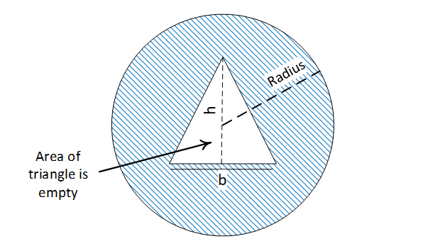
Figure 1. Shaded area calculation

Question 2: Explain why the for-loop can also be referred to as a counting-loop and give an example of when you would use it.
The for loop is often referred to as a counting loop because the number of repetitions a for loop performs is generally determined by values set within a counter. A counter sets an initial value and an upper value (when the upper value is reached, the program will terminate), we can then ask the program to add one (counter++) each time we go around the loop. By doing this, we can set a fixed number of times a loop initiates when we run our program. This helps us economise and save valuable memory, ensuring our compiler operates as intended.
The unique thing about a for/counted loop when compared with, for example, a while loop, is that we must know or intend to allow the user to determine a specific number of times for the program to run. A count-down or counting-up program could be written, where upper or lower values for the loop are set by either programmer or user, and the program will then run from the start to end based on the values and direction of count. Alternatively, a times’ table program could be written where the loop number is utilised to multiply by the times’ table being run through. By printing the loop number and multiplying the times table by the loop number, a times table program can easily be written and capped (perhaps at 12).

Question 3: Explain what an array is, what their features are, and give an example of when you would use one.
Arrays are a means of structuring data within a program. Rather than naming and declaring a vast number of variables that relate to the same aspect of a program, we can structure and store potentially a vast number of related values within an array. This has huge benefits in terms of adherence to naming conventions, as we can structure and store huge numbers of values within an array. An array can be thought of like a table of stored values. While a generic variable can have a single stored value, an array is a series of stored values and can be thought of as a row of values (one-dimensional) or a table of values (two-dimensional).
A one-dimensional array could be used, for example, to store a series of characters that make up an individual’s name (Please see figure 2). A two-dimensional array could be used, for example, to store a series of assignment results for a series of students (Please see figure 3). Useful tasks such as calculating the average grade could then be performed.
A | D | A | M
0 1 2 3
Figure 2. One-dimensional Array
Student: 1 2 3 4 5 6
82 | 71 | 48 | 65 | 62 | 90
95 | 75 | 45 | 62 | 85 | 86
68 | 73 | 50 | 68 | 56 | 82
70 | 79 | 40 | 70 | 40 | 82
91 | 92 | 62 | 58 | 78 | 99
80 | 64 | 55 | 48 | 60 | 76
0 1 2 3 4 5
Figure 3. A Two-dimensional array, columns represent different students and rows represent respective grades for different assignments. NB the first column is actually [0], the second [1] etc.

PART B

Question 1: Storing three variables

Solution breakdown

- Identify the different types of variables (Integer, Character and Float)
- Select appropriate values to store
- Store selected values in the appropriate variables
- Ensure values align with variable type (Integer, Character and Float)
- Print the three different stored values

1.2 Annotated Code

#include <stdio.h>
void main()
{
float height = 1.73; // Variable with pre-determined value, stored by programmer
int age = 25; // Variable with pre-determined value, stored by programmer
char name[20] = "Adam"; // Variable with pre-determined value, stored by programmer
printf("My name is %s \n", name); // Print statement collects stored value for ‘Name’ variable
printf("I am %d years old \n", age); // Print statement collects stored value for ‘Age’ variable
printf("I am %.2f metres tall \n", height); // Print statement collects stored value for ‘Height’ variable
}

1.3 Testing

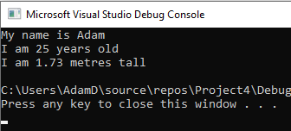
As, in this instance, the values are stored by the programmer and not the program user, there is only one possible outcome (with the stored values). Unless we change the actual code (and more specifically the values stored) there is no additional way to test this code, from a user’s perspective.

Question 2: Calculating the shaded area

Please note that units have not been specified in this program but could be done so as per any specified requirement to do so.

2.1 Solution breakdown
- Consider any additional information the program will need to perform calculations. Specifically, in this instance, to calculate the area of a circle, PI is required.
- Define PI globally within the program
- Write out the equations that must be used to ultimately calculate shaded area (this will help with identifying all variables)
- By using all equations, note all variables that will need to be used to perform the calculations within the program.
- Consider the types of variable they will be (in this case, float)
- Declare variables within the program
- Identify variables that will have user-determined values
- Use printf and scanf to enable the user to determine these values
- The code in relevant equations we looked at in step 3, this will calculate the circle area, triangle area and subsequently enable us to calculate shaded area
- As we have not put any constraints in what values the user enters, we need to ensure the circle is always larger than the triangle – a negative final value for the shaded area would not make any sense at all.
- Utilise while loops to ensure that, if a value is not acceptable to our program (IE if the triangle will not fit inside the circle) the user will need to re-input values for the base and/or height of the triangle.

2.2 Annotated Code
#include <stdio.h>
#define PI 3.142 // We can globally define PI so that the equation needed (PI * radius squared) to calculate area of our circle can be implemented
void main()
{
float radius, base = -1, height = -1, carea, tarea, sarea, diameter; // We must declare all the necessary variables for our equations to work within the program. All values will need to work with decimal places (float).

printf("Please enter a value for the radius of your circle: \n"); // Printf to request value for radius variable from user
scanf("%f", &radius); // user inputs radius value and value is stored in radius variable
diameter = radius + radius; // equation calculates diameter of circle in this instance
while (base == -1) // while loop initiated to ensure base of triangle is smaller than the diameter of the circle
{
printf("Please enter a value for the base of your triangle: \n"); // prompt user to provide base value
scanf("%f", &base); // stores users value in base variable
if (base > diameter) // if function to determine whether requirements of while loop are met. If the size of the triangle base is greater than that of the circle’s diameter, the while loop must re-initiate and request an alternate value. If it is smaller than the circles diameter, the program will proceed
{
base = -1;
printf("Base greater than circle diameter, please enter a smaller base size: \n\n"); // notify user of the issue, and request alternate value. This step is necessary to ensure user understands why program will not proceed and what they must do for the program to proceed
}
}
while (height == -1) // While loop initiated to ensure height of triangle remains smaller than diameter of circle
{
printf("Please enter a value for the height of your triangle: \n"); // prompt user to provide height value
scanf("%f", &height); // stores users value in height variable
if (height > diameter) // if function to determine whether requirements of while loop are met. If the size of the triangle height is greater than that of the circle’s diameter, the while loop must re-initiate and request an alternate value. If it is smaller than the circles diameter, the program will proceed
{
height = -1;
printf("Height greater than circle diameter, please enter a smaller height size: \n\n"); // notify user of the issue, and request alternate value. This step is necessary to ensure user understands why program will not proceed and what they must do for the program to proceed
}
}
carea = PI * (radius*radius); // equation to calculate area of circle and store result in ‘carea’
printf("The area of your circle is %.2f \n\n", carea); // inform user of the area of their circle
tarea = (base*height) / 2; // equation to calculate area of circle and store result in ‘tarea’
printf("The area of your triangle is %.2f \n\n", tarea); // inform user of the area of their triangle
sarea = carea - tarea; // equation to calculate the shaded area and store result in ‘sarea’
printf("The shaded area (circle size minus triangle size) is %.2f \n\n", sarea); // inform user of the shaded area
}

2.3 Testing

2.3.1 Whole numbers
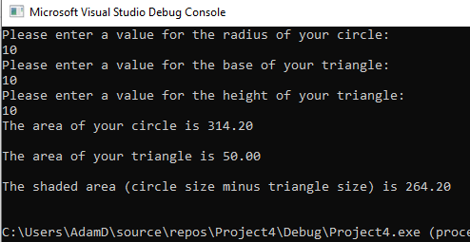
Result: Program ran as expected

2.3.2 Decimalised Numbers
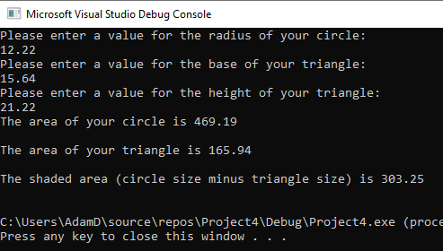
Result: Program ran as expected

2.3.3 Negative Values
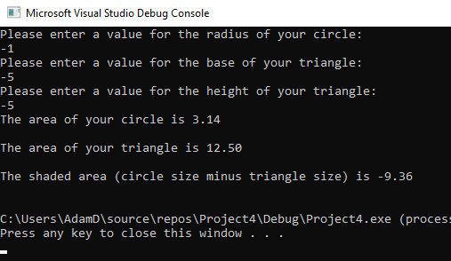
In all instances, while loops prevented the program from allowing the user to input values for base or height due to the if tests within the code. However, in one specific attempt, an erroneous result (negative shaded area value) was output.
Result: Program Failed

2.3.4 Impossible Values
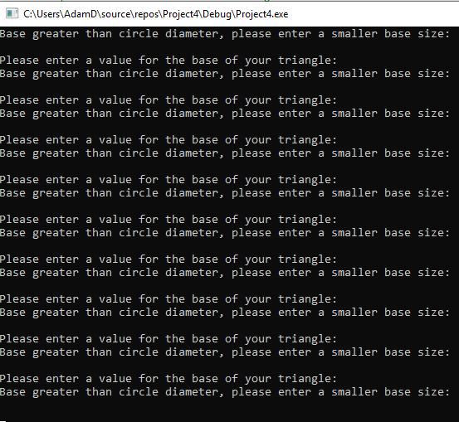
The program continually re-initiated while loop regarding base value.
Result: Program Failed.

Question 3: Five products in an Array

3.1 Solution breakdown
- Consider the types of variables required for this exercise (floats)
- Declare an array variable in such a way that 5 values (and ONLY five values) can be stored in it.
- Consider the equations needed to sum the values stored in the array and then subsequently add VAT (at 20%). Declare these variables.
- Request and subsequently store values to provide values in the array.
- Write an equation to calculate the sum of user input values.
- Inform the user of this value.
- Write an equation to add VAT onto the sum of input values.
- Inform user of this value.

3.2 Annotated Code
#include <stdio.h>

void main()
{

float myarray[5], arraysum, arraysumvat; // We must declare all the necessary variables for our equations to work within the program. All values will need to work with decimal places (float). The ‘[5]’ attached to the ‘myarray’ variable denotes that 5 values will be stored in the array.

printf("Please enter first amount: \n"); // request first value from user
scanf("%f", &myarray[0]); // store first value in myarray[0] (in arrays, the first value is always stored in 0. We should be mindful that when we declare an array variable, we count the values we need to store from 1 (IE, in this instance, we have selected 5 (1,2,3,4,5) as we need five values, despite the fact that when storing values we start from 0 (0,1,2,3,4))

printf("Please enter second amount: \n"); // request second value from user
scanf("%f", &myarray[1]); // store value in myarray[1]

printf("Please enter third amount: \n"); // request third value from user
scanf("%f", &myarray[2]); // store value in myarray[2]

printf("Please enter fourth amount: \n"); // request fourth value from user
scanf("%f", &myarray[3]); // store value in myarray[3]

printf("Please enter fifth amount: \n"); // request fifth value from user
scanf("%f", &myarray[4]); // store value in myarray[4]

arraysum = myarray[0] + myarray[1] + myarray[2] + myarray[3] + myarray[4]; // equation used to calculate total sum of all stored values
printf("The sum of your values is: %.2f \n", arraysum); // inform user of the value of the sum

arraysumvat = arraysum * 1.2; // equation to add VAT onto sum total of all values
printf("The sum of your values including vat is: %.2f \n", arraysumvat); // inform user of sum total including VAT

}

3.3 Testing

3.3.1 Whole Numbers
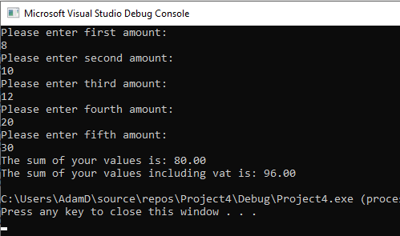
Result: Program ran as expected

3.3.2 Decimalised Numbers
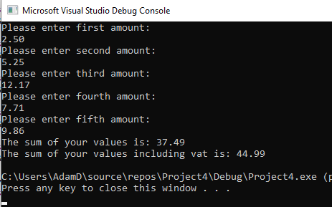
Result: Program ran as expected

3.3.3 Negative Values
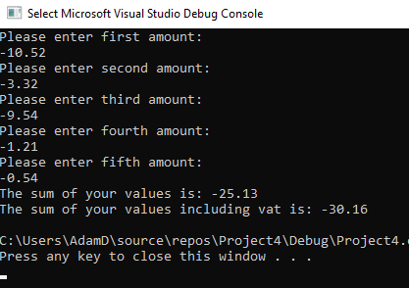
Result: Program ran as expected.

3.3.4 Impossible Values
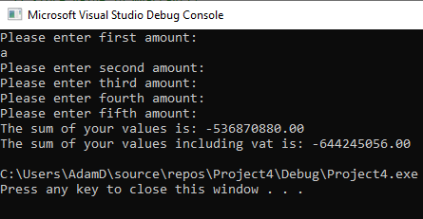
Result: Program failed.

Question 4: Slot Machine (Non-Cumulative Scoring)

4.1 Solution Breakdown
- Utilise additional resources to enable ‘random’ number generation (#include)
- Values for all scoring and random generation are whole numbers and no user input for values is factored into the program – the user only has control on whether program re-initiates. Therefore, Integers should be used.
- To produce this slot machine, we know we must have three different expressed random values or ‘reels’. Declare these variables.
- The slot machine only wishes to generate numbers between one and five, declare parameters for randomly generated numbers (1-5).
- An array would be a more effective means of storing a series of values for scoring, rather than simply declaring a series of whole number variables.
- As we want our user to be able to ‘play again’, a while loop would allow us to provide the user with an option to play again by inputting a value equal to that of a declared variable (play). Where this value is not equal the program will not re-initiate.
- We need to generate our three ‘random’ numbers side by side, to do this we first generate them and then store these generated values in the variables we previously declared. We can then express these stored variables.
- Using if and else if we can tie every type of outcome to a specific score that we specified in our array.
- We must then inform the user of their score.
- Finally, we need to allow the user to input a value to determine whether our ‘play again’ while loop will be re-initiated or broken. We need to inform the user of the value they need to input to play again.

4.2 Annotated Code
#include <stdio.h>
#include <stdlib.h> // required to enable ‘random’ number generation
#include <time.h> // required to enable ‘random’ number generation
#define playagain 1 // globally defining play again as a means of ensuring while loop to re-initiate program works. Intention is to enable user to submit a value for a variable, while this variable value is equal to that of this globally defined ‘playagain’, the while loop will ensure the program re-runs.
void main()
{
int myrand1, myrand2, myrand3; // variables declared to store the randomly generated numbers we’ll generate later
int low = 1; // fixed value stored in this, will enable us to later generate numbers within our specified boundaries (1-5).
int high = 5; // fixed value stored in this, will enable us to later generate numbers within our specified boundaries (1-5).
int scoreboard[4]; // There are four different possible scores in our slot machine, so we are declaring an array that can store these four values
int points; // variable used to inform user of points scored
int play; // variable declared, while the value of this variable matches our globally defined ‘playagain’ value (1) the program will re-initialise. At the end of our program, it is this variable we will give the user the chance to input a value for.
play = 1; // by default the value for the play variable will be 1, although the user can over-ride this once the program has run.
scoreboard[0] = 0; // declaring the first score in our array
scoreboard[1] = 20; // declaring the second score in our array
scoreboard[2] = 100; // declaring the third score in our array
scoreboard[3] = 2000; // declaring the fourth score in our array
while (play == playagain) // this while loop gives the user the option to re-initialise the program by entering a value of 1. If the stored value for play matches the globally defined playagain, the program can re-run.
{
srand(time(NULL)); // required to generate ‘random’ number using time module we included.
myrand1 = rand() % (high - low + 1) + low; // generates and stores a value in myrand1 between 1 and 5 (as we specified earlier) by subtracting low value from high value and adding 1.
myrand2 = rand() % (high - low + 1) + low; // generates and stores a value in myrand2 between 1 and 5 (as we specified earlier) by subtracting low value from high value and adding 1.
myrand3 = rand() % (high - low + 1) + low; // generates and stores a value in myrand3 between 1 and 5 (as we specified earlier) by subtracting low value from high value and adding 1.

printf("\n \n %d %d %d \n \n", myrand1, myrand2, myrand3); // demonstrates the three randomly generated numbers or ‘reels’ to user.
if (myrand1 == myrand2 && myrand2 == myrand3 && myrand1 == 5) // if the first number is equal to the second number, and the second number is equal to the third number and the first number has a value of 5 (if all three numbers have a value of 5) then…
{
points = scoreboard[3]; // … the variable ‘points’ will have a value equal to that stored in scoreboard[3] (2000)
}
else if (myrand1 == myrand2 && myrand1 == 5) // if the previous is not true, and the first number is equal to the second number and the first number has a value of 5 then…
{
points = scoreboard[2]; // // … the variable ‘points’ will have a value equal to that stored in scoreboard[2] (100)
}
else if (myrand1 == myrand3 && myrand1 == 5) // if the previous is not true, and the first number is equal to the third number and the first number has a value of 5 then…
{
points = scoreboard[2]; // … the variable ‘points’ will have a value equal to that stored in scoreboard[2] (100)
}
else if (myrand2 == myrand3 && myrand3 == 5) // if the previous is not true, and the second number is equal to the third number and the third number has a value of 5 then…
{
points = scoreboard[2]; // … the variable ‘points’ will have a value equal to that stored in scoreboard[2] (100)
}
else if (myrand1 == myrand2 && myrand2 == myrand3 && myrand1 <= 4) // if the previous is not true, and the first value is equal to the second value, and the second value is equal to the third value, and the first value is equal to or less than 4 then..
{
points = scoreboard[1]; // … the variable ‘points’ will have a value equal to that stored in scoreboard[1] (20)
}
else // if none of the aforementioned are true, then…
{
points = scoreboard[0]; //… the variable ‘points’ will have a value equal to that stored in scoreboard[0] (0)
}
printf("Your score is %d !! \n\nPlay again?\n\nType 1 and hit enter\n\n\n", points); // Inform the user of the value of the points scored and offer the opportunity to re-initialise the program
scanf("%d \n", &play); // collect value and store in variable ‘play’. This will either re-initialise the program or terminate it, based on the outcome of the while loop (which is determined by value)
}
}

4.3 Testing

4.3.1 Does program allow user to ‘Play Again’?
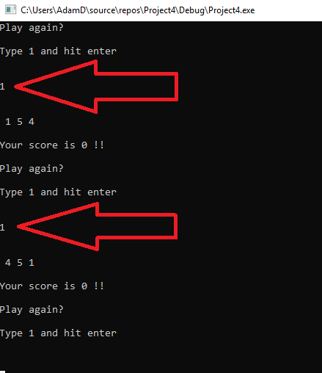
Result: Program works as expected when ‘1’ entered. Red arrows indicate user entered values.

4.3.2 Does scoring work correctly?

4.3.2.1 Zero points
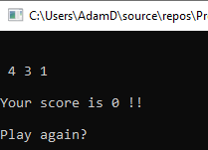
Result: Works as expected, not every single possible combination tested but after hundreds of tests always worked as expected.

4.3.2.2 Twenty points
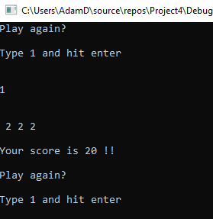
Result: All four variants work exactly as expected.

4.3.2.3 One hundred points
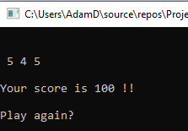
Result: Works as expected, all three possible combinations of 2x 5s work perfectly.

4.3.2.4 Two thousand points (Jackpot)
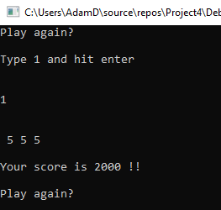
Result: Works as expected.

4.3.3 Impossible Values
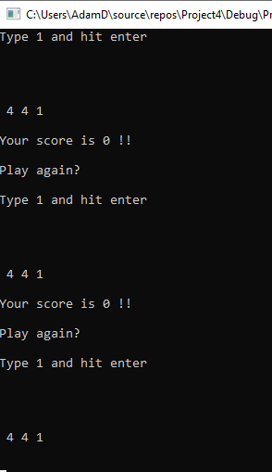
Result: Program Failed. When entering a character, the program is continuously re-initialised rapidly.

Figure taken from lecture assignment specification.

