DS 1 Template

My Screenshots/Photos
- Please add 4–6 screenshots or photos of your digital life.
- You can use your phone or laptop.
- For each screenshot, write one or two sentences explaining what it shows.

Screenshot/Photo 1
[Insert Photo/Screenshot below]
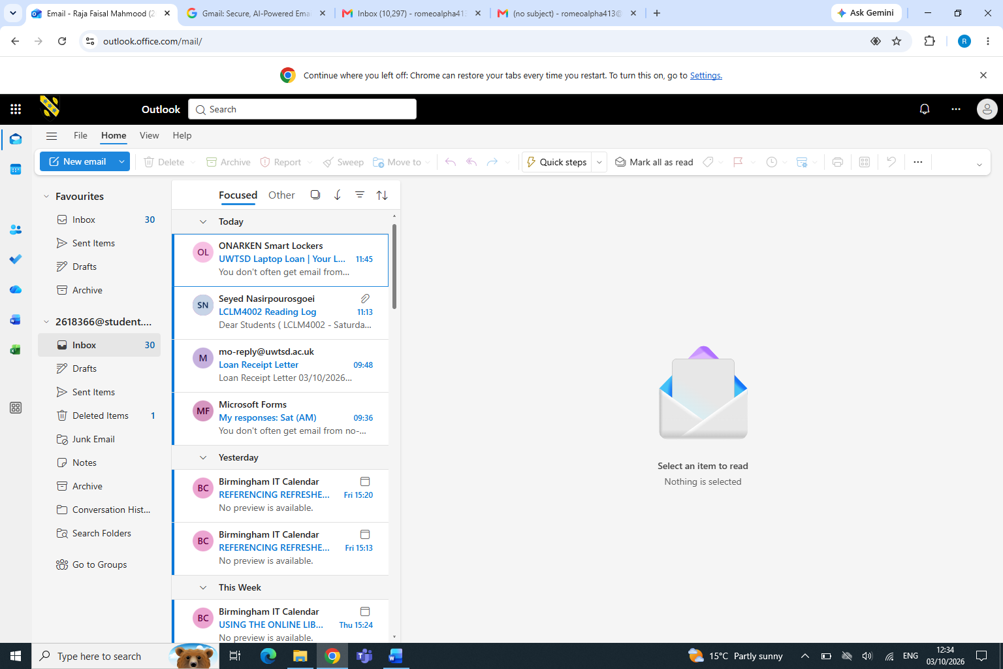
This is my university email, from here I can receive my emails from my lectures.

Screenshot/Photo 2
[Insert Photo/Screenshot below]
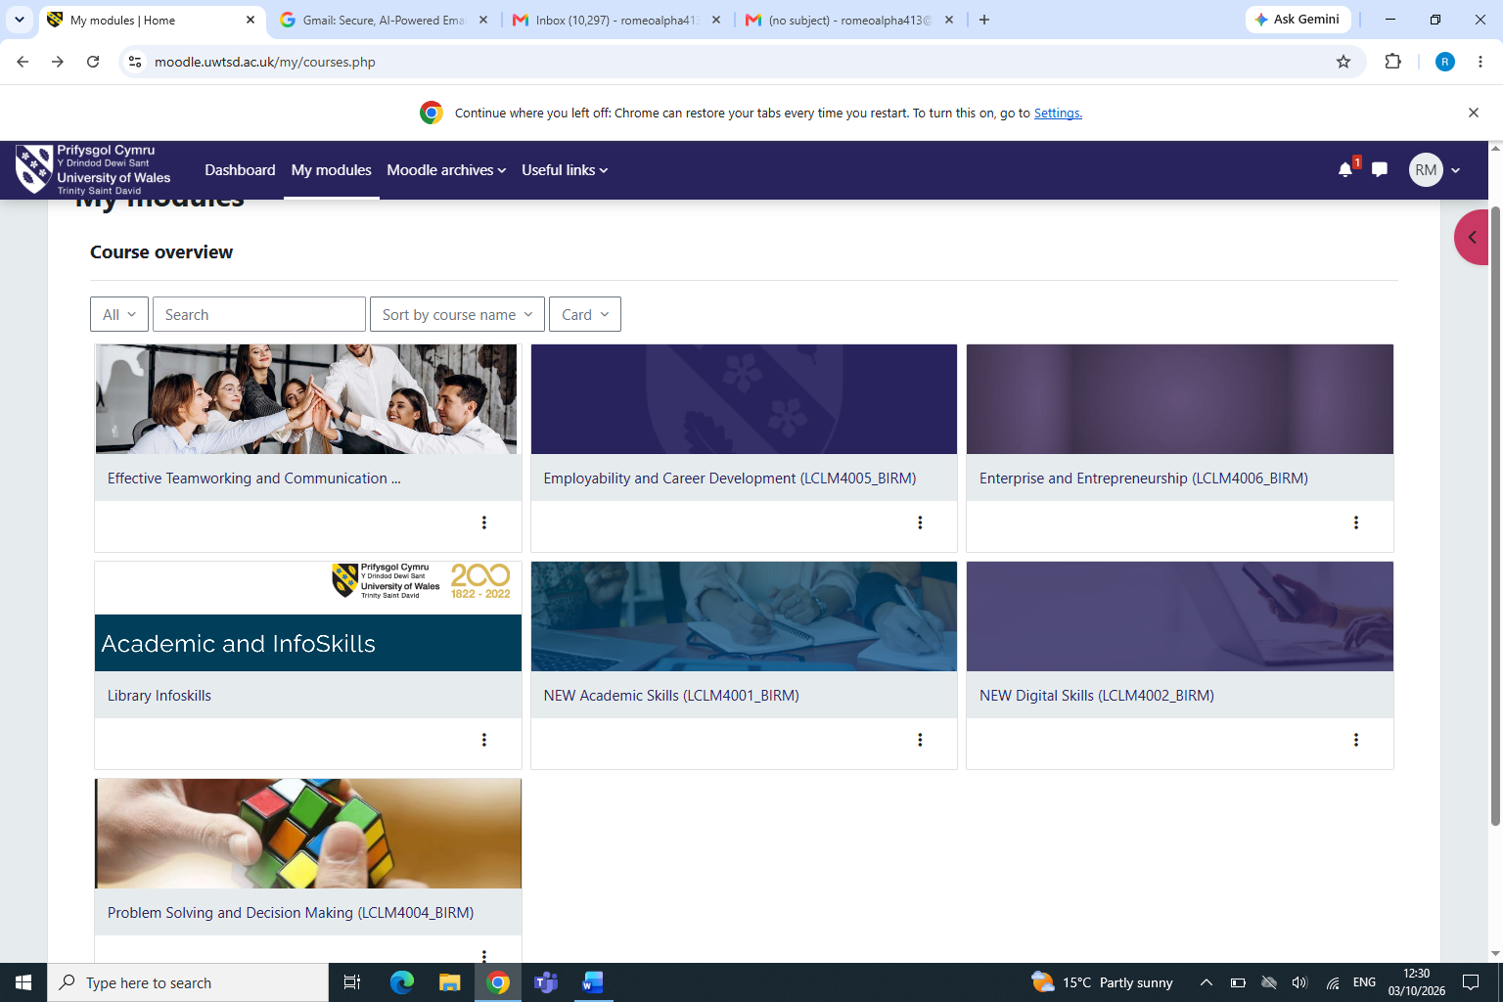
This is a moodle page, from here I can submit assignments and a lot of other tasks.

Screenshot/Photo 3
[Insert Photo/Screenshot below]
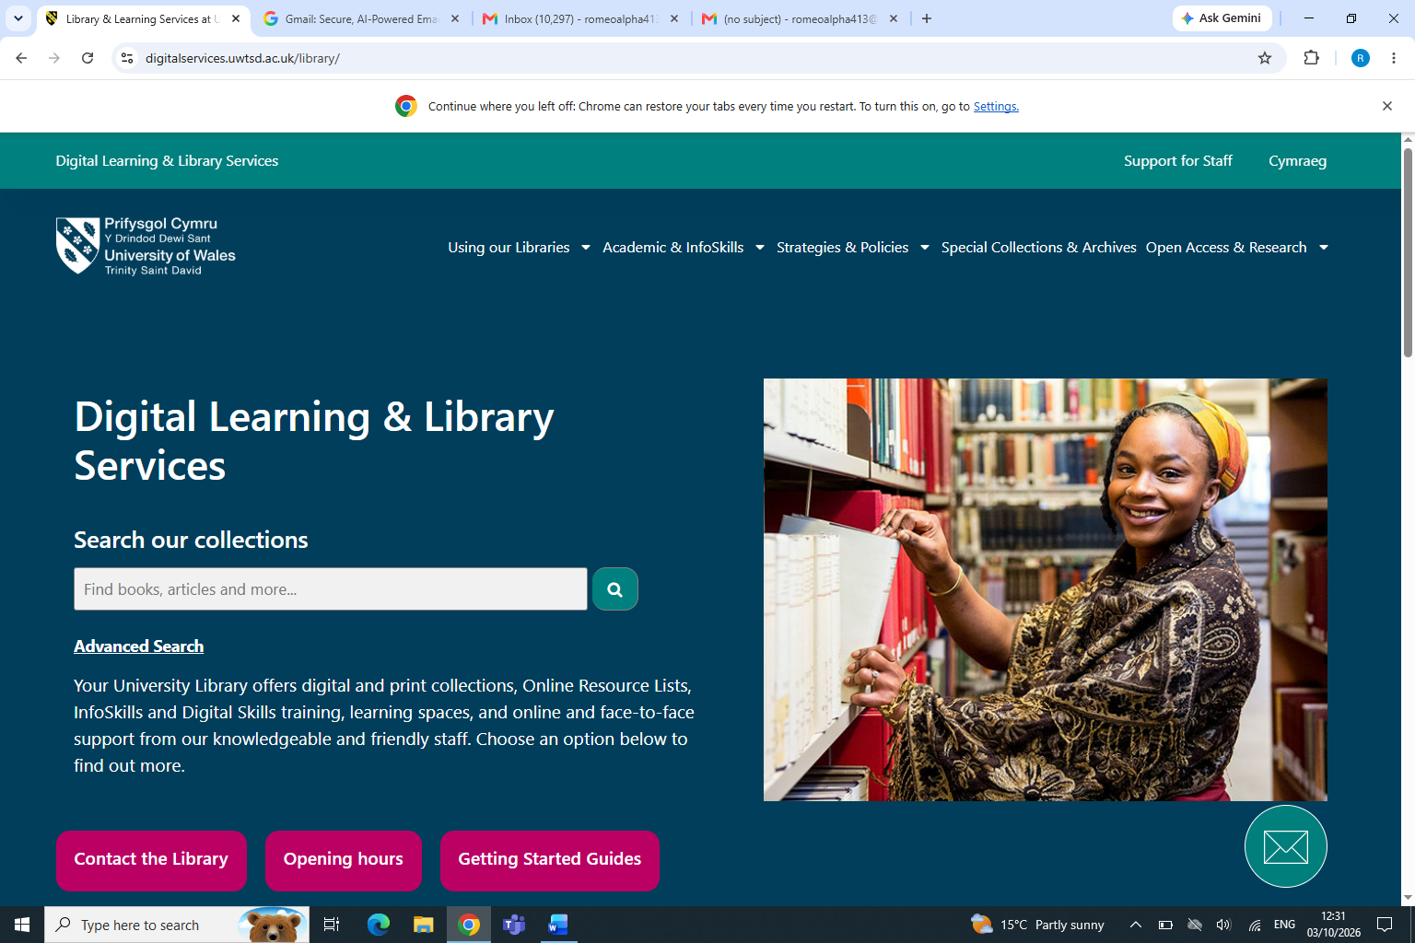
This is the moodle library page, very helpful to find useful information

Screenshot/Photo 4
[Insert Photo/Screenshot below]
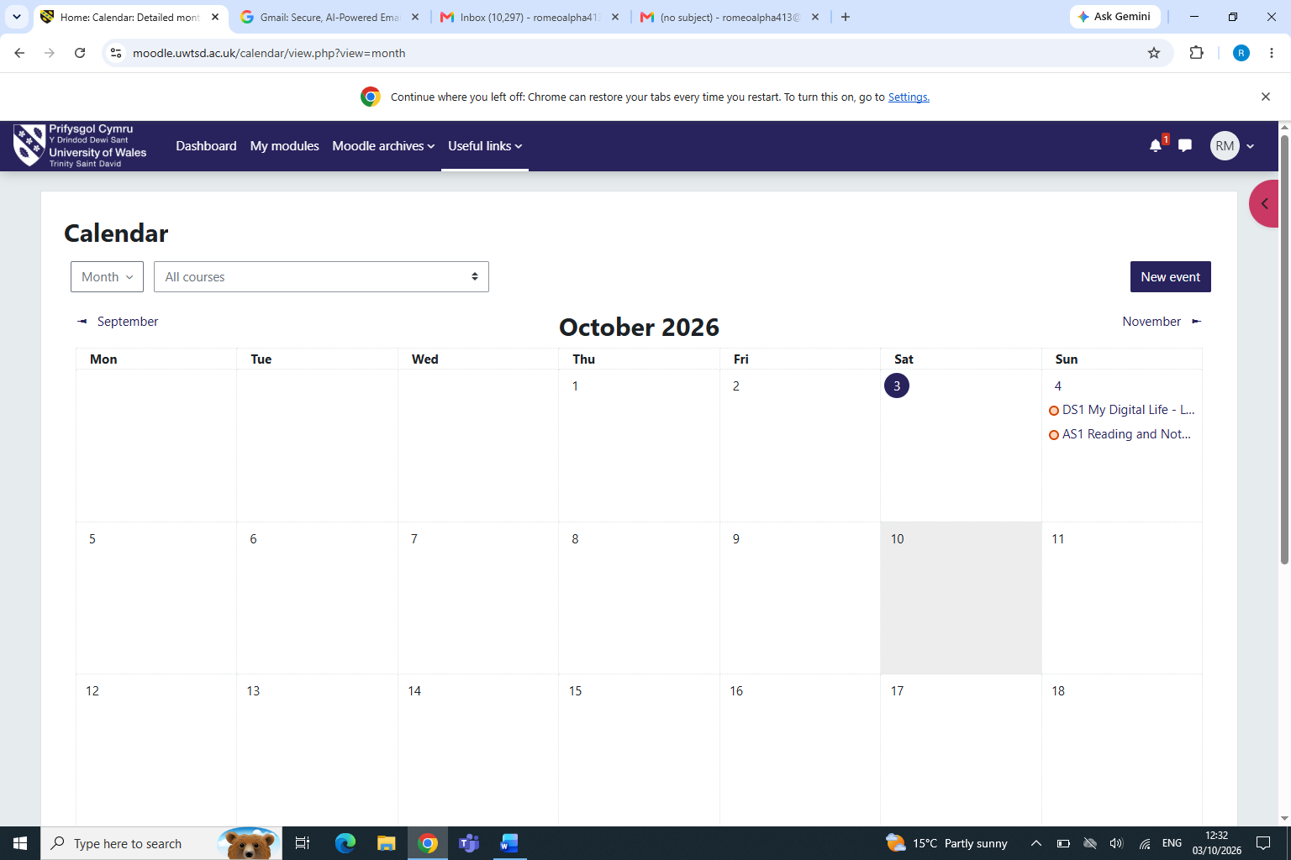
This is my university timetable, from here I know wat time and which class im in.

Screenshot/Photo 5
[Insert Photo/Screenshot below]
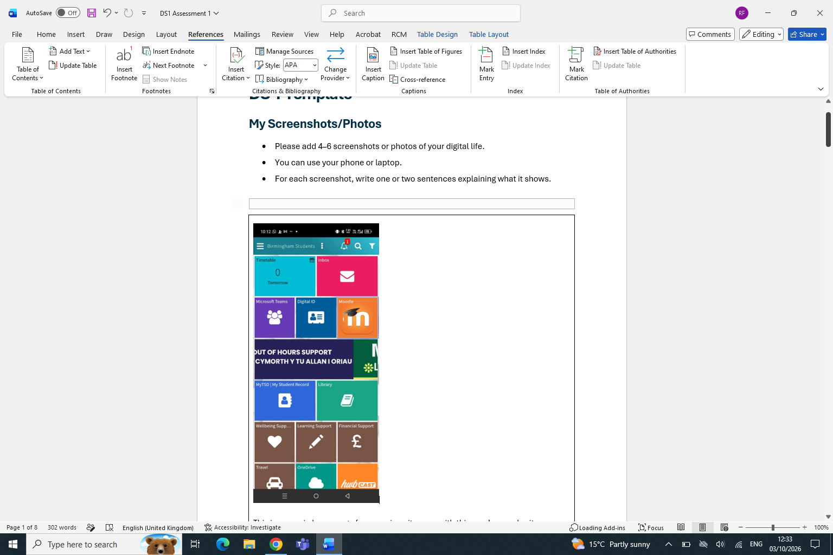
This is my university application from here I can access everything, including the moodle page.

Screenshot/Photo 6
[Insert Photo/Screenshot below]
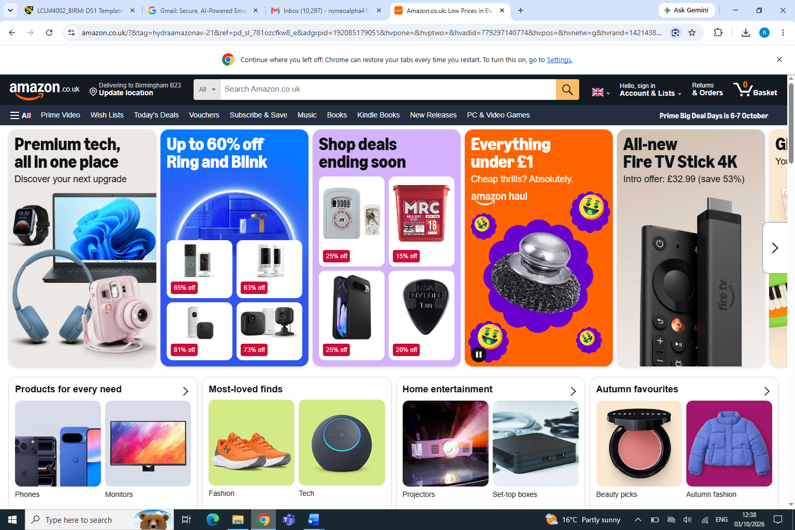
This is amzon, very well known by a lot of people I use this to buy many online products

My Short Reflection
- Write 5–8 simple sentences about your digital life.
- You can use the sentence starters below if helpful.
I’ll be very honest I don’t have much of a digital life I think. In the sense where I keep things very basic and simple, only if I really have to use digital related stuff. I am more of a pen and paper face to face person. I am aware the future is heading towards digital now with applications such as chat gbt, (which I still have not used of yet) and with AI now. I do use WhatsApp to communicate with friends and family such as sending photos, video calling voice recording. That’s about it, don’t really use applications such as Facebook tik Tok Instagram etc. As I have mentioned earlier where the future is heading towards and digital skills are and will be very important in a everday life not only for me but for everyone. Im glad im doing this digital skills course, already I feel more confident than before as I have not really even used a laptop before as there was know need to. I really want to improve on my laptop skills such sending files, templates and many other tasks which will have to be done on the laptop.

I still am nervous about digital skills but we have a great lecturer Naveed who is very helpfull and understanding and hopefully my digitall skills will grow each week and this will boost my confidence levels.

Submission Checklist
Before you submit, please check:
​​​ ☐ I added 4–6 screenshots
☐ I wrote short sentences for each screenshot
☐ I wrote my short reflection
☐ My work is my own
☐ My file opens correctly
​​☐ My file opens correctly

