Humanities Sprint 1 UG DL

General information to consider
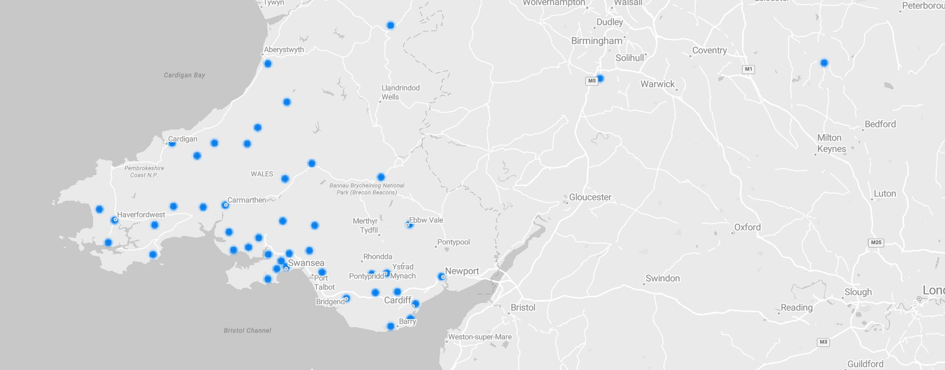Post-Covid Humanities discipline has attracted students primarily from West and South Wales.

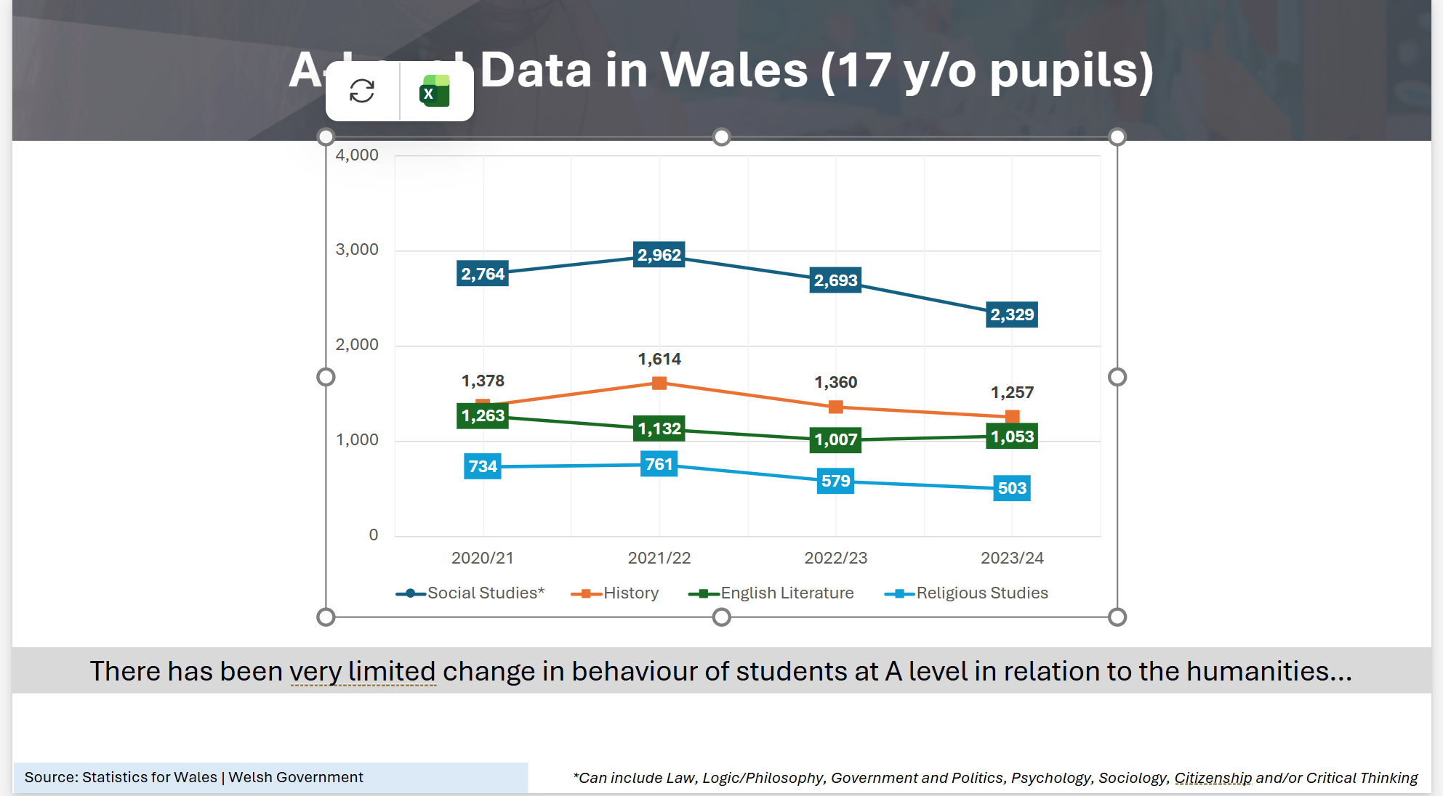
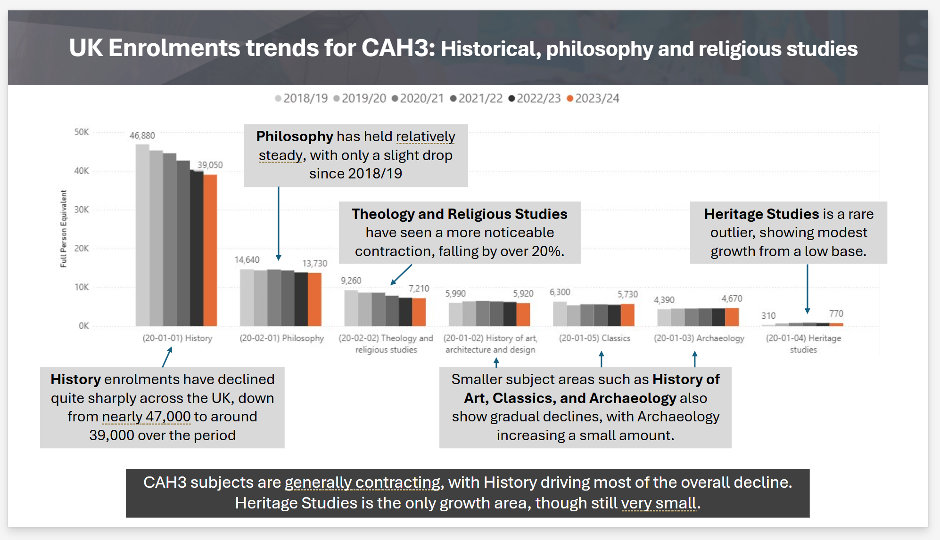

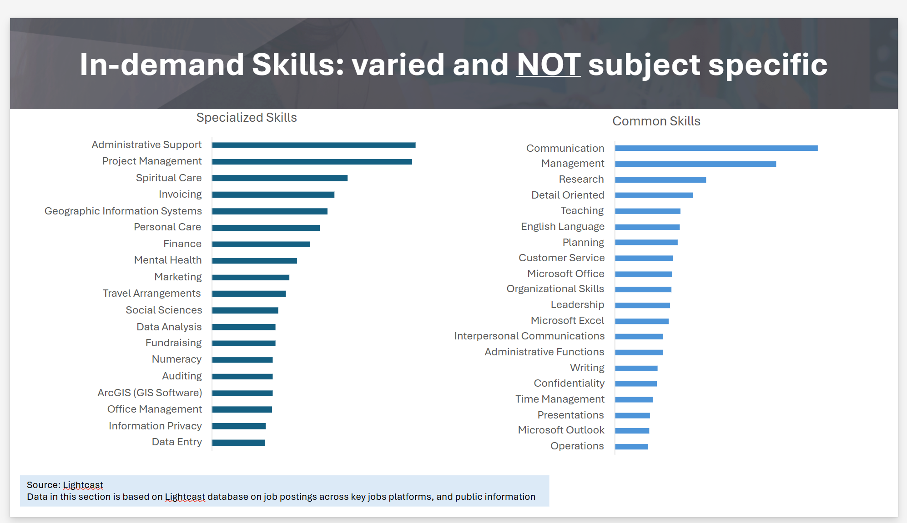

Main Competitors
For the humanities overall (in order of importance)
- S93 Swansea University
- C15 Cardiff University
- C20 Cardiff Metropolitan University
- W76 University of Winchester
- A40 Aberystwyth University

Swansea Offer (Pillar 3)
None

Cardiff Offer (Pillar 3)
- 3 year BA
- Tariff: BBB-BCC
- Across the board lower actual accepted grades
Religion, Philosophy and Ethics (BA) – ON CAMPUS
Religion and Theology (BA) - Study - Cardiff University - DISCONTINUED

Cardiff Met Offer (Pillar 3)
None

Winchester Offer (Pillar 3)
None

Aberystwyth Offer (Pillar 3)
- 3/4 year BA
- Tariff: 120 – 104 BBB-CCC
- Average grade of accepted: CCC
Aberystwyth University - Celtic Studies Q500 BA – ON CAMPUS
Aberystwyth University - Welsh and the Celtic Languages Q562 BA – ON CAMPUS

Other competitors

London School of Theology (Pillar 3)
BA (Hons) Theology
BA (Hons) Theology - London School of Theology
Fully online or blended, three semesters per year 3 years (PT possible)

Intake in October; covers Scripture, systematic, historical, and practical theology
Entry: 2 A-levels + GCSEs (or equivalent, mature students considered)

Queen’s Foundation (UK)
BA in Theology (via Queen’s Online)
The Queen's Foundation: Bachelor of Arts (Hons) in Theology, Ministry and Mission
Modular distance format: CertHE → DipHE → BA (total 3 years PT)
Core areas include Bible, doctrine, worship, theological reflection
Normally at least three A-levels (Grade E or above) or equivalent. Graduates in other subjects may enter the BA programme, and students who have completed the Diploma in Theology, Ministry and Mission successfully may be admitted to the final year of the BA programme

Nazarene Theological College (NTC) / University of Manchester (UK)
BA (Hons) Theology – Online
BA (Hons) in Theology | NTC
120 credits via modular online study
Duration: 3 years FT or up to 6 years PT
Two A-Levels, Highers, or equivalent: For traditional entry, we welcome applicants with 2 A-Levels, Highers, or their equivalent.
Non-Traditional Entry: We recognize the value of diverse experiences. If you don’t meet the traditional criteria, don’t worry; non-traditional entry paths are available.

Overseas (US) competitors

Liberty University (USA)
B.S. in Theology – Bible
BS in Bible Degree Online | Theology | Liberty University
Fully online, 120 credit hours [liberty.edu], [liberty.edu]
Focus: in-depth biblical study, Christian doctrine, worldview, capstone research
Flexible 8‑week terms and eight annual start dates [liberty.edu], [liberty.edu]

Biola University – Talbot School of Theology (USA)
B.S. in Bible, Theology, and Apologetics
Online B.S. in Bible, Theology, and Apologetics - Academics - Biola University
Fully online, 120 credits; can complete in 2–4 years
Built for deep scriptural understanding, theological training, and defence of faith

Moody Bible Institute – Moody Online (USA)
B.S. in Theological Studies
BS in Theological Studies | Moody Online
Fully online, 120 credits
Accreditation: Association for Biblical Higher Education & Higher Learning Commission
Prepares for ministry, theological literacy, communication of Scripture
B.S. in Biblical Studies
Emphasis on biblical interpretation with historical and cultural context

Cedarville University (USA)
B.A. in Biblical and Theological Studies
BA in Biblical Studies | Cedarville University
Fully online
51 credits in general education, 24 in biblical studies, 24 in theology, 27 in ministry courses [cedarville.edu]
Tuition: $375/credit

Corban University (USA)
B.S. in Biblical and Theological Studies
Biblical and Theological Studies | Corban University
Fully online, 120 credits
$475 per credit
Focuses on biblical narrative, systematic theology, mission, and practical application

Lancaster Bible College (USA)
B.A. in Biblical Studies
Bachelor of Arts in Biblical Studies - Online Biblical Studies Bachelors and Associates Degrees - Lancaster Bible College
Fully online, 120 credits
8‑week modules, personalized student coaching, flexible scheduling

