

Data Handling and Business Intelligence
(LCBB5000)
Component 2

Student Name: Cătălin Tabaras
Student Number: 2247295

Word Count: 2824

Table of Contents
PART 1 3
Introduction 3
Analysis 3
Conclusion 3
PART 2 4
References 5

PART 1

Introduction
A dataset is an organized collection of data utilized for research, analysis, and machine learning. It is essential for training and testing algorithms, helping researchers develop and assess models in various fields (Li et al., 2019).
This report examines the "USA Housing Dataset," which is a detailed collection of housing information gathered over three months. It includes important details like prices, the number of bedrooms and bathrooms, sizes of the properties, and their locations. The goal of this analysis is to use Microsoft Excel and SPSS software to find important insights and patterns in the data. We will look at statistics like average, median, mode, and standard deviation to better understand pricing trends and differences in housing features. By visualizing data in Excel and conducting deeper analysis in SPSS, this report aims to provide useful information for potential buyers about current market trends and pricing, helping them make better decisions in the housing market.

Analysis

APPLICATION OF STATISTICAL FUNCTIONS
There are many statistical functions available, but the AVERAGE function is the one that is most commonly used (McGrath and Price, 2023). The mean value of the price is approximately 553,062.88. This indicates that, on average, the prices of the accommodations in the dataset are around this amount. This was determined with the use of the function “=AVERAGE (B2:B4141)”.
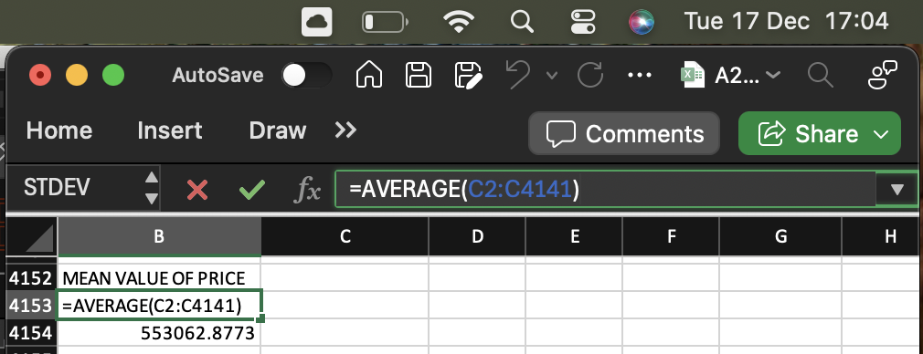

The median value of the price is 460,000. This means that half of the accommodations in the dataset are priced below 460,000, while the other half are priced above this amount. It serves as a useful measure of the typical price, especially when there are extreme values in the data. This information was determined with the help of the function “= MEDIAN(B2:B4141)”.

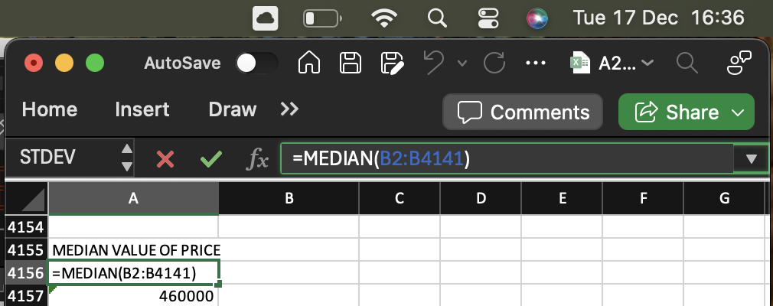

The mode value of the price is 0. This means that the price that appears most often in the dataset is 0, which could suggest that many listings do not have a price listed. The data was determined through the function “= MODE(B2:B4141)”. This might suggest a mistake or problem with the dataset therefore It is important to look into this more to see if these are real listings without prices, default entries, or errors in how the data was collected.

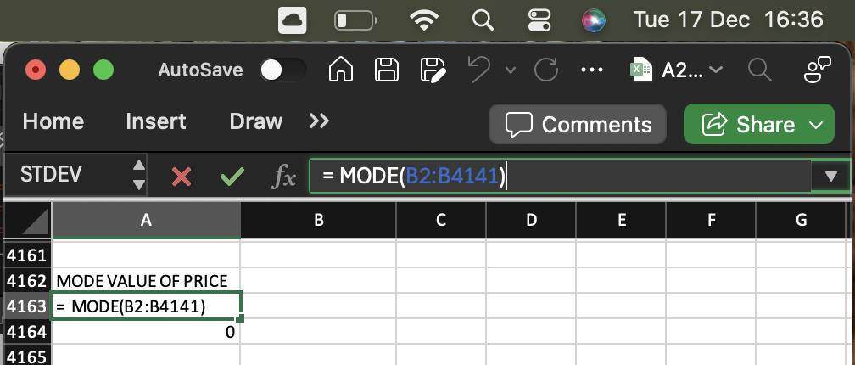

The standard deviation for the number of bedrooms is about 0.90. This means that, on average, the number of bedrooms in the listings varies by 0.90 from the average. A low standard deviation shows that most properties have a number of bedrooms similar to the average, indicating consistency in the dataset. The standard deviation was identified through the formula “= STDEV(C2:C4141)”.

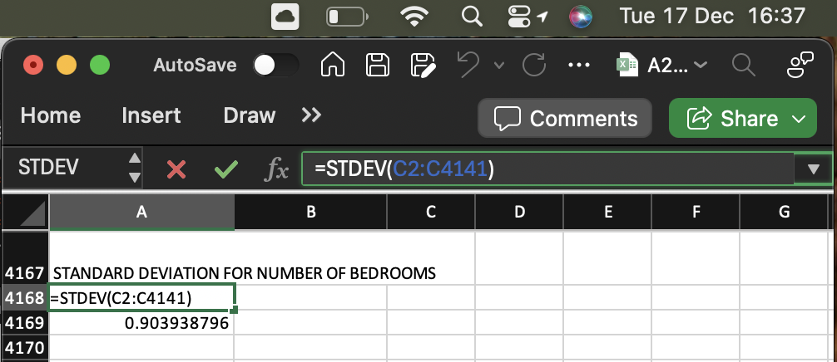

In order to determine the larger variance, it was necessary to calculate the variance for all the relevant numerical variables. Variables such as yr_built or yr_renovated are not relevant to have the variance or standard deviation calculated. The larger variance in the dataset is associated with price, which has a variance of 340,690,000,000 (3.4069E+11 in standard format). To determine this, all the variance values for the listed variables were compared. The price variance indicates significant differences in housing prices within the dataset. This suggests considerable variation from the average, influenced by factors such as location, size, and property condition.

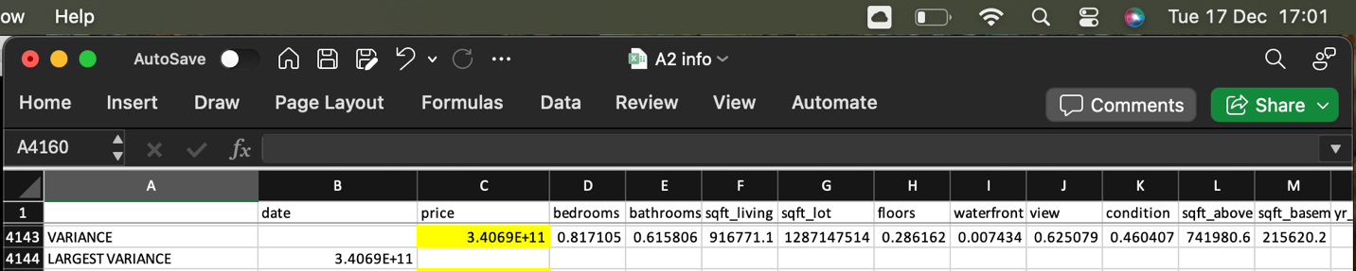

The larger standard deviation in the dataset is for price, which is 583,686.4522. This was determined by calculating and then comparing the standard deviation values of all listed variables that were relevant in this case. The price having the highest standard deviation, indicates a wide range of prices across the properties, meaning that property prices vary greatly from the average.

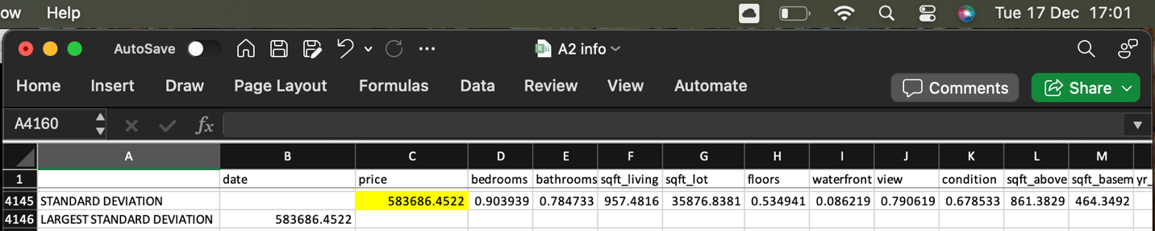

The standard deviation for the number of bedrooms is about 0.90, which means that most homes have a similar number of bedrooms. In contrast, the price has a much larger variance of 340,690,000,000 (or 3.4069E+11), showing that there are big differences in property prices in the dataset. The standard deviation for price is 583,686.4522, indicating that property prices can vary widely from the average, resulting in a broad range of prices among the homes.

PIVOT TABLE
A Pivot Table is a robust tool for data analysis that automatically organizes large sets of data into smaller, easier-to-handle categories (McFedries, 2022).
This pivot table is a simplified version of the "USA Housing Dataset" that makes important information easier to understand and analyse. It's organized by city, allowing users to compare housing features across different areas and see trends specific to each location. The table highlights the maximum number of bedrooms and bathrooms, helping buyers with specific needs find the right homes without going through many listings. It also shows the year homes were built, focusing on the newest properties for those looking for modern options. The lowest prices for the homes that meet the criteria are included, helping buyers find good deals while meeting their space requirements. Plus, a filter for purchase dates lets users sort the data by when homes were bought, which helps in studying market trends, including seasonal buying habits and how quickly homes sell throughout the year.
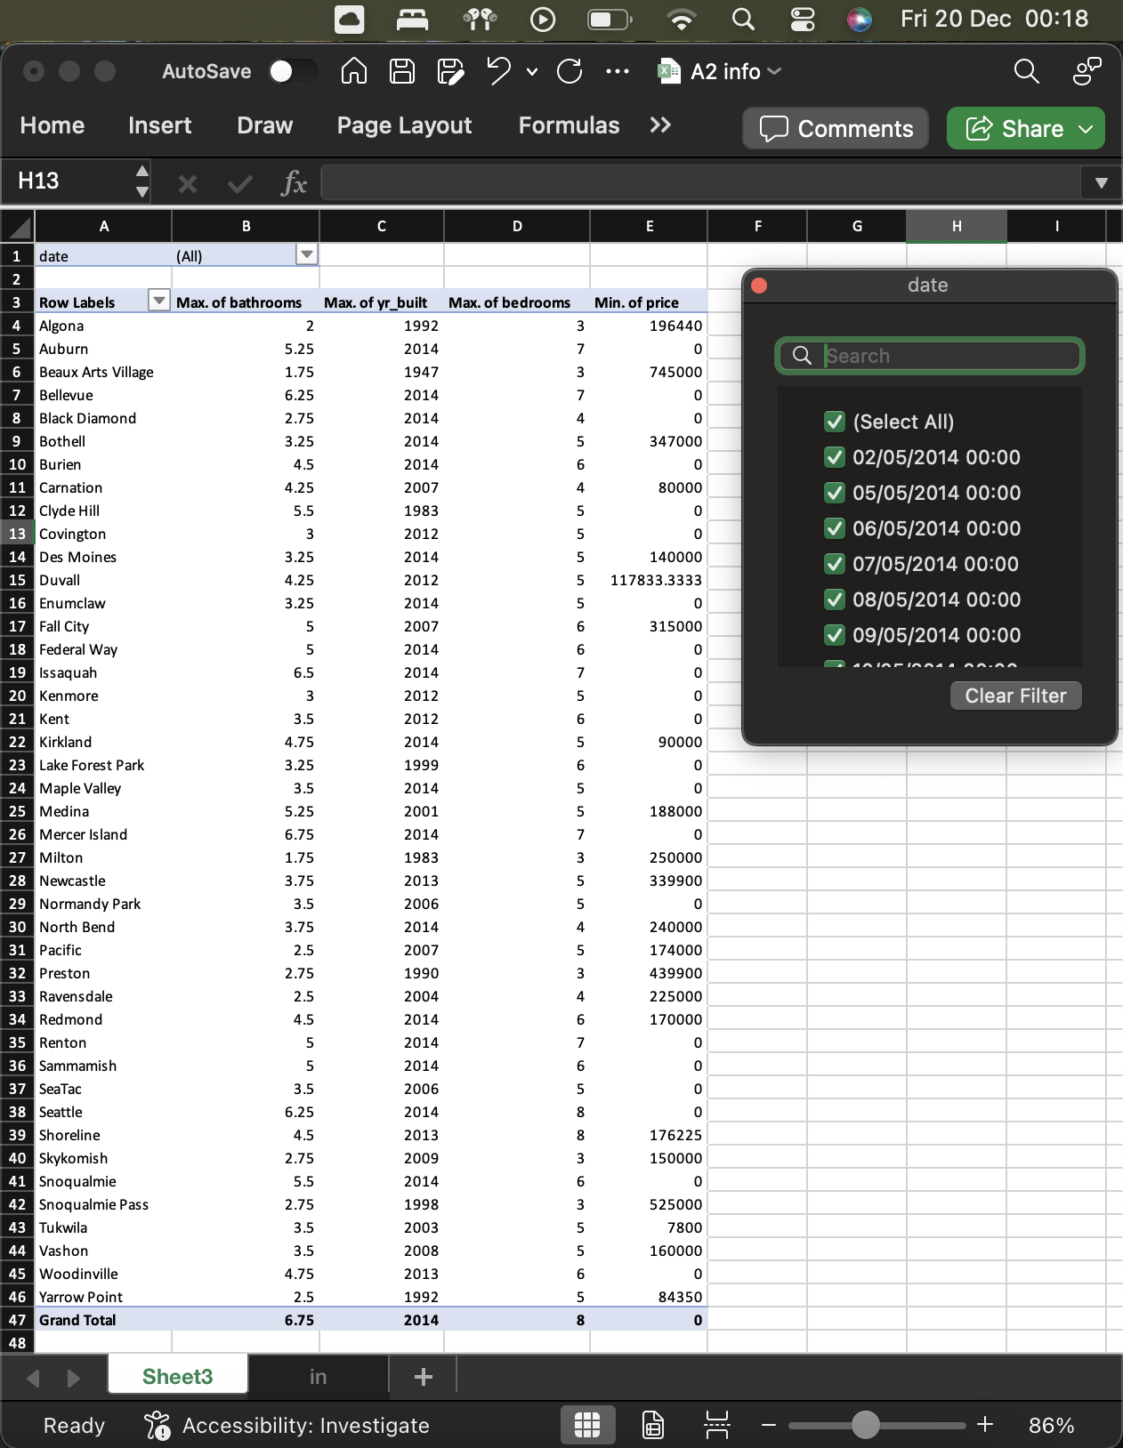
SPSS ANALYSIS

IBM SPSS Statistics is the top statistical software used worldwide to address business and research issues through various methods like quick analyses, testing ideas, analysing geographic data, and making predictions (IBM SPSS Software, n.d.). To determine if there is a correlation between the number of bedrooms and the price of properties, it is needed to calculate the correlation coefficient using statistical software like Excel or SPSS.
The SPSS analysis shows that the correlation between price and the number of bedrooms has a Pearson correlation coefficient of 0.189, indicating a weak positive relationship. This means that as the number of bedrooms goes up, the price tends to increase, but the connection isn't very strong. The significance value is < .001, which means this relationship is statistically significant and not likely due to chance. The analysis is based on 4140 observations, making the results reliable. In summary, while there is a noticeable positive link between the number of bedrooms and price, the weak strength suggests that other factors might also influence property prices.
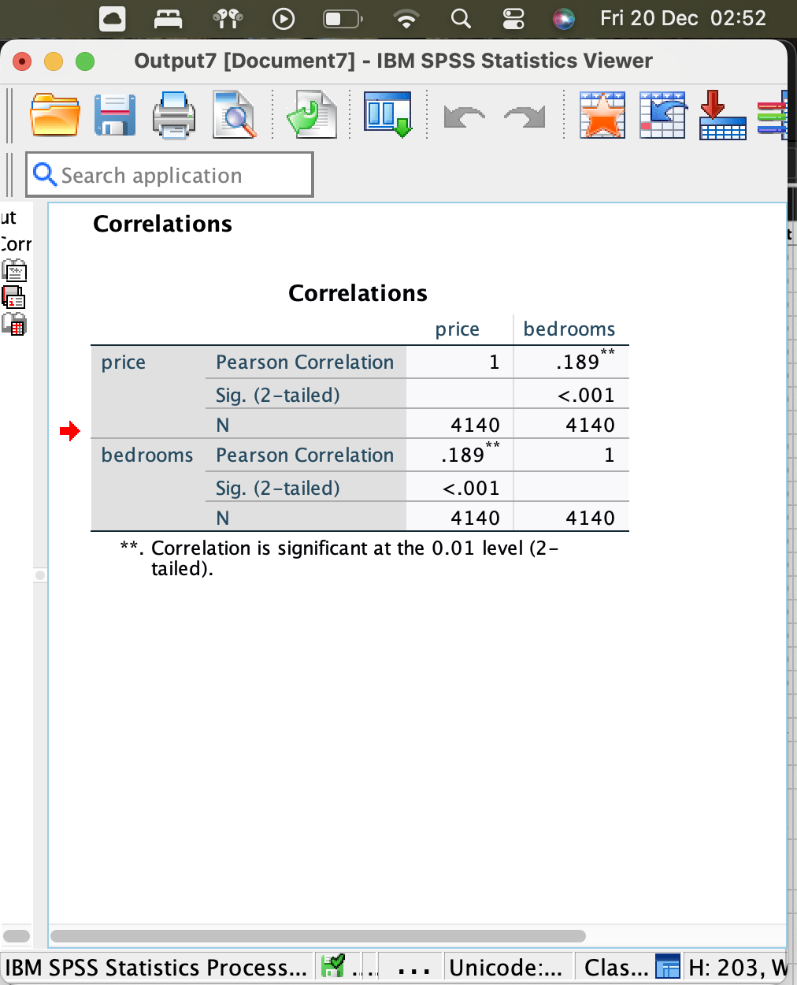
The scatter plot titled "Scatter Plot of Price by Bedrooms" shows how the number of bedrooms in a property relates to its price. The X-axis shows the number of bedrooms, from 0 to 8, including studio apartments to large homes. The Y-axis indicates property prices ranging from $0 to $300,000,000, covering both cheap and luxury homes. Most properties with fewer bedrooms (0 or 1) are cheaper and are clustered at the lower price range. As the number of bedrooms goes up, the prices generally increase, and there are fewer cheap properties. However, some properties with 2, 3, 4, and 6 bedrooms are much more expensive because of special factors like their location or luxury features. Generally, more bedrooms mean higher prices, but this isn't always the case. The grid lines make it easier to read the plot. Overall, the plot helps us understand how the number of bedrooms affects property prices, though more details like location and condition of the property would give a clearer picture.

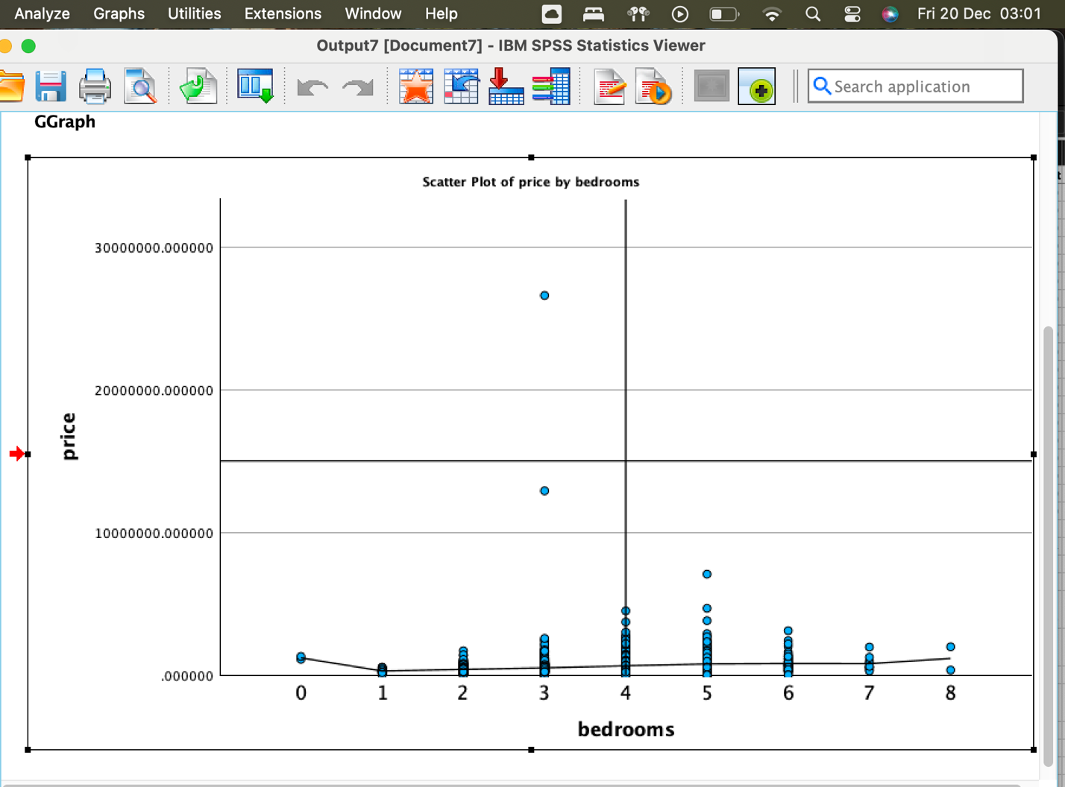

The scatter plot titled "Scatter Plot of Price by Bedrooms" shows how the number of bedrooms in a property relates to its price. The X-axis shows the number of bedrooms, from 0 to 8, including studio apartments to large homes. The Y-axis indicates property prices ranging from $0 to $300,000,000, covering both economic and luxury homes. Most properties with fewer bedrooms (0 or 1) are cheaper and are clustered at the lower price range. As the number of bedrooms goes up, the prices generally increase, and there are fewer cheap properties. However, some properties with 2, 3, 4, and 6 bedrooms are much more expensive because of special factors like their location or luxury features. Generally, more bedrooms mean higher prices, but this isn't always the case. The grid lines make it easier to read the plot. Overall, the plot helps us understand how the number of bedrooms affects property prices, though more details like location and condition of the property would give a clearer picture.

Conclusion

The analysis of the "USA Housing Dataset" with Excel and SPSS highlights their importance in understanding housing market trends and prices. Excel's initial analysis showed an average property price of $553,063, using functions like AVERAGE and MEDIAN, and explored price influences like location and size through Pivot Tables. Meanwhile, SPSS provided deeper statistical insights, including a positive correlation between bedrooms and prices, illustrating the complex factors affecting property values. This study emphasizes how Excel and SPSS assist in examining the housing market, offering valuable insights for buyers.

PART 2

Advantages and Disadvantages of Using Excel
Microsoft Excel is a very popular spreadsheet program used all over the world. People use it in many areas, such as business, finance, education, and data analysis (McFedries, 2022). Excel can be a useful tool for organizing data, doing calculations, and creating visuals based on that data, however, like any tool, it has its advantages and disadvantages.
Advantages of Using Excel
Excel has a simple and easy-to-use interface that helps users move around the program easily. This means people can do complicated calculations without needing a lot of training. For instance, a small business owner can quickly create a budget spreadsheet without needing advanced skills, making Excel available for many types of users.
Excel lets users organize data in tables, making it easy to sort and filter information. For example, a sales team can use Excel to keep track of leads by sorting them based on their status, location, and possible earnings.
Microsoft Excel has many built-in functions and formulas that help users perform complex calculations easily. For instance, financial analysts often use Excel to create financial models, using functions like NPV (Net Present Value) and IRR (Internal Rate of Return) to evaluate investment options.
Excel offers various chart types, like line graphs, pie charts, and histograms, that help users easily spot data trends (McFedries, 2022). For example, a marketing manager can make visuals to display sales trends over a few months, which makes it easier to share this information with others.
Excel has powerful data analysis tools, like PivotTables, that let users summarize large sets of data to find useful information. For example, a project manager can use PivotTables to look at project expenses and how resources are allocated.
Another advantage of Excel is that it works well with other Microsoft Office programs and various data sources, like SQL databases and online services. This easy connection helps teams work better together and makes their processes smoother when working on projects.
Finally, Excel is widely used and supported in many businesses. Its standardized format lets users share files and collaborate on projects without running into compatibility issues.
Disadvantages of Using Excel
Excel is prone to errors because it relies on manual data entry, which can be particularly problematic with complex formulas or large datasets (Singh Mehta, 2023). For example, if a financial analyst makes a mistake while entering a formula for sales calculations, it may result in inaccurate financial reports.
Working together can be hard when several people edit different copies of the same Excel file, causing problems with keeping versions straight. This can lead to confusion and differences in the data, especially when teams are working on project budgets (Team Sigma, n.d.).
Excel is not designed to handle very large datasets effectively. As the spreadsheet gets bigger, it can slow down a lot, leading to longer processing times. For example, managing a dataset with millions of entries is usually better done with a database management system instead of Excel.
While Excel has tools for creating visuals, but they are quite simple and might not meet the needs of advanced data analysis (Team Sigma, n.d.). That is why data scientists usually prefer using specialized software like SPSS or Tableau, which offer more flexibility and interactive dashboard features.
Excel files can be easily accessed without permission, especially when sent by email. If financial data is not well-protected, it can lead to problems following laws and keeping data private for companies (Team Sigma, n.d.).
Though Excel is easy to use for simple tasks, its advanced features can be confusing for those who are inexperienced. For example, beginners may find it challenging to work with array formulas or use VBA (Visual Basic for Applications) for task automation (Singh Mehta, 2023).
Lastly, although Excel provides some collaborative tools, its real-time editing capabilities are limited compared to cloud-based options like Google Sheets. As a result, users collaborating remotely might experience delays in syncing their changes.
Overall, Microsoft Excel is a handy tool for managing and analyzing data. It is easy to use, can do complex calculations, and helps visualize data, hence its extended popularity. However, it can have errors, does not always handle large data well, and lacks some advanced features for teamwork.

Importance and Meaning of the Data Mining Cycle
The Data Mining Cycle is crucial as it provides a structured approach to extracting valuable insights from data, which can inform decision-making, enhance efficiency, and drive business growth. It involves several phases, including understanding the problem, preparing the data, exploring it, building models, evaluating these models, and deploying the most effective ones. This cycle helps in identifying hidden patterns and relationships in data, turning raw data into meaningful knowledge that can significantly benefit various sectors (Brown, 2014).
Business Understanding
In the business understanding phase of the data mining cycle, the focus is on outlining the project’s aims and needs from the viewpoint of the business. This phase guarantees that the data mining initiative is in line with the goals of the organization and pinpoints the issue or chance that data mining should tackle. It lays the groundwork for the project by defining precise goals, which then direct the later stages of the data mining process.
Data Understanding
In the Data Understanding phase of the data mining cycle, the process includes gathering, getting to know, and evaluating the data's quality. The aim here is to uncover insights from the data at hand, pinpoint any issues, and consider how the data can help meet the project's business goals. This stage encompasses activities like the initial gathering of data, investigating the data for any patterns or discrepancies, and determining the data's suitability and quality for further in-depth analysis in the next steps.
Data Preparation
Every stage is equally vital for the quality of outcomes and the value they add to the business. However, when it comes to the amount of time needed, data preparation takes the lead. It usually consumes more time than all the other stages in the data mining process put together (Brown, 2014). Data Preparation in data mining involves cleaning, selecting, and transforming data for analysis. This step is crucial for producing a reliable dataset by addressing missing data, fixing errors, and discarding useless data. It ensures high-quality, precise insights despite being time-consuming.
Modelling
In the Modelling phase of the data mining process, diverse mathematical and computational techniques are applied to the ready data to spot patterns or foresee future events. Depending on the goals of the project, methods like classification, regression, and clustering are employed. This step involves testing various models and fine-tuning their settings to discover the best performing approach. The aim is to create a model that precisely captures the data's inherent patterns and connections, serving as a basis for making informed decisions or predicting upcoming trends.
Evaluation
During the Evaluation phase of the data mining process, the performance of the created models is analyzed to ensure they align with the project's aims and correctly solve the identified issue. This step entails assessing the models' predictions or identified patterns by comparing them with actual results or existing data to verify their precision and tweaking them as needed. The objective here is to confirm the model's dependability and its suitability for application in real-world situations for decision-making or forecasting. It's a vital step in assuring that the model is prepared for real-life use.
Deployment
In the Deployment phase of the data mining process, the tested and approved models are applied in real-world settings. This step includes integrating these models into the business setting for decision-making, forecasting, or revealing new insights with incoming data. Depending on the project, this could mean anything from creating reports to embedding the model into existing operational systems for automated actions. The aim is to leverage the insights obtained through the data mining process to fulfill business aims and generate tangible value. This stage is essential for bringing the practical advantages of data mining to fruition.

Excel excels in data handling and analysis, thanks to its easy-to-use interface, robust calculation features, and visualization tools, making it popular among professionals. Yet, it's important to note its downsides like error-proneness, limited scalability, and basic collaborative functions. Equally important is grasping the data mining process, which helps analysts utilize data to the fullest. This process helps in extracting insights that are crucial for informed strategic choices, enhancing efficiency, and spurring growth across industries by revealing unseen patterns and connections in data.

References

Brown, M. S. (2014) Data Minimg for Dummies. Wiley.
IBM SPSS (n.d.) IBM SPSS software. Available at: https://www.ibm.com/spss. (Accessed on 19 December 2024)
Li, X., Tian, Y., Wang, K., Deng, F., Yan, L., & Wang, F.-Y. (2019) “The ParallelEye Dataset: A Large Collection of Virtual Images for Traffic Vision Research”. IEEE Transactions on Intelligent Transportation Systems, 20(6), 2072–2084. https://doi.org/10.1109/tits.2018.2857566.
Maheshwari, A. (2015) Business Intelligence and Data Mining. New York: Business Expert Press.
McFedries, P. (2022) Teach Yourself VISUALLY Excel 365. 1st edn. Visual.
McGrath, M. and Price, M. (2023) Microsoft Excel in easy steps. In Easy Steps Limited.
TeamSigma (n.d.) 5 Disadvantages of Excel for Data Visualization. Available at: https://www.sigmacomputing.com/blog/5-excel-disadvantages-for-data-visualization. (Accessed on 20 December 2024)
Singh Mehta, CA., M. (2023) Microsoft Excel Professional 2021 Guide. BPB Publications.

