

Employability, Personal Brand and Career Action Plan for the Role of Health Visitor (SCPHN)

Name: Mimi Alero Imo

Student ID: 2414781

Module Code: BMHP5015

Module Title: Changemakers: Building your Personal Brand for Sustainable Employment
Lecturer: Caroline Salami & Brian Mashumba

Word Count: 2000

Submission Date: 07/08/2026

Introduction
This report examines the employability skills required for the Health Visitor position, a Band 6 Specialist Community Public Health Nurse (SCPHN) role, my career aspiration for the next five years. Having recently completed a BSc (Hons) in Health and Social Care, I am at the beginning of my professional journey and currently lack both paid and voluntary experience in a care setting. This report evaluates an active job vacancy in London, analyses the skills required for the role, and provides an honest assessment of my existing skills and areas for improvement relative to these requirements. Furthermore, it outlines a realistic action plan and timeline for acquiring the necessary experience and qualifications. Throughout the document, I also explore strategies for developing my personal brand, professional identity, and networking opportunities from this early stage to achieve my long-term objectives.

The Target Role: Health Visitor (Band 6, SCPHN), London
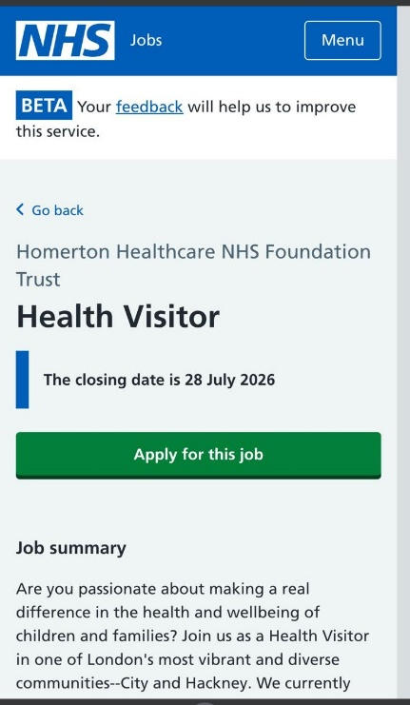
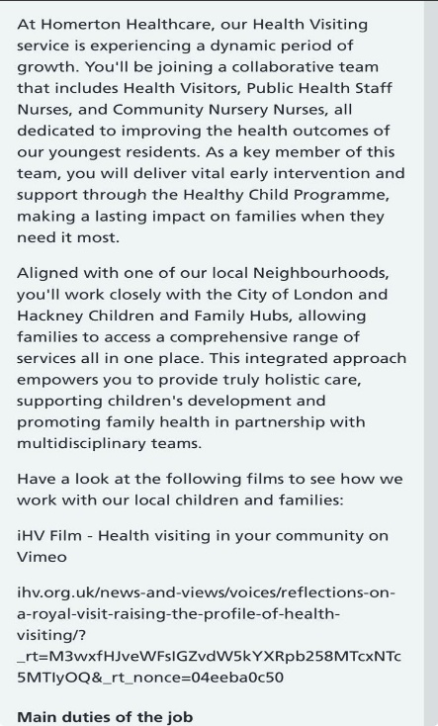
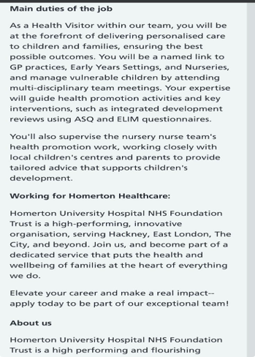
This report focuses on the Health Visitor (Band 6) role at Homerton Healthcare NHS Foundation Trust in Hackney, East London. It also includes the job description from the London Borough of Newham Children's Health Service, detailing similar responsibilities for Health Visitors in a London Safeguarding Children Partnership area. A screenshot of the vacancy is provided below.

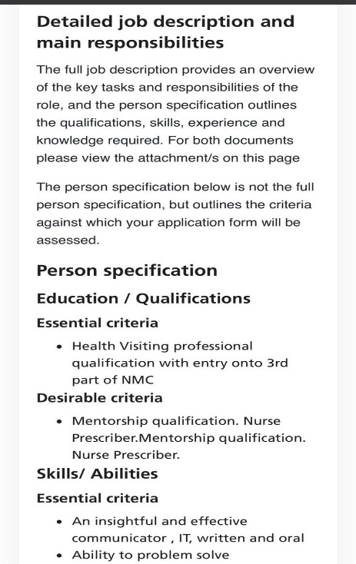


Figure 1: Job Vacancy Screenshot
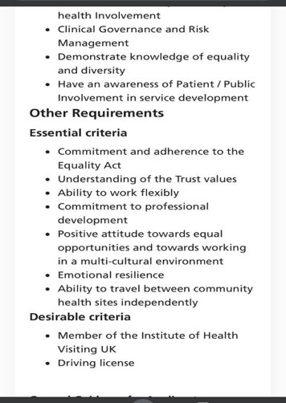
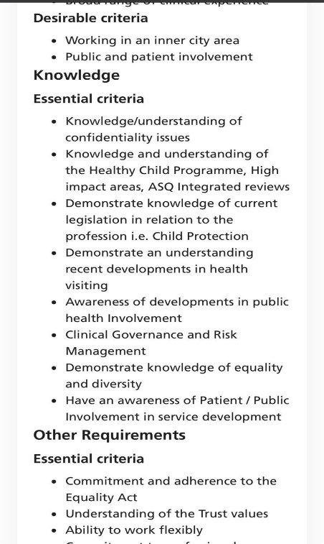
The Health Visitor is a Specialist Community Public Health Nurse in a designated London borough, responsible for delivering the Healthy Child Programme and identifying health and developmental issues in children while adhering to All-London Child Protection Procedures. Applicants must hold a professional qualification in Health Visiting and be registered on the NMC's third part or be a current nurse or midwife progressing toward this qualification. A strong understanding of safeguarding processes, teamwork ability, and excellent communication skills are essential. This role requires both a nursing or midwifery qualification and a specialist postgraduate award, emphasising the importance of knowledge of multi-agency safeguarding arrangements specific to London.

Analysis of the Employability Skills Required
Beyond formal qualifications, the person specification and the broader literature on health visiting practice highlight several essential employability skills. First and foremost, safeguarding competence is vital; the Health Visitor serves as the lead professional in identifying and addressing child protection concerns. They must apply statutory frameworks such as the Children Act 2004 and Working Together to Safeguard Children (HM Government, 2023), in addition to adhering to London-specific multi-agency safeguarding procedures as outlined in the job description (London Borough of Newham, 2024).
Second, effective communication and relationship-building skills are crucial, as the role entails establishing trust with vulnerable families, particularly those dealing with postnatal depression, domestic abuse, or social isolation, and sensitively conveying complex information (Institute of Health Visiting, 2019).
Third, leadership and teamwork abilities are necessary, since Health Visitors operate within multi-disciplinary, multi-agency teams and are expected to support the broader workforce over time, reflecting the profession's commitment to the development of others (Klinge, 2015; Whiting and de Janasz, 2004).
Fourth, proficiency in digital and administrative tasks is expected. The person specification explicitly mentions the importance of written, oral, and IT communication skills, along with a solid understanding of clinical governance and infection control standards.
Lastly, resilience and adaptability are highly valued in a demanding, high-cost urban environment like London, where caseloads can be unpredictable and often require swift safeguarding decisions. This aligns with Duckworth et al.'s (2007) concept of grit as a predictor of sustained professional performance and with Larsson and Tacking's (2023) discussion on antifragility in response to workplace change. As a new graduate, I have yet to demonstrate most of these skills in a professional care setting, which highlights the central gap addressed in the subsequent sections.

Self-Assessment Against the Required Skills
Evaluating my skills honestly against this profile, I recognise that my most significant gap is my lack of direct, practical experience. Currently, I do not possess any paid or voluntary care experience, which limits my ability to provide evidence for the person specification's requirement for hands-on safeguarding practice, chaperoning, or collaboration within a multi-disciplinary care team. Nonetheless, my BSc (Hons) in Health and Social Care has equipped me with a solid theoretical foundation in safeguarding legislation, communication skills, and public health principles, which I developed through academic modules, group projects, presentations, and written assignments.
Applying Houston's (2019) CAR framework (Competence, Autonomy, Relatedness) to this self-assessment, I find my competence strongest in theoretical and written communication, referencing, and independent research, all of which I have cultivated over three years of study. However, I acknowledge weakness in the practical, applied skills required for a care role, given my absence of experience in a care setting. My sense of autonomy is similarly underdeveloped in a professional context, as my experience in managing my own workload has primarily been shaped by academic deadlines rather than clinical decision-making. Regarding relatedness, I find it challenging to provide professional evidence at this stage, although my involvement in group projects and part-time or student roles outside my studies demonstrates my ability to collaborate effectively with others.
Overall, my primary development need is to acquire firsthand care experience, preferably in a role that allows for direct contact with families or children, before pursuing nurse or midwifery registration and, ultimately, SCPHN training. To assess my skills honestly and objectively as I embark on this journey, I plan to employ self-reflection guided by Gibbs' reflective cycle, seek feedback from any placement or employment supervisors, and engage in structured conversations with my university's careers service and personal tutor (Meadows, 2015; Bermingham, 2010).

Relevant Experience and Qualifications
At this point, my BSc (Hons) in Health and Social Care is my sole relevant qualification, and I currently lack both paid and voluntary experience in a health or social care setting. My degree has equipped me with a solid theoretical understanding of safeguarding legislation, person-centred care, public health, and the social determinants of health, all of which are foundational to the Healthy Child Programme's approach to promoting the well-being of children and families (NHS England, 2021). Additionally, the practice placements I completed as part of the course have provided me with limited and supervised exposure to care environments. I acknowledge that this represents a significant gap in relation to the essential experience criteria outlined in the person specification. Therefore, my immediate priority is to address this gap by pursuing an entry-level care role, rather than claiming to have already fulfilled this requirement.

Building My Personal Brand and Professional Identity
Personal branding involves the intentional management of how one's skills, values, and reputation are perceived by others. It is widely recognised as essential for achieving sustainable career progression in competitive professional fields (Peters, 1997; Khedher, 2014). As a new graduate without a work history to reference, my personal brand must focus primarily on my academic achievements, values, and potential rather than experience. My plans include: creating a LinkedIn profile that clearly outlines my degree, my academic interests in safeguarding and public health, and my career aspiration of becoming a Health Visitor; maintaining a structured portfolio that includes coursework, reflective assignments, and any placement evidence from my studies; and crafting a CV that authentically highlights my qualifications as my primary asset while emphasizing transferable skills such as communication, time management, and teamwork, derived from my academic experiences and any part-time work or extracurricular activities.
As a newly qualified health and social care graduate, I am motivated and grounded in safeguarding and public health, seeking initial experiences in the sector. By openly acknowledging my position as a career starter and framing it as ambition towards my long-term goals, I embody what Roy (2008) refers to as productive ambition. This approach aligns with the boundaryless career concept by Arthur, Khapova, and Wilderom (2005), where individuals proactively shape their career narratives.

Networking for Employment Success
Networking will be especially crucial, given my limited professional contacts in the sector. I plan to leverage my university's alumni network and career services to connect with health and social care graduates currently working in care roles. Additionally, I will attend career fairs and NHS recruitment events tailored for new graduates, and I aim to join the Institute of Health Visiting (iHV) as a student affiliate to enhance my visibility within the profession. I also intend to utilise LinkedIn to follow and engage thoughtfully with London NHS Trusts, including Homerton Healthcare and nearby boroughs like Newham, which fall within the area covered by the vacancy analysed in Section 2, to stay informed about entry-level opportunities as they become available (NHS England, 2022).

Value I Can Add and Unique Selling Point
As a recent graduate, my unique selling point lies not in extensive experience, but in my current and relevant academic foundation. My BSc (Hons) in Health and Social Care has equipped me with up-to-date knowledge of safeguarding legislation, public health, and person-centred care theory, all of which align directly with the Healthy Child Programme (NHS England, 2021). Coupled with my genuine enthusiasm and a clear long-term objective, this positions me as a motivated candidate for entry-level care roles, actively pursuing a defined professional pathway rather than lacking direction.

Action Plan and Timeline (Five-Year Plan)
The table below outlines a practical, step-by-step action plan for advancing from my status as a recent graduate with no paid or voluntary care experience to a registered Health Visitor position. This plan aligns with the qualification pathway detailed in the person specification, which involves obtaining a registered nurse or midwife credential, followed by the SCPHN award.
Table 1: Action Plan and Timeframe
Timeframe | Goal | Actions | Resources
Year 1 | Gain my first paid or voluntary care experience and apply for a nursing or midwifery degree. | Apply for entry-level Healthcare Assistant, Support Worker or volunteering roles in a London NHS Trust or care setting; shadow a Health Visitor where possible; join iHV as a student affiliate. | NHS Jobs; iHV membership; UCAS/London University prospectuses
Years 2–4 | Complete a registered nurse or midwifery degree and gain NMC registration | Study full-time while continuing part-time care work; undertake safeguarding training and clinical placements; build a portfolio of practice evidence and reflective writing | University placement support; NHS e-learning for Health; academic and placement supervision
Year 5 | Undertake SCPHN (Health Visiting) training and apply for Band 6 Health Visitor posts. | Secure a Trust-sponsored student SCPHN training post (e.g. Homerton Healthcare NHS Foundation Trust or a neighbouring East London Trust); complete the postgraduate programme; tailor CV and LinkedIn profile to Health Visiting and apply via NHS Jobs. | NMC-approved SCPHN programme (e.g. King's College London); employer sponsorship; NHS Jobs; updated CV/portfolio

This timeline is deliberately structured in a staged manner rather than following a strictly linear format. It acknowledges that gaining initial care experience and obtaining registration as a nurse or midwife are essential prerequisites for SCPHN training. Additionally, it recognises the need for resilience to maintain motivation throughout a rigorous, multi-year journey that begins with no prior experience (Duckworth et al., 2007; Ullsperger, Nittono, and Von Cramon, 2007). I will conduct an annual review of my progress in relation to this plan with my university's careers service. Once I am enrolled in a further course, I will also consult with my academic personal tutor to adjust timelines as necessary, taking into account job availability, course placements, funding opportunities, and potential employer sponsorship.

Communicating My Skills to Employers
To effectively and honestly communicate my skills at this stage, I will maintain a CV and LinkedIn profile that highlight my degree, safeguarding knowledge, and genuine motivation, rather than focusing on experience I have yet to acquire. When filling out application forms that require values-based or competency statements, I will utilise examples from academic assignments, group projects, presentations, and relevant transferable skills gained through part-time work or volunteering, structured using the STAR (Situation, Task, Action, Result) technique. I will be careful to accurately represent my level of experience. Additionally, I will seek references from academic tutors in the absence of a workplace manager and use interviews to convey my enthusiasm, self-awareness, and a clear understanding of my future pathway.

Conclusion
This report analyses the employability skills necessary for a Health Visitor (SCPHN) role. It provides an honest assessment of my current skills and identifies gaps as a recent BSc (Hons) Health and Social Care graduate with no prior paid or volunteer care experience. Furthermore, it outlines a five-year action plan aimed at acquiring the experience, registration, and qualifications needed to achieve this career goal. Although I am just at the outset of this journey, I possess a strong academic foundation in safeguarding and public health, a clear understanding of the requirements, and a structured plan that includes ongoing personal branding and networking strategies to secure registration and, ultimately, a position as a Health Visitor within the NHS.

Reference
Arthur, M.B., Khapova, S.N. and Wilderom, C.P.M. (2005) 'Career success in a boundaryless career world', Journal of Organisational Behaviour, 26(2), pp.177–202.
Bermingham, D. (2010) Overcoming Limiting Beliefs. London: Career Development Press.
Duckworth, A.L., Peterson, C., Matthews, M.D. and Kelly, D.R. (2007) 'Grit: Perseverance and passion for long-term goals', Journal of Personality and Social Psychology, 92(6), pp.1087–1101.
HM Government (2023) Working Together to Safeguard Children. London: Department for Education.
Homerton Healthcare NHS Foundation Trust (2026) Health Visitor – Band 6 [Job advertisement]. Hackney, London. Available at: https://www.jobs.nhs.uk/candidate/jobadvert/C9293-26-0311 (Accessed: 18 July 2026).
Houston, D. (2019) Self-Determination Theory and Career Motivation: The CAR Framework. Bristol: UWE Bristol Learning Materials.
Institute of Health Visiting (2019) Health Visiting: Delivering the Healthy Child Programme. London: iHV.
Khedher, M. (2014) 'Personal branding phenomenon', International Journal of Information, Business and Management, 6(2), pp.29–40.
Klinge, C.M. (2015) 'A conceptual framework for mentoring in a learning organization', Adult Learning, 26(4), pp.160–166.
Larsson, A. and Tacking, N. (2023) Antifragility and Career Resilience in Changing Professions. Stockholm: Nordic Career Press.
London Borough of Newham (2024) Health Visitor: Job Description [PDF]. Newham Council Children's Health Service. Available at: https://www.newham.gov.uk/downloads/file/3181/health-visitor-jd (Accessed: 18 July 2026).
Meadows, D.H. (2015) Thinking in Systems: Limiting Beliefs and Personal Change. London: Earthscan.
NHS England (2021) Healthy Child Programme: Pregnancy and the First Five Years of Life. London: NHS England.
NHS England (2022) NHS People Plan 2022/23. London: NHS England.
Nursing and Midwifery Council (2004) Standards of Proficiency for Specialist Community Public Health Nurses. London: NMC.
Peters, T. (1997) 'The brand called you', Fast Company, August/September, pp.83–90.
Roy, D. (2008) 'Ambition and the modern career', Career Development International, 13(4), pp.316–329.
Ullsperger, M., Nittono, H. and Von Cramon, D.Y. (2007) 'When goals are missed: dealing with error and failure', Cognitive, Affective, & Behavioural Neuroscience, 7(4), pp.319–330.
United Kingdom (2022) Health and Care Act 2022. London: The Stationery Office.
Whiting, V.R. and de Janasz, S.C. (2004) 'Mentoring in the 21st century: Using the internet to build skills and networks', Journal of Management Education, 28(3), pp.275–293.

