

University of Wales Trinity Saint David
School of Engineering
Management Assignment
Jeffrey Elliss
1802644
Motorsport Engineering Beng
Date
Module Name and Code

Abstract

Project REV aims to design an electric hill climb car to compete in the British hill climb championship. Recently an electric class has been spawned by motorsport UK, at the moments the regulations are almost purely safety based. Simply allowing for electric vehicles and referring to FIA Appendix J for safety regulations. This leaves plenty of room for developing any format of powertrain desired. The vehicle will use Toms F3 tub and aims to be at world record pace at each course. The team will develop an aerodynamic package, electric powertrain and appropriate chassis elements. We are participating in this project in order to demonstrate the high-performance possibilities of full electric powertrains as well as the valuable experience of working in a larger team on a full-scale project. By the end of the year our objective is to have a vehicle constructed and ready to test.

Contents

Table of Contents
Abstract 1
Contents 1
Introduction 3
1.0 Team Roles 3
2.0 Belbin Self Assessment 3
2.1 Group Tasks 4
2.2 Personal Tasks 4
2.2.1 Preliminary Bill of materials 5
2.3 Personal Gateways 5
2.4 Personal Milestones 5
2.5 Personal Gantt 6
2.6 Overall Milestones 6
Gateway 7
3.0 Risks 8
Evaluation 9
References 10
Appendix 1 11

Introduction

The following report will set out the roles and responsibilities of each member in the powertrain group, a general overview of our targets and plan for when each task will be completed. Within this there is a detailed list of my own tasks and responsibilities and targets for timings and performance. Having completed a self-assessment inventory I will apply the information to my tasks and identify possible methods to overcome my shortcomings.

Team Roles

Reza Shafi Pour Motlag– motor selection (Specify power and torque requirements and select appropriate motor supplier)

Daniel Wilcox – Duty Cycle(Research hillclimb courses, time between runs etc)

Steffan Robinson – Cooling(Calculate amount of heat rejection and appropriate cooling method and amount.)

Pete Oliffe – Regulations and safety(Find existing electric vehicle regulations and monitor the evolution of regulations)

George Dalton Brown – Controllers(Find appropriate motor controllers and identify data inputs etc required for the project)

Jeffrey Elliss – Transmission(Calculate gear ratios, decide on tyope of transmission and gears, select driveshafts)

Timothy Stanbury – Energy storage(Select energy storage, battery capacitor or combination etc)

2.0 Belbin Self Assessment

Belbin team roles are a useful way to examine a group of people and identify strengths and weaknesses. The system relies on each person completing a self-assessment sheet which scores them in each of the nine roles. These roles are, Resource investigator, team worker, coordinator, plant, monitor evaluator, specialist, shaper, implementer and completer finisher.
For my role deciding on and designing the transmission solution. It is important that I can generate ideas, find existing solutions and can focus on coming to a deep understanding of the solutions that I will be implementing. For example, it is essential that I have an in depth understanding of planetary gear sets. The ability to focus in on individual ideas is important, focusing on individual problems such as the method by which to change gear ratios will mean that the most efficient solution will be refined and implemented. These requirements are identified by Belbins model in the categories of plant, specialist and resource investigator.(Belbin.com, 2019)
Having completed a self-perception inventory, I meet some of the requirements I set out above. Scoring highly in plant and monitor evaluator, this implies that I will be good at generating ideas and solving problems as well as making good judgements about which ones to use. However, I scored very low in resource investigator this suggests that I won’t spend enough time investigating existing solutions. Realizing this each time I begin a new task on this project I will choose to spend time researching existing solutions more than I naturally would and hope to offset my natural tendency to spend little time searching for existing solutions.

2.1 Group Tasks
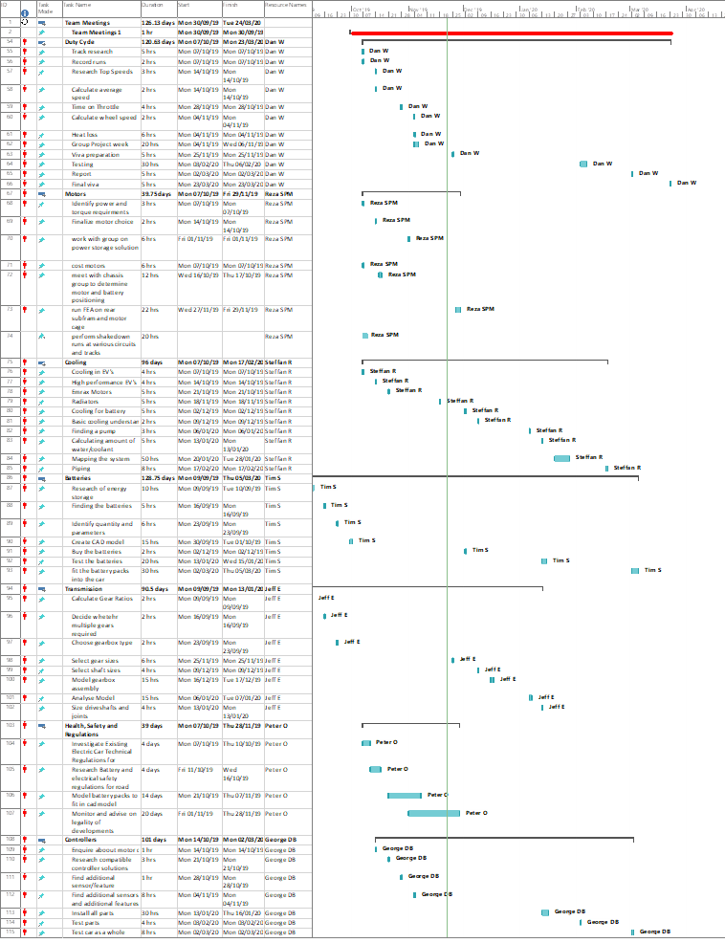
Figure 1-Group tasks and Gantt chart

2.2 Personal Tasks

Table 1-Personal Tasks
Task | Time | Start Date | Deadline | Description
Calculate gear ratios | 2hr | Mon 21/10/19 | Fri 25/10/19 | Calculate the ratios needed to achieve the required top speeds with the selected wheel size.
Select gears | 8hrs | Mon 18/11/19 | Fri 01/11/19 | Select appropriate gears from a supplier as a reference to begin modeling work and workout packaging concerns.
Assist with energy storage selection | 30hrs | Mon 04/11/19 (Project Week) | Thu 07/11/19 | During project week work on finalizing the energy storage choice (Battery supercapacitor choices etc)
Determine method of changing ratios | 10hrs | Mon 25/11/19 | Mon 09/12/19 | Consider ways in which to quickly change between ratios for different courses or on the day of a test if necessary.
Calculate shaft dimensions | 8hrs | Mon 02/12/19 | Fri 13/12/19 | Calculate the diameter and lengths of input and output shafts as well as driveshafts
Model moving components of gearbox | 8hrs | Mon 16/12/19 | Fri 20/12/19 | Model the shafts and gears in order to validate the design ideas and in preparation for stress analysis.
Analyze function and strengths of model | 16hrs | Tue 17/12/19 | Fri 24/01/20 | Examine each moving component and system as a whole to ensure that calculations and selections of gear sizes and shaft dimensions are appropriate.
Model housing and mounting method | 8hrs | Mon 06/01/20 | Fri 31/01/20 | Model an appropriate housing for the moving components and a method of mounting to the vehicle, checking with chassis group and motor to ensure chosen mounting is possible.
Analyze strength of mounting and housing | 16hrs | Tue 07/01/20 | Mon 17/02/20 | Use software tools to ensure that mountings and housing can withstand the forces they need to.
Refine design where necessary | 8hrs | Thu 09/01/20 | Fri 21/02/20 | Make any corrections needed such as strengthening mounting brackets, reducing weight if possible etc.
Order components | 1hr | Mon 10/02/20 | Tue 11/02/20 | Order off the shelf components
Manufacture or order components which need to be manufactured | 8hrs | Tue 11/02/20 | Fri 21/02/20 | Bring technical drawings to company capable of manufacturing required components or if possible manufacture in university workshops.
Assemble | 8hrs | Mon 24/02/20 | Wed 11/03/20 | Assemble the components into the two gearboxes required.
Test | 8hrs | Mon 09/03/20 | Fri 20/03/20 | On car testing or on dyno testing with appropriate emrax motor.

2.2.1 Preliminary Bill of materials

Table 2 is an estimation of the materials that will be needed to construct the gearbox and their costs where known.

Table 2-Materials
Item | Cost | Availability
Gears | £20 and up, dependent on strength and sizes. | Wide variety of suppliers
Shafts |  | Need to be manufactured
Housing |  | Must be manufactured

Personal Gateways

- Targets for torque, rolling radius and maximum grip known.
- Ratios and maximum torque figures identified.
- Gearbox type chosen and method of achieving the full range of ratios determined.
- Appropriate strength gears and shafts identified, and availability known.
- Mounting method determined, including dimensions and any hardpoints that are needed from the chassis group.

2.4 Personal Milestones

- Gear Ratios calculated, this is the first significant task for me as it will determine the type of gearbox and whether or not ratios need to be changed.
- Max torque calculated, this is the next significant point as it will determine the strength of each component that is required
- Face width of gears selected, determines the other characteristics required of each gear and will be a significant factor in the size of the gearbox.
- Method of changing ratios chosen, this may have a bearing on how the units can be mounted to the motor, for instance if the held component of a planetary gear set is changed to change between ratios the mounting method may need to be changeable.
- Shaft dimensions
- Cad model of moving parts complete, including input and output locations, shafts and gears.
- Mounting system considered.
- CAD model of housing complete, must be done after the moving parts are modelled as they will determine the size and where mounting equipment can be placed.
- Driveshaft dimensions calculated
- Driveshaft angles calculated
- Driveshaft joints selected

Personal Gantt
Figure 2-Gantt chart for transmission responsibility
Figure 2 is a Gantt chart mapping out an estimation of how long each stage of my area of responsibility will take. It may evolve as then project proceeds as tasks may take more or less time than they have been projected to take. As I have little experience of estimating how much time engineering tasks take me the timings and dates of the plan may need to be changed as I work through the project.

Overall Milestones

- Initial targets set for project, including mass, power, drag and lift, grip, torque, overall dimensions and duty cycle.
- Battery Volume calculated and flexibility of modules decided.
- Location battery modules and distribution of mass determined.
- Viva 1, 4th December 2019
- Full car model complete, including powertrain elements, chosen aero package, chassis and suspension components.
- Cost to build calculated and all info required for this in one location.
- Viva 2, W/C 23rd March 2020
- First whole car test, June-July dependent on build completion date.
- Compete in first British Hill climb event
- Develop car as necessary, refining the vehicle as it is run in more events under different conditions.

Gateway

An engineering gateway is a requirement that must be fulfilled in order for a project to proceed, if the gateway cannot be passed then the project cannot be completed to the targets set out.
The gateway I have selected is to have a complete gearbox design concept that is capable of avoiding critical failure under the torque loads and will be sufficiently versatile to provide for the varying top speed requirements of the hill climb courses. These requirements are dependent on, the max torque output of the motor, the maximum grip available and the target top speeds set for the vehicle. These have all been defined and are show in Table 1. Due to aero loads it is possible that the worst case for torque through the gearbox may not be at the start as the car will generate significant downforce. This means that the maximum grip available exceeds the maximum torque for most gear ratios when exceeding 100mph. The ratios required vary significantly between 2.5:1 and 4.6:1, it is important that this is possible within any packaging constraints that I am given, though none have been specified at this time. The wide range of gear ratios needed for the courses makes constructing a sufficiently flexible design difficult. If a design which fulfills the strength criteria cannot be completed then the project cannot move forward.
Once this gateway has been passed components can be ordered and manufactured as necessary or if necessary the design can be refined and adjusted with any changes that happen external to my area. For example, if target top speed changes the ratios needed would change. Furthermore, once the gateway is completed information about precise dimensions and mounting needs can be distributed to the appropriate people.

Table 3-Gateway objectives
Objective | Measurement
Range of Ratios | 2.5:1 to 4.6:1
Strength | Max grip @6000Nm downforce, 4558N(per side as each gear set only applies to one side)
Packaging | TBC

Risks

Risk 1

Failure to identify a method of attaining the full range of gear ratios required within the packaging and mounting constraints that the project involves. The consequences of this would be a reduction in performance at the courses which a correct gear ratio cannot be attained for. To reduce the chance of this happening, the ratios required have been calculated early and the method of changing gear ratios is an area which I have spent time considering early in the design process. If it is not possible to select a full range of ratios, the performance impact can be reduced by, choosing a set of ratios that will be most appropriate for the widest variety of courses. As well as this the calculated required gear ratio have been given to the simulation group who will ensure that they are appropriate and feedback information if they are not realistic or ideal for performance purposes.

Risk 2

Changing downforce and torque figures could lead to insufficient strength of gears and or shafts. This consequences of this are gear and or shafts will shear under the loads and may cause extra damage to other items such as the motor and the bodywork. If they are sized for smaller amounts of torque than the vehicle is capable of using. The inverse also has a risk associated with it, a loss of performance due to increased mass. This consequence is preferable to expensive damages to the car. To mitigate this risk, I will keep up to date with the downforce figures that the aero group are expecting and am currently working to their target downforce of 6000N and work with a safety factor applied to components such that they will be slightly oversized and less likely to fail if loads are slightly higher than expected. The disadvantage of this is that there will be some performance loss due to added mass.

References

Belbin.com. (2019). Belbin. [online] Available at: https://www.belbin.com/about/belbin-team-roles/. Accessed: Saturday 23rd November 2019

